HW8 RV

Rachael Valdez

10/24/2017

## Importing Files

12 .csv files will be imported and bound together to create one large file using a loop. These files contain information regaurding the time and temperature per trial number conducted.

# Plot 1

Data frame will be plotted to get the temperature for each TC0 time point. 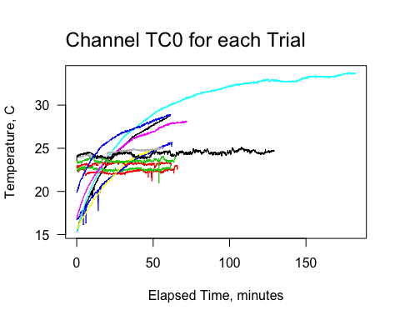

## Importing excel

Heating trial info will be imported which contains mussel tag ID's,the channel, trial number information, and if the specimin is dead or alive.

## Plot 2

Plot two will parce out TCLocation for In50 for each trial 1-12.

