***MUHAMMAD REVAN ADZANUAR***

***XI RPL B***

***20***

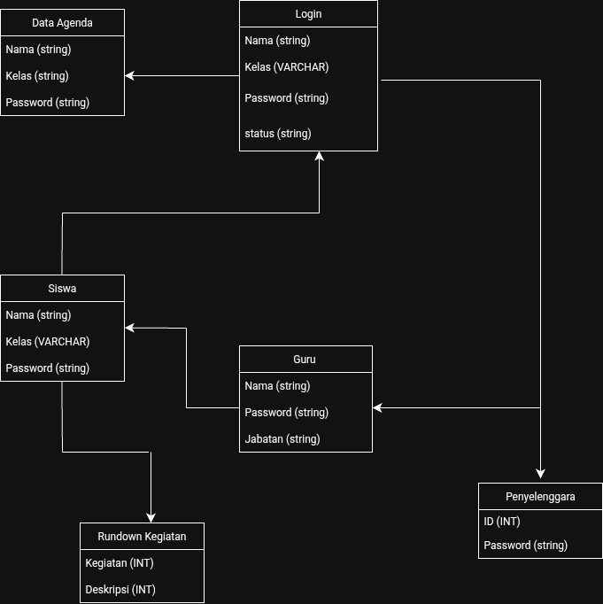

Tabel Penyelenggara

| **Nama Penyelenggara** | **Password Penyelenggara** | **ID Penyelenggara** |
| --- | --- | --- |
| Budi Kurniawan | 01836014 | P001 |
| Eko Prasetyo | 04736199 | P002 |
| Joko Purnama | 83651818 | P003 |
| Josep Asep | 64828717 | P004 |
| Surya Permata | 53528276 | P005 |
| Siti Amanah | 84625188 | P006 |
| Heni Suryani | 47728263 | P007 |
| Ririn Thamrin | 64929267 | P008 |
| Rizka Azka | 73926520 | P009 |
| Putri Lestari | 36291726 | P010 |

Guru

| **Nama Guru** | **Jabatan Sebagai** | **Password** | **ID Guru** |
| --- | --- | --- | --- |
| Pak Boan | Kepala Sekolah | 29196362 | G001 |
| Pak Dani | Guru Jurusan | 74929265 | G002 |
| Pak Fahmi | Guru Olahraga | 47291763 | G003 |
| Pak Dani | Guru Jurusan | 04727103 | G004 |

Data Kegiatan

| **Hari/Tanggal** | **Kegiatan** | **ID Kegiatan** | **Tempat & Lokasi** |
| --- | --- | --- | --- |
| 05‐05-2025 | Pembukaan & Pameran Buku | K001 | Lapangan Utama & Lorong Sekolah |
| 06-05-2025 | Lomba Baca Puisi | K002 | Aula RPS |
| 07-05-2025 | Lomba Cipta Cerpen & Poster  Literasi | K003 | Ruang Kelas Masing-Masing |
| 09-05-2025 | Puncak Acara & Penghargaan | K005 | Lapangan Utama |

SISWA

| **Nama** | **NIS** | **Password** | **Kelas** |
| --- | --- | --- | --- |
| Bulan Indah | 2008001 | 1763289 | 11 RPL A |
| Mentari Siska | 2009002 | 8392928 | 10 AK B |
| Sintia Cinta | 2007003 | 8462018 | 12 TKJ B |
| Pernama Mustika | 2008004 | 9635190 | 10 TKR B |
| Suci Hasturi | 2006005 | 1428392 | 12 RPL B |
| Xeno Dirgantara | 2010006 | 6362010 | 11 BB A |
| Karisma Putra | 2009007 | 0273628 | 10 DKV B |
| Andi Susilo | 2008008 | 0830187 | 11 TP A |
| Hazrul Cipta | 2007009 | 3729173 | 12 TPFL B |
| Angkasa Zakaria | 2009010 | 2947289 | 11 TKR B |