**Tugas Service**

|  |  |
| --- | --- |
| **Nama** | Moch Revano Budiansyah |
| **Nim** | 2018019 |
| **Kelas** | A |

1. **Mengimplementasikan Service pada program.**

Source code:

|  |
| --- |
| package com.revanmalang.musicbackground;  import android.app.Notification;  import android.app.NotificationChannel;  import android.app.NotificationManager;  import android.app.Service;  import android.content.Context;  import android.content.Intent;  import android.content.SharedPreferences;  import android.graphics.Color;  import android.media.MediaPlayer;  import android.os.Build;  import android.os.IBinder;  import android.support.v4.app.NotificationCompat;  import android.util.Log;  import android.widget.Toast;  public class BackgroundSoundService extends Service {  private static final int FOREGROUND_SERVICE_ID = 111;  private static final String TAG = "BackgroundSoundService";  MediaPlayer player;  public IBinder onBind(Intent arg0) {  Log.i(TAG, "onBind()" );  return null;  }  @Override  public void onCreate() {  super.onCreate();  Log.i(TAG, "onCreate()");  player = MediaPlayer.create(this, R.raw.bensound_funnysong);  player.setLooping(true); // Set looping  player.setVolume(100,100);  Toast.makeText(this, "Service started...", Toast.LENGTH_SHORT).show();  }  public int onStartCommand(Intent intent, int flags, int startId) {  Log.i(TAG, "onStartCommand()");  if (Build.VERSION.SDK_INT >= Build.VERSION_CODES.O) {  String NOTIFICATION_CHANNEL_ID = "com.revanmalang.musicbackground";  String channelName = "My BackgroundSound Service";  NotificationChannel chan = new NotificationChannel(NOTIFICATION_CHANNEL_ID, channelName, NotificationManager.IMPORTANCE_NONE);  chan.setLightColor(Color.BLUE);  chan.setLockscreenVisibility(Notification.VISIBILITY_PRIVATE);  NotificationManager manager = (NotificationManager) getSystemService(Context.NOTIFICATION_SERVICE);  assert manager != null;  manager.createNotificationChannel(chan);  Notification.Builder builder = new Notification.Builder(this, NOTIFICATION_CHANNEL_ID)  .setContentTitle(getString(R.string.app_name))  .setContentText("BackgroundSoundService Running")  .setSmallIcon(R.mipmap.ic_launcher)  .setAutoCancel(true);  Notification notification = builder.build();  startForeground(FOREGROUND_SERVICE_ID, notification);  Log.e(TAG,"startForeground >= Build.VERSION_CODES.O");  } else {  NotificationCompat.Builder builder = new NotificationCompat.Builder(this)  .setContentTitle(getString(R.string.app_name))  .setContentText("BackgroundSoundService Running")  .setPriority(NotificationCompat.PRIORITY_DEFAULT)  .setSmallIcon(R.mipmap.ic_launcher)  .setAutoCancel(true);  Notification notification = builder.build();  startForeground(FOREGROUND_SERVICE_ID, notification);  Log.e(TAG,"startForeground < Build.VERSION_CODES.O");  }  if(Preferences.getMediaPosition(getApplicationContext())>0){  Log.i(TAG, "onStartCommand(), position stored, continue from position : " + Preferences.getMediaPosition(getApplicationContext()));  player.start();  player.seekTo(Preferences.getMediaPosition(getApplicationContext()));  }else {  Log.i(TAG, "onStartCommand() Start!...");  player.start();  }  //re-create the service if it is killed.  return Service.START_STICKY;  }  public IBinder onUnBind(Intent arg0) {  Log.i(TAG, "onUnBind()");  return null;  }  public void onStop() {  Log.i(TAG, "onStop()");  Preferences.setMediaPosition(getApplicationContext(), player.getCurrentPosition());  }  public void onPause() {  Log.i(TAG, "onPause()");  }  @Override  public void onDestroy() {  super.onDestroy();  Log.i(TAG, "onDestroy() , service stopped! Media position: " + player.getCurrentPosition());  //Save current position before destruction.  Preferences.setMediaPosition(getApplicationContext(), player.getCurrentPosition());  player.pause();  player.release();  }  @Override  public void onLowMemory() {  Log.i(TAG, "onLowMemory()");  Preferences.setMediaPosition(getApplicationContext(), player.getCurrentPosition());  }  //Inside AndroidManifest.xml add android:stopWithTask="false" to the Service definition.  @Override  public void onTaskRemoved(Intent rootIntent) {  Log.i(TAG, "onTaskRemoved(), save current position: " + player.getCurrentPosition());  //instead of stop service, save the current position.  //stopSelf();  Preferences.setMediaPosition(getApplicationContext(), player.getCurrentPosition());  }  } |

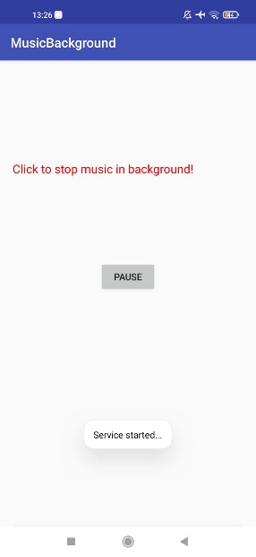

#### Hasil Tampilan

Analisa:

Pada Program diatas ketika dijalankan terdapat tombol start yang jika ditekan akan memutar sebuah lagu dan dapat berjalan dilatar belakang seperti gambar diatas.