github url: https://github.com/j2eeexpert2015

Remote Debug Spring Boot Web Service:

command:

java -Xdebug -Xnoagent -Xrunjdwp:transport=dt_socket,server=y,suspend=n,address=8001 -jar <springboot_jar_name>.jar

Goto Run> Edit Configurations>

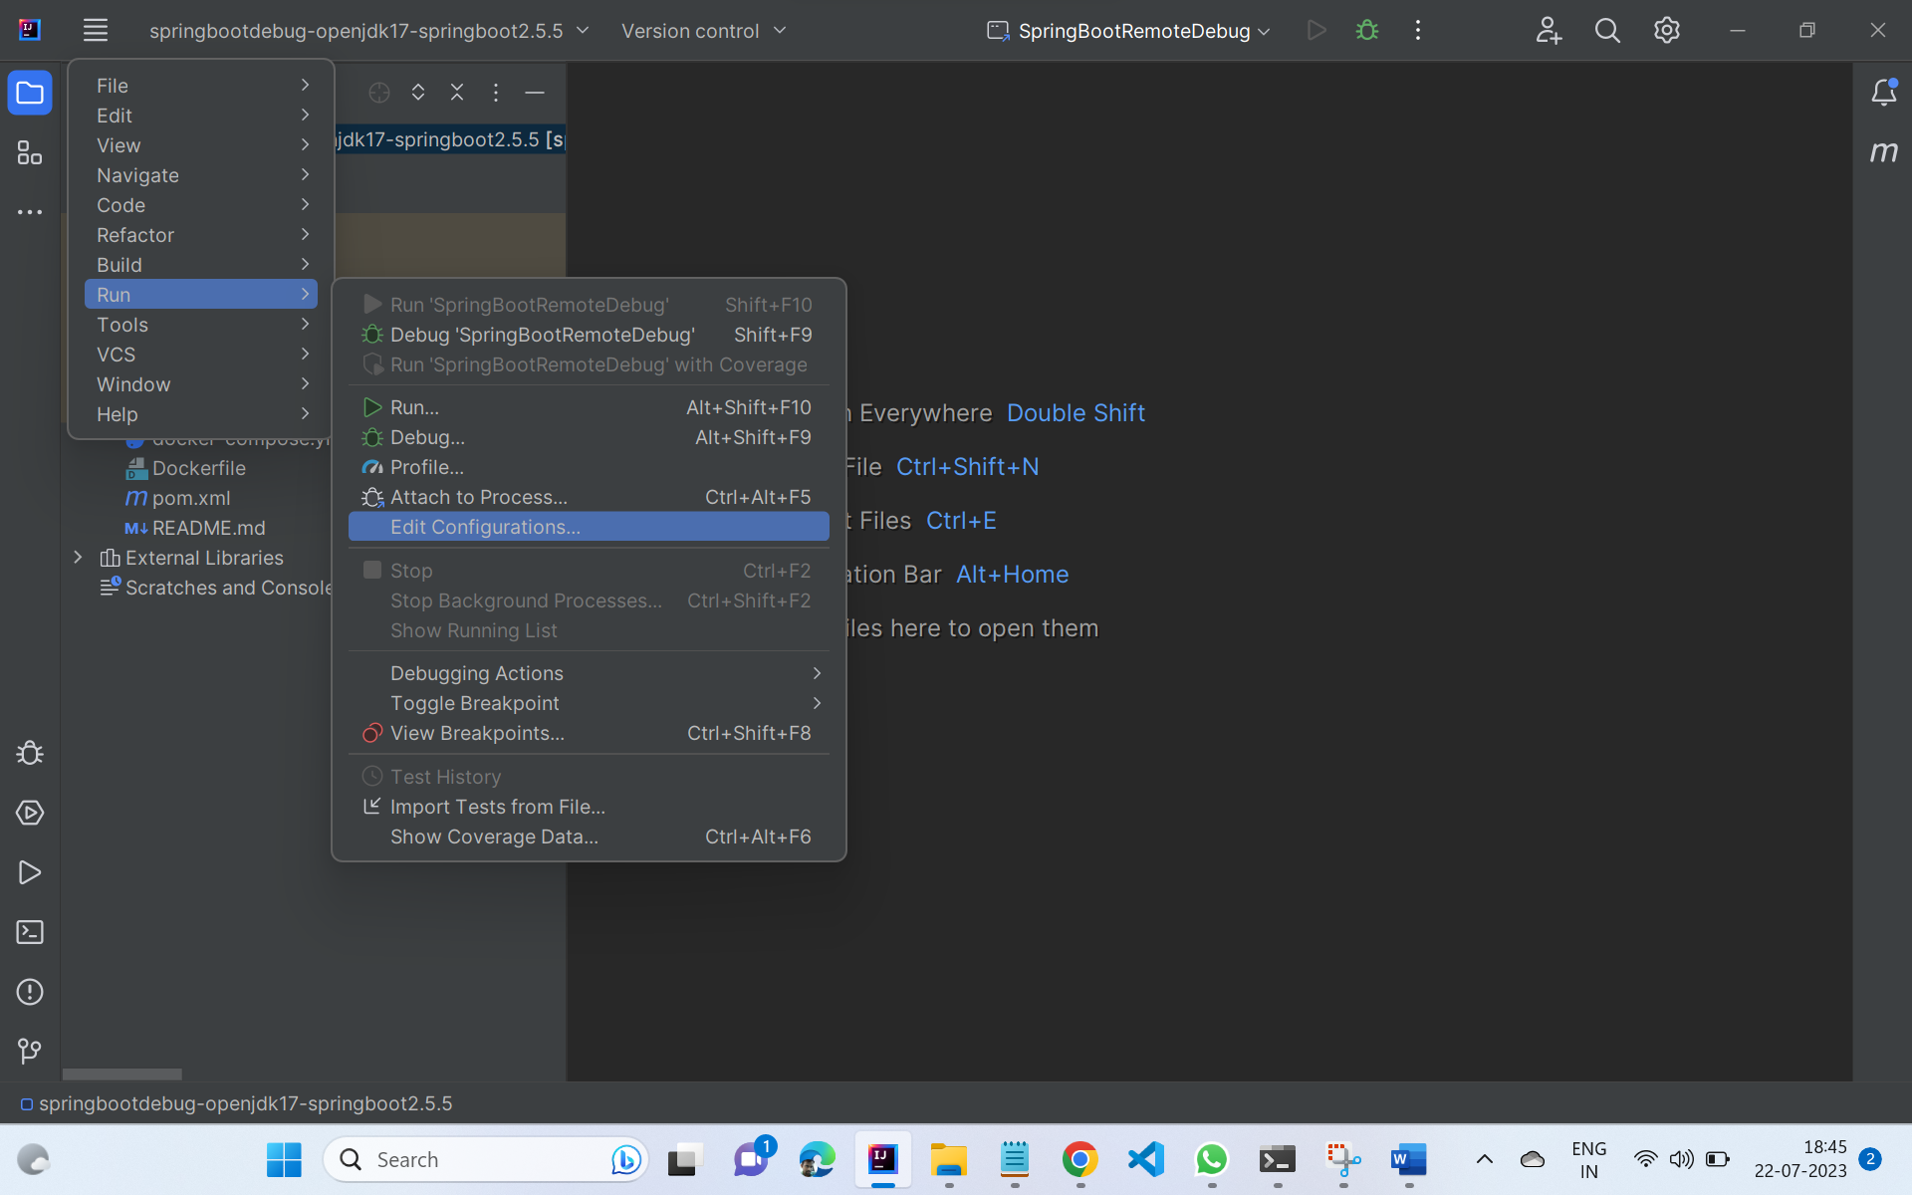

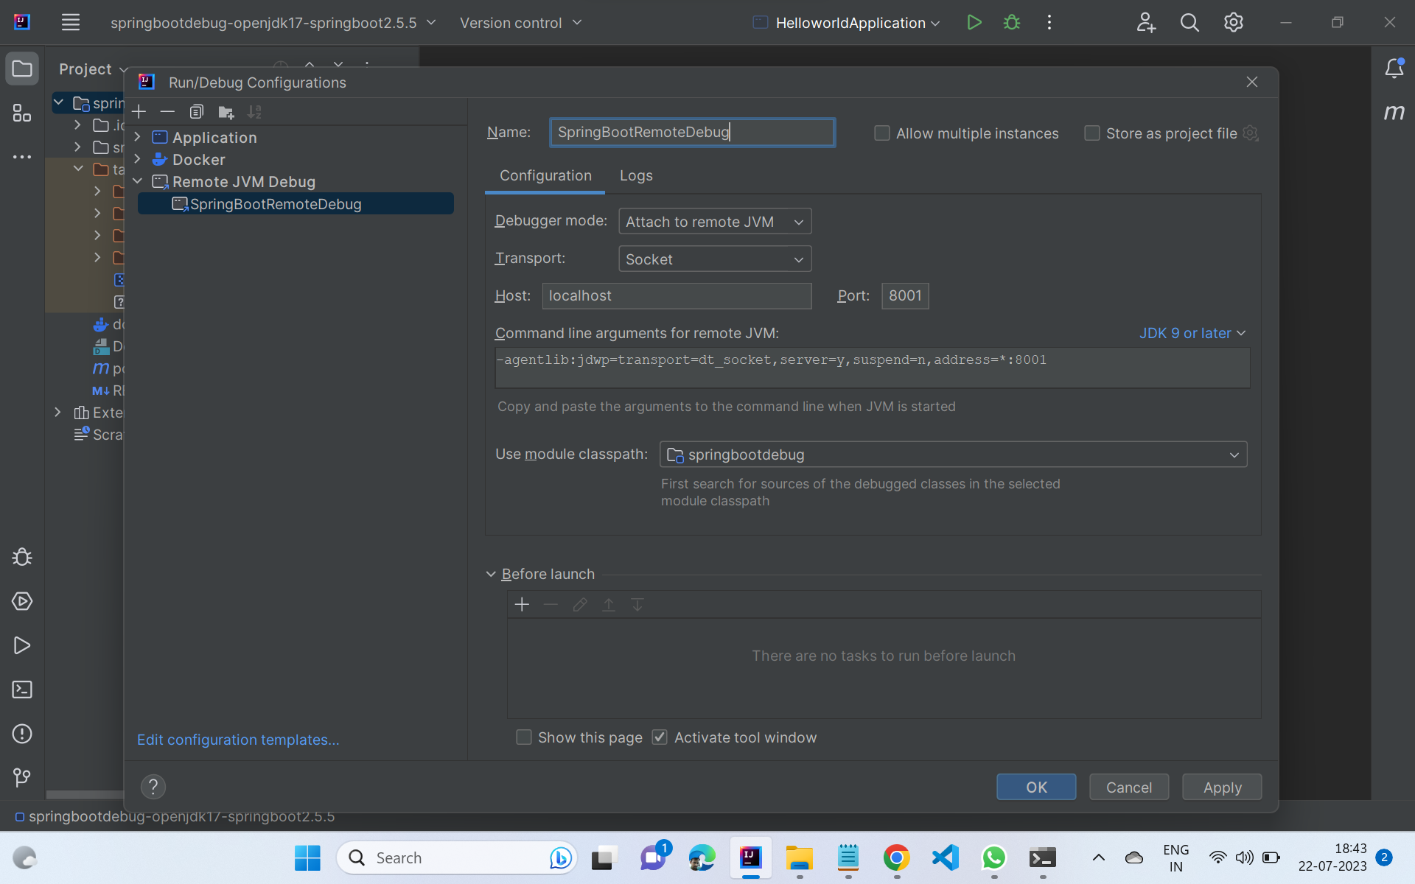

Add Apache Plugin in Maven Web App

<plugin>

<groupID>org.apache.tomcat.maven</gorupid>

<artifactid>tomcat7-maven-plugin</>

</plugin>

