<https://docs.google.com/forms/d/1GknAaibhAuvAEme0sTwkiOm34G0jt5UYQ5CiG1CYS0k>

Tyler Moak

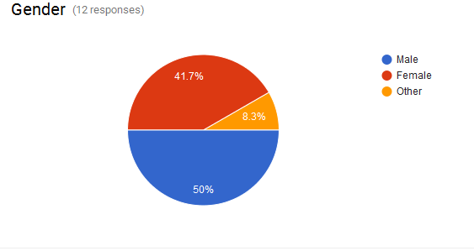

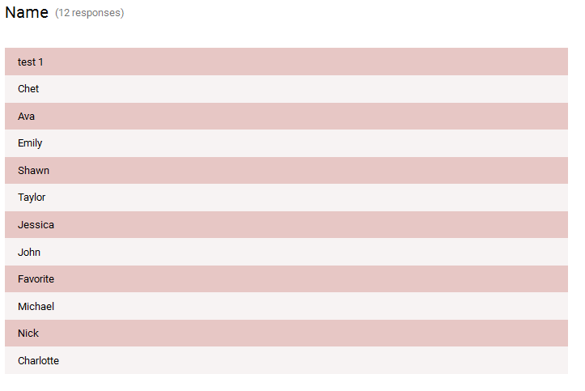

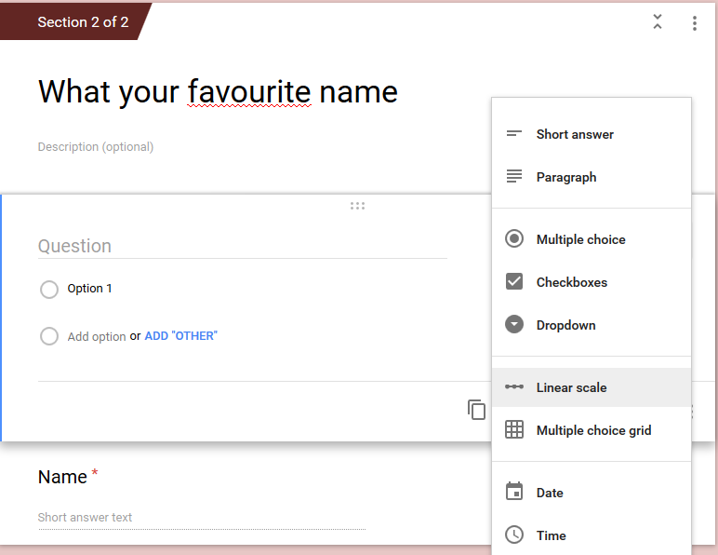From this assignment I was able to learn a few things including design choices and different form types. Google forms is a great way to quickly make a simple form that can range from a survey to online quizzes. The way Google has implemented this is what makes it so successful. Google forms lets a creator to make an online form that can be configured to be secure. It provides many different options for the creator to suit most needs. Different form fields a creator can use are: Short answer, Paragraph, Multiple choice, Checkboxes, Dropdown, Linear scale, Choice grid and date time. These fields reflect their name and only allow certain types of input. These inputs may also be required should the creator make it. If a required field is left empty, then a validation message is displayed.

Figure Form Questions

Once the form logic and questions are set up, Google Forms gives the option to the creator to stylize and design the look and feel of their form. They can do this in a few ways including, picking a theme, creating their own theme, choosing background photo, or adding multimedia and form sections. The themes, I must say, are a bit lackluster as they are pretty basic. Creating one’s own theme is equally as basic and limiting to what a creator can actually modify. The same goes for choosing a background photo. Adding media like photos and videos can spice up a form and can be added in any section. Forms may also be broken up into sections that can contain related content. These sections can optionally have titles and descriptions along with their own photos and videos.

A very useful feature Google Forms has added is the ability to see the responses left on a creator’s form. The collected data is organized in a very meaningful way in both an overall summary and individual reports. The summary can include graphs and all the responses that users have. The creators can also view individual reports from each user and can even print those out along with the summary. There is also an option to print the form results to excel for a higher level view as well as a more detailed and individual report. What is really interesting is that a form can be made into a quiz and have assigned points with correct answers.