Software Requirements Specification
for
<Project>
Version 1.0 approved
Sai Krishna Revanth Majety
U101114FCS207
NIIT university
Date-21/09/2016
Table of Contents
Table of Contents ii
Revision History ii
1. Introduction 1
1.1 Purpose 1
1.2 Document Conventions 1
1.3 Intended Audience and Reading Suggestions 1
1.4 Product Scope 1
1.5 References 1
2. Overall Description 2
2.1 Product Perspective 2
2.2 Product Functions 2
2.3 User Classes and Characteristics 2
2.4 Operating Environment 2
2.5 Design and Implementation Constraints 2
2.6 User Documentation 2
2.7 Assumptions and Dependencies 3
3. External Interface Requirements 3
3.1 User Interfaces 3
3.2 Hardware Interfaces 3
3.3 Software Interfaces 3
3.4 Communications Interfaces 3
4. System Features 4
4.1 System Feature 1 4
4.2 System Feature 2 (and so on) 4
5. Other Nonfunctional Requirements 4
5.1 Performance Requirements 4
5.2 Safety Requirements 5
5.3 Security Requirements 5
5.4 Software Quality Attributes 5
5.5 Business Rules 5
6. Other Requirements 5
Appendix A: Glossary 5
Appendix B: Analysis Models 5
Appendix C: To Be Determined List 6

Revision History
Name | Date | Reason For Changes | Version

Introduction

Purpose
I am writing this SRS document which states the correct description of the exam cell project.In this we are going to discuss about the hardware and software requirements of the automatic obtaination of seating allotment of students and invigilator’s class allotment.We are also going to discuss the functions and constraints in the project.

Document Conventions
All the text is in Times New Roman, and font for main heading is 18, for sub-main heading is 16 and the contact is of 14. The BOLD refers to as Type of function used.

Intended Audience and Reading Suggestions
We are building this document in a way such that it is easily understandable i.e., user friendly.The main aim of this project is the automatic obtaination of seating allotment means this is to be made in such a way that is easily read by faculties and students.

Product Scope
The main aim of the project is to obtain the seating allotment automatically.By doing this project,this is to be a huge time saver for the exam cell as at present they are doing this work manually.This also leads to avoid the confusion that students and faculties face during the time of exams.This will be done in such a mechanism that student and faculty will get the details of their self exam details.We also want to make the exam time table in which the student able to see only his subjects leaving aside all the rest.This also leads to the efficient working of the exam cell during the exam cell if we do this project.

References
This SRS is written on the basis of the format provided by IEEE.The format for the software requirement document is IEEE std 830-1998.

Overall Description

Product Perspective
The project which we are doing now is on working but it is done manually by a person but we are going to implement our algorithm in such a way that the exam cell is going to do the seating allotment and invigilator’s class allotment automatically.According to the technical point of view,this one is a new,self contained project.Here exam cell is going to be a admin and they can allot in such a way that they really want.This one is also a user friendly methodology.

Product Functions
In the summarized form I can say these points which are going to work in our project.
- We are implementing a algorithm to obtain the exam schedule automatically,at present exam cell is doing that manually.
- We are also going to implement the automatic obtaination of student’s seating allotment
- We are also going to work on the automatic ontaination of faculty’s invigilation allotment
- We are taking the help from the existing server nucleusERP in order to obtain the attendance of the students automatically because students who are having the attendance less than 75% are not allowed to write the given examination until the exam cell permits.

User Classes and Characteristics
There should be a admin for each and every project that we do.In our case,the admin is exam cell i.e., they can do whatever they want once this is completed.
- Exam cell as a admin can update the data with direct access to the database i.e., while doing seating allotment process they can add or remove the classrooms
- Students,staff and faculties are our users for this project because they will get the information regarding the seating allotment and invigilator allotment.They will be accessing the web application with the present database login in the college.

Operating Environment
As we thinking of developing a web application there must be a operating environment to work through,in our case it is as follows.
- Platforms such as windows,linux,ios.
- Compatible with all types of browsers which support CGI,ASP.net,HTML..

Software components:
- IDE: Visual studio 2015 enterprise
- Cloud server: Microsoft Azure cloud
- Database: Microsoft Azure storage explorer.

Design and Implementation Constraints
When our case comes,at present I thought of only 2 constraints.
- We should have to complete this project within a span of 2 months i.e., for us testing phase is of very limited period in order to overcome the bugs that are developed during the developing phase.
- For the user login,I am not much aware of using which hasing algorithm is good to encrypt the passwords.

User Documentation
An user manual is provided to the exam cell in both the ways as a soft copy as well as a hard copy such that they can overcome the errors in future if they got any.While coming to the user point of view,this use to be look as the present college website,so that everyone can easily access to it without the help of any.

Assumptions and Dependencies
At present there are no assumptions for me because once we enter into the developing phase we will think of some assumptions but according to my point of view there are no assumptions

Now coming to the dependencies,there are 2 main dependencies.
- We are going to take the attendance database from the existing database i.e., NucleusERP because students who are having the attendance less than 75% attendace they should be debarred and their names should not be present in the final list.
- Coming to the algorithm,we will develop the most efficient algorithm but if anything comes wrong means we should have to start from the very beginning.

External Interface Requirements

User Interfaces
IDE: Visual studio 2015 enterprise.
Back end software: Microsoft azure storage explorer.
Cloud platform: Microsoft azure.
Algorithm: Shuffling algorithm.

Hardware Interfaces
Any operating system.
Browser which supports CGI, Web app, JavaScript, HTML5, Asp.net.

Software Interfaces
OS | Windows 10 pro (for the best support of Visual studio 2015 enterprise)as it has a developer mode which is designed for developing purpose and it also supports high level software’s for developing purpose.
IDE(Integrated development environment) | Visual studio 2015 enterprise is the best platform for developing web app in (asp.net). It makes easy for developers to host the web app to Microsoft azure cloud.
Cloud server | Microsoft Azure. Our web app will be hosted in Microsoft azure cloud as it can handle million hits per second and it is easy to work in azure than compare to other cloud servers.
Database | Microsoft azure storage explorer as it is easy to create database and also compatible to connect with Microsoft azure cloud server.
Asp.net | It is an open source web framework for building modern web applications and services and another reason for choosing this is we use more tools from Microsoft for this software.
HTML5 and CSS | We use this two common languages to develop the frontend and styling for the web app.
Algorithm | Shuffling algorithm is used to make seating allotment for the students and invigilation duty for the faculties.

Communications Interfaces
- This web app will be supported by all types of browsers.

- It will communicate with the server to send e-mail to the particular person or group.

- The communication standards will be HTTP.

- The app will fetch the data from different tables of the database hosted in cloud server, then place them in a single table and at last they are displayed in the output page by a random order which is done by shuffling algorithm.

- The app include electronic forms for student details such as Enrollment no, Name, Section, Batch, Department, Subjects.

- It also include electronic forms for faculties detail such as Name, Subject handling.

- Password encryption for log in with sha1 or md5 as they are one way encryption.

- Sql injections will be prevented by type safe SQL command parameters.

System Features

System Feature 1
Exam Schedule
4.1.1 Description and Priority
The system is designed in such a way that for a particular student database it shows the courses in which he/she enrolled and also the schedule is obtained in which the subjects he got enrolled only that time table will be obtained and rest is not obtained
4.1.2 Stimulus/Response Sequences
Finally the exam schedule is obtained

System Feature 2
Seating/Invisilation allotment

4.2.1 Description and Priority
The database is designed completely with the presence of all class rooms and exam cell will select the number of classes in which the exam is going to be held and finally they will click on obtain allotment and the seating allotment is finally sent to each and every member through email.

4.1.2 Stimulus/Response Sequences
Each and every member who got enrolled for tomorrow’s exam the seating allotment is obtained and received to their respective mail accounts.

Other Nonfunctional Requirements

Performance Requirements
The main aim of project is to make a user friendly application.It means the project consists of less number of options to browse and therefore every user can easily get access to our web application.We will take a lot of care on UI such that we can optimize our web application to certain extent. We will also make this web application to work in all types of browsers.

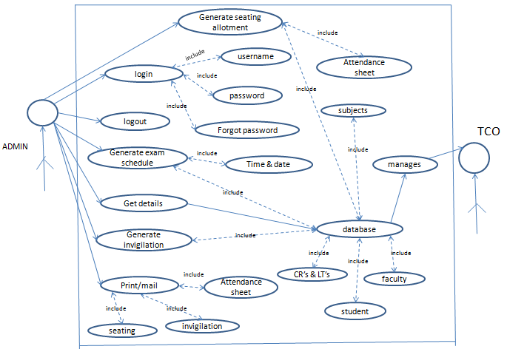

Safety Requirements
As we have mentioned earlier that the server will be created on the basis of Microsoft azure.They also maintain a facility for the backup options such that our data can be regained back if our built server is corrupted.We will also provide a certified safety once it is implemented to real world.

Security Requirements
Every one who want to get access to our web application should have to proceed through user name and password.We will use the best hashing algorithm to encrypt the user data.Until this extent we havn’t decided the correct information of the hasing algorithm that we are going to use.

Software Quality Attributes
We will provide the feedback option at the end of the web application.A maintainence team will take power for this feedback window to look over the complaints registered.If they are not still impressed with the functional behavior,we will meet them and get the best out of which they are expected.

Business Rules
The role of the web application is to automatically obtain the seating allotment of students and class allotment for faculty.This all can be obtained by single click from the user.

Other Requirements
To be determined later.

Appendix A: Glossary
There are many terms used in our project which can be understood well by reading this.
1. IDE - Integrated development environment
2. OS – Operating system
3. System – The software that will be prepared has been termed as a system in our document.

