ChipIN Centre C-DAC Bangalore

(C2S PROGRAMME)

DIGITAL IC DESIGN

Design of Very Large Scale Integrated Circuits

EXERCISE: CADENCE SIMULATION USING ASYNC. FIFO IP CORE- GUI & COMMAND LINE

Phase – 1

Module Creation

Contents
1. What is Simulation? 3
2 Design For Simulation Analysis – Parameterized Asynchronous FIFO 4
3 Setting Up Environment For Cadence Xcelium Simulatior – Simvision Tool 5
4 Cadence Xcelium Simulator – Simvision Tool 7
4.1 Invoke Xcelium Simulator Simvision Tool 7
4.2 Xcelium Simulatior Simvision App Wizard 9
4.3 Xcelium Simulator – Simvision App Main Window Orientation 10
5 FIFO IP Core Simulation Analysis Using Cadence Xcelium Simulator – Simvision Tool – GUI 11
5.1 Run Simulation 11
5.2 Stop Simulation 26
6 Setting Up the Environment For Cadence Xcelium Simulation – Simvision Tool – Command Line 34

What is Simulation?

Simulation is used to verify the functionality of the digital design that is modelled using HDL like Verilog. RTL simulation ensures that the design is logically correct and without major timing errors. For Simulation purpose we apply different input stimulus to the design at different time, to check whether the RTL code behaves in intended way or not. We need both Verilog module (RTL) and Test bench both to perform simulation. Afterwards, we evaluate the results through waveforms and ensure that RTL code written for circuit is working properly.
It is advantageous to perform this step, especially in the early stages of the design, because long synthesis and place-and-route times can be avoided when an error is discovered at this stage.
Cadence simulation tool i.e., Xcelium Simulator-SimVision is used to perform Simulation analysis.

Design For Simulation Analysis – Parameterized Asynchronous FIFO
For Simulation, we are considering Parameterized Asynchronous FIFO IP core. The details of the FIFO IP core are mentioned below.
Top module name of FIFO IP core: fifo
List of Verilog files associated with FIFO IP core:
- fifo.v (Top File)
- fifo_mem.v
- reset_sync.v
- fifo_full.v
- fifo_empty.v
- sync_ptr_clx.v
Parameters used in design:
- DATASIZE = 8
- ADDRSIZE = 4
- MEM_DEPTH = 16
Input ports of FIFO IP core:
- i_wr_clk (write clock)
- i_rd_clk (read clock)
- i_wr_rst_n (active low write reset)
- i_rd_rst_n (active low read reset)
- i_wr_en (write enable)
- i_rd_en (read enable)
- i_wr_data (write data)
Output ports of FIFO IP core:
- o_full (full flag)
- o_empty (empty flag)
- o_rd_data (read data)

Setting Up Environment For Cadence Xcelium Simulatior – Simvision Tool

The procedure for setting up the environment for Simulation analysis is mentioned below.
- Open the VM and right click on the screen. Then click n ‘Open Terminal’
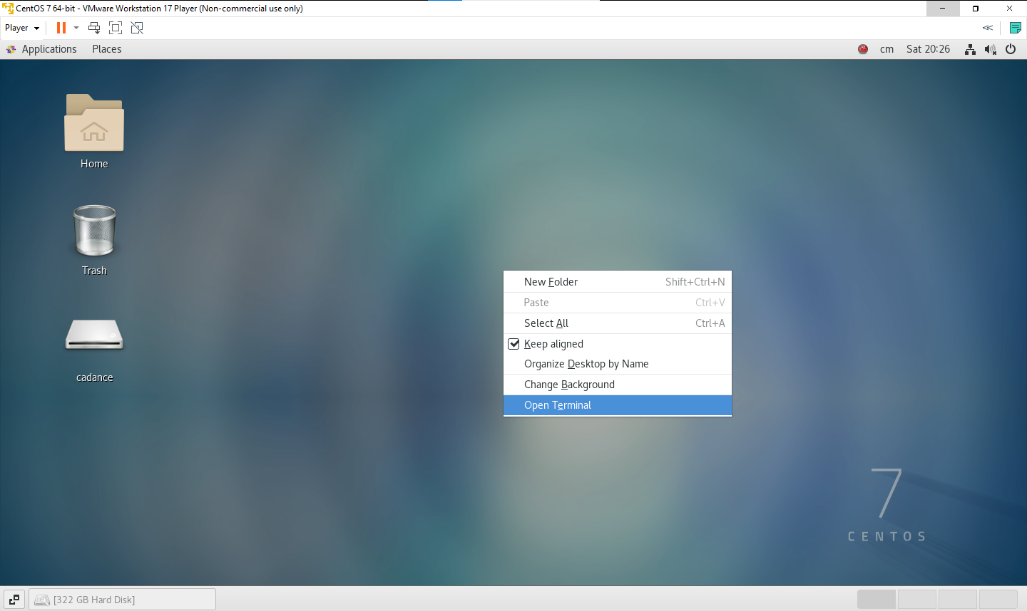
- The terminal will open as shown below
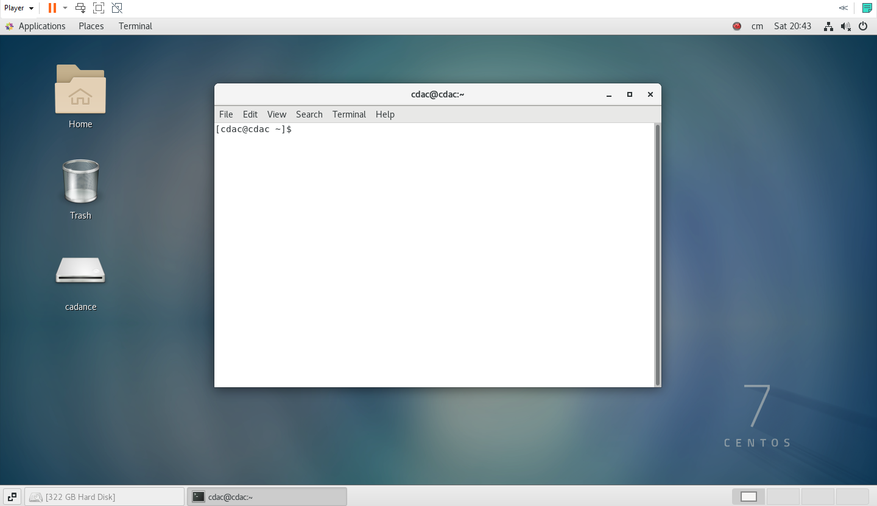

- Enter the given command in the terminal to go to the given directory through the given path
- cd /home/cdac/CHIPINIEP_FEB2024/ASYNC_FIFO_CADENCEFLOW
- Create a directory for Simulation (Command is listed below).
- mkdir 06_Async_FIFO_sim
- Move to the above directory (Command is listed below )
- cd 06_Async_FIFO_sim
- Set up the csh environment
- csh +ENTER
- source /home/cdac/CHIPINIEP_FEB2024/cshrc_cadence +ENTER
The screenshot for the above steps is depicted below.
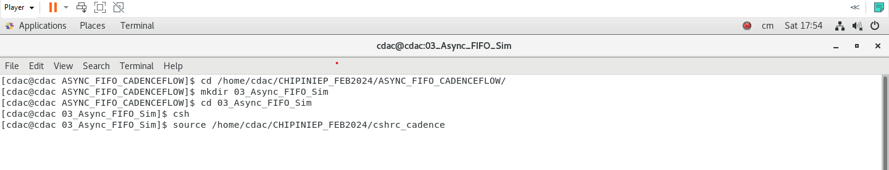
While seeing the below message, the environment for Simulation analysis using Cadence Xcelium Simulator-SimVision Tool is successfully done.
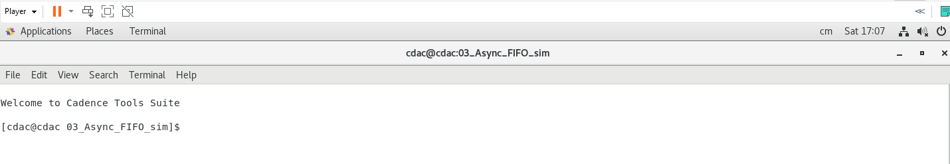

Cadence Xcelium Simulator – Simvision Tool

Invoke Xcelium Simulator Simvision Tool
- Invoke the tool, use the following command:
- Syntax : xrun file_name.v file_test.v -access +rwc -gui
- Command : xrun ../01_Async_FIFO_src/fifo_mem.v ../01_Async_FIFO_src/fifo_full.v ../01_Async_FIFO_src/fifo_empty.v ../01_Async_FIFO_src/fifo.v ../01_Async_FIFO_src/reset_sync.v ../01_Async_FIFO_src/sync_ptr_clx.v ../02_Async_FIFO_tb/fifo_tb.v -access +rwc -gui +ENTER
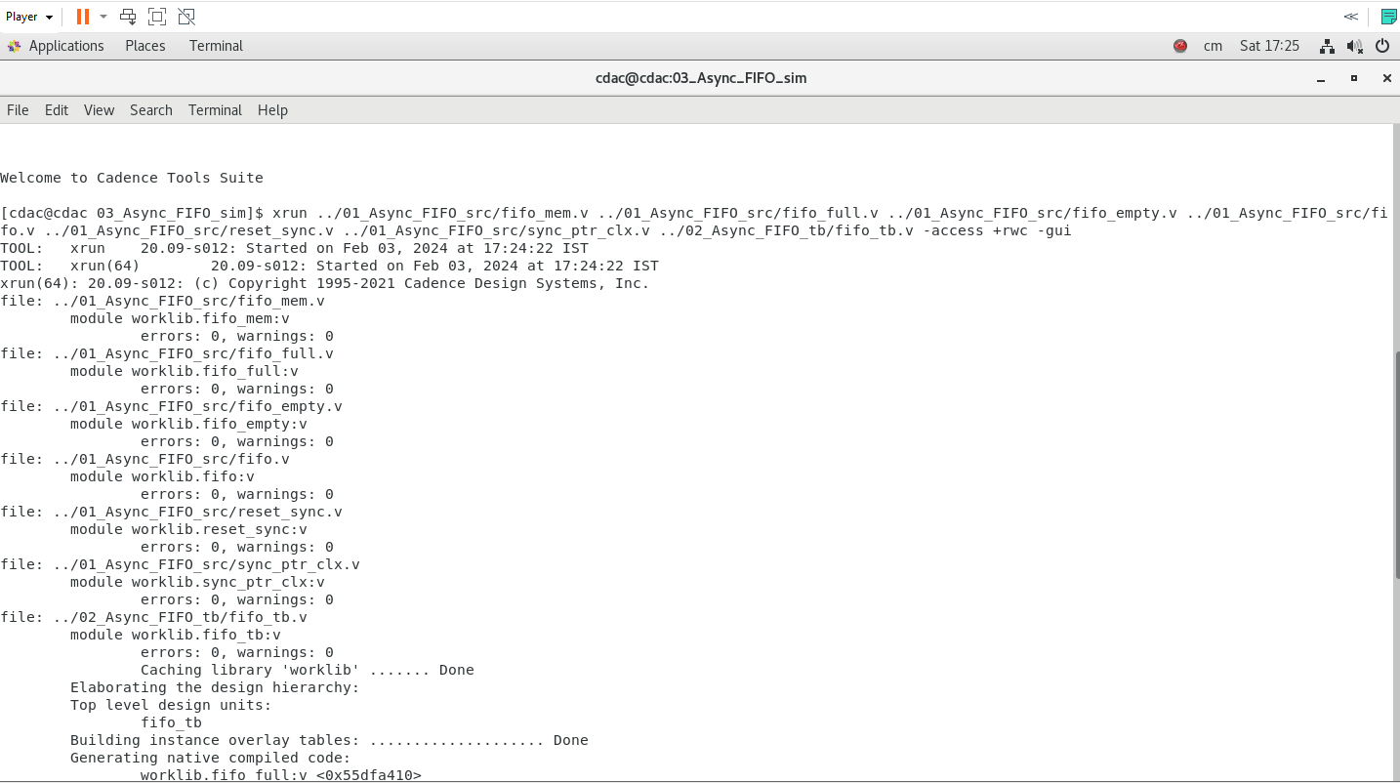
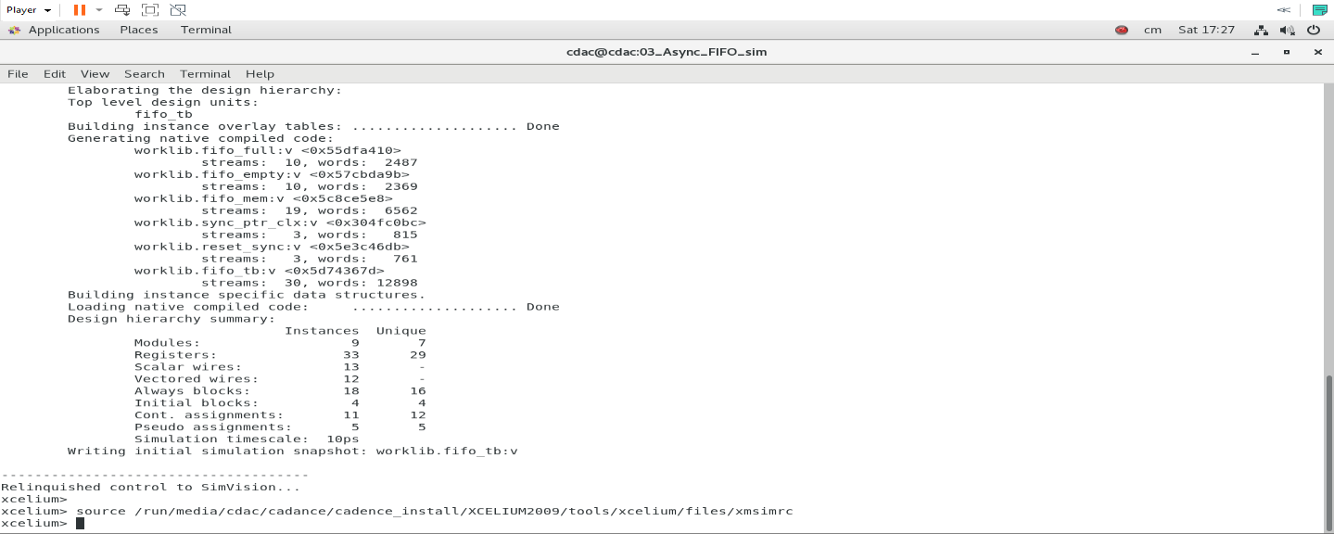

A GUI for Xcelium Simulator-SimVision tool will appear.
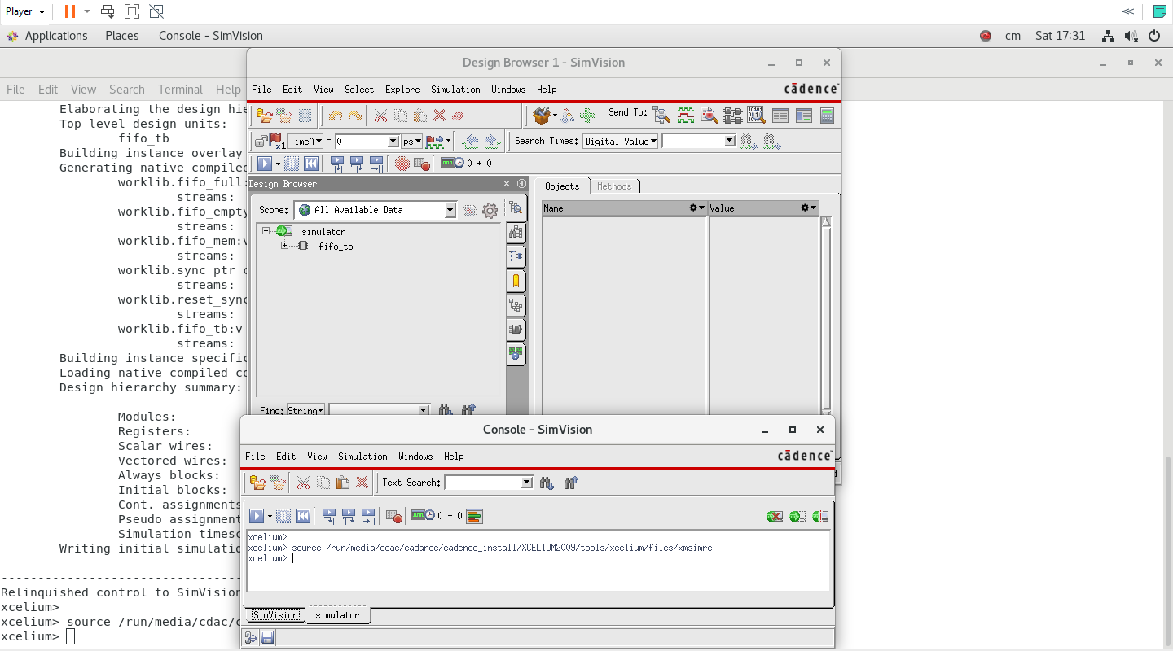

Xcelium Simulatior Simvision App Wizard
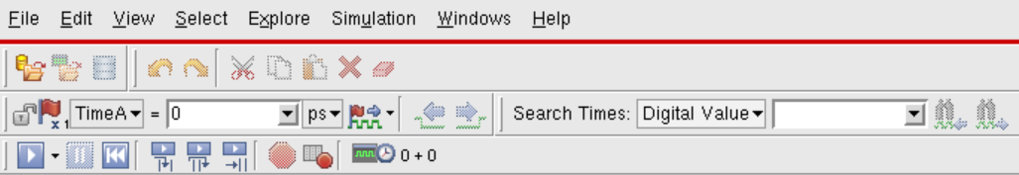

a b c d e f g h i j k

a: Run/Continue the simulation until the next breakpoint, or for the duration entered
in the time field.
b: Interrupt the simulator.
c: Reset the simulation back to time zero.
d: Run one behavioral statement, stepping into subprogram/function calls.
e: Run one behavioral statement, stepping over subprogram/function calls.
f: Run to the next statement, maintaining focus in the active scope/thread.
g: Set a breakpoint on selected objects.
h: Show Breakpoints page.
i: Current time in the simulator.
j: Move primary cursor to previous edge of select signals.
k: Move primary cursor to next edge of select signals.

Xcelium Simulator – Simvision App Main Window Orientation
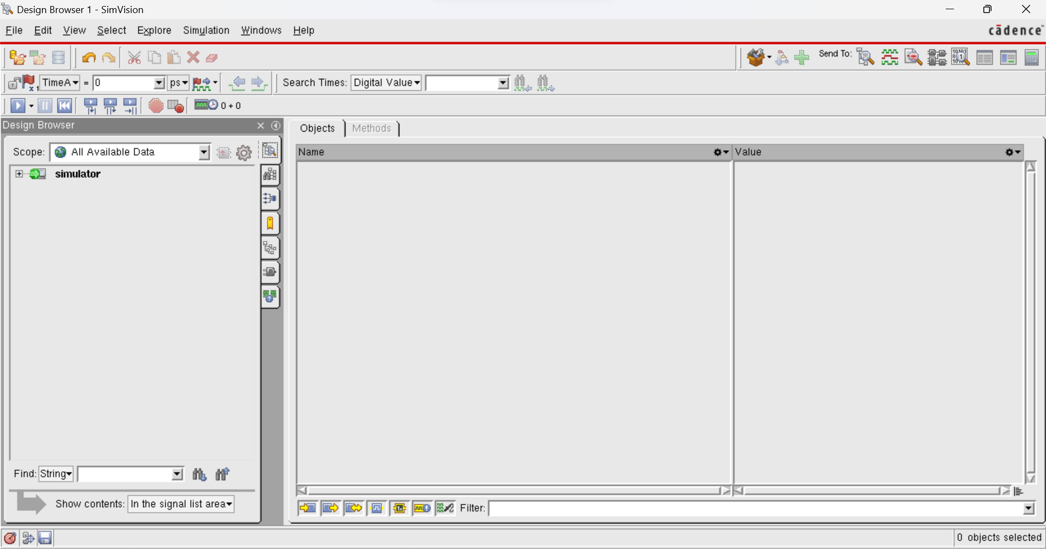
Code (FIFO) signal names and values display Tab.
Design Browser

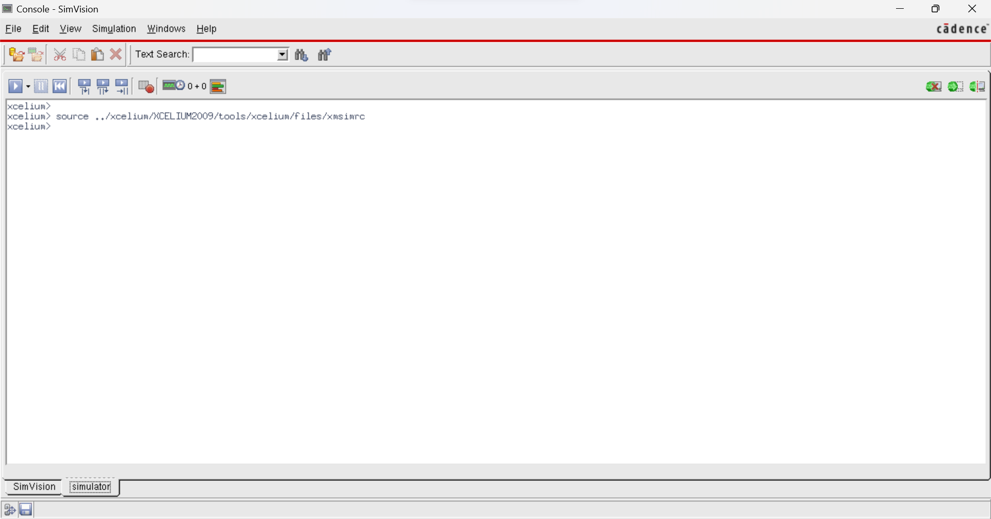
Console

FIFO IP Core Simulation Analysis Using Cadence Xcelium Simulator – Simvision Tool – GUI
This section details about the Simulation analysis steps/procedure followed for FIFO IP core using Cadence Xcelium Simulator SimVision tool in GUI.

Run Simulation
To analyze Simulation for all the FIFO IP core Verilog RTL code files, the steps for performing the Simulation analysis are mentioned below.
- In Design Bowser window, click the (+) checkbox before simulator keyword.
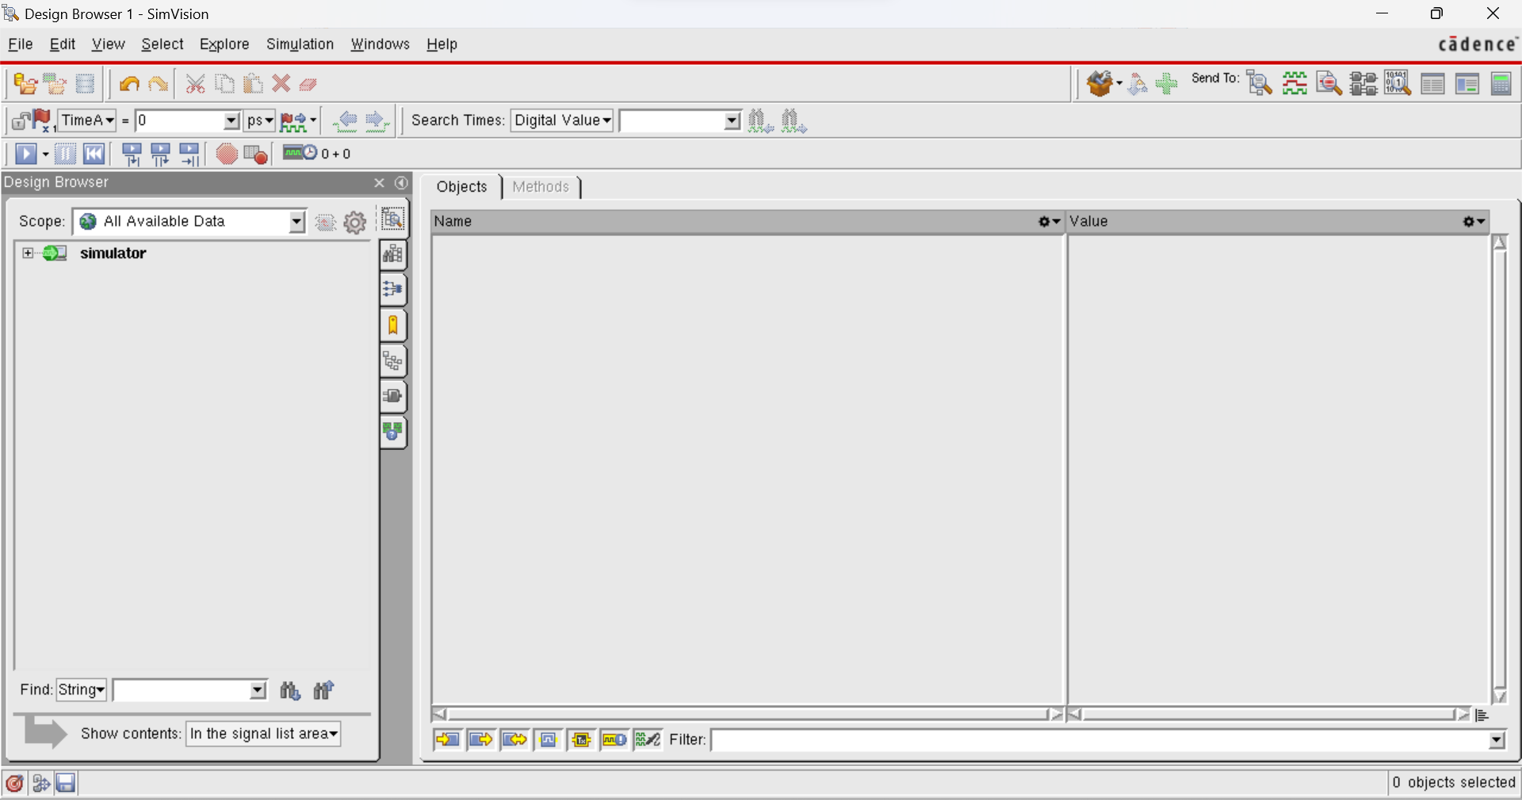

- FIFO design files are already saved in the work directory as an example (/home/cdac/CHIPINIEP_FEB2024/ASYNC_FIFO_CADENCEFLOW/01_Async_FIFO_src).

- fifo_tb will appear just below the simulator.

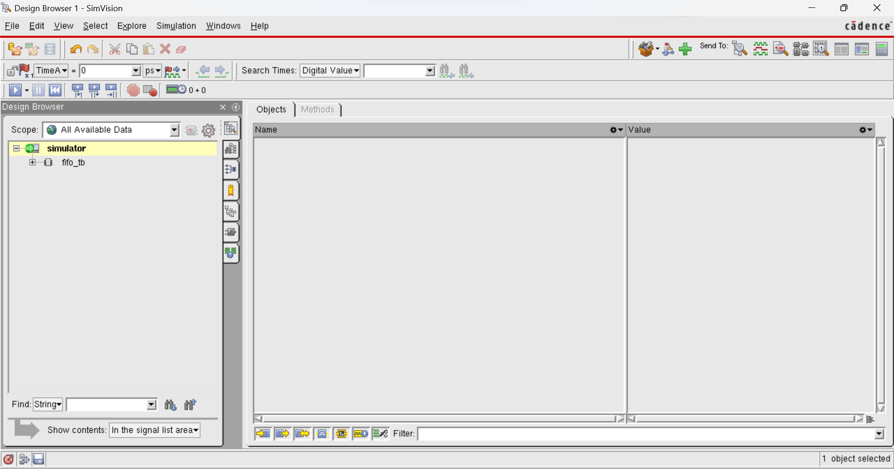

- Enable plus (+) checkbox before fifo_tb keyword.

- fifo_inst will appear just below the fifo_tb Click on the fifo_inst keyword. Name and Value Browser will display Top module signals and their values.
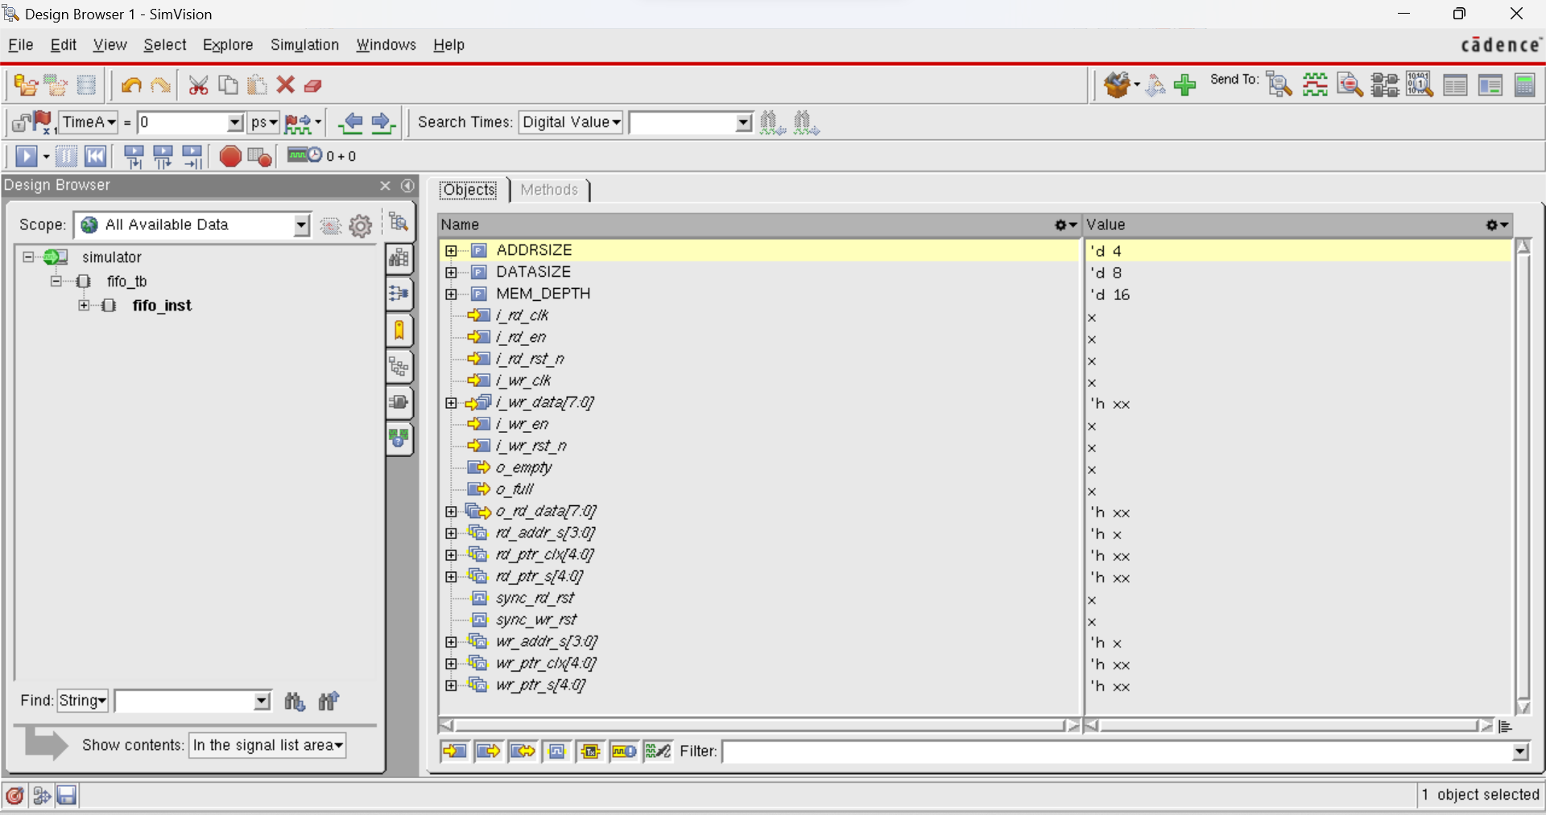
- To extend further fifo_inst keyword in Design Browser, enable plus (+) checkbox before fifo_inst keyword.
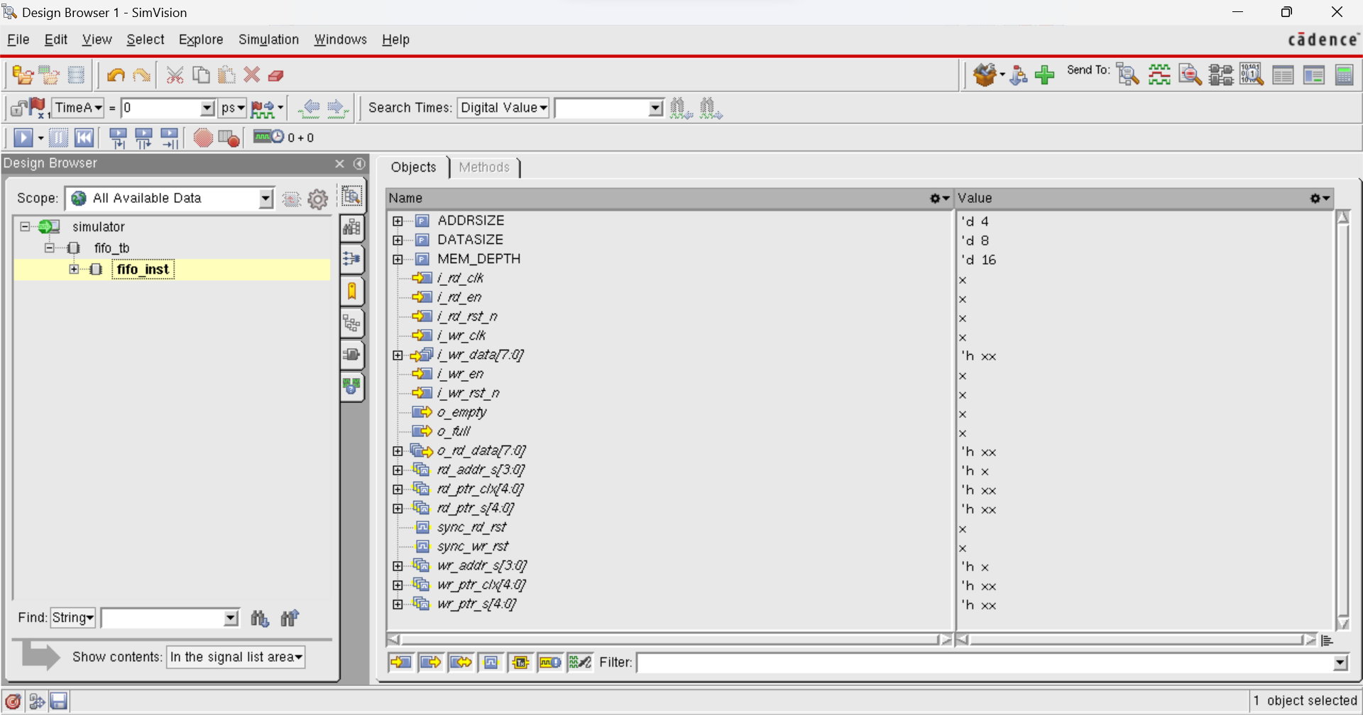

- All instances name under fifo_inst instance in Test bench will appear as,
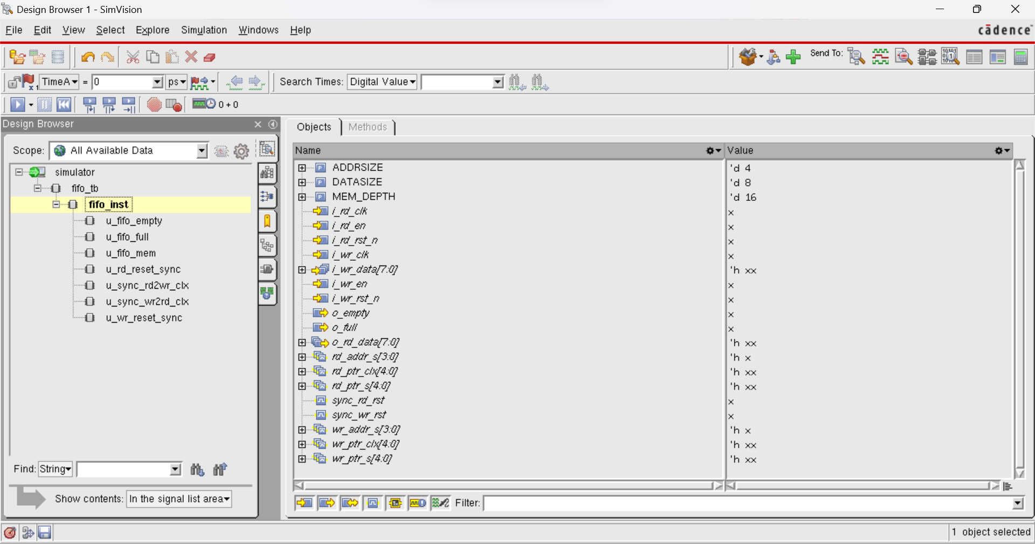
- To change the formats of signals name in Name Browser, click on drop-down menu in Name Browser.
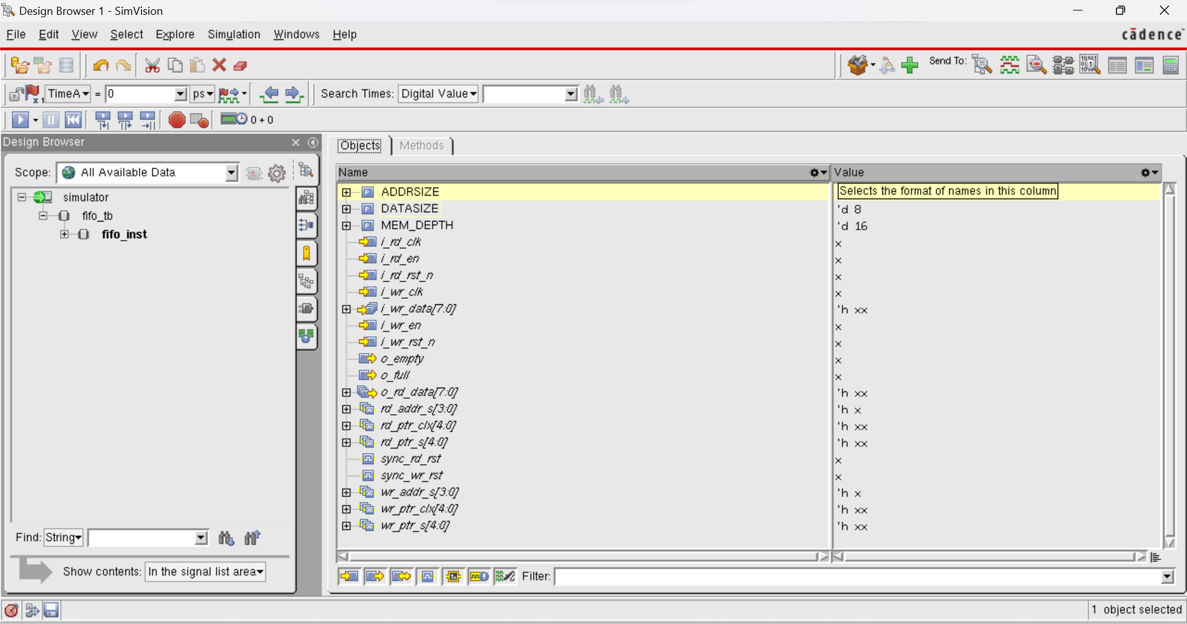

- Drop- down menu (by default selected name format is Name) will appear as,
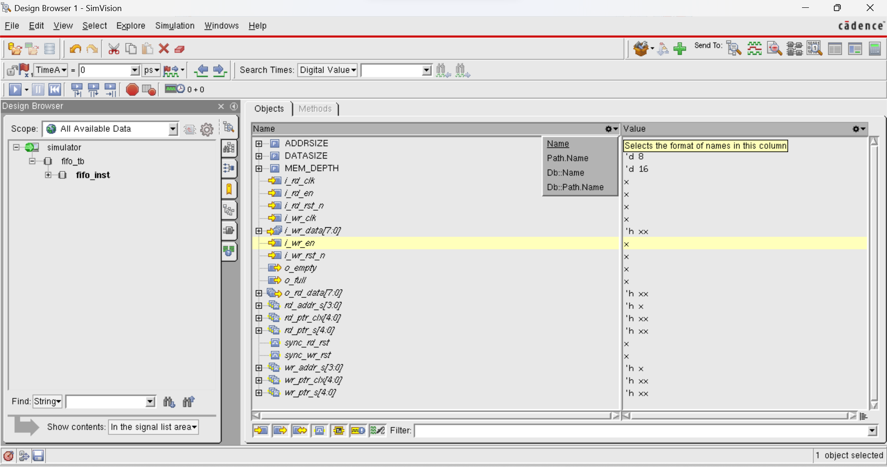

- Select Path.Name option in drop-down menu.
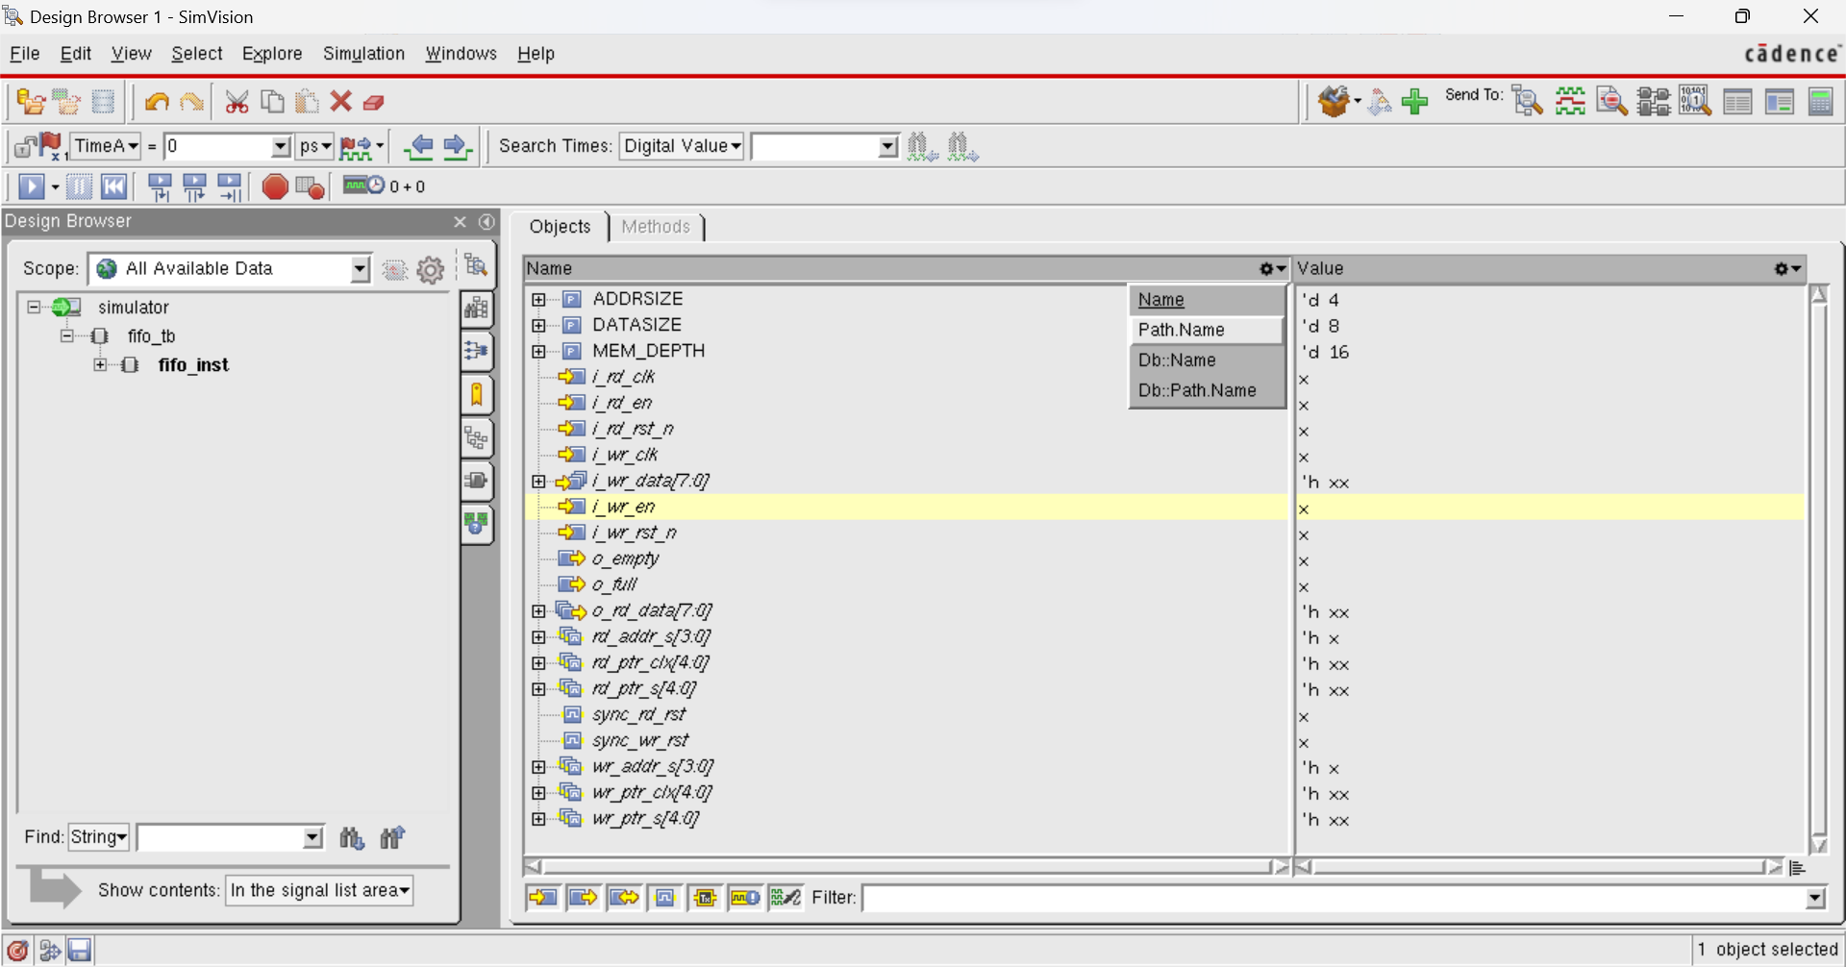

- Name Browser with signals of Path:Name format (<test bench name>.<instance name>.<signal name> ) will appear as,
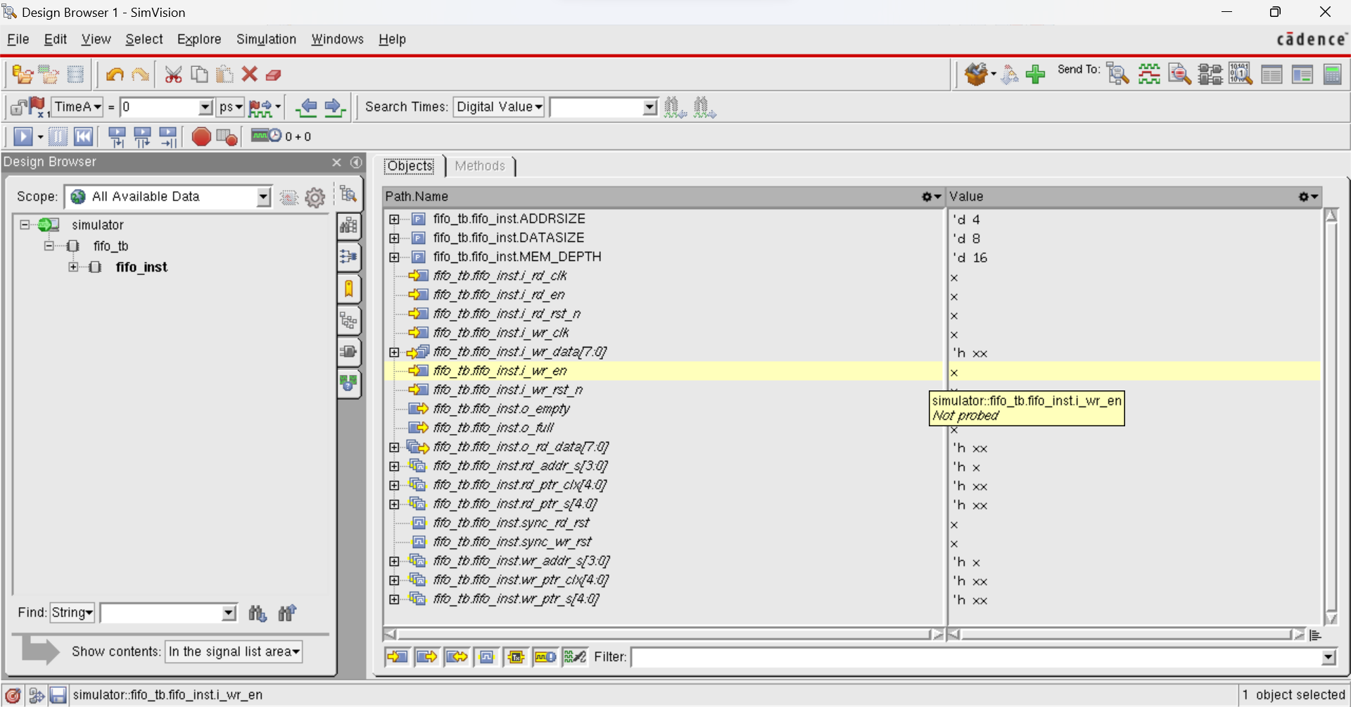
- To change the other signal’s name format again, click on drop-down menu in Name Browser.
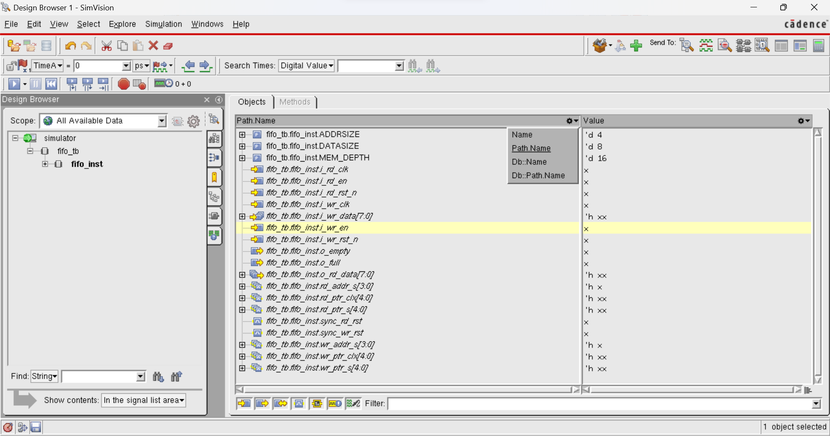

- Select Db::Name signal name format in drop-down menu.
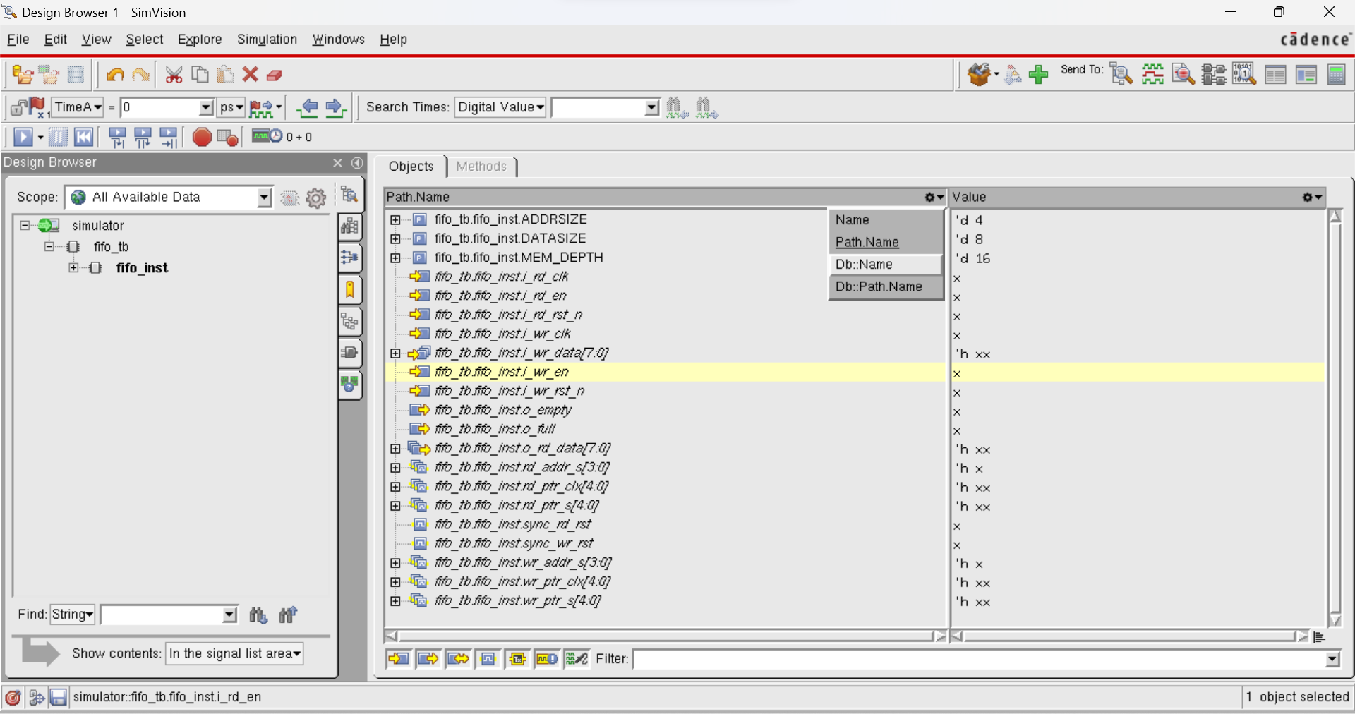

- Name Browser with signals name format Db::Name (<simulator>.<signal name>) will appear as,
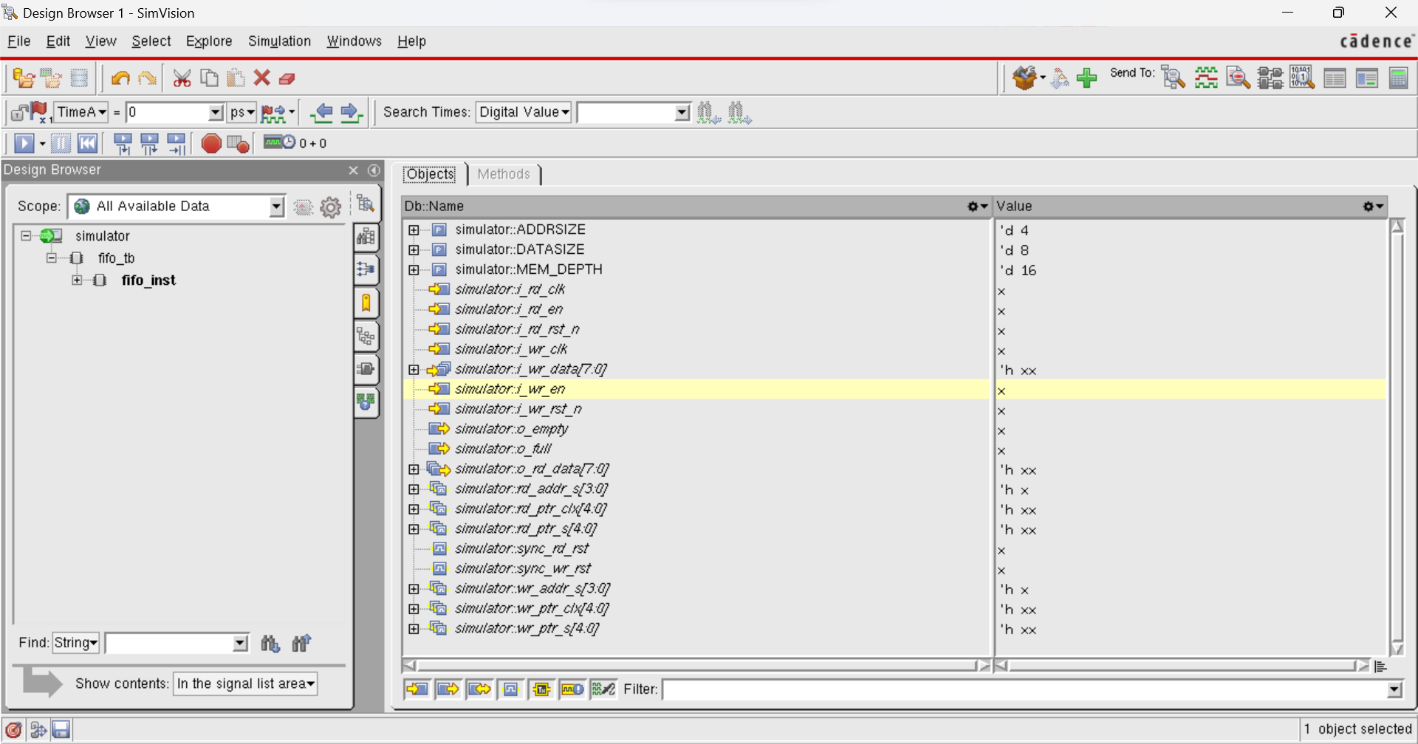

- To change the other signal’s name format again, click on drop-down menu in Name Browser.
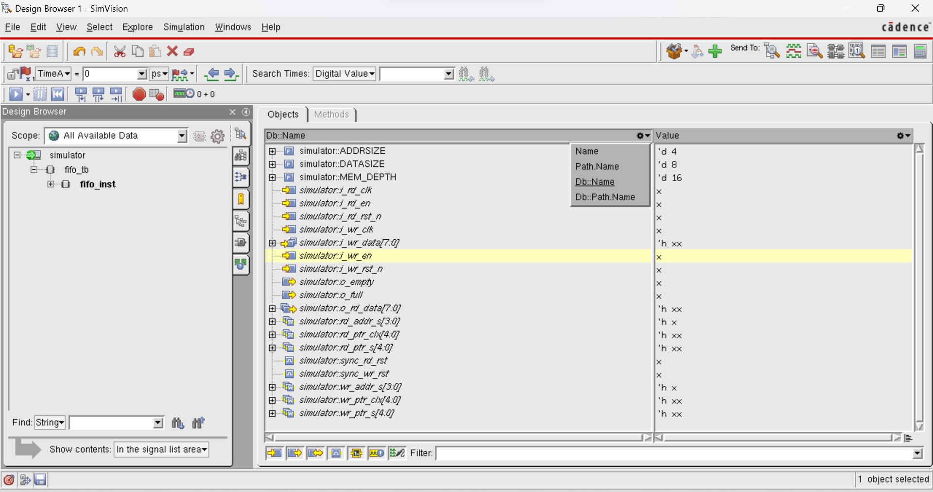

- To Db::Path.Name signal name format in drop-down menu.
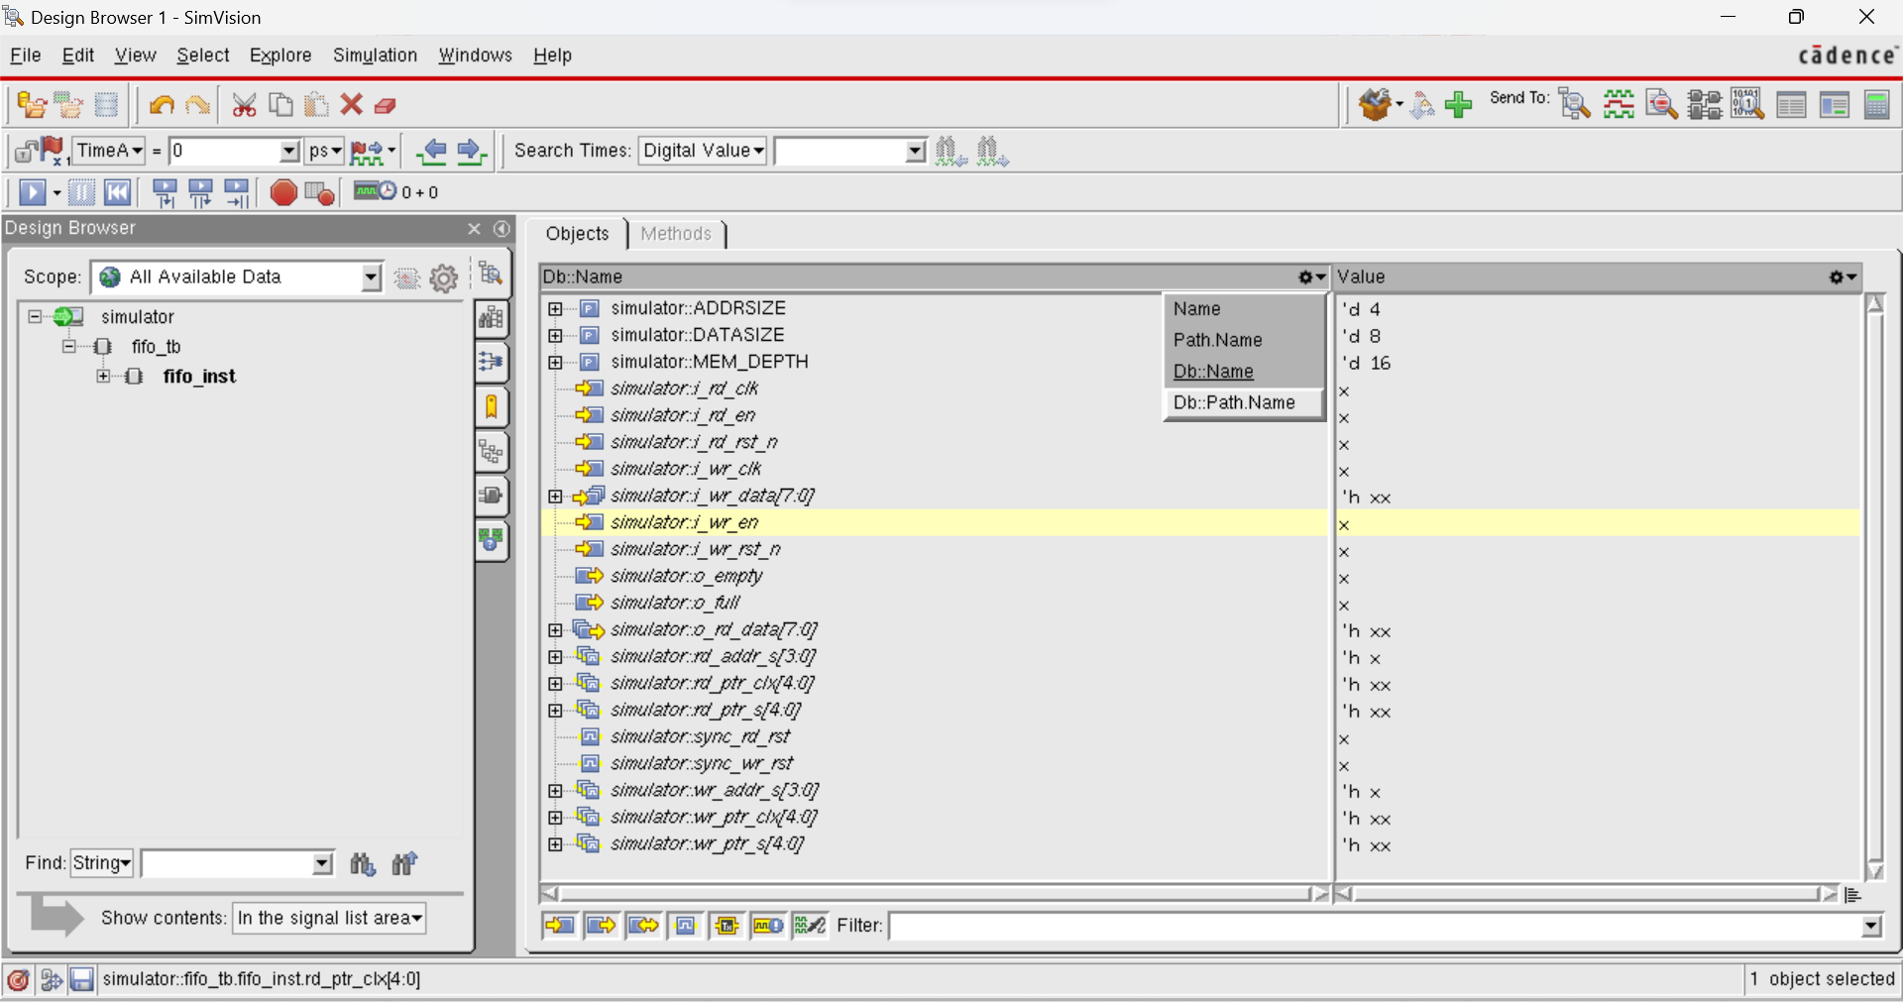

- Name Browser with signals name format Db::Path.Name (<simulator><test bench name>.<instance name>.<signal name> ) will appear as,
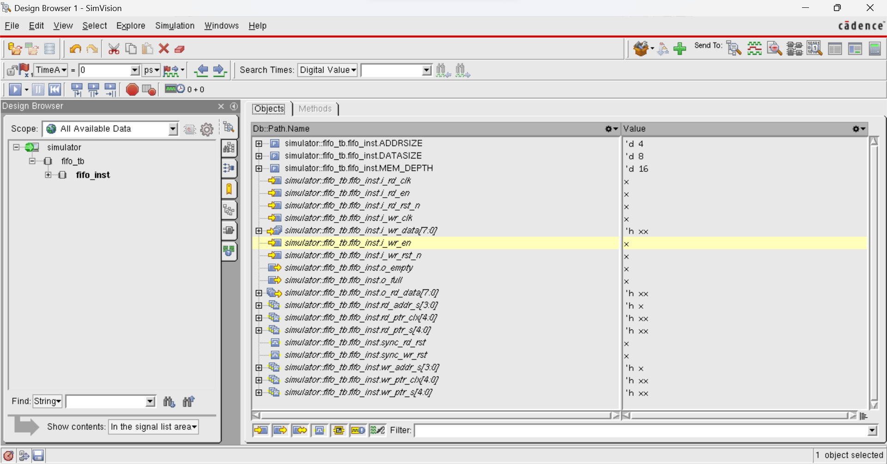

- Radix for signal values can be changed in Value Browser. Click on drop-down menu in Value Browser (by default Value option is selected).
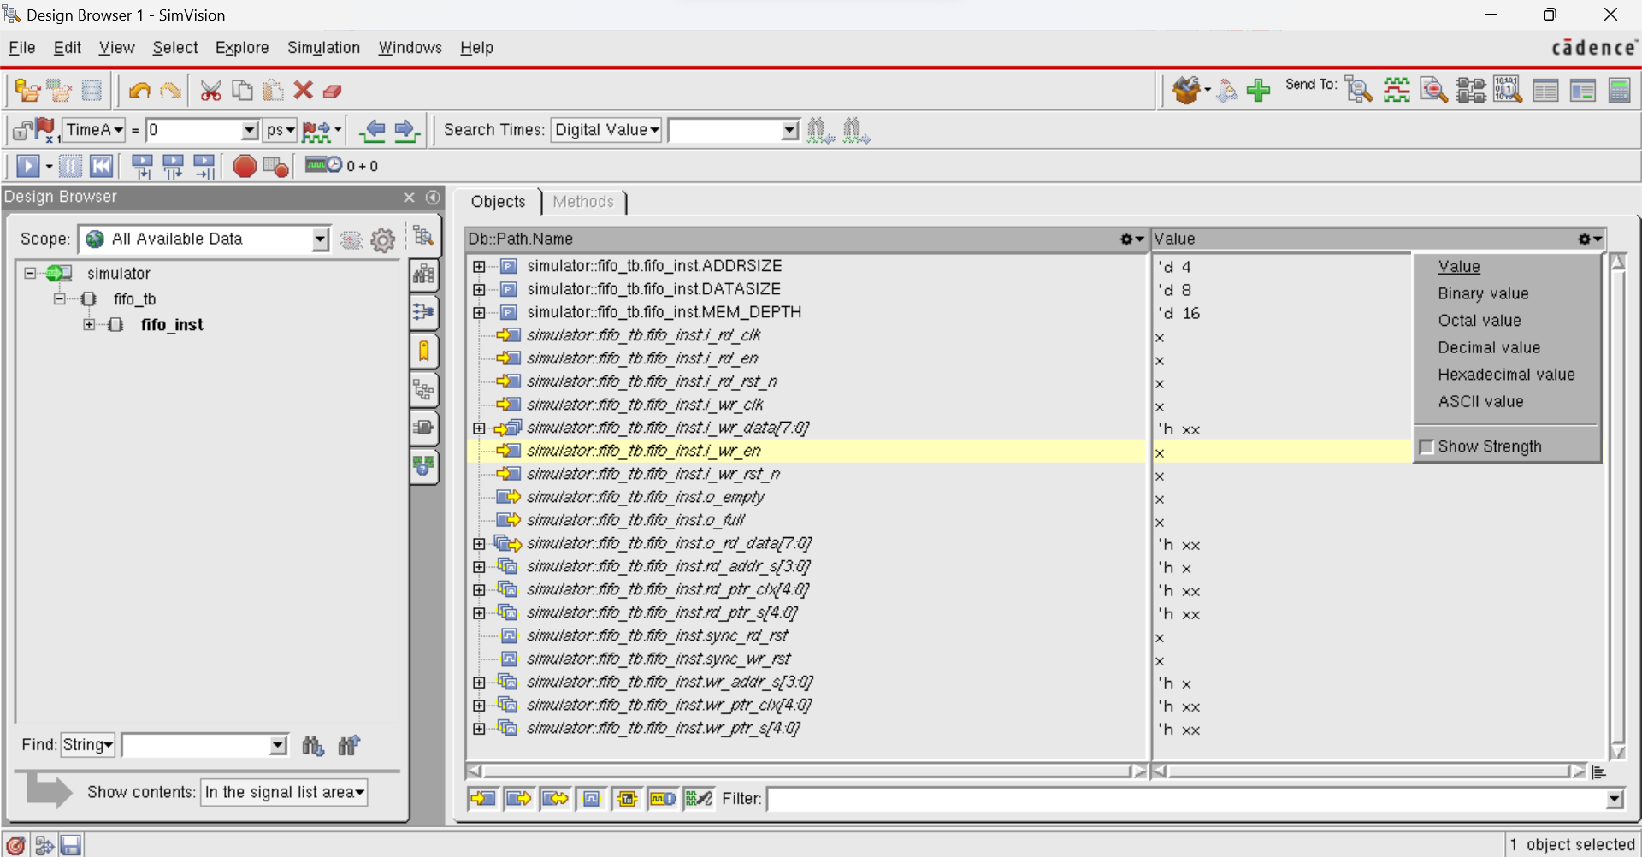

- To change the radix for signal values to binary, select Binary value in drop-down menu.
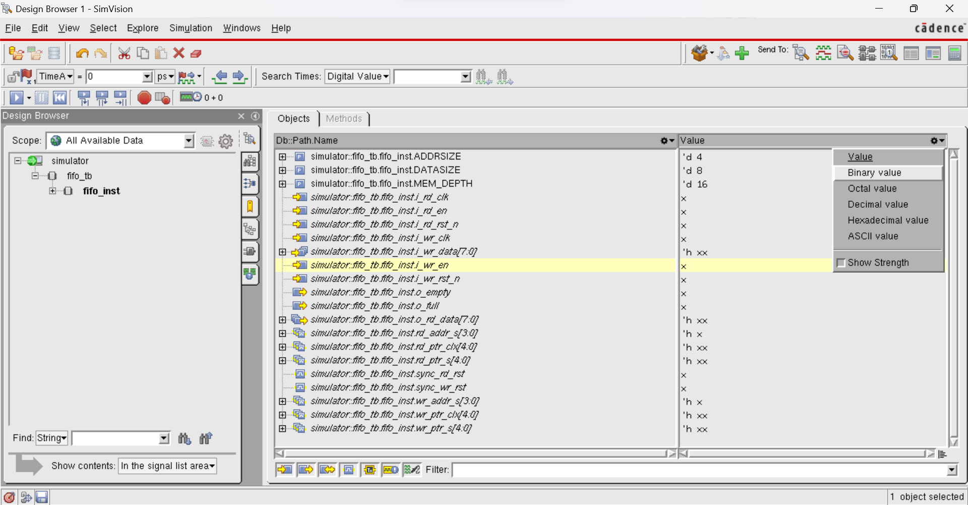

- Value Browser with signals value in Binary form will appear as,
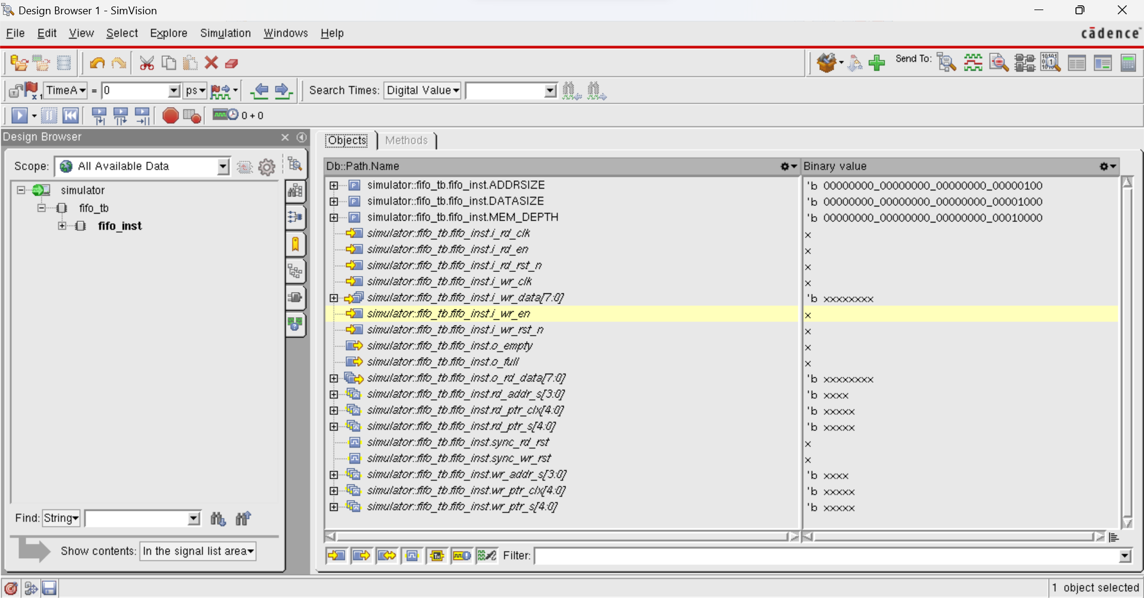

- For user friendly we will again change the signal format to Name format using the method explained in above steps.

- Now, to analyse the simulation through waveforms select all signals in Name Browser as,
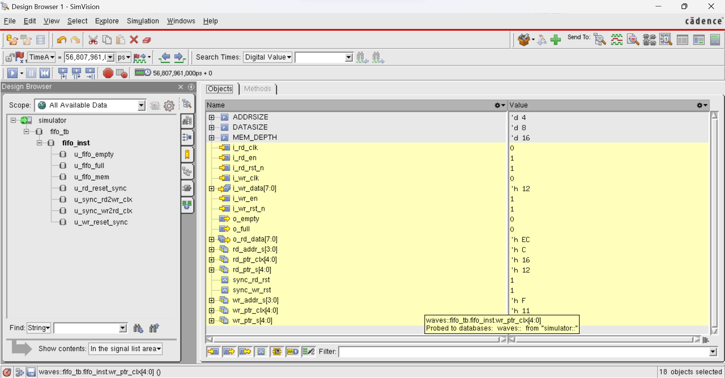

- Right click on selected signals, menu with options will pop up as,
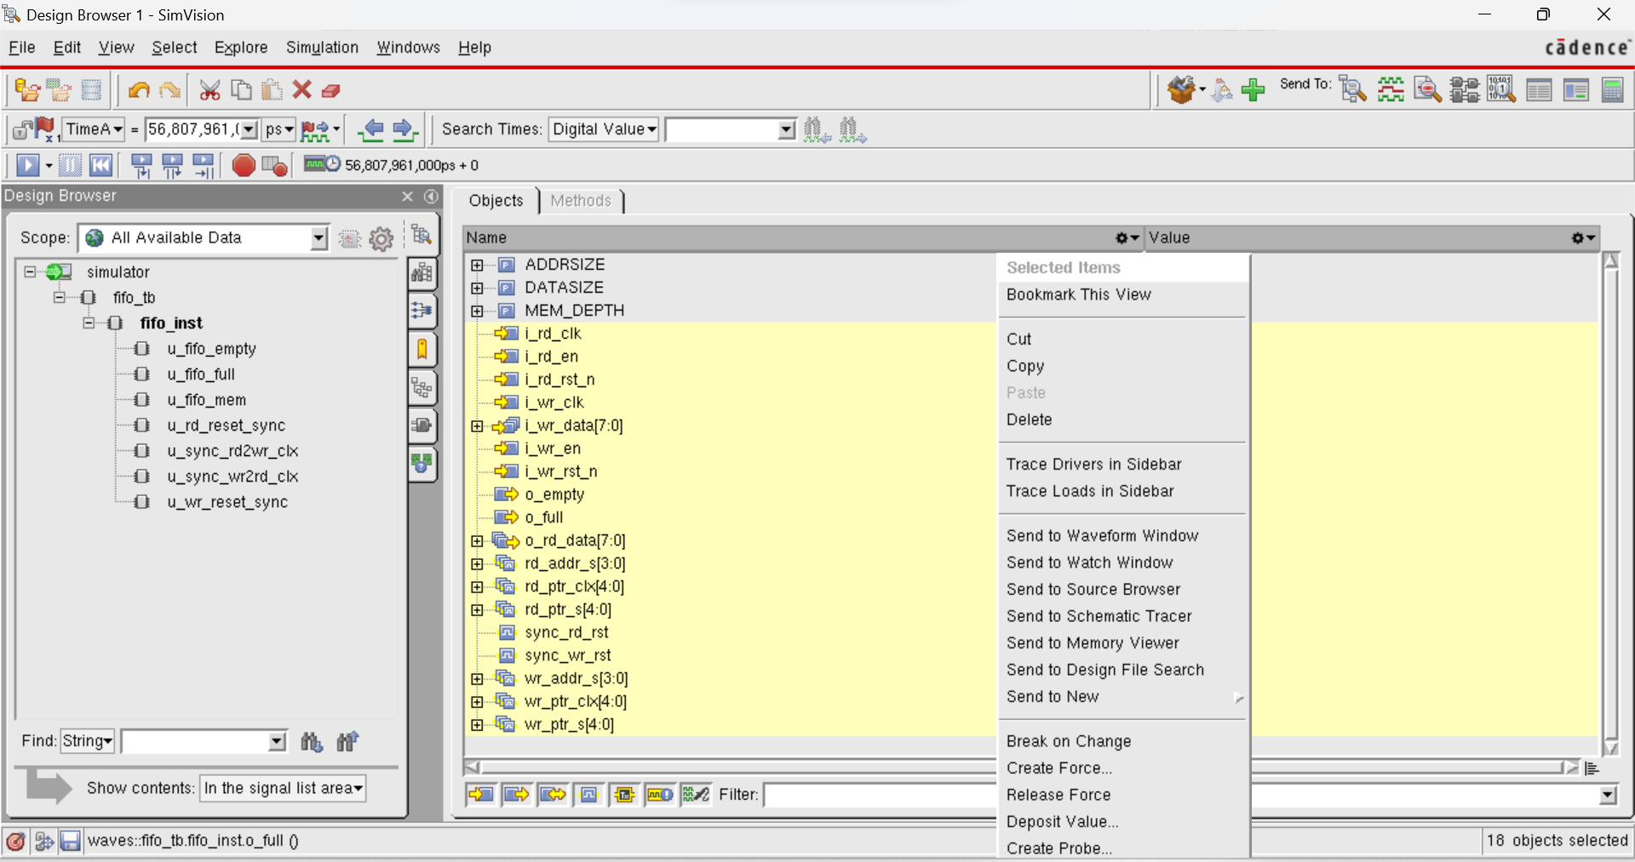

- Click send to Waveform Window option in menu.
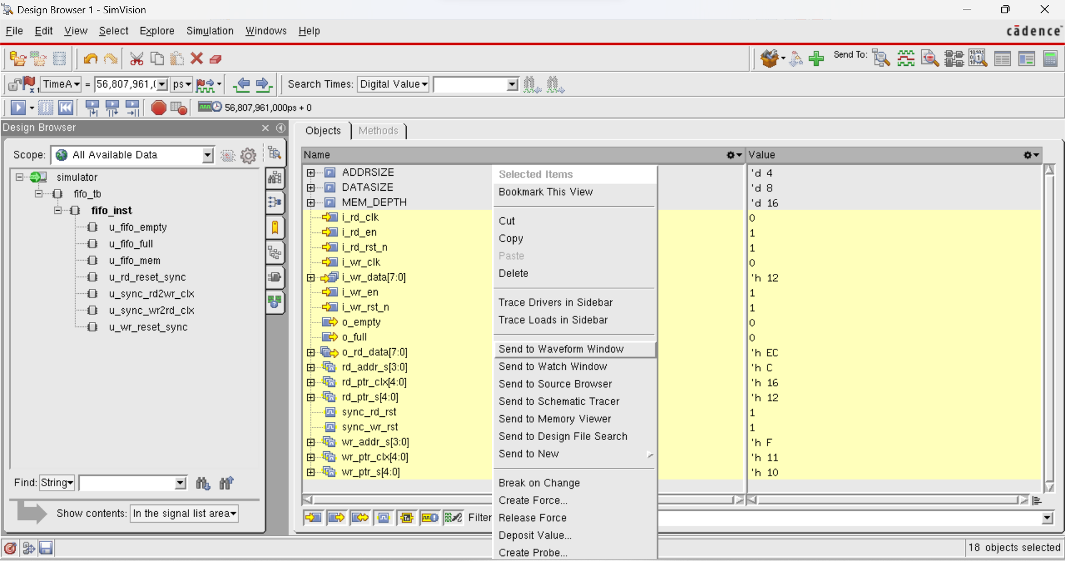

- Waveform1 – SimVision window will pop up as,
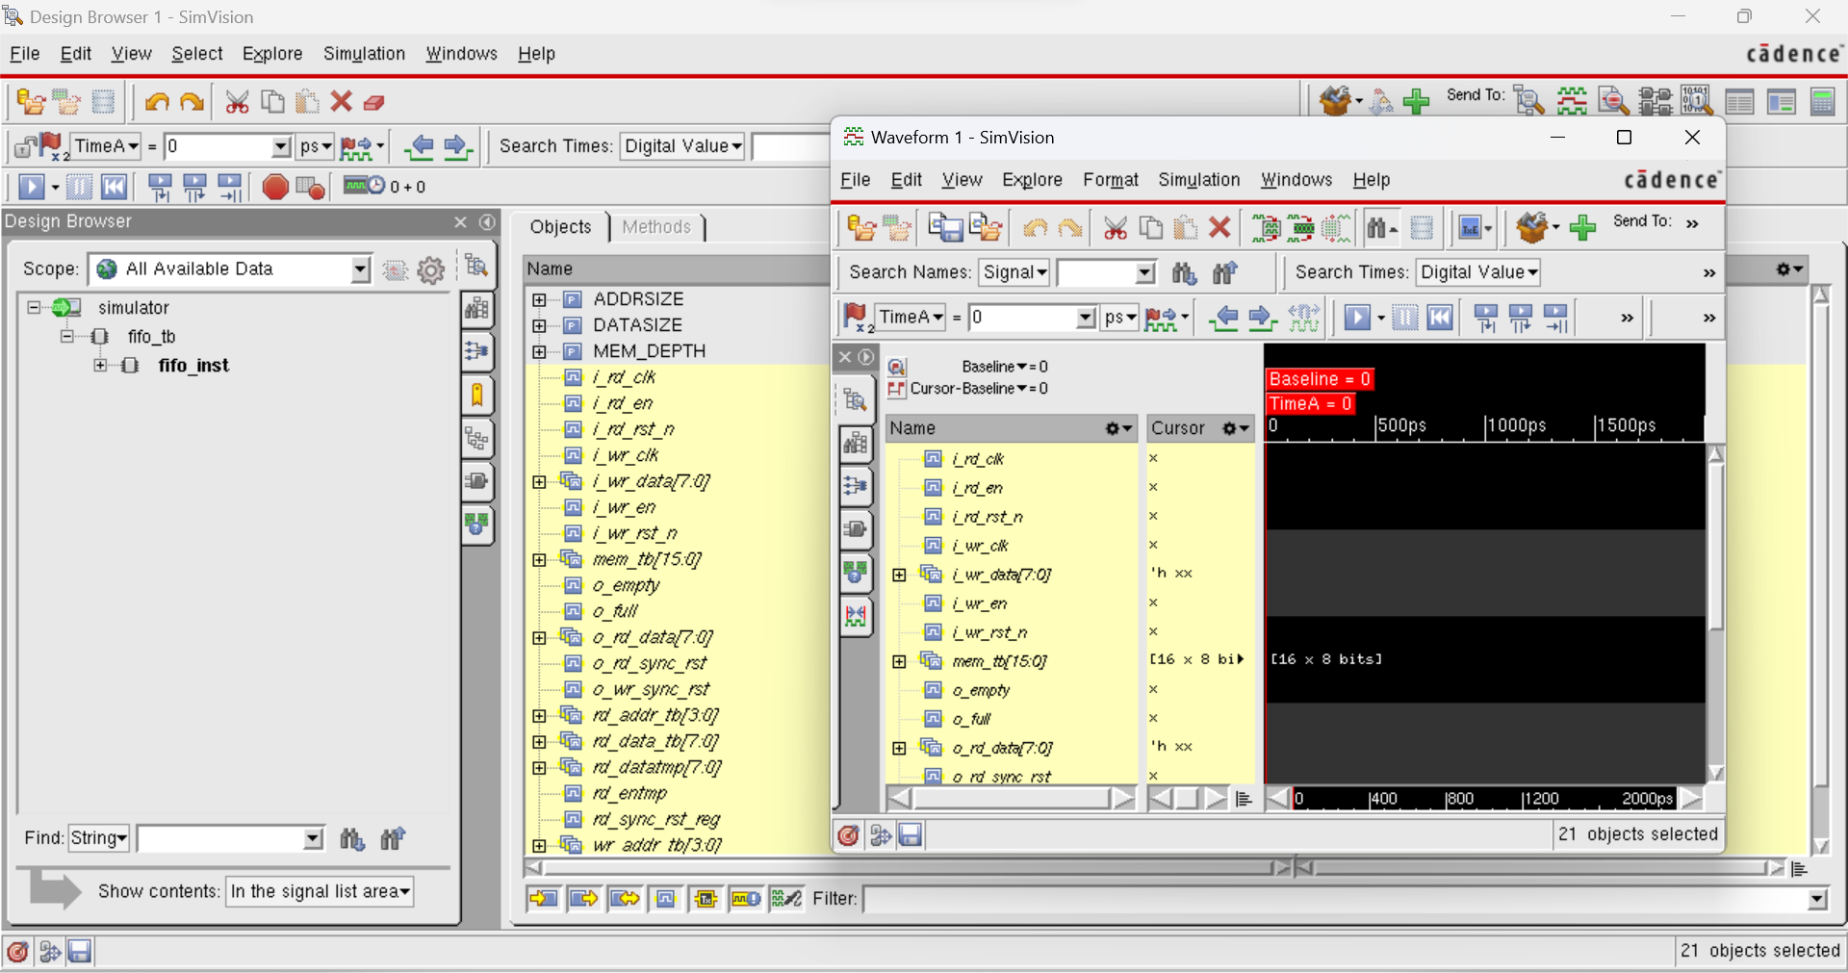

- To run the simulation, click on ‘Run/Continue the simulation until the next breakpoint, or for the duration entered in the time field.
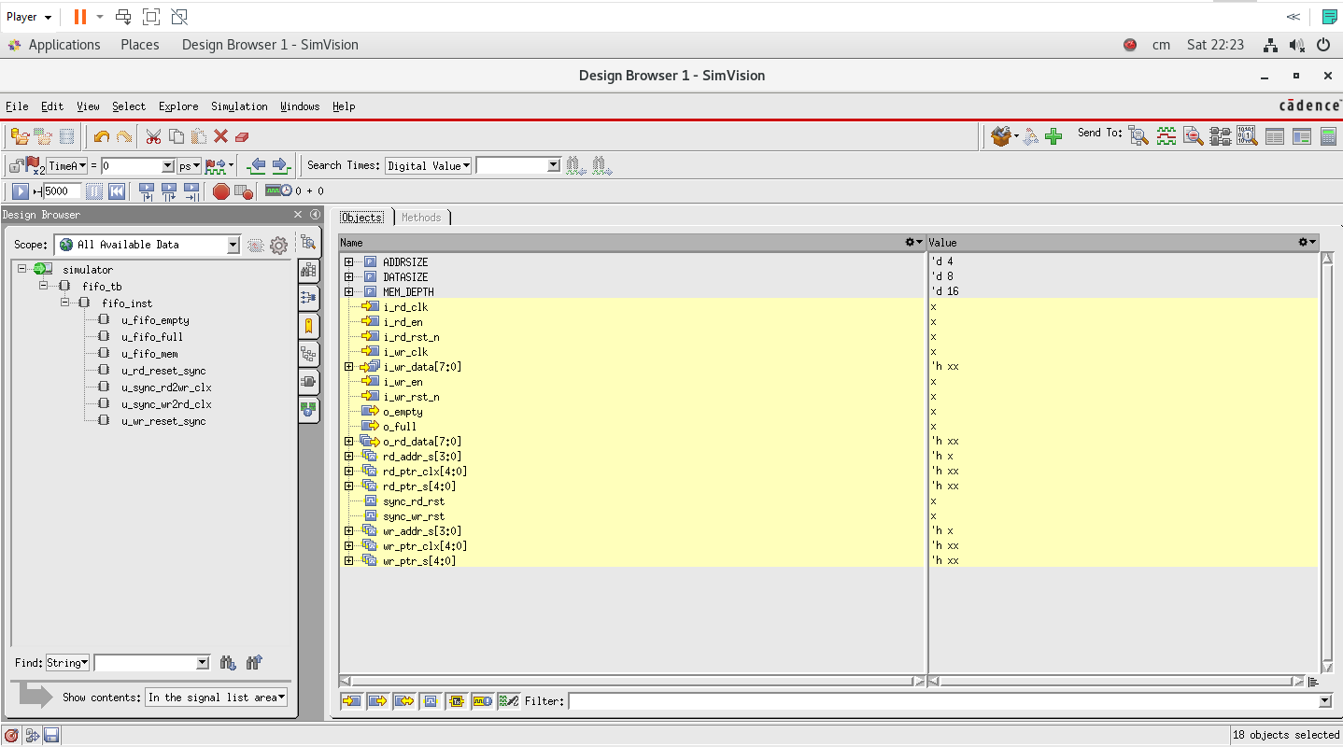

- We can give the value of the breakpoint by clicking the arrow with the Run button mentioned on the above point and a space will come for writing the value.

- Now open the wave window and run the silumation by clicking the Run Button.
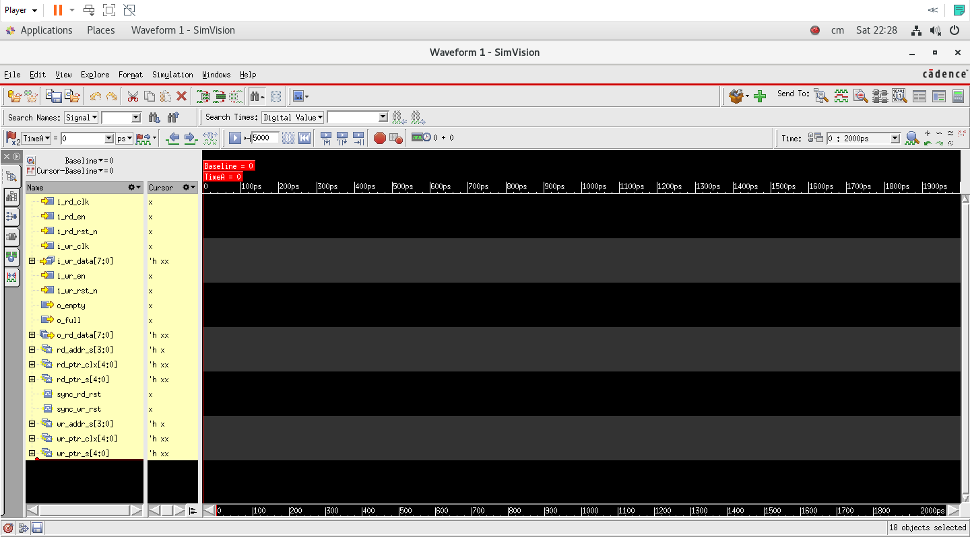

- Waveform 1 – SimVision window will start showing waveforms as shown below.
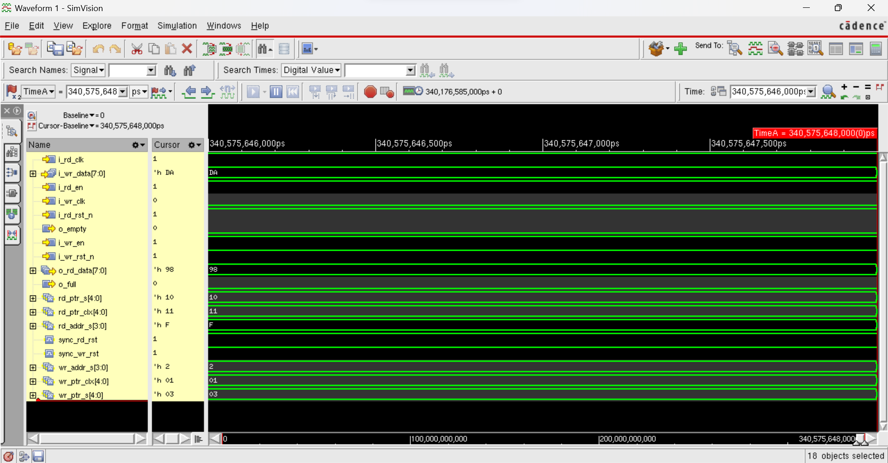

- Simultaniously, in Console-SimVision window ( SimVision pane) will show few commands and show the output as Matched messages as shown below.
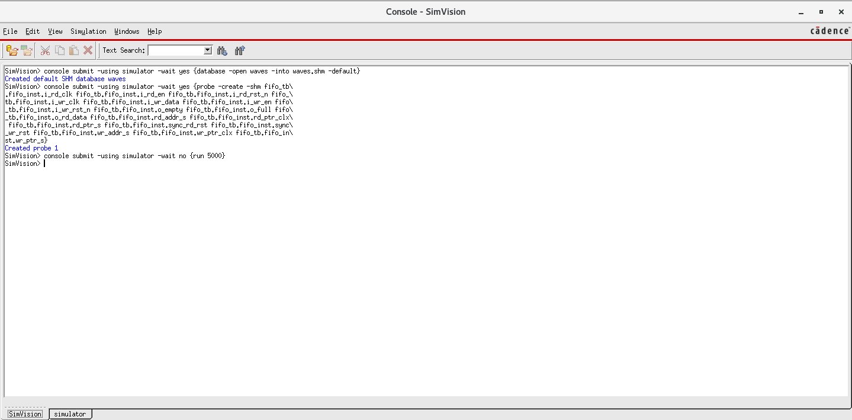

- The simulator window will also provide some commands and the message “Matched” is also shown as mentioned below.
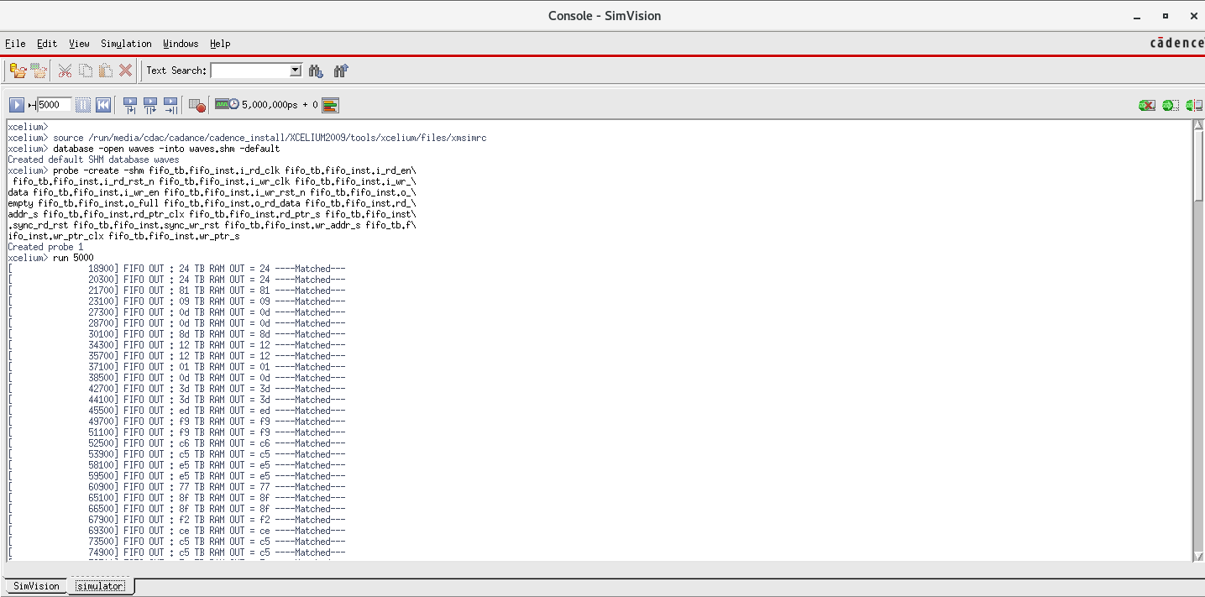

Stop Simulation
Else in the case if we are not providing a breaking point for the simulator to stop running as mentioned before, the Simulator Console in Console – SimVision window will continuously blink messages. So to stop the blinking messages follow the below specified steps.
- In the Waveform 1 – SimVision window and click Interrupt the Simulator Icon shown below.
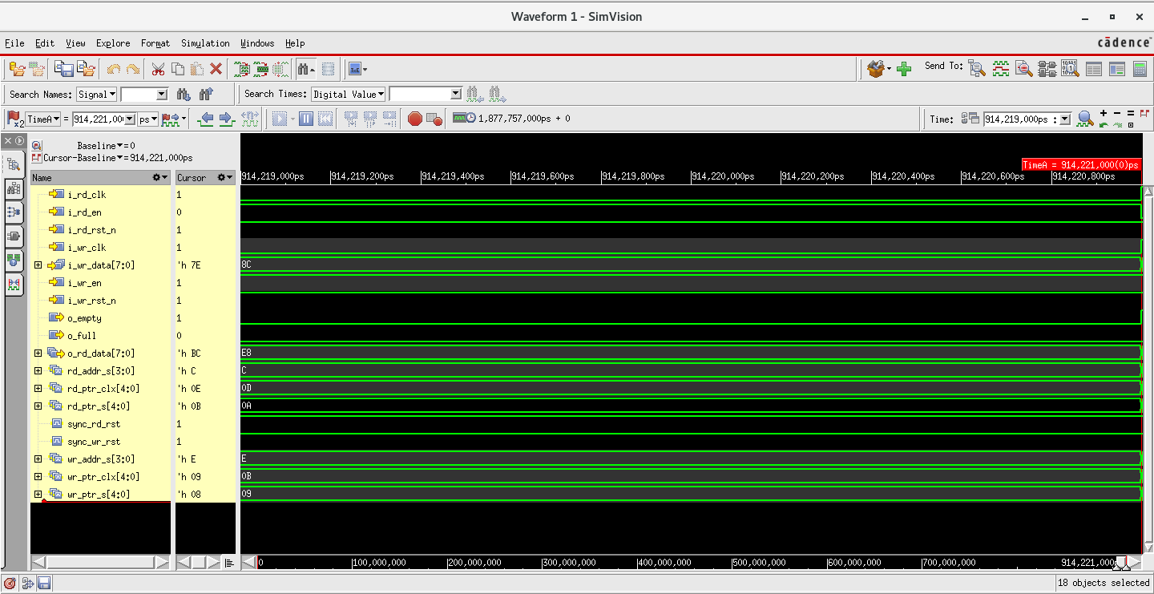

- Simulation will get interrupted and Simulator console in Console – SimVision window will stop blinking continuous messages and show “Simulation interrupted” message.
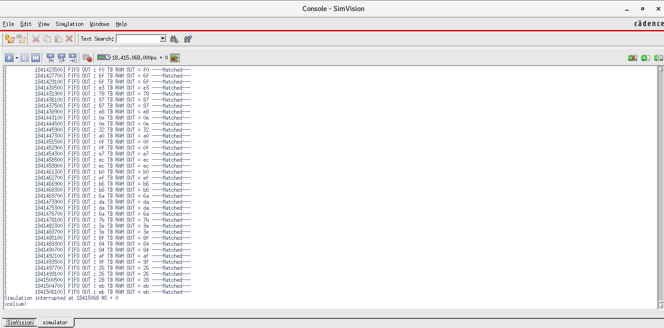

- Simvision console in Console – SimVision window will appear with messages as,
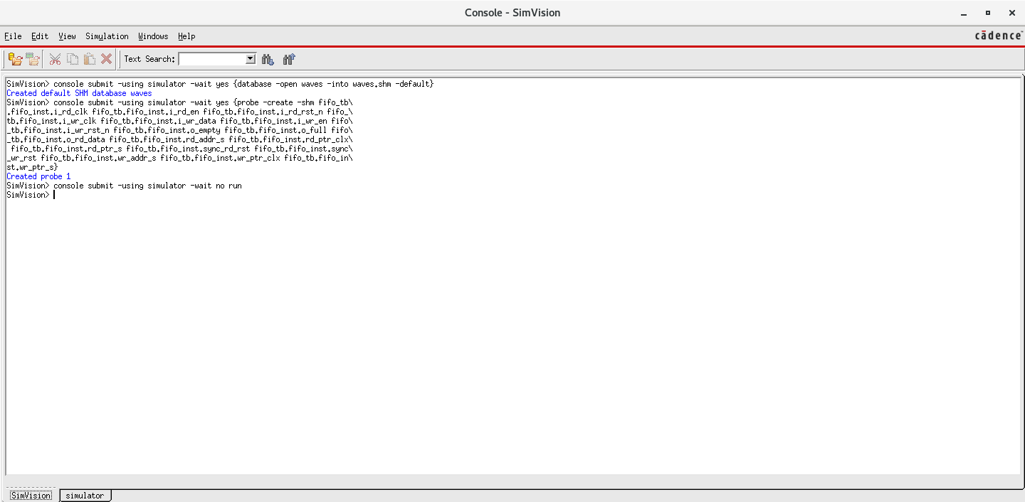

- In order to analyse waveforms in Waveform 1 - SimVision window, default waveform appearance should be zoomed in and zoomed out along X-axis.

- For doing the zooming out keep on clicking minus (-) sign till we get clear waveforms with values.

- After adjusting minus (-) sign final waveforms will appear with values as,
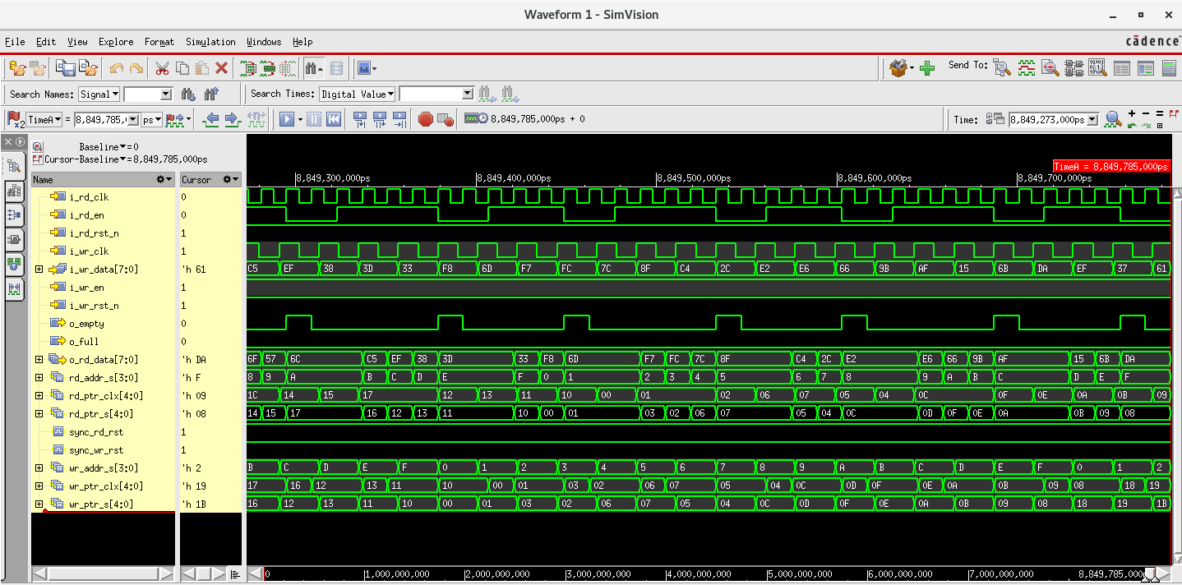

- In order to search any signal, type signal name in search name dialog box in Waveform 1 – SimVision window as,

- Type i_rd_clk ( or any other signal ) in search signal dialog box as shown below.
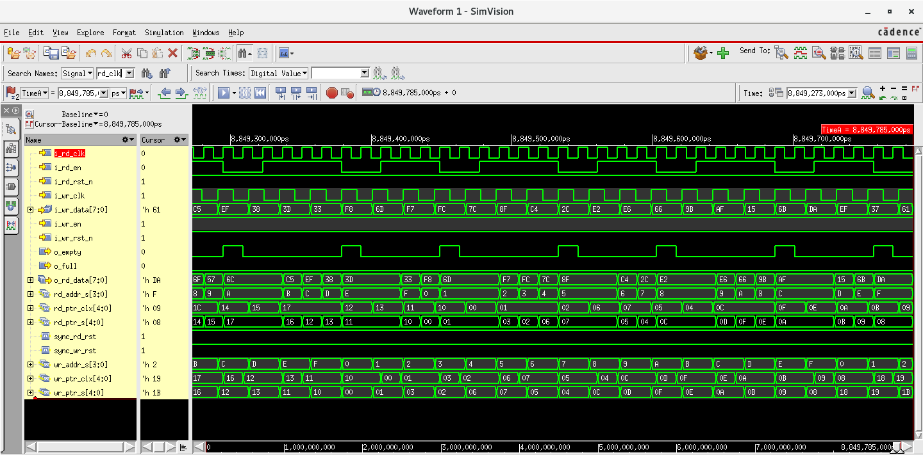

- Searched signal will get highlighted with red colour as,

- Default unit of time in the Waveform 1 – SimVision will be picosecond (ps).

- In order to change the time unit ( s, ms, us, ns, ps and fs ) click on drop-down menu in Time tab as,

- Drop-down menu will appear as, (select time unit as per your requirements)
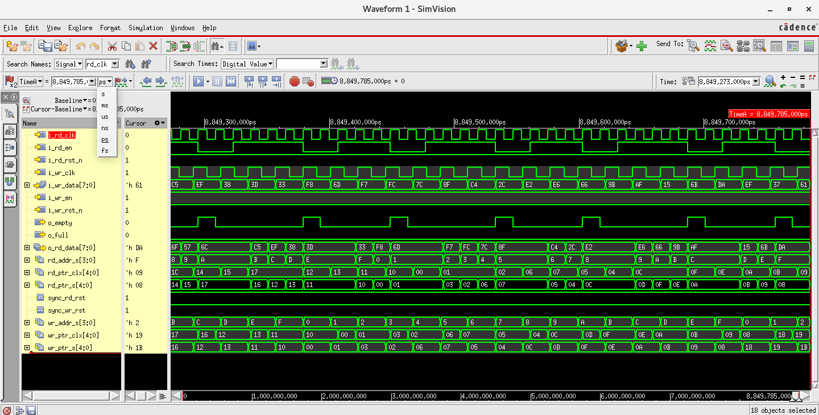

- Select the searched signal i.e., i_rd_clk. To analyse waveforms by moving cursor to the previous edge of selected signals, click left blue arrow icon as,
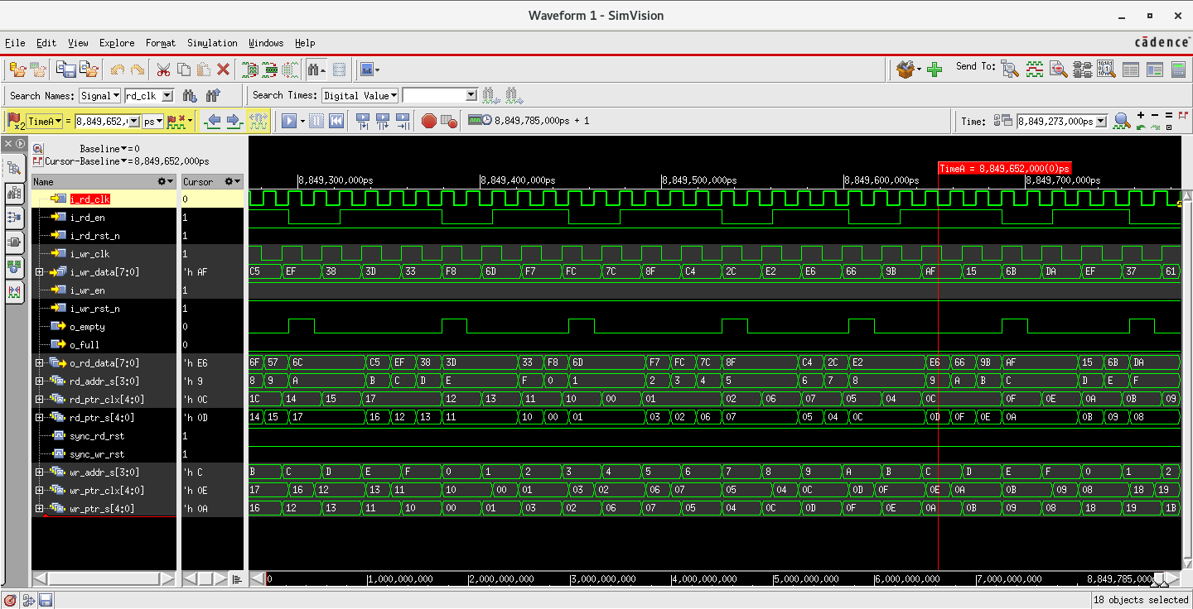

- Cursor highlighted by red vertical line ( TimeA = <time><time unit> ) will get adjusted at previous edges of selected signals.

- Similarly, to analyse waveforms by moving cursor to the next edge of selected signals, click right blue arrow icon as,
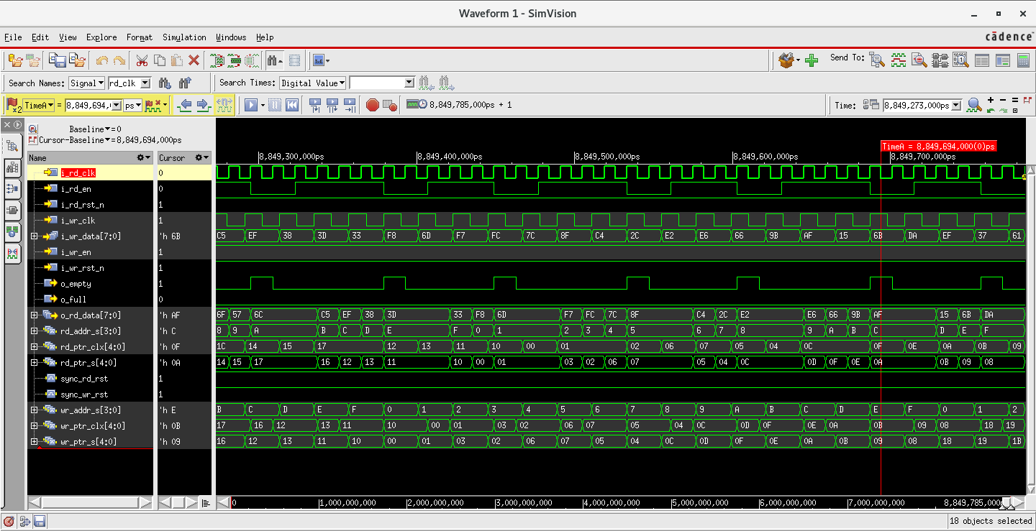

- Cursor highlighted by red vertical line ( TimeA = <time><time unit> ) will get adjusted at next edges of selected signals.

Setting Up the Environment For Cadence Xcelium Simulation – Simvision Tool – Command Line

This section details the Simulation analysis steps/procedure for FIFO IP core using Cadence Xcelium Simulation- Simvision tool in Command Line

Run Simulation
- To run simulation, through command line follow steps from starting till Waveform 1 – SimVision window will pop up point under Run Simulation headline (5.1).
- Type following command in simulator console in Console – SimVision window.
- Syntax : run <time limit><time unit>
- Command : run 2000ns +ENTER

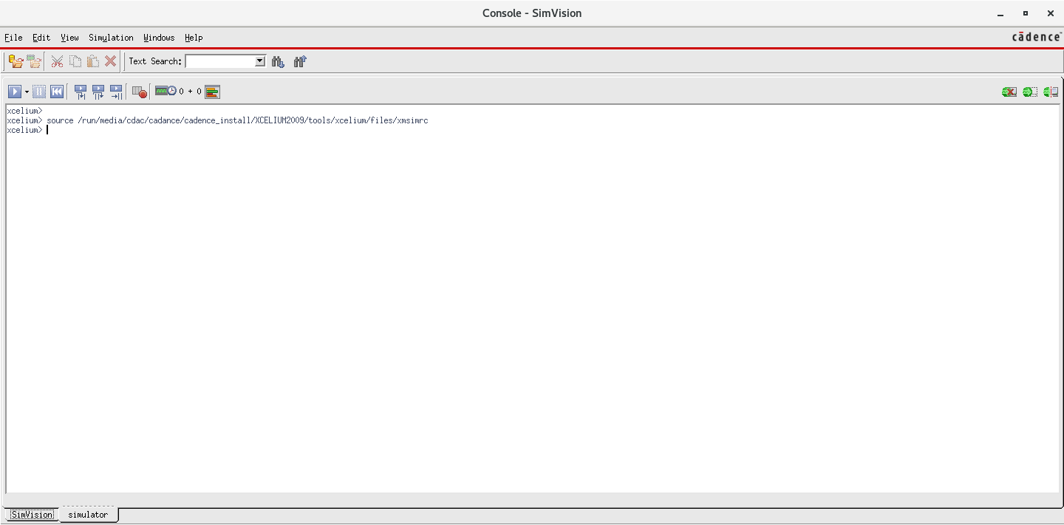

- Simulator console will appear with messages as,
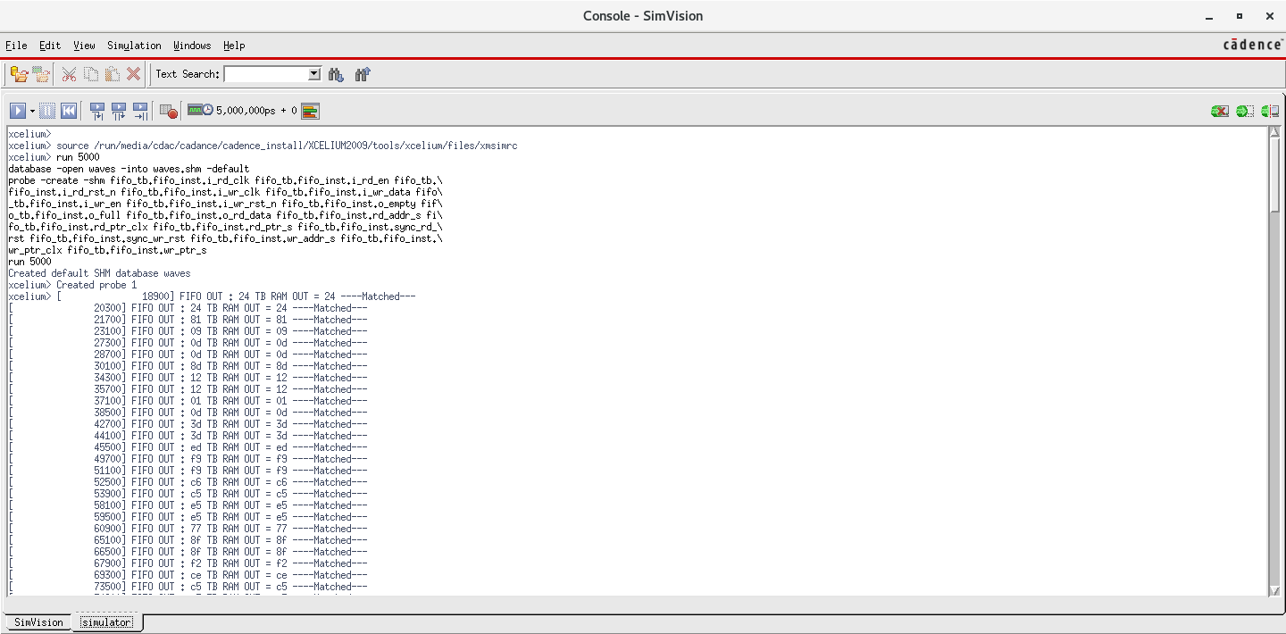

- Simvision console will appear as,
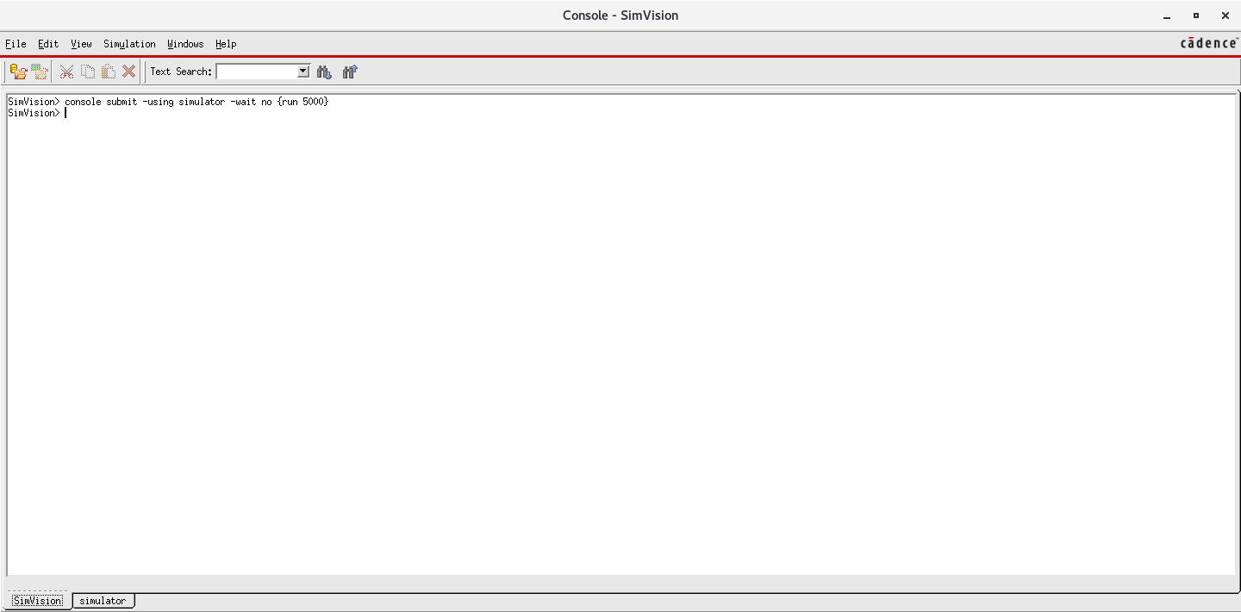

- Waveforms will appear in Waveform 1 – SimVision window as,
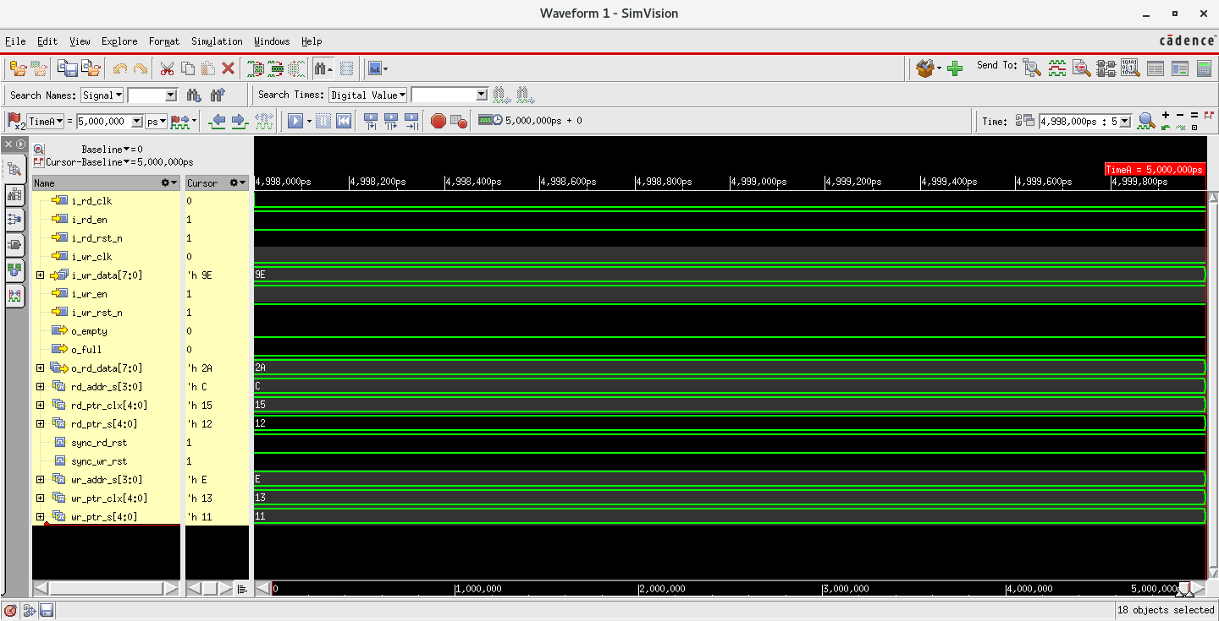

- To analyse waveforms clearly follow same steps till point ‘After adjusting minus (-) sign final waveforms will appear with values as’, under section Stop Simulation (5.2).


