**Assignment 1**

**HT.NO 2403A52418**

**1. Install Anaconda**

Anaconda is a distribution that makes it easy to manage Python environments and packages.

**Steps:**

1. Go to the Anaconda official website.
2. Download the installer for your operating system (Windows/Mac/Linux).
3. Run the installer:
   * On **Windows**, check **“Add Anaconda to PATH”** if asked (recommended).
   * Choose **Just Me** unless you want it for all users.
4. After installation, open **Anaconda Navigator** or **Anaconda Prompt** to verify.

conda --version

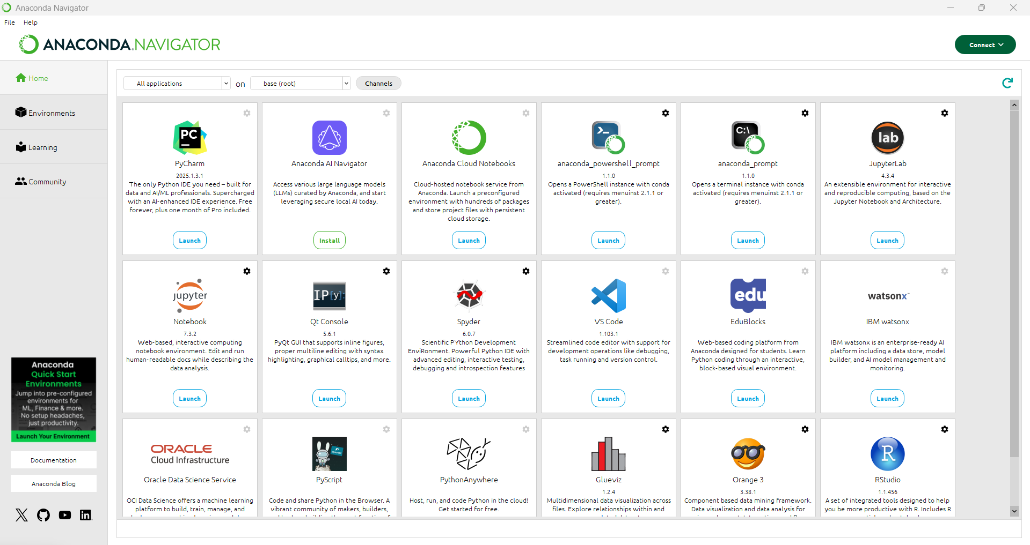

## 2. Install ****Visual Studio Code (VS Code)****

1. Download from VS Code official site.
2. Run the installer:
   * Select **Add to PATH** and **Register Code as an editor** during setup.
3. After installation, open VS Code.

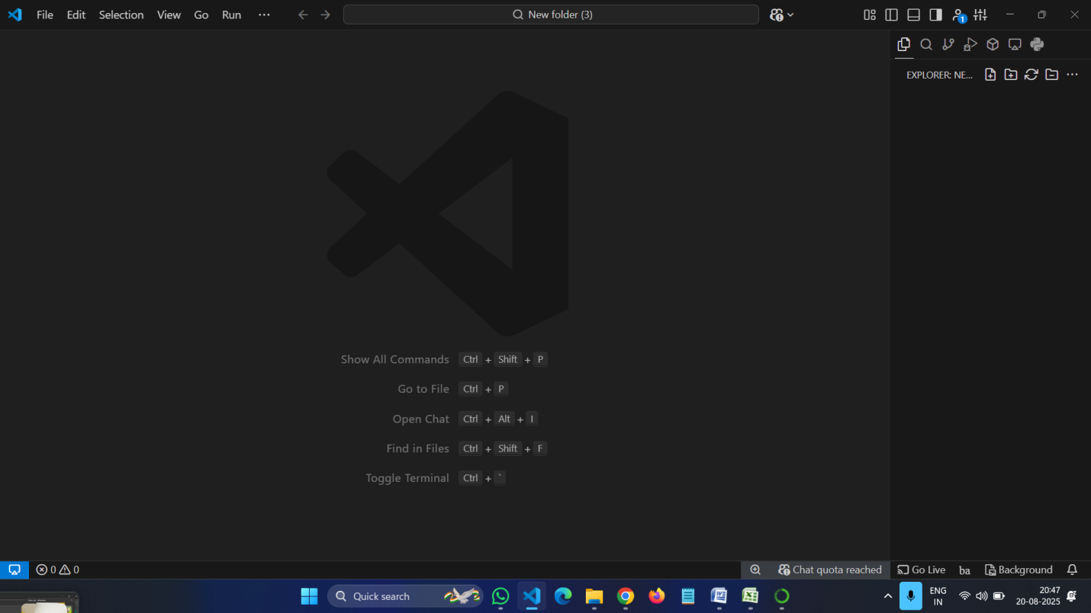

## 3. Create a ****GitHub Account****

1. Go to [GitHub Sign Up](https://github.com/).
2. Click **Sign up**.
3. Enter:
   * Email
   * Username
   * Password
4. Verify your account (GitHub might ask for CAPTCHA or email confirmation).
5. Once done, you have your GitHub profile ready.

## 

## 4. Install ****GitHub Copilot in VS Code****

GitHub Copilot is an AI coding assistant.

**Steps:**

1. Open **VS Code**.
2. Go to **Extensions Marketplace** (left sidebar or press Ctrl+Shift+X).
3. Search for **GitHub Copilot**.
4. Click **Install**.
5. After installation:
   * Sign in with your **GitHub account**.
   * Grant permission for Copilot to access VS Code.
6. Restart VS Code.
7. Now, when you type code, Copilot will suggest completions.

