**ASSIGNMENT-7**

**LAB-7**: Error Debugging with AI – Systematic Approaches to Finding and Fixing Bugs

**Task Description #1:**• Introduce a buggy Python function that calculates the factorial of a number using recursion. Use  
Copilot or Cursor AI to detect and fix the logical or syntax errors.

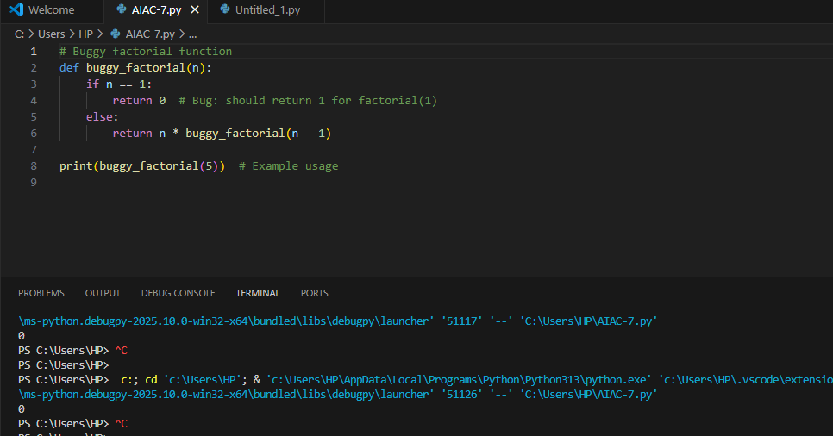

**Expected Outcome #1**:  
•detect and fix the logical or syntax errors.

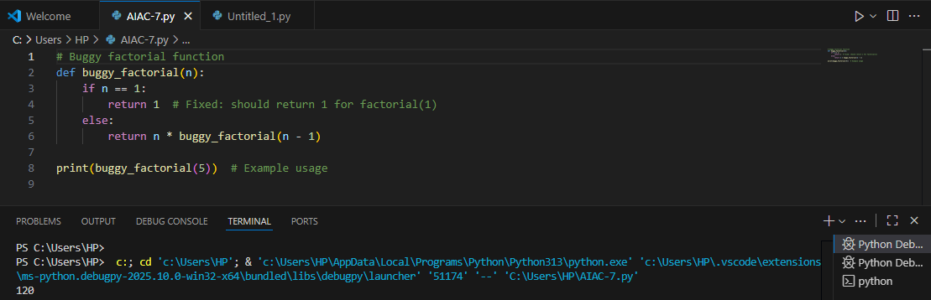

**Task Description #2:**  
• Provide a list sorting function that fails due to a type error (e.g., sorting list with mixed  
integers and strings)

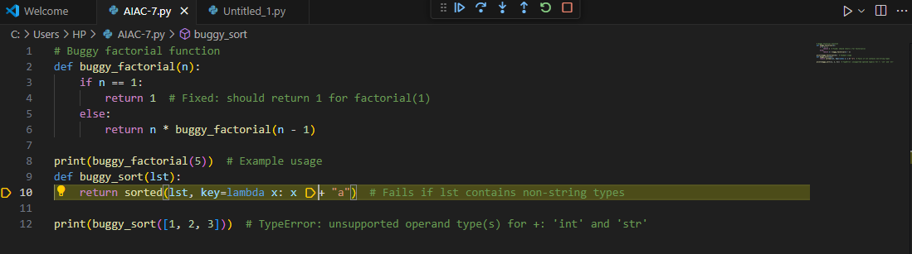

**Expected Outcome #2:**  
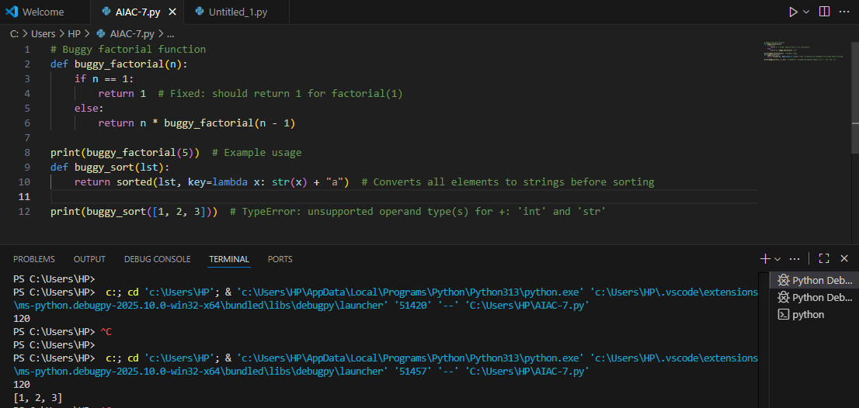

**Task Description #3:**• Write a Python snippet for file handling that opens a file but forgets to close it. 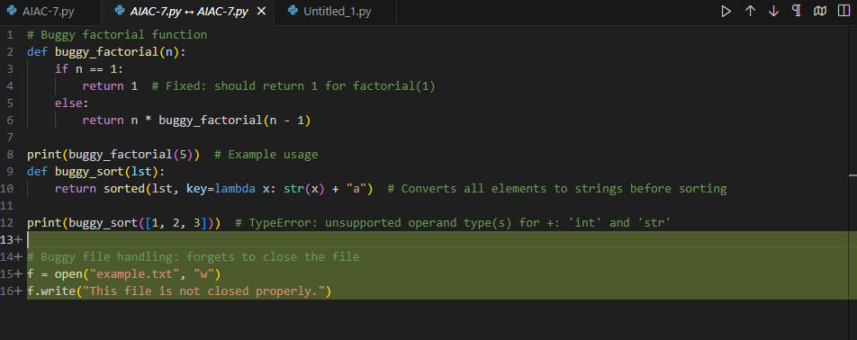  
Expected Outcome #3:

improve it using the best practice (e.g., with open() block).  
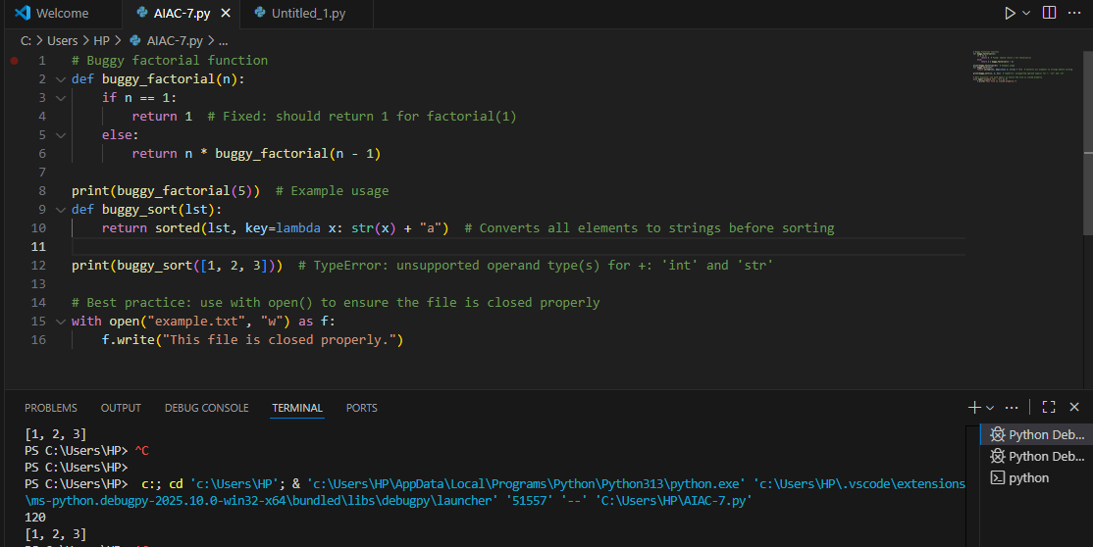

Task Description #4:  
• Provide a piece of code with a ZeroDivisionError inside a loop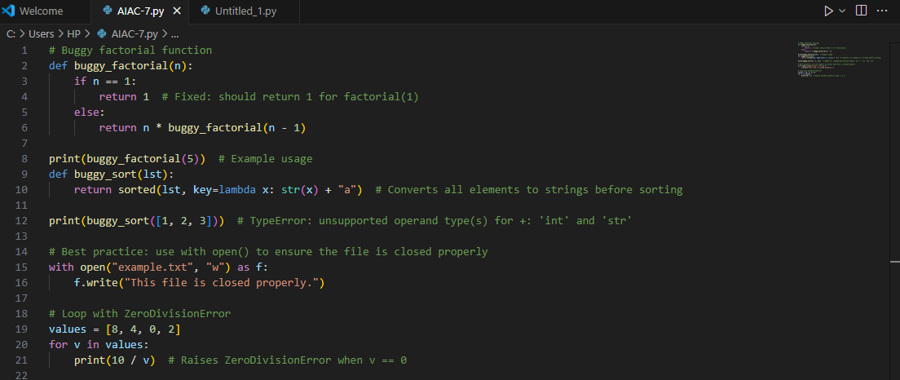

Expected Outcome #4:  
. add error handling using try-except and continue execution safely.

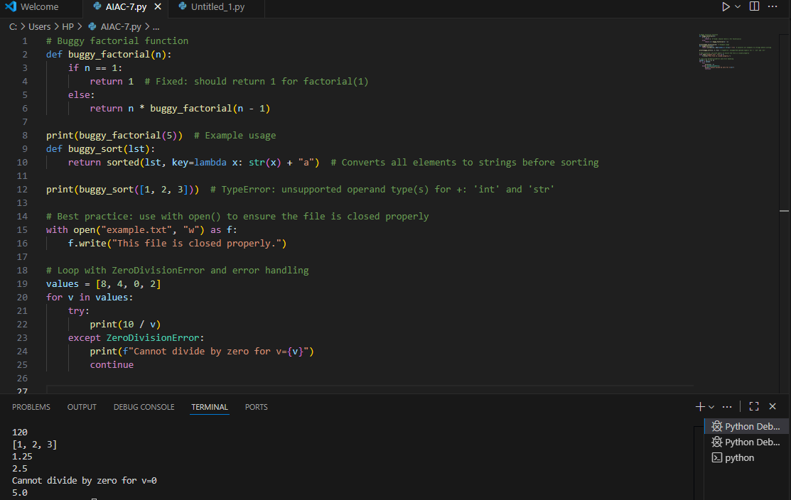

Task Description #5:  
• Include a buggy class definition with incorrect __init__ parameters or attribute references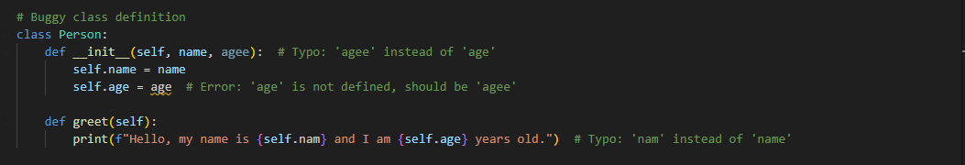

Expected Outcome #5:  
. analyze and correct the constructor and attribute usage.

