**LAB TEST-2**

NAME: RADHARAPU REVANTH

HTNO: 2403A52418

BATCH : 15

**TASK 1:**

Parse to nested dict; cast obvious ints ..

**Prompt:**

Write a python function to parse an INI configuration text into a nested dictionary of type dict(str,dict(str,object)

Each section became a top levelkey in the dictionary

Each key value pair inside a section should be stored as sub dictionary like value integers

Assume simple INI format and provide the code

**Code:**

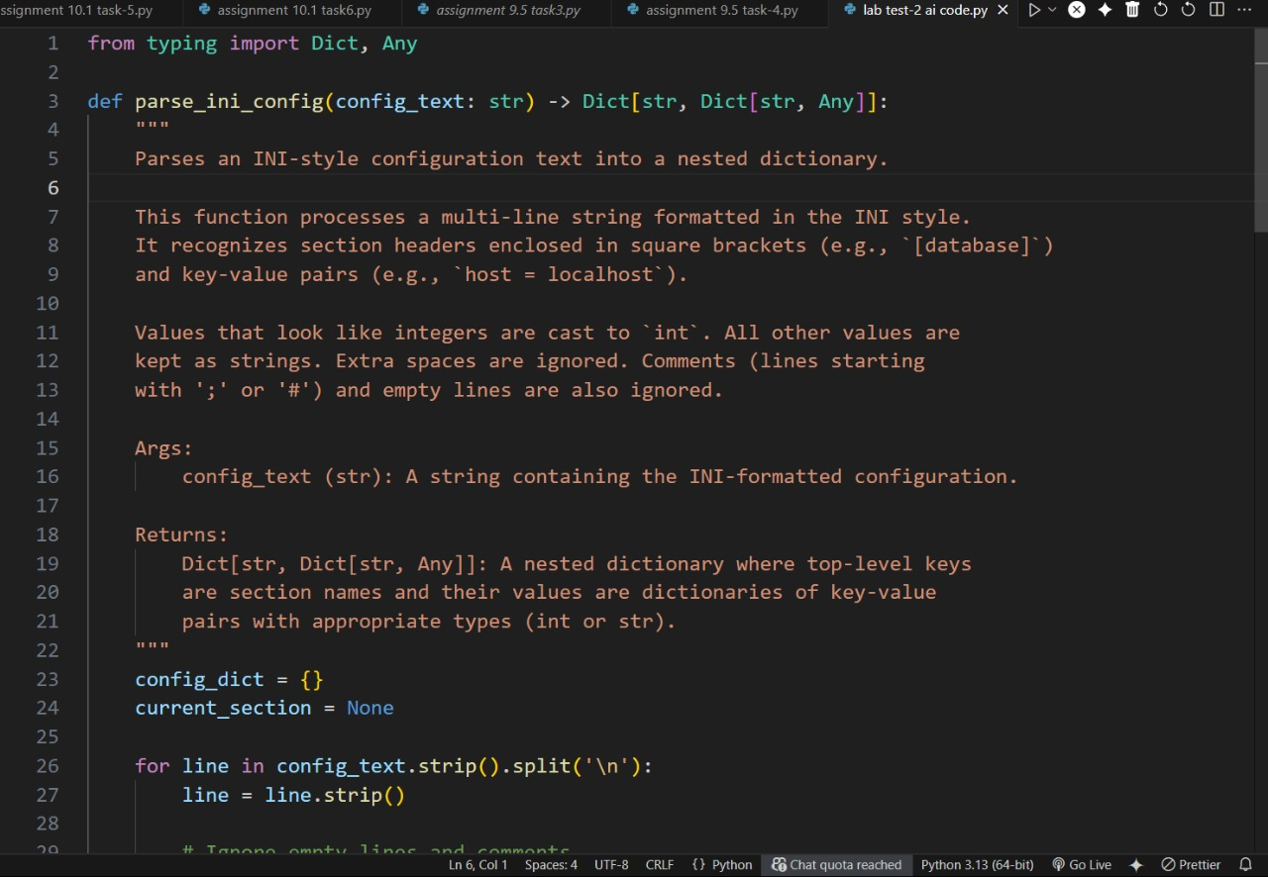

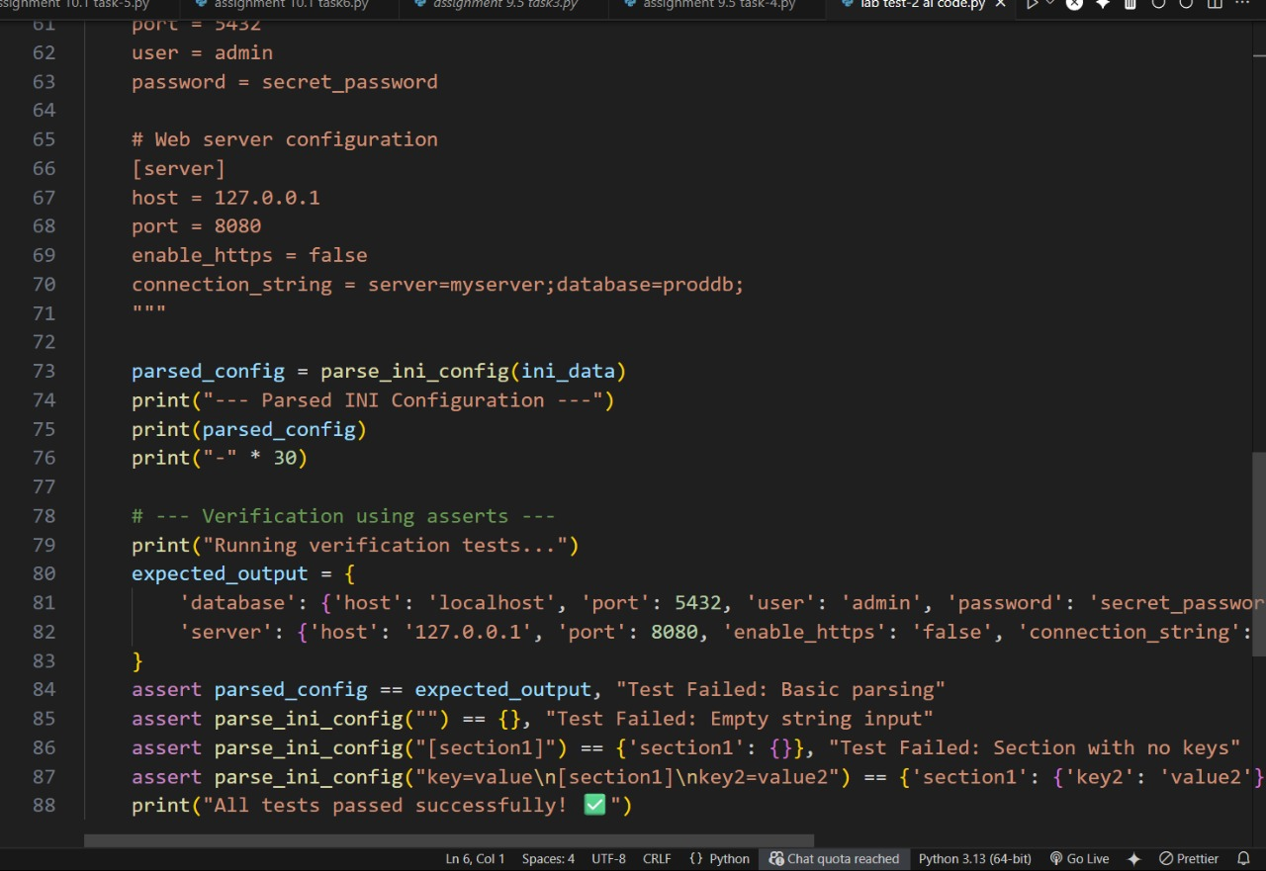

**OUTPUT:**

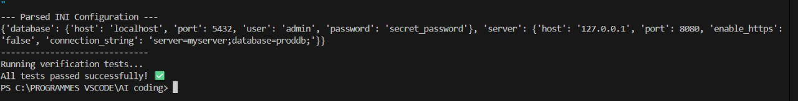

**Observation:**The program successfully parses INI-style configuration text into a nested dictionary. It handles sections, key-value pairs, integers, strings, comments, and empty lines correctly. All test cases executed and passed as expected

**TASK 2:**

Average ticket durations in minutes from opened/closed ISO timestamps.

**PROMPT:**

write a python function that takes a list of dict with “opened" and “closed” 130 time stamps and returns the average duration in minute between them

Use datatime for parsing and minute calculation.

**Code:**

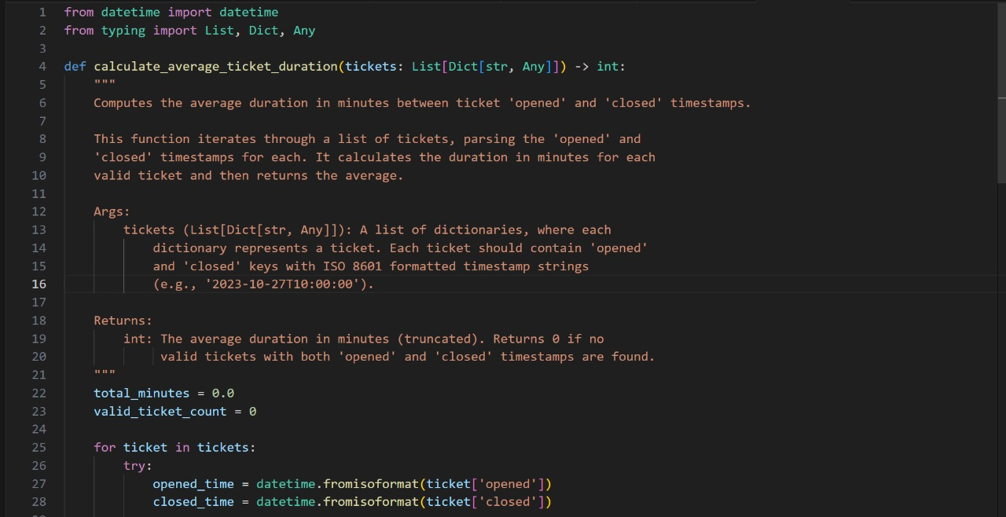

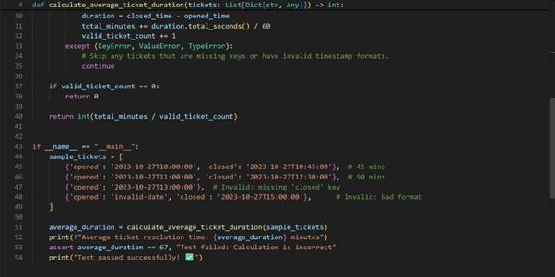

**Output :**

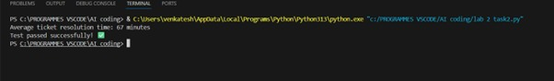

**Observation:**

The program calculates the average resolution time of tickets by parsing opened and closed timestamps. It correctly handles valid tickets, skips invalid/missing data, and computes the average in minutes. The output matched the expected result (67 minutes), and all tests passed successfully