

End-User Guide 5-Step Journey Format

*Professional. Visual. Simple. Journey-Led.*

# Platform Overview

**What is MetaBrain?**

MetaBrain is an AI-driven strategic intelligence platform that integrates curated industry datasets with enterprise systems. Operating within SAP BTP, it leverages conversational interfaces to enhance decision-making through predictive and prescriptive analytics.

**Key Features:**

* **AI-Powered Insights:** Utilizes AI to deliver strategic insights by combining enterprise data with external industry information.
* **Conversational Interface:** Engage with the platform using natural language queries.
* **Integration with SAP:** Seamlessly integrates with SAP systems for enhanced data analysis.

# Step 1: Access & Onboard

**Go to:** <https://demo.metafrost.ai/dashboard>

**Signup:** Signup at the portal by providing

* + Name, Email ID, Password, Company Name, Industry, Phone number, & Address

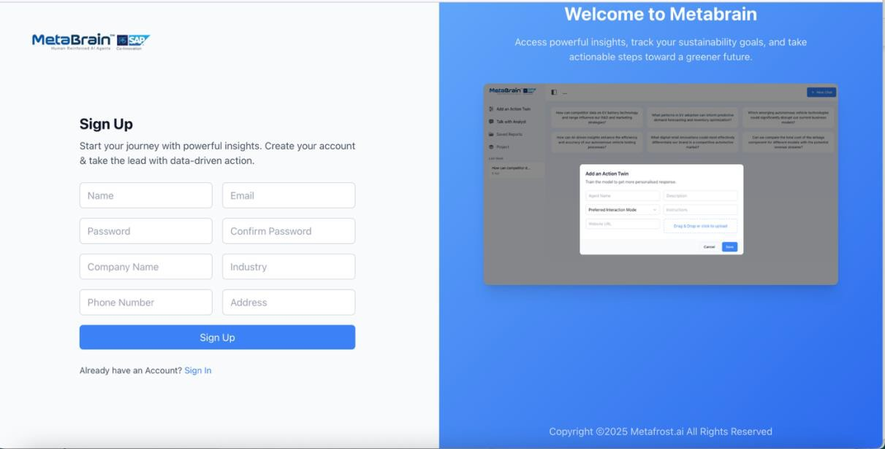

**Click the Sign Up Button:**

**Verify your Email:** Enter the code sent to your provided email ID to complete the Sign Up process.





**Welcome to the MetaBrain Dashboard**

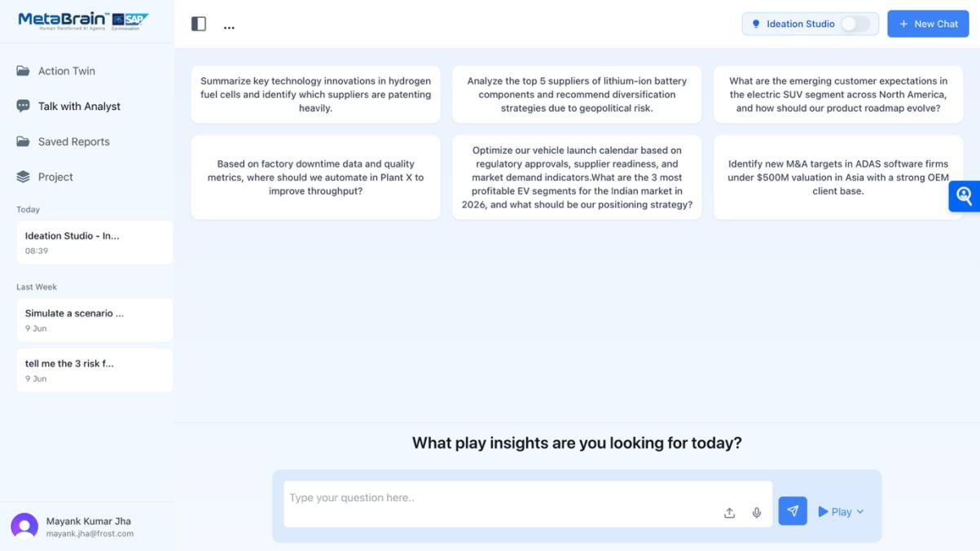

# Step 2: Ask & Analyze

Use the **Prompt Bar** to ask business questions like:

* “What are the top 5 risks in lithium-ion battery sourcing?”
* “Which EV segments will be profitable in India by 2026?”

 You can:

* **Upload a document** (PDF, Excel, PPT) to enrich your prompt
* **Use voice input** to ask naturally
* **Select a preloaded use case** for your industry

**Visual**:

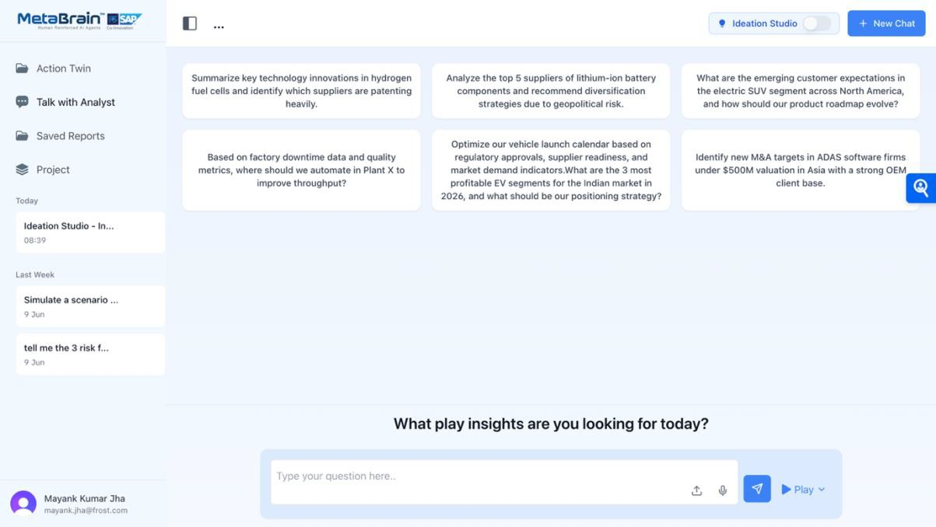

**Prompt Bar**

**Voice Input**

**Prompt bar**

**Talk with Analyst**

**Saved Projects**

**New Chat**

**Open /Create Project**

**Ideation Studio**

**Developer Workflow:**

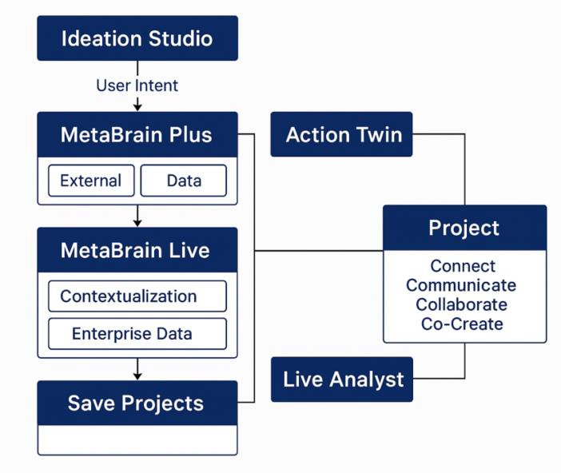

**For Prompting Choose Your desired mode**:

|  |  |  |
| --- | --- | --- |
| **Mode** | **Use When You Want To...** | **Best For** |
| **Play** | Combine your SAP ERP data with external market  data for contextual insights | Strategy, Innovation |
| **Plus** | Use expert-curated Frost & Sullivan insights for  fast, accurate strategy answers | Planning, Ops |
| **Ideation**  **Studio** | Collaborate on custom ideas, brainstorm, or  simulate strategy shifts | CXOs, Consultants |

**Visual**:

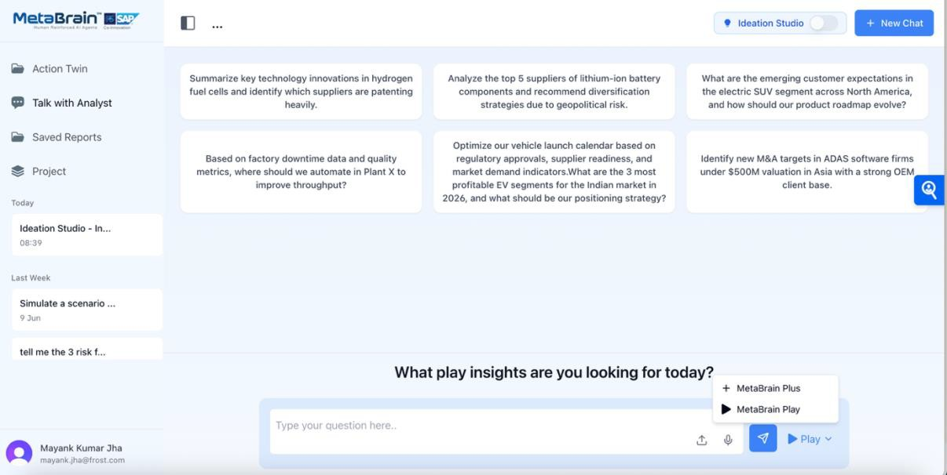

**Modes of Operation**

**Ideation Studio Mode:**

**Click the ‘*Ideation Studio’* mode to switch ON**

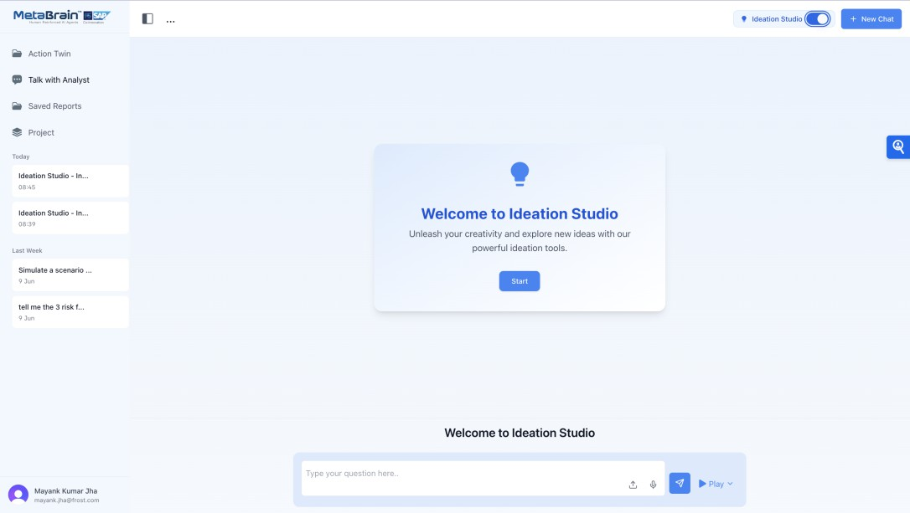

**Ideation Studio Mode**

**Steps:**

* 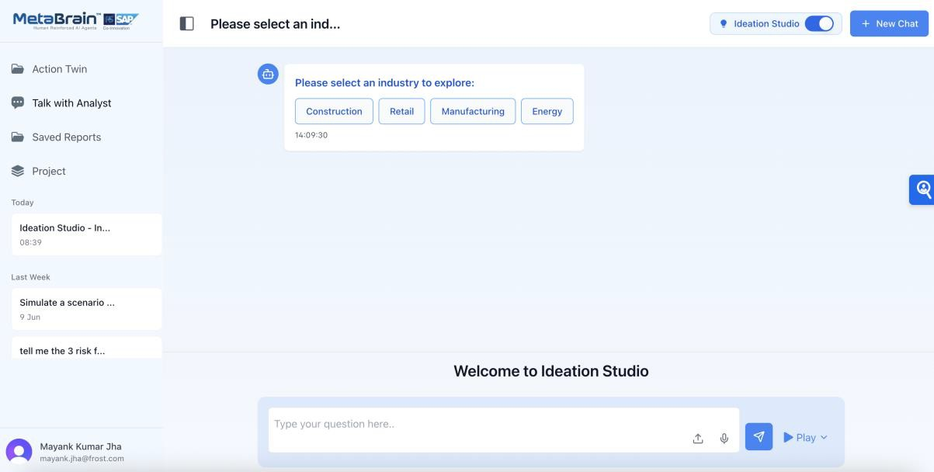**Choose Industry to explore:**
* **Choose a Sub- Industry:**



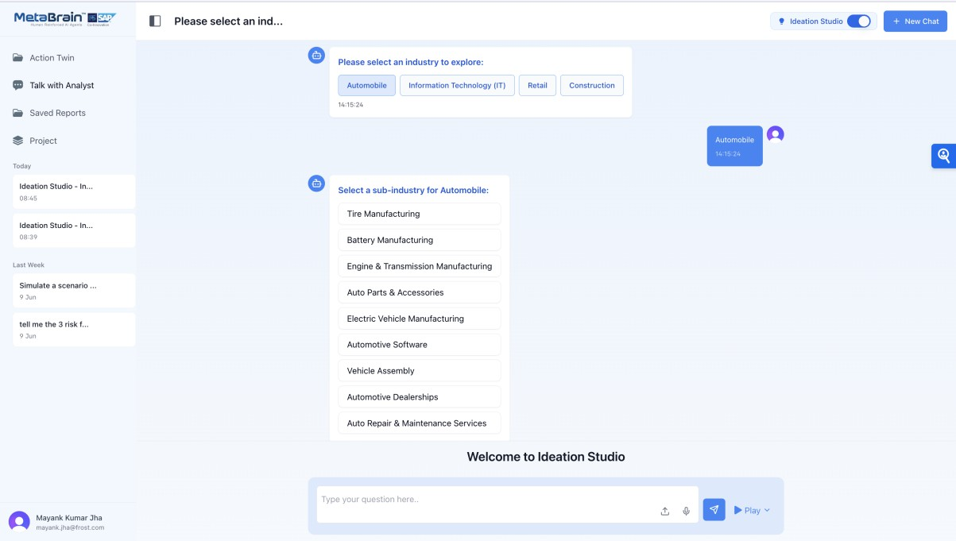

# Step 3: Interpret & Use the Insights

Once the system processes your question:

* + You'll see a **response window** with detailed AI-driven answers
  + It will show **sources used** (SAP, Frost, etc.)
  + You can export the insight in:
    - PDF
    - PowerPoint
    - MP3 audio
    - Video summary

You can also **create Assignments** to follow up on insights and track actions.

**Visual**:

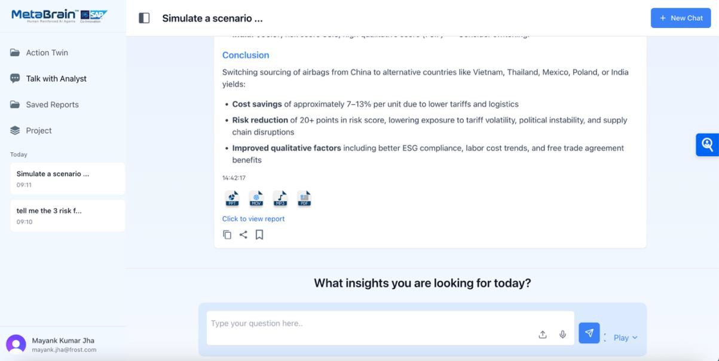

**Export options**

# Step 4: Organize & Collaborate

Use the **Projects** tab to group your conversations and insights.

Track and view **chat history** by date (Today, This Week, Last Month).

Use **Talk with Analyst** to validate findings or co-build a strategy.

**Tip:** Create a new chat thread for each unique use case to stay organized.

**Visual**:

|  |  |
| --- | --- |
|  | |
|  |  |
| **Navigating Platform** | |

**Action Twin:** *Train the model to get more personalised response*

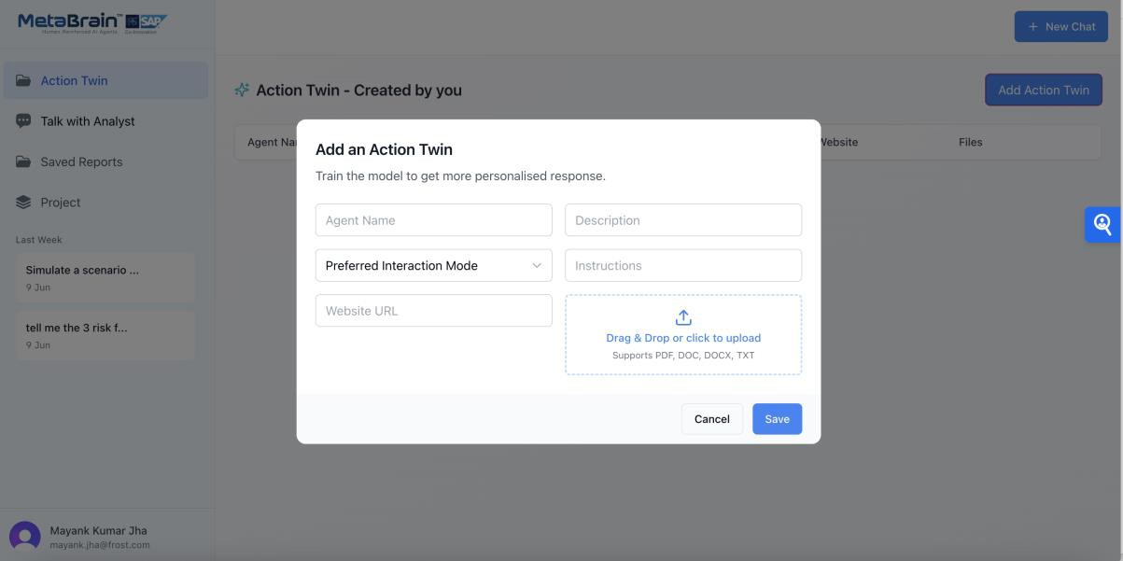

**Project:**

**For Trial version:**

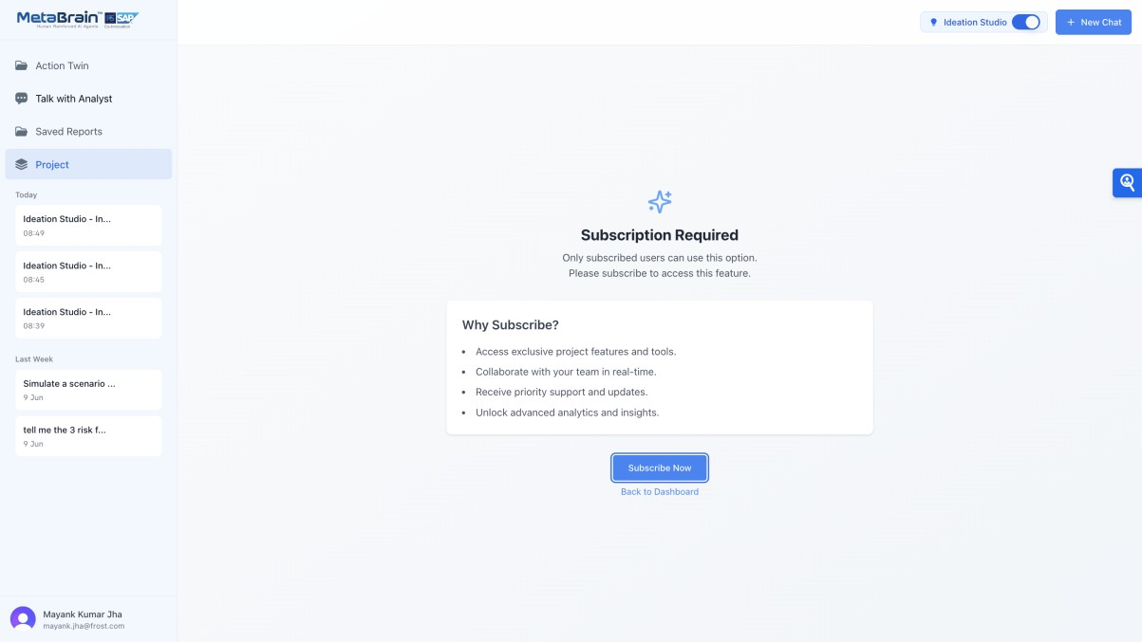

**Talk with Analyst:**

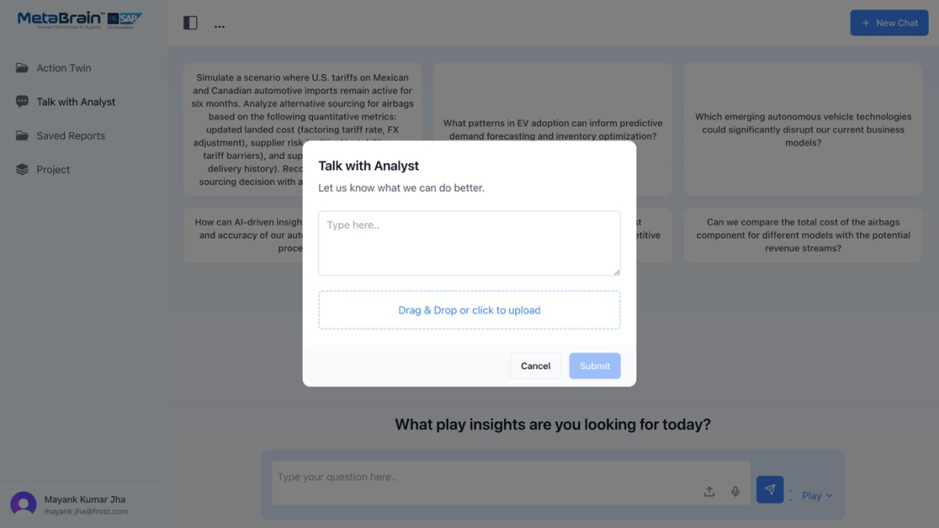

**Saved Reports:**

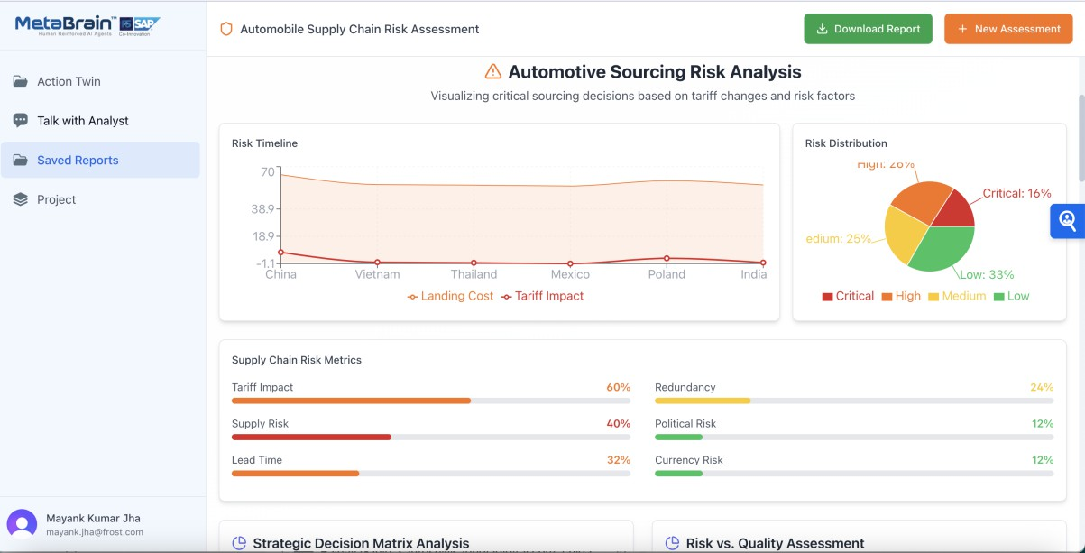

**Generate Dynamic Reports:**

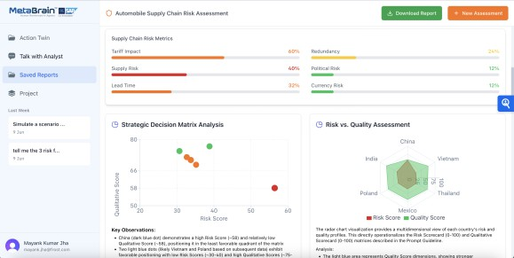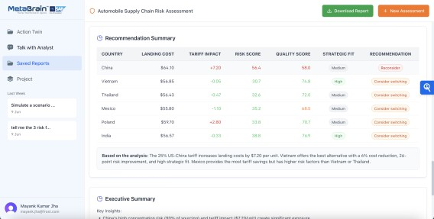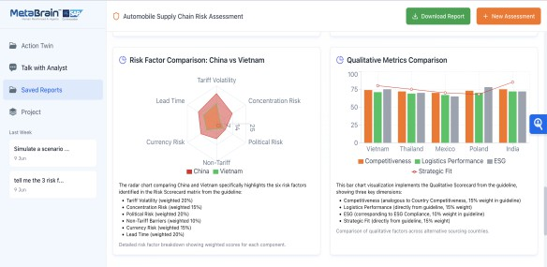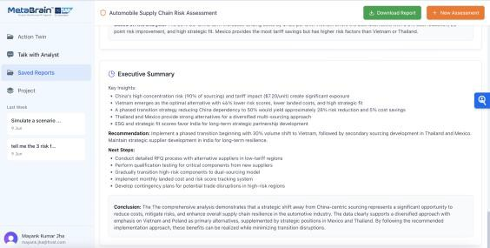

# Step 5: Edition Comparison:

**Feature Availability Summary**

|  |  |  |  |
| --- | --- | --- | --- |
| **Feature** | **Trial** | **Standard** | **Premium** |
| **Project creation** |  |  |  |
| **Save chats & documents** |  |  |  |
| **Collaborative access** |  |  |  |
| **Version tracking** |  |  |  |
| **Analyst co-pilot** |  | Optional |  |
| **Export full archive** |  |  |  |

# Detailed comparison:

|  |  |  |  |
| --- | --- | --- | --- |
| **Feature** | **7-Day Free Trial** | **Standard Edition** | **Premium Edition** |
| **Duration** | 7 days | 12 months  (minimum) | Custom contract |
| **User Access** | Up to 50 enterprise users | Up to 50 enterprise users | Unlimited enterprise users |
| **Industry Scope** | 1 Industry  2 Sub-industries  2 Strategic Imperatives | Same as trial | Fully customizable (industries, sub- industries, imperatives) |
| **Prompt Library** | 200 curated prompts | 200 curated prompts | Unlimited prompts + custom ontologies |
| **Data Integration** | Sandbox access with SAP BTP datasets | Sandbox + pre- connected APIs | Full SAP S/4HANA, IBP,  Joule, and BTP integration |
| **Customization** | Fixed datasets, no custom API training | Optional: live analyst sessions ($200/hr) | Fully custom-trained API calls, logic layers, dashboards |
| **Support** | Email-based FAQ, onboarding video | Email support + onboarding walkthrough | 24×7 support + 40 hours analyst time/month |
| **Decision Cockpit Access** | No | Limited view | Full cockpit with role- based dashboards, alerting |
| **Report Export** | Yes (PDF, PPT,  MP3, Video) | Yes | Yes, with collaborative annotations |
| **Compliance Readiness** | SAP BTP compliant | SAP IBP, Joule- ready | ISO, SOC 2, GDPR,  DLM-compliant |
| **Pricing** | Free | Starting at USD  9,999/month + setup fee | Price upon request |

**Do’s & Don’ts for a Smooth Experience:**

|  |  |
| --- | --- |
| **Do** | **Don’t** |
| **Ask domain-specific questions like**  **“Battery supplier geo-risk”** | Avoid vague prompts like “tell me something about the market” |
| **Upload relevant documents for better grounding** | Don’t skip project folders—it helps track insights easily |
| **Use Play mode for SAP-integrated scenarios** | Don’t run multiple tabs simultaneously |
| **Bookmark insights and share via report links** | Don’t forget to tag your projects for easy  retrieval |

# Support and Resources

**Ambassador Support:**

During the trial period, leverage the support of a MetaBrain ambassador who can assist with:

* Defining use cases.
* Coordinating with analysts and SAP experts.
* Guiding onboarding for cross-functional users.
* Monitoring insight quality and engagement.

# Need Help?

Your **MetaBrain Ambassador** will:

* Help you set up high-impact use cases
* Arrange onboarding or demo calls
* Guide you in collaborating with our analysts

□ **Contact:** [support@metafrost.ai](mailto:support@metafrost.ai)

● **Learn More:** [https://metafrost.ai](https://metafrost.ai/)

**Upgrade the Plan (SAP Store):** <https://store.sap.com/dcp/en/product/display-2002002392_live_v1>