Python – The Programming Language of the future

History of Python

- Python was developed by Guido van Rossum in the late eighties and early nineties at the National Research Institute for Mathematics and Computer Science in the Netherlands.

- Python is derived from many other languages, including ABC, Modula-3, C, C++, Algol-68, SmallTalk, Unix shell, and other scripting languages.

- Python is copyrighted. Like Perl, Python source code is now available under the GNU General Public License (GPL).

- Python is now maintained by a core development team at the institute, although Guido van Rossum still holds a vital role in directing its progress.

Features of Python

- Simple - Python is a simple and minimalistic language. Reading a good Python program feels almost like reading English, although very strict English! This pseudo-code nature of Python is one of its greatest strengths. It allows you to concentrate on the solution to the problem rather than the language itself.

- Easy to Learn - Python has an extraordinarily simple syntax, as already mentioned.

- Free and Open Source - Python is an example of a FLOSS (Free/Libré and Open Source Software). In simple terms, you can freely distribute copies of this software, read its source code, make changes to it, and use pieces of it in new free programs

- High-level Language - When you write programs in Python, you never need to bother about the low-level details such as managing the memory used by your program, etc.

- Portable - Due to its open-source nature, Python has been ported to (i.e. changed to make it work on) many platforms. All your Python programs can work on any of these platforms without requiring any changes at all.

- Interpreted - You just run the program directly from the source code. Internally, Python converts the source code into an intermediate form called byte codes and then translates this into the native language of your computer and then runs it. . This also makes your Python programs much more portable, since you can just copy your Python program onto another computer and it just works!

- Object Oriented- Python supports procedure-oriented programming as well as object-oriented programming. Python has a very powerful but simplistic way of doing OOP, especially when compared to big languages like C++ or Java.

- Extensible - If you need a critical piece of code to run very fast or want to have some piece of algorithm not to be open, you can code that part of your program in C or C++ and then use it from your Python program.

- Embeddable - You can embed Python within your C/C++ programs to give scripting capabilities for your program’s users.

- Extensive Libraries - The Python Standard Library is huge indeed. It can help you do various things involving regular expressions, documentation generation, unit testing, threading, databases, web browsers, CGI, FTP, email, XML, XML-RPC, HTML, WAV files, cryptography, GUI (graphical user interfaces), and other system-dependent stuff.

First Python Program

Different Modes of execution:
- Interactive Mode:
Invoking the interpreter brings up the following prompt
Python 2.7.11 (v2.7.11:6d1b6a68f775, Dec 5 2015, 20:40:30) [MSC v.1500 64 bit (AMD64)] on win32
Type "copyright", "credits" or "license()" for more information.
>>>

Type the text at the Python prompt and press the Enter:
>>> print "Hello, Python!";

If you are Python version 2.7, this produces the following result:
Hello, Python!

- Script Mode:

- Invoking the interpreter with a script parameter begins execution of the script and continues until the script is finished. When the script is finished, the interpreter is no longer active.

- Let us write a simple Python program in a script. Python files have extension .py. Type the following source code in a test.py file

Now, try to run this program as follows:
python test.py

This produces the following result:

Hello, Python!

Python Identifiers

- A Python identifier is a name used to identify a variable, function, class, module, or other object.

- An identifier starts with a letter A to Z or a to z, or an underscore (_) followed by zero or more letters, underscores and digits (0 to 9).

- Python does not allow punctuation characters such as @, $, and % within identifiers. Python is a case sensitive programming language.

Here are naming conventions for Python identifiers:

- Class names start with an uppercase letter. All other identifiers start with a lowercase letter.

- Starting an identifier with a single leading underscore indicates that the identifier is private.

- Starting an identifier with two leading underscores indicates a strongly private identifier.

- If the identifier also ends with two trailing underscores, the identifier is a language-defined special name.

Python Keywords

The following list shows the Python keywords. These are reserved words and you cannot use them as constant or variable or any other identifier names. All the Python keywords contain lowercase letters only.
assert | finally | or
break | for | pass
class | from | print
continue | global | raise
def | if | return
del | import | try
elif | in | while
else | is | with
except | lambda | yield

Lines and Indentation

- Python provides no braces to indicate blocks of code for class and function definitions or flow control. Blocks of code are denoted by line indentation, which is rigidly enforced.

- The number of spaces in the indentation is variable, but all statements within the block must be indented the same amount.

For example:
if True:

print "True"

else:

print "False"

However, the following block generates an error:

if True:

print "Answer"
print "True"
else:
print "Answer"

print "False"

Multi-Line Statements

Statements in Python typically end with a new line. Python does, however, allow the use of the line continuation character (\) to denote that the line should continue.

For example:

total = item_one + \
item_two + \
item_three

Statements contained within the [], {}, or () brackets do not need to use the line continuation character.

For example:

days = ['Monday', 'Tuesday', 'Wednesday',

'Thursday', 'Friday']

days = ['Monday', 'Tuesday', 'Wednesday',

Quotation in Python

Python accepts single ('), double (") and triple (''' or """) quotes to denote string literals, as long as the same type of quote starts and ends the string.

The triple quotes are used to span the string across multiple lines.

For example, all the following are legal:

word = 'word'
sentence = "This is a sentence."
paragraph = """This is a paragraph. It is
made up of multiple lines and sentences."""

Comments in Python

A hash sign (#) that is not inside a string literal begins a comment. All characters after the # and up to the end of the physical line are part of the comment and the Python interpreter ignores them.

# First comment

print "Hello, Python!"; # second comment

You can type a comment on the same line after a statement or expression:

name = "India" # This is again comment

You can comment multiple lines as follows:

# This is a comment.
# This is a comment, too.
# This is a comment, too.
# I said that already.

Using Blank Lines

A line containing only whitespace, possibly with a comment, is known as a blank line and Python totally ignores it.
In an interactive interpreter session, you must enter an empty physical line to terminate a multiline statement.

Multiple Statements on a Single Line

The semicolon ( ; ) allows multiple statements on the single line given that neither statement starts a new code block. Here is a sample snip using the semicolon:

Multiple Statement Groups as Suites

A group of individual statements, which make a single code block are called suites in Python. Compound or complex statements, such as if, while, def, and class require a header line and a suite.

Header lines begin the statement (with the keyword) and terminate with a colon ( : ) and are followed by one or more lines which make up the suite.

For example:

if expression :
suite

elif expression :
suite
else :

suite

4. VARIABLE TYPES

Variables are nothing but reserved memory locations to store values. This means when you create a variable, you reserve some space in memory.

Based on the data type of a variable, the interpreter allocates memory and decides what can be stored in the reserved memory. Therefore, by assigning different data types to variables, you can store integers, decimals, or characters in these variables.

Assigning Values to Variables

Python variables do not need explicit declaration to reserve memory space. The declaration happens automatically when you assign a value to a variable. The equal sign (=) is used to assign values to variables.

The operand to the left of the = operator is the name of the variable and the operand to the right of the = operator is the value stored in the variable.

For example:

counter = 100 # An integer assignment
miles = 1000.0 # A floating point
name = "John" # A string
print counter
print miles
print name

Here, 100, 1000.0, and "John" are the values assigned to counter, miles, and name variables respectively. This produces the following result:

100
1000.0
John

Multiple Assignment

Python allows you to assign a single value to several variables simultaneously.

For example:
a = b = c = 1

Here, an integer object is created with the value 1, and all three variables are assigned to the same memory location.

You can also assign multiple objects to multiple variables.

For example:
a, b, c = 1, 2, "john"

Here, two integer objects with values 1 and 2 are assigned to variables a and b respectively, and one string object with the value "john" is assigned to the variable c.

Standard Data Types

The data stored in memory can be of many types. For example, a person's age is stored as a numeric value and his or her address is stored as alphanumeric characters.

Python has various standard data types that are used to define the operations possible on them and the storage method for each of them.

Python has five standard data types:

- Numbers
- String
- List
- Tuple
- Dictionary

Python Numbers

Number data types store numeric values. Number objects are created when you assign a value to them.

For example:

var1 = 1
var2 = 10

You can also delete the reference to a number object by using the del statement. The syntax of the del statement is:

del var1[,var2[,var3[....,varN]]]]

You can delete a single object or multiple objects by using the del statement.

For example:

del var
del var_a, var_b

Python supports four different numerical types:

- int (signed integers)
- long (long integers, they can also be represented in octal and hexadecimal)
- float (floating point real values)
- complex (complex numbers)

Examples :

Here are some examples of numbers:

int | long | float | complex
10 | 51924361L | 0.0 | 3.14j
100 | -0x19323L | 15.20 | 45.j
-786 | 0122L | -21.9 | 9.322e-36j
080 | 0xDEFABCECBDAECBFBAEl | 32.3+e18 | .876j
-0490 | 535633629843L | -90. | -.6545+0J
-0x260 | -052318172735L | -32.54e100 | 3e+26J
- Python allows you to use a lowercase l with long, but it is recommended that you use only an uppercase L to avoid confusion with the number 1. Python displays long integers with an uppercase L.

- A complex number consists of an ordered pair of real floating-point numbers denoted by x + yj, where x is the real part and y is the imaginary part of the complex number.

Python Strings

- Strings in Python are identified as a contiguous set of characters represented in the quotation marks. Python allows for either pairs of single or double quotes.

- Subsets of strings can be taken using the slice operator ([ ] and [:] ) with indexes starting at 0 in the beginning of the string and working their way from -1 at the end.

- The plus (+) sign is the string concatenation operator and the asterisk (*) is the repetition operator.

For example:

str = 'Hello World!'
print str # Prints complete string
print str[0] # Prints first character of the string
print str[2:5] # Prints characters starting from 3rd to 5th
print str[2:] # Prints string starting from 3rd character
print str * 2 # Prints string two times
print str + "TEST" # Prints concatenated string

This will produce the following result:

Hello World!
H
llo
llo World!
Hello World!Hello World!
Hello World!TEST

Python Lists

- Lists are the most versatile of Python's compound data types. A list contains items separated by commas and enclosed within square brackets ([]).

- To some extent, lists are similar to arrays in C. One difference between them is that all the items belonging to a list can be of different data type.

- The values stored in a list can be accessed using the slice operator ([ ] and [:]) with indexes starting at 0 in the beginning of the list and working their way to end -1.

- The plus (+) sign is the list concatenation operator, and the asterisk (*) is the repetition operator.

For example:

list = [ 'abcd', 786 , 2.23, 'john', 70.2 ]
tinylist = [123, 'john']
print list # Prints complete list
print list[0] # Prints first element of the list
print list[1:3] # Prints elements starting from 2nd till 3rd
print list[2:] # Prints elements starting from 3rd element
print tinylist * 2 # Prints list two times
print list + tinylist # Prints concatenated lists
This produces the following result:

['abcd', 786, 2.23, 'john', 70.200000000000003]
abcd
[786, 2.23]
[2.23, 'john', 70.200000000000003]
[123, 'john', 123, 'john']
['abcd', 786, 2.23, 'john', 70.200000000000003, 123, 'john']

Python Tuples

A tuple is another sequence data type that is similar to the list. A tuple consists of a number of values separated by commas. Unlike lists, however, tuples are enclosed within parentheses.

The main differences between lists and tuples are: Lists are enclosed in brackets ( [ ] ) and their elements and size can be changed, while tuples are enclosed in parentheses ( ( ) ) and cannot be updated. Tuples can be thought of as read-only lists.

For example:

tuple = ( 'abcd', 786 , 2.23, 'john', 70.2 )
tinytuple = (123, 'john')
print tuple # Prints complete tuple
print tuple[0] # Prints first element of the tuple
print tuple[1:3] # Prints elements starting from 2nd till 3rd
print tuple[2:] # Prints elements starting from 3rd element
print tinytuple * 2 # Prints tuple two times
print tuple + tinytuple # Prints concatenated tuples

This produces the following result:

('abcd', 786, 2.23, 'john', 70.200000000000003)
abcd
(786, 2.23)
(2.23, 'john', 70.200000000000003)
(123, 'john', 123, 'john')
('abcd', 786, 2.23, 'john', 70.200000000000003, 123, 'john')

The following code is invalid with tuple, because we attempted to update a tuple, which is not allowed. Similar case is possible with lists:

tuple = ( 'abcd', 786 , 2.23, 'john', 70.2 )
list = [ 'abcd', 786 , 2.23, 'john', 70.2 ]
tuple[2] = 1000 # Invalid syntax with tuple
list[2] = 1000 # Valid syntax with list

Python Dictionary

- Python's dictionaries are kind of hash table type. They work like associative arrays or hashes found in Perl and consist of key-value pairs.

- A dictionary key can be almost any Python type, but are usually numbers or strings. Values, on the other hand, can be any arbitrary Python object.

- Dictionaries are enclosed by curly braces ({ }) and values can be assigned and accessed using square braces ([]).

For example:

dict = {}
dict['one'] = "This is one"
dict[2] = "This is two"
tinydict = {'name': 'john','code':6734, 'dept': 'sales'}
print dict['one'] # Prints value for 'one' key
print dict[2] # Prints value for 2 key
print tinydict # Prints complete dictionary
print tinydict.keys() # Prints all the keys
print tinydict.values() # Prints all the values

This produces the following result:

This is one
This is two
{'dept': 'sales', 'code': 6734, 'name': 'john'}
['dept', 'code', 'name']
['sales', 6734, 'john']

- Dictionaries have no concept of order among elements. It is incorrect to say that the elements are "out of order"; they are simply unordered.

Data Type Conversion

- Sometimes, you may need to perform conversions between the built-in types. To convert between types, you simply use the type name as a function.

- There are several built-in functions to perform conversion from one data type to another. These functions return a new object representing the converted value

Function | Description
int(x [,base]) | Converts x to an integer. base specifies the base if x is a string.
long(x [,base] ) | Converts x to a long integer. base specifies the base if x is a string.
float(x) | Converts x to a floating-point number.
complex(real [,imag]) | Creates a complex number.
str(x) | Converts object x to a string representation.
repr(x) | Converts object x to an expression string.
eval(str) | Evaluates a string and returns an object.
tuple(s) | Converts s to a tuple.
list(s) | Converts s to a list.
set(s) | Converts s to a set.
dict(d) | Creates a dictionary. d must be a sequence of (key,value) tuples.
frozenset(s) | Converts s to a frozen set.
chr(x) | Converts an integer to a character.
unichr(x) | Converts an integer to a Unicode character.
ord(x) | Converts a single character to its integer value.
hex(x) | Converts an integer to a hexadecimal string.
oct(x) | Converts an integer to an octal string.

You also can write the repr(x) function using backquotes as ´x´. Note that the str() and repr() functions may return different results. repr() typically creates an expression string that can be evaluated with eval() to re-create the object. On the other hand, str() produces a concise or nicely formatted representation of the object (and is used by the print statement). The ord() function returns the integer ordinal value for a standard or Unicode character. The chr() and unichr() functions convert integers back into standard or Unicode characters, respectively.
To convert strings back into numbers and other objects, use the int(), long(), and float() functions. The eval() function can also convert a string containing a valid expression to an object. Here's an example:
a = int("34") # a = 34
b = long("0xfe76214", 16) # b = 266822164L (0xfe76214L)
b = float("3.1415926") # b = 3.1415926
c = eval("3, 5, 6") # c = (3,5,6)
In functions that create containers (list(), tuple()h, set(), and so on), the argument may be any object that supports iteration.

5. BASIC OPERATORS

Types of Operators

Python language supports the following types of operators.

- Arithmetic Operators
- Comparison (Relational) Operators
- Assignment Operators
- Logical Operators
- Bitwise Operators
- Membership Operators
- Identity Operators

Let us have a look on all operators one by one.

Python Arithmetic Operators

Assume variable a holds 10 and variable b holds 20, then:

Operator | Description | Example
+ Addition | Adds values on either side of the operator. | a + b = 30
- Subtraction | Subtracts right hand operand from left hand operand. | a – b = -10
* Multiplication | Multiplies values on either side of the operator | a * b = 200
Division | Divides left hand operand by right hand operand | b / a = 2
% Modulus | Divides left hand operand by right hand operand and returns remainder | b % a = 0
** Exponent | Performs exponential (power) calculation on operators | a**b =10 to the power 20
// | Floor Division - The division of operands where the result is the quotient in which the digits after the decimal point are removed. | 9//2 = 4 and 9.0//2.0 = 4.0

Python Comparison Operators

These operators compare the values on either sides of them and decide the relation among them. They are also called Relational operators.

Assume variable a holds 10 and variable b holds 20, then:

Operator | Description | Example

== | If the values of two operands are equal, then the condition becomes true. | (a == b) is not true.
!= | If values of two operands are not equal, then condition becomes true. | (a != b) is true.
<> | If values of two operands are not equal, then condition becomes true. | (a <> b) is true. This is similar to != operator.
> | If the value of left operand is greater than the value of right operand, then condition becomes true. | (a > b) is not true.
< | If the value of left operand is less than the value of right operand, then condition becomes true. | (a < b) is true.
>= | If the value of left operand is greater than or equal to the value of right operand, then condition becomes true. | (a >= b) is not true.
<= | If the value of left operand is less than or equal to the value of right operand, then condition becomes true. | (a <= b) is true.

Python Assignment Operators

Assume variable a holds 10 and variable b holds 20, then:

Operator | Description | Example
= | Assigns values from right side operands to left side operand | c = a + b assigns value of a + b into c
+=  Add AND | It adds right operand to the left operand and assign the result to left operand | c += a is equivalent to c = c + a
-=  Subtract AND | It subtracts right operand from the left operand and assign the result to left operand | c -= a is equivalent to c = c - a
*=  Multiply AND | It multiplies right operand with the left operand and assign the result to left operand | c *= a is equivalent to c = c * a
/=  Divide AND | It divides left operand with the right operand and assign the result to left operand | c /= a is equivalent to c = c / a
%=  Modulus AND | It takes modulus using two operands and assign the result to left operand | c %= a is equivalent to c = c % a
**=  Exponent AND | Performs exponential (power) calculation on operators and assign value to the left operand | c **= a is equivalent to c = c ** a
//=  Floor Division | It performs floor division on operators and assign value to the left operand | c //= a is equivalent to c = c // a

Python Bitwise Operators

Bitwise operator works on bits and performs bit by bit operation. Assume if a = 60; and b = 13; Now in binary format they will be as follows:

a = 0011 1100
b = 0000 1101
-----------------

a&b = 0000 1100

a|b = 0011 1101

a^b = 0011 0001

~a = 1100 0011

There are following Bitwise operators supported by Python language

Operator | Description | Example
&  Binary AND | Operator copies a bit to the result if it exists in both operands. | (a & b) = 12  (means 0000 1100)
| Binary OR | It copies a bit if it exists in either operand. | (a | b) = 61  (means 0011 1101)
^ Binary XOR | It copies the bit if it is set in one operand but not both. | (a ^ b) = 49 (means 0011 0001)
~  Binary  Ones Complement | It is unary and has the effect of 'flipping' bits. | (~a ) = -61 (means 1100 0011 in 2's complement form due to a signed binary number.
<<  Binary Left Shift | The left operands value is moved left by the number of bits specified by the right operand. | a << 2 = 240  (means 1111 0000)

>>  Binary Right Shift | The left operands value is moved right by the number of bits specified by the right operand. | a >> 2 = 15  (means 0000 1111)

Python Logical Operators
Following are the logical operators supported by Python language. Assume variable a holds 10 and variable b holds 20 then:

Operator | Description | Example
and  Logical AND | If both the operands are true then condition becomes true. | (a and b) is true.
or  Logical OR | If any of the two operands are non-zero then condition becomes true. | (a or b) is true.
not  Logical NOT | Used to reverse the logical state of its operand. | Not (a and b) is false.
Python Membership Operators

Python’s membership operators test for membership in a sequence, such as strings, lists, or tuples. There are two membership operators as explained below:

Operator | Description | Example
in | Evaluates to true if it finds a variable in the specified sequence and false otherwise. | x in y, here in results in a 1 if x is a member of sequence y.
not in | Evaluates to true if it does not finds a variable in the specified sequence and false otherwise. | x not in y, here not in results in a 1 if x is not a member of sequence y.
Python Identity Operators

Identity operators compare the memory locations of two objects. There are two Identity operators as explained below:

Operator | Description | Example
is | Evaluates to true if the variables on either side of the operator point to the same object and false otherwise. | x is y, here is results in 1 if id(x) equals id(y).
is not | Evaluates to false if the variables on either side of the operator point to the same object and true otherwise. | x is not y, here is not results in 1 if id(x) is not equal to id(y).

Python Operators Precedence

The following table lists all operators from highest precedence to lowest.

Operator | Description
** | Exponentiation (raise to the power)
~ + - | complement, unary plus and minus (method names for the last two are +@ and -@)
* / % // | Multiply, divide, modulo and floor division
+ - | Addition and subtraction
>> << | Right and left bitwise shift
& | Bitwise 'AND'
^ | | Bitwise exclusive `OR' and regular `OR'
<= < > >= | Comparison operators
<> == != | Equality operators
= %= /= //= -= += *= **= | Assignment operators
is is not | Identity operators
in not in | Membership operators
not or and | Logical operators

Operator precedence affects how an expression is evaluated.

6. Input and Output

print(value, ..., sep=' ', end='\n', file=sys.stdout)

Prints the values to a stream, or to sys.stdout by default.
Optional keyword arguments:
file: a file-like object (stream); defaults to the current sys.stdout.
sep: string inserted between values, default a space.
end: string appended after the last value, default a newline.

Examples:

- Print “ Hello, world”

you simply put the formatted variables in the string, and then a % (percent) character, followed by the variable. The only catch is that if you want multiple formats in your string to print multiple variables, you need to put them inside ( ) (parentheses) separated by , (commas).

Basic formatting
Simple positional formatting is probably the most common use-case. Use it if the order of your arguments is not likely to change and you only have very few elements you want to concatenate.
Since the elements are not represented by something as descriptive as a name this simple style should only be used to format a relatively small number of elements.

Old Format:
print “My name is %s. I am %d years old” %(“Kumar ”,25)
New Format:
print( “My name is{0}. I am {1} years old”.format(“Kumar ”,25))
print( “My name is{}. I am {} years old”.format(“Kumar ”,25))

Padding and aligning strings
By default values are formatted to take up only as many characters as needed to represent the content. It is however also possible to define that a value should be padded to a specific length.
Unfortunately the default alignment differs between old and new style formatting. The old style defaults to right aligned while for new style it's left.

Align right:
Old:
Print “%s10s” %(“Test”)
New:

Print(“{:>10}”..format('”Test”))

Align left:
Old:
Print “%-10s” % (“Test”)

New:

Print(“{:10}”.format(“Test”))

Again, new style formatting surpasses the old variant by providing more control over how values are padded and aligned.
You are able to choose the padding character:
This operation is not available with old-style formatting.
New:
Print (“{:_<10}”..format(“Test”'))

And also center align values:
This operation is not available with old-style formatting.
New:
Print (“{:^10}”.format(“Test”))

When using center alignment where the length of the string leads to an uneven split of the padding characters the extra character will be placed on the right side:
This operation is not available with old-style formatting.
New:
Print(“{:^6}”.format(“zip”))

Truncating long strings
Inverse to padding it is also possible to truncate overly long values to a specific number of characters.
The number behind a . in the format specifies the precision of the output. For strings that means that the output is truncated to the specified length. In our example this would be 5 characters.

Old
Print “%.5s” %(“xylophone”)

New
Print(“{:.5}”.format(“xylophone”)

Output
xylop

Combining truncating and padding
It is also possible to combine truncating and padding:

Old
Print “'%-10.5s” % (“xylophone”)

New
Print (“{:10.5}”.format(“xylophone”))

Output
xylop

Numbers
Of course it is also possible to format numbers.
Integers:

Old

Print “%d” % (42)

New
Print (“{:d}'.format(42))

Output
42

Floats:

Old
Print “%f” % (3.141592653589793)

New
Print(“{:f}”.format(3.141592653589793))

Output
3.141593

Padding numbers
Similar to strings numbers can also be constrained to a specific width.

Old

Print “%4d” % (42)

New

Print(”{:4d}”.format(42))

Output
42

Again similar to truncating strings the precision for floating point numbers limits the number of positions after the decimal point.
For floating points the padding value represents the length of the complete output. In the example below we want our output to have at least 6 characters with 2 after the decimal point.

Old

Print “%06.2f” %(3.141592653589793)

New

Print (“{:06.2f}”.format(3.141592653589793))

Output
003.14

For integer values providing a precision doesn't make much sense and is actually forbidden in the new style (it will result in a ValueError).

Old
Print “%04d” % (42)

New
Print(“{:04d}”.format(42))

Output
0042

Signed numbers
By default only negative numbers are prefixed with a sign. This can be changed of course.

Old
Print “%+d” %(42,)

New
Print(“{:+d}”.format(42))

Output
+42

Use a space character to indicate that negative numbers should be prefixed with a minus symbol and a leading space should be used for positive ones.

Old
Print “% d” % ((- 23))

New
Print(“{: d}”.format((- 23)))

Output
-23

Old
'% d' % (42,)

New
'{: d}'.format(42)

Output
42

New style formatting is also able to control the position of the sign symbol relative to the padding.
This operation is not available with old-style formatting.

New
Print (“{:=5d}”.format((- 23)))

Output
- 23

New
Print(“{:=+5d}”.format(23))

Output
+ 23

There will be situations where your program has to interact with the user. For example, you would want to take input from the user and then print some results back. We can achieve this using the raw_input() function and print statement respectively

raw_input([prompt])
If the prompt argument is present, it is written to standard output without a trailing newline.
The function then reads a line from input, converts it to a string (stripping a trailing newline), and returns that.
When EOF is read, EOFError is raised.
Example:
>>>
name=raw_input(“What’s your name?”)
print “My name is %s “ %name

Output
What’s your name?Kumar
My name is Kumar

If the input contains numbers, and you want them as numbers use appropriate data converters.

For example

a=int(raw_input(“Enter your age:”))
print “Your age is %d” %a

Output
Enter your age:25
Your age is 25

radius=float(raw_input(“Enter radius:”))
area=3.142*radius**2
print “Area of Circle is %f” %area

Output
Enter radius:10.5
Area of circle is 346.405500

input([prompt])
If the prompt argument is present, it is written to standard output without a trailing newline. The function then reads a line from input, converts it to a string (stripping a trailing newline), and returns that. When EOF is read, EOFError is raised.
Example:
Name=input(“What’s your name?”)
Print(“Good morning, {0}”.format(name))

Output
What's your name?'Jayasankar'
Good morning, Jayasankar
Note: The string has to be enclosed in single quotes.

Example 02.
Age=int(input(“Enter your age:”))
Print(“You are {0} years old.”.format(age))
Enter your age:25
Your are 25 years old.

Reading Multiple input using raw_input()
The general format to read many inputs is
var1, var2 = raw_input("Enter two numbers here: ").split()

Later the data can be converted into specific type using conversion operators.

Example:

length,breadth=raw_input("Enter length & breadth:").split()
length=float(length)
breadth=float(breadth)
area=length*breadth
print ("Area of rectangle is {0}".format(area))

Output
Enter length & breadth:10.5 12.5
Area of rectangle is 131.25

The previous program can be re-written as
length, breadth=map(float, raw_input("Enter length & breadth:").split())
area=length*breadth
print ("Area of rectangle is {0}".format(area))

Output
Enter length & breadth:10.5 12.5
Area of rectangle is 131.25

Note: The map function applies the conversion operation to each input item. The input items are converted to float type of values.

We can do the operations using the input function.

# Program to find the area of rectangle using input()
values=input("Enter length & breadth:")
length,breadth=map(float,values.split(' '))
area=length*breadth
print("Area of rectangle is {}".format(area))

Output
Enter length & breadth:'10.5 12.5'
Area of rectangle is 131.25

Decision Making

- In the programs we have seen till now, there has always been a series of statements executed by Python in exact top-down order. However, in serious programming situations, seldom do we want the instructions to be executed sequentially.

- Many a times, we want a set of instructions to be executed in one situation, and an entirely different set of instructions to be executed in another situation.

- This kind of situation is dealt in Python programs using a decision control instruction. As mentioned earlier, a decision control instruction

Decision structures evaluate multiple expressions which produce TRUE or FALSE as outcome. You need to determine which action to take and which statements to execute if outcome is TRUE or FALSE otherwise.

- Following is the general form of a typical decision making structure found in most of the programming languages:

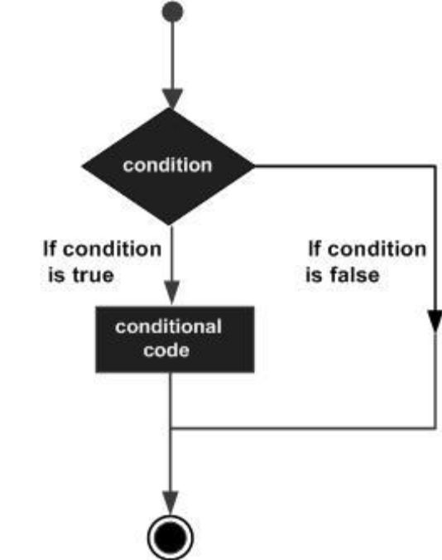
Python programming language assumes any non-zero and non-null values as TRUE, and if it is either zero or null, then it is assumed as FALSE value.

Python programming language provides following types of decision making statements. Click the following links to check their detail.

Statement | Description
if statements | if statement consists of a boolean expression followed by one or more statements.
if...else statements | if statement can be followed by an optional else statement, which executes when the boolean expression is FALSE.
nested if statements | You can use one if or else if statement inside another if or else if statement(s).

If Statement

Syntax

if expression:
statement(s)

If the Boolean expression evaluates to TRUE, then the block of statement(s) inside the if statement is executed. If Boolean expression evaluates to FALSE, then the first set of code after the end of the if statement(s) is executed.

Flow Diagram

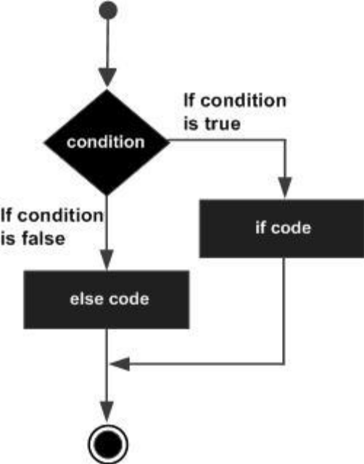
Examples:
# Program to check whether a number is even
n=int(raw_input("Enter a number:"))
if n%2==0:
print "%d is even " %(n)

print "The end"

Output
Enter a number:11
The end

Enter a number:10
10 is even
The end
#Program to test whether a number is -ve
n=(int(raw_input("Enter an integer:")))
if n<0:
print "%d is negative" %(n)
print "The End"

Output
Enter an integer:10
The End

Enter an integer:-12
-12 is negative
The End

If…else Statement

An else statement can be combined with an if statement. An else statement contains the block of code that executes if the conditional expression in the if statement is 0 or FALSE .

The else statement is an optional statement and there could be at most only one else statement following if.

Syntax

The syntax of the if...else statement is:

if expression:
Statement(s)
else:
Statement(s)

Examples:

#Program to test whether a number is odd or even
n=(int(raw_input("Enter a number:")))
if n%2==0:
print "%d is even" %(n)
else :
print "%d is odd" %(n)
print "The End"

Output
Enter a number:10
10 is even
The End
Enter a number:11
11 is odd
The End

Flow Diagram

#Program to test whether number is +ve or - ve
n=int(raw_input("Enter a number:"))
if n<0:
print "%d is -ve" %(n)
else:
print "%d is +ve" %(n)
print "The End"

Output
Enter a number:-42
-42 is -ve
The End

Enter a number:25
25 is +ve
The End

The elif Statement

The elif statement allows you to check multiple expressions for TRUE and execute a block of code as soon as one of the conditions evaluates to TRUE.
Similar to the else, the elif statement is optional. However, unlike else, for which there can be at most one statement, there can be an arbitrary number of elif statements following an if.

Syntax

if expression1:
statement(s)

elif expression2:
statement(s)

elif expression3:
statement(s)

else:
statement(s)

Examples:

#Program to demonstrate elif statement
n=int(raw_input("Enter an integer:"))
if( n<0):
print "%d is negative" %(n)
elif(n>0):
print "%d is positive" %(n)
else:
print "number is zero"
print "The End"

Output

Enter an integer:-10
-10 is negative
The End

Enter an integer:25
25 is positive
The End

Enter an integer:0
number is zero
The End

A textile showroom offers discount for the purchases as specified below.

If purchase is less than Rs.1000, there is no discount.
If purchase is above Rs.1000 and less than Rs.5000, discount is 5%
If purchase is above Rs.5000 and less than Rs.10,000, discount is 10%
If purchase is above Rs.10,000, discount is 15%

Given the amount of purchase, calculate the discount and display the amount to be paid by the customer.

Answer:

#Program to calculate the discount
amount=float(raw_input("Enter the amount of purchase:"))
if(amount<1000.0):
discount=0.0
elif(amount>=1000.0 and amount<5000.0):
discount=.05*amount
elif(amount>=5000.0 and amount<10000.0):
discount=0.1*amount
else:
discount=0.15*amount

net_amount=amount-discount
print "Purchase made Rs.%10.2f" %(amount)
print "Discount Rs.%10.2f" %(discount)
print "Please pay Rs.%10.2f" %(net_amount)

Output
Enter the amount of purchase:975.50
Purchase made Rs. 975.50
Discount Rs. 0.00
Please pay Rs. 975.50

Enter the amount of purchase:1500.75
Purchase made Rs. 1500.75
Discount Rs. 75.04
Please pay Rs. 1425.71

Enter the amount of purchase:7000.0
Purchase made Rs. 7000.00
Discount Rs. 700.00
Please pay Rs. 6300.00

Enter the amount of purchase:16000.0
Purchase made Rs. 16000.00
Discount Rs. 2400.00
Please pay Rs. 13600.00

7. LOOPS

Sometimes, it is required to execute a part of the program repeatedly. A part of the program that is executed repeatedly either for a specific number of times or until a specified logical condition is true is called a loop.

The following diagram illustrates a loop statement.

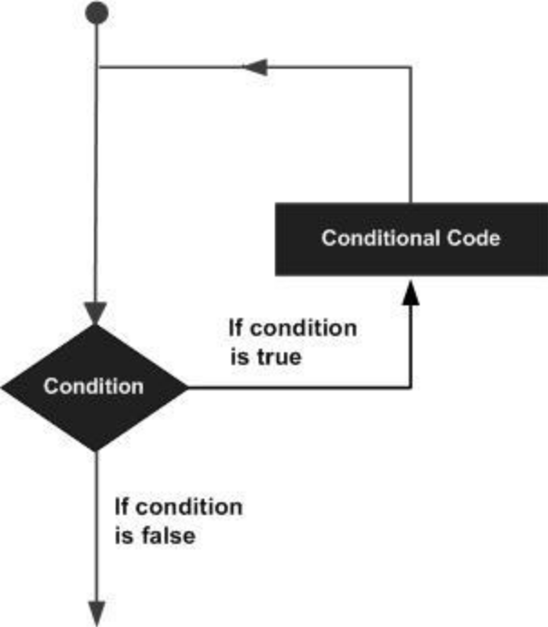

Looping operations in Python language are carried out using the following statements. They are

- While loop
- For loop

While loop

The while statement allows you to repeatedly execute a block of statements as long as a condition is true.

Syntax

The syntax of a while loop in Python programming language is:

while condition:
statement(s)
else:
statement(s)

Flow Diagram

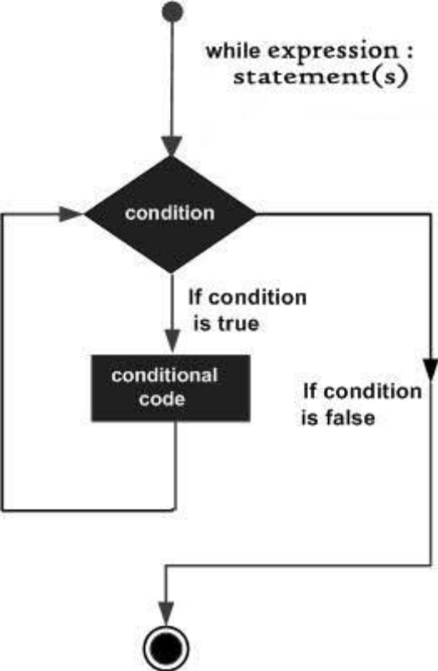

Here, statement(s) may be a single statement or a block of statements. The condition may be any expression, and true is any non-zero value. The loop iterates while the condition is true.

When the condition becomes false, program control passes to the line immediately following the loop.

If the else statement is used with a while loop, the else statement is executed when the condition becomes false.

The Infinite Loop

A loop becomes infinite loop if a condition never becomes FALSE. You must be careful when using while loops because of the possibility that this condition never becomes FALSE. This results in a loop that never ends. Such a loop is called an infinite loop.

An infinite loop might be useful in client/server programming where the server needs to run continuously so that client programs can communicate with it as and when required.

Using else Statement with Loops

Python supports to have an else statement associated with a loop statement.

- If the else statement is used with a for loop, the else statement is executed when the loop has exhausted iterating the list.
- If the else statement is used with a while loop, the else statement is executed when the condition becomes false.

For Loop

Python provides a language mechanism, the for loop,that can be used to simplify programs containing this kind of iteration.

The general form of a for statement is

for variable in sequence:
code block

The variable following for is bound to the first value in the sequence, and the code block is executed. The variable is then assigned the second value in the sequence, and the code block is executed again.

The process continues until the sequence is exhausted or a break statement is executed within the code block.

The sequence of values bound to variable is most commonly generated using the built-in function range, which returns a sequence containing an arithmetic progression. The range function takes three integer arguments: start, stop, and step.

It produces the progression start, start + step, start + 2*step, etc. If step is positive, the last element is the largest integer start + i*step less than stop. If step is negative, the last element is the smallest integer start + i*step greater than stop.

Flow Diagram

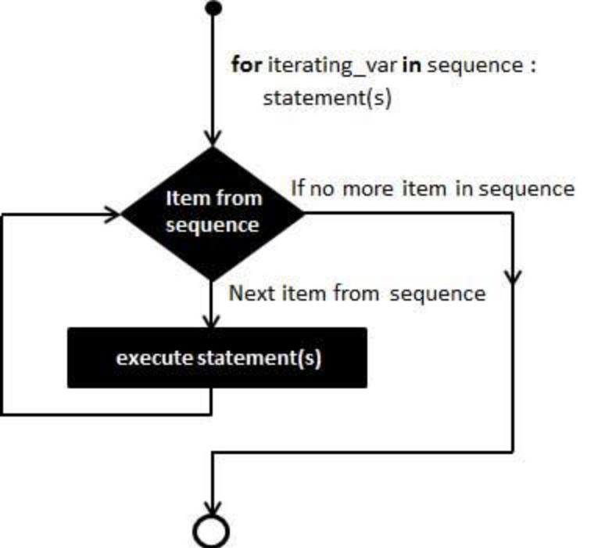

Nested Loops

Python programming language allows to use one loop inside another loop. Following section shows few examples to illustrate the concept.

Syntax

for iterating_var in sequence:
for iterating_var in sequence:
statements(s)
statements(s)

The syntax for a nested while loop statement in Python programming language is as follows:

while expression:
while expression:
statement(s)
statement(s)

A final note on loop nesting is that you can put any type of loop inside of any other type of loop. For example a for loop can be inside a while loop or vice versa.

Iterating over list items:

The following program iterates through list items.

#Program to iterate through list
a=['cat','dog','horse','lion','deer','tiger']
for i in a:
print i
print "The End"

Output:
cat
dog
horse
lion
deer
tiger
The End

Iterating over tuple items:

The following program iterates through tuple items

#Program to iterate through tuple
a=('Jaya',12,123.56)
for i in a:
print i
print "The End"

Output:
Jaya
12
123.56
The End
Iterating over dictionary
To loop all the keys from a dictionary
#Program to iterate through dictionary keys
result ={'RegNo':1234,'Name':'Jayasankar','Branch':'CSE','Result':'Pass'}
for i in result:
print i
print "The End"

Output:
Branch
Name
RegNo
Result
The End

To loop all the values from a dictionary

#Program to iterate through dictionary values
result ={'RegNo':1234,'Name':'Jayasankar','Branch':'CSE','Result':'Pass'}
for i in result.itervalues():
print i
print "The End"

Output:
CSE
Jayasankar
1234
Pass
The End
To loop every key and value from a dictionary
#Program to iterate through dictionary key, value pairs
result ={'RegNo':1234,'Name':'Jayasankar','Branch':'CSE','Result':'Pass'}
for k,v in result.items():
print k,v
print "The End"

Output:
Branch CSE
Name Jayasankar
RegNo 1234
Result Pass
The End
Loop Control Statements

Loop control statements change execution from its normal sequence. When execution leaves a scope, all automatic objects that were created in that scope are destroyed.

Python supports the following control statements.

Break Statement

It terminates the current loop and resumes execution at the next statement, just like the traditional break statement in C.

The most common use for break is when some external condition is triggered requiring a hasty exit from a loop. The break statement can be used in both while and for loops.

If you are using nested loops, the break statement stops the execution of the innermost loop and start executing the next line of code after the block.

Syntax

The syntax for a break statement in Python is as follows:

break

Flow Diagram

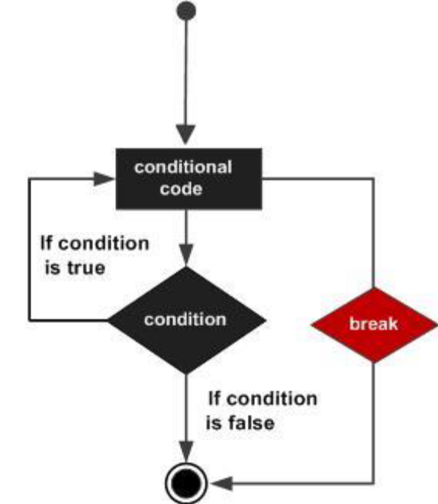

Example:

#Program to check whether a number is prime using for and break
n=int(raw_input("Enter a +ve integer:"))
for i in range(2,n):
if(n%i==0):
print n," is not prime"
break
else:
print n, " is prime"
print "The End"

Output
Enter a +ve integer:50
50 is not prime
The End
Enter a +ve integer:23
23 is prime
The End
Continue Statement

It returns the control to the beginning of the while loop. The continue statement rejects all the remaining statements in the current iteration of the loop and moves the control back to the top of the loop.

The continue statement can be used in both while and for loops.

Syntax
continue

Flow Diagram

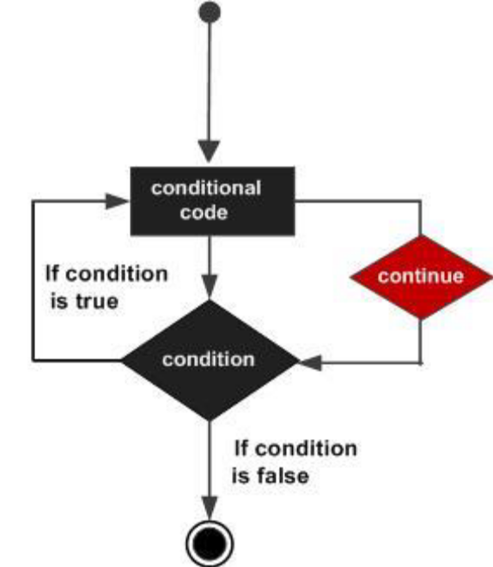
#Program to print only even numbers using continue
for num in range(2, 10+1):
if num % 2 != 0:
continue
print num
print "The End"

Output
2
4
6
8
10
The End

8. NUMBERS

Number data types store numeric values. They are immutable data types, means that changing the value of a number data type results in a newly allocated object.

Number objects are created when you assign a value to them. For example:

Number objects are created when you assign a value to them. For example:

var1 = 1
var2 = 10

You can also delete the reference to a number object by using the del statement.

The syntax of the del statement is:

del var1[,var2[,var3[....,varN]]]]

You can delete a single object or multiple objects by using the del statement.

For example:

del var
del var_a, var_b

Python supports four different numerical types:

- int (signed integers): They are often called just integers or ints, are positive or negative whole numbers with no decimal point.

- long (long integers): Also called longs, they are integers of unlimited size, written like integers and followed by an uppercase or lowercase L.

- float (floating point real values) : Also called floats, they represent real numbers and are written with a decimal point dividing the integer and fractional parts. Floats may also be in scientific notation, with E or e indicating the power of 10 (2.5e2 = 2.5 x 10² = 250).

- complex (complex numbers) : are of the form a + bJ, where a and b are floats and J (or j) represents the square root of -1 (which is an imaginary number). The real part of the number is a, and the imaginary part is b. Complex numbers are not used much in Python programming.

Number Type Conversion

Python converts numbers internally in an expression containing mixed types to a common type for evaluation. But sometimes, you need to coerce a number explicitly from one type to another to satisfy the requirements of an operator or function parameter.

- Type int(x) to convert x to a plain integer.
- Type long(x) to convert x to a long integer.
- Type float(x) to convert x to a floating-point number.
- Type complex(x) to convert x to a complex number with real part x and imaginary part zero.
- Type complex(x, y) to convert x and y to a complex number with real part x and imaginary part y. x and y are numeric expressions

Mathematical Functions

Python includes following functions that perform mathematical calculations.

Function | Returns ( description )
abs(x) | The absolute value of x: the (positive) distance between x and zero.
ceil(x) | The ceiling of x: the smallest integer not less than x
cmp(x, y) | -1 if x < y, 0 if x == y, or 1 if x > y
exp(x) | The exponential of x: ex
fabs(x) | The absolute value of x.
floor(x) | The floor of x: the largest integer not greater than x
log(x) | The natural logarithm of x, for x> 0
log10(x) | The base-10 logarithm of x for x> 0.
max(x1, x2,...) | The largest of its arguments: the value closest to positive infinity
min(x1, x2,...) | The smallest of its arguments: the value closest to negative infinity
modf(x) | The fractional and integer parts of x in a two-item tuple. Both parts have the same sign as x. The integer part is returned as a float.
pow(x, y) | The value of x**y.
round(x [,n]) | x rounded to n digits from the decimal point. Python rounds away from zero as a tie-breaker: round(0.5) is 1.0 and round(-0.5) is -1.0.
sqrt(x) | The square root of x for x > 0

Examples

#Program to find the roots of Quadratic equation
from math import sqrt
values=raw_input("Enter a,b,c:")
a,b,c=map(float,values.split())
d=b**2-4.0*a*c
if(d<0.0):
print "Roots are imaginary"
if(d==0.0):
x=-b/(2.0*a)
print "Roots are equal"
print "x= %f" %(x)
if(d>0.0):
x1=(-b+sqrt(d))/(2.0*a)
x2=(-b-sqrt(d))/(2.0*a)
print "Roots are distinct"
print "x1 = %f, x2 =%f" %(x1,x2)
print "The End"

Output

Enter a,b,c:1.0 4.0 2.0
Roots are distinct
x1 = -0.585786, x2 =-3.414214
The End

Enter a,b,c:2.0 5.0 2.0
Roots are distinct
x1 = -0.500000, x2 =-2.000000
The End

Enter a,b,c:2.0 1.0 3.0
Roots are imaginary
The End

Enter a,b,c:1.0 2.0 1.0
Roots are equal
x= -1.000000
The End

#Program to demonstrate abs, fabs, floor and ceil functions
import math
print "Absolute value of -10 is %d " %(abs(-10))
print "Absolute value of -12.5 is %f" %(math.fabs(-12.5))
print "floor(2.7)=%d" %(math.floor(2.7))
print "ceil(2.1)=%d" %(math.ceil(2.1))
print "The End"

Output
Absolute value of -10 is 10
Absolute value of -12.5 is 12.500000
floor(2.7)=2
ceil(2.1)=3
The End

#Program to test log, log10 and exp functions
import math
print "log(2.0)=%f" %(math.log(2.0))
print "log10(2.0)=%f" %(math.log10(2.0))
print "exp(2.0)=%f" %(math.exp(2.0))

Output
log(2.0)=0.693147
log10(2.0)=0.301030
exp(2.0)=7.389056

#Program to demonstrate modf,sqrt, round and pow functions
import math
print "modf(2.7)=%f,%f" %(math.modf(2.7))
print "sqrt(25.0)=%f" %(math.sqrt(25.0))
print "pow(2.0,3.0)=%f" %(math.pow(2.0,3.0))
print "round(23.12)=%d" %(round(23.12))

Output
modf(2.7)=0.700000,2.000000
sqrt(25.0)=5.000000
pow(2.0,3.0)=8.000000
round(23.12)=23

Random Number Functions

Random numbers are used for games, simulations, testing, security, and privacy applications. Python includes following functions that are commonly used.

Function | Description
choice(seq) | A random item from a list, tuple, or string.
randrange ([start,] stop [,step]) | A randomly selected element from range(start, stop, step)
random() | A random float r, such that 0 is less than or equal to r and r is less than 1
seed([x]) | Sets the integer starting value used in generating random numbers. Call this function before calling any other random module function. Returns None  .
shuffle(lst) | Randomizes the items of a list in place. Returns None.
uniform(x, y) | A random float r, such that x is less than or equal to r and r is less than y

#Program to demonstrate choice
print "choice([1,3,23,90,342])=%d" %(random.choice([1,3,23,90,342]))
print "choice((1,3,23,90,342))=%d" %(random.choice((1,3,23,90,342)))
print "choice('I LIKE INDIA')=%s" %(random.choice("I LIKE INDIA"))

Output

choice([1,3,23,90,342])=1
choice((1,3,23,90,342))=3
choice('I LIKE INDIA')=E

#Program to demonstrate randrange function
import random
print "Randomly selected number %d" %(random.randrange(1,100,10))
print "The End"

Output
Randomly selected number 11
The End

#Program to demonstrate random() and seed() functions
import random
random.seed(10)
for i in range(1,10):
print i," ",random.random()
print "The End"

Output

1 0.57140259469
2 0.428889054675
3 0.578091301134
4 0.20609823214
5 0.813321251357
6 0.823588872533
7 0.653472533901
8 0.160229556519
9 0.52066935964
The End

#Program to demonstrate shuffle() function
import random
random.seed(10)
a=[1,2,3,4,5]
for i in range(len(a)):
random.shuffle(a)
print i, " ", a
print "The End"

Output
0 [5, 1, 4, 2, 3]
1 [4, 5, 1, 2, 3]
2 [3, 2, 4, 5, 1]
3 [5, 2, 4, 3, 1]
4 [3, 5, 4, 1, 2]
The End

#Program to demonstrate uniform() function
import random
random.seed(1)
for i in range(1,5):
print random.uniform(5,10)
print "The End"

Output
5.67182122056
9.23716868469
8.81887309488
6.2753451287
The End
Trigonometric Functions

Python includes following functions that perform trigonometric calculations.

Function | Description
acos(x) | Return the arc cosine of x, in radians.
asin(x) | Return the arc sine of x, in radians.
atan(x) | Return the arc tangent of x, in radians.
atan2(y, x) | Return atan(y / x), in radians.
cos(x) | Return the cosine of x radians.
hypot(x, y) | Return the Euclidean norm, sqrt(x*x + y*y).
sin(x) | Return the sine of x radians.
tan(x) | Return the tangent of x radians.
degrees(x) | Converts angle x from radians to degrees.
radians(x) | Converts angle x from degrees to radians.

#Program to demonstrate sin, cos and tan functions
print "sin(45)=%f" %(math.sin(math.radians(45)))
print "cos(45)=%f" %(math.cos(math.radians(45)))
print "tan(45)=%f" %(math.tan(math.radians(45)))
print "The End"

Output

sin(45)=0.707107
cos(45)=0.707107
tan(45)=1.000000
The End

Mathematical Constants

The module also defines two mathematical constants:

Constants | Description
pi | The mathematical constant pi.
e | The mathematical constant e.

#Program to demonstrate pi and e constants
import math
print "pi = %f" %(math.pi)
print "e = %f" %(math.e)
print "The End"

Output

pi = 3.141593
e = 2.718282
The End

9. STRINGS

A string is a sequence of characters enclosed within single, double or triple quotes.
Triple quotes aren’t very useful for short strings. Their most common use is to create multiline strings

If you have multiple lines within triple quotes, the line ending characters will be preserved in the string.

Convert Data Types by Using str()

You can convert other Python data types to strings by using the str() function:
>>> str(98.6)
'98.6'
>>> str(1.0e4)
'10000.0'
>>> str(True)
'True'

Escape with \

Python lets you escape the meaning of some characters within strings to achieve effects that would otherwise be hard to express. By preceding a character with a backslash (\), you give it a special meaning. The most common escape sequence is \n, which means to begin a new line.

You will see the escape sequence \t (tab) used to align text:
>>> print('\tabc')
abc
>>> print('a\tbc')
a bc

You might also need \' or \" to specify a literal single or double quote inside a string
that’s quoted by the same character:
>>> testimony = "\"I did nothing!\" he said. \"Not that either! Or the other thing.\""
>>> print(testimony)
"I did nothing!" he said. "Not that either! Or the other thing."

Combine with +

You can combine literal strings or string variables in Python by using the + operator, as demonstrated here:
>>> 'Release the innocent! ' + 'At once!'
'Release the innocent! At once!'
You can also combine literal strings (not string variables) just by having one after the other:
>>> "My word! " "A gentleman caller!"
'My word! A gentleman caller!'

Duplicate with *

You use the * operator to duplicate a string. Try typing these lines into your interactive interpreter and see what they print:

>>> start = 'Na ' * 4 + '\n'
>>> start
'Na Na Na Na \n'
>>>

Extract a Character with []

To get a single character from a string, specify its offset inside square brackets after the string’s name. The first (leftmost) offset is 0, the next is 1, and so on. The last (rightmost) offset can be specified with –1 so you don’t have to count; going to the left are –2, –3, and so on.

>>> letters = 'abcdefghijklmnopqrstuvwxyz'
>>> letters[0]
'a'
>>> letters[-1]
'z'
>>> letters[-2]
'y'

If you specify an offset that is the length of the string or longer (remember, offsets go
from 0 to length–1), you’ll get an exception:

>>> letters[100]

Traceback (most recent call last):
File "<stdin>", line 1, in <module>
IndexError: string index out of range

Because strings are immutable, you can’t insert a character directly into one or change
the character at a specific index. Let’s try to change 'Henny' to 'Penny' and see what
happens:

>>> name = 'Henny'
>>> name[0] = 'P'

Traceback (most recent call last):
File "<stdin>", line 1, in <module>
TypeError: 'str' object does not support item assignment

Slice with [ start : end : step ]

You can extract a substring (a part of a string) from a string by using a slice. You define a slice by using square brackets, a start offset, an end offset, and an optional step size. Some of these can be omitted. The slice will include characters from offset start to one before end.

• [:] extracts the entire sequence from start to end.
• [ start :] specifies from the start offset to the end.
• [: end ] specifies from the beginning to the end offset minus 1.
• [ start : end ] indicates from the start offset to the end offset minus 1.
• [ start : end : step ] extracts from the start offset to the end offset minus 1,
skipping characters by step.

Let’s make a string of the lowercase English letters:
>>> letters = 'abcdefghijklmnopqrstuvwxyz'

Using a plain : is the same as 0: (the entire string):
>>> letters[:]
'abcdefghijklmnopqrstuvwxyz'

Here’s an example from offset 20 to the end:
>>> letters[20:]
'uvwxyz'

And another, offset 12 to 14 (Python does not include the last offset):
>>> letters[12:15]
'mno'

The three last characters:
>>> letters[-3:]
'xyz'

In this next example, we go from offset 18 to the fourth before the end; notice the
difference from the previous example, in which starting at –3 gets the x, but ending at
–3 actually stops at –4, the w:

>>> letters[18:-3]
'stuvw'

In the following, we extract from 6 before the end to 3 before the end:
>>> letters[-6:-2]
'uvwx'

If you want a step size other than 1, specify it after a second colon, as shown in the next series of examples.

From the start to the end, in steps of 7 characters:
>>> letters[::7]
'ahov'

From offset 4 to 19, by 3:
>>> letters[4:20:3]
'ehknqt'

From offset 19 to the end, by 4:
>>> letters[19::4]
'tx'

(Again, the end needs to be one more than the actual offset.)

And that’s not all! Given a negative step size, this handy Python slicer can also step
backward. This starts at the end and ends at the start, skipping nothing:
>>> letters[-1::-1]
'zyxwvutsrqponmlkjihgfedcba'

It turns out that you can get the same result by using this:
>>> letters[::-1]
'zyxwvutsrqponmlkjihgfedcba'

in and not in operators

Assume string variable a holds 'Hello' and variable b holds 'Python', then:

in | Membership - Returns true if a character exists in the given string
not in | Membership - Returns true if a character does not exist in the given string

>>> a="Hello"
>>> b="Python"
>>> 'H' in a
True
>>> 'P' not in b
False

Built-in String Methods

Get Length with len()

So far, we’ve used special punctuation characters such as + to manipulate strings. But there are only so many of these. Now, we start to use some of Python’s built-in functions: named pieces of code that perform certain operations.

The len() function counts characters in a string:

>>> len(letters)
26
>>> empty = ""
>>> len(empty)
0

Split with split()

Unlike len(), some functions are specific to strings. To use a string function, type the name of the string, a dot, the name of the function, and any arguments that the function needs: string . function ( arguments ).

You can use the built-in string split() function to break a string into a list of smaller strings based on some separator.

>>> a="cat,bat,rat,apple,mango,ball"
>>> a.split(',')
['cat', 'bat', 'rat', 'apple', 'mango', 'ball']

In the preceding example, the string was called a and the string function was called split(), with the single separator argument ','. If you don’t specify a separator, split() uses any sequence of white space characters—newlines, spaces, and tabs.

Combine with join()

the join() function is the opposite of split(): it collapses a list of strings into a single string. It looks a bit backward because you specify the string that glues everything together first, and then the list of strings to glue: string .join( list ). So, to join the list lines with separating newlines, you would say '\n'.join(lines). In the following example, let’s join some names in a list with a comma :

>>> list=['kumar','sonia','gopal','sankar','geetha']
>>> list
['kumar', 'sonia', 'gopal', 'sankar', 'geetha']
>>> ','.join(list)
'kumar,sonia,gopal,sankar,geetha's
>>>

Python has a large set of string functions. Let’s explore how the most common of them work. Let us consider a poem:

>>> poem = '''All that doth flow we cannot liquid name
Or else would fire and water be the same;
But that is liquid which is moist and wet
Fire that property can never get.
Then 'tis not cold that doth the fire put out
But 'tis the wet that makes it die, no doubt.'''

To begin, get the first 13 characters (offsets 0 to 12):
>>> poem[:13]
'All that doth'
How many characters are in this poem? (Spaces and newlines are included in the count.)
>>> len(poem)
250

startswith()

Its syntax is startswith(str, beg=0,end=len(string))

Determines if string or a substring of string (if starting index beg and ending index end are given) starts with substring str; returns true if so and false otherwise.

>>> poem.startswith('All')
True

endswith()

Its syntax is endswith(suffix, beg=0, end=len(string))

Determines if string or a substring of string (if starting index beg and ending index end are given) ends with suffix; returns true if so and false otherwise.

>>> poem.endswith('That\'s all, folks!')
False

find()
Its syntax is find(str, beg=0 end=len(string))

Determine if str occurs in string or in a substring of string if starting index beg and ending index end are given returns index if found and -1 otherwise.

let’s find the offset of the first occurrence of the word the in the poem:

>>> word = 'the'
>>> poem.find(word)
73

rfind()
Its syntax is rfind(str, beg=0,end=len(string))

Same as find(), but search backwards in string.
And the offset of the last the:

>>> poem.rfind(word)
214

count()
Its syntax is count(str, beg= 0,end=len(string))

Counts how many times str occurs in string or in a substring of string if starting index beg and ending index end are given.

How many times does the three-letter sequence the occur?
>>> poem.count(word)
3
isalnum()
Its syntax is isalnum()

Returns true if string has at least 1 character and all characters are alphanumeric and false otherwise.

Are all of the characters in the poem either letters or numbers?

>>> poem.isalnum()
False

Case and Alignment

strip()

Its syntax is strip([chars])

Return a copy of the string with the leading and trailing characters removed. The chars argument is a string specifying the set of characters to be removed. If omitted or None, the chars argument defaults to removing whitespace.

The chars argument is not a prefix or suffix; rather, all combinations of its values are stripped:

>>> setup = 'a duck goes into a bar...'

Remove . sequences from both ends:

>>> setup.strip('.')
'a duck goes into a bar'
rstrip()

Its syntax is rstrip([chars])

Return a copy of the string with trailing characters removed. The chars argument is a string specifying the set of characters to be removed. If omitted or None, the chars argument defaults to removing whitespace.

The chars argument is not a suffix; rather, all combinations of its values are stripped:

>>> ' spacious '.rstrip()
' spacious'

>>> 'mississippi'.rstrip('ipi')
'mississ'

lstrip()

Its syntax is lstrip([chars])

Return a copy of the string with leading characters removed. The chars argument is a string specifying the set of characters to be removed. If omitted or None, the chars argument defaults to removing whitespace.

The chars argument is not a prefix; rather, all combinations of its values are stripped:

>>> ' spacious '.lstrip()
'spacious '

>>> 'www.example.com'.lstrip('cmowz.')
'example.com'

capitalize( | )
 | Its syntax is capitalize()
Return a copy of the string with only its first character capitalized.

>>> setup = 'a duck goes into a bar...'

>>> setup.capitalize()
'A duck goes into a bar...'

title() | )
Its syntax is title()

Return a title-cased version of the string: words start with uppercase characters, all remaining cased characters are lowercase.

>>> setup = 'a duck goes into a bar...'

>>> setup.title()
'A Duck Goes Into A Bar...'

upper()
Its syntax is upper().

Return a copy of the string converted to uppercase.

>>> setup = 'a duck goes into a bar...'

>>> setup.upper()
'A DUCK GOES INTO A BAR...'

lower()
Its syntax is lower().

Return a copy of the string converted to lowercase.

>>> setup = 'a duck goes into a bar...'

>>> setup.lower()
'a duck goes into a bar...'

swapcase()
Its syntax is swapcase().

Return a copy of the string with uppercase characters converted to lowercase and vice versa.

>>> setup = 'a duck goes into a bar...'

>>> setup.swapcase()
'A DUCK GOES INTO A BAR...'
Now, let us consider some the layout alignment functions. The string is aligned within the specified total number of spaces (30 here).

center()
Its syntax is center(width, fillchar)

Returns a space-padded string with the original string centered to a total of width columns.

>>> setup = 'a duck goes into a bar...'

>>> setup.center(30)
' a duck goes into a bar... '
>>> setup.center(30,'*')
'**a duck goes into a bar...***'

ljust()
Its syntax is ljust(width[, fillchar])

Returns a space-padded string with the original string left-justified to a total of width columns.

>>> setup = 'a duck goes into a bar...'

>>> setup.ljust(30)
'a duck goes into a bar... '

>>> setup.ljust(30,'*')
'a duck goes into a bar...*****'

rjust()
Its syntax is rjust(width,[, fillchar])

Returns a space-padded string with the original string right-justified to a total of width columns.

>>> setup = 'a duck goes into a bar...'

>>> setup.rjust(30)
' a duck goes into a bar...'

>>> setup.rjust(30,'*')
'*****a duck goes into a bar...'

Substitute with replace()

Its syntax is replace(old, new [, max])

Replaces sall occurrences of old in string with new or at most max occurrences if max given.

>>> setup="I like Ice-cream. I like Ooty. I love India. I like Rajinikanth."
>>> setup.replace('I ', 'We ')
'We like Ice-cream. We like Ooty. We love India. We like Rajinikanth.'
>>> setup.replace('I ', 'We ',3)
'We like Ice-cream. We like Ooty. We love India. I like Rajinikanth.'
>>>

Unicode String

Normal strings in Python are stored internally as 8-bit ASCII, while Unicode strings are stored as 16-bit Unicode. This allows for a more varied set of characters, including special characters from most languages in the world. I'll restrict my treatment of Unicode strings to the following:

#!/usr/bin/python
print u'Hello, world!'

When the above code is executed, it produces the following result:
Hello, world!

String Formatting Operator

One of Python's coolest features is the string format operator %. This operator is unique to strings and makes up for the pack of having functions from C's printf() family.

Here is the list of complete set of symbols which can be used along with %:

Format Symbol | Conversion
%c | character
%s | string conversion via str() prior to formatting
%i | signed decimal integer
%d | signed decimal integer
%u | unsigned decimal integer
%o | octal integer
%x | hexadecimal integer (lowercase letters)
%X | hexadecimal integer (UPPERcase letters)
%e | exponential notation (with lowercase 'e')
%E | exponential notation (with UPPERcase 'E')
%f | floating point real number
%g | the shorter of %f and %e
%G | the shorter of %f and %E

Other supported symbols and functionality are listed in the following table:

Symbol | Functionality
* | argument specifies width or precision
- | left justification
+ | display the sign
<sp> | leave a blank space before a positive number
# | add the octal leading zero ( '0' ) or hexadecimal leading '0x' or '0X', depending on whether 'x' or 'X' were used.
0 | pad from left with zeros (instead of spaces)
% | '%%' leaves you with a single literal '%'
(var) | mapping variable (dictionary arguments)

10. LISTS

- The most basic data structure in Python is the sequence. Each element of a sequence is assigned a number - its position or index. The first index is zero, the second index is one, and so forth.

- Python has six built-in types of sequences, but the most common ones are lists and tuples.

- There are certain things you can do with all sequence types. These operations include indexing, slicing, adding, multiplying, and checking for membership.

- In addition, Python has built-in functions for finding the length of a sequence and for finding its largest and smallest elements.

Create with [] or list()

A list is made from zero or more elements, separated by commas, and surrounded by
square brackets:

>>> empty_list = [ ]
>>> weekdays = ['Monday', 'Tuesday', 'Wednesday', 'Thursday', 'Friday']
>>> big_birds = ['emu', 'ostrich', 'cassowary']
>>> first_names = [‘Kumar’,’Jayasankar’,’Sunil’,’Anil’]

Here the empty_list is a list with no elements.

You can also make an empty list with the list() function:

>>> another_empty_list = list()
>>> another_empty_list
[]

Note: Similar to string indices, list indices start at 0, and lists can be sliced, concatenated and so on.

Accessing Values in Lists

To access values in lists, use the square brackets for slicing along with the index or indices to obtain value available at that index.

For example:

>>> a=[1,2,3,4,5]
>>> b=['a','b','c','d','e']
>>> print "a[0] = ",a[0]
a[0] = 1
>>> print "b[2]=",b[2]
b[2]= c

>>> print a[1:3]
[2, 3]
>>> print b[2:]
['c', 'd', 'e']

Updating Lists

You can update single or multiple elements of lists by giving the slice on the left-hand side of the assignment operator, and you can add to elements in a list with the append() method.

For example:

>>> a
[1, 2, 3, 4, 5]
>>> a[2]
3
>>> a[2]=2222
>>> a[2]
2222
>>> a
[1, 2, 2222, 4, 5]

Deleting List Elements

To remove a list element, you can use either the del statement if you know exactly which element(s) you are deleting or the remove() method if you do not know.

For example:
>>> a=[1,2,3,4,5]
>>> a
[1, 2, 3, 4, 5]
>>> a[1]
2
>>> del a[1]
>>> a
[1, 3, 4, 5]

Basic List Operations

Lists respond to the + and * operators much like strings; they mean concatenation and repetition here too, except that the result is a new list, not a string.

Python Expression | Results | Description
len([1, 2, 3]) | 3 | Length
[1, 2, 3] + [4, 5, 6] | [1, 2, 3, 4, 5, 6] | Concatenation
['Hi!'] * 4 | ['Hi!', 'Hi!', 'Hi!', 'Hi!'] | Repetition
3 in [1, 2, 3] | True | Membership
for x in [1, 2, 3]: print x, | 1 2 3 | Iteration

Indexing and Slicing

Because lists are sequences, indexing and slicing work the same way for lists as they do for strings.

Assume the following input:

a=[“Kumar”, “Gopal”, “Geetha”]

Python Expression | Results | Description
a[2] | 'Geetha' | Offsets start at zero
a[-2] | 'Gopal' | Negative: count from the right
a[1:] | ['Gopal', 'Geetha'] | Slicing fetches sections

Built-in List Functions and Methods

Python includes the following list functions:

Sr. No. | Function with Description
1 | cmp(list1, list2) Compares elements of both lists.
2 | len(list) Gives the total length of the list.
3 | max(list) Returns item from the list with max value.
4 | min(list) Returns item from the list with min value.
5 | list(seq) Converts a tuple into list.

Let us discuss the functions.

Cmp(list1, list2) : Compares two lists.

Return Value

- If elements are of the same type, perform the comparison and return the result. The return value is negative if list1 < list2, zero if list1==list2 and strictly positive if list1 >list2

- If we reached the end of one of the lists, the longer list is "larger." If we exhaust both lists and share the same data, the result is a tie, meaning that 0 is returned.

Example:
>>> a=[1,2,3]
>>> b=[1,3,4]
>>> cmp(a,b)
-1
>>> cmp(b,a)
1
>>> c=[1,2,3]
>>> cmp(a,c)
0

len(List)
len() returns the number of items in a list.

Example:
>>> a=[1,2,3]
>>> len(a)
3
>>> d=['a','n','t','u']
>>> len(d)
4

max(iterable[, key]

Returns the largest item in an iterable or the largest of two or more arguments.

>>> a=[34,12,5,7,10]
>>> max(a)
34

min(iterable[, key]

Returns the smallest item in an iterable or the largest of two or more arguments.

>>> a=[34,12,5,7,10]
>>> min(a)
5

list()
Python’s list() function converts other data types to lists.

Examples:

- The following example converts a string to a list of one-character strings:

>>> list('cat')
['c', 'a', 't']

- This example converts a tuple (coming up after lists in this chapter) to a list:

>>> a=('cat','bat','rat')
>>> a
('cat', 'bat', 'rat')
>>> list(a)
['cat', 'bat', 'rat']

List Methods

Python includes following list methods:

Sr. No. | Methods with Description
1 | list.append(obj) Appends object obj to list
2 | list.count(obj) Returns count of how many times obj occurs in list
3 | list.extend(seq) Appends the contents of seq to list
4 | list.index(obj) Returns the lowest index in list that obj appears
5 | list.insert(index, obj) Inserts object obj into list at offset index
6 | list.pop(obj=list[-1]) Removes and returns last object or obj from list
7 | list.remove(obj) Removes object obj from list
8 | list.reverse() Reverses objects of list in place
9 | list.sort([func]) Sorts objects of list, use compare function if given

append()
list.append(obj) --Appends object obj to list .

Example:

>>> a=['cat','cow','dog']
>>> a
['cat', 'cow', 'dog']
>>> a.append('goat')
>>> a
['cat', 'cow', 'dog', 'goat']
>>>

count()
list.count(obj)-- Returns count of how many times obj occurs in list

Example:

>>> a=[11,34,2,5,33,34,2,90,56,11]
>>> a.count(11)
2

extend()
list.extend(seq)-- Appends the contents of seq to list.

Example:

>>> a=[1,2,3,4]
>>> b=[5,,6,7,8,9]
>>> a.extend(b)
>>> a
[1, 2, 3, 4, 5, 6, 7, 8, 9]

Alternatively, you can use +=:

>>> a=[1,2,3,4]
>>> b=[5,6,7,8,9]
>>> a+=b
>>> a
[1, 2, 3, 4, 5, 6, 7, 8, 9]

index()
list.index(obj) --Returns the lowest index in list that obj appears, otherwise raise an exception indicating that value does not find.

Example:

>>> a=[1,2,3,6,3]
>>> a.index(6)
3
>>> a.index(3)
2

insert()
list.insert(index, obj)-- Inserts object obj into list at offset index

Example:

>>>a=[1,2,3,6,3]
>>>a
[1, 2, 3, 6,3]
>>> a.insert(4,444)
>>> a
[1, 2, 3, 6, 444, 3]

pop()
list.pop(obj=list[-1]) --Removes and returns last object or obj

Example:

>>> a=['cat', 'man','tiger','lion']
>>> a.pop()
'lion'
>>> a
['cat', 'man', 'tiger']
>>> a.pop(1)
'man'
>>> a
['cat', 'tiger']

Delete an Item by Offset with del

- When you delete an item by its position in the list, the items that follow it move back to take the deleted item’s space, and the list’s length decreases by one.

Example:

>>> a=['cat','man','tiger','lion','horse']
>>> a
['cat', 'man', 'tiger', 'lion', 'horse']
>>> del a[2]
>>> a
['cat', 'man', 'lion', 'horse']

Note: del is a Python statement, not a list method

remove()
list.remove(obj) --Removes object obj from list.

Example:

>>> a=['cat','man','tiger','lion','horse']
>>> a
['cat', 'man', 'tiger', 'lion', 'horse']
>>> a.remove('tiger')
>>> a
['cat', 'man', 'lion', 'horse']

reverse()
list.reverse() Reverses objects of list in place.
.

Example:

>>> a=[1,2,3,4,5,6]
>>> a
[1, 2, 3, 4, 5, 6]
>>> a.reverse()
>>> a
[6, 5, 4, 3, 2, 1]

sort()
list.sort([func]) --Sorts the list itself, in place..

Example:

>>> a=['xavier','sunitha','anil','kumar','mohan']
>>> a
['xavier', 'sunitha', 'anil', 'kumar', 'mohan']
>>> a.sort()
>>> a
['anil', 'kumar', 'mohan', 'sunitha', 'xavier']

The default sort order is ascending, but you can add the argument reverse=True to set
it to descending:

>>> a = [2, 1, 4.0, 3]
>>>a.sort(reverse=True)
>>> a
[4.0, 3, 2, 1]

Assign with =
- When you assign one list to more than one variable, changing the list in one place also changes it in the other, as illustrated here:

Example:
>>> a =['anil', 'kumar', 'mohan', 'sunitha', 'xavier']
>>> a
['anil', 'kumar', 'mohan', 'sunitha', 'xavier']
>>> b=a
>>> b
['anil', 'kumar', 'mohan', 'sunitha', 'xavier']
>>> a[0]='jaya'
>>> a
['jaya', 'kumar', 'mohan', 'sunitha', 'xavier']
>>> b
['jaya', 'kumar', 'mohan', 'sunitha', 'xavier']

- You can copy the values of a list to an independent, fresh list by using any of these methods:
• The list() conversion function
• The list slice [:]

Our original list will be a again. We’ll make b with the list copy() function, c with the list() conversion function, and d with a list slice:

Example:

>>> a['geetha', 'kumar', 'mohan', 'sunitha', 'xavier']
['geetha', 'kumar', 'mohan', 'sunitha', 'xavier']
>>> b=list(a)
>>> c=a[:]
>>> a
['geetha', 'kumar', 'mohan', 'sunitha', 'xavier']
>>> b
['geetha', 'kumar', 'mohan', 'sunitha', 'xavier']
>>> c
['geetha', 'kumar', 'mohan', 'sunitha', 'xavier']

Again, b and c are copies of a: they are new objects with their own values and no connection to the original list..Changing a does not affect the copies b and c.

>>> a[0]='kishore'
>>> a
['kishore', 'kumar', 'mohan', 'sunitha', 'xavier']
>>> b
['geetha', 'kumar', 'mohan', 'sunitha', 'xavier']
>>> c
['geetha', 'kumar', 'mohan', 'sunitha', 'xavier']

join():
join() method converts a list into a string.

Example:

>>> animals=['cat','elephant','lion','deer']
>>> separator=','
>>> separator.join(animals)
'cat,elephant,lion,deer'

Lists of Lists

Lists can contain elements of different types, including other lists, as illustrated here:

>>> small_birds = ['hummingbird', 'finch']
>>> extinct_birds = ['dodo', 'passenger pigeon', 'Norwegian Blue']
>>> carol_birds = [3, 'French hens', 2, 'turtledoves']
>>> all_birds = [small_birds, extinct_birds, 'macaw', carol_birds]

So what does all_birds, a list of lists, look like?

>>> all_birds
[['hummingbird', 'finch'], ['dodo', 'passenger pigeon', 'Norwegian Blue'], 'macaw',
[3, 'French hens', 2, 'turtledoves']]

The first item is a list: in fact, it’s small_birds, the first item we specified when creating all_birds. You should be able to guess what the second item is:
>>> all_birds[1]
['dodo', 'passenger pigeon', 'Norwegian Blue']

It’s the second item we specified, extinct_birds. If we want the firs t item of
extinct_birds, we can extract it from all_birds by specifying two indexes:

>>> all_birds[1][0]
'dodo'

The [1] refers to the list that’s the second item in all_birds, whereas the [0] refers to
the first item in that inner list.

