AW AZURE DATA ENGINEERING PROJECT
AdventureWorks end-to-end pipeline: Data Factory → Databricks → Synapse → Power BI
Project notes for future reference | Revanth | October 2026

1. Project Overview
What this project does
This project builds a complete data engineering pipeline on Azure using the AdventureWorks dataset. Raw CSV files are pulled from GitHub into a data lake, cleaned and transformed with Databricks (PySpark), exposed through Azure Synapse, and finally shown in a Power BI dashboard.
It follows the Medallion Architecture (Bronze → Silver → Gold), which is the standard way to organise data in a lakehouse.

Stage | Azure service | Job in one line
Source | GitHub (HTTP) | Hosts the AdventureWorks CSV files
Ingestion | Azure Data Factory | Pipeline using Lookup, ForEach and Copy to load files into the lake
Storage | Azure Data Lake Storage Gen2 | Containers: bronze, silver, gold
Transformation | Azure Databricks (PySpark) | Cleans data and writes Parquet to silver
Serving | Azure Synapse (serverless SQL) | Views over silver, external tables write to gold
Reporting | Power BI | Dashboard built on the Synapse data

2. Architecture
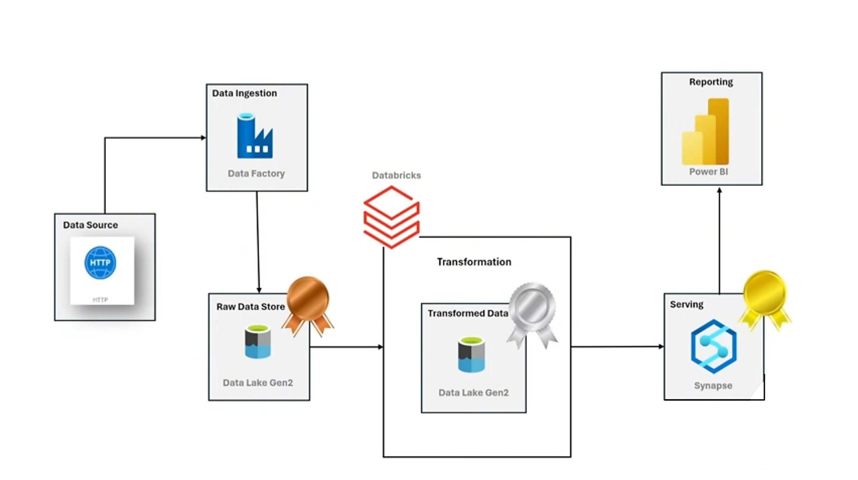
Data flow in simple words: GitHub (HTTP) → Data Factory copies files → raw data lands in the bronze container → Databricks reads, transforms and writes to silver → Synapse reads silver through views and writes gold using external tables → Power BI reads the gold data.

The three layers
BRONZE  Raw data store  Container: bronze  Raw CSV files exactly as copied from GitHub by Data Factory  No changes made | SILVER  Cleaned / transformed  Container: silver  Parquet files written by Databricks  Columns added, text cleaned, sales files merged | GOLD  Serving layer  Container: gold  Parquet files created by Synapse external tables  Ready for Power BI

3. Azure Resources Used
Resource | Name / detail | What I used it for
Storage account (ADLS Gen2) | awprojectdata | Data lake with three containers: bronze, silver, gold
Azure Data Factory | Pipeline with Lookup, ForEach, Copy | Copy data from GitHub (HTTP) to the bronze container
Azure Databricks | Notebook (PySpark) | Read bronze CSVs, transform, write Parquet to silver
Microsoft Entra ID service principal | App registration (client ID, secret, tenant) | Lets Databricks authenticate to the storage account using OAuth
Azure Synapse Analytics | Serverless SQL pool, database with gold schema | Create views on silver and external tables that write to gold
Managed identity credential | cred_ansh | Lets Synapse read and write the storage account without keys
Power BI | Dashboard | Connected to Synapse to visualise the data

4. Dataset (AdventureWorks)
File / table | What it holds | Silver-layer change
Calendar | Date table | Added Month and Year columns
Customers | Customer details | Added Fullname = Prefix + FirstName + LastName
Product_Categories | Top-level product categories | Copied as is
Product_Subcategories | Sub-categories of products | Copied as is
Products | Product details | Cleaned ProductSKU and ProductName using split
Returns | Returned products | Copied as is
Sales 2015, 2016, 2017 | Order lines (three yearly files) | Merged into one table, StockDate to timestamp, OrderNumber S replaced with T, added Multiply
Territories | Sales territories | Copied as is

5. Step-by-Step: What I Did

Step 1: Create the storage account
- Created an ADLS Gen2 storage account named awprojectdata (hierarchical namespace enabled).
- Created three containers: bronze (raw), silver (transformed), gold (final).

Step 2: Ingest data with Azure Data Factory
I built one pipeline that copies many files without creating a separate copy step for each file:
Activity | Role
Lookup | Reads the list of files to copy (file names / paths)
ForEach | Loops over every item returned by Lookup
Copy | Inside the loop, copies each file from GitHub (HTTP source) to the bronze container

Why this design?
Adding a new file only needs a new entry in the list. The pipeline itself stays the same. This is a metadata-driven pipeline, a very common interview topic.

Step 3: Transform with Azure Databricks
- Connected Databricks to the storage account with a service principal (OAuth).
- Read each CSV from bronze with header=True and inferSchema=True.
- Applied the transformations from section 4 using PySpark.
- Wrote every table to silver in Parquet format.

Step 4: Serve the data with Azure Synapse
- Created a gold schema in the Synapse database.
- Created views using OPENROWSET that read the Parquet files in silver. Views only read data, they do not store it.
- Created a master key, a managed identity credential, two external data sources (source_silver, source_gold) and a Parquet file format.
- Created external tables with CETAS (CREATE EXTERNAL TABLE ... AS SELECT). These read from the views and write the result into the gold container.

Step 5: Build the dashboard in Power BI
- Connected Power BI to Synapse and loaded the gold tables.
- Built the dashboard on top of the data.
To add later
Dashboard screenshot, the pages and visuals built, and the DAX measures used.

6. Code Reference
Security note
The original notebook had the client secret, client ID, tenant ID and the Synapse master key password written directly in the code. In this document they are replaced with placeholders. Never save real secrets in notebooks or documents. Store them in Azure Key Vault and read them in Databricks with a secret scope.

6.1 Databricks: connect to the storage account
storage = "awprojectdata"

spark.conf.set(f"fs.azure.account.auth.type.{storage}.dfs.core.windows.net", "OAuth")
spark.conf.set(f"fs.azure.account.oauth.provider.type.{storage}.dfs.core.windows.net",
"org.apache.hadoop.fs.azurebfs.oauth2.ClientCredsTokenProvider")
spark.conf.set(f"fs.azure.account.oauth2.client.id.{storage}.dfs.core.windows.net", "<CLIENT_ID>")
spark.conf.set(f"fs.azure.account.oauth2.client.secret.{storage}.dfs.core.windows.net", "<CLIENT_SECRET>")
spark.conf.set(f"fs.azure.account.oauth2.client.endpoint.{storage}.dfs.core.windows.net",
"https://login.microsoftonline.com/<TENANT_ID>/oauth2/token")

6.2 Databricks: read the bronze files
The same pattern is used for every table, only the folder name changes:
df_cus = spark.read.format('csv')\
.option('header', True)\
.option('inferSchema', True)\
.load('abfss://bronze@awprojectdata.dfs.core.windows.net/AdventureWorks_Customers')

DataFrame | Bronze folder
df_cal | AdventureWorks_Calendar (same read pattern, this cell was not in my notes)
df_cus | AdventureWorks_Customers
df_Pro_Cat | AdventureWorks_Product_Categories
df_Pro_sub_cat | AdventureWorks_Product_Subcategories
df_Pro | AdventureWorks_Products
df_ret | AdventureWorks_Returns
df_Ad_Te | AdventureWorks_Territories
df_sal | AdventureWorks_Sales* (wildcard reads the 2015, 2016 and 2017 files together)

6.3 Databricks: transformations
from pyspark.sql.functions import *
from pyspark.sql.types import *

# Calendar: add Month and Year
df_cal = df_cal.withColumn('Month', month(col('Date')))\
.withColumn('Year', year(col('Date')))

# Customers: build full name
df_cus = df_cus.withColumn('Fullname',
concat(col('Prefix'), lit(' '), col('FirstName'), lit(' '), col('LastName')))

# Products: keep the part before '-' in SKU and before ',' in name
df_Pro = df_Pro.withColumn('ProductSKU', split(col('ProductSKU'), '-')[0])\
.withColumn('ProductName', split(col('ProductName'), ',')[0])

# Sales: read all three years together
df_sal = spark.read.format('csv')\
.option('header', True).option('inferSchema', True)\
.load('abfss://bronze@awprojectdata.dfs.core.windows.net/AdventureWorks_Sales*')

df_sales = df_sal.withColumn('StockDate', to_timestamp('StockDate'))
df_sales = df_sales.withColumn('OrderNumber', regexp_replace(col('OrderNumber'), 'S', 'T'))
df_sales = df_sales.withColumn('Multiply', col('OrderLineItem') * col('OrderQuantity'))

6.4 Databricks: write to the silver layer
# Pattern used for every table
df_cus.write.format('parquet')\
.mode('append')\
.option("path", "abfss://silver@awprojectdata.dfs.core.windows.net/AdventureWorks_Customers")\
.save()

DataFrame | Silver folder
df_cal | AdventureWorks_Calendar
df_cus | AdventureWorks_Customers
df_Pro | AdventureWorks_Product
df_Pro_Cat | AdventureWorks_Product_category
df_Pro_sub_cat | AdventureWorks_Product_Sub_Categories
df_ret | AdventureWorks_Returns
df_Ad_Te | AdventureWorks_Territories
df_sales | AdventureWorks_Sales

6.5 Synapse: schema and views on silver
-- Create schema
CREATE SCHEMA gold;

CREATE VIEW gold.calendar
AS
SELECT *
FROM OPENROWSET(
BULK 'https://awprojectdata.dfs.core.windows.net/silver/AdventureWorks_Calendar/',
FORMAT = 'PARQUET'
) AS calendar;

CREATE VIEW gold.customer
AS
SELECT *
FROM OPENROWSET(
BULK 'https://awprojectdata.blob.core.windows.net/silver/AdventureWorks_Customers/',
FORMAT = 'PARQUET'
) AS customer;

CREATE VIEW gold.products
AS
SELECT *
FROM OPENROWSET(
BULK 'https://awprojectdata.blob.core.windows.net/silver/AdventureWorks_Product/',
FORMAT = 'PARQUET'
) AS products;

CREATE VIEW gold.products_sub_categories
AS
SELECT *
FROM OPENROWSET(
BULK 'https://awprojectdata.blob.core.windows.net/silver/AdventureWorks_Product_Sub_Categories/',
FORMAT = 'PARQUET'
) AS products_sub_categories;

CREATE VIEW gold.products_categories
AS
SELECT *
FROM OPENROWSET(
BULK 'https://awprojectdata.blob.core.windows.net/silver/AdventureWorks_Product_category/',
FORMAT = 'PARQUET'
) AS products_categories;

CREATE VIEW gold.Returns
AS
SELECT *
FROM OPENROWSET(
BULK 'https://awprojectdata.blob.core.windows.net/silver/AdventureWorks_Returns/',
FORMAT = 'PARQUET'
) AS returns;

CREATE VIEW gold.sales
AS
SELECT *
FROM OPENROWSET(
BULK 'https://awprojectdata.blob.core.windows.net/silver/AdventureWorks_Sales/',
FORMAT = 'PARQUET'
) AS sales;

CREATE VIEW gold.Territories
AS
SELECT *
FROM OPENROWSET(
BULK 'https://awprojectdata.blob.core.windows.net/silver/AdventureWorks_Territories/',
FORMAT = 'PARQUET'
) AS territories;

6.6 Synapse: credential, data sources and file format
CREATE MASTER KEY ENCRYPTION BY PASSWORD = '<MASTER_KEY_PASSWORD>';

CREATE DATABASE SCOPED CREDENTIAL cred_ansh
WITH IDENTITY = 'Managed Identity';

CREATE EXTERNAL DATA SOURCE source_silver
WITH ( LOCATION = 'https://awprojectdata.dfs.core.windows.net/silver',
CREDENTIAL = cred_ansh );

CREATE EXTERNAL DATA SOURCE source_gold
WITH ( LOCATION = 'https://awprojectdata.dfs.core.windows.net/gold',
CREDENTIAL = cred_ansh );

CREATE EXTERNAL FILE FORMAT format_parquet
WITH ( FORMAT_TYPE = PARQUET,
DATA_COMPRESSION = 'org.apache.hadoop.io.compress.SnappyCodec' );

6.7 Synapse: external tables (write to gold)
Views only access data. External tables (CETAS) access, transform and save the result to an external location, here the gold container.
CREATE EXTERNAL TABLE gold.extsales
WITH (
LOCATION = 'extsales',
DATA_SOURCE = source_gold,
FILE_FORMAT = format_parquet
) AS
SELECT * FROM gold.sales;

CREATE EXTERNAL TABLE gold.ext_calendar
WITH (
LOCATION = 'calendar',
DATA_SOURCE = source_gold,
FILE_FORMAT = format_parquet
) AS
SELECT * FROM gold.calendar;

CREATE EXTERNAL TABLE gold.ext_customer
WITH (
LOCATION = 'customer',
DATA_SOURCE = source_gold,
FILE_FORMAT = format_parquet
) AS
SELECT * FROM gold.customer;

CREATE EXTERNAL TABLE gold.ext_products
WITH (
LOCATION = 'products',
DATA_SOURCE = source_gold,
FILE_FORMAT = format_parquet
) AS
SELECT * FROM gold.products;

CREATE EXTERNAL TABLE gold.ext_products_sub_categories
WITH (
LOCATION = 'products_sub_categories',
DATA_SOURCE = source_gold,
FILE_FORMAT = format_parquet
) AS
SELECT * FROM gold.products_sub_categories;

CREATE EXTERNAL TABLE gold.ext_products_categories
WITH (
LOCATION = 'products_categories',
DATA_SOURCE = source_gold,
FILE_FORMAT = format_parquet
) AS
SELECT * FROM gold.products_categories;

CREATE EXTERNAL TABLE gold.ext_Returns
WITH (
LOCATION = 'Returns',
DATA_SOURCE = source_gold,
FILE_FORMAT = format_parquet
) AS
SELECT * FROM gold.Returns;

CREATE EXTERNAL TABLE gold.ext_Territories
WITH (
LOCATION = 'Territories',
DATA_SOURCE = source_gold,
FILE_FORMAT = format_parquet
) AS
SELECT * FROM gold.Territories;

-- Check the result
SELECT * FROM gold.extsales;

7. Issues Spotted and Improvements
Issue | Why it matters | Better approach
Secrets hard-coded in notebook and SQL | Anyone with the notebook can use the credentials | Use Azure Key Vault and a Databricks secret scope; rotate exposed secrets
mode('append') when writing to silver | Running the notebook twice duplicates every row | Use overwrite for reruns, or Delta tables with merge
gold.Returns view created twice | The second CREATE VIEW fails because the view already exists | Create it once, or use CREATE OR ALTER VIEW
Multiply line was outside a code cell | If it never ran, the column is missing in silver | Keep every transformation in an executed cell
CETAS cannot overwrite an existing folder | Re-running a CREATE EXTERNAL TABLE ... AS SELECT fails if the gold folder already exists | Drop the external table and delete the gold folder before re-running
Notebook says "dedicated" but code is serverless | The two pool types behave differently (cost, features) | Always note which Synapse pool type you used: this project used serverless

8. How to Explain This Project (60 seconds)
Interview summary
"I built an end-to-end Azure data engineering project using the AdventureWorks dataset and the Medallion architecture. A Data Factory pipeline with Lookup, ForEach and Copy activities loads CSV files from GitHub into the bronze layer of ADLS Gen2. Databricks with PySpark cleans the data (full names, SKU cleanup, merging three sales files, date and order-number fixes) and saves it as Parquet in silver. In Synapse serverless SQL, I created views over silver and used external tables (CETAS) to publish the final data to the gold layer. Finally, I connected Power BI to build the sales dashboard."

Likely follow-up questions
Question | Short answer
Why Parquet instead of CSV? | Columnar, compressed and faster to query, and it keeps data types.
Why Lookup + ForEach + Copy? | One reusable pipeline for many files instead of one Copy activity per file.
View vs external table in Synapse? | A view only reads data. An external table can also write the result to storage (CETAS).
How does Databricks access the lake? | Service principal with OAuth. Better practice is to keep the secret in Key Vault.
What is the Medallion architecture? | Bronze (raw), silver (cleaned), gold (business-ready) layers.

