1. **XPLORE1_UI_COMPLETION_ASSESSMENT**

**Question:**

Write HTML, CSS, JavaScript code below requirement:

The page has background color as pink should have form with name “my_form”.

The form will have below labels and controls:

1. Label “Student Name” followed by textbox, the label should be created with span and id is “name_label”. The Textbox should have attribute name mapped to value “student_name” and id attribute mapped to value “student_name”. Background color of this text box and label should be yellow.
2. Label “Age” followed by textbox, the label should be created with span and id is “age_label”. The textbox should have attribute name mapped to value “student_age” and id attribute mapped to value “student_age”. background color of this textbox and label should be yellow.
3. Radio options Gender (m and f). Default selection should be m and the name should be “gender’.
4. Label “city followed by drop down. The drop down should have attribute name mapped to value “city” and id should be “city”. There should be populated cities (options) as Delhi, Mumbai, Kolkata, Chennai (all city names are case sensitive).
5. Label “Hobby” followed by three check boxes. Name and id of those three checkboxes will be painting, dancing, sports respectively. Display labels after these checkboxes as – Dancing, Painting, Sports respectively.
6. Submit button.

After submit button, have a div tag to display script results in below format:

“Name:” followed by hidden label with id “name_value”

“Age:” followed by hidden label with id “age_value”

“City:” followed by hidden label with id “city_value”

“Hobbies:” followed by hidden label with id “hobbies_value”

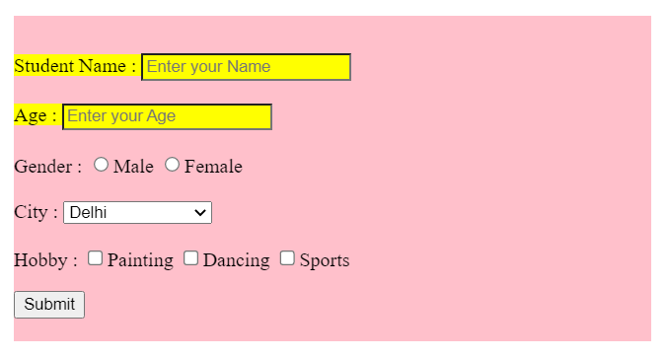

Next, write JavaScript code for below validation (separate function for each of these validations):

1. Name should not contain numbers. Max length is 20 characters. For validation failure, set “name_value” text as “invalid” else set it as per name value.
2. Age should not contain any non-numeric character. Max age is 100. For validation failure, set “age_value” text as “invalid” else set as per value.
3. City value should not be empty. For validation failure, set “city_value” text as “invalid” else set it as per city value.
4. At least one hobby is selected. For validation failure, set “hobbies_value” as “invalid” else set it as per selected hobbies in lower case separated by #. E.g., if Dancing is selected, then value set should be dancing#. if Dancing and Sports is selected, then value should be dancing#sports#

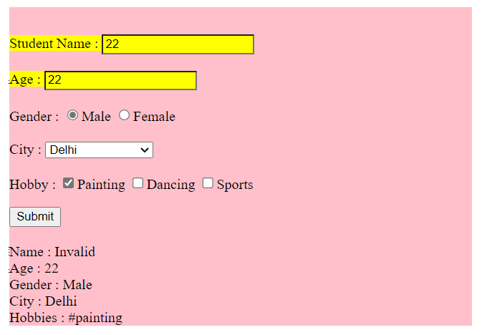

**Note:**

1. For label design keep span
2. Above script should be called in above sequence when submit button is clicked.
3. All the html code should be enclosed inside div with id “body” and the background color need to be enabled for this div
4. The page design should be based on the screen shot attached above
5. All style should be inline