Course Code: | CSA0-1918 | Course Title: | PROGRAMMING IN JAVA
CO Assessed: | CO1 | Assessment: | Assessment Tool 3 – FLOWGORITHM FLOWCHART ASSIGNMENTS
CO1 Statement: | Each student must draw and execute all three flowcharts in Flowgorithm, test them with valid and invalid inputs, and write the equivalent Java concept used. For  OOP questions, implement the behaviour using functions and control structures in Flowgorithm, then explain the mapping to Java classes, objects, inheritance, polymorphism,  overloading, packages, or interfaces.
Student Name: | K. Revanth Royal | Reg. No.: | 192472116
Section / Batch: | 2024 | Date:
SIMATS ENGINEERING (SAVEETHA SCHOOL OF ENGINEERING)
Department of Computer Science and Engineering
ASSESSMENT TOOL 3 – FLOWGORITHM FLOWCHART ASSIGNMENTS

FLOWGORITHM FLOWCHART ASSIGNMENT
- Ticket Pricing Based On Age

Problem statement
Read the price of a ticket and the age of the customer. Apply child, adult, or senior-citizen pricing and display the payable amount.
Flowgorithm behaviour
- Read ticketPrice
- Read age
- If age < 0 → invalid age
- If age < 12 → child discount
- Else if age >= 60 → senior discount
- Else → adult price
- Display payable amount

Test cases
Input | Output
Price = 500, Age = 10 | Payable = 250
Price = 500, Age = 30 | Payable = 500
Price = 500, Age = 65 | Payable = 350
Price = 500, Age = -5 | Invalid age
Equivalent Java concept used
- Scanner for input
- if-else control structure
- Variables (double, int)
- Function: calculateFare(price, age)
OOP mapping to Java
- Create a class TicketPricing
- Create a method calculateFare()
- The object calls the method to calculate the payable amount
Example:
class TicketPricing {
double calculateFare(double price, int age) {
if(age < 12) return price * 0.5;
else if(age >= 60) return price * 0.7;
else return price;
}
}
This demonstrates encapsulation (method inside a class) and objects calling methods.

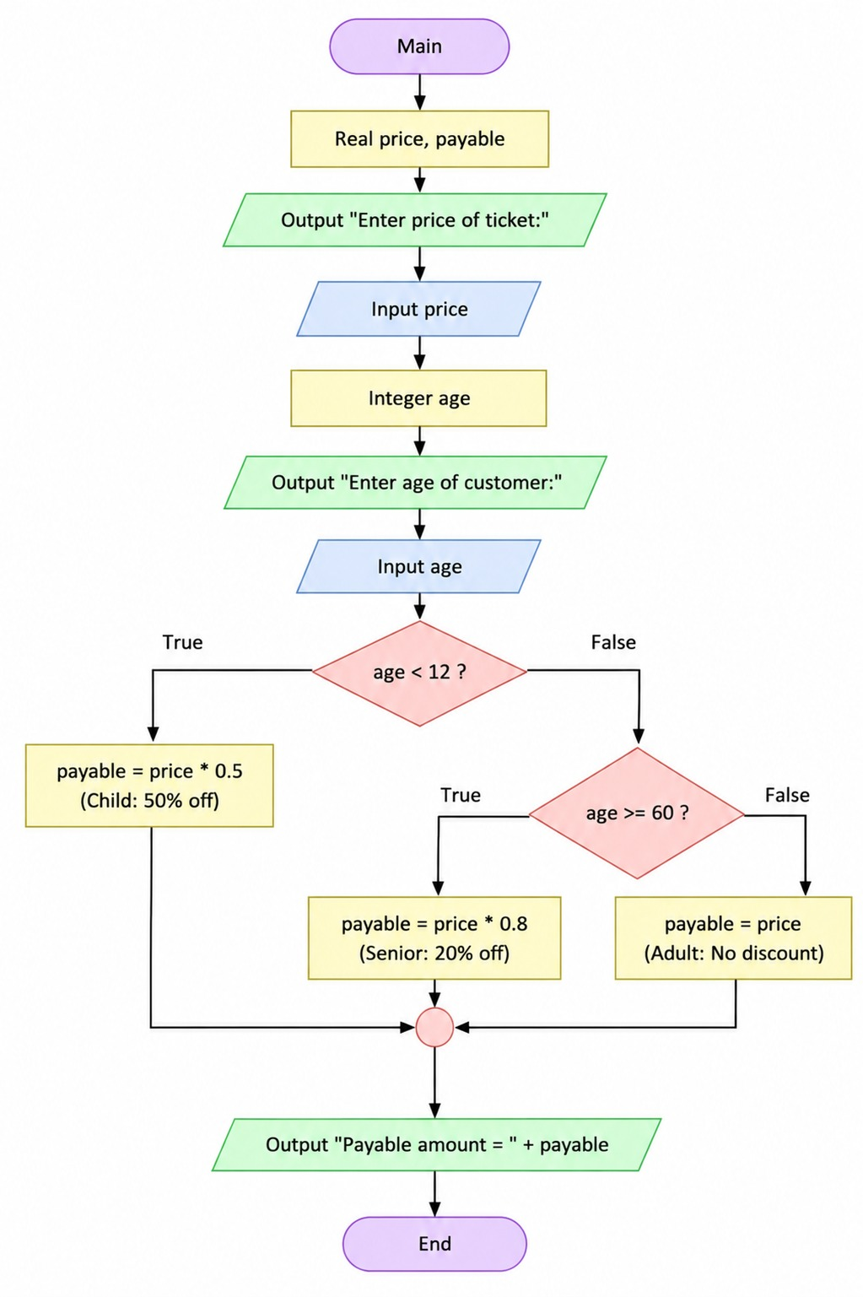
2: Compare first-half and second-half array sums

Problem statement
Read N integers and compare the first half and second half sums of the array.
Flowgorithm behaviour
- Read N
- If N <= 0 → invalid input
- Read array elements
- Calculate first-half sum
- Calculate second-half sum
- Compare both sums
- Display the result
Test cases
Input | Output
N=6, 1 2 3 4 5 6 | First=6, Second=15, Second greater
N=4, 5 5 5 5 | Sums are equal
N=0 | Invalid size
Equivalent Java concept used
- Arrays (int[])
- for loops
- if-else
- Function: compareHalfSums(arr, n)
OOP mapping to Java
Create a class ArrayAnalysis.
class ArrayAnalysis {
void compareHalfSums(int[] arr) {
// sum calculation
}
}
This demonstrates:
- Objects
- Methods
- Arrays as class data
No inheritance is required.
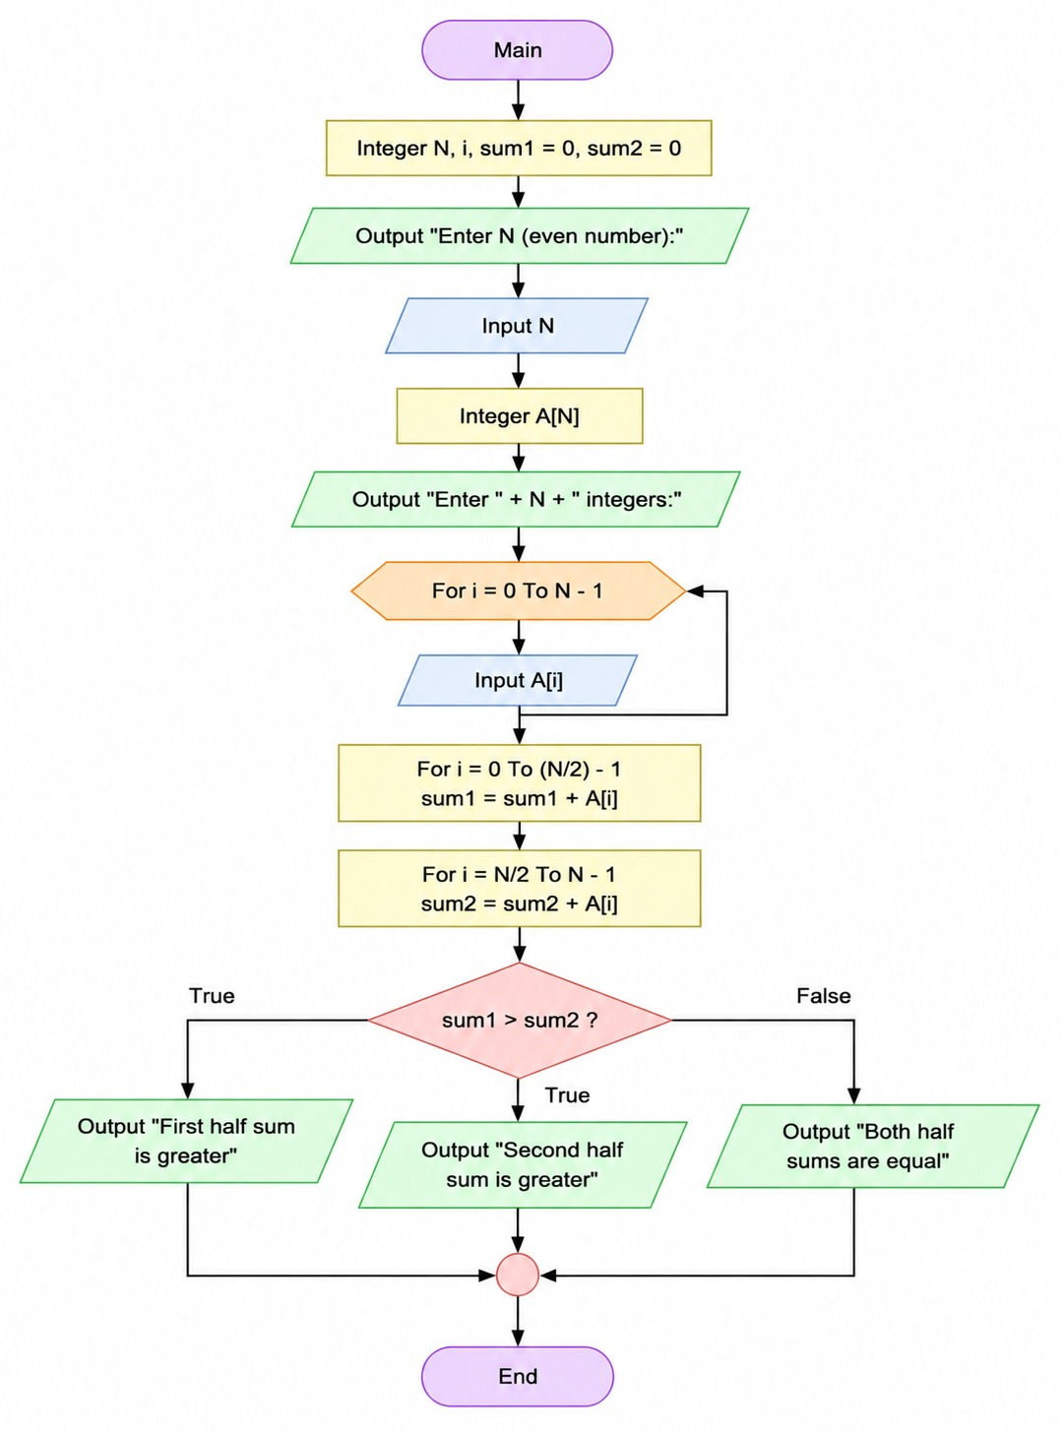

3: Validate a date and calculate the next date (non-leap year)

Problem statement
Create functions to validate a date and calculate the next date for a non-leap year.
Flowgorithm behaviour
- Read day, month, year
- Validate month
- Validate day according to month
- If invalid → display invalid date
- Else calculate next date
- Display next date
Functions used
- isValidDate(day, month, year)
- nextDate(day, month, year)
Test cases
Input | Output
15/08/2026 | 16/08/2026
31/01/2026 | 01/02/2026
30/02/2026 | Invalid date
31/12/2026 | 01/01/2027
Equivalent Java concept used
- Functions (methods)
- Arrays (days in each month)
- Conditional statements
- Return values
OOP mapping to Java
Create a class DateUtility.
class DateUtility {
boolean isValidDate(int d, int m, int y) {
return true;
}

void nextDate(int d, int m, int y) {
// calculate next date
}
}
This demonstrates:
- Function decomposition
- Encapsulation
- Method interaction inside a class
