**SIMATS UNIVERSITY**

**NAME : Vinjam Revanth**

**Roll no : 192311327**

**Course : Software Engineering**

**KANBAN BOARD:**

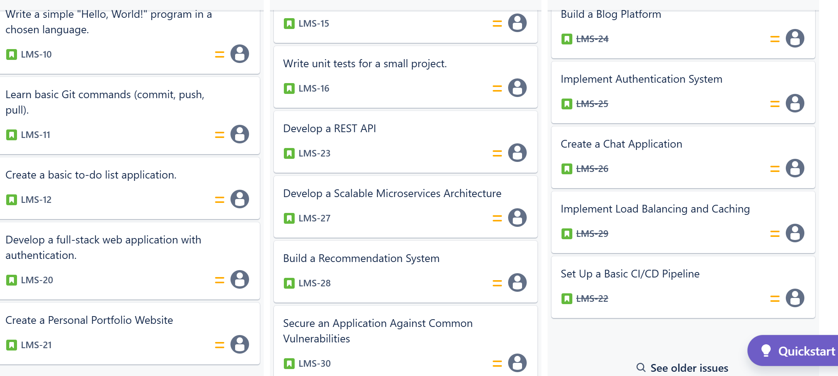

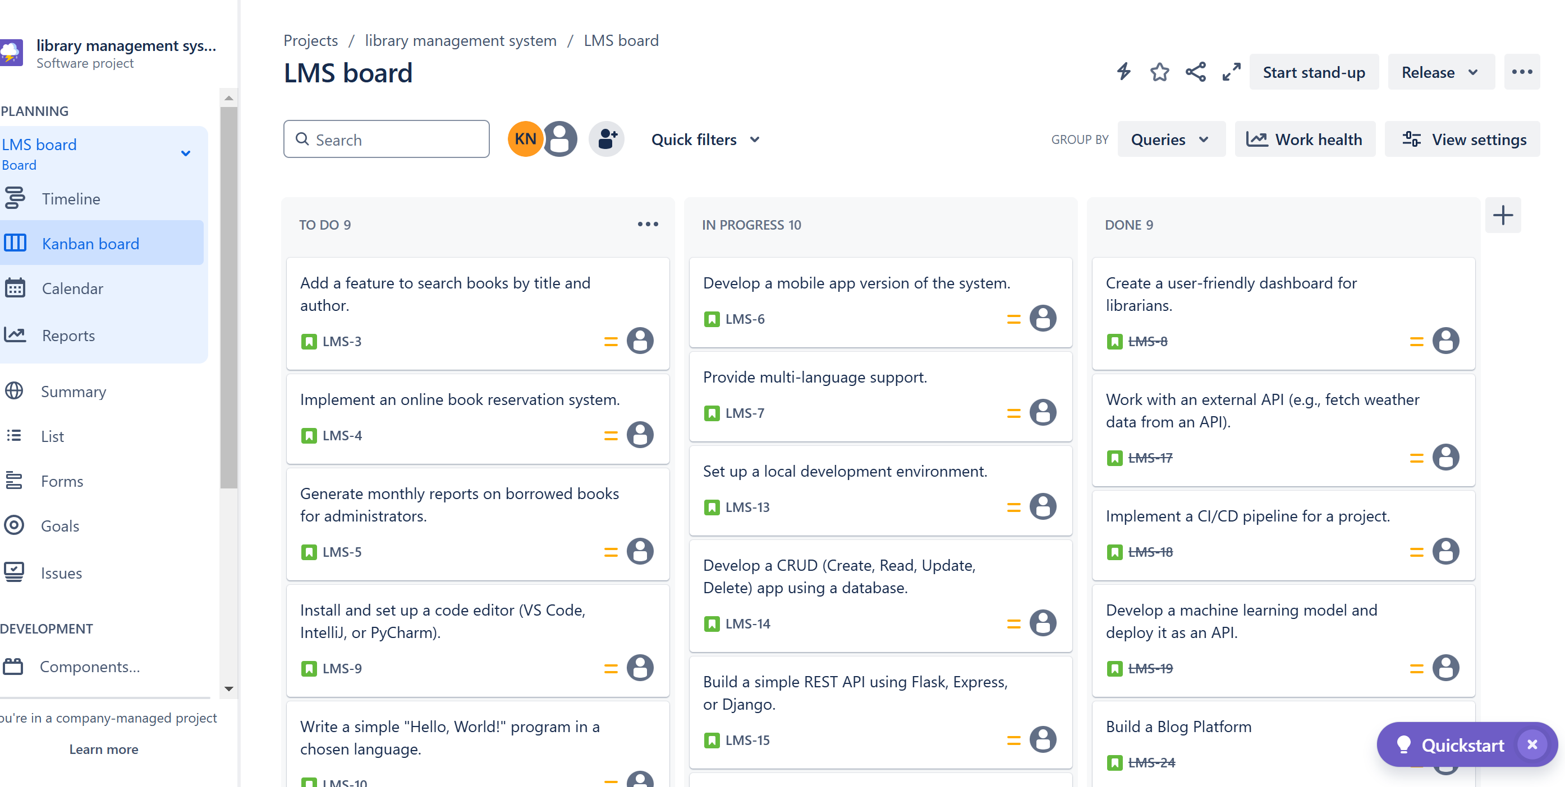

EXPALINATION:

**Step 1: Set Up the Kanban Board**

1. Open the Kanban board tool or prepare a physical board.
2. Create three columns labeled:
   * **To Do**
   * **In Progress**
   * **Done**

**Step 2: Add Sample Tasks**

1. Define at least five tasks to be managed on the board:
   * Task 1: Create a user-friendly dashboard for librarians
   * Task 2: Add a feature to search books by title and author
   * Task 3: Implement an online book reservation system
   * Task 4: Generate monthly reports on borrowed books for administrators
   * Task 5: Provide multi-language support
2. Place all tasks under the "To Do" column initially.

**Step 3: Simulate the Workflow**

1. Move **Task 1** (Research project requirements) from "To Do" to "In Progress."
2. Once completed, move **Task 1** to "Done."
3. Repeat the process for other tasks:
   * Move **Task 2** to "In Progress" and then to "Done."
   * Follow the same steps for **Task 3**, **Task 4**, and **Task 5.**
4. Ensure tasks progress logically through the columns to reflect their status.

**Step 4: Review the Board**

1. Observe the distribution of tasks across the columns.
2. Verify that all tasks eventually move to the "Done" column, indicating completion.

LIST:

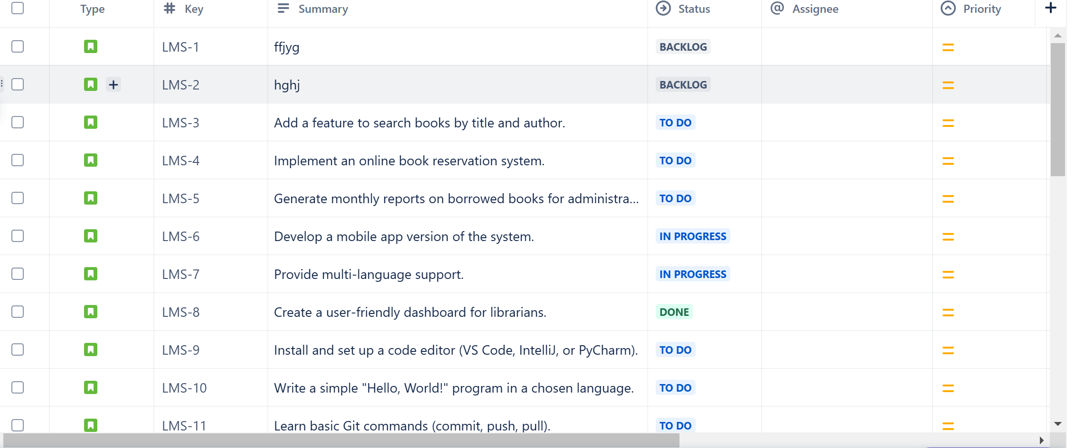

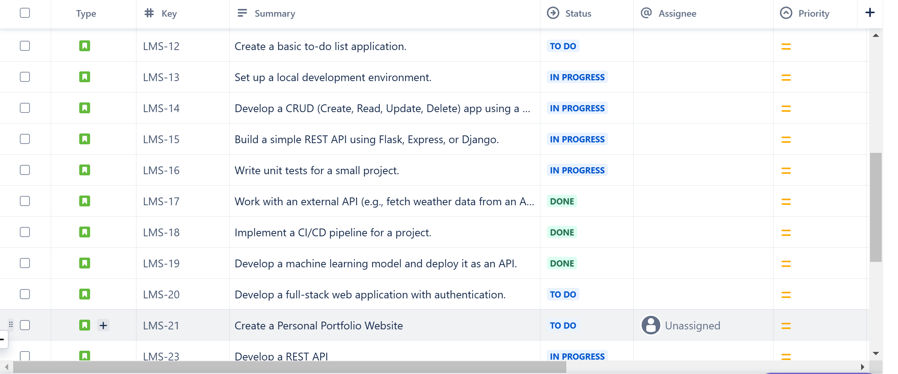

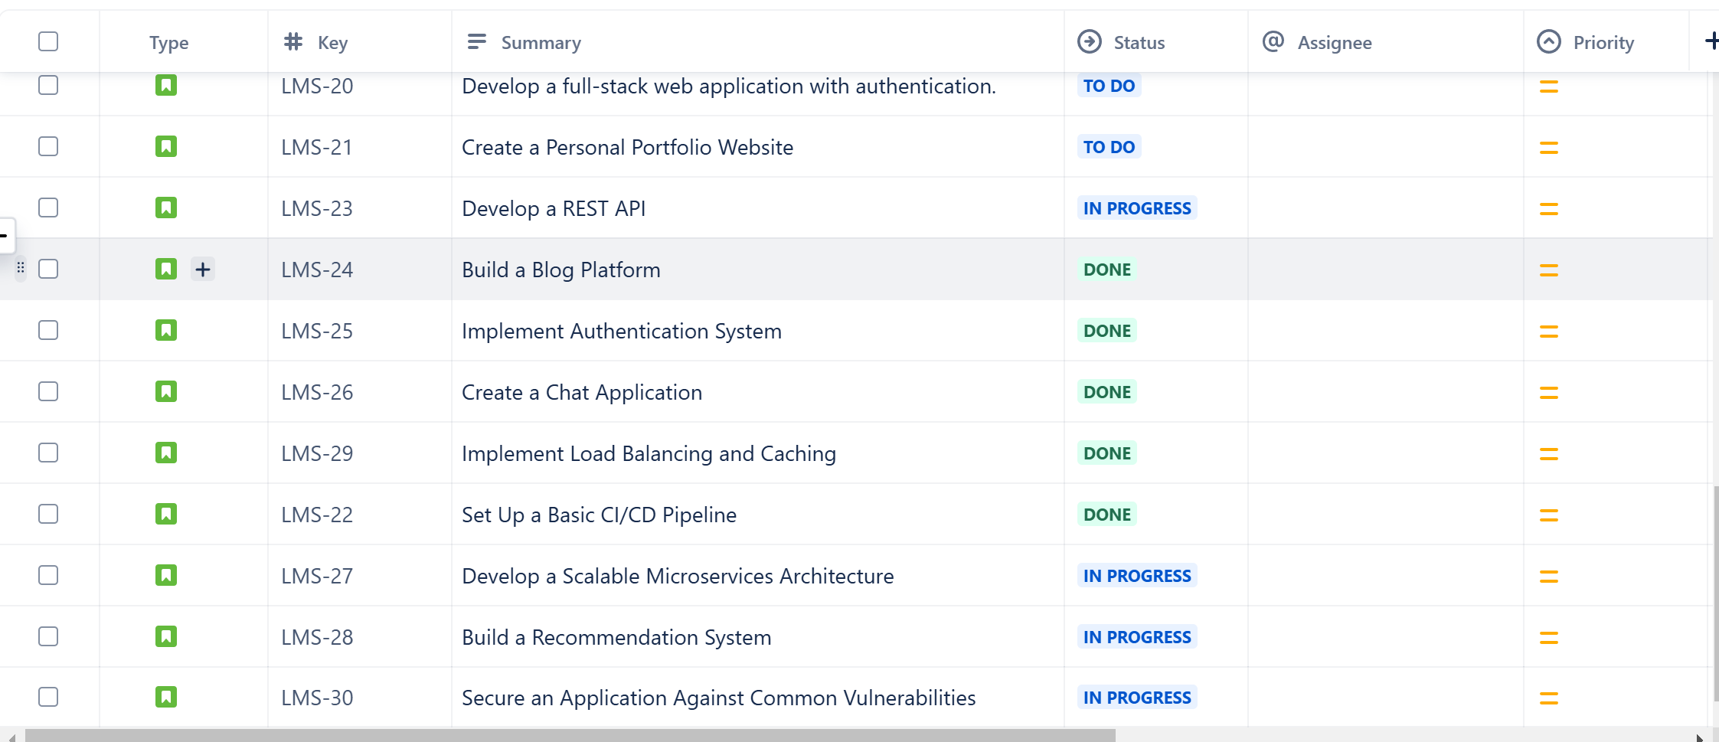

Conclusion : In software engineering, tasks range from beginner-friendly exercises like building simple applications to advanced projects involving system architecture and security. By working on these tasks, you can strengthen your coding skills, problem-solving abilities, and knowledge of best practices. Whether you're a beginner learning the basics or an experienced developer tackling complex challenges, continuous learning and hands-on practice are key to growth in this field. 🚀 Keep building, experimenting, and improving!