Sustainable Supply Chain Performance Dashboard in Power BI

4-WEEKS INTERNSHIP with EDUNET FOUNDATION

***WEEK 1 PROJECT***: *DESCRIPTION OF Power BI*

**STEP-1:-**

**Installation of Power BI by clicking on this link:** [**http://microsoft.com/en-us/download/details.aspx?id=58494**](http://microsoft.com/en-us/download/details.aspx?id=58494)

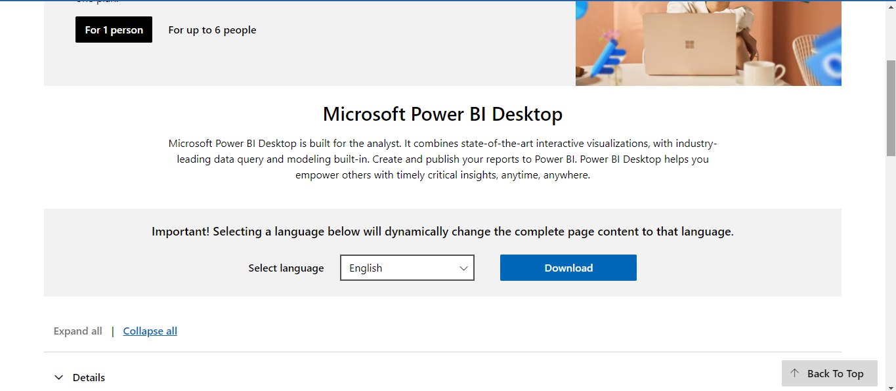

STEP-2:-

Open the Power BI and Click on Blank Report to do any operation in the Power BI

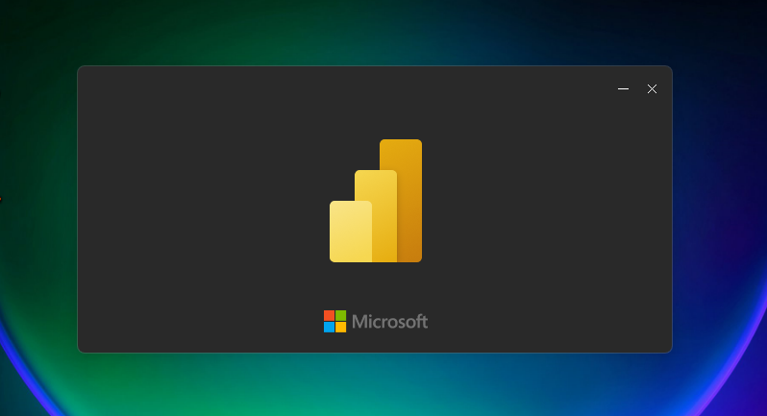

STEP-3:-

* Their will Be a Window Displayed here Which is called Power BI Desktop.
* In that window on the Left side we can observe Visualizations Tab and Blank Window at the centre is Called as Canvas.
* In Canvas we will Draw Charts.
* In this way This Windows Consists of many features Filters,home tab,Modeling Tab.
* The Page Would be Look Like: 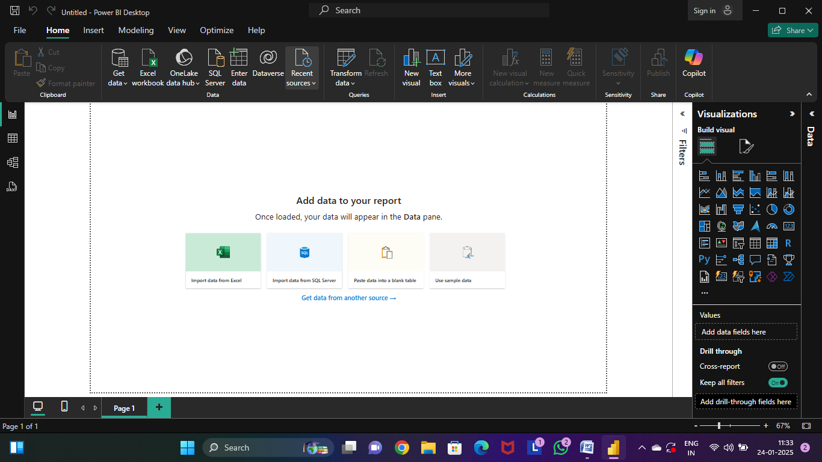

STEP-3-

* Now we will Study About the Extract Function of a Power BI.
* So From the Get data option on the top of window.
* Here we can observe many options for extracting files to Power BI Window.

STEP-4:-

* As I have the Data in the form of Excel I will select on the excel Option.
* In forward their will be Pop up Window for Selection of the file from the File Manager. As Shown

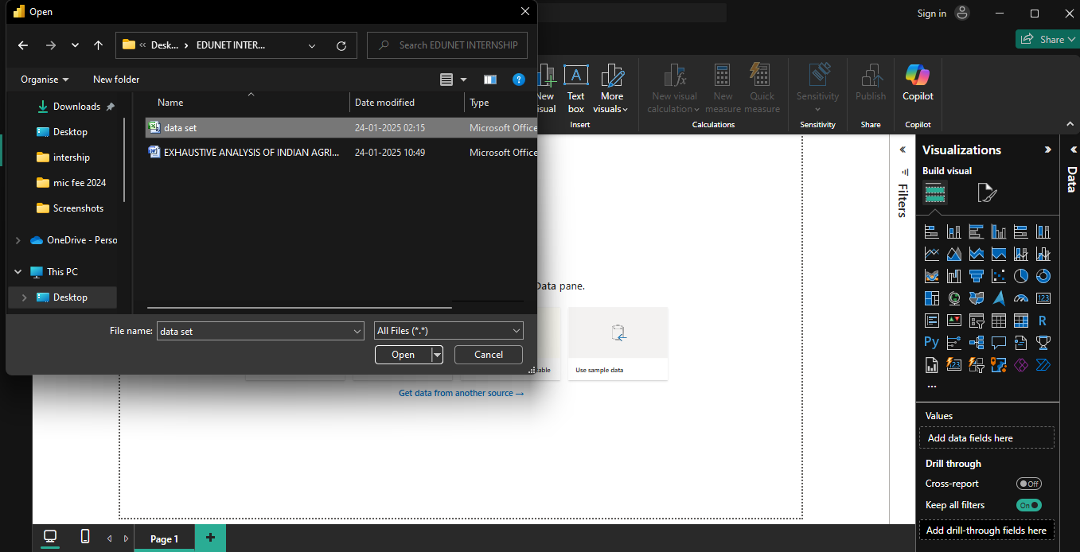

STEP-5:-

* By clicking On the Open Their Will be a new Window opened.
* This Window Tells us the overview of the Data that we had Given.
* On the window we can observe its consists of 3 buttons.

LOAD:- Click on the option Load when your Data is Cleaned

TRANSFORM:- Click on the Option When you Want to Process the Data.

Cancel:- If no Operation is to be Performed .

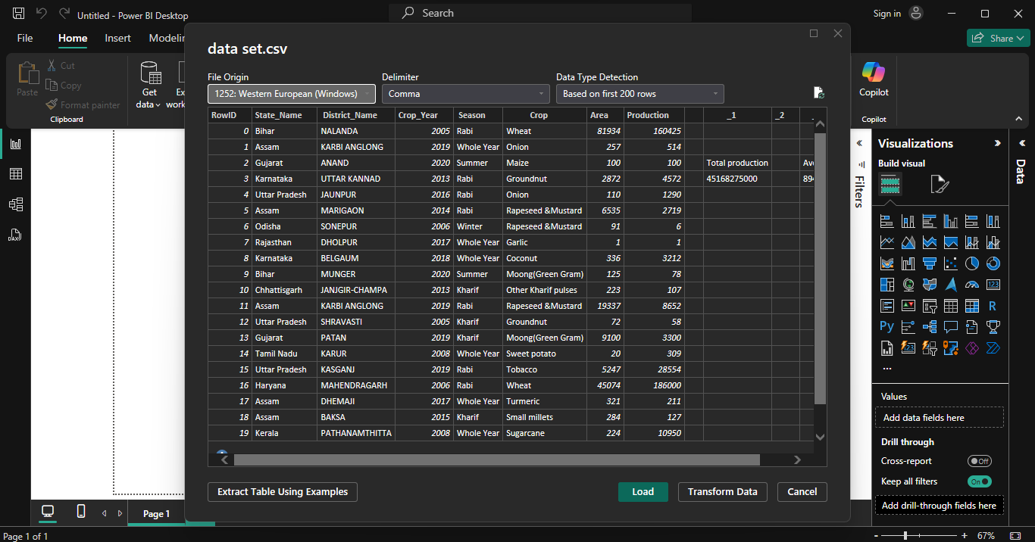

* In this Case let’s Select Load Option Even though we know it’s not Clear.
* Lets wait for few seconds to load

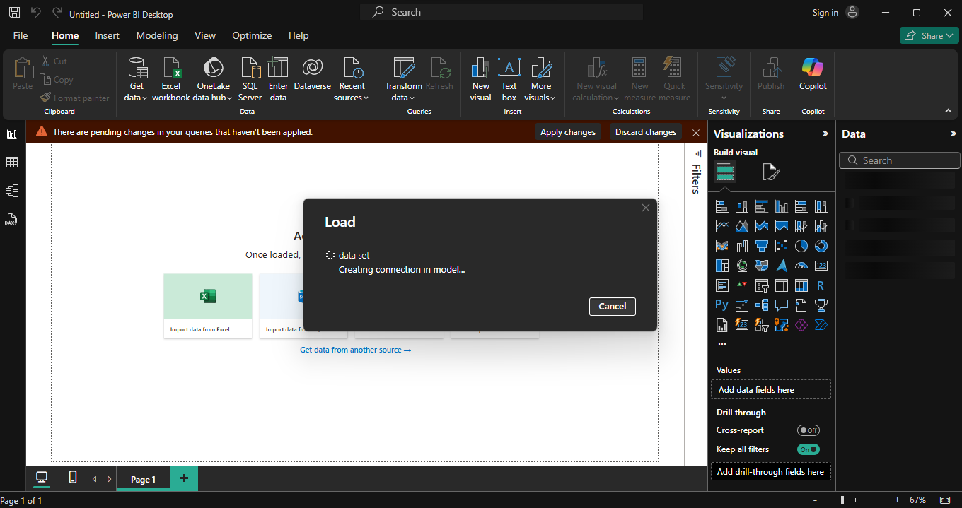

STEP-3:-

* Now on the Left side of the Window we can observe 3 option

Report view: We perform all the Visualizations.

Table view :Overview of the data we had uploaded.

Model view : So that we can create Relationship Among the Data.

* Here we will Use all the Three view in the Development of this Project .
* If we want to Transform the data to clear the errors
* Once you click on the transform Button on the Top it redirects to Another window which is Very important to any analyst.
* In this window we can Perform all the clears what we want to Perform.
* This Window is said to be Power Query Editor.
* Here We can all the Transform operation.
* By just selecting any option like REMOVE,REPLACE ,…etc operations

STEP-4:-

* Let’s perform Some Operations on the Power query Editor.
* Here in this sheet we can Observe some Blank Columns Which is not Useful.

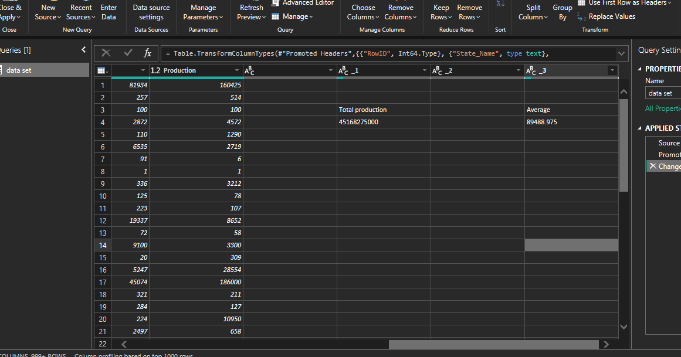

* So I needed to remove the Unwanted Columns and Row id column.
* So to Remove the column go to column and click right click. Their will be a option named Remove now click on Remove.
* In the Same way Remove the Remaining Unwanted Columns.
* By removing columns we can observe removed list on the right side window.

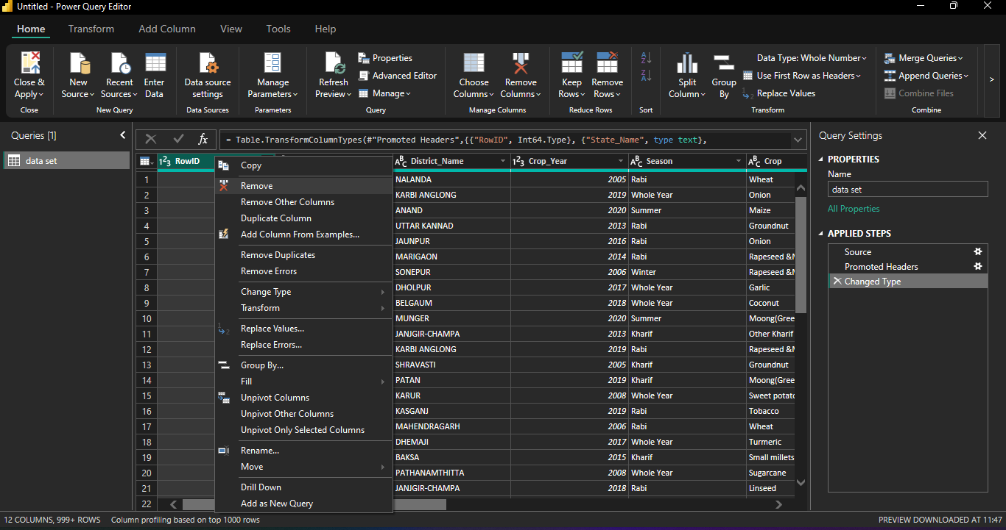

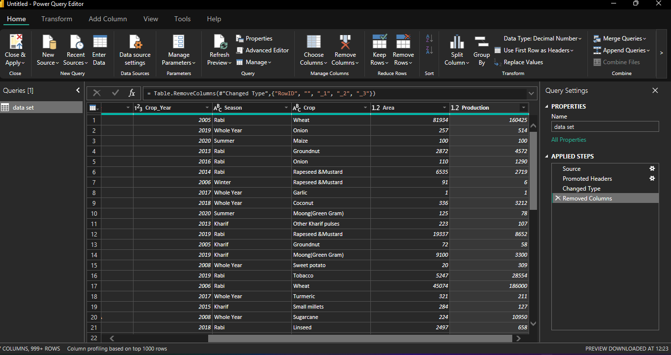

STEP-8:-

* Now as to check as there is any Null value in the data set .
* Go to view option and select “column quality”.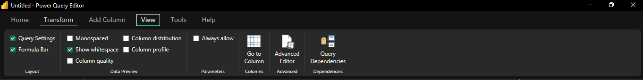
* By this we can a small box for every column as shown which show either the column consists of any NULL value or not.

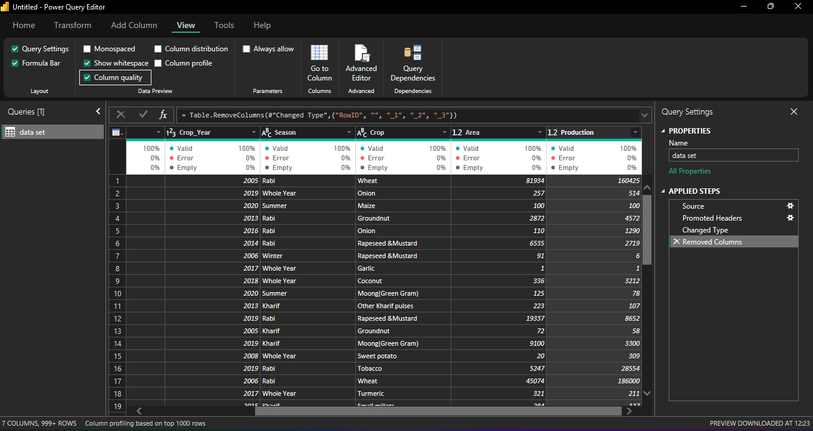

* Clearly we can Observe either any of the column has any NULL or not.
* By this output acquired we can say their no NULL value in any of the column.

STEP-9:-

* If in the Window a error is Acquired the these can be removed by choosing any of the Following options in the Home tab.
* In home tab, there is a option Remove rows So by choosing any Option of the Our problem with get cleared.
* If there is any Duplicates those were also can be removed using Remove Duplicate option in the above Image.

STEP-10:-

* We can also change the Data types of the columns by selecting any of the options shown below.

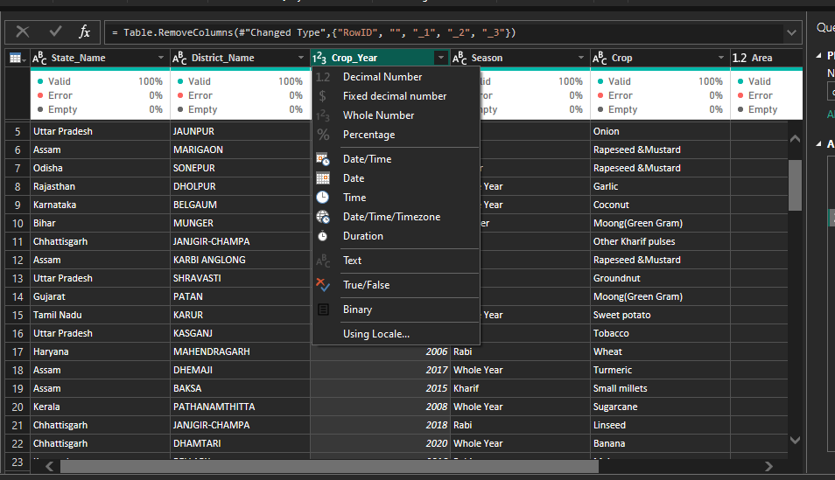

STEP-11:-

* Now, whatever the changes we has done in this we save it. because whatever the changes we had done now will not reflect in the power BI window
* So to reflect the changes in the Power BI we should Go to Home Tab and select “close and apply option” which is at the left side of Home tab.
* Now by clicking what for certain time while the feature is under execution.
* Now go to table view and Verify either the scrap data is removed or not.

