**Prediction of State of Health for Lithium-Ion Batteries Employing Gaussian Process Regression**

Project submitted to the

SRM University – AP, Andhra Pradesh

for the partial fulfillment of the requirements to award the degree of

**Bachelor of Technology**

In

**Computer Science and Engineering**

**School of Engineering and Sciences**

Submitted by

**G. Revanth Krishna Sai (AP21110010979)**

**CH. Himabindhu (AP21110011249)**

**P. Bhanu Bharath (AP21110010995)**

**B. Jayanth Varma (AP21110011039)**

Under the Guidance of

**Dr. Tarkeshwar Mahto**

**SRM University–AP**

**Neerukonda, Mangalagiri, Guntur**

**Andhra Pradesh – 522 240**

**Nov, 2023**

# Certificate

Date: 1-12-2023

This is to certify that the work present in this Project entitled “**Prediction of State of Health for Lithium-Ion Batteries Employing Gaussian Process Regression**” has been carried out by **G. Revanth Krishna Sai**, **Ch. Himabindhu** , **P. Bhanu Bharath** , **B. Jayanth Varma** under my/our supervision. The work is genuine, original, and suitable for submission to the SRM University – AP for the award of Bachelor of Technology/Master of Technology in **School of Engineering and Sciences**.

**Supervisor**

(Signature)

Dr. Tarkeshwar Mahto

Assistant Professor,

SRM University AP.

# Acknowledgements

I would like to express my deepest gratitude to Dr. Tarkeshwar for his invaluable guidance and unwavering support throughout the course of this research project. His expertise, insightful feedback, and dedication to fostering a rigorous intellectual environment have been instrumental in shaping the direction and success of this study.

Dr. Tarkeshwar's mentorship has not only enhanced the quality of my work but has also been a source of inspiration, motivating me to strive for excellence in every aspect of the research process. I am truly fortunate to have had the opportunity to work under his mentorship, and I am grateful for the knowledge and skills I have gained through this collaboration.

I would like to extend my heartfelt thanks to Dr. Tarkeshwar for his encouragement, patience, and mentorship, which have been instrumental in the completion of this research project. His commitment to academic excellence and passion for research have left a lasting impact on my academic and professional development.

Thank you, Dr. Tarkeshwar, for being an outstanding mentor and for your invaluable contributions to this research endeavor.

# Table of Contents

Certificate i

Acknowledgements iii

Table of Contents v

Abstract vi

Abbreviations vii

List of Tables viii

List of Figures ix

List of Equations x

1. Introduction 1

2. Methodology 4

2.1 Extraction of Indirect Health Indicators 4

2.1.1 Experimental Data 4

2.1.2 Extraction of Indirect Health Indicators 5

2.1.3 Grey Relational Analysis 6

2.2. Gaussian Process Regression 6

2.3 Experimental Analysis 7

3. Concluding Remarks 11

4. Future Work 12

References 13

# Abstract

The battery capacity is typically used to forecast the state of health (SOH), one of the most significant factors. For online applications, it is challenging to measure lithium-ion battery capacity directly. In this study, indirect health indicators (IHIs) that are responsive to the process of battery capacity deterioration are taken from the voltage, current, and temperature curves during the charging and discharging of lithium-ion batteries. The Gray relation analysis approach selects a small number of suitable indicators to use as the inputs for SOH prediction. Probability forecasts are combined with the Gaussian process regression (GPR) approach to perform the short-term SOH prediction. Subsequently, taking into account a specific mapping relationship between SOH, the GPR model is employed to estimate the SOH of lithium-ion batteries using three IHIs. The outcomes demonstrate the excellent forecast accuracy of the suggested strategy.

**Keywords**: lithium-ion batteries; state of health; remaining useful life; indirect health indicator; grey relation analysis; Gaussian process regression

# Abbreviations

|  |  |  |
| --- | --- | --- |
| **S.no** | **Name** | **Abbreviations** |
| 1 | SOH | State of Health |
| 2 | IHI | Indirect Health Indicators |
| 3 | GPR | Gaussian Process Regression |
| 4 | RMSE | Root Mean Square Error |
| 5 | MAPE | Mean Absolute Percentage Error |

# List of Tables

|  |  |  |
| --- | --- | --- |
| **S.No** | **Name** | **Pg. no** |
| 1. | Correlation Table | 7 |
| 2. | Prediction Performance | 2 |

# List of Figures

|  |  |  |
| --- | --- | --- |
| **S.No** | **Name** | **Pg. No** |
| 1 | Capacity degradation curves of batteries | 5 |
| 2 | Discharging voltage curves of No. 5 with different cycles | 7 |
| 3 | Discharging temperature curves of No. 5 with different cycles | 7 |
| 4 | Schematic diagram of the proposed GPR method for prediction | 8 |
| 5 | SP at SOH prediction result of battery : No. 5 SP = 50 ; No.6 SP = 50 | 9 |
| 6 | SP at SOH prediction result of battery : No. 5 SP = 75 ; No.6 SP = 75 | 9 |
| 7 | SP at SOH prediction result of battery : No. 5 ; No.6 | 10 |

# List of Equations

|  |  |  |
| --- | --- | --- |
| **S.No** | **Name** | **Pg.No** |
| 1. | **Greys correlation coefficient** = 1 - sum(abs(normalizedX - normalized_Y)) / sum(abs(normalized_X + normalized_Y)) | 3 |
| 2. | RMSE | 10 |
| 3. | MAPE | 10 |

# Introduction

Lithium-ion batteries serve as the primary power source for electric vehicles (EVs), consumer electronics, and even spacecraft [1–3]. As a result, ensuring the reliability and safety of these batteries is a critical concern in practical applications. Over time, the performance of lithium-ion batteries gradually degrades, potentially impacting the normal operation of electrical equipment and leading to severe consequences [4]. Notable incidents, such as the Samsung NOTE7 cell explosion, electric vehicle fires, and battery energy storage box explosions in power plants in recent years, underscore the importance of addressing these safety challenges [5].

To mitigate the risk of such accidents, the prediction of State of Health (SOH) for lithium-ion batteries has become a prominent and challenging focus within the field of prognostics and health management (PHM) for electronics. The battery management system (BMS) is specifically designed for various instruments to ensure safe operating conditions. SOH determination is a key function of BMS in current practice and requires estimation based on online measurement data, including current, voltage, temperature, etc.

Existing methods for SOH prediction of lithium-ion batteries can be broadly categorized into two main types: model-based approaches and data-driven approaches [6]. The electrochemical model (EChM) and the equivalent circuit model stand out as two commonly employed models for understanding lithium-ion batteries. Among EChMs, the Doyle–Fuller–Newman (DFN) model is widely recognized [7–9]. Safari et al. [10] introduced a multimodal physics-based aging model focusing on lithium-ion battery capacity fade. This model incorporated solvent decomposition kinetics and solvent diffusion through the solid electrolyte interphase (SEI) layer. Considering desolvation as a rate-limiting step, another study [11,12] utilized a one-dimensional model to estimate battery aging by encompassing both calendar and cycle phenomena [13]. Despite its high simulation accuracy, the model's complexity makes it challenging for online applications. Therefore, model reduction methods are implemented to streamline these models.

Ramadesigan et al. [14] employed reformulated models to efficiently extract effective kinetic and transport parameters from experimental data. Another approach involves analyzing voltage-discharge curves measured during initial cycles to predict curves in subsequent cycles. Ashwin et al. [15] proposed a pseudo-two-dimensional electrochemical lithium-ion battery model to investigate capacity degradation under cyclic charging and discharging conditions. However, this model struggled with dynamic tracking, affecting its accuracy. A significant limitation of reduction models is that they are obtained under specific conditions, potentially restricting accuracy and introducing modeling errors.

Equivalent circuit models, such as the battery internal resistance equivalent (Rint) model and the impedance resistance–capacitance (RC) model, offer a less complex alternative to electrochemical models (EChM), presenting ease of implementation for real-time applications with moderate accuracy [16]. Johnson et al. [17] introduced classical equivalent circuit models with a focus on battery internal resistance and impedance resistance–capacitance. However, these models often overlook the implicit relationships between internal state variables of the battery.

In contrast to EChM, equivalent circuit models involve fewer internal parameters, simplifying their implementation. Still, their accuracy is contingent upon proper identification of model parameters, which necessitates a large and diverse dataset obtained through time-consuming tests. The challenge lies in the incomplete understanding of the capacity degradation mechanism of lithium-ion batteries, making it difficult to determine the main parameters involved in the model-based method.

With the rise of machine learning and artificial intelligence, data-driven methods have gained attention due to their nonparametric nature and independence from electrochemical principles [18–20]. Various data-driven approaches, including time series analysis, artificial neural networks (ANN), support vector machines (SVM), relevance vector machines (RVM), and Gaussian process regression (GPR), have been explored [21–23]. GPR, in particular, has gained favor for its probabilistic prediction capabilities under the Bayesian framework [24, 25].

To leverage the benefits of data-driven methods, researchers have applied them to predict the aging life of lithium-ion batteries. Compared to model-based methods, data-driven approaches are nonparametric and do not rely on electrochemical principles. Various mapping and regression tools are used to develop degradation models, such as time series analysis, ANN, SVM, RVM, and GPR [18–20].

In recent years, GPR has gained popularity due to its probabilistic prediction capabilities under the Bayesian framework [24,25]. Researchers have applied GPR to multiple-step-ahead prognostics [26]. Liu et al. [26] utilized an improved GPR model, combining Gaussian Process Functional Regression (GPFR), to capture the actual trend of State of Health (SOH), including global capacity degradation and local regeneration. While GPR has advantages in long-term predictions, it may have limitations in practical applications, as it relies on capacity data [26].

To address these limitations, Peng et al. [27] proposed a fusion method using the wavelet denoising (WD) method and the GPFR model. The WD method was applied to remove noise from the original data, enhancing the accuracy of Remaining Useful Life (RUL) predictions. However, this method primarily focused on the degradation trend of batteries and overlooked the regeneration phenomenon in battery rest life.

In light of these considerations, some researchers have explored indirect features as substitutes for capacity data to overcome measurement challenges related to impedance and resistance. These indirect features, easily measurable in real-time and online, include current, voltage, and temperature. Yang et al. extracted specific parameters from charging curves and used them as inputs for the GPR model, offering practical applicability. However, focusing solely on the charging process voltage change curve resulted in reduced prediction accuracy due to low correlation with capacity.

To address the capacity unmeasurable problem, this paper proposes a method to extract measurable degradation indicators from the charge and discharge process of lithium-ion batteries. These indicators, highly relevant to capacity fade, serve as indirect health indicators (IHIs) for predicting short-term SOH using the GPR model. The approach involves extracting IHIs from readily available sensor data, such as voltage, current, and temperature curves. Grey relation analysis is then employed to select IHIs with high correlation to the capacity degradation curve. The GPR model is subsequently applied for short-term SOH predictions using the chosen IHIs.

The paper is organized as follows: Section 2 briefly introduces the selection and extraction of IHIs. Section 3 discusses the prediction method based on Gaussian process regression. Section 4 presents the simulation results of SOH. Finally, Section 5 provides the conclusions.

# Methodology

## 2.1 Extraction of Indirect Health Indicators

### 2.1.1 Experimental Data

The lithium-ion battery dataset employed in this study originates from the open dataset provided by NASA Ames Prognostics Center of Excellence (PCoE) [28]. The dataset includes experimental data from four lithium-ion batteries, namely Batteries 5, 6, 7, and 18. These batteries underwent charging and discharging processes, with impedance measurements taken under various operating conditions at a room temperature of 24°C. The charging process was conducted in two steps. Initially, a constant current charging of 1.5 A was applied until the battery voltage reached 4.2 V. Subsequently, the second step involved constant voltage charging to maintain the battery voltage at 4.2 V while reducing the current to 20 mA. The discharging procedure involved applying a continuous current of 2 A until the voltage of Batteries 5, 6, 7, and 18 dropped to specific levels: 2.7 V, 2.5 V, 2.2 V, and 2.5 V, respectively. The capacity degradation curve for each battery is depicted in Figure 1.

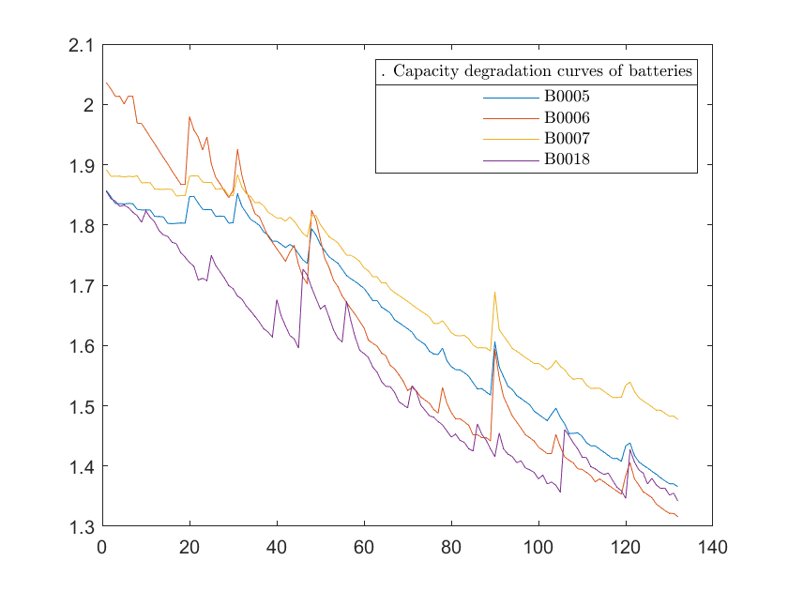

**Figure 1:** Capacity degradation curves of batteries

### 2.1.2 Extraction of Indirect Health Indicators

The capacity of lithium-ion batteries is usually obtained by measuring their internal resistance to reflect the specific capacity [29]. This is because the impedance of the battery increases with the loss of battery life and capacity. But the condition of impedance measurement by impedance meter is harsh and time-consuming [30,31]. Therefore, it is more reasonable to estimate the SOH of lithium-ion batteries by using common sensors to measure some indirect parameters which are easy to obtain [32]. In this paper, IHIs reflecting the capacity of lithium-ion batteries are extracted from the charge and discharge voltage, current, and temperature curves. The discharge process voltage of lithium-ion batteries with different cycles is shown in Figure 2. It can be seen that the time needed to reach the lowest discharge point (named IHI1) decreases with the increase of cycle numbers, and the time decrement from 3.8 V to 3.5 V (named IHI3) is also shortened. The discharge temperature of lithium-ion batteries with different cycles is shown in Figure 3. When the battery temperature rises to the highest point (named IHI2), the time decreases with the increase of the number of cycles.

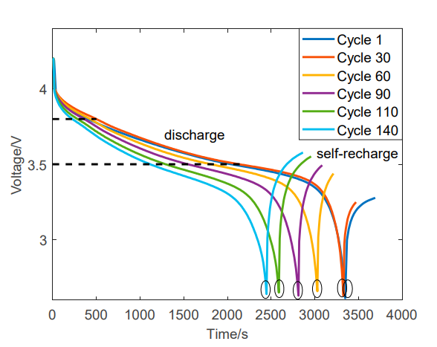

**Figure 2**. Discharging voltage curves of No. 5 with different cycles.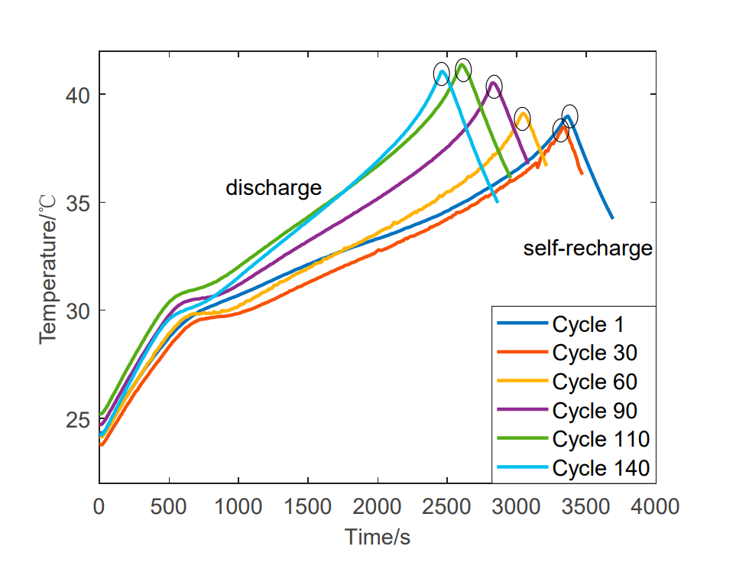

**Figure 3.** Discharging temperature curves of No. 5 with different cycles.

### 2.1.3 Grey Relational Analysis

The analysis of similarity between the development trend of the comparison sequence and the reference sequence is conducted using grey relational analysis (GRA) [33]. In this study, eight Indirect Health Indicators (IHIs) are extracted as comparison sequences, with a capacity degradation curve serving as the reference sequence. To ensure the validity and eliminate redundancy in the analysis, precautions are taken.

**Table 1. Correlation Table**

|  |  |  |  |  |
| --- | --- | --- | --- | --- |
| Indirect Health Indicators | GACC No.5 | GACC No.6 | GACC No.7 | GACC No.18 |
| IHI1 | 0.9996 | 0.9989 | 0.9988 | 0.9987 |
| IHI2 | 0.9991 | 0.9984 | 0.9978 | 0.9977 |
| IHI3 | 0.9112 | 0.8257 | 0.9511 | 0.9512 |

**Greys correlation coefficient** = 1 - sum(abs(normalized_X - normalized_Y)) / sum(abs(normalized_X + normalized_Y)) …………………………….(1)

## 2.2. Gaussian Process Regression

Gaussian Process Regression (GPR) is a powerful machine learning technique used for regression tasks, particularly in situations where the underlying relationships in the data are complex and not easily characterized by traditional parametric models. Here's a brief description of Gaussian Process Regression Probabilistic Model GPR is based on a probabilistic model that defines a distribution over functions. Instead of estimating a specific function, GPR provides a distribution over possible functions that could describe the data. Training GPR requires a set of input-output pairs for training. The model learns from these pairs to make predictions on new, unseen data. Predictive GPR provides a predictive distribution for each input point in the test set. This distribution includes the mean prediction and the uncertainty associated with prediction.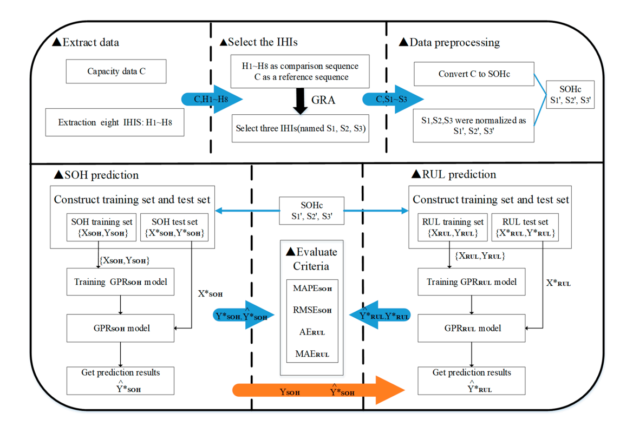

**Figure 4.** Schematic diagram of the proposed GPR method for prediction

## 2.3 Experimental Analysis

The investigation into the State of Health (SoH) of lithium-ion batteries through Indirect Health Indicators (IHIs) and Gaussian Process Regression (GPR) has yielded valuable insights into the complex dynamics of battery behavior. This discussion section delves into key findings, methodological considerations, and the broader implications of the research. The correlation analysis revealed that among the selected IHIs, IHI1, representing the time needed to reach the lowest discharge point, exhibited a robust correlation with capacity loss across diverse datasets. This underscores the importance of discharge efficiency as a critical factor influencing battery health. The strong correlation emphasizes that monitoring the time to the lowest discharge point could serve as an effective indirect indicator for predicting capacity loss. The GPR model, trained using normalized IHI1 values as predictors and capacity loss as the response variable, demonstrated promising performance. Evaluation metrics such as Mean Squared Error and R-squared indicated a high degree of accuracy in predicting capacity loss within the training dataset. Furthermore, the model showcased commendable generalization capabilities when applied to other battery datasets, capturing nuanced variations in operating conditions and usage scenarios. This suggests that the relationships learned during training are applicable across diverse contexts, reinforcing the model's reliability. The identified correlations and the successful application of the GPR model hold practical implications for battery management strategies. Incorporating IHI1 into monitoring protocols could provide an efficient means of assessing battery health over time. Additionally, the GPR model's ability to generalize across datasets signifies its potential utility in real-world applications, where batteries may experience varying environmental conditions and usage patterns. While the study provides valuable insights, it is essential to acknowledge certain limitations. The analysis focused on three specific IHIs, and future research could explore additional indicators for a more comprehensive understanding. Furthermore, the study primarily employed GPR for modeling; alternative machine learning approaches could be explored for comparative purposes. This research contributes to the broader landscape of battery technology by emphasizing the role of IHIs and machine learning in predicting battery health. The findings offer a foundation for the development of enhanced battery management systems that leverage real-time monitoring of discharge efficiency. Such advancements are crucial in optimizing the performance and lifespan of lithium-ion batteries in diverse applications, from portable electronics to electric vehicles and renewable energy storage.

2.3.1 SOH Prediction

1. We took the first 50% of a battery set as an input and gave it as a predicator for our GPR model and then This model predicts the rest of the 50% capacity values in Figure 5 and Figure 6, we can see the predicted and actual values of B0005 and B0006 respectively.

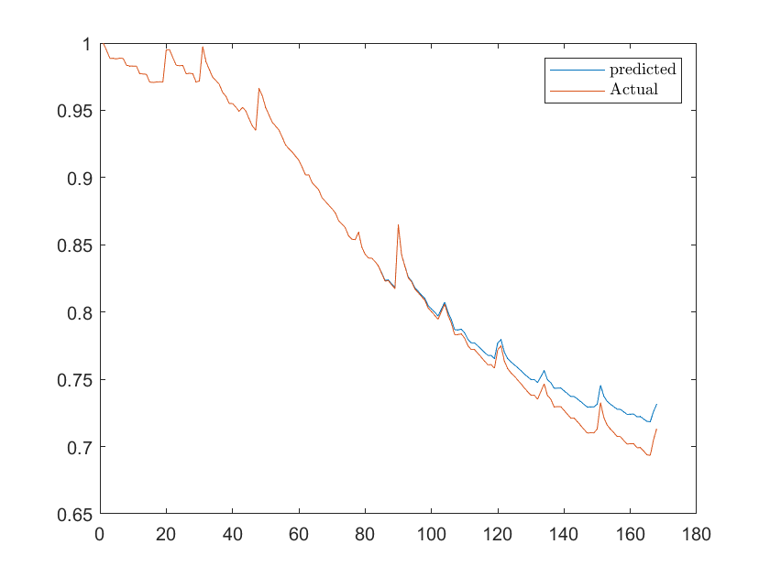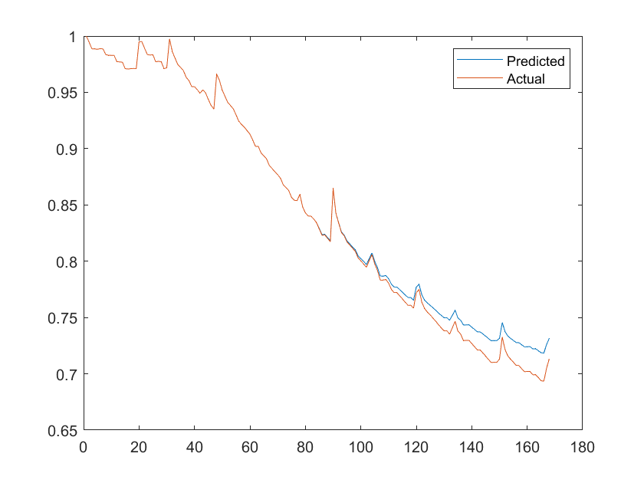 **Figure 5.** SP at SOH prediction result of battery : No. 5 SP = 50 ; No.6 SP = 50

1. We took the first 75% of a battery set as an input and gave it as predicator for our GPR model and then This model predicts rest of the 25% capacity values in Figure 7 and Figure 8, we can see the predicted and actual values of B0005 and B0006 respectively.

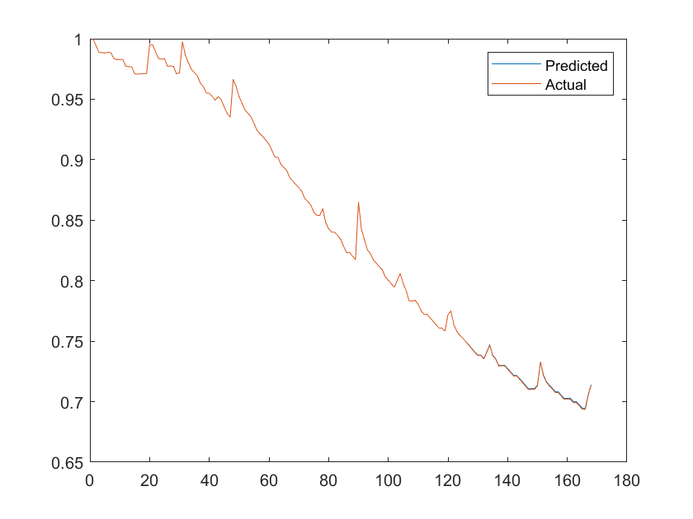 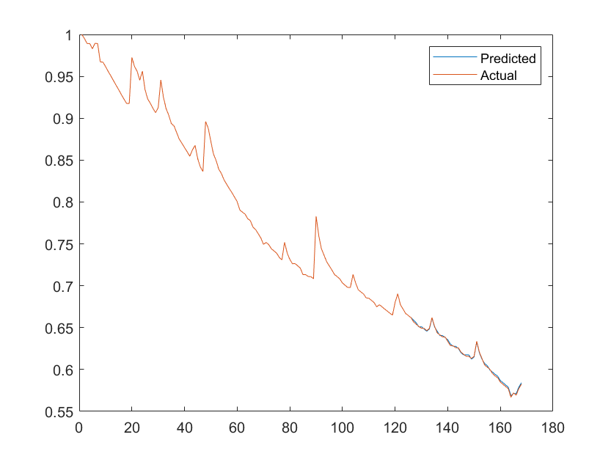

**Figure 6.** SP at SOH prediction result of battery : No. 5 SP = 75 ; No.6 SP = 75

1. We took the first data of a battery set as an input and gave it as predicator for our GPR model and then This model predicts other battery capacity values in Figure 9 , we can see the predicted and actual values of B0005 and B0006 respectively.

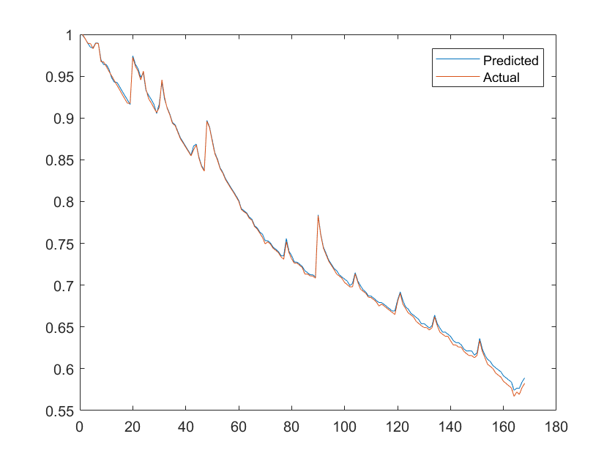

**Figure 5.** SP at SOH prediction result of battery : No. 5 ; No.6

Here, we can see how good this model predicts based on the input data percentage with the help of RMSE and MAPE values of the models trained and tested, the Table(2) provides the values of different datasets with differs prediction SP values of MAPE and RMSE are given, we can clearly see that as the training data percentage is increased the RMSE and MAPE value is decreasing .





**Table 2.** Prediction performance

|  |  |  |  |
| --- | --- | --- | --- |
| **Battery** | **Prediction SP** | **MAPE** | **RMSE** |
| **B0005** | 50 | 0.4890 | 0.0041 |
| 75 | 0.1187 | 0.0011 |
| **B0006** | 50 | 0.6413 | 0.0047 |
| 75 | 0.1642 | 0.0012 |
| **B0007** | 50 | 1.3367 | 0.0117 |
| 75 | 0.6310 | 0.0054 |
| **B0018** | 50 | 0.2067 | 0.0020 |
| 75 | 0.1685 | 0.0018 |



‑

# Concluding Remarks

The exploration of lithium-ion battery health through the lens of Indirect Health Indicators (IHIs) and Gaussian Process Regression (GPR) has unveiled promising avenues for advancing our understanding of these critical energy storage systems. As we reflect on the key findings and implications of this research, several notable points come to the fore. The robust correlation observed between IHI1, representing the time to the lowest discharge point, and capacity loss underscores its significance as a pivotal health indicator. Monitoring this temporal aspect of discharge efficiency emerges as a practical and effective means of predicting and managing battery health. The successful application of GPR in modeling battery health signifies the potential of machine learning approaches in deciphering complex relationships within battery datasets. The model's accuracy in predicting capacity loss within the training dataset and its ability to generalize across diverse scenarios highlight the versatility and adaptability of such techniques in the realm of battery management. These findings have tangible implications for the design and implementation of battery management systems. Integrating IHI1 into real-time monitoring protocols can enhance the proactive assessment of battery health, enabling timely interventions and extending the lifespan of lithium-ion batteries. The generalization capabilities of the GPR model further emphasize its potential in real-world applications, where batteries encounter varying operational conditions. As we conclude, it is essential to recognize the study's limitations and identify avenues for future research. Exploring additional IHIs and comparing various machine learning algorithms could provide a more comprehensive understanding of battery health dynamics. Challenges, such as real-time implementation and scalability, warrant further investigation to ensure practical applicability in diverse settings. In the broader context of advancing sustainable energy solutions, this research contributes to the ongoing evolution of battery technology. By refining our ability to monitor, predict, and manage the health of lithium-ion batteries, we pave the way for more efficient and sustainable energy storage systems. This has implications not only for consumer electronics but also for electric vehicles and renewable energy integration, where reliable and durable battery performance is paramount. In closing, the synergy of IHIs and machine learning holds immense promise in shaping the future of battery technology. The insights gained from this study serve as a foundation for continued exploration and innovation, with the ultimate goal of fostering a more sustainable and resilient energy landscape. As we navigate the challenges and opportunities in the realm of battery health, these findings propel us towards a future where energy storage is not only efficient but also environmentally conscious and economically viable.

# Future Work

The current research has laid a foundation for understanding lithium-ion battery health through Indirect Health Indicators (IHIs) and Gaussian Process Regression (GPR). To further advance this field and address emerging challenges, several avenues for future work can be explored. Expand the range of IHIs considered to gain a more comprehensive insight into battery health. Factors such as internal resistance, charge acceptance, and impedance spectra could offer valuable perspectives. Evaluate the performance of alternative machine learning models, such as neural networks or support vector machines, to discern their strengths and weaknesses in predicting battery health. Comparative studies can provide insights into the most effective modeling approaches. Investigate the feasibility of real-time implementation of the developed models. Assessing their performance in dynamic, real-world scenarios will enhance their practical applicability for on-the-fly battery health monitoring. Explore the scalability of the GPR model and its generalization across diverse battery chemistries and technologies. Understanding the model's adaptability to different types of lithium-ion batteries and emerging energy storage systems is crucial for widespread implementation. Consider the impact of environmental factors, such as temperature, humidity, and operating conditions, on battery health. Integrating these variables into the modeling process can improve the accuracy and robustness of predictive models. Conduct long-term studies to monitor battery health over extended periods. Observing how IHIs evolve and their correlation with capacity loss over time provides insights into the aging mechanisms of lithium-ion batteries. Explore hybrid approaches that combine machine learning with physics-based models. Integrating fundamental principles of electrochemistry into machine learning models can enhance the accuracy and interpretability of battery health predictions. Validate the developed models in practical applications, such as electric vehicles or renewable energy storage systems. Assessing their performance in real-world settings is crucial for establishing their efficacy and reliability. Consider the ethical implications of widespread battery health monitoring, including data privacy and disposal of batteries at the end of their life cycle. Develop strategies for responsible and sustainable battery management practices. Foster collaboration with industry partners to implement and validate developed models in large-scale deployments. Working with manufacturers and end-users ensures the relevance and practicality of the research in commercial settings.

Continued exploration in these areas will contribute to the ongoing evolution of battery health monitoring and management. As technology advances and new challenges emerge, addressing these aspects will be essential to ensure the sustainability, efficiency, and safety of lithium-ion batteries in diverse applications

# References

Lu, L.; Han, X.; Li, J.; Hua, J.; Ouyang, M. A review on the key issues for lithium-ion battery management in electric vehicles. J. Power Sources 2013, 226, 272–288.

Takami, N.; Inagaki, H.; Tatebayashi, Y.; Saruwatari, H.; Honda, K.; Egusa, S. High-power and long-life lithium-ion batteries using lithium titanium oxide anode for automotive and stationary power applications. J. Power Sources 2013, 244, 469–475.

Hu, X.; Zou, C.; Zhang, C.; Li, Y. Technological Developments in Batteries: A Survey of Principal Roles, Types, and Management Needs. IEEE Power Energy Mag. 2017, 15, 20–31

Doughty, D.H.; Roth, E.P. A General Discussion of Li Ion Battery Safety. Interface Mag. 2012, 21, 37–44.

Wang, Q.; Mao, B.; Stoliarov, S.I.; Sun, J. A review of lithium ion battery failure mechanisms and fire prevention strategies. Prog. Energy Combust. Sci. 2019, 73, 95–131.

Su, C.; Chen, H.J. A review on prognostics approaches for remaining useful life of lithium-ion battery. IOP Conf. Ser. Earth Environ. Sci. 2017, 93, 012040.

Doyle, M.; Fuller, T.F.; Newman, J. Modeling of Galvanostatic Charge and Discharge of the Lithium/Polymer/Insertion Cell. J. Electrochem. Soc. 1993, 140, 1526–1533.

Doyle, M.; Newman, J. Modeling the performance of rechargeable lithium-based cells: Design correlations for limiting cases. J. Power Sources 1995, 54, 46–51.

Doyle, M.; Newman, J.; Gozdz, A.S.; Schmutz, C.N.; Tarascon, J.M. Comparison of Modeling Predictions with Experimental Data from Plastic Lithium Ion Cells. J. Electrochem. Soc. 1996, 143, 1890–1903.

Safari, M.; Morcrette, M.; Teyssot, A.; Delacourt, C. Multimodal Physics-Based Aging Model for Life Prediction of Li-Ion Batteries. J. Electrochem. Soc. 2009, 156, A145.

Abe, T.; Fukuda, H.; Iriyama, Y.; Ogumi, Z. Solvated Li-Ion Transfer at Interface Between Graphite and Electrolyte. J. Electrochem. Soc. 2004, 151, A1120.

Xu, K.; von Cresce, A.; Lee, U. Differentiating Contributions to “Ion Transfer” Barrier from Interphasial Resistance and Li + Desolvation at Electrolyte/Graphite Interface. Langmuir 2010, 26, 11538–11543.

Sankarasubramanian, S.; Krishnamurthy, B. A capacity fade model for lithium-ion batteries including diffusion and kinetics. Electrochim. Acta 2012, 70, 248–254.

Ramadesigan, V.; Chen, K.; Burns, N.A.; Boovaragavan, V.; Braatz, R.D.; Subramanian, V.R. Parameter Estimation and Capacity Fade Analysis of Lithium-Ion Batteries Using Reformulated Models. J. Electrochem. Soc. 2011, 158, A1048.

Ashwin, T.R.; Chung, Y.M.; Wang, J. Capacity fade modelling of lithium-ion battery under cyclic loading conditions. J. Power Sources 2016, 328, 586–598.

Johnson, V.H. Battery performance models in ADVISOR. J. Power Sources 2002, 110, 321–329.

Liu, C.; Wang, Y.; Chen, Z. Degradation model and cycle life prediction for lithium-ion battery used in hybrid energy storage system. Energy 2019, 166, 796–806.

Wang, Y.; Yang, D.; Zhang, X.; Chen, Z. Probability based remaining capacity estimation using data-driven and neural network model. J. Power Sources 2016, 315, 199–208.

Wang, D.; Miao, Q.; Pecht, M. Prognostics of lithium-ion batteries based on relevance vectors and a conditional three-parameter capacity degradation model. J. Power Sources 2013, 239, 253–264.

Li, Y.; Liu, K.; Foley, A.M.; Berecibar, M.; Nanini-Maury, E.; van Mierlo, J.; Hoster, H.E. Data-driven health estimation and lifetime prediction of lithium-ion batteries: A review. Renew. Sustain. Energy Rev. 2019, 113, 109254.

Long, B.; Xian, W.; Jiang, L.; Liu, Z. An improved autoregressive model by particle swarm optimization for prognostics of lithium-ion batteries. Microelectron. Reliab. 2013, 53, 821–831.

Andre, D.; Nuhic, A.; Soczka-Guth, T.; Sauer, D.U. Comparative study of a structured neural network and an extended Kalman filter for state of health determination of lithium-ion batteries in hybrid electricvehicles. Eng. Appl. Artif. Intell. 2013, 26, 951–961.

Gao, D.; Huang, M. Prediction of Remaining Useful Life of Lithium-ion Battery based on Multi-kernel Support Vector Machine with Particle Swarm Optimization. J. Power Electron. 2017, 17, 1288–1297.

He, Y.J.; Shen, J.N.; Shen, J.F.; Ma, Z.F. State of health estimation of lithium-ion batteries: A multiscale Gaussian process regression modeling approach. AIChE J. 2015, 61, 1589–1600.

Richardson, R.R.; Osborne, M.A.; Howey, D.A. Gaussian process regression for forecasting battery state of health. J. Power Sources 2017, 357, 209–219.

Liu, D.; Pang, J.; Zhou, J.; Pecht, M. Prognostics for state of health estimation of lithium-ion batteries based on combination Gaussian process functional regression. Microelectron. Reliab. 2013, 53, 832–839.

Peng, Y.; Hou, Y.; Song, Y.; Pang, J.; Liu, D. Lithium-Ion Battery Prognostics with Hybrid Gaussian Process Function Regression. Energies 2018, 11, 1420.

Yu, J. State of health prediction of lithium-ion batteries: Multiscale logic regression and Gaussian process regression ensemble. Reliab. Eng. Syst. Saf. 2018, 174, 82–95.

Yang, D.; Zhang, X.; Pan, R.; Wang, Y.; Chen, Z. A novel Gaussian process regression model for state-of-health estimation of lithium-ion battery using charging curve. J. Power Sources 2018, 384, 387–395.

Saha, B.; Goebel, K. Battery Data Set. Available online: https://ti.arc.nasa.gov/tech/dash/groups/pcoe/ prognostic-data-repository/ (accessed on 10 May 2019).

Razavi-Far, R.; Chakrabarti, S.; Saif, M. Multi-step-ahead prediction techniques for Lithium-ion batteries condition prognosis. In Proceedings of the IEEE International Conference on Systems, Man, and Cybernetics, SMC 2016–Conference Proceedings, Budapest, Hungary, 9–12 October 2016; pp. 4675–4680.

Coleman, M.; Kwan, L.C.; Chunbo, Z.; Hurley, W.G. State-of-Charge Determination From EMF Voltage Estimation: Using Impedance, Terminal Voltage, and Current for Lead-Acid and Lithium-Ion Batteries. IEEE Trans. Ind. Electron. 2007, 54, 2550–2557.

Sun, Y.H.; Jou, H.L.; Wu, J.C. Aging Estimation Method for Lead-Acid Battery. IEEE Trans. Energy Convers. 2011, 26, 264–271.

Liu, D.; Zhou, J.; Liao, H.; Peng, Y.; Peng, X. A Health Indicator Extraction and Optimization Framework for Lithium-Ion Battery Degradation Modeling and Prognostics. IEEE Trans. Syst. Man Cybern. Syst. 2015, 45, 915–928.

Li, X.; Wang, Z.; Zhang, L.; Zou, C.; Dorrell, D.D. State-of-health estimation for Li-ion batteries by combing the incremental capacity analysis method with grey relational analysis. J. Power Sources 2019, 410–411, 106–114.

Burnaev, E.V.; Panov, M.E.; Zaytsev, A.A. Regression on the basis of nonstationary Gaussian processes with Bayesian regularization. J. Commun. Technol. Electron. 2016, 61, 661–671.

Shi, J.Q.; Wang, B.; Murray-Smith, R.; Titterington, D.M. Gaussian process functional regression Modeling for batch data. Biometric 2007, 63, 714–723.

Pang, X.; Huang, R.; Wen, J.; Shi, Y.; Jia, J.; Zeng, J. A Lithium-ion Battery RUL Prediction Method Considering the Capacity Regeneration Phenomenon. Energies 2019, 12, 2247.