**Q4.**

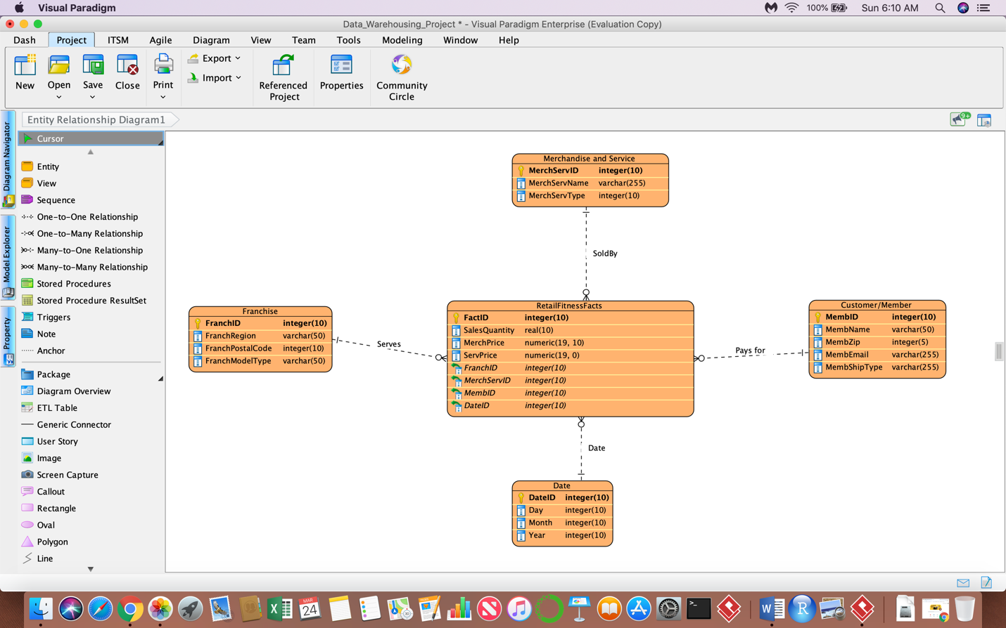

**Create Table Syntax:**

**1. Franchise Dimension Table:**

Create Table Franchise (

FranchID Int Primary key,

FranchRegion Varchar(255) Not Null,

FranchPostalCode Varchar(255) Not Null,

FranchModelType Varchar (255) Not Null

);

**2. Date Dimension Table:**

Create Table Date (

DateID Int Primary Key,

Day Int Not Null,

Month Int Not Null,

Year Int Not Null

);

**3. Customer/ Member Dimension Table:**

Create Table Customer (

MemberID Int Primary Key,

Member Zip Int Not Null,

MemberEmail Varchar(255) Not Null,

Membership Type Varchar (255) Not Null

);

**4. Merchandise_And_Service Dimension Table:**

Create table Merchandise_And_Service (

MerchServID Int Primary Key,

MerchServName Varchar(255) Not Null,

MerchServType Varchar (255) Not Null

);

**5. Retail Fitness Facts Dimension Table:**

Create table RetailFitnessFacts (

FactID Int PrimaryKey,

SalesQuantity Decimal(10,5) Not Null,

MerchPrice Decimal (10,5) Not Null,

ServPrice Decimal (10,5) Not Null,

Constraint FK1 Foreign Key (FranchID) References Franchise,

Constraint FK2 Foreign Key (DateID) Reference Date,

Constraint FK3 Foreign Key (MemberID) Reference Customer/Member,

Constraint FK4 Foreign Key (MerchServID) Reference Merchandise_And_Service ,

);