**MCIS 6333_002 – Data Visualization Programming**

**Fall 2023 Dr. Esther Ledelle Mead, Professor**

**Assignment 1 (A1)** Module 1 12 points

**Instructions**: Work as a team to fill in your team and team member information. Then continue to work as a team to enter responses for each of the five sections: 1) Applying Gestalt principles of Similarity, Proximity, and Enclosure, 2) Making the best Color choices based on context, 3) Understanding the four levels of data measurement, 4) Some of the basics of R for DVP, and 5) Some of the basics of Python for DVP. Do not change the file name of this template except for adding your Team Number and name at the end of "A1-MCIS6333_001" (for example, "A1-MCIS6333_001-Team_1-Bad-To-The-Bone.docx"). Do not remove any content from this template. **Before submission, be sure that all required components are visible on the final version of your file by expanding their edges as needed and by inserting extra space as needed. Be careful not to move around the objects on this document in a way that messes up the flow. As you add content, the items will be pushed down, which is fine, but be sure to not let any images get split up or caught in between two pages. If you do accidentally mess it up, download a fresh copy of the A1 template from Bb. Turning in work created by students/teams from a past semester will result in a score of zero (0) and an official Academic Dishonesty and Integrity Violation report for each team member to the SAU Authorities.**

**Team #: _1_ Team Name: __Datavana__  
   
Team Members (*full names are required*): Contributed effort to this A1? *(Y or N):*  
1. _Revanth Kumar Madasu____________________ __Y__  
2. _Anusha Pakkiru___________________________ __Y__  
*(Remove any unused lines from above.)***

**1) Applying Gestalt principles of Similarity, Proximity, and Enclosure:**

**a)** *Which gestalt principle(s) is(are) being utilized in the following data visualization? Insert an X inside (or otherwise mark or fill) the box or boxes that apply.:*

*

Similarity Proximity Enclosure

**b)** *Which gestalt principle(s) is(are) being utilized in both of the following data visualizations? Insert an X inside (or otherwise mark or fill) the box or boxes that apply.:*

*

Similarity Proximity Enclosure

**c)** *Which gestalt principle(s) is(are) being utilized in the following data visualization? Insert an X inside (or otherwise mark or fill) the box or boxes that apply.:*

*

Similarity Proximity Enclosure

**d)** *Which gestalt principle(s) is(are) being utilized in both of the following data visualizations? Insert an X inside (or otherwise mark or fill) the box or boxes that apply.:*

*

Similarity Proximity Enclosure

**2) Making the best Color choices based on context:**

*Instructions: What are the ideal color choices for designing a data visualization for a company that wants to track the number of software testing bugs in terms of both severity and priority levels that are categorized using the following labels:* ***Priority****: Low, Medium, High, Critical;* ***Severity****: Low, Moderate, Major, Critical? Show your answer by inserting the appropriate label from the before-mentioned list into the text box next to the color in the below matrix:*

Low

Medium

High

Low

Medium

High

Critical

Critical

**3) Understanding the four levels of data measurement:**

*Instructions: For each of the below lettered items (a, b, c, d) designate which level of data measurement is being captured (nominal, ordinal, interval, or ratio) by changing the text “Your response” in the text boxes to the correct level of data measurement.*

**

*Nominal*

**

*Ordinal*

**c)** 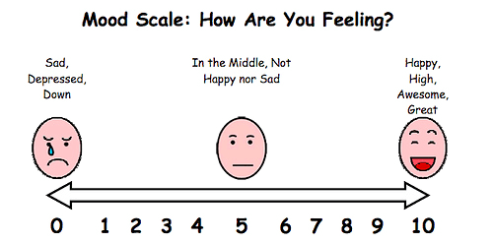

*Interval*

**d)** 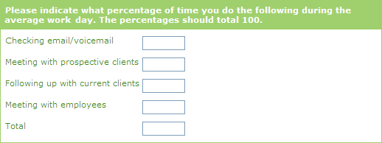

*Ratio*

***(Section 3 continued on next page with item e).)***

**e)** *Instructions: Use the “Extensive Requirements” test (as explained in Class Session 3) to determine whether or not the following measurement instrument (a question on a survey) is capturing data that is at the interval level of data measurement. Designate your answer by placing an “X” in the box next to either “Passed” or “Failed”.*

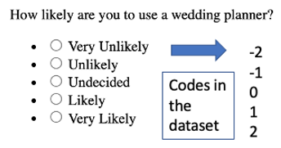

*

**Passed**

**Failed**

**f)** *Instructions: Use the “Extensive Requirements” test (as explained in Class Session 3) to determine whether or not the following measurement instrument (a question on a survey) is capturing data that is at the interval level of data measurement. Designate your answer by placing an “X” in the box next to either “Passed” or “Failed”.*

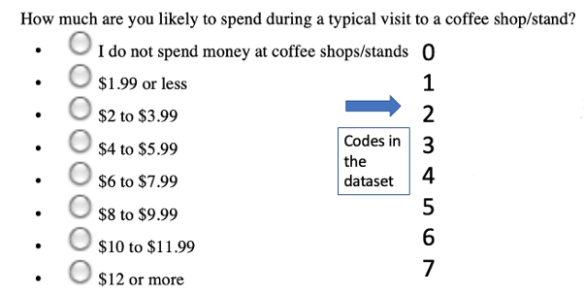

*

**Passed**

**Failed**

***(Section 3 continued on next page with item g).)***

**g)** *Instructions: Use the “Extensive Requirements” test (as explained in Class Session 3) to determine whether or not the following measurement instrument (a question on a survey) is capturing data that is at the interval level of data measurement. Designate your answer by placing an “X” in the box next to either “Passed” or “Failed”.*

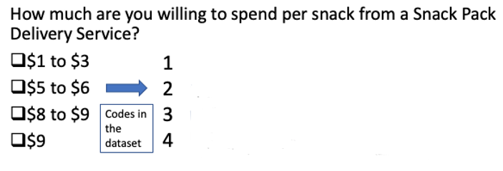

**Passed**

*

**Failed**

**4) Some of the basics of R for DVP:**

*Instructions: For each of the lettered items below (a, b, c, d), insert the correct line of basic R code (from S5 lecture pptx) that would produce the desired result.*

**a)** Load a CSV file.

Insert your response below this line.

**data<-read.csv(“file_name.csv”)**

**b)** Load an XLSX file.

Insert your response below this line.

**data<-read_excel(“file_name.xlsx”)**

**c)** Define a variable based on a column in a dataset.

Insert your response below this line.

**x <- data$column_name**

**d)** Basic plot of two variables.

Insert your response below this line.

**library(ggplot2)**

**ggplot(data, aes(x=x, y=y))+geom_point()**

***(Continued on next page with Section 5.)***

**5) Some of the basics of Python for DVP:**

*Instructions: For each of the lettered items below (a, b, c, d), insert the correct line of basic Python code (from S5 lecture pptx) that would produce the desired result.*

Insert your responses below this line.

**a)** Load a CSV file.

Insert your response below this line.

**import pandas as pd**

**df = pd.read_csv(“data.csv”)**

**b)** Load an XLSX file.

Insert your response below this line.

**df = pd.read_excel(“data.xlsx”)**

**c)** Define a variable based on a column in a dataset.

Insert your response below this line.

**x = df[“column_name”]**

**d)** Basic plot of two variables.

Insert your response below this line.

**from matplotlib import pyplot as plt**

**fig, ax = plt.subplots()**

**ax.plot(x, y, linewidth=2.0)**

**MCIS 6333_002 – Data Visualization Programming**

**Fall 2023 Dr. Esther Ledelle Mead, Professor**