CREATE TABLE CUSTOMERS(CUST_NO NUMBER(3),CNAME VARCHAR(10),CITY VARCHAR2(20),PRIMARY KEY(CUST_NO));

CREATE TABLE ORDERS(ORDER_NO NUMBER(3),O_DATE DATE,CUST_NO NUMBER(3),ORD_AMT REAL,PRIMARY KEY(ORDER_NO),FOREIGN KEY(CUST_NO) REFERENCES CUSTOMERS);

CREATE TABLE ITEM(ITEM_NO NUMBER(3),UNIT_PRICE REAL,PRIMARY KEY(ITEM_NO));

CREATE TABLE ORDER_ITEM(ORDER_NO NUMBER(3),ITEM_NO NUMBER(3),QTY NUMBER(3),PRIMARY KEY(ORDER_NO,ITEM_NO),FOREIGN KEY(ORDER_NO) REFERENCES ORDERS,FOREIGN KEY(ITEM_NO) REFERENCES ITEM);

CREATE TABLE WAREHOUSE(WAREHOUSE_NO NUMBER(3), CITY VARCHAR2(20),PRIMARY KEY(WAREHOUSE_NO));

CREATE TABLE SHIPMENT(ORDER_NO NUMBER(3),WAREHOUSE_NO NUMBER(3),SHIP_DATE DATE,FOREIGN KEY(ORDER_NO) REFERENCES ORDERS,FOREIGN KEY(WAREHOUSE_NO) REFERENCES WAREHOUSE);

INSERT INTO CUSTOMERS VALUES(&CUST_NO,'&CNAME','&CITY');

SELECT * FROM CUSTOMERS;

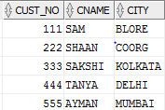

INSERT INTO ORDERS VALUES(&ORDER_NO,'&O_DATE',&CUST_NO,&ORD_AMT);

SELECT * FROM ORDERS;

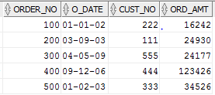

INSERT INTO ITEM VALUES(&ITEM_NO,&UNIT_PRICE);

SELECT * FROM ITEM;

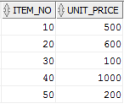

INSERT INTO ORDER_ITEM VALUES(&OREDR_NO,&ITEM_NO,&QTY);

SELECT * FROM ORDER_ITEM;

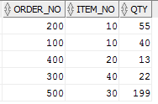

INSERT INTO WAREHOUSE VALUES(&WAREHOUSE_NO,'&CITY');

SELECT * FROM WAREHOUSE;

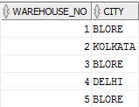

INSERT INTO SHIPMENT VALUES(&ORDER_NO,&WAREHOUSE_NO,'&SHIP_DATE');

SELECT * FROM SHIPMENT;

