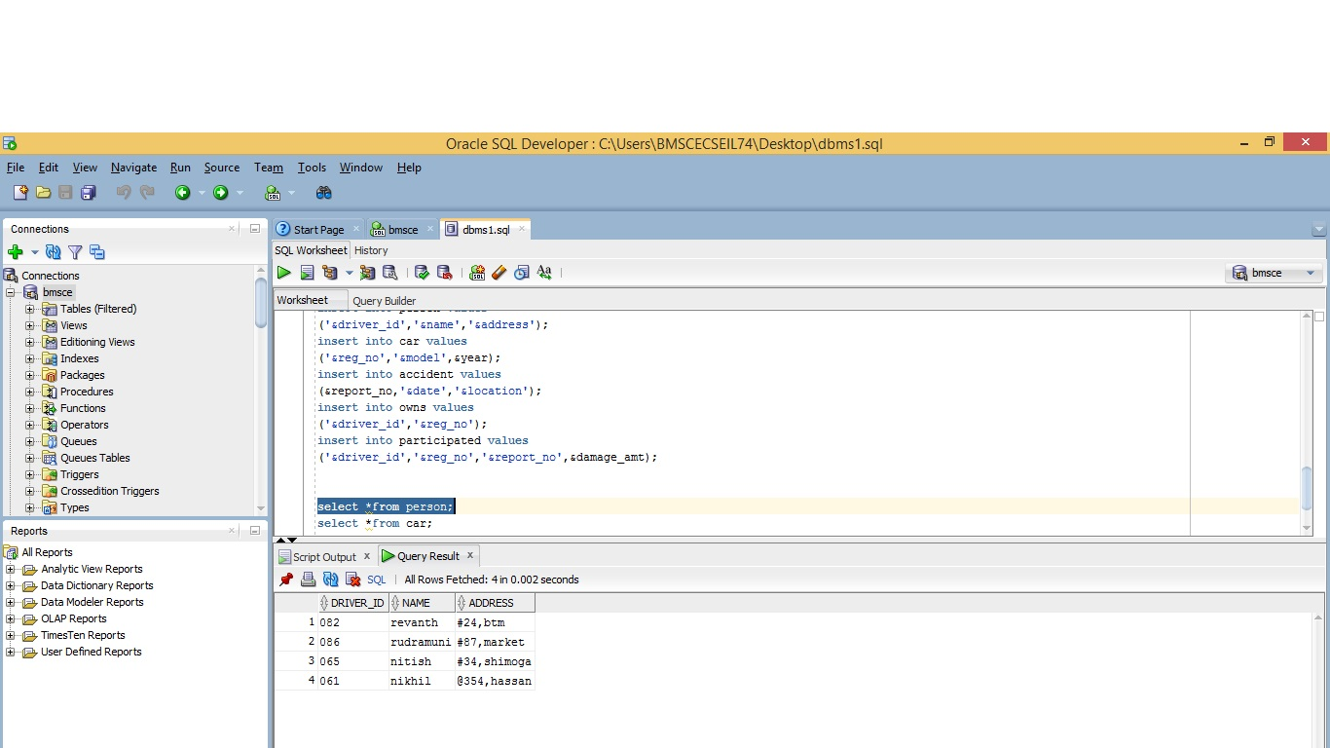

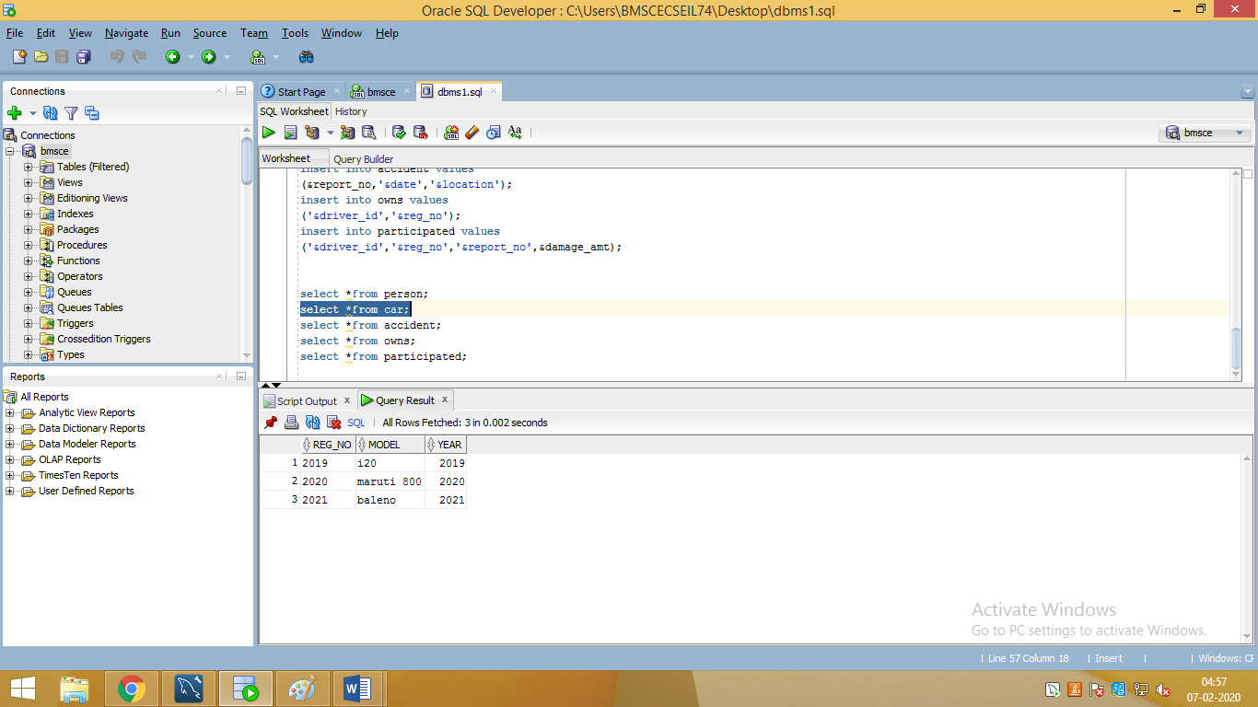

create table person

(

driver_id varchar2(10),

name varchar2(20),

address varchar2(15),

primary key(driver_id)

);

create table car(

reg_no varchar2(10),

model varchar2(10),

year number(4),

primary key(reg_no)

);

create table accident

(

report_no number(5),

adate date,

location varchar2(15),

primary key(report_no)

);

create table owns

(

driver_id varchar2(10),

reg_no varchar2(10),

primary key(driver_id,reg_no),

foreign key(driver_id)references person(driver_id),

foreign key(reg_no)references car(reg_no)

);

create table participated

(

driver_id varchar2(10),

reg_no varchar2(10),

report_no number(5),

damage_amt number(7,2),

primary key(driver_id,reg_no,report_no),

foreign key(driver_id,reg_no)references owns(driver_id,reg_no)on delete cascade,

foreign key(report_no)references accident(report_no)on delete cascade

);

insert into person values

('&driver_id','&name','&address');

insert into car values

('&reg_no','&model',&year);

insert into accident values

(&report_no,'&date','&location');

insert into owns values

('&driver_id','&reg_no');

insert into participated values

('&driver_id','&reg_no','&report_no',&damage_amt);

select *from person;

select *from car;

select *from accident;

select *from owns;

select *from participated;

