Generative adversarial networks for image Generation
Background and Methodology:
Generative Adversarial Networks (GAN) is a deep learning model useful for unsupervised learning. GAN is often used for generating the synthetic data that will be similar to real world data. It was introduced in 2014 by Ian Goodfellow. It has two neural networks called generator and the discriminator which helps the GAN to generate synthetic data. GAN variants like DCGAN, WGAN, Cycle GAN, StyleGAN are also developed to improve stability and performance. In this project I used GAN to generate images by using MNIST and CIFAR-10 datasets. GAN is one of the key component for modern day data science. It is useful in applications like data generation, data augmentation, anomaly detection, image to image translations. GAN will make datasets balanced and it will improve the model’s performance by not collecting more real data. If there are any missing values in real-world datasets GAN can realistically impute the missing values by learning the data distribution.
GANs are comprised of two networks, generator and discriminator, and are trained adversarially. Generator generates data from noise to replicate real data distributions and the discriminator to verify samples for determining whether samples are real or fake. It's a minimax game wherein the generator is trying to generate what it is generating more quality to attempt to fool the discriminator, and the discriminator is trying to improve in order to spot forgery. The training is performed by interchanging the training of both the networks such that it obtains loss function optimization, i.e., for binary cross-entropy or Wasserstein distance, e.g., both the networks improve and improve until the generator generates as fine as real and discriminator can differentiate fully none at all.
Task description:
Develop a generative adversarial network (GAN) that :
- Creates realistic 64x64 RGB images from random noise.
- Learns features effectively from MNIST dataset.
- Trains stably with well-balanced generator-discriminator dynamics.
Dataset:
- Total number of images: 70000
- Total number of training images: 60000
- Total number of testing images: 10000
- Total number of classes: 10
- Class types: handwritten digits 0,1,2,3,4,5,6,7,8,9.
- Each image is 28x28 pixels with single channel (grayscale)
- Pixel values range from 0 to 255 (black to white)
Implementation details:
Generator :
This generator produces 28 x 28 grayscale images from 100 dimensional random noise vector. This generator model contains fully connected layers like Dense layers, activation layers, upsampling layers and convolutional layers. We also used batch normalization to stabilize training and tanh as activation function to rescale pixel values between -1 and 1.

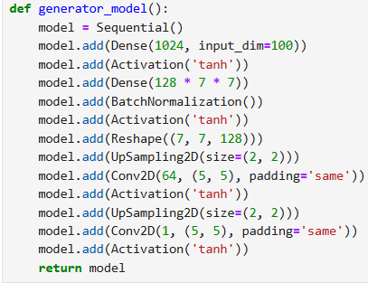
Input : 100-dim random noise vector
Output : 28 X 28 grayscale images.

Discriminator :
The discriminator acts as a binary classifier to classify the images as real MNIST images or images generated by the generator. It takes a 28 x 28 image as input(it can be real or generated) and classifies that image as real or fake.

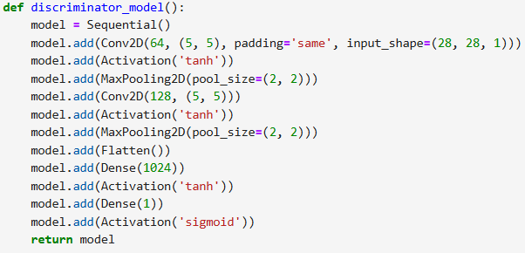
Combined GAN model :
This function combines both generator and discriminator model so that the generator can be trained based on the feedback of the discriminator model.

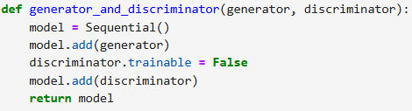

Training :
In this training process we reshape the images from MNIST dataset into (28,28,1) and normalize the values between -1 and 1. We set the batch size as 128 and we use Stochastic gradient descent with nesterov momentum as an optimizer.

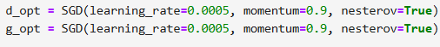

We used binary cross entropy loss as loss function for both models. During training, we save generated samples every 20 steps and save weights every 10 batches. We also calculated Generator_loss and discrimnator_loss.

Generating Images :
This function generates images after the whole training process.
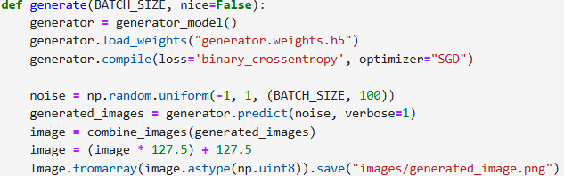

Evaluation Metrics :
To evaluate the generated image quality, we implemented Fréchet Inception Distance (FID) using the InceptionV3 network. We computed the mean and covariance of the feature vectors for both image sets and calculated the FID score.

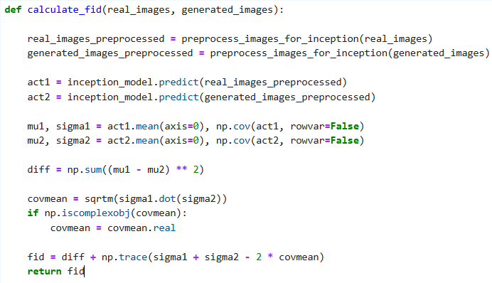

Results:
1.
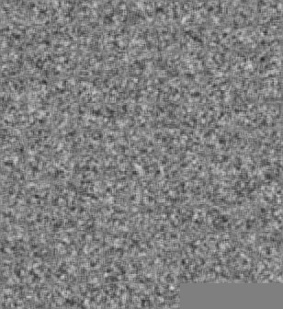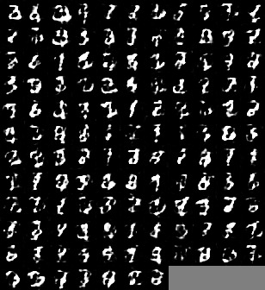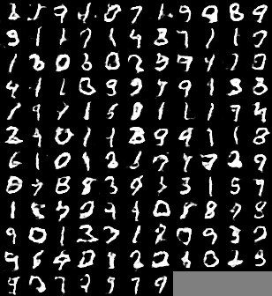
Initial noise epoch 5 epoch 15
We can see in the above images that after epoch good quality image is generated.
2.
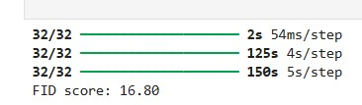
FID score of 16.80 shows that the generated image quality is pretty good.
3.
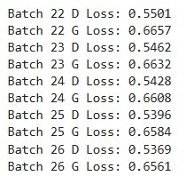
There is good balance between D loss and G loss which means the training process is stable.
4.Quality of generated image is looking good with the naked eye as well.
Performance Improvement strategies:
- Replace regular CNN with DCGAN or RENSET blocks for sharper image generation.
- Learning rate scheduling.
- Add dynamic LR adaptation to converge more.
- Data augmentation.
- Apply rotations/scaling on MNIST to increase diversity and reduce overfitting.
- Generalize to labeled generation (eg. Generate certain digits on demand).
References:
- https://search.app/ZGMi3dxGc47gi4mJ8
- https://search.app/tDJomcTWPKqC1rVc7
- https://search.app/EnRwMnumYCooR9Cw9
- https://search.app/25xD2eRcXrcVxHN99
- https://search.app/tXXPfShBGBqZmyHeA

