Lang Chain
Model.ts

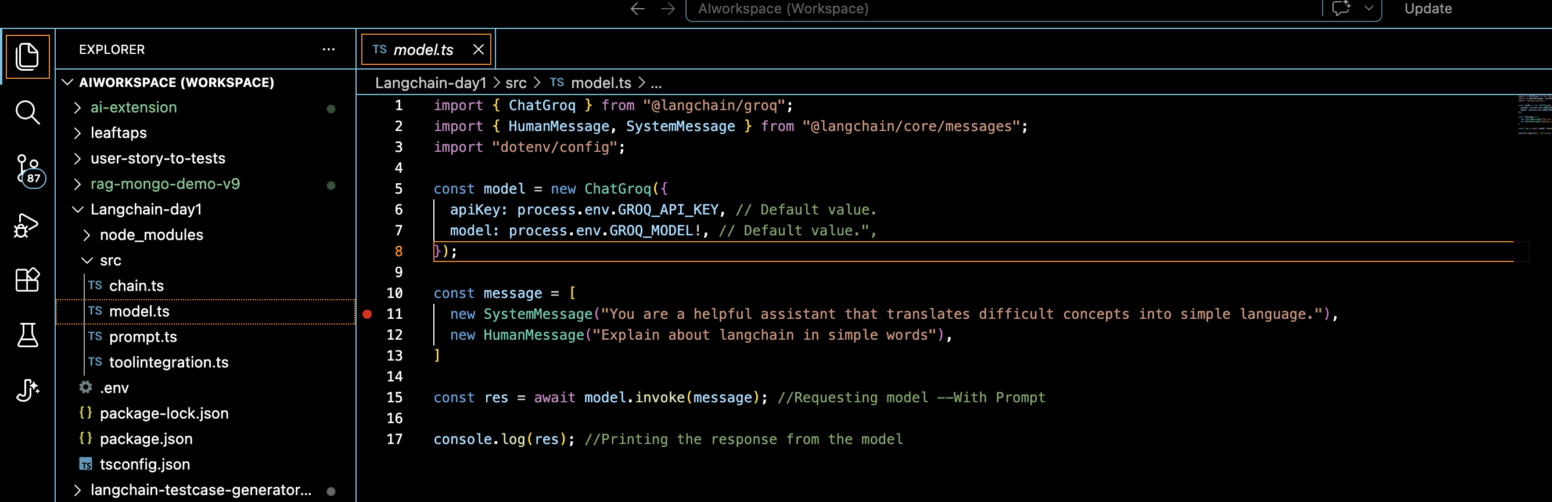
Command : tsx src/model.ts
Output :
AIMessage {
"content": "**LangChain in a nutshell**\n\nImagine you have a very smart robot that can read, write, and think, but it can only do one tiny thing at a time—like answering a question, looking up a fact, or generating a short paragraph. To make it useful for real‑world tasks (like planning a trip, writing a report, or answering a customer’s request), you need to connect many of these tiny abilities together, just like you’d connect LEGO bricks to build something bigger.\n\nThat’s exactly what **LangChain** does. It’s a toolbox (a set of Python libraries) that helps developers **link together** language‑model “bricks” and other useful services so the whole system can solve more complex problems.\n\n---\n\n### The core ideas, explained simply\n\n| Concept | What it means (simple) | Everyday analogy |\n|---------|------------------------|------------------|\n| **Language Model (LLM)** | A powerful text‑generator (like ChatGPT) that can understand and produce language. | A very knowledgeable friend who can talk about almost anything. |\n| **Chain** | A sequence of steps where each step can call an LLM, a database, an API, or some custom code. | A recipe: first you gather ingredients, then you mix, then you bake. |\n| **Prompt** | The text you give the LLM to tell it what to do. | The question you ask your friend. |\n| **Prompt Template** | A reusable way to build prompts with blanks that get filled in automatically. | A fill‑in‑the‑blank form: “My name is ___ and I live in ___.” |\n| **Memory** | A way for the system to remember what happened earlier in the conversation or workflow. | A notebook where you jot down previous answers so you don’t repeat yourself. |\n| **Agents** | Smart controllers that decide *which* tool or LLM to use next, based on the current goal. | A personal assistant that says, “First check the weather, then book the flight.” |\n| **Tools** | External services (search engines, calculators, APIs, databases) that the LLM can call. | A kitchen gadget like a blender or a timer that the chef (LLM) can use. |\n| **Retriever / Vector Store** | A fast lookup system that finds relevant documents or facts from a large collection. | A librarian who quickly finds the right book on a shelf. |\n| **Callbacks / Logging** | Hooks that let you watch what the chain is doing, useful for debugging or analytics. | A camera that records every step of a cooking show. |\n\n---\n\n### How a simple LangChain workflow might look\n\n1. **User asks:** “What’s the best way to plant tomatoes in a balcony garden?”\n2. **Prompt Template** fills in the question and sends it to the LLM → “Explain step‑by‑step…”.\n3. **Retriever** searches a knowledge base for recent gardening articles.\n4. The LLM **combines** the retrieved facts with its own knowledge to write a clear answer.\n5. **Memory** stores the question and answer, so if the user later says “What about watering?” the system can refer back to the first answer.\n6. **Agent** decides whether to call a weather‑API (to give local climate tips) or just stick with text generation.\n7. The final answer is sent back to the user.\n\nAll of those pieces—prompt, retrieval, memory, agent decision, external API—are linked together by **LangChain** so you don’t have to code each connection from scratch.\n\n---\n\n### Why developers love it\n\n| Need | LangChain provides |\n|------|--------------------|\n| **Speed** – want to prototype quickly | Pre‑built classes for prompts, chains, memory, etc. |\n| **Flexibility** – need to swap out a model or a database | Modular design; you can replace the LLM, the vector store, or any tool. |\n| **Scalability** – run on many users or large data | Works with cloud services (OpenAI, Anthropic, Azure, etc.) and scalable vector DBs (Pinecone, Chroma, etc.). |\n| **Complex logic** – need the system to decide what to do next | Agents + tools let the LLM act like a planner. |\n| **Observability** – want to see what’s happening | Callbacks, logging, and tracing built‑in. |\n\n---\n\n### A quick “hello‑world” code sketch\n\n```python\nfrom langchain import LLMChain, PromptTemplate\nfrom langchain.llms import OpenAI # or any other LLM you have access to\n\n# 1️⃣ Define a prompt with a placeholder\ntemplate = \"Explain in simple terms: {question}\"\nprompt = PromptTemplate.from_template(template)\n\n# 2️⃣ Build a chain that sends the prompt to the LLM\nchain = LLMChain(llm=OpenAI(model=\"gpt-4o-mini\"), prompt=prompt)\n\n# 3️⃣ Run it\nanswer = chain.run({\"question\": \"What is photosynthesis?\"})\nprint(answer)\n```\n\nEven this tiny snippet shows the **core pattern**: *template → LLM → result*. From here you can add a retriever, memory, or an agent with just a few more lines.\n\n---\n\n### Bottom line\n\n- **LangChain = glue + recipes** for language‑model applications. \n- It lets you **mix and match** prompts, memory, external tools, and decision‑making agents without reinventing the wheel. \n- Think of it as a **Lego set for AI**: each block (LLM, search, calculator, database) snaps together, and you can build anything from a simple Q&A bot to a multi‑step research assistant.\n\nThat’s LangChain in plain English—your toolkit for turning a single smart language model into a full‑featured, interactive system.",
"additional_kwargs": {},
"response_metadata": {
"tokenUsage": {
"completionTokens": 1262,
"promptTokens": 94,
"totalTokens": 1356
},
"finish_reason": "stop",
"id": "chatcmpl-cbee7dfb-2b96-4346-ab02-4138f4bb0521",
"object": "chat.completion",
"created": 1782666956,
"model": "openai/gpt-oss-120b",
"usage": {
"queue_time": 0.282721111,
"prompt_tokens": 94,
"prompt_time": 0.014525157,
"completion_tokens": 1262,
"completion_time": 2.6300721940000003,
"total_tokens": 1356,
"total_time": 2.644597351,
"completion_tokens_details": {
"reasoning_tokens": 29
}
},
"usage_breakdown": null,
"system_fingerprint": "fp_df9620fe21",
"x_groq": {
"id": "req_01kw7kp0f9eyw8x3r27frchmcc",
"seed": 62845430
},
"service_tier": "on_demand",
"model_provider": "groq"
},
"tool_calls": [],
"invalid_tool_calls": [],
"usage_metadata": {
"input_tokens": 94,
"output_tokens": 1262,
"total_tokens": 1356
}
}
Prompt.ts

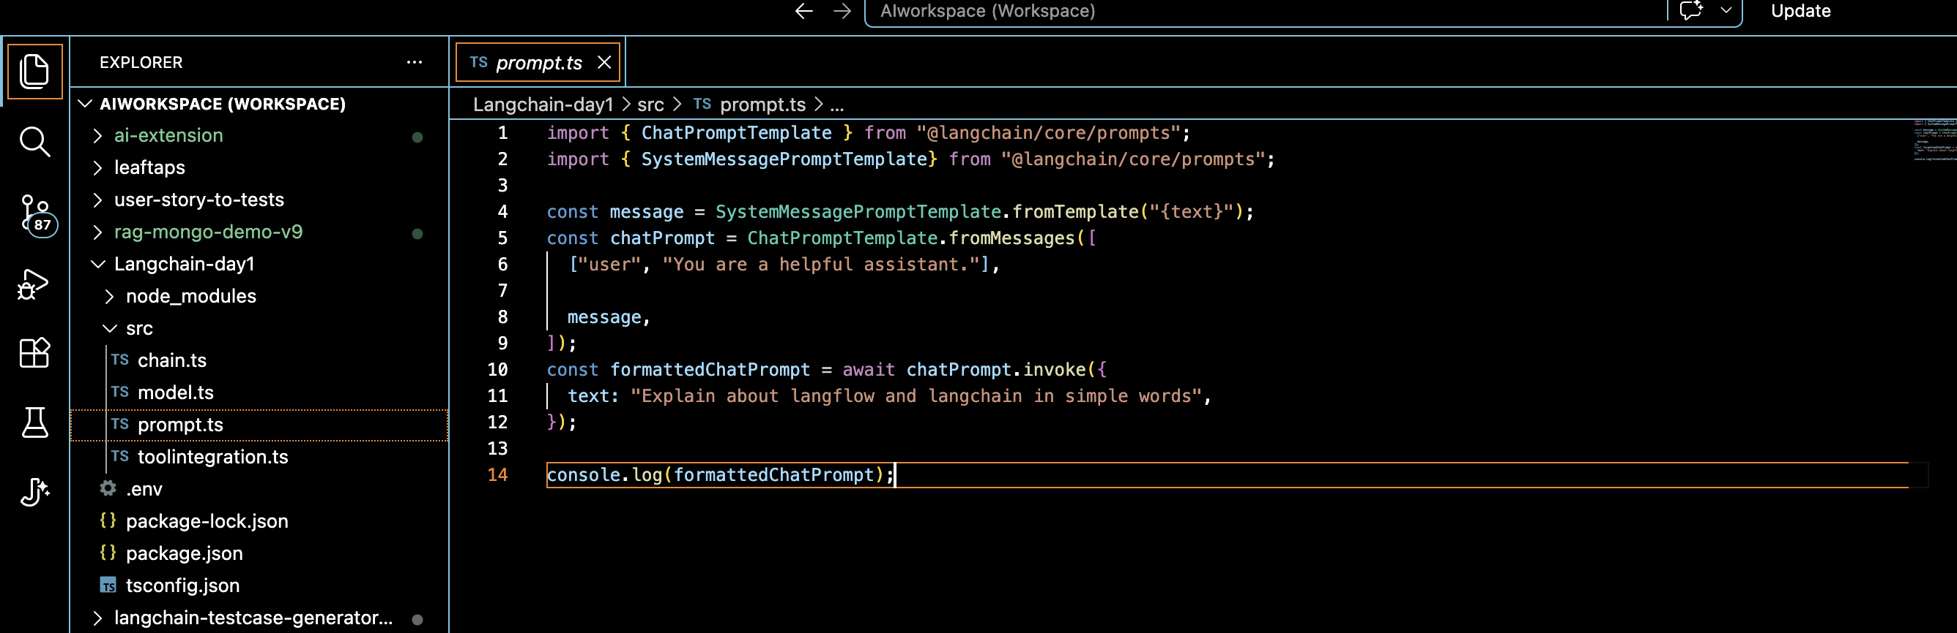
Command: tsx src/prompt.ts
prints system message and human message as output
Output:
hatPromptValue {
lc_serializable: true,
lc_kwargs: {
messages: [
HumanMessage {
"content": "You are a helpful assistant.",
"additional_kwargs": {},
"response_metadata": {}
},
SystemMessage {
"content": "Explain about langflow and langchain in simple words",
"additional_kwargs": {},
"response_metadata": {}
}
]
},
lc_namespace: [ 'langchain_core', 'prompt_values' ],
messages: [
HumanMessage {
"content": "You are a helpful assistant.",
"additional_kwargs": {},
"response_metadata": {}
},
SystemMessage {
"content": "Explain about langflow and langchain in simple words",
"additional_kwargs": {},
"response_metadata": {}
}
]
}
Chain.ts
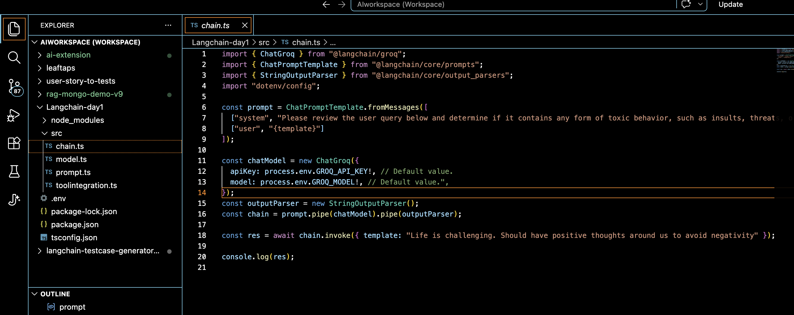

Output:
Toolintegration.ts
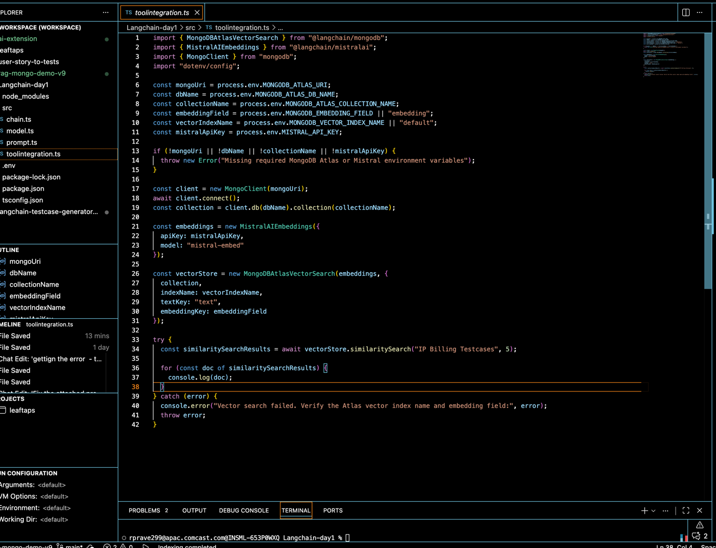
Command: tsx src/toolintegration.ts
Output:

Document {
pageContent: '',
metadata: {
_id: new ObjectId('6a3681cd5944380aef397705'),
module: 'IP Billing',
id: 'TC_3342',
preRequisites: 'UHID:APJ1.0003504849',
title: 'Dashboards ->IP Dash Board->Generate IP Bill',
description: 'Verify user able to generate Generate IP Bill',
steps: '1.Launch the Application.\r\n' +
'2.Login to the application with valid credentials\r\n' +
'3.Click on Common Support Services Tab and select Billing from the drop down.\r\n' +
'4.Navigate to Functions -> Dashboards -> IP Dash Board.\r\n' +
'5.Click on IP Dash Board.\r\n' +
'6.Enter UHID no and click on "View Details".\r\n' +
'7.Right click on IP Number and click on "Generate IP Bill".\r\n' +
'8.Data is automatically populated in fields like Bill Details, Deposit Details, Discount Details, Packages, Deposit Relaxation, Previous Interim Bill, Credit Details, Tax Details and Adjustment.\r\n' +
'9.If required to view Bed Details click on Bed Details and click on BedCategory Details link.\r\n' +
'10.If required add PAN form 60, click on PAN form 60 and choose a file by clicking "Choose File" button.\r\n' +
'10.Click on "Save" button.\r\n' +
'11.Click on "Gen Final Bill" button.',
expectedResults: 'User should be able to generate Interim Bill',
automationManual: 'Automated',
priority: 'P1',
createdBy: 'Sankar',
createdDate: 45227,
lastModifiedDate: 45284,
linkedStories: 'HC-027, HC-119',
risk: 'High',
version: 'v14.0',
type: 'Integration',
createdAt: 2026-06-20T12:04:29.099Z,
embeddingMetadata: {
model: 'mistral-embed',
cost: 0.000027210000000000002,
tokens: 272,
apiSource: 'mistral-batch',
batchNumber: 53,
createdAt: 2026-06-20T12:04:28.905Z
}
},
id: undefined
}
Document {
pageContent: '',
metadata: {
_id: new ObjectId('6a3682025944380aef397eb9'),
module: 'IP Billing',
id: 'TC_3695',
preRequisites: 'Valid IP Number',
title: 'Reports-Bills Report',
description: 'Verify User able to view Bills Report',
steps: '1.Launch the application\r\n' +
'2.Login to the application with valid credentials.\r\n' +
'3.Click on Common Support Services Tab and select Billing from the drop down.\r\n' +
'4.Navigate to Functions -> Reports -> Bills Report\r\n' +
'5. Enter IPNO and Click on Search',
expectedResults: 'In Patient Bill should be displayed',
automationManual: 'Automated',
priority: 'P1',
createdBy: 'Sumitha',
createdDate: 45047,
lastModifiedDate: 45193,
linkedStories: 'HC-004, HC-086',
risk: 'High',
version: 'v2.0',
type: 'Integration',
createdAt: 2026-06-20T12:05:22.864Z,
embeddingMetadata: {
model: 'mistral-embed',
cost: 0.000016941999999999998,
tokens: 169,
apiSource: 'mistral-batch',
batchNumber: 93,
createdAt: 2026-06-20T12:05:21.907Z
}
},
id: undefined
}
Document {
pageContent: '',
metadata: {
_id: new ObjectId('6a3681bd5944380aef3974d7'),
module: 'IP Billing',
id: 'TC_3657',
preRequisites: 'Valid Bill No',
title: 'Reports-Admin Reports-Others-IP Bills With Date-Original Bill',
description: 'Verify User able to view IP Bills With Date - Original Bill',
steps: '1.Launch the application\r\n' +
'2.Login to the application with valid credentials.\r\n' +
'3.Click on Common Support Services Tab and select Billing from the drop down.\r\n' +
'4.Navigate to Functions -> Reports -> Admin Reports\r\n' +
'5. Navigate to Others Tab and Click on IP Bills With Date\r\n' +
'6. Enter Bill No and Click on View\r\n' +
'7. Click on Bill Number under Original Bill Column',
expectedResults: 'Original Bill Should be displayed',
automationManual: 'Automated',
priority: 'P1',
createdBy: 'Sankar',
createdDate: 45095,
lastModifiedDate: 45096,
linkedStories: 'HC-004, HC-086',
risk: 'High',
version: 'v9.0',
type: 'Integration',
createdAt: 2026-06-20T12:04:13.380Z,
embeddingMetadata: {
model: 'mistral-embed',
cost: 0.000016858000000000004,
tokens: 169,
apiSource: 'mistral-batch',
batchNumber: 42,
createdAt: 2026-06-20T12:04:11.932Z
}
},
id: undefined
}
Document {
pageContent: '',
metadata: {
_id: new ObjectId('6a3681cd5944380aef39770f'),
module: 'IP Billing',
id: 'TC_3352',
preRequisites: 'No Pre-requisite',
title: 'Dashboards ->IP Dash Board->Generate IP Bill->IPHOME',
description: 'Verify user able to navigate to IP Home screen',
steps: '1.Launch the Application.\r\n' +
'2.Login to the application with valid credentials\r\n' +
'3.Click on Common Support Services Tab and select Billing from the drop down.\r\n' +
'4.Navigate to Functions -> Dashboards -> IP Dash Board.\r\n' +
'5.Click on IP Dash Board.\r\n' +
'6.Enter UHID no and click on "View Details".\r\n' +
'7.Right click on IP Number and click on "Generate IP Bill".\r\n' +
'8.Click on IPHOME Services which is top right corner.\r\n',
expectedResults: 'User should be able to navigate to IP Home screen',
automationManual: 'Automated',
priority: 'P1',
createdBy: 'Sudarshan',
createdDate: 44646,
lastModifiedDate: 44937,
linkedStories: 'HC-027, HC-186',
risk: 'High',
version: 'v7.0',
type: 'Integration',
createdAt: 2026-06-20T12:04:29.099Z,
embeddingMetadata: {
model: 'mistral-embed',
cost: 0.000027210000000000002,
tokens: 272,
apiSource: 'mistral-batch',
batchNumber: 53,
createdAt: 2026-06-20T12:04:28.905Z
}
},
id: undefined
}
Document {
pageContent: '',
metadata: {
_id: new ObjectId('6a3681cd5944380aef397701'),
module: 'IP Billing',
id: 'TC_3338',
preRequisites: 'No Pre-requisite',
title: 'Dashboards ->IP Dash Board->Change Billing Type',
description: 'Verify user able to change Bill type',
steps: '1.Launch the Application.\r\n' +
'2.Login to the application with valid credentials\r\n' +
'3.Click on Common Support Services Tab and select Billing from the drop down.\r\n' +
'4.Navigate to Functions -> Dashboards -> IP Dash Board.\r\n' +
'5.Click on IP Dash Board.\r\n' +
'6.Enter UHID no and click on "View Details".\r\n' +
'7.Right click on IP Number and click on "Change Billing Type".\r\n' +
'8.Select Customer name and Agreement Name.\r\n' +
'9.Enter Subscriber Name and select Employer Name, Relationship.\r\n' +
'10.Enter Employee ID and click on "Add" button.\r\n' +
'11.Click on "Save" button.',
expectedResults: 'User should be able to estimate bill',
automationManual: 'Automated',
priority: 'P1',
createdBy: 'Prabakaran',
createdDate: 45248,
lastModifiedDate: 45287,
linkedStories: 'HC-027, HC-186',
risk: 'High',
version: 'v7.0',
type: 'Integration',
createdAt: 2026-06-20T12:04:29.099Z,
embeddingMetadata: {
model: 'mistral-embed',
cost: 0.000027210000000000002,
tokens: 272,
apiSource: 'mistral-batch',
batchNumber: 53,
createdAt: 2026-06-20T12:04:28.905Z
}
},
id: undefined
}

