**Day3 Assignment**

1. Created the docker image and ran the container.

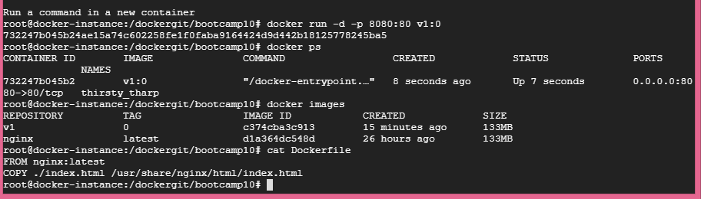

1. Pushing the tagged image to dockerhub.

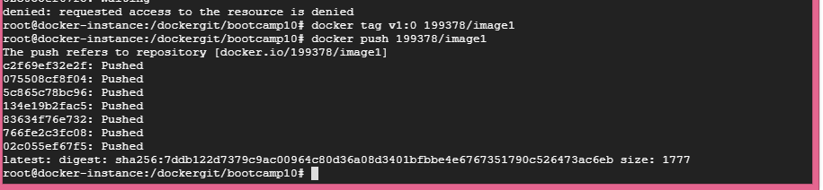

1. Dockerhub images.

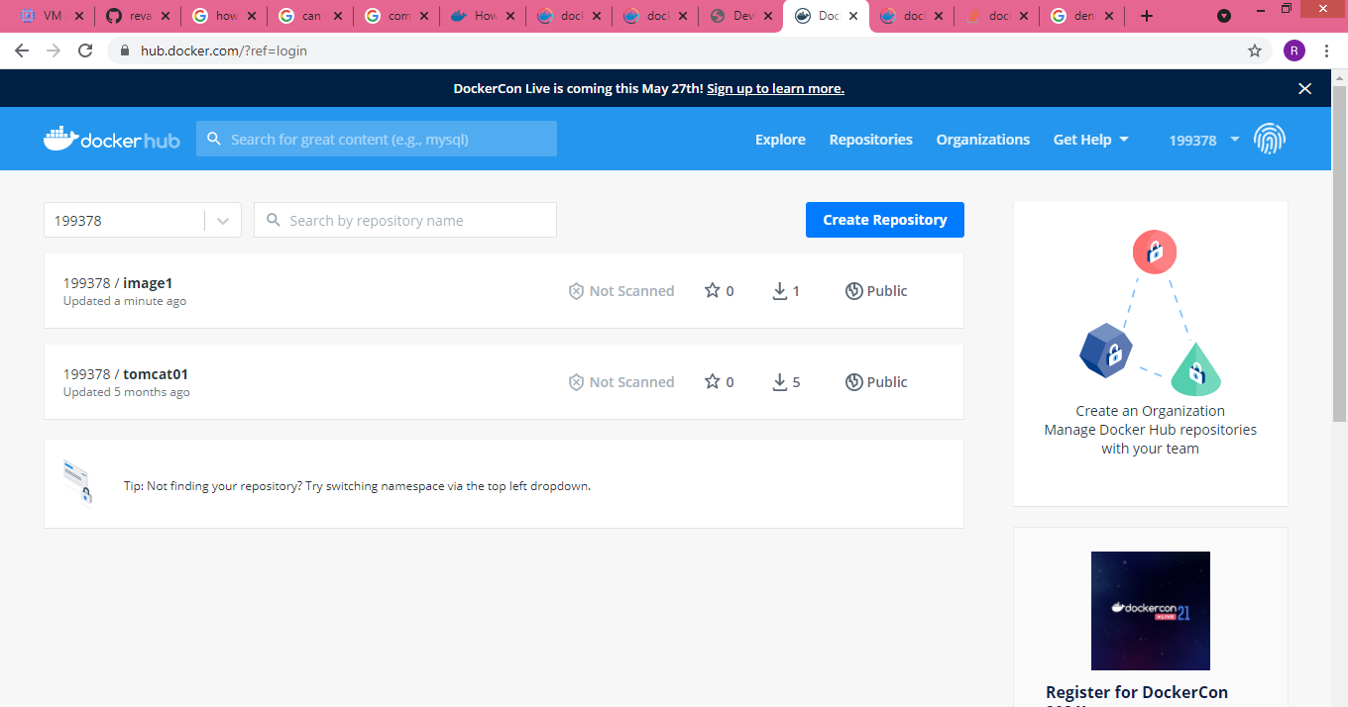

1. Pulling the image from dockerhub.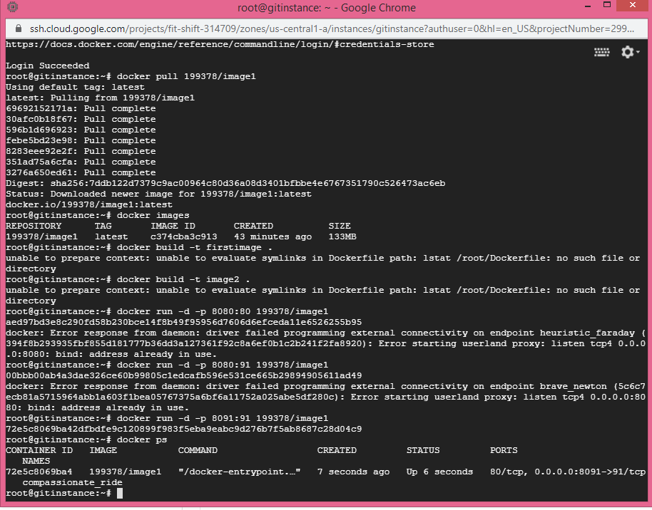
2. Application ran successfully.

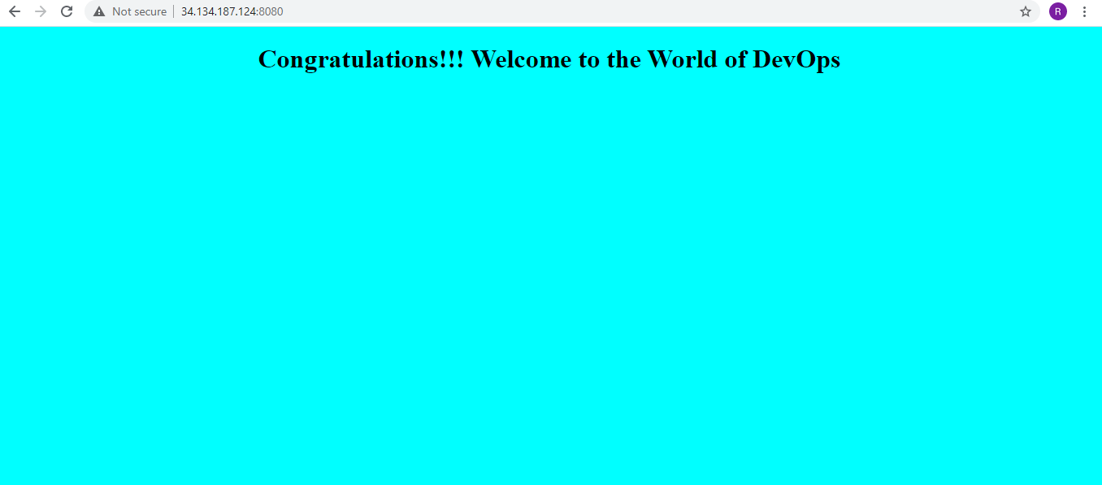

1. Running the docker-compose service.

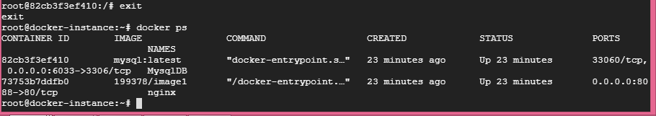

1. Checking the database and creating the table.

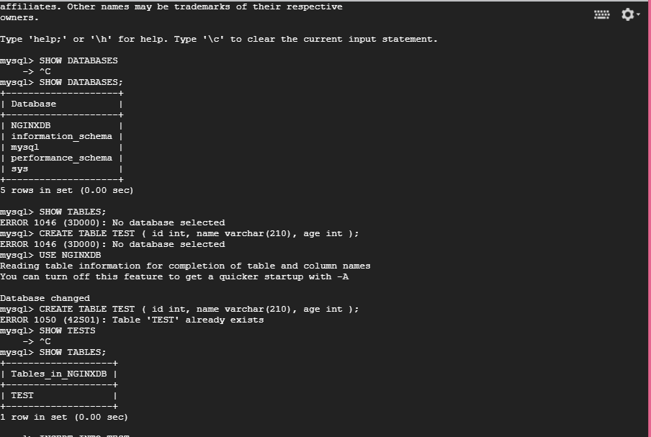

1. Inserting the value in table

