1. Creating and adding files to staging in DeveloperA folder

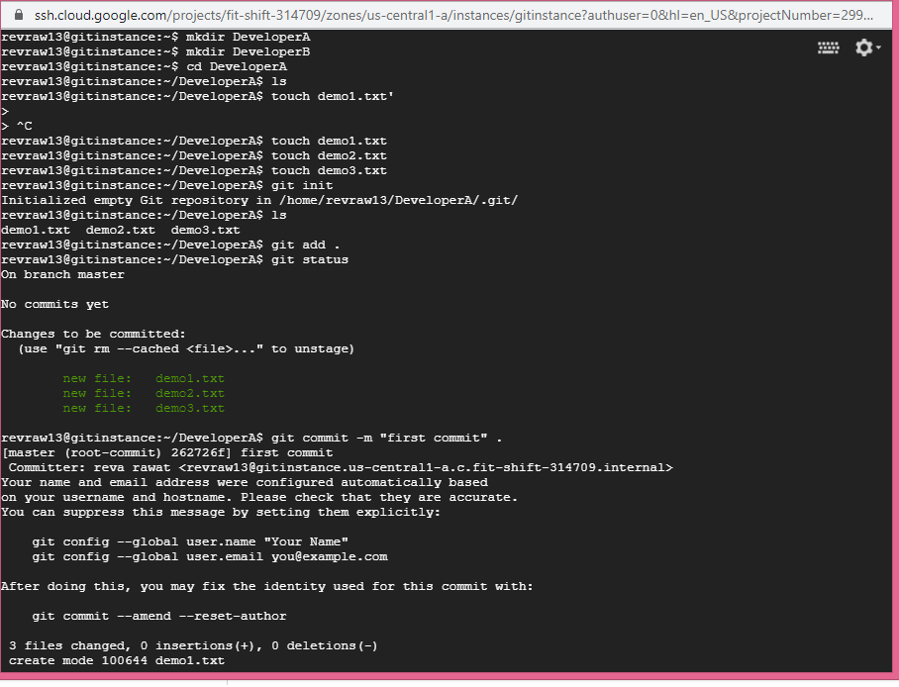

1. Pushing files to remote repository.

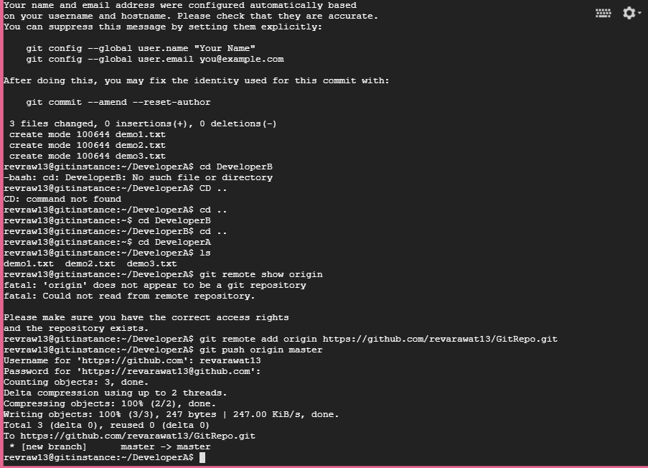

1. Clonning the repository in DeveloperB folder and adding the file to staging after making the changes.

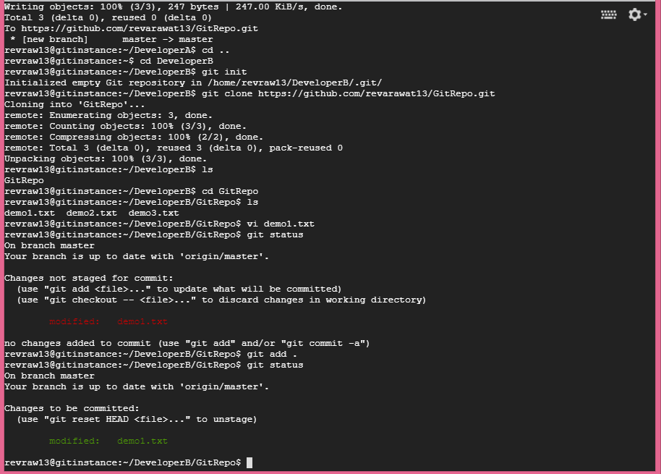

1. Commiting the changes .

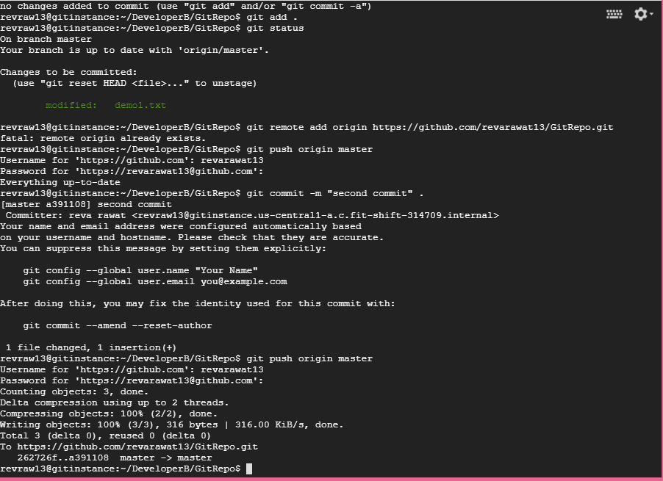

1. Pulling the changes in DeveloperB.

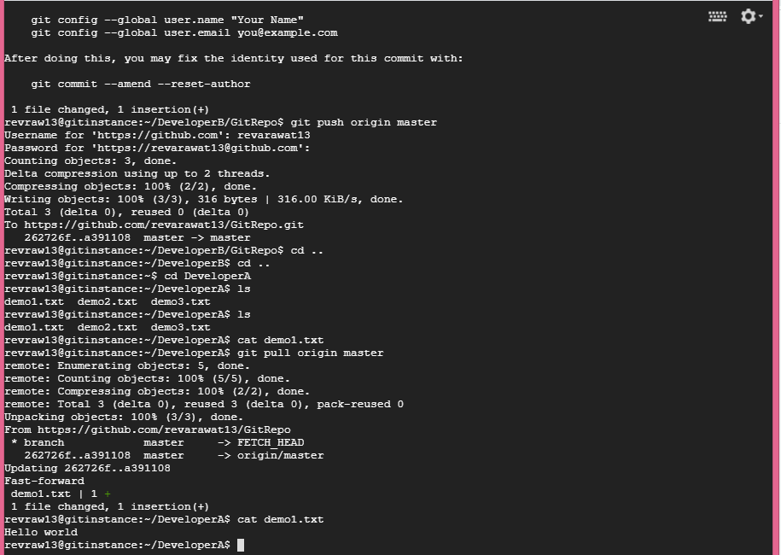

1. Creating the feature branch and merging the changes with master.

