|  |
| --- |
| **Questions= getanswers (“Do pregnant women with suspected or confirmed covid-19 need to give birth by caesarean section?)**  **showTopAnswers(answers)** |
| 1. **Exisitng Biobert Question Answering system** |
| 10% ) compared to nonpregnant women of pregnant patients , 27 (79.41% ) completed pregnancy , 5 (14.71%) had natural delivery , 18 (52.94%) had cesarean section, and 4 (11.76%) had abortion , patients were asymptomatic………….. |
| Birth ( or 3.34% to 160-70) and cesarean section ( or 3.63, 95% ) there was no statistical difference in low birth weight, neonatal , asphysixa……………. |
| 1. **Proposed Question Answering System** |
| **Authors-** C Menendez, C Pons Duran, L Garcia-ontero. Article- Hydroxychloroquine efficacy and safety in preventing SARS-CoV-2 infection and COVID-19 disease severity during pregnancy (COVID-Preg) **ANSWE**R- Fetal distress and preterm delivery seen in some cases. All women delivered caesarean section and the new-born tested negative…………..... |
| **Authors-** [K F Walker](https://pubmed.ncbi.nlm.nih.gov/?term=Walker+KF&cauthor_id=32531146) , [K O'Donoghue](https://pubmed.ncbi.nlm.nih.gov/?term=O%27Donoghue+K&cauthor_id=32531146) , [N Grace](https://pubmed.ncbi.nlm.nih.gov/?term=Grace+N&cauthor_id=32531146).  **Article-** Maternal transmission of SARS-COV-2 to the neonate, and possible routes for such transmission: a systematic review and critical analysis  **ANSWER** -Clinically, pregnant women with the more severe covid-19 infection appear to prefer delivery by casesarean delivery………………………. |

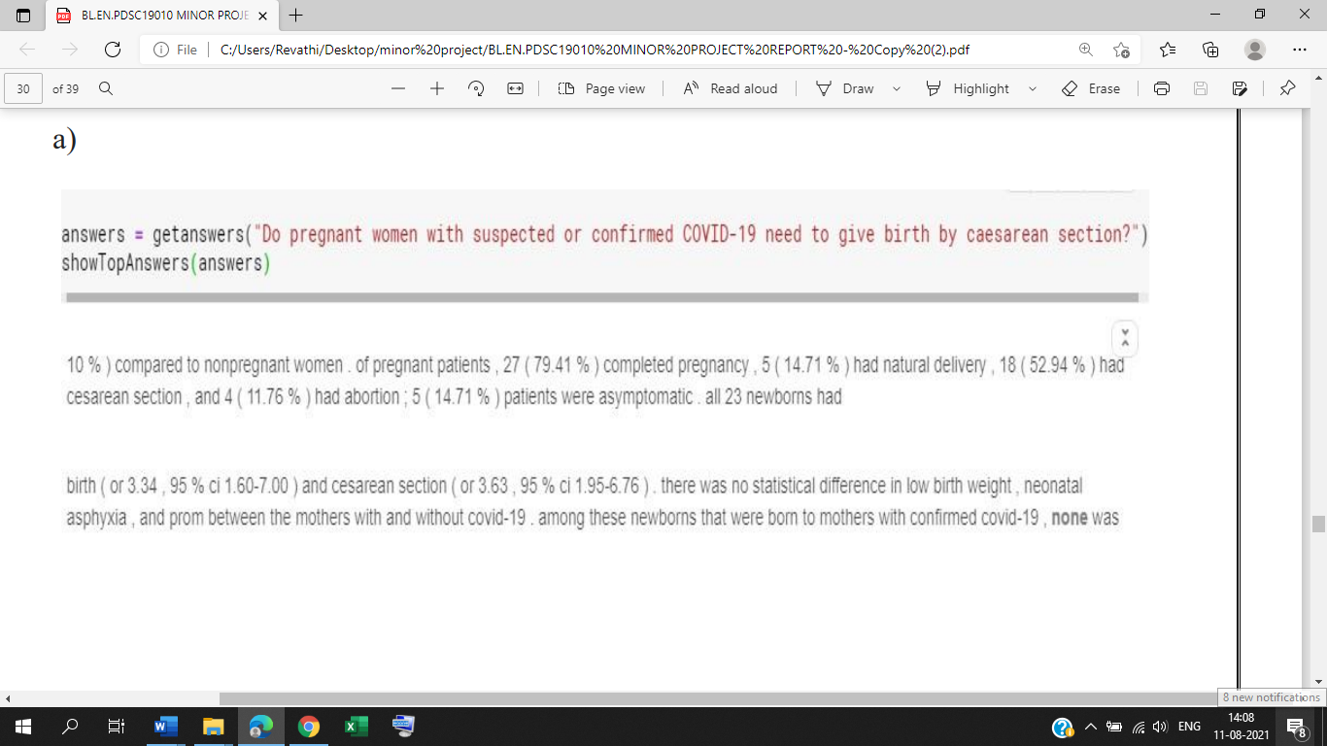

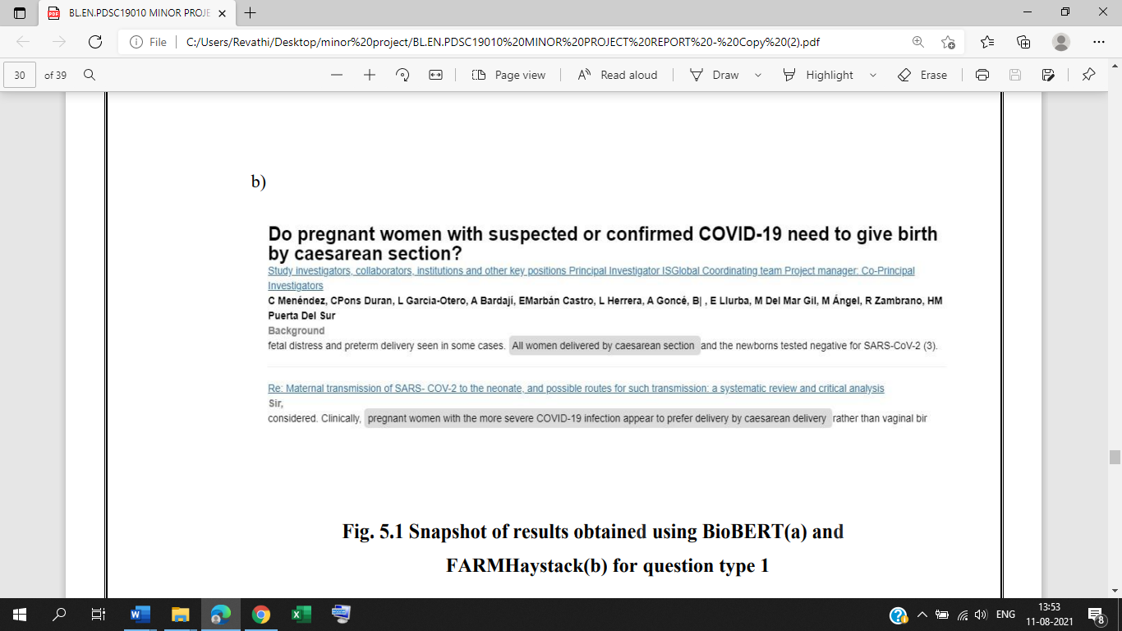

|  |
| --- |
| **Questions= getanswers (“who is most at risk for covid-19 pregnant women or non-pregnant women?)**  **showTopAnswers(answers)** |
| 1. **Exisitng Biobert Question Answering system** |
| Self-reported sars-cov2 testing and difference between pregnant women and non-pregnant women who were hospitalized and those who recovered in the community multivariable regression was used to investigate disease severity and comorbidity……. |
| Difference between pregnant women and non-pregnant women who were hospitalized and those who recovered in the community multivariable regression was used to investigate disease severity and comorbidity effects results.……. |
| 1. **Proposed Question Answering System** |
| **Authors-** KA Pastick, MR Nicol, E Smyth….  **Articles-** A Systematic Review of Treatment and Outcomes of Pregnant Women With COVID-19-A Call for Clinical Trials…….  **ANSWER-** Of 70% of the total healthcare workforce. Pregnant women and women of reproductive potential are therefore at a high risk of contracting covid-19…………… |
| **Authors-** H Dong, M Zhang…  **Article-** Investigation on the mental health status of pregnant women in china during the pandemic covid-19………  **ANSWER-** Pregnant women were more likely to have an adverse pregnancy outcome when compared to women who were not pregnant …….. |

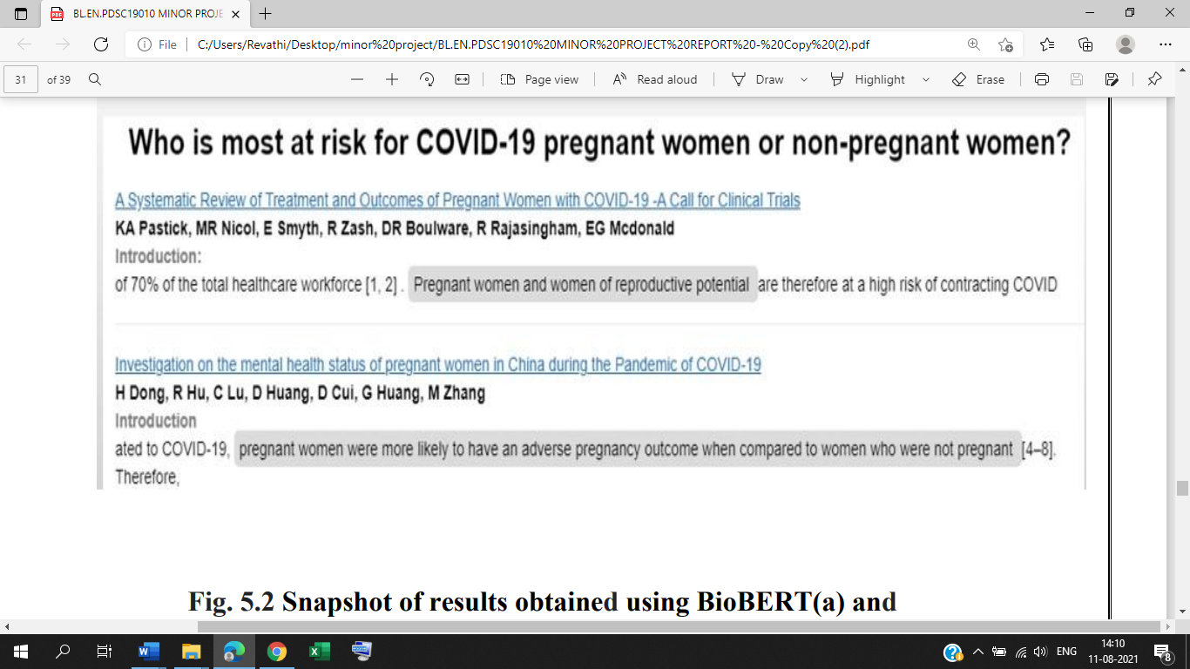

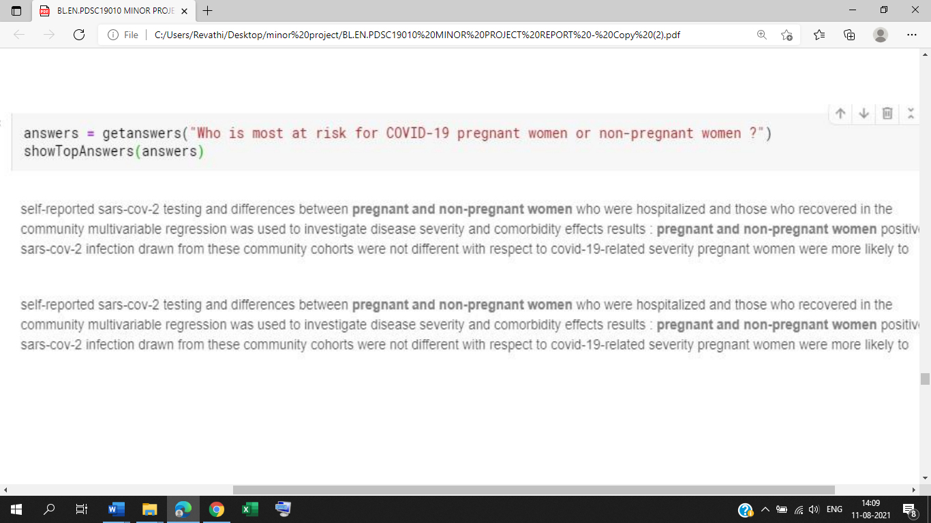

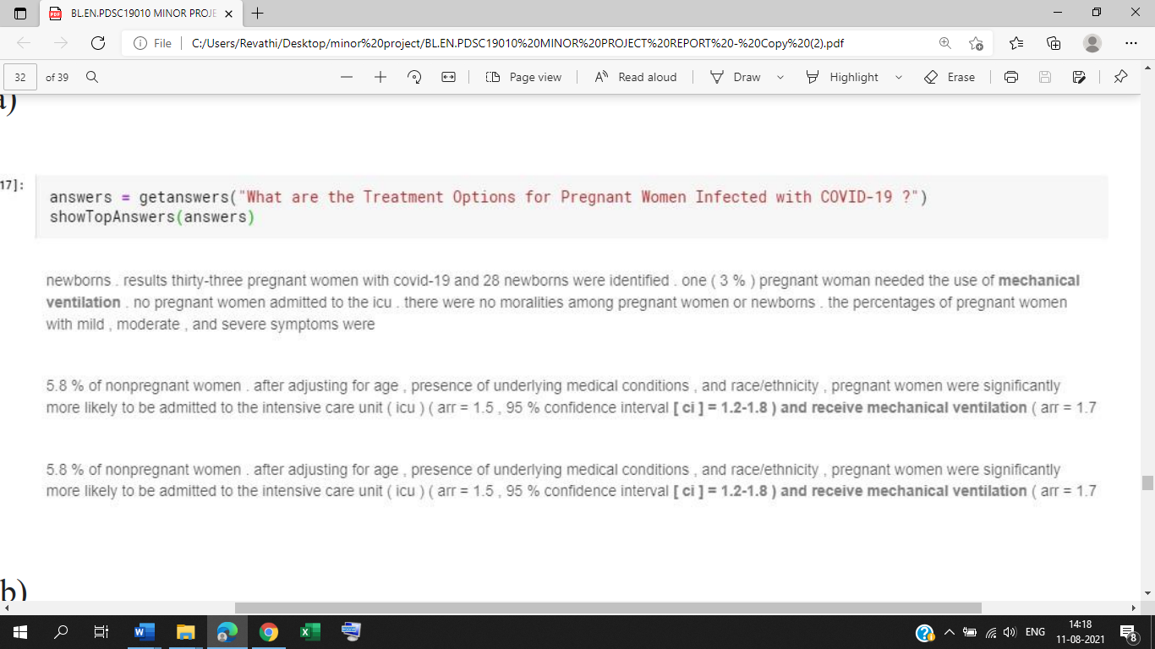

|  |
| --- |
| **Questions= getanswers (“what are the treatment options for pregnant women infected with covid-19?)**  **showTopAnswers(answers)** |
| 1. **Exisitng Biobert Question Answering system** |
| Results thirty-three pregnant women with covid-19 and 28 newborns were identified. one (3%) pregnant woman needed the use of mechanical ventilation. There were no moralities among the pregnant women or newborns………. |
| 5.8% of non pregnant women , after adjusting for age, presence of underlying medical conditions , and pregnant women were significantly more likely to be admitted to the intensive care unit…………… |
| 1. **Proposed Question Answering System** |
| **Authors**- N Tug, M Yassa, E Kole……..  **Article-** Pregnancy worsens the morbidity of COVID-19 and this effect becomes more prominent as pregnancy advance……………………  **ANSWER-** Either by hospital admission due to the COVID-19 disease symptoms or by universal testing for all obstetrical admissions……….. |
| **Authors**- G Eysenbach, M Schoen, YHeng Yaw, L Wei……..  **Article-** Pregnancy worsens the morbidity of COVID-19 and this effect becomes more prominent as pregnancy advance……………………  **ANSWER-** Hence, early diagnosis, isolation and treatment are crucial for the pregnant women and neonates…………………… |

