Brain Tumor Classification using MR

Images and Transfer Learning

***Abstract***-

**Brain tumor is the irregular development of a mass tissue within the brain or close it, which has the capacity to spread and duplicate widely affecting the functions of the other organs with in the body. Brain tumor classification is the vital assignment to access the tumors and make a treatment choice concurring to their classes. In this paper, a profound learning show foe classification of brain tumor from MRI pictures utilizing exchange learning is displayed. The profound brain MRI highlights are extricated utilizing the pretrained demonstrate VGG16 and InceptionV3. The precision. Accuracy. Review, back and f1score execution markers are utilized to survey the exchange learning model’s viability.  
  
The results obtained shows that proposed pretrained model VGG16 achieved better results than other models with an accuracy of 98%**

Keywords— Brain Tumor Classification, Deep Learning, Magnetic Resonance Images, Convolution Neural Network, Visual Geometry Group (VGG16), InceptionV3.

# Introduction

A brain tumor is caused by uncontrolled development of tissue interior brain or close it[1]. Brain tumors are broadly classified as two types i.e. primary and secondary tumors. Primary brain tumours, which account for 70% of all brain tumours, are those that grow inside the brain. The remaining 30% of tumours, however, are secondary brain tumours, the majority of which are cancerous and originate from other body areas and spread to the brain [2]. The tumor which is noncancerous are called as benign brain tumor. Noncancerous brain tumor may grow over time and press on the brain tissue. The malignant brain tumors are cancerous and grow quickly. These cancer cells can attack and crush the brain tissue, subsequently it ought to be recognized at an early organize must be analyzed appropriately.

In clinical studies on brain anatomy, magnetic resonance images (MRI) has become a crucial tool. MRI is most frequently used to detect brain tumor because it provides high resolution and contrast [3]. In the proposed method the MRI image dataset is used for classifying tumors and non-tumorous images. The MRI images in axial, coronal and sagittal planes are considered for feature analysis and classification using various transfer learning methods. The brain tumors classified in proposed method are gliomas, meningioma and pituitary tumors. Gliomas are one of the most frequently occurring tumor and arise from glial cells in brain. Meningiomas are brain tumors that begin within the films around the brain and spinal line. Brain tumors that start in and around the Pituitary organ are named as Pituitary tumors.

# II. MOTIVATION

Within the proposed work, a model for brain tumor classification is displayed utilizing CNN and transfer learning procedures. The comes about gotten proposed that VGG16 model gives way better comes about in comparison to CNN and InceptionV3 with accuracy of 98% on the test dataset. This show is computationally successful, less time expending and gives strong design for classification of brain tumors. In future scope, the tumor discovery can be performed utilizing multimodal MRI pictures for moved forward execution.

III. OBJECTIVE

The objective of this paper is to propose and evaluate a deep learning model for the classification of brain tumors from MRI images using transfer learning. Specifically, we utilize pre-trained models VGG16 and InceptionV3 to extract deep features from brain MRI images. The performance of the transfer learning model is assessed using accuracy, precision, recall, F1-score, and confusion matrix analysis. The primary focus is to demonstrate the effectiveness of the VGG16 model in accurately classifying brain tumors, aiming to achieve an accuracy of 98% or higher. Through this research, we aim to contribute to the advancement of brain tumor classification techniques, thereby facilitating more accurate diagnosis and treatment decisions in clinical settings.

# Related Works

There are many works presented in literature for classification of brain tumors. Some of them are discuseed here. Cinar et al. [4] presents a hybrid model for brain tumor classification using CNN by replacing the last 5 layers of the ResNet50 architecture with 10 new layers. Advantages of this model include improved accuracy and the potential for future research using hybrid structures. Limitations include the lack of detailed architectural information and limited evaluation metrics.The work proposed by Rai et al. [5] uses LU-Net show for brain tumor division and classification in MR pictures has appeared predominant execution compared to other profound- neural models such as Le-Net and VGG-16. It achieved an impressive overall accuracy of 98%, indicating its effectiveness in accurately identifying brain tumors in medical images. In the model proposed by Islam et al. [6] PCA, and TK-means are used for brain tumor detection. The strategy utilized superpixels and PCA for include extraction, diminishing the measurements and complexity of MR pictures.Das et al. [7] proposes a Deep-CNN model for brain tumor identification from MRI scans. The model achieves high accuracy and detects abnormalities effectively. The use of a GAP layer improves classification and reduces misclassification. The model may not work well for MRI images with varying intensity levels, and further classification of tumor subtypes is not considered.

Togacar et al. [8] introduces a new model called BrainMRNet that effectively distinguishes between abnormal and normal brain MR images. The model achieves superior classification accuracy compared to previous studies using the same dataset. The key features of BrainMRNet include attention modules to focus on relevant regions in the images, the use of the hypercolumn technique to retain and transfer efficient features, and the incorporation of residual blocks to mitigate performance degradation with increasing model depth.The work proposed by Jia et al. [9] uses a Fully Automatic Heterogeneous Segmentation using Support Vector Machine (FAHS-SVM) method presents a fully automatic approach for brain tumor identification and segmentation. It achieves high accuracy comparable to manual segmentation and combines image structure hierarchy and statistical classification for effective tumor region detection.. By and large, the proposed approach appears guarantee for helping within the precise and fast recognizable proof of brain tumors, supporting clinical choice frameworks within the field of MR symbolism brain tumor location.

# Proposed Model

Objective of this proposed work is to construct a framework that works with Convolution Neural Organize (CNN) utilizing Exchange Learning Methods. The demonstrate is prepared with increase strategies so as to supply brain tumor classification with made strides exactness. The piece graph of proposed show is illustrated in Fig. 1. At first the pictures are stacked from datset, taken after by information uagmnettaion. Another the pictures are passes to CNN and exchange learning engineering to perform classification of pictures as tumorous or non-tumor.

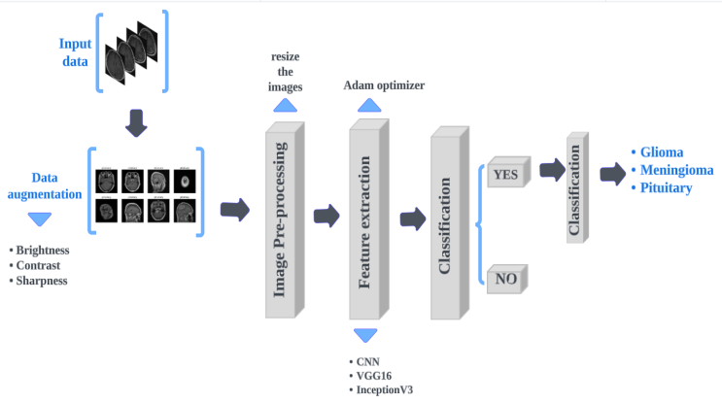

Fig. 1. Block diagram of the proposed system

## Dataset and Image Pre-processing

The datset utilized in proposed work is gotten from kaggle[10]. The dataset comprises of 7023 MRI pictures. These pictures are utilized for preparing the proposed framework and testing its execution. 5712 pictures are utilized to prepare the demonstrate and 1311 pictures are utilized for testing. The dataset contains pictures of gliomas, meningioma, pituitary and pictures with no tumor. The portrayal of daset is summarized in Fig. 2. The preprocessing is performed on the input dataset so as to progress the to make strides the generalization and execution of machine learning models and decrease overfitting. Moreover the sharpness and differentiate of the pictures is controlled for way better investigation.

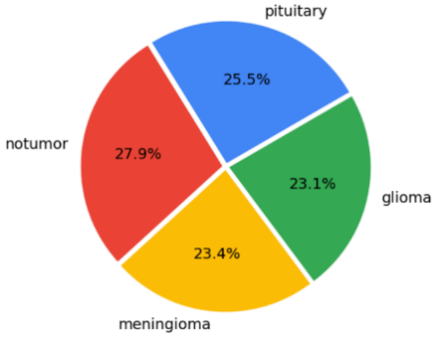

Fig. 2. Datset description

## CNN model

The convolutional neural arrange (CNN)[11] show is utilized within the planned demonstrate to classify the pictures into four classes as clarified in datset. It comprises of completely associated layers for classification and a set of convolutional and pooling layers for include extraction. The CNN engineering executed in proposed think about is outlined in Fig.3

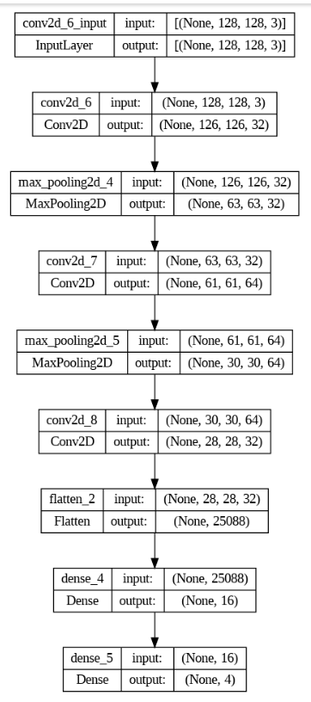

Fig. 3. CNN Architecture

## Transfer Learning

Rather than making a one of a kind CNN show for the picture classification assignment, we may utilize a exchange learning technique in profound learning where a pre-trained CNN show that has as of now been prepared on a tremendous benchmark dataset like ImageNet is reused. The advantage of exchange learning is that it leverages past learning.It is a powerful technique used in machine learning that involves taking a pre-trained model and modifying it to fit a new task[12]. Due to its capacity to conserve both time and computational resources while obtaining high accuracy in the new work, it has grown in popularity in recent years. It is a powerful technique used in machine learning that involves taking a pre-trained model and modifying it to fit a new task.It has ended up progressively prevalent in later a long time due to its capacity to spare time and computational assets, whereas still accomplishing tall

exactness within the modern assignment.

In proposed work VGG-16 and InceptionV3 transfer learning techniques were used for brain tumor detection.

In 2014, the Visual Geometry Group at the University of Oxford proposed the Visual Geometry Group (VGG), a convolutional neural network design. It could be a exceptionally profound neural arrange with 16-19 layers. The VGG-16 demonstrate is stacked with pre-trained weights from ImageNet and all layers are set to non-trainable[13]. At that point, the final three layers of the VGG16 demonstrate are set to trainable, so that they can be fine-tuned on a unused classification assignment. Following, a modern model is characterized utilizing the Consecutive API. The primary layer of the modern demonstrate is an input layer that anticipates picture information with shape `(IMAGE_SIZE, IMAGE_SIZE, 3)` (3 channels for RGB color). The moment layer is the pre-trained VGG16 show, which forms the input picture and extricates valuable highlights. The yield of the moment layer is changed into a one-dimensional cluster by the third layer, known as the "Straighten" layer. The fourth layer may be a "Dropout" layer, which, in arrange to avoid overfitting, randomly evacuates portion of the yield units from the going before layer amid training. The fifth layer could be a "Thick" layer with 128 units and the "relu" activation function, which may be a well known alternative for intermediate layers in neural systems. The sixth layer is another `Dropout` layer. The ultimate layer could be a "Thick" layer that yields a likelihood dissemination over the names and has as numerous units as there are unmistakable names within the classification assignment. Figure 4 portrays the VGG-16 architecture.

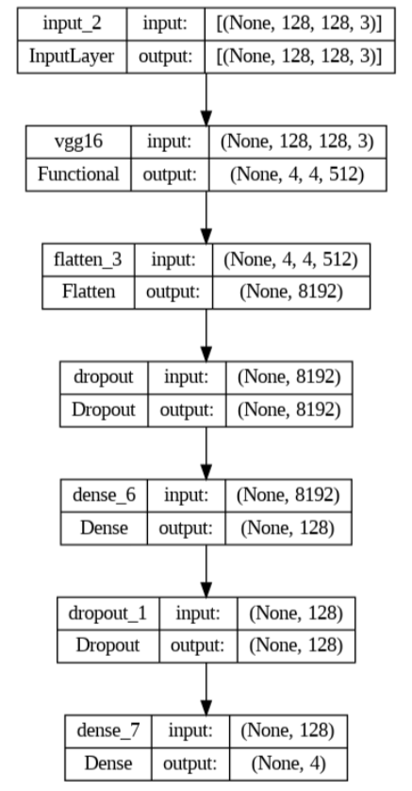

Fig. 4. VGG-16 Architecture

InceptionV3 could be a profound convolutional neural network architecture that uses a combination of convolutional, pooling, and normalization layers to memorize highlights from input images[14]. The organize comprises of a few Inception modules that permit it to extricate highlights at distinctive spatial scales and resolutions. The key development in Inceptionv3 is the utilize of "Inception modules," which are multi-branch convolutional systems with diverse channel sizes. These modules can capture a wide range of highlight sizes and offer assistance diminish the number of parameters within the model[15]. The Inception modules moreover incorporate 1x1 convolutions, which can offer assistance diminish the computational fetched of the arrange. Instead of using large convolutions, Inception v3 uses factorized convolutions, which break down the convolution into smaller convolutions, reducing the number of parameters and improving efficiency. Additionally, normalizing the inputs to each layer helps to improve training stability and speed up convergence. Inception v3 uses L2 regularization to reduce overfitting. The network includes two auxiliary classifiers that provide additional supervision during training and can improve performance. Architecture of InceptionV3 network is shown in Fig. 5.

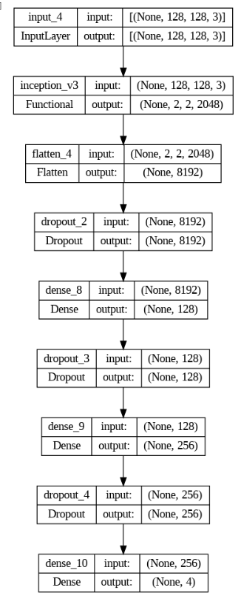

Fig. 5. Inception V3 Architecture

The deep learning and transfer learning models utilised in this work are described in detail in Table 1.

Table 1 Description of models used in the System

|  |  |
| --- | --- |
| **Models** | **Key Features** |
| 1.Convolution Neural Network(CNN) | * The network comprises of different layers of interconnected neurons. * The connections between neurons are represented y weights * The network is trained utilizing the backpropagation calculation, which alters the weights and baises. |
| 2.Visual Geometry Group(VGG16) | * VGG16 has deep architectures. * VGG16 has 16 layers, including 13 convolution layers and 3 fully connected layers. * The convolution layers in VGG16 have a small receptive field of 3x3 pixels * VGG16 uses max pooling with 2x2 filters size and a stride of 2 to downsample the features maps and reduce the dimensionally of input. * Input image size is 224x224 in RGB format. |
| 3.Inception V3 | * It has 48 layers. * Input images of size 229x229 pixels. * Uses auxiliary classifiers at intermediate layers of the network to encourage to learn more discriminating features. * Batch normalization is utilized to normalize the inputs to each layer. |

# System Design and Implementation

System design refers to the process of defining the architecture, components, interfaces, and behavior of a software system. It involves transforming the requirements and specifications into a detailed design that can be implemented. UML diagrams, including use case diagrams and class diagram, are commonly used in system design to visually represent the system's structure and behavior.The Usecase diagram and the class diagram of the proposed method are shown in Figure 6 and Figure 7,

respectively.

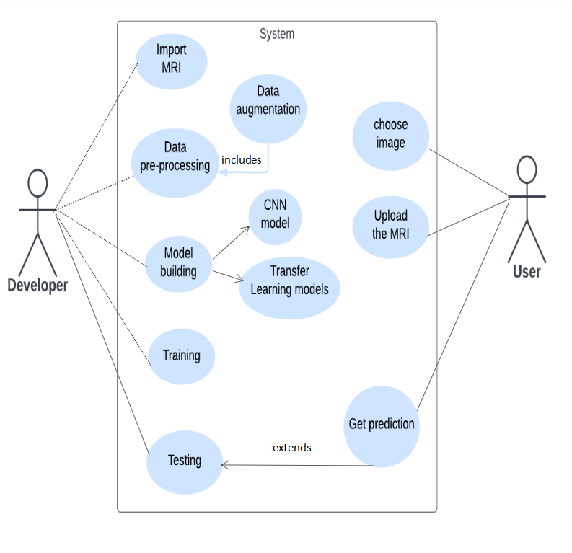

Fig. 6. Usecase diagram of proposed system

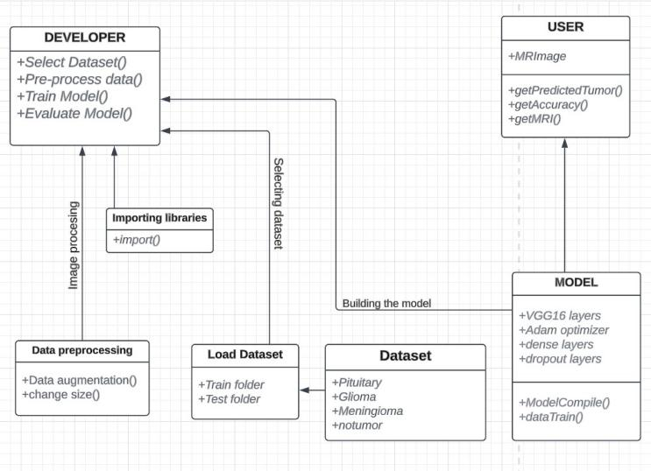

Fig. 7. Class diagram of proposed system

System implementation refers to the process of translating a conceptual system design into a functioning software or hardware system. It involves the actual development, configuration, and deployment of the system components. Workflow is important part of system implementation and endures the work progresses in a logical and organized manner to achieve desired outcomes. Fig. 8 gives the workflow for the proposed system and its implementation.

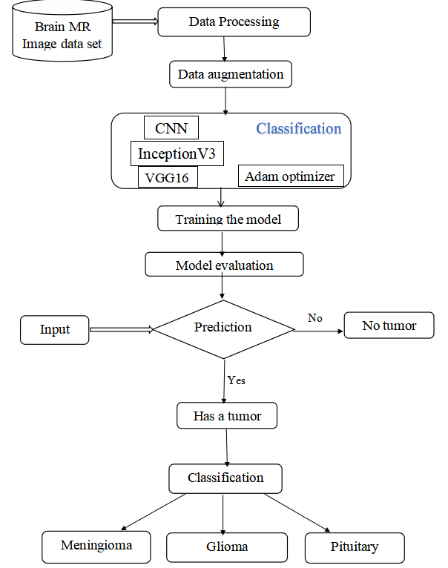

Fig. 8.Proposed system workflow

The model descriptions for CNN, VGG-16, and InceptionV3 are displayed in Fig. 9 to Fig. 11, respectively.

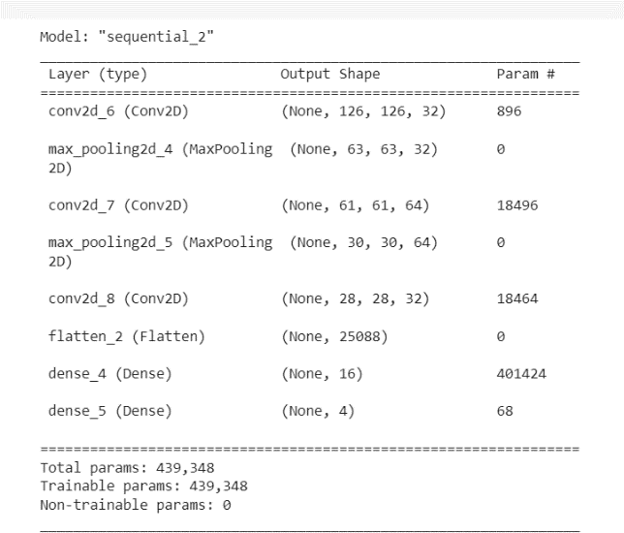

Fig. 9. CNN Summary for proposed model

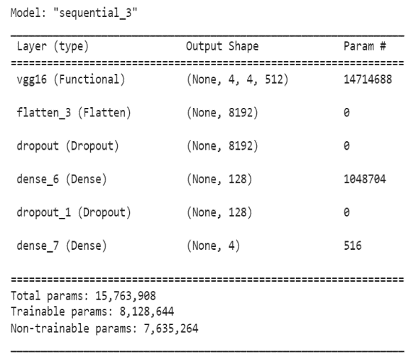

Fig. 10. VGG16 Summary for proposed model

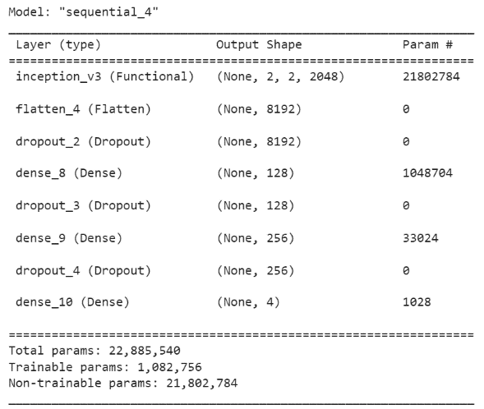

Fig. 11. InceptionV3 Summary for proposed model

# Model Evaluation

The effectiveness of the proposed model for brain diagnosis and classification is measured by calculating four values

 such as accuracy, precision, recall, and f1 score.These

 measurements are calculated using the following equation.

(1)

(2)

(3)

(4)

Among them, P stands for Positive i.e tumor patients and N stands for Negative i.e. non-tumor patients. TP is the anticipated positive cases that are really positive, TN is the anticipated negative case which is really negative, FN is the anticipated negative cases that are really positive and FP is the anticipated positive cases that are within the real negative.

# Results

In this section, the results obtained from the proposed modelare discussed. The accuracy, recall, and f1-score values ​​obtained for glioma, pituitary, meningioma, and non-cancerous tumors by the CNN, VGG-16, and InceptionV3 algorithms are shown in Figure 12, Figure 13, and Figure 14. As observed from the results VGG16 provides better results for multiclass tumor classification among three classifiers considered in this study. It attained F1-score of 97% for glioma, 96% for meningioma, 99% for pituitary and 100% for no-tumor cases.

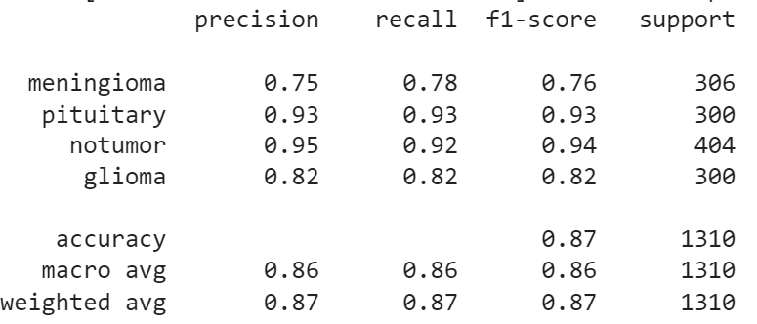

Fig. 12. CNN classification report

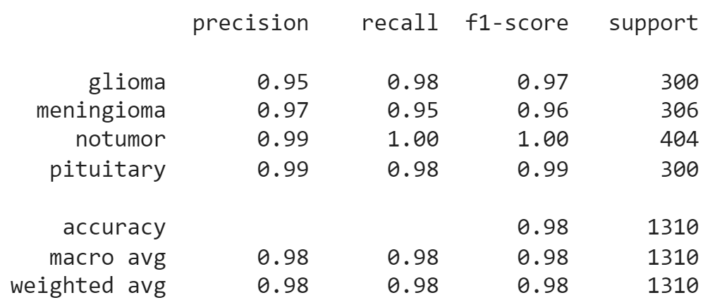

Fig. 13. VGG16 classification report

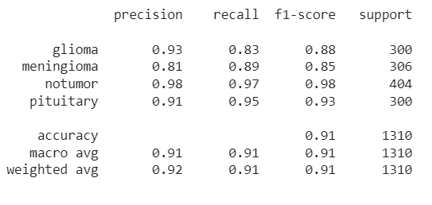

Fig. 14. InceptionV3 classification report

Figure 15 presents the accuracy and loss analysis of the proposed model on the training data for different values.

The red colored curve is for loss and green colored graph is for the accuracy values. As seen VGG16 provide better accuracy-loss behavior in comparsion to CNN and InceptionV3.

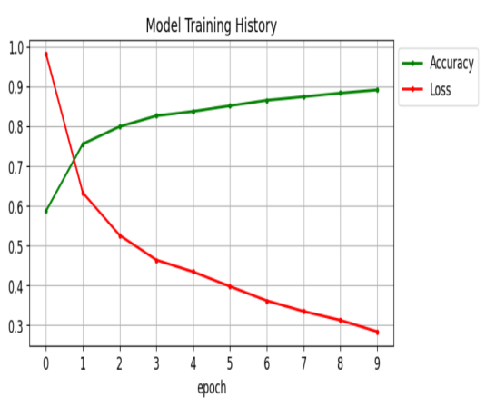

Fig. 15(a). CNN model training analysis

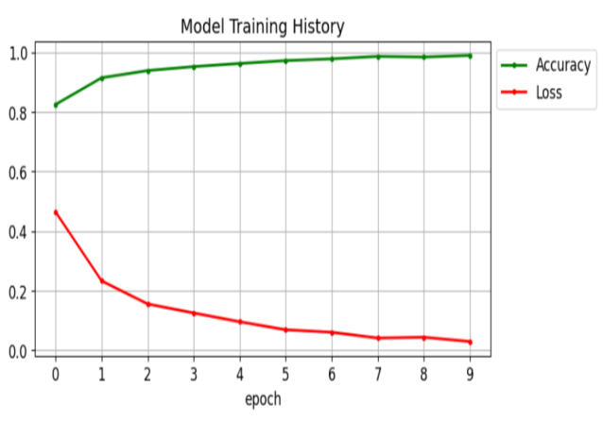

Fig. 15(b). VGG16 model training analysis

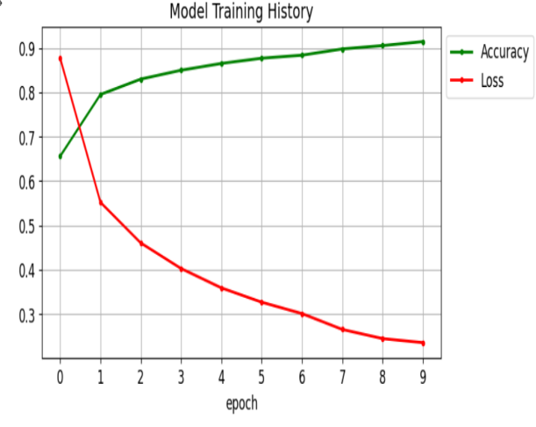

Fig. 15(c). InceptionV3 model training analysis

Furthermore, the accuracy obtained and time consumed for CNN, VGG-16 and InceptionV3 algorithms for proposed model is computed for test dataset. The values are computed for epoch value of 5,7 and 10 as summarized in Table 2. The results obtained shows that VGG16 classifer attained highest accuracy of 98% for 10 epochs. Whereas CNN and InceptionV3 received accuracy of 86% and 90% respectively.

Table 2 Comparison of results for various classifiers

|  |  |  |  |  |  |  |  |
| --- | --- | --- | --- | --- | --- | --- | --- |
|  | **Epochs** | | | | | | |
| **Classifier** | **Five** | | **Seven** | | | **Ten** | |
| Time  (in sec) | Acc-uracy | Time  (in sec) | | Acc-uracy | Time  (in sec) | Acc-uracy |
| **CNN** | 175 | 80% | 179 | 80% | | 171 | 86% |
| **VGG-16** | 179 | 97% | 181 | 97% | | 176 | 98% |
| **InceptionV3** | 173 | 87% | 221 | 87% | | 183 | 90% |

Examples of glioma, meningioma, pituitary, and no-tumors using the proposed method are shown in Figure 16.

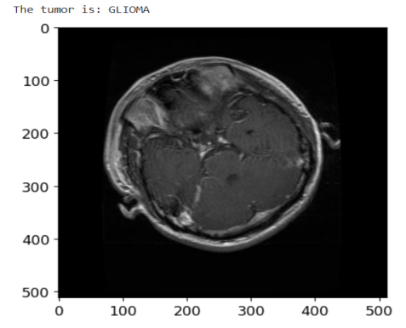

Fig. 16(a). Sample image of Glioma case

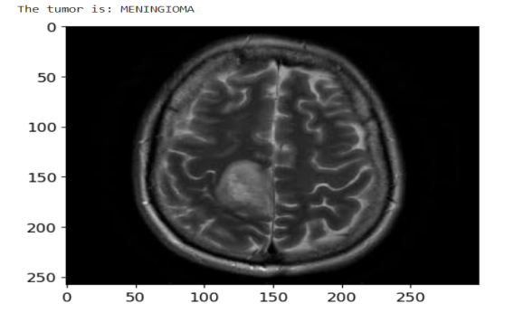

Fig. 16(b). Sample image of meningioma case

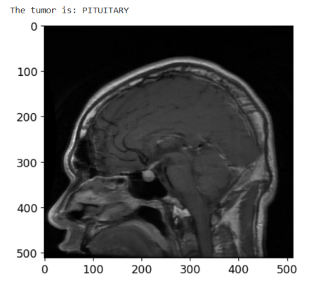

Fig. 16(c). Sample image of Pituitary case

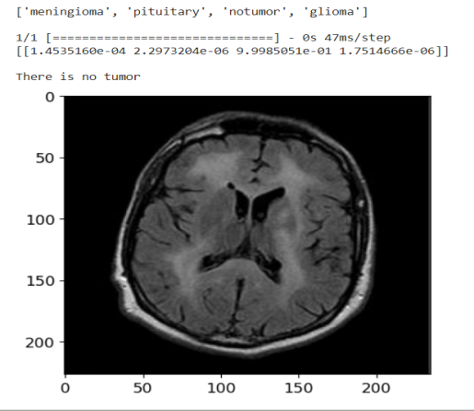

Fig. 16(d). Sample image of No-Tumor case

We compared the performance of the proposed model with previous studies in the literature [4, 6, 8]. It can be seen from Figure 17 that the proposed model provides greater accuracy for tumor classification than existing models.This shows that transfer learning can provide better analysis of images, with improved feature detection for complex and unstructured data as in brain tumor images.

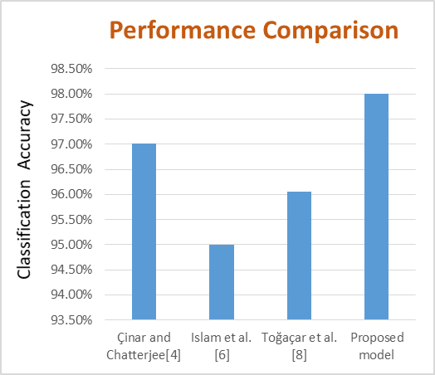

Fig. 17. Performance Comparison of proposed and exsisting models

##### References

1. P.Afshar, K.N.Plataniotis and A. Mohammadi, “Capsule networks for brain tumor classification based on MRI images and coarse tumor boundaries,” IEEE international conference on acoustics, speech and signal processing (ICASSP), 2019, pp. 1368-1372.
2. R. Mehrotra, M. A. Ansari, R. Agrawal and R. S.Anand, “A Transfer Learning approach for AIbased classification of brain tumors,” Mach. Learn. Appl. 2020, vol. 2, pp. 10–19.
3. M.Gupta and S.Gupta, “Classification of Gliomas Using Efficient Zernike Moments Based Shape Descriptors Extracted from Segmented MR Images,” Soft Computing and Signal Processing: Proceedings of 3rd ICSCSP 2020, Volume 1 (pp. 445-454). Springer Singapore.
4. A. Çinar and M. Yildirim, ‘‘Detection of tumors on brain MRI images using the hybrid convolutional neural network architecture,’’ Med. Hypotheses, vol. 139, Jun. 2020, Art. no. 109684.
5. H. M. Rai and K. Chatterjee, ‘‘Detection of brain abnormality by a novel Lu-Net deep neural CNN model from MR images,’’ Mach. Learn. Appl., vol. 2, Dec. 2020, Art. no. 100004.
6. M. K. Islam, M. S. Ali, M. S. Miah, M. M. Rahman, M. S. Alam, and M. A. Hossain, ‘‘Brain tumor detection in MR image using superpixels, principal component analysis and template based K-means clustering algorithm,’’ Mach. Learn. Appl., vol. 5, Sep. 2021, p. 100044.
7. T. K. Das, P. K. Roy, M. Uddin, K. Srinivasan, C.-Y. Chang, and S. Syed-Abdul, ‘‘Early tumor diagnosis in brain MR images via deep convolutional neural network model,’’ Comput., Mater. Continua, vol. 68, no. 2, pp. 2413–2429, 2021.
8. M. Toğaçar, B. Ergen, and Z. Cömert, ‘‘BrainMRNet: Brain tumor detection using magnetic resonance images with a novel convolutional neural network model,’’ Med. Hypotheses, vol. 134, Jan. 2020, p. 109531.
9. Z. Jia and D. Chen, ‘‘Brain tumor identification and classification of MRI images using deep learning techniques,’’ IEEE Access, early access, Aug. 13, 2020.
10. Nickparvar, M., 2021 Brain Tumor Dataset from kaggle. Available: <https://www.kaggle.com/datasets/masoudnickparvar/brain-tumor-mri-dataset>. Accessed on 3rd March 2021.
11. S. Basheera, M. S. S. Ram, “Classification of brain tumors using deep features extracted using CNN,” J. Phys., 2019, vol. 1172, p. 012016.
12. M. Talo, U. B. Baloglu, O. Yldrm, U. R. Acharya, “Application of deep transfer learning for automated brain abnormality classification using MRI images, “Cognitive Systems Research, 54 (2019), 176–188.
13. A. Rehman, S. Naz, M. I. Razzak, F. Akram, M. Imran, “A Deep Learning-Based Framework for Automatic Brain Tumors Classification Using Transfer Learning,” Circuits Syst. Signal Process, 2020,vol. 39, pp. 757–775.
14. F. Taher, M.R. Shoaib, H. M. Emara, K.M. Abdelwahab, F.E.Abd El-Samie and M.T.Haweel,“ Efficient framework for brain tumor detection using different deep learning techniques”, Front Public Health. 2022, vol. 10.
15. D.Rastogi, P. Johri and V.Tiwari, “Brain Tumor Detection and Localization: An Inception V3-Based Classification Followed By RESUNET-Based Segmentation Approach,” International Journal of Mathematical, Engineering and Management Sciences, 2023, vol. 8(2), p.336.