**Revathi Atchi**

**700742168**

**GITHUB LINK**: <https://github.com/revathiatchi/NeuralAssignment3.git>

**RECORDINGLINK:** <https://github.com/revathiatchi/NeuralAssignment3/assets/156601745/599e0320-5310-4eb1-9aa8-fdd4baa0fd10>

1. Create a class Employee and then do the following: -

* Create a data member to count the number of Employees.
* Create a constructor to initialize name, family, salary, department.
* Create a function to average salary.
* Create a Fulltime Employee class and it should inherit the properties of Employee class.
* Create the instances of Fulltime Employee class and Employee class and call their member functions.

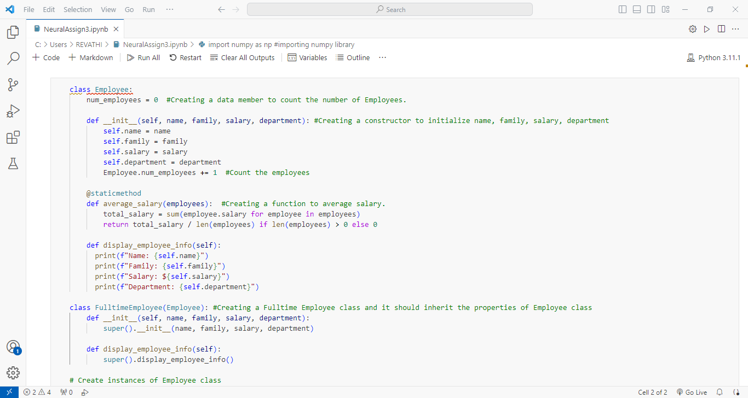

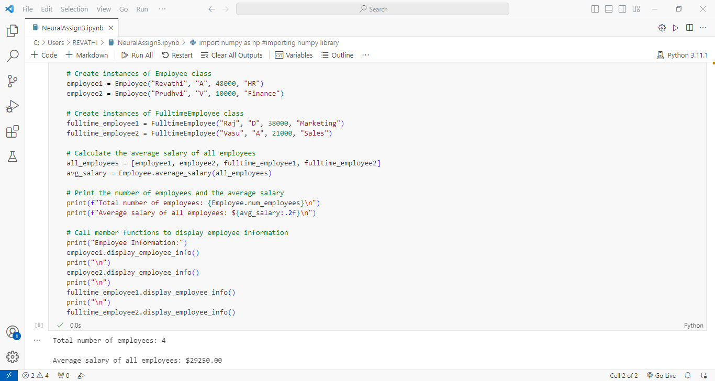

**Output:-**

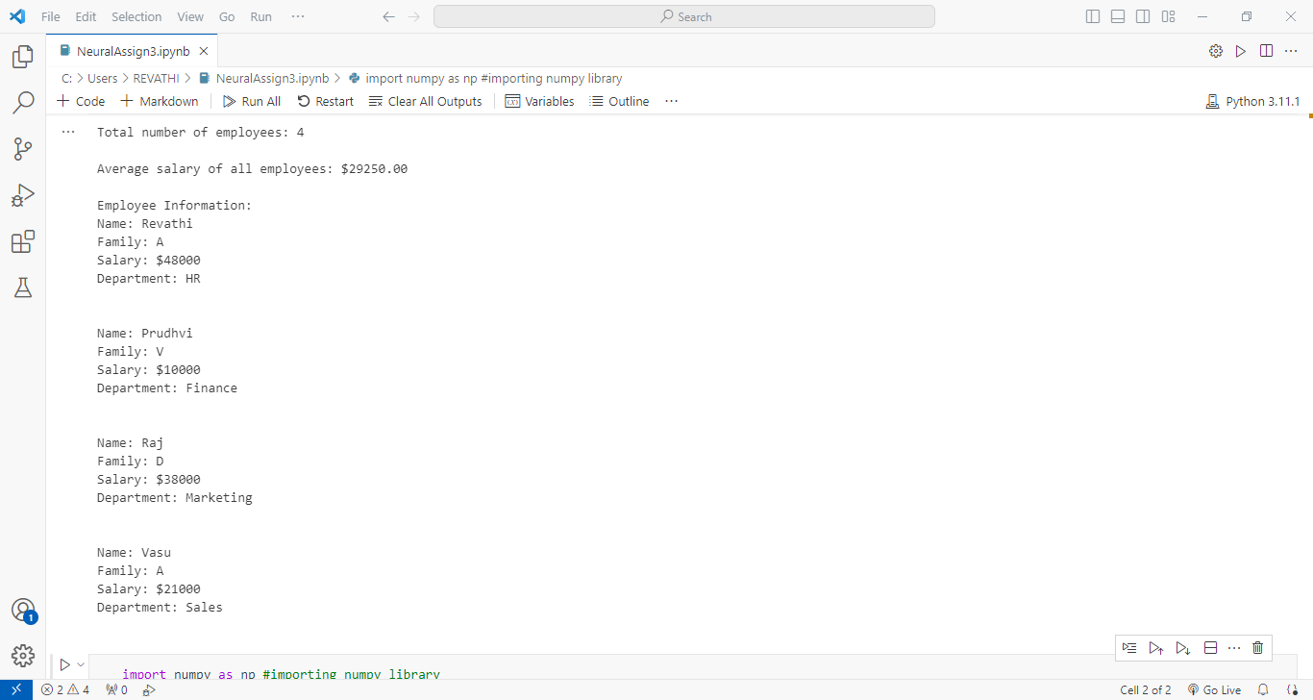

1. Using NumPy create random vector of size 20 having only float in the range 1-20. Then reshape the array to 4 by 5 Then replace the max in each row by 0 (axis=1) (you can NOT implement it via for loop)

**Output**:-

