Section 1: Introduction to Data Science (3 Hours)

1. What is Data Science? (With Example)
Definition
Data Science is the process of collecting, analyzing, and interpreting large amounts of data to discover useful information, patterns, and trends that help in decision-making.
👉 In simple words:
Data Science = Using data to find answers and make predictions

Why Data Science is Needed
Today, data is generated everywhere:
- Mobile phones
- Social media
- Online shopping
- Banks
- Hospitals
Humans cannot manually analyze this huge data.
So, Data Science uses computers, statistics, and machine learning to analyze data.

Simple Real-Life Example
College Attendance System
- Raw data: Daily attendance records
- Data Science helps to find:
  - Students with low attendance
  - Attendance trends
  - Predict who may get detained
👉 This helps teachers take action early

Another Example
Weather Prediction
- Past temperature, rainfall, humidity data
- Data Science predicts:
  - Tomorrow’s weather
  - Chances of rain

Data Science Lifecycle (Step-by-Step with Example)
The Data Science Lifecycle is a systematic process followed to solve a problem using data.

Example Problem (Used Throughout Lifecycle)
📌 “A college wants to predict which students may fail the semester.”

Step 1: Problem Understanding
What happens here?
- Understand the problem clearly
- Decide what we want to predict
Example
- Problem: Students failing exams
- Objective: Predict weak students early

Step 2: Data Collection
What happens here?
Collect data from different sources.
Example Data
- Attendance percentage
- Internal marks
- Assignment submission
- Previous semester results
Sources:
- College database
- Excel sheets
- Online portals

Step 3: Data Cleaning
Why needed?
Real-world data is dirty:
- Missing values
- Duplicate entries
- Wrong data types
Example
Student | Attendance | Marks
Rahul | 85 | 72
Anu | NULL | 65
Rahul | 85 | 72
Cleaning includes:
- Filling missing attendance
- Removing duplicate Rahul record

Step 4: Data Exploration & Analysis (EDA)
What happens here?
- Understand data using graphs and statistics
- Find patterns
Example Findings
- Students with attendance < 70% mostly fail
- Students submitting assignments regularly score higher
Graphs used:
- Bar charts
- Line graphs
- Pie charts

Step 5: Data Modeling
What happens here?
- Apply Machine Learning algorithms
- Train a model using past data
Example
Using a model to predict:
- Pass or Fail
Input:
- Attendance
- Marks
- Assignments
Output:
- Prediction (Pass / Fail)

Step 6: Model Evaluation
Why needed?
To check how accurate the model is.
Example
- Model accuracy: 90%
- Wrong predictions: 10%
If accuracy is low → improve the model

Step 7: Deployment
What happens here?
- Model is used in real applications
Example
- College system automatically shows:
  - “High Risk Student”
  - “Low Risk Student”

Step 8: Monitoring & Maintenance
Why needed?
- Data changes over time
- Model must be updated
Example
New syllabus → retrain model
3. Data Analyst vs Data Scientist (With Clear Examples)
Feature | Data Analyst | Data Scientist
Focus | Past data | Future prediction
Work | Reports & charts | ML models
Tools | Excel, SQL, Tableau | Python, ML, AI
Output | Insights | Predictions

Example (Sales Data)
Data Analyst
- “Sales dropped by 15% last month.”
- Creates charts and reports.
Data Scientist
- “Sales will drop further next month unless discounts are offered.”
- Builds prediction models.
Real-World Applications of Data Science (With Examples)
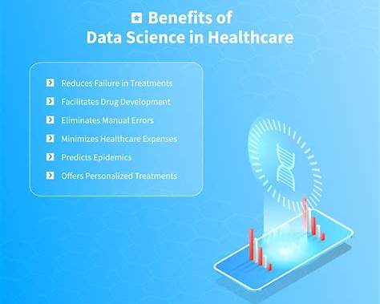
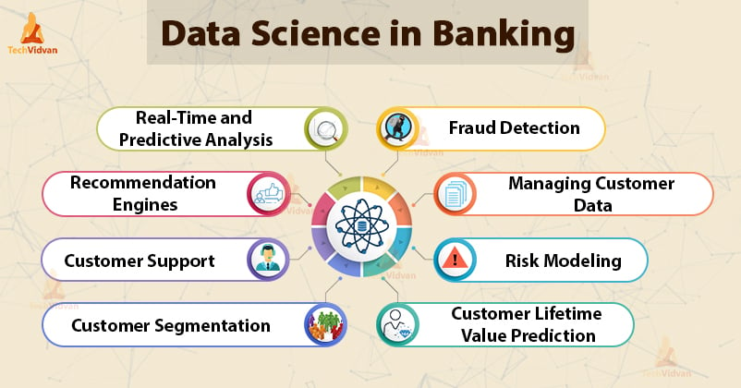

4

1. Healthcare
- Disease prediction
- Medical diagnosis
Example
- Predicting diabetes using patient history

2. Banking & Finance
- Fraud detection
- Credit scoring
Example
- Detecting fake credit card transactions

3. E-Commerce
- Product recommendation
- Customer analysis
Example
- Amazon recommending products you may like

4. Education
- Student performance analysis
- Personalized learning
Example
- Identifying slow learners early

5. Transportation
- Traffic prediction
- Route optimization
Example
- Google Maps showing fastest route

6. Social Media
- Sentiment analysis
- Trend prediction
Example
- Analyzing public opinion on Twitter

