8-bit Arithmetic Logic Unit:
8-bit ALU (Arithmetic Logic Unit) is the core computational block in a CPU that processes 8-bit binary data. This is foundational "mathematical brain" of a computer's Central Processing Unit (CPU). It is a digital electronic circuit responsible for executing all mathematical calculations and logical decisions required by your software and system instructions. An 8-bit Arithmetic Logic Unit (ALU) is the computational core of simple processors, processing 8 bits of data simultaneously. It acts as a digital calculator inside microcontrollers, executing arithmetic (addition, subtraction) and logical (AND, OR, NOT) operations, producing results alongside status flags (e.g., zero, carry, overflow).
ALU is in two primary ways:
1.Arithmetic Operations:
The ALU handles the core math that drives computing.
Basic Math: Addition, subtraction, multiplication, and division.
Counters: Incrementing (adding 1) and decrementing (subtracting 1) values.
2. Logical Operations
The ALU evaluates conditions and manipulates data at the bit level.
Comparisons: Checking if two numbers are equal, greater than, or less than one another. This allows the computer to make decisions and branch program paths.
Bitwise Operations: Using Boolean logic (AND, OR, NOT, XOR) to mask, toggle, or shift specific bits of data.
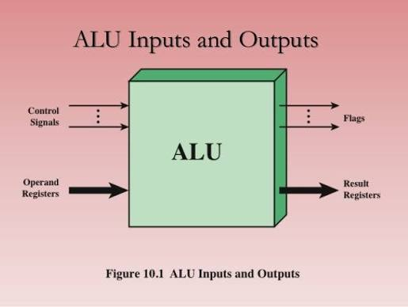
Status Flags: Outputs specific indicators based on the result, such as:
Zero (Z): Result is all zeros.
Carry (C): An extra bit generated during addition/subtraction, used to link multiple ALUs together.
Overflow (V): The result exceeded the maximum 8-bit capacity.

How It Works:
It is constructed by cascading eight 1-bit ALUs side-by-side. Each 1-bit ALU handles one bit from two separate 8-bit inputs (Operand A and Operand B), linking them together via carry propagation.
1.Inputs: The CPU’s control unit sends instructions and data operands (the numbers to be calculated) from memory into the ALU's temporary registers.
2.Processing: Using hardware logic gates, the ALU manipulates the binary inputs based on the requested instruction.
3.Outputs: The ALU produces the result and updates "status flags" (which indicate conditions like an overflow or a zero result), then sends the final output back to the registers or memory.

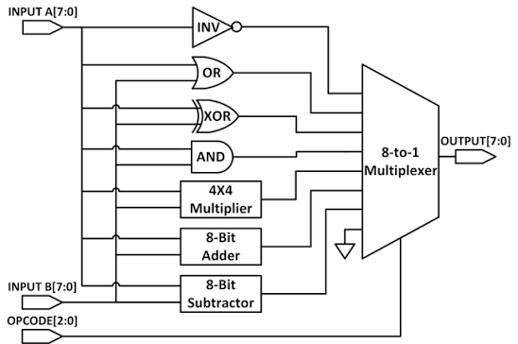
Architecture:
An 8-bit ALU is typically constructed by connecting eight 1-bit ALUs in a chain. The hardware routes two 8-bit inputs (A and B), operation controls, and a carry-in value into logic gates and full-adder circuits. Because ALUs are combinational logic circuits, the inputs propagate through the system, producing the final outputs after a specific delay (typically 20–50 nanoseconds depending on the circuit technology)

Main explanation:

🔥 8-Bit Arithmetic Logic Unit (ALU) using Verilog:
📌 Project Overview:
This project implements an 8-Bit Arithmetic Logic Unit (ALU) using Verilog HDL and verifies its functionality using a custom testbench in Xilinx Vivado.
The ALU is a fundamental component of digital processors, responsible for performing arithmetic and logical operations based on a control signal (sel).
This project was developed as part of my VLSI Design & Verification learning journey.

🚀 Features:
The ALU supports the following operations:
Select (sel) Operation
000 Addition (A + B)
001 Subtraction (A - B)
010 Bitwise AND
011 Bitwise OR
100 Bitwise XOR
101 Bitwise NOT (~A)
110 Left Shift (A << 1)
111 Right Shift (A >> 1)
🧪 Verification:
Test Inputs
A = 20
B = 10
Simulation Results:
Operation Result:
20 + 10 30
20 - 10 10
20 AND 10 0
20 OR 10 30
20 XOR 10 30
NOT 20 235
20 << 1 40
20 >> 1 10
All operations were successfully verified through behavioral simulation.

🎯 Learning Outcomes:
Through this project, I gained hands-on experience in:
- Verilog HDL Coding
- Combinational Logic Design
- RTL Development
- Testbench Writing
- Functional Verification
- Simulation and Debugging
- Vivado Design Flow
🔮 Future Improvements:
- Carry-Out Flag
- Zero Flag Detection
- Overflow Detection
- Parameterized ALU Design
- SystemVerilog Testbench

code:
module alu(
input [7:0] a,
input [7:0] b,
input [2:0] sel,
output reg [7:0] result,
output reg carryout
);

always @(*) begin
carryout = 0; // Default carryout

case(sel)
3'b000: begin // Addition
{carryout, result} = a + b;
end

3'b001: begin // Subtraction
{carryout, result} = a - b;
end

3'b010: begin // AND
result = a & b;
carryout = 0;
end

3'b011: begin // OR
result = a | b;
carryout = 0;
end

3'b100: begin // XOR
result = a ^ b;
carryout = 0;
end

3'b101: begin // NOT (complement)
result = ~a;
carryout = 0;
end

3'b110: begin // Left shift
result = a << 1;
carryout = a[7]; // Carry out is the MSB being shifted out
end

3'b111: begin // Right shift (logical)
result = a >> 1;
carryout = a[0]; // Carry out is the LSB being shifted out
end

default: begin
result = 8'b00000000;
carryout = 0;
end
endcase
end

endmodule

module alu_tb;

reg [7:0] a;
reg [7:0] b;
reg [2:0] sel;

wire [7:0] result;
wire carryout; // Missing wire

alu uut (
.a(a),
.b(b),
.sel(sel),
.result(result),
.carryout(carryout)
);

initial begin
$display("Time\tSel\tA\tB\tResult\tCarry");
$monitor("%0t\t%b\t%d\t%d\t%d\t%b",
$time, sel, a, b, result, carryout);

a = 8'd20;
b = 8'd10;

sel = 3'b000; #10; // Add
sel = 3'b001; #10; // Sub
sel = 3'b010; #10; // AND
sel = 3'b011; #10; // OR
sel = 3'b100; #10; // XOR
sel = 3'b101; #10; // NOT
sel = 3'b110; #10; // Left Shift
sel = 3'b111; #10; // Right Shift

$finish;
end

endmodule

