Problem Statement:
An online learning platform sells various digital courses to learners across different countries. Each learner can purchase multiple courses, and each course belongs to a specific category.
The management team wants to analyze purchase data to understand sales trends, learner behavior, and popular course categories.
Creating Database:
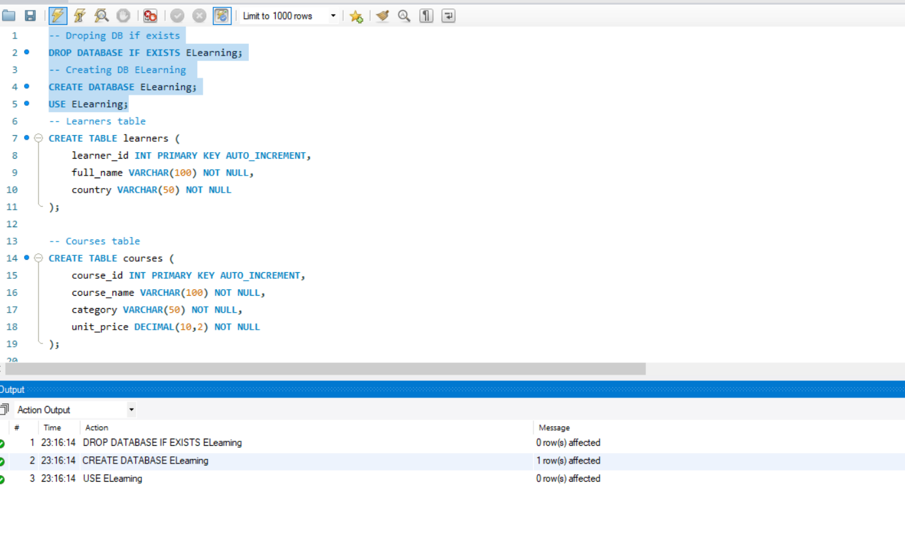
Dataset Description:
Three tables:
- Table: learners
Attributes:
- learner_id (Primary Key)
- full_name
- Country
-- Learners table
CREATE TABLE learners (
learner_id INT PRIMARY KEY AUTO_INCREMENT,
full_name VARCHAR(100) NOT NULL,
country VARCHAR(50) NOT NULL
);
Table: courses
Attributes:
- course_id (Primary Key)
- course_name
- category
unit_price
-- Courses table
CREATE TABLE courses (
course_id INT PRIMARY KEY AUTO_INCREMENT,
course_name VARCHAR(100) NOT NULL,
category VARCHAR(50) NOT NULL,
unit_price DECIMAL(10,2) NOT NULL
);
- Table: purchases
Attributes:
- purchase_id (Primary Key)
- learner_id (Foreign Key → learners.learner_id)
- course_id (Foreign Key → courses.course_id)
- Quantity
- purchase_date
-- Purchases table
CREATE TABLE purchases (
purchase_id INT PRIMARY KEY AUTO_INCREMENT,
learner_id INT NOT NULL,
course_id INT NOT NULL,
quantity INT NOT NULL,
purchase_date DATE NOT NULL,
FOREIGN KEY (learner_id) REFERENCES learners(learner_id),
FOREIGN KEY (course_id) REFERENCES courses(course_id)
);
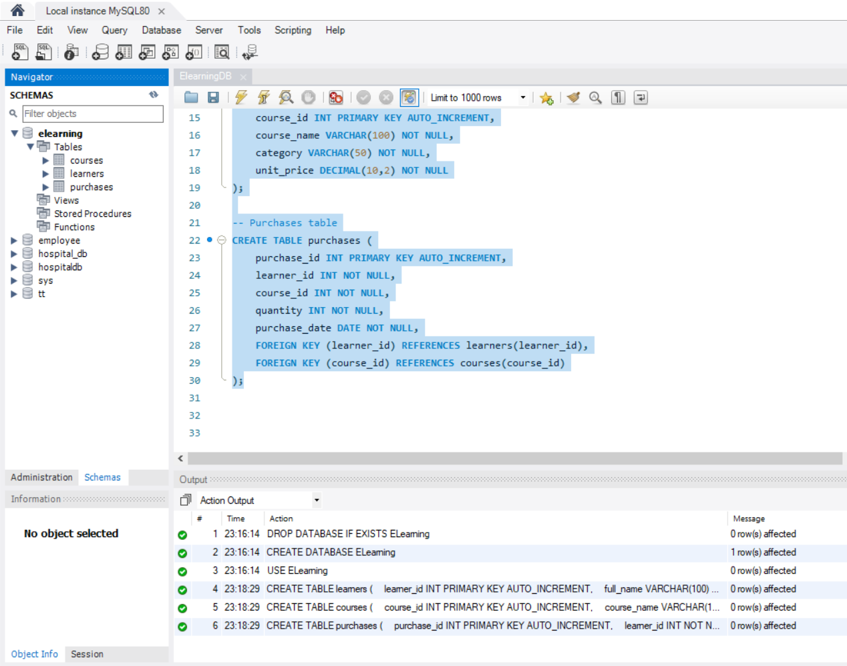

Tasks
1. Created the database and schema. And populated the Schema:
- Created a Database for this project and
- Created all three tables in MySQL with appropriate data types and relationships.
- Inserted sample data covering at least:
  - 4–5 learners
  - 4–5 courses (spread across multiple categories)
  - 6–8 purchase records as follows
-- Inserting learners accross countries
INSERT INTO learners (full_name, country) VALUES
('Alice Johnson', 'USA'),
('Ravi Kumar', 'India'),
('Maria Gonzalez', 'Spain'),
('Chen Wei', 'China'),
('James Smith', 'UK');

-- Inserting courses
INSERT INTO courses (course_name, category, unit_price) VALUES
('Python for Beginners', 'Programming', 50.00),
('Advanced Excel Analytics', 'Data Analysis', 40.00),
('Digital Marketing Basics', 'Marketing', 30.00),
('Machine Learning Essentials', 'Programming', 80.00),
('Project Management Fundamentals', 'Business', 60.00);

-- Inserting into Purchases
INSERT INTO purchases (learner_id, course_id, quantity, purchase_date) VALUES
(1, 1, 1, '2026-03-01'), -- Alice buys Python
(2, 2, 2, '2026-03-05'), -- Ravi buys Excel (2 licenses)
(3, 3, 1, '2026-03-07'), -- Maria buys Marketing
(4, 4, 1, '2026-03-10'), -- Chen buys ML
(5, 5, 1, '2026-03-12'), -- James buys Project Mgmt
(1, 4, 1, '2026-03-15'), -- Alice also buys ML
(2, 1, 1, '2026-03-18'), -- Ravi buys Python
(3, 2, 1, '2026-03-20'); -- Maria buys Excel
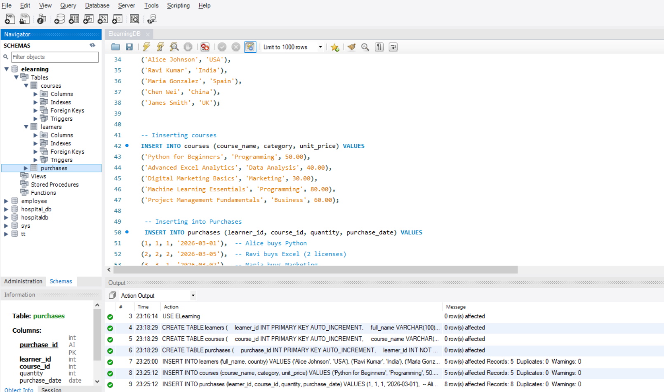
2. Data Exploration Using Joins
- Format currency values to 2 decimal places.
  - Already formatted as 2 decimal places as it is is currency value.
- Used aliases for column names (e.g., AS total_revenue).
SELECT FORMAT(SUM(c.unit_price * p.quantity), 2) AS total_revenue
FROM purchases p
JOIN courses c ON p.course_id = c.course_id;
- Total Revenue
  - 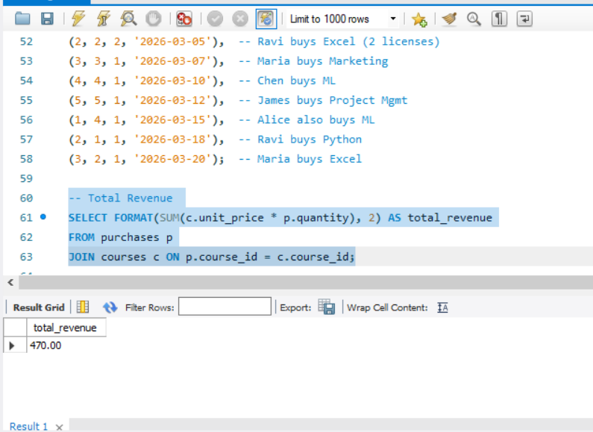

- Country-Wise Revenue
SELECT l.country, FORMAT(SUM(c.unit_price * p.quantity), 2) AS revenue
FROM purchases p
JOIN learners l ON p.learner_id = l.learner_id
JOIN courses c ON p.course_id = c.course_id
GROUP BY l.country
ORDER BY revenue DESC;
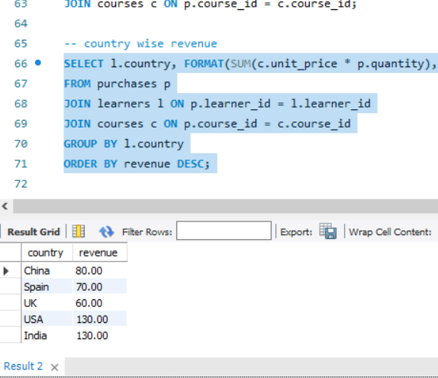
- Sorted results appropriately (e.g., highest total_spent first).
Learners are ranked by total_spent, highest first.
-- Learner’s Total Spending (sorted highest first)
SELECT
l.full_name,
l.country,
FORMAT(SUM(p.quantity * c.unit_price), 2) AS total_spent
FROM purchases p
INNER JOIN learners l ON p.learner_id = l.learner_id
INNER JOIN courses c ON p.course_id = c.course_id
GROUP BY l.full_name, l.country
ORDER BY SUM(p.quantity * c.unit_price) DESC;
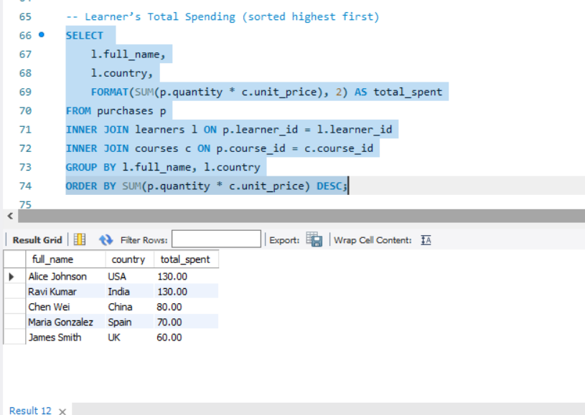

- Learners Spend:
SELECT l.full_name,
FORMAT(SUM(c.unit_price * p.quantity), 2) AS total_spent,
FORMAT(AVG(c.unit_price * p.quantity), 2) AS avg_spent_per_purchase
FROM purchases p
JOIN learners l ON p.learner_id = l.learner_id
JOIN courses c ON p.course_id = c.course_id
GROUP BY l.full_name
ORDER BY total_spent DESC;
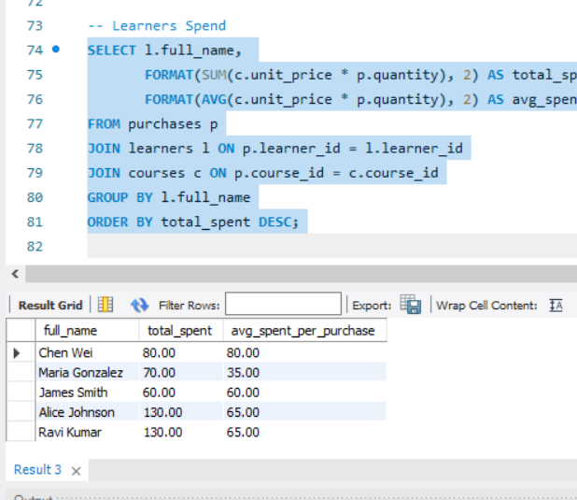
JOINS
- INNER JOIN (only learners who made purchases)
This will return records only where there is a match in all three tables.

SELECT l.full_name, l.country, c.course_name, c.category, p.quantity,
FORMAT(c.unit_price * p.quantity, 2) AS total_amount,
p.purchase_date
FROM purchases p
INNER JOIN learners l ON p.learner_id = l.learner_id
INNER JOIN courses c ON p.course_id = c.course_id
ORDER BY l.full_name, p.purchase_date;
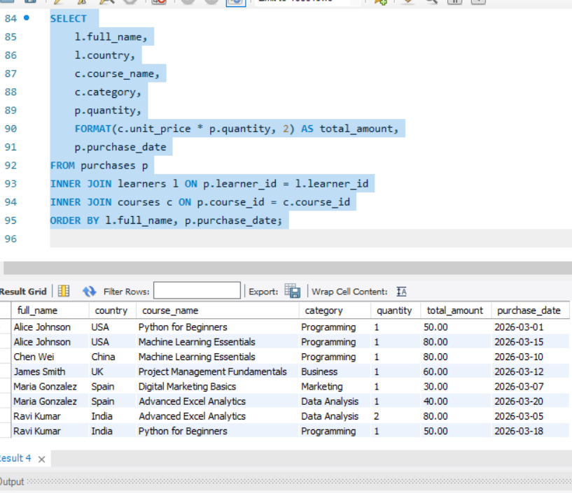
Output: Shows only learners who purchased courses, with details like course name, category, quantity, total amount, and purchase date.
- LEFT JOIN (all learners, even if no purchases)
This ensures all learners are listed, even if they haven’t purchased anything yet. If no purchase exists, course-related fields will be NULL.
SELECT
l.full_name,
l.country,
c.course_name,
c.category,
p.quantity,
FORMAT(c.unit_price * p.quantity, 2) AS total_amount,
p.purchase_date
FROM learners l
LEFT JOIN purchases p ON l.learner_id = p.learner_id
LEFT JOIN courses c ON p.course_id = c.course_id
ORDER BY l.full_name, p.purchase_date;
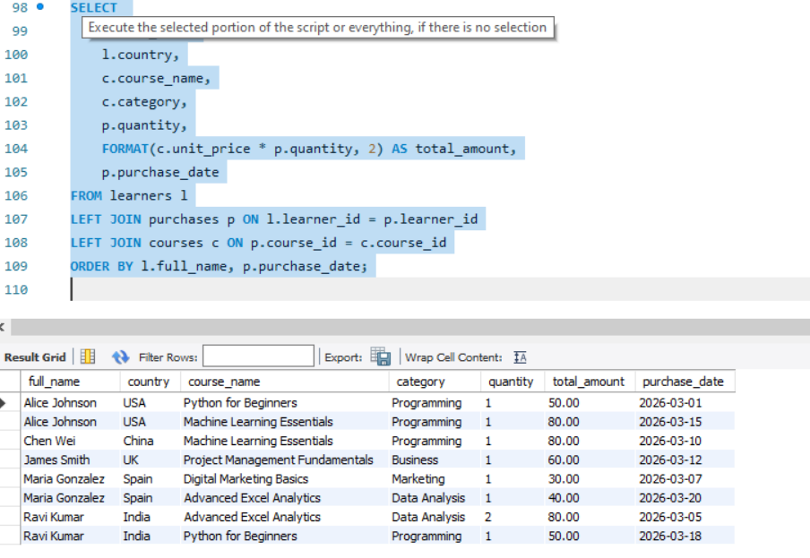
Output: Includes learners with zero purchases (they’ll show up with NULL in course/category/amount).
- RIGHT JOIN (all courses, even if not purchased)
This ensures all courses are listed, even if no learner has purchased them yet.
SELECT
l.full_name,
l.country,
c.course_name,
c.category,
p.quantity,
FORMAT(c.unit_price * p.quantity, 2) AS total_amount,
p.purchase_date
FROM purchases p
RIGHT JOIN courses c ON p.course_id = c.course_id
RIGHT JOIN learners l ON p.learner_id = l.learner_id
ORDER BY c.course_name, p.purchase_date;
Output: Includes all courses, even those with no purchases (they’ll show up with NULL in learner/quantity/amount).
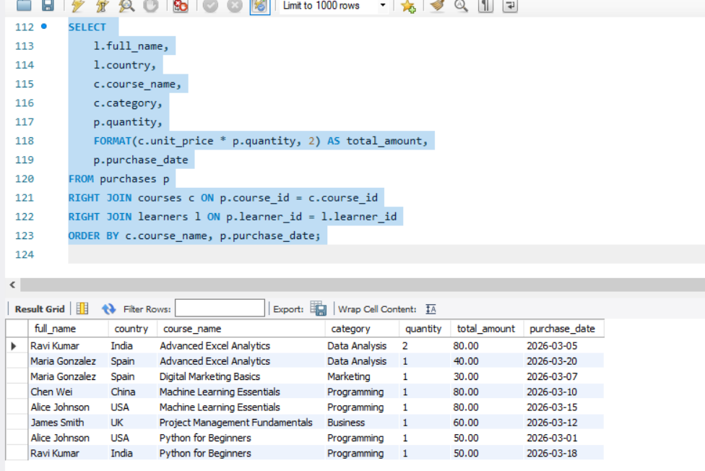
Key Takeaways
- INNER JOIN → Only matched records (active purchases).
- LEFT JOIN → All learners, purchases if available.
- RIGHT JOIN → All courses, purchases if available.

Q1. Each learner’s total spending with country
SELECT
l.full_name,
l.country,
FORMAT(SUM(p.quantity * c.unit_price), 2) AS total_spending
FROM purchases p
INNER JOIN learners l ON p.learner_id = l.learner_id
INNER JOIN courses c ON p.course_id = c.course_id
GROUP BY l.full_name, l.country
ORDER BY total_spending DESC;
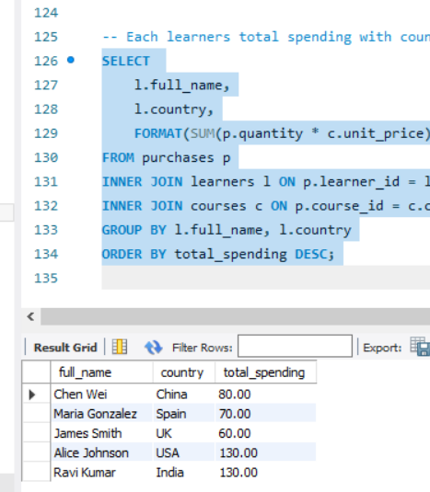
Q2. Top 3 most purchased courses (by quantity sold) sql
SELECT
c.course_name,
SUM(p.quantity) AS total_quantity_sold
FROM purchases p
INNER JOIN courses c ON p.course_id = c.course_id
GROUP BY c.course_name
ORDER BY total_quantity_sold DESC
LIMIT 3;

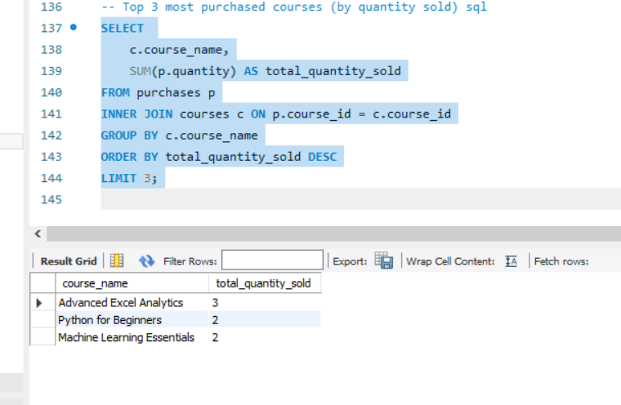
Q3. Each course category’s total revenue and unique learners.
SELECT
c.category,
FORMAT(SUM(p.quantity * c.unit_price), 2) AS total_revenue,
COUNT(DISTINCT p.learner_id) AS unique_learners
FROM purchases p
INNER JOIN courses c ON p.course_id = c.course_id
GROUP BY c.category
ORDER BY total_revenue DESC;
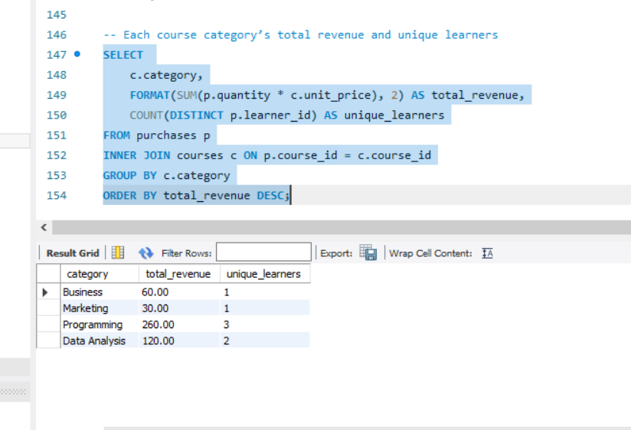

Learners who purchased from more than one category
SELECT
l.full_name,
l.country,
COUNT(DISTINCT c.category) AS categories_purchased
FROM purchases p
INNER JOIN learners l ON p.learner_id = l.learner_id
INNER JOIN courses c ON p.course_id = c.course_id
GROUP BY l.full_name, l.country
HAVING COUNT(DISTINCT c.category) > 1
ORDER BY categories_purchased DESC;
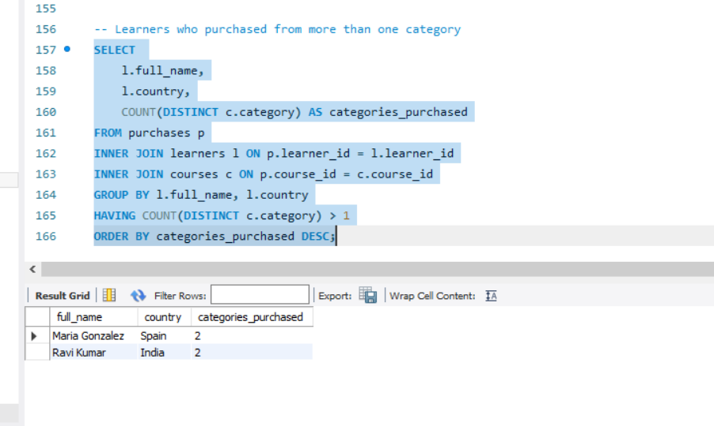
Q5. Courses that have not been purchased at all
SELECT
c.course_name,
c.category,
FORMAT(c.unit_price, 2) AS price
FROM courses c
LEFT JOIN purchases p ON c.course_id = p.course_id
WHERE p.course_id IS NULL;
