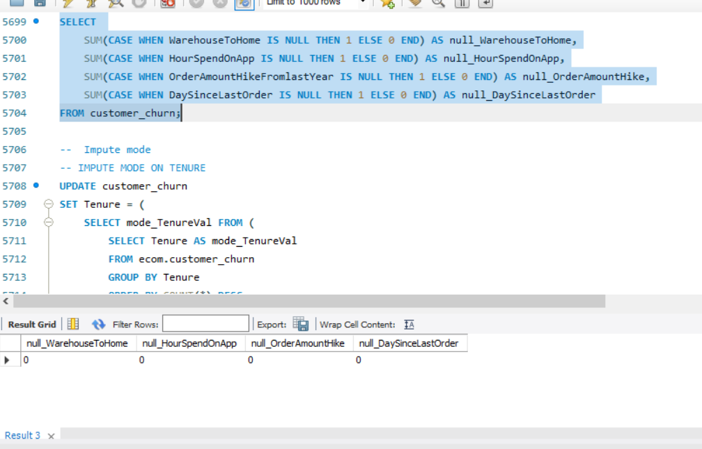

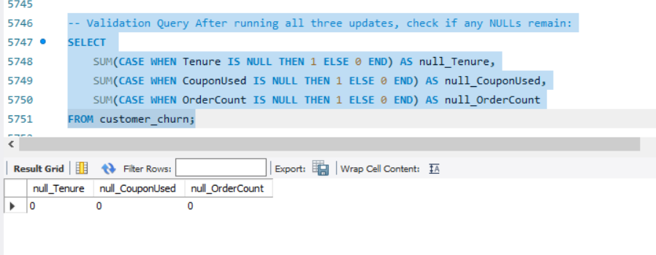

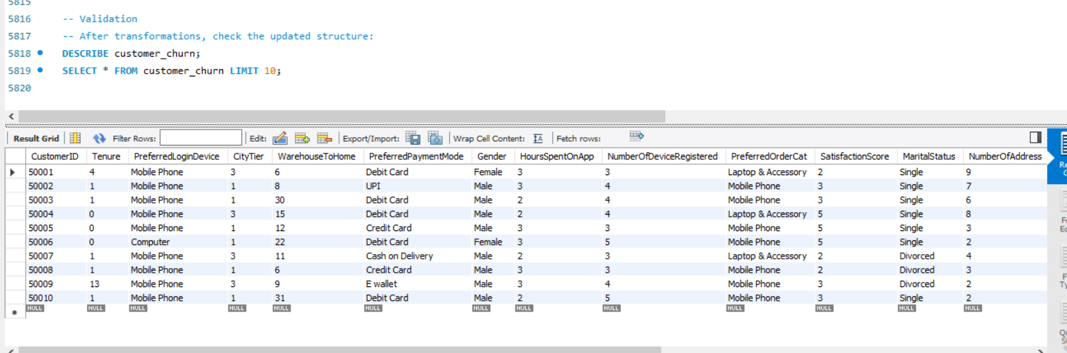

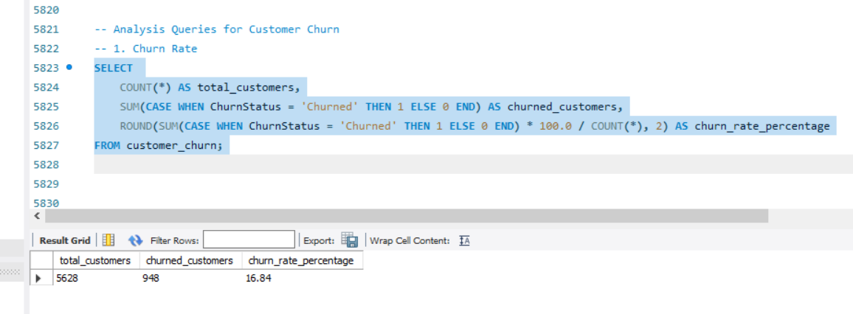

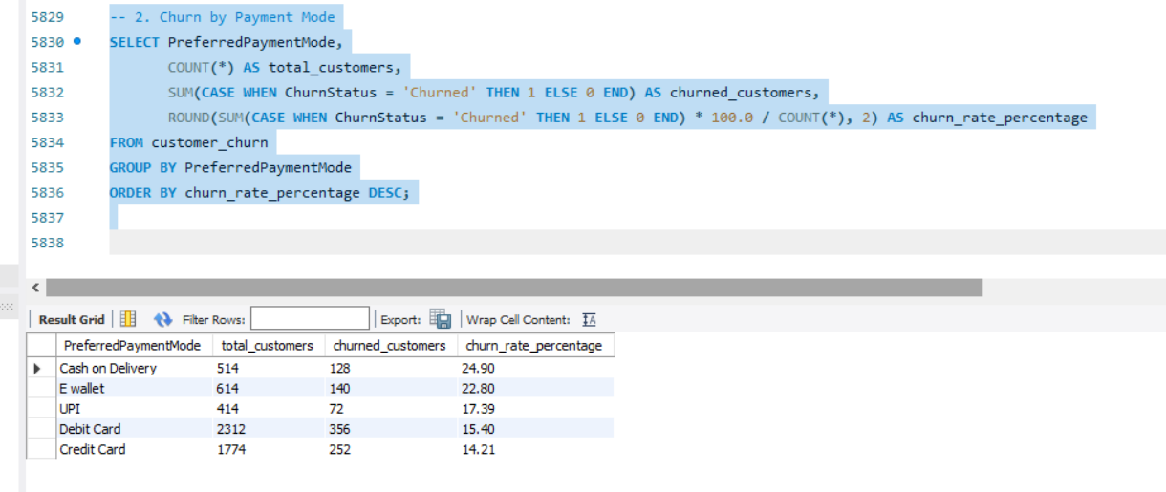

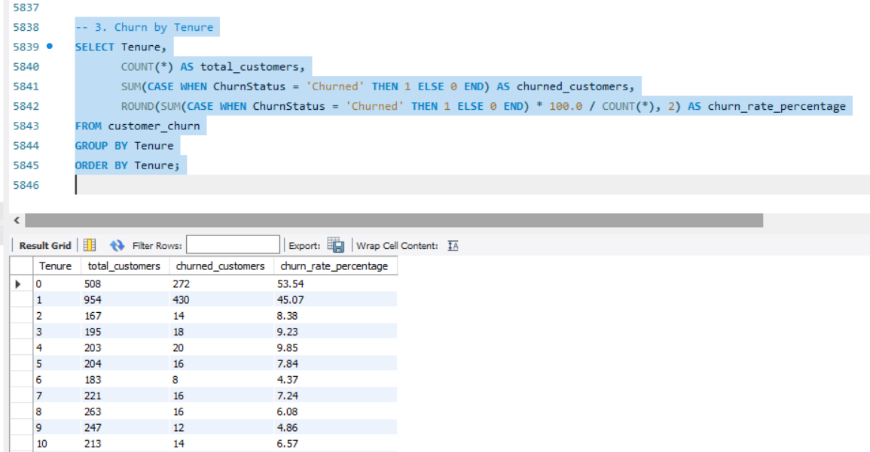
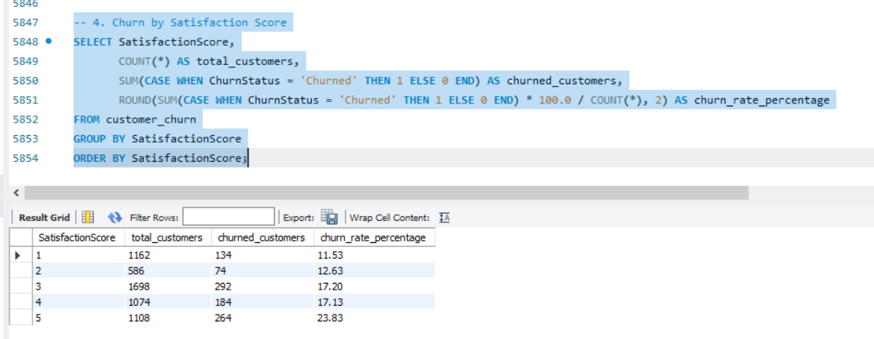

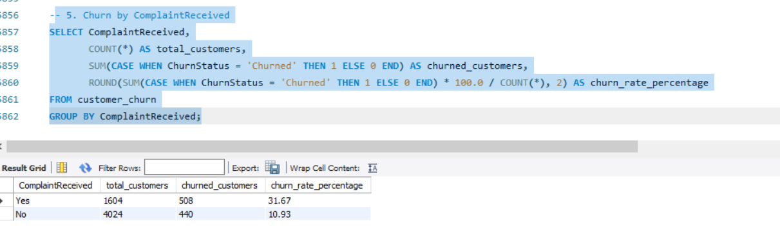
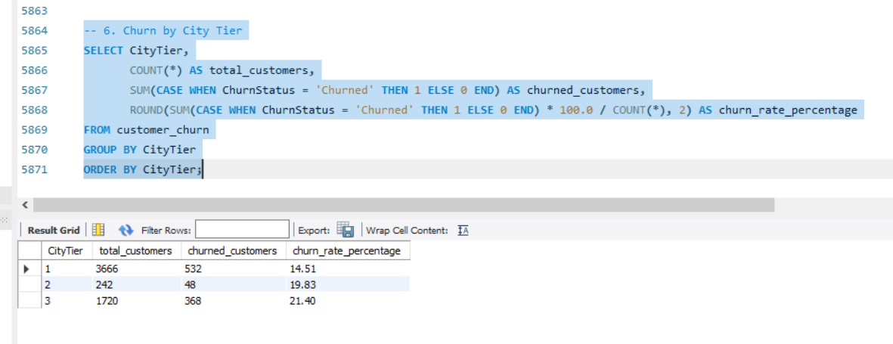
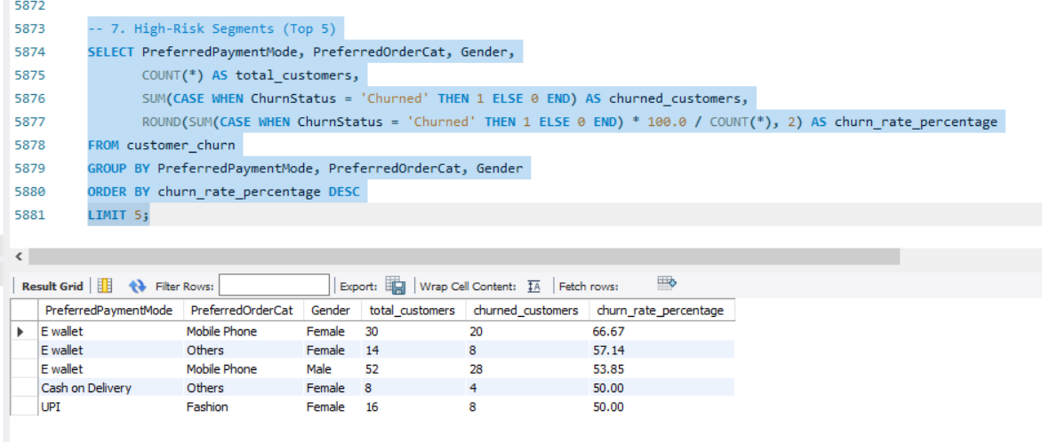
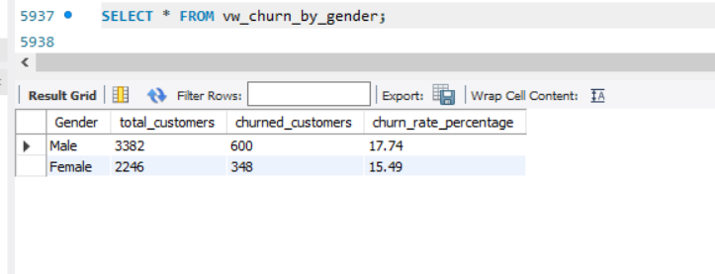
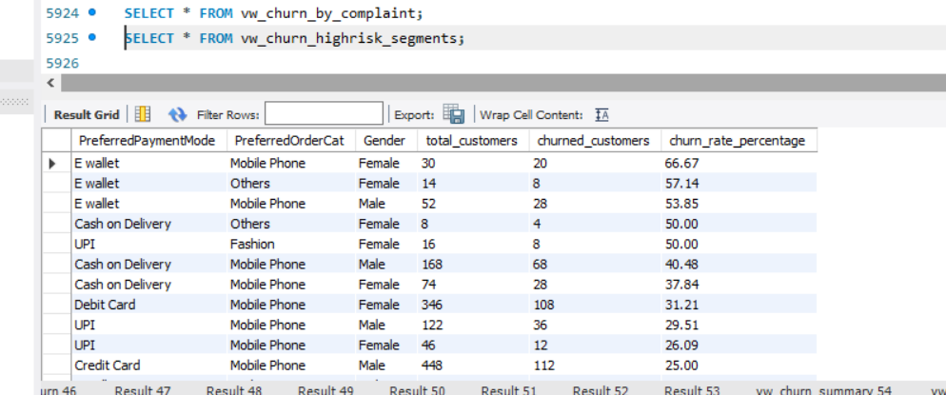

E-Commerce Customer Churn Analysis
Slide 1: Title & Context
- Title: Customer Churn Analysis – E-Commerce Domain
- Objective: Understand churn drivers and provide actionable retention strategies.
- Context: Dataset includes tenure, payment modes, satisfaction, complaints, and purchase behavior.
Slide 2: Overall Churn Rate
- Metric: X% of customers churned.
- Insight: High churn indicates urgent need for retention programs.
- Recommendation: Launch loyalty rewards and personalized onboarding campaigns.
Slide 3: Churn by Payment Mode
- Metric: COD customers churn at the highest rate; UPI/Wallet users churn less.
- Insight: Payment trust and convenience strongly influence retention.
- Recommendation: Promote digital payments (UPI, Wallets) with cashback offers.
Slide 4: Churn by Tenure
- Metric: Early-tenure customers churn more; long-tenure churn signals dissatisfaction.
- Insight: Lifecycle stage matters — onboarding vs. long-term engagement.
- Recommendation:
  - New customers → personalized onboarding, welcome offers.
  - Long-tenure customers → exclusive loyalty tiers, premium support.
Slide 5: Churn by Satisfaction Score
- Metric: Low satisfaction scores correlate with high churn.
- Insight: Customer experience is the strongest churn predictor.
- Recommendation: Improve service quality, faster delivery, and proactive feedback loops.
Slide 6: Churn by ComplaintReceived
- Metric: Customers who raised complaints churn significantly more.
- Insight: Complaint handling is a critical retention lever.
- Recommendation: Strengthen complaint resolution processes, track SLA compliance.
Slide 7: Churn by City Tier
- Metric: Tier 2/3 cities show higher churn than Tier 1.
- Insight: Logistics and brand presence challenges in smaller cities.
- Recommendation: Invest in regional delivery hubs, localized marketing.
Slide 8: High-Risk Segments
- Metric: Male COD users buying fashion items show highest churn.
- Insight: Segment-specific vulnerabilities exist.
- Recommendation: Targeted retention campaigns for high-risk segments (discounts, personalized offers).
Slide 9: Strategic Recommendations
- Retention Playbook:
  - Lifecycle-based engagement (onboarding vs. loyalty).
  - Payment mode promotions (UPI/Wallets).
  - Complaint resolution excellence.
  - Regional logistics improvements.
  - Segment-specific retention campaigns.
Slide 10: Next Steps
- Operationalize: Build dashboards from SQL views (vw_churn_summary, vw_churn_by_payment, etc.).
- Monitor: Track churn monthly by segment.
- Act: Implement targeted retention strategies and measure impact.

