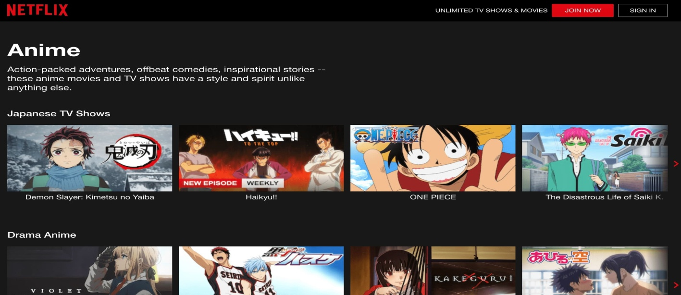

# **Project Name: Netflix**

**Created By: Revati Vidhale**

**Overview Of Project**

Netflix is an Internet based company specializing in providing on-demand Internet streaming media. Netflix is a global streaming entertainment service which was founded in 1997 by American entrepreneurs Reed Hastings and Marc Randolph. Netflix offers movies, TV series and games commercial free with unlimited viewing on any internet connected screen for an affordable with no commitment monthly fee. Netflix is just not a generic video company which plays all types of videos. It is a movies and television series entertainment network. Netflix is the world’s leading entertainment services with 221 million paid membership in over 190 countries enjoying TV series, movies, documentaries and mobile games across a wide variety of languages. All the members can watch as much as they want, anytime, anywhere, on any internet-connected screen. Members can play, pause and resume watching all without any kind of commercials or commitments

**Content Of Project**

The Project consists of the following content

* Get Started
* Enter Mail Id
* Create Account
* Choose Plan
* Directing To Payment Gateway
* Customizing Choices Of Languages
* Directing To Homepage

**Technologies Used**

1. The Frontend of application is developed using following technologies

* Html, CSS, Javascript, Bootstrap, Jquery

1. The Backend of application is developed using following technologies

* Nodejs, ReactJS, API’s

1. The Database of application is developed using following technologies

* Mongodb, SQL, Reactjs

1. The Devops used for developing the application

* Gitbash, Github, Vscode

