Course 1: DATA STORYTELLING AND VISUALIZATION
Capstone Project: TRAVEL AND TOURISM
Team Members: RIYA, REVATI, ROHAN

- INTRODUCTION: Our project focuses on analysing global travel and tourism data through a dashboard. Through this analysis, we can understand tourism performance, travel trends, revenue growth, and how different regions are performing. The dashboard helps us identify important trends and patterns from the data that can help in better decision-making.

OBJECTIVES | VISUALS | INTERPRETATIONS
- Country-wise dependency on tourism Exports (%)  - To identify which country is most dependent on tourism for export earnings.  - To compare tourism exports of different countries. | Tools/Techniques: Bar Chart, Data Comparison, Categorization by country | - Antigua and Barbuda has the highest dependency at 79.55%.  - This indicates its economy is highly dependent on tourism.  - Countries like Armenia (29.66%) and Austria (13.20%) show moderate dependency.  - UAE (7.86%) has the Lowest dependency on tourism.  - Developing countries like Austria & Belgium have low export dependency despite good arrivals, indicating they have strong other export sectors.
- Tourism arrivals vs Tourism Income  - To analyze the correlation between tourist arrivals & tourism income generated.  - To find out if more tourists directly result in higher tourism revenue | Tools/Techniques: Scatter plot, Correlation analysis, trendline(R=0.9), outlier detection. | - Strong positive correlation  (R = 0.9).  - As tourist arrivals increase, tourism income also increases proportionally.  - The Arab World cluster at the top-right shows the highest arrivals generating the highest income.  - Data points for Austria & Australia are clustered in the mid-range, showing balanced performance with moderate arrivals generating moderate income.  - Shows high volume but lower per-tourist revenue model.
- Unemployment distribution  - To find the country with the highest unemployment rate among selected countries.  - To understand unemployment share distribution. | Tools/Techniques: Pie Chart, Percentage Calculation, Data Labelling, Color coding for comparison. | - Armenia has the highest unemployment at 19.62%, followed by Argentina(10.76%)  & the Arab World(10.07%).  - This suggests tourism dependency does not directly reduce unemployment – focused economic policies needed.  - Belgium has the lowest unemployment at 2.46%, showing a strong economy and job stability.  - Large difference(16.78%) between highest & lowest shows unemployment is unevenly distributed among selected countries.
- Global Tourism :  Income vs Spending  - To track year-wise contribution of Global tourism income and spending.  - To identify the growth pattern and peak year of the tourism economy | Tools/Techniques: Double Doughnut Chart, Percentage share calculation, year-wise grouping | - Peak year is 2017 – In 2017, both income (28%) and spending ( 21%) are highest.  - This means the global tourism economy was at its peak in 2017.  - In 2015 & 2017, income share(24% & 28%) is more than spending share(21% & 21%),  showing tourism became more profitable.  - The lowest contribution in 2001 shows only 45 income and 11% spending, the lowest income year due to maybe global factors like the 9/11 impact on travel.  - Recovery after 2008 – After 2008 ( Income 16%, Spending 14%), both Income & Spending dipped but recovered strongly in 2010(16% & 15%) and jumped to 24%/21% in 2015.  - There is steady growth where income increased from 5% to 28%, almost 5 times growth in 17 years.
- Tourist arrivals trend by Country  - To compare tourist arrivals trend across different countries over the years.  - To identify the top country attracting the maximum tourists consistently. | Tools/Techniques: Line Chart with Markers, Time series analysis, Growth rate calculation | - Upward trend – The line is continuously going up from 2000 to 2017, which shows global tourism is growing year by year without a major downfall.  - Peak in 2017 – The highest point of both lines is in 2017. So 2017 is the best performing year for tourism.  - Slow growth from 2000 – 2005  From 2000 to 2005, the line is almost flat/ slow increase, meaning growth was slow in the initial years.  - Fast growth in 2010: After 2010, the slope becomes very steep, especially from 2010 to 2017.  - This shows tourism boomed due to cheaper flights, internet booking, and social media promotion.  - Income and spending lines move together – Both lines follow the same pattern, proving a direct relationship – when tourist arrivals increase, income and spending both increase together.

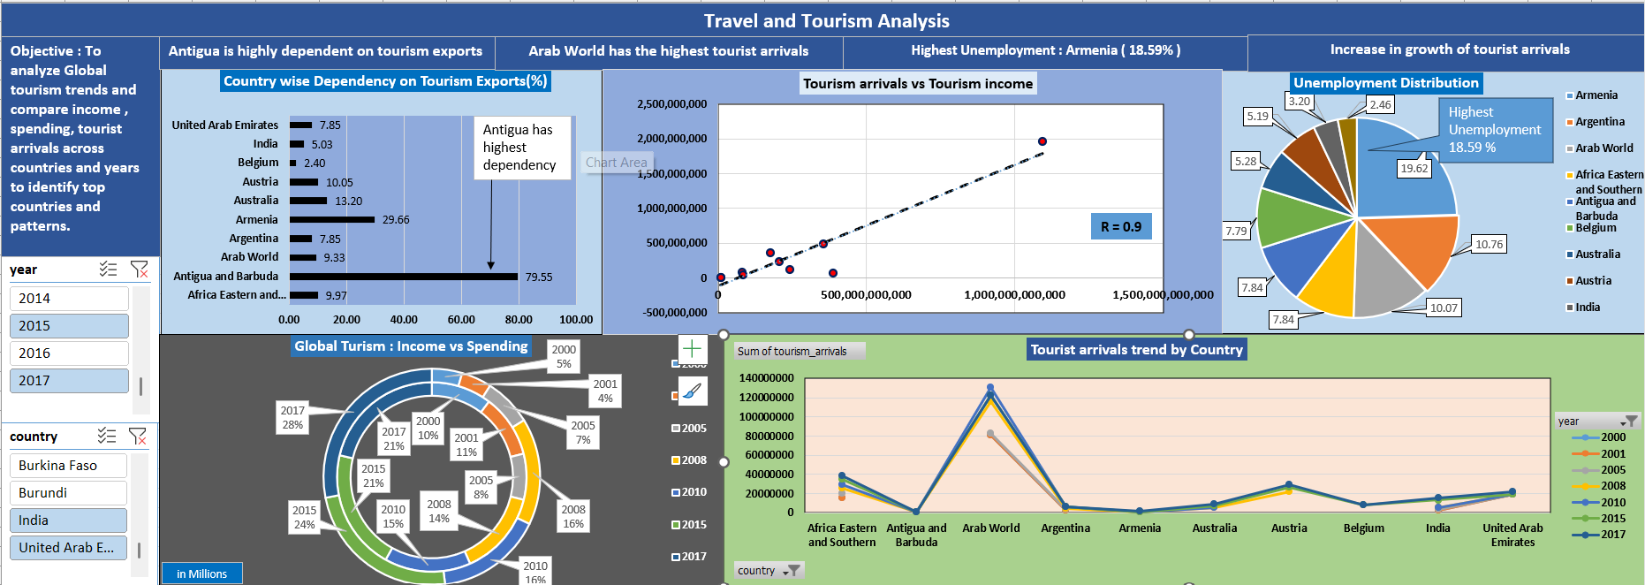
- DASHBOARD:

Fig. 1: Interactive Dashboard Overview

This dashboard consolidates all four visualizations into a single interactive view, filterable by year through a shared slicer. KPIs and chart callouts are fully dynamic — built using array formulas — so all figures and R-value interpretations update live as the filter changes, rather than remaining static.

- SUMMARY: This project analyzes global tourism trends across 21 countries from 1999 to 2017, evaluating the interplay between tourist arrivals, receipts, export dependency, and macroeconomic indicators such as inflation and unemployment. The dataset was cleaned via country-wise interpolation and structured into interactive Excel dashboards utilizing pivot tables, correlation modeling, and dynamic charts.
The findings show substantial global tourism growth and a strong link between arrival numbers and revenue generation, with activity heavily concentrated in select regions—such as the Arab World leading total arrivals, and economies like Antigua and Barbuda showing high tourism export dependency. However, broader macroeconomic conditions (including high-unemployment outliers like Armenia at ~18.59%) demonstrated only a weak relationship with overall tourism performance, indicating that travel demand operates largely independent of domestic economic headwinds

- CONCLUSION/ FINDINGS:
- Steady Growth: Global tourism grew steadily from 1999 to 2017 and is a key driver of revenue.
- Strong Link: There is a strong link between tourist arrivals and tourism income, with R = 0.9.
- Regional Leader: The Arab World is leading in tourist arrivals and post-pandemic growth.
- High Dependency: Benefits are concentrated in top hubs. Small countries like Antigua are highly dependent on tourism exports.
- Weak Macro Impact: Tourism has only a weak impact on unemployment and inflation.
- Need for Diversification: Tourism gives high growth, but countries also need economic diversification for balanced development.
Final Takeaway: Tourism is growing and profitable with a strong arrivals-to-income link.

