1. `GET /tasks`: Retrieve a list of all tasks.

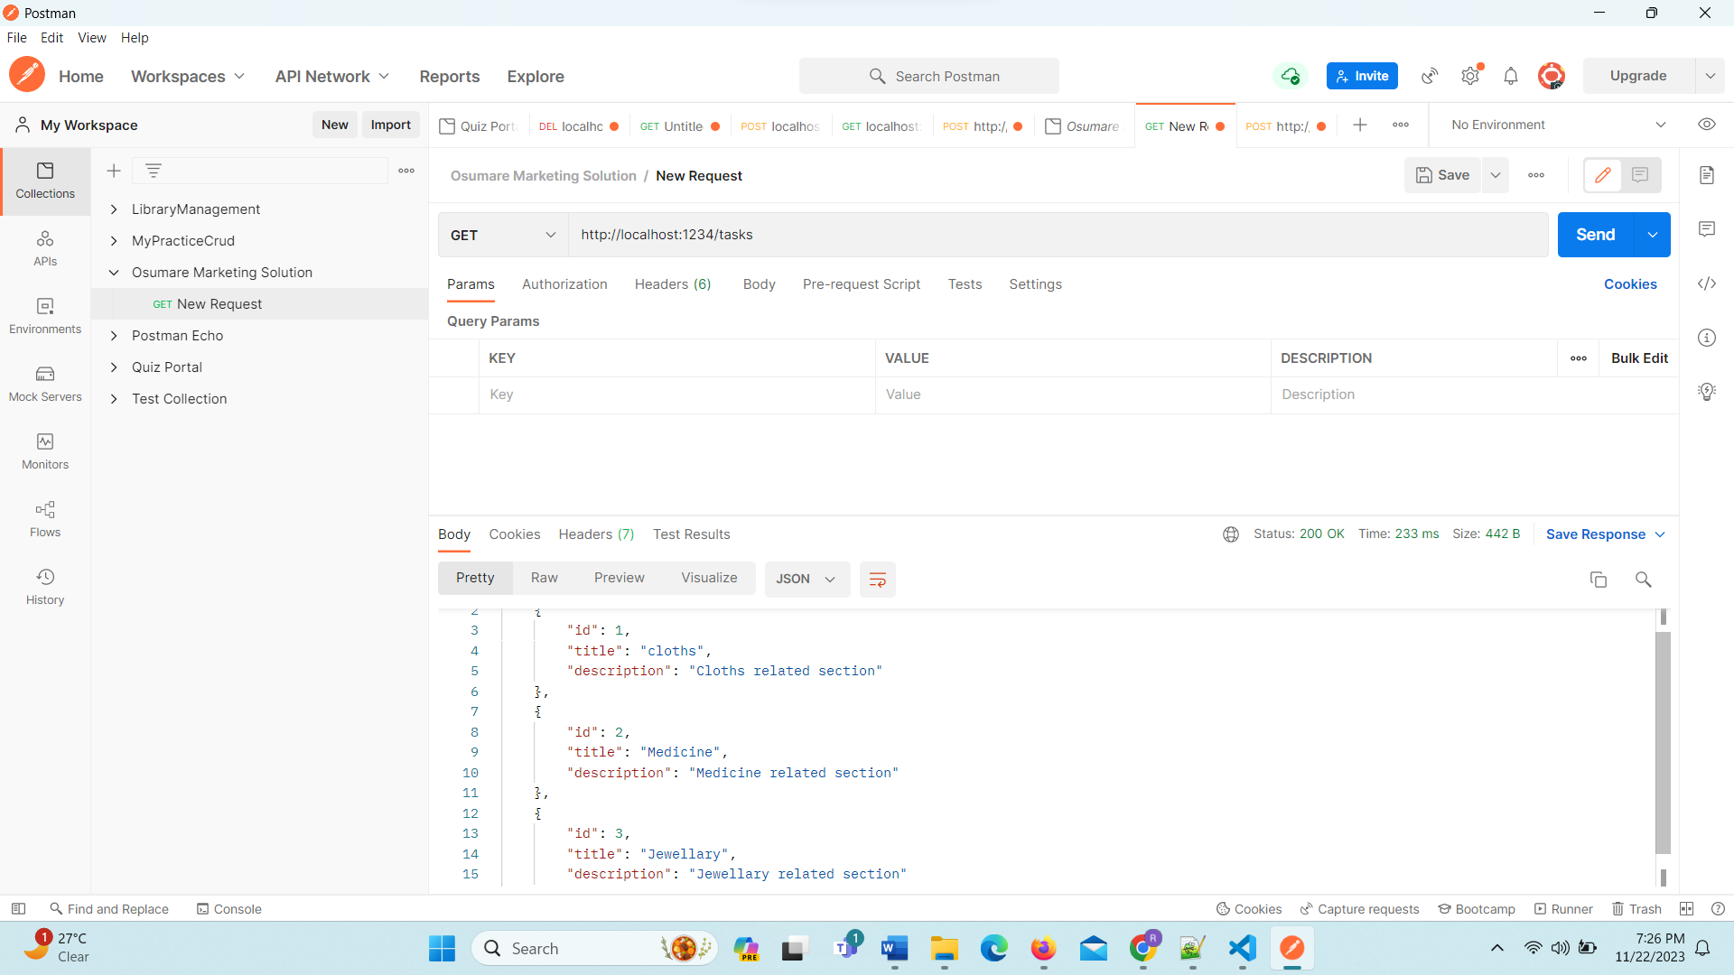

2. `GET /tasks/:id`: Retrieve a specific task by ID.

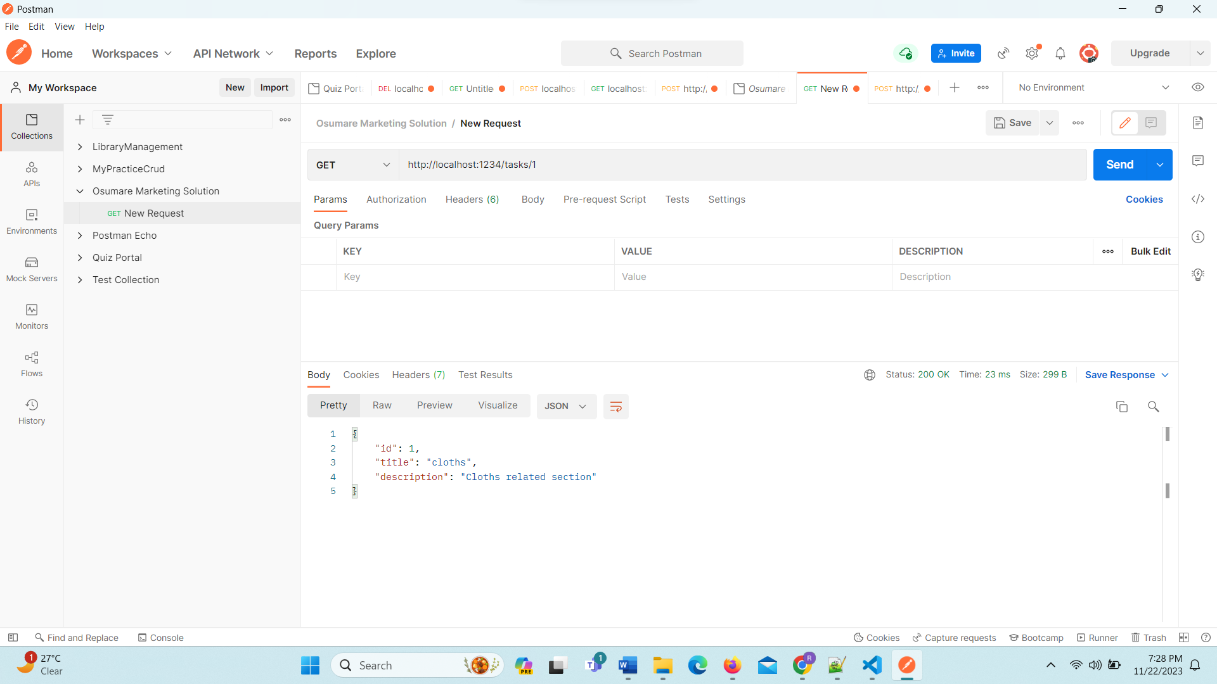

3. `POST /tasks`: Create a new task.

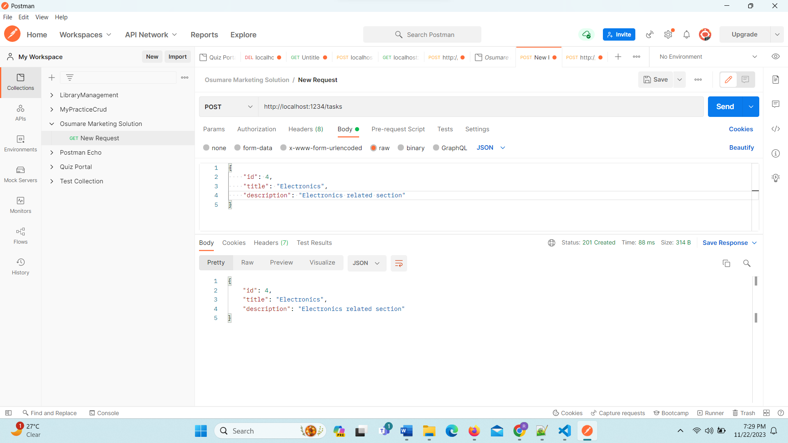

4. `PUT /tasks/:id`: Update an existing task by ID.

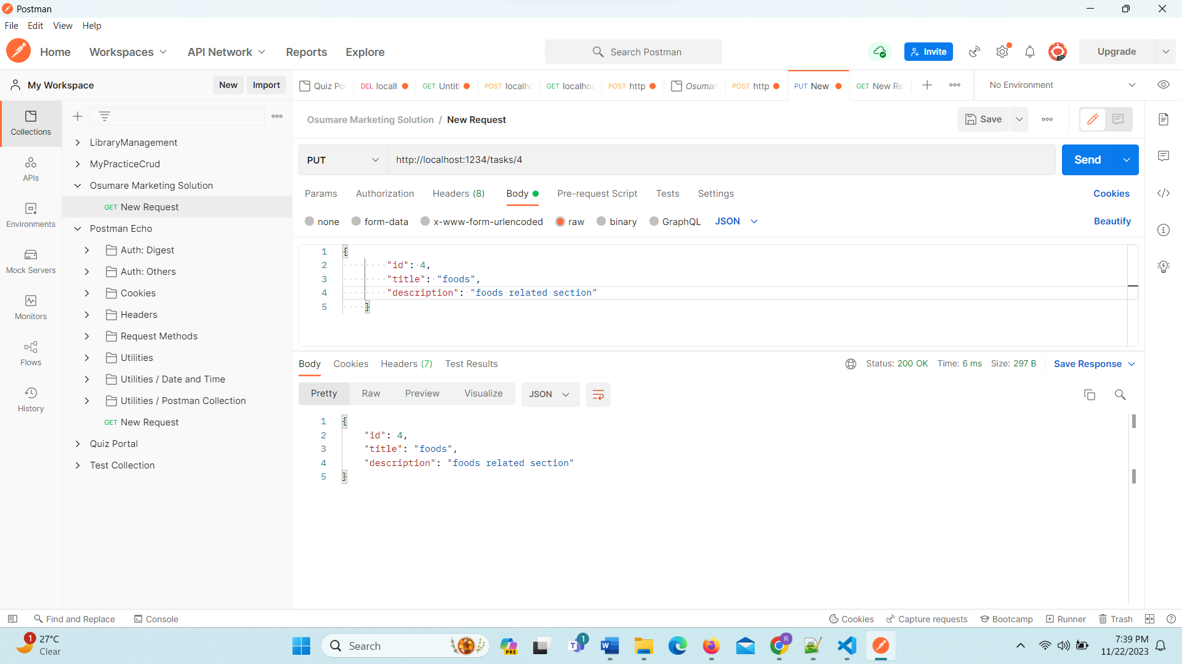

5. `DELETE /tasks/:id`: Delete a task by ID.

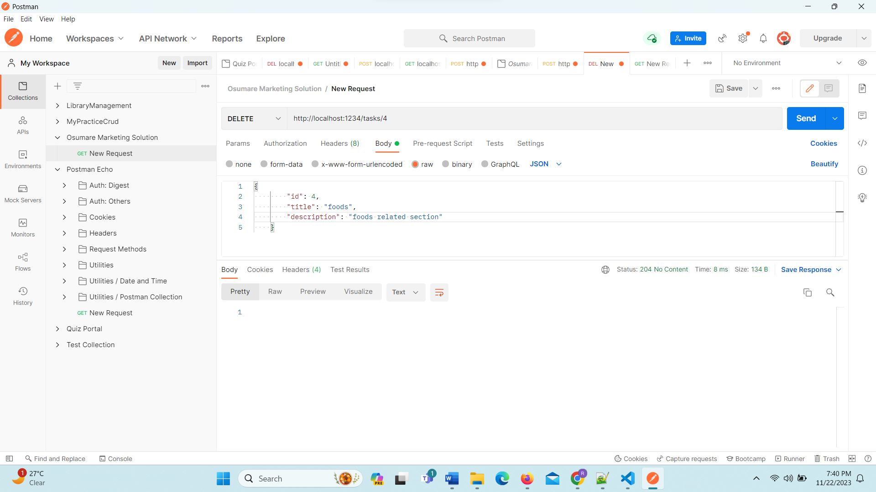

----exception handling id 4 not fund status------

