Dev-Ops Pipeline Master Document

VERSION | AUTHOR | UPDATED | DETAILS
0.1 | Ryan Lessley | 10/18/2018 | Document First Draft Up To Tomcat
0.2 | Ryan Lessley | 10/18/2018 | First Draft Up To A Finished pipeline
0.3 | Christina Russ | 9/24/2019 | Updated Outdated Portions of Guidelines

SCM (Source Code Manager) 3
Github 3
Gitlab 4
Pushing Your Project 5
SETTING UP YOUR AWS ACCOUNT 7
SETTING UP YOUR DATABASE ENVIRONMENT 8
SETTING UP YOUR EC2 9
Creating the EC2 9
SSH Into Your EC2 12
EC2 Environment: Java 13
EC2 Environment: Tomcat 8.5 PART 1 (Acquisition and Environment Variables) 14
EC2 Environment: Tomcat 8.5 PART 2 (Tomcat Configuration) 15
EC2 Environment: Git 16
EC2 Environment: Jenkins Acquisition 17
SETTING UP THE PIPELINE 18
Unlocking Jenkins 18
Changing Your Admin User Password 19
Acquiring Essential Plugins 20
Setting Up Maven 20
Setting Up Slack Notifications 21
Setting Up Push Detection For Github 22
Create The Pipeline 23

SCM (Source Code Manager)

Github
- https://github.com/
- Assuming you have created a Github account, you will login and create a new repository by clicking the “Start a project” button.

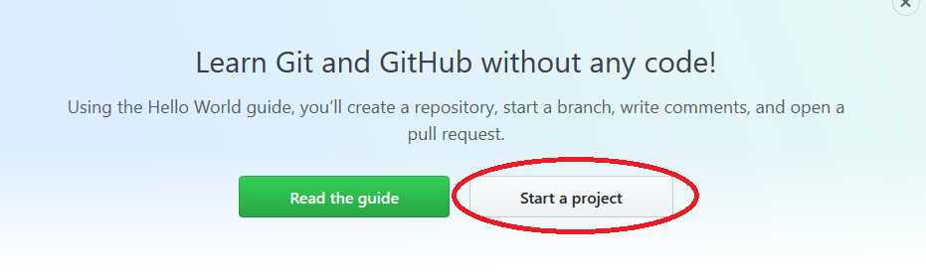
- Next you will be brought to the project information screen:
  - Ensure you are the owner or using an organization of your choice.
  - Ensure the project is public unless you want to spend money for a private project.
    - NOTE: You are now allowed a free private project on GitHub.
  - Ensure you initialize the repository with a README.md (This will also initialize the ‘master’ branch).
  - Ensure you add a ‘.gitignore’ for the language of your choice. Chances are you want to include one for Java.
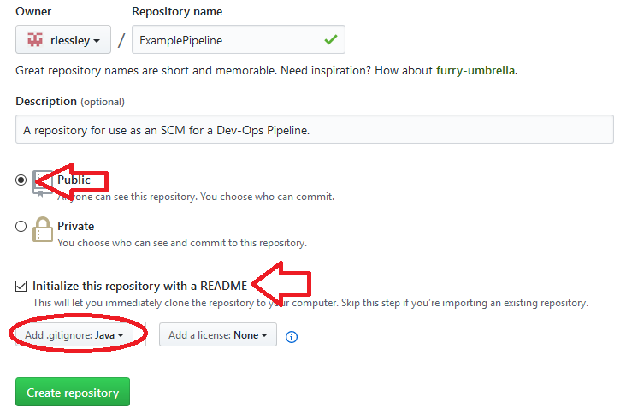
- Next you will add the project of your choice. Ensure it is a Maven Project. The key file we will be leveraging is the ‘pom.xml’.
- You can either push a folder containing the project (useful for housing multiple projects in the same repository), or you can place the project root files in the repository solely (I.e. the src folder, pom.xml, etc).

Gitlab
-TBD

Pushing Your Project
- At this stage you should be used to this process, but for the sake of completion I will detail the specific steps below:
- First you will want to have the repository locally on your machine. Be sure to grab the remote URL from the project page online. Typically it will be an ‘https’ unless you are using ssh keys. For example:
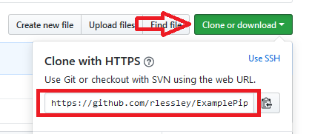
- Next navigate to where you want your repository to be. Remember the two ways to make a local repository: (Both through the ‘git-bash’)
  - git clone https://whatever-your-url-is
    - Which creates a folder containing the repository at the location in which you invoked this command.
- Or you can transform your current folder into the repository via:
  - git init
  - git remote add origin https://whatever-your-url-is
  - git pull origin master
- Once done you will setup your project in the repository. Via eclipse you will create a ‘new maven project’.
- Next you will want to change the default workspace to be in your location of the repo so you can push changes more easily.
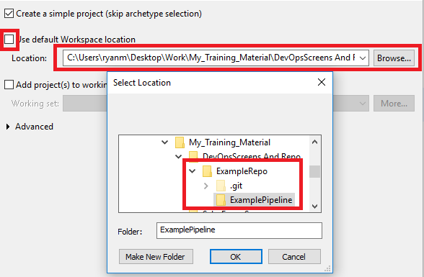
- Note: If you want your repo to be the root folder for the project, then selecting the repo’s location will suffice. HOWEVER, if you want to separate the contents into its own folder in the repo, you will need to create a folder for it within, like I did so above. I created the folder “ExamplePipeline” inside of my local repo folder “ExampleRepo”.
- For this example you will want to package the project as “war” and be sure to remember the “artifact id” you give the project as you will need to reference it later on.
- NOTE: Be sure to name your project the same as the folder you set as its default directory, otherwise you may get a description error.
- Finally, simply create an “index.html” (Specifically named this, casing and all) with “Hello world” in it.
- You will also need to generate a deployment descriptor.
- Once finished, you should be able to push your project to your Source Code Manager (SCM)n and be able to see it on the website. For my example:
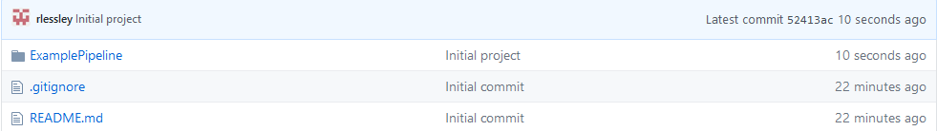

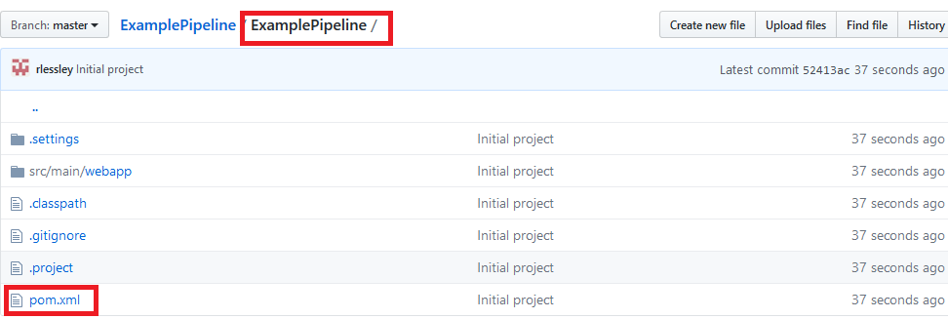
- NOTE THE POM FILE’S LOCATION, WE WILL NEED IT LATER
- With the SCM properly constructed and set up, we can now start setting up our cloud environment.

SETTING UP YOUR AWS ACCOUNT
-At this point, you should already have an AWS account. I won’t humor you.

SETTING UP YOUR DATABASE ENVIRONMENT
-Again, you’ve been using an RDS for a while. I won’t explain this because I believe in you.

SETTING UP YOUR EC2

Creating the EC2
- So now we will need our EC2 to host our application and necessary tools.
- In AWS, navigate to the EC2 portal and choose to launch a new one. Make sure you are comfortable with the Region you are creating it under. Once ready you should be at the following screen:
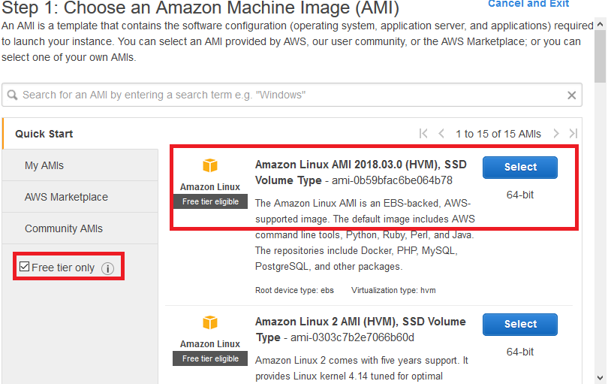
- You will want to check the “Free tier…” checkbox on the left-hand side. For our purposes, we will use the Amazon Linux AMI. (Amazon Machine Image) Don’t choose #2 as it is unnecessary for our purposes.
  - NOTE: CHECK THE “FREE TIER” OPTION. I’M SERIOUS.
- Next you will pick your EBS (Elastic Block Store). Free tier allows only the t2.micro, so you can simply pick it and move on to the next step.

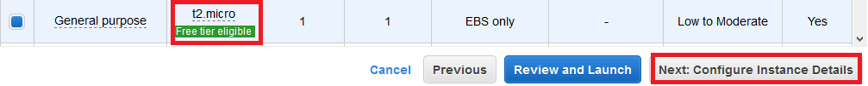
- Now you should be at Step 3, the defaults are all that will be necessary here unless you want to spend money. Simply click the “Next: Add Storage” button on the bottom right.
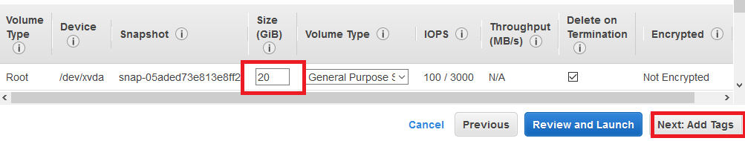
- Here you can allocate how much storage you want. (STEP 4 btw) You can use 30 GiB max for free. like to use 20 typically (probably because I’m paranoid about spending money when using AWS). Once you have your storage, move on to tags.

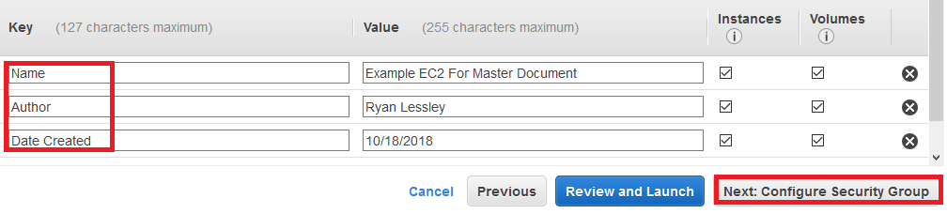
- Next you will add tags for your EC2; these are for informatiional purposes only and you should add many in order to disambiguate your EC2s from each other. It is also useful in team environments for determining who is in charge of what and what each is being used for. Once done move on to the next step.
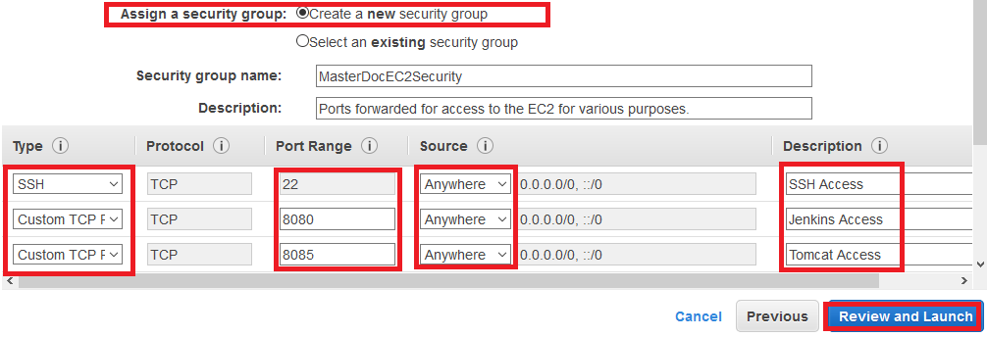
- Now you are at security groups, this step is VERY IMPORTANT.
- Here you determine what ports to allow access through and from where. NEVER OPEN ALL PORTS FOR ALL TRAFFIC, THESE KINDS OF SECURITIES ARE HACKED OFTEN.
  - I’LL SAY IT AGAIN: NEVER OPEN ALL PORTS FOR ALL TRAFFIC. YOU KNOW BETTER.
- For our purposes, I will keep port 22 for SSH and allow for “Anywhere”.
- Next I will add a port for Jenkins on 8080.
- Finally I add a port for Tomcat on 8088.
- The ports are up to you, though you’ll probably choose these exact ports because you’ll be afraid not to follow this document to a tee.
- In the step ahead you can review everything. Once done, choose to “Launch”.
- You will be brought to the final step: the security key pair. Choose to either leverage an existing pair or create a new one. In either event, you will be prompted to download the key.
- DO NOT LOSE THIS KEY AS YOU WILL NOT BE ABLE TO LOG INTO YOUR EC2 WITHOUT IT. YOU WILL NOT BE GIVEN ANOTHER CHANCE TO DOWNLOAD IT EVER AGAIN. READ: YOU’LL HAVE TO SPIN UP A NEW EC2 INSTANCE IF YOU LOSE THIS KEY.

- Once done, navigate to your EC2 portal on AWS and find the EC2 you created. Click it and you should see a details section below it. Here you can view all details and make changes as you may need to. For now we only care about the IPv4 Public IP as seen below:
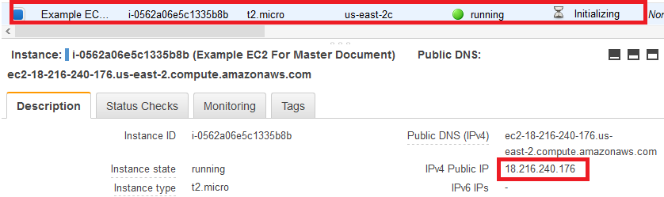
With that we can move on to SSH-ing into our EC2 to setup the environment.

SSH Into Your EC2
- In order to connect to your EC2 you will need the key file you downloaded. There are a few steps that need to be performed to ensure it works:
  - FOR WINDOWS:
    - Ensure you aren’t using your key in an administrator environment. (Directly in the C:/ drive for instance.) If you need to do so, you will have to revoke permissions on the file for everyone but the user of the file. Also, limit it down to read only.
  - FOR MAC:
    - Invoke the following command on the file: sudo chmod 400 your-key-name.pem
    - This will allow you to use the key, should it prevent you otherwise.
- To connect to the EC2, open up your shell/cmd with git commands installed to path, then invoke the following command to connect:
  - ssh -i location/of/your-key.pem ec2-user@your.public.ip.address
    - The public ip address is on your EC2 information in AWS
    - “ec2-user” MUST be used.
    - Upon success you will be asked if you want to trust the connection. Enter “yes” (or “no” for some weird reason) and you should be greeted with the following:
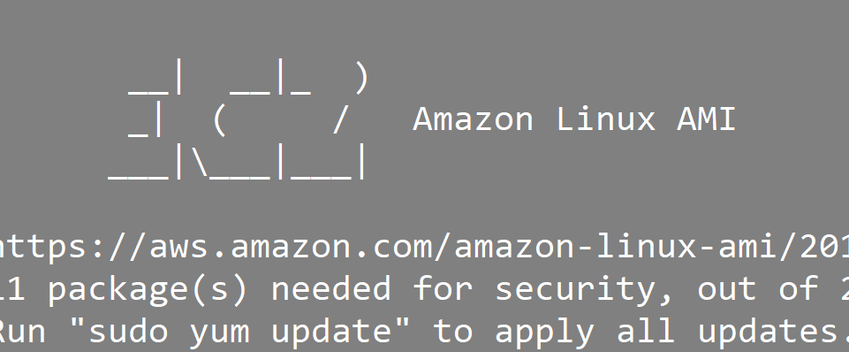
- To start things off you should invoke the following command in order to update your AMI
  - sudo yum -y update
    - “sudo” allows you to run a command with elevated permissions (as the super user)
    - “yum” is the package manager this distribution of Linux uses
    - the “-y” indicates that you want to say “yes” to all of the options you’ll be prompted to either accept or reject. Trust me: I’m saving you time.

EC2 Environment: Java
- Your EC2 will have Java installed, but it will be an old version we don’t care to use. First remove this old version via:
  - sudo yum remove -y java
- Next you will want to install a more up-to-date, open source Java JDK using the following command:
  - sudo yum install -y java-1.8.0-openjdk-devel
- That should be all there is to this step.
- You can confirm success by seeing Java 8 as the version with:
  - java -version
- And confirming JAVA_HOME is properly set by invoking the following:
  - echo $JAVA_HOME
- Which should yield: /usr/lib/jvm/jre
- If for some reason you don’t have a JAVA_HOME, you must manually set your JAVA_HOME by navigating to the /etc/profile.d directory and adding a file which exports the JAVA_HOME variable.
  - NOTE: YOU’LL HAVE TO EXIT YOUR EC2 AND SSH BACK IN WHENEVER YOU ADD A NEW ENVIRONMENT VARIABLE.

EC2 Environment: Tomcat 8.5 PART 1 (Acquisition and Environment Variables)
- Can’t host a web application without Tomcat.
- First you are going to want to download the tar.gz of Tomcat (Linux’s .zip)
- To get it, invoke the following:
  - wget https://www-us.apache.org/dist/tomcat/tomcat-8/v8.5.46/bin/apache-tomcat-8.5.46.tar.gz
    - NOTE: The version is static. It may be more updated at the time of reading this. As of 9/24/2019, this is the most up-to-date version. Please check the official Apache Tomcat website for the most recent version.
- Once done invoke:
  - ls
- And you should see, in red text, the tomcat tar.gz.
- To unpack it, invoke the following:
  - tar -zxvf apache-tomcat-whateverversionitis_use_tab_to_autofill
    - The “tar” command unzips the file
    - “-z” filters the archive through gzip
    - “-x” extracts the archive file
    - “-v” shows the progress of the archive file
    - “-f” denotes that you’re providing the filename of the archive file
- This should yield the tomcat folder with all necessary files for hosting the server.
- Remove the tar.gz of tomcat to avoid confusion in the next step:
  - rm apache-tomcat-yaddayadaa.tar.gz
- Next, we want our tomcat accessible by all and this is best done by moving it to the following location: “/etc/”.
- To do this, invoke the following:
  - sudo mv apache-tomcat-yaddayadda /etc/
- Side note: I really hope you aren’t literally typing “yaddayadda” in these examples. Clearly, that is up to you to replace with proper naming.
- To confirm success, move to the tomcat folder as it is in the /etc/ folder:
  - cd /etc/apache-tomcat-yadda-yadda
- While in that folder, invoke:
  - pwd
- Which will show the directory you are in. Copy that directory as we will need it for the next step:
- We will change directory to the following:
  - cd /etc/profile.d
- Any shellscript files we create here get executed for any logged in user, as a result we will want to create a script for setting our CATALINA_HOME environment variable.
- To do this we will invoke the following:
  - sudo vim catalina.sh
- Next do the following
  - type “i” to enter INSERT mode.
  - Type the following:
    - export CATALINA_HOME=/etc/apache-tomcat-yadda-yadda
      - You can paste it assuming you copied it from the ‘pwd’ in step 14.
  - Finally, save and quit via:
    - :wq
- Now exit your ec2 and re-enter/login to see if you set the variable correctly, if you did, you should be able to invoke the following without error:
  - cd $CATALINA_HOME

EC2 Environment: Tomcat 8.5 PART 2 (Tomcat Configuration)
- Assuming you have finished the step before this one, we will now configure Tomcat itself. To begin, let us navigate to the tomcat configuration files which are stored in:
  - cd $CATALINA_HOME/conf
- First we want to change the port we host with on Tomcat, this will be done in the server.xml
  - sudo vim server.xml
  - Then you will want to change the existing port “8080” to be whatever port you chose to forward for tomcat in the EC2 setup. DO NOT ALTER THE PORT 8005 OR 8009.
- Next we need to configure administrative tomcat users for use in our pipeline, you will need to add the following. Access the tomcat-users.xml:
  - sudo vim tomcat-users.xml
  - Below is an example of what you need:
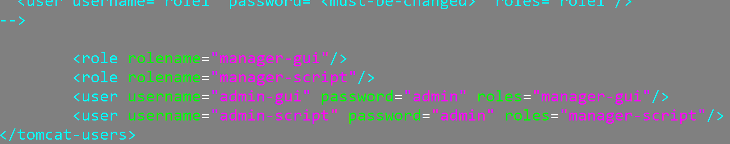
- Note: the <role> tags are ABSOLUTE and MUST be named exactly the same as I have them above. The <user> tags have more flexibility, you can name them whatever you want long as the “roles” attribute has the correct roles attached.
- With that done, navigate to the /bin of tomcat
  - cd $CATALINA_HOME/bin
- we will now start the server:
  - sh startup.sh &
    - NOTE THE AMPERSAND AT THE END! It tells the system to run the command in the background.
- To confirm all has worked, connect to your tomcat through a browser of your choice at the following url:
  - your.public.ip:yourTomcatPort
    - In my case:
  - 18.216.240.176:8085
    - You should see the Tomcat homepage.

EC2 Environment: Git
- Invoke the following:
  - sudo yum -y install git
- Confirm success with:
  - whereis git
- Which should yield the folder location of git. Congrats on completing this section of the setup.

EC2 Environment: Jenkins Acquisition
- Navigate to your home directory
  - cd ~
- create a folder for your jenkins to go in:
  - mkdir jenkins
- Navigate to the folder
  - cd jenkins
- invoke the following command to get the latest version of jenkins:
  - wget https://updates.jenkins-ci.org/stable/latest/jenkins.war
- Jenkins is now ready to be used. Setting it up is a bit of hell, so I will give it its own section below.
  - Ryan Lessley was definitely here...

SETTING UP THE PIPELINE
NOTE: FOR THIS PART OF THE SETUP, YOU WILL OFTEN HAVE TO SWITCH BETWEEN THE UTA AUTOLOGIN AND UTA GUEST NETWORKS AS THE FORMER’S FIREWALL BLOCKS JENKINS.

Unlocking Jenkins
- Navigate to where you have your jenkins.war file located.
- When there, you will start it up via:
  - nohup java -jar jenkins.war &
    - nohup tells the operating system not to stop running a command after it has started (even if the user logs out)
- You will not get any messages since we nohup’d it.
  - Note: Just hit enter again to regain control of your console.
- Now navigate to your public ip in a browser at port 8080.
- In the browser you should see the following:
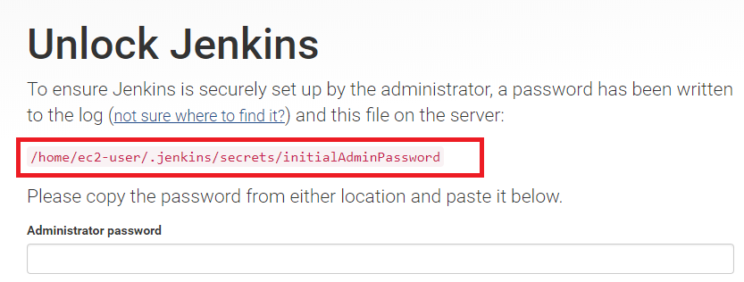
- With which you will copy the path highlighted above, go into your ssh console and invoke:
  - sudo cat /home/yadda/yadda/
- Which will expose the secret key you need to give jenkins to activate it, like so:
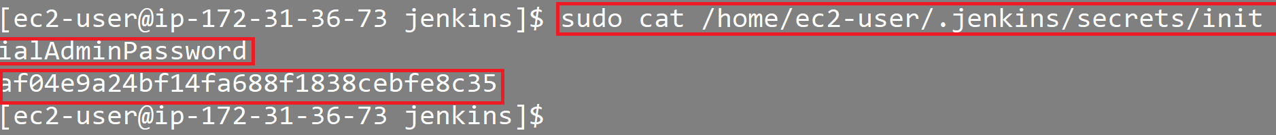
- Next you need to install the “Suggested Plugins”.
Just click on the button to do so.
- After plugins are installed, you will be asked to create an admin user. Just hit “continue as admin” instead.
- After this you will be at the “Instance Configuration” page. Simply click “Save and Finish”.
- Finally, it will say “Jenkins is ready!” Continue on to the home page of Jenkins.

Changing Your Admin User Password
- From the homepage navigate as such:
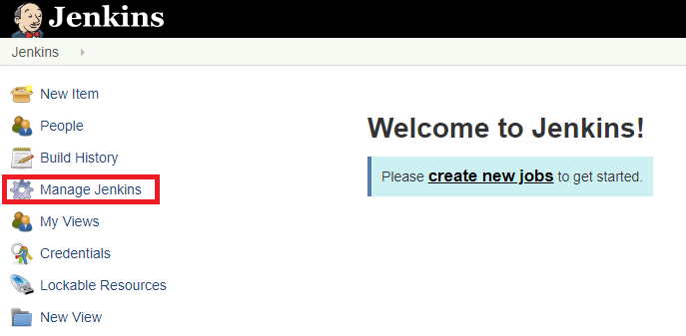
- Click “Manage Jenkins”
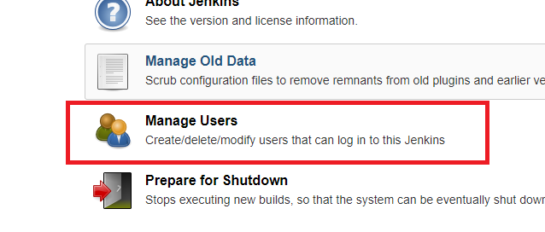
- Manage Users
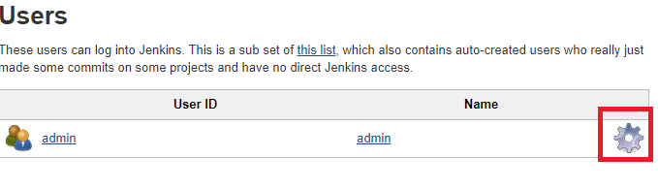
- Click the cog for Admin
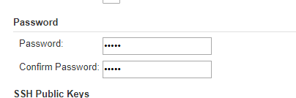
- Then change the password so you don’t have to use that long string for the “admin” user anymore.

Acquiring Essential Plugins
- Next, we will want to configure plugins, so navigate to:
  - Manage Jenkins > Manage Plugins
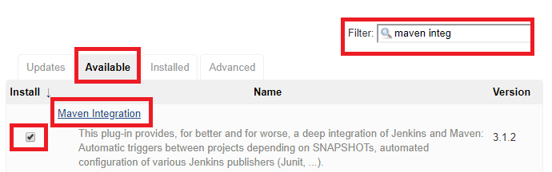
- What you need to do here is ensure you click the “Available” tab. Then, in the filter box type and look for the “Maven Integration” plugin. Once it appears click the checkbox then do the same for the following others:
  - Maven Integration (We just did this. I listed it for completion)
  - Slack Notification
  - Github Integration
  - Deploy to Container
- Once you have checked the box for all of them, click “Download Now and Restart”.
- After they download, check the box for “restart after…”

Setting Up Maven
- Navigate to:
  - Manage Jenkins > Global Tool Configuration
- Scroll down to “Maven” and click “Add Maven”
  - Fill in the name field with whatever you want then save, as seen below:
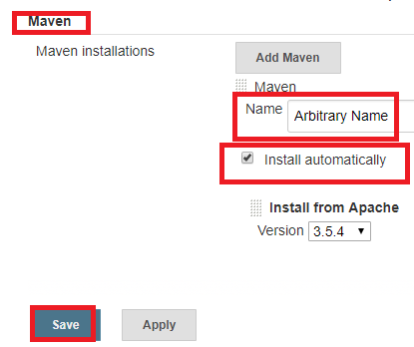

Setting Up Slack Notifications
- Go to:
  - Manage Jenkins > Configure System
- Scroll down to “Global Slack Notifier Settings
- We need an Integration token, the way we go about this is for you all to go to the subdomain of slack that you want to use, then append /apps to it. So for a specific batch it would be:
  - https://xxxx-jta.slack.com/apps

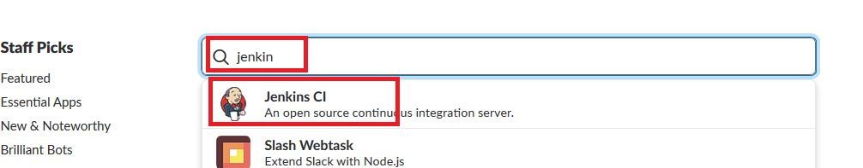
- Here you will go to the search bar below and search for Jenkins. The Jenkins CI app should pop up. Select that.
- Next choose to install it, afterr which it will ask for a channel to integrate with. Pick the one you want to receive notifications on.
- At this step, Slack will forward you to a page explaining what you need to do on the Jenkins side. It will show you which base url to apply as well as the integration token to use. Input them and then save. Be sure to hit save on the Slack side as well.

Setting Up Push Detection For Github
- Navigate to:
  - Manage Jenkins > Configure System
- Scroll down to “Github” and choose to add a “Github Server”
- Give it a name and keep the API URL the way it is.
- Under the “Add github Server” button there is a button that says “Advance…”, click that to show additional options.
  - One option is a button that says “Manage additional Github actions”. Click that and select “Convert login and password to token”.
    - This brings up an option to generate from credentials or “From login and password”. Select the latter:
    - Input your access credentials for GitHub then click “Create Token Credentials”, which will now make available a GitHub token option in the “credentials” section of the “GitHub Server” piece. See below for aid:
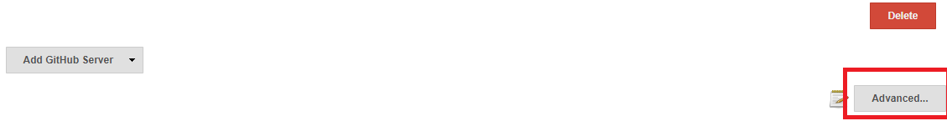
Clicking advanced as depicted above reveals the rest of the options as seen below:
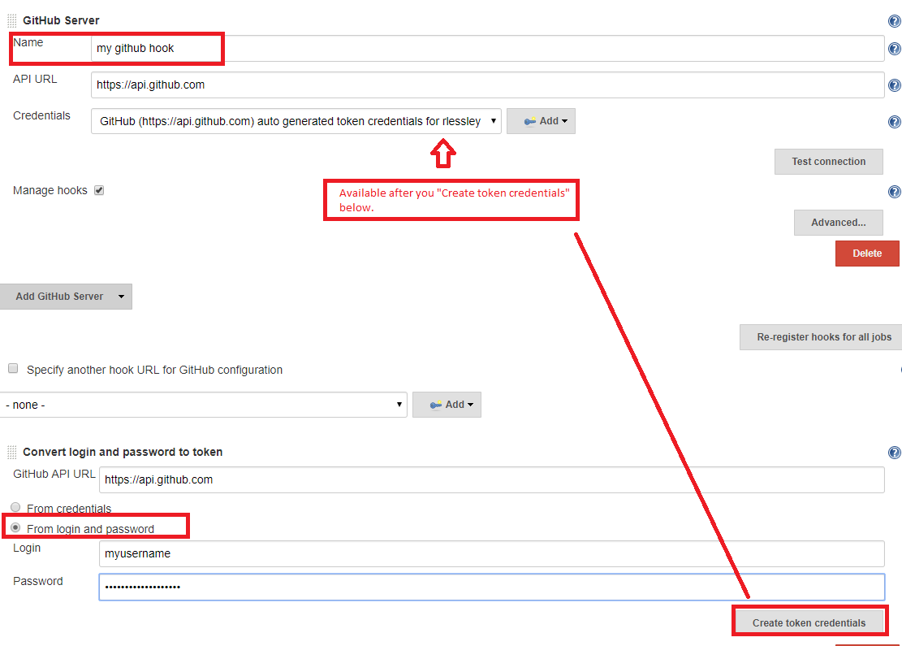
- After you have completed this step, you’ll also want to add a GitHub webhook to enable push detection by going to your GitHub repo, hitting “settings”, and navigating to the “webhooks” page as seen below:
  - NOTE: Your payload url should be: http://my_ec2_endpoint:my_jenkins_port/github-webhook/
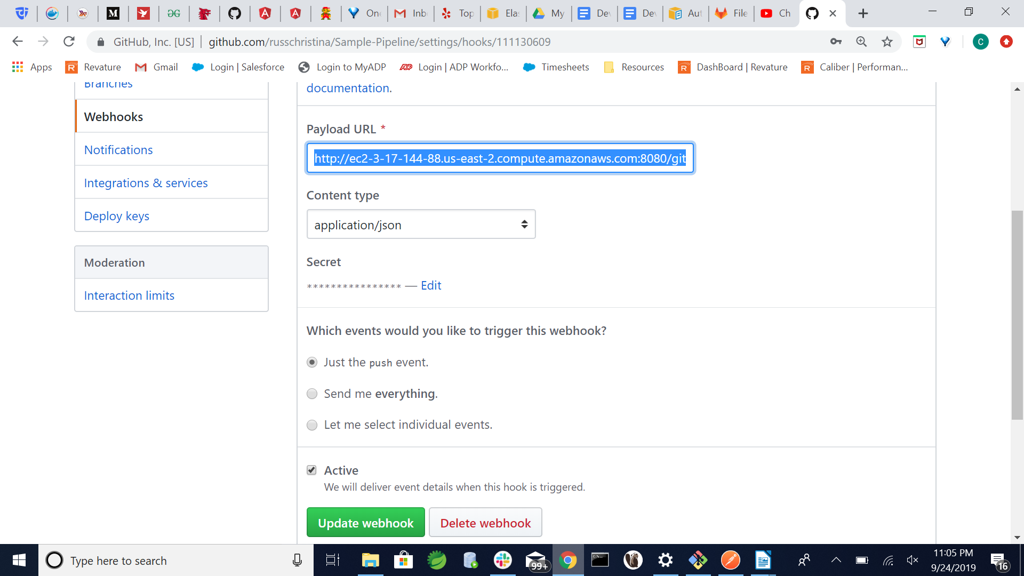

Create The Pipeline
- From the main Jenkins page, click “New Item”
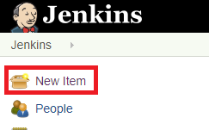
- Next name your pipeline and select “Maven Project”, then click “Ok”
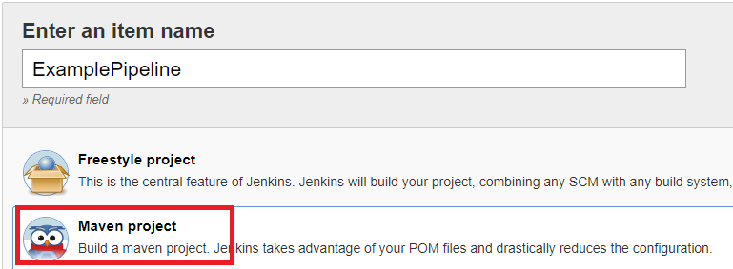
- To start off, check “discard old builds”.
- Move onto the “Source Code Management” section and choose “git”.
- Use the direct link to your repository for the “Repository Url” (Not the .git link)
- For credentials, add the credentials you use to log into the github repo.
- Build Triggers
  - Uncheck “Build Whenever a snapshot dependency is built”
  - Check “GitHub Hook Trigger for GITScm polling”
    - This is key for allowing PUSH detection on your repo.
- Build
  - Root POM:
    - Input the location of the pom.xml in relation to your repository. If it is in the root folder of the repo, the “pom.xml” will simply suffice. In my example I placed the pom in the ExamplePipeline folder so my full path would be “ExamplePipeline/pom.xml
  - Goals and Options
    - clean package
- Post-build Actions
  - Deploy war/ear to container
    - WAR/EAR files
      - **/*.war
    - Context Path
      - Should be your artifact ID
    - Containers
      - Tomcat 8.x
      - Using the “manager-script” user credentials you made in the tomcat-users.xml. In my case my user was “admin-script”
    - Tomcat Url
      - http://localhost:8085
- Slack Notifications
  - Here you can choose to pick what events cause an alert.
- With the above finished, click “save”.
- You will be re-routed to the pipeline page where you can click “Build Now” in the side menu. This will give you a notification in Slack and a blinking blue orb with a number next to it will appear. Click the blinking orb to see the logs as they happen in real time. If the build succeeds, then navigate to the url: your-public-ip:8085/artifcatID-of-yourproject to see it live!
- Last but not least, change up your code and push the change to your GitHub Your pipeline should automatically start a new job and push the code to the server. This way everyone’s code can be seen on a live demo as soon as you push.

