**Low Level Design Document**

iRevatureQuizPro

iOS Mobile App Development Batch

Location : USF – NEC

Version: 1.0

Change History:

|  |  |  |  |
| --- | --- | --- | --- |
| Author | Date | Description | Reviewed by |
|  |  |  |  |
|  |  |  |  |
|  |  |  |  |

**Contents**

1. Introduction
2. Use cases
3. Use Case Diagram
4. App Database Design
5. App Configurations
6. UI/UX Wireframes
7. Class Diagram
8. Component Diagram
9. Deployment Diagram
10. API’s Consumption

# Introduction

# iRevatureQuizPro is an iOS Mobile App which provides features of Revature Pro quizzes on users’ Apple mobile devices. The app enables trainers and ambassadors to configure and add quizzes, import questions into Revature Pro, add quizzes to a Revature Event with the Marketo Code, and view quiz results using their iOS device. Associates can log in to complete their weekly written evaluation quizzes and view the results of completed quizzes.

# Use Cases

# Use Case Diagrams

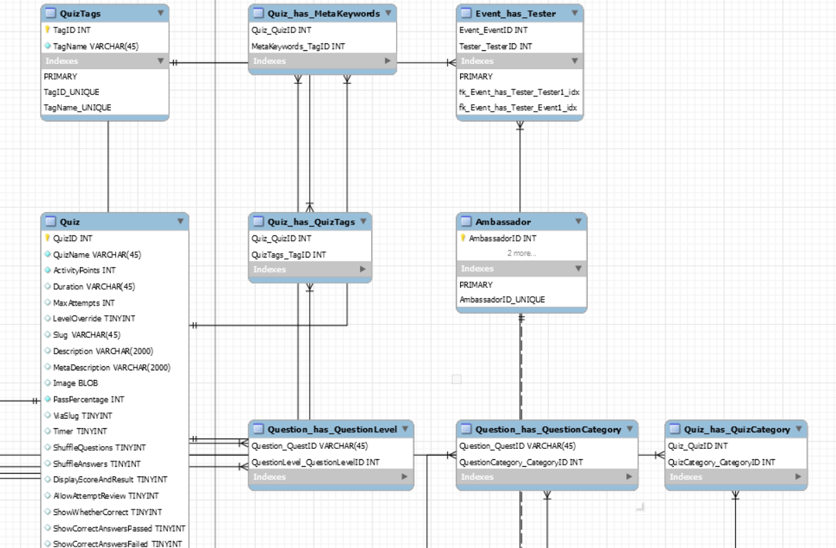

# App Configurations

# UI/UX Wireframes

# Class Diagram

# Deployment Diagram

# API’s Consumption