**OUTLINED ALL THE STEPS FOLLOW TO A T AND MAKE SURE TO REPLACE WITH YOUR OWN INFO**

**ALL THIS IS DONE IN WINDOWS and CHROME**

**RED IS GOOD**

**GREEN IS GOOD**

**BLUE IS BAD**

**BEFORE STARTING GET DEVELOPER MODE IN DISCORD**

**HOW TO DO THAT**

1. **Go to discord app, scroll down in settings and go to advanced and click developer mode**
2. **Go to any server u are in and type**
3. **Long press on ur pfp and click copy user id**
4. **Store this id ( and put it in the code section where it says authorized users can control the bot)**

**Also note this wont work if u arent logged in on the account u want the bot to work, discord has changed the way their tokens work so it changes everytime u log out or log in again so make sure to update this in the code**

1. Create the directory in **VS CODE terminal ( get vs code if u dont have it)** 
   1. **First chose what folder you want it in then in files click in the bar to get the path**

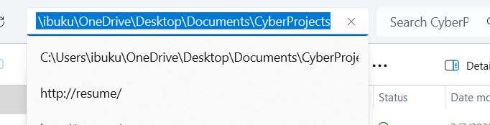

* 1. **When you get the path put a \ after the C: so it looks like C:\\**
  2. **Type : mkdir * the path * and hit enter should look like this if you did it right**
  3. 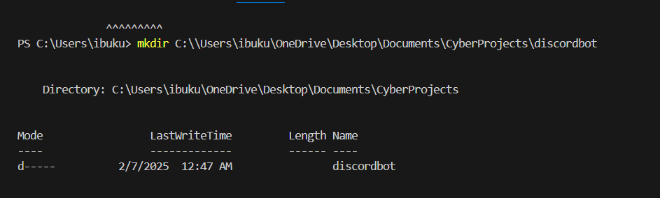
  4. **Next type : cd \**the path from earlier*\* should look like this**

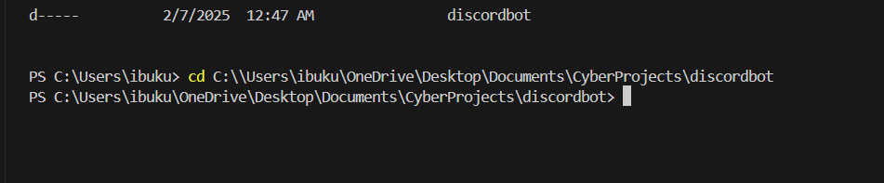

**You are now in there**

1. **Install nodejs :** [**https://nodejs.org/en**](https://nodejs.org/en)
   1. **When installing make sure to click add to path unless it will bring errors down the line**
   2. 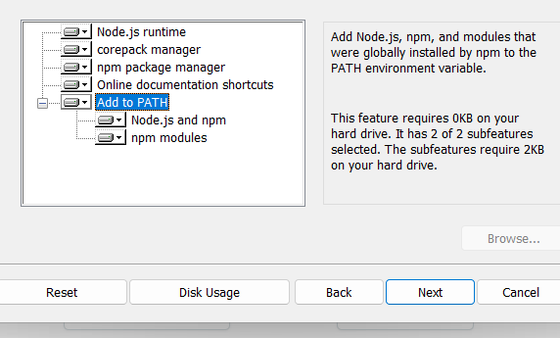
   3. **Follow all the steps, and if it opens up in poweshell or command line just keep hitting enter till things look green**
   4. **Open terminal and type : node -v ( if you see a version you have it downloaded) and then type npm -v ( if you see it nice)**
   5. **IF YOU GET AN ERROR:** 
      1. **Open terminal as admin and Type : Get-ExecutionPolicy ( if it returns Restricted it means it u need to change ur settings)**
      2. **Type: Set-ExecutionPolicy Unrestricted -Scope CurrentUser and everything should be fine**
      3. **Then try npm -v again or reinstall node js**
      4. **Once that is done close VS Code and reopen it. Then type these commands and it should result the same thing**
      5. 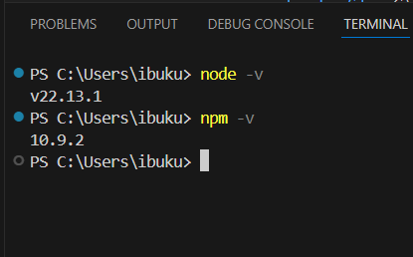
2. **Now go back in vs code and type : npm init -y (should look like this )**
   1. 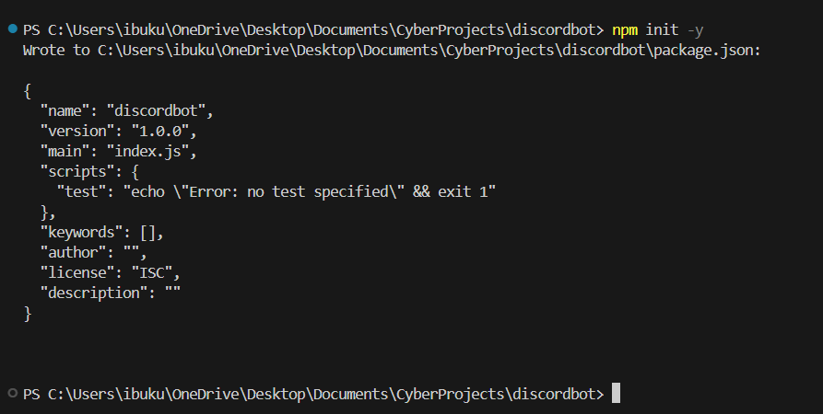
3. **Then type: npm install discord-user-bots openai dotenv**
   1. **Should look like** 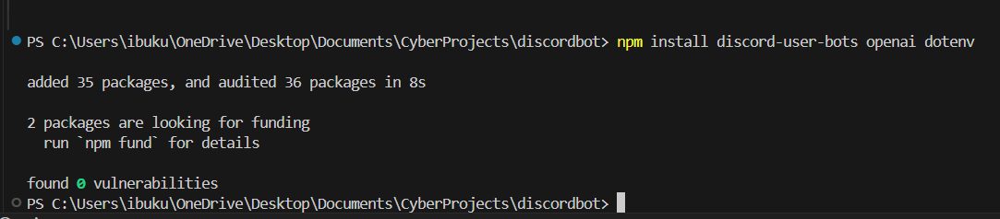
   2. **The functions of these are** 
      1. **discord-user-bots: Logs in as a user. ( this will be a semi complicated process earlier so pay attention to every step so far)**
      2. **openai: Enables ChatGPT responses.**
      3. **dotenv: Manages API keys securely.**

**PAY ATTENTION HERE THIS IS WHERE WE WILL CREATE THE DISCORD ACCOUNT ND GET THE TOKEN**

**TOKEN: how you log into the account / let the bot do its work. You need to keep this secure.**

**Steps:**

1. **CREATE THE ACCOUNT OR ACCOUNTS you want to be controlled by the bot**
2. **Log into the account DO NOT ENABLE 2FA OF ANY TYPE**
3. **While logged in, on ur keyboard hit : Ctrl + Shift + I to open developer tools in ur browser**
4. **Click the button and go to the application side should look like that the bar under will let you know u in there**
5. 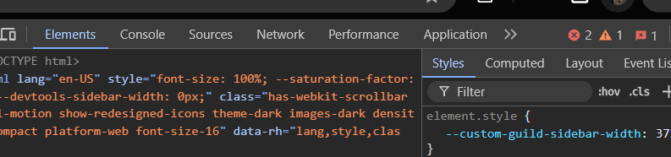
6. **If you dont see the application hit the arrow and go to it**
7. **When you are there hit local storage and then the discord website**
8. 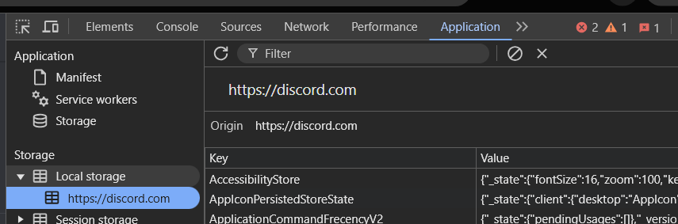
9. **In the search bar type: token and then click that computer/ phone button all the way to the left**
10. 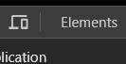
11. **WHen you click that ur token should appear. Hit the one that says TOKEN without the S and store it somewhere. ( do not give ur shi away lmao dont rrly matter since this a fake acc but js know u can EASILY get banned using ur token cuz u not even posed to use it lmao**
12. 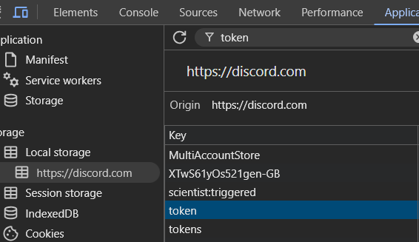

**HOW TO GET OPENAI TOKEN**

1. **Create an openai developer account / google login**
2. **Then go here :** [**https://platform.openai.com/api-keys**](https://platform.openai.com/api-keys)
3. **Hit create new secret key name it and write it down somewhere copy and paste somewhere wtv u wanna do**
4. 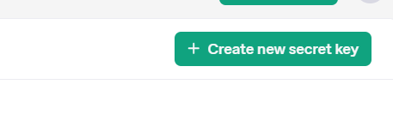

**BACK INTO VS CODE**

1. **Type: ni .env in terminal in vs code to create the file**
2. **Then use code -r .env to open and edit the file in there put ur tokens in should look like this after that command if it doesnt work try again**
3. 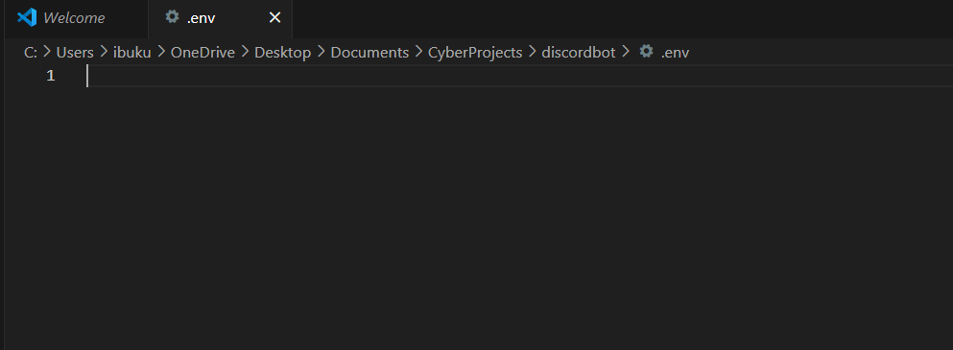
4. **Copy and paste this command ( dont put quotes around it):** 
   1. **DISCORD_USER_TOKEN= your key**
   2. **OPENAI_API_KEY= your open ai key** 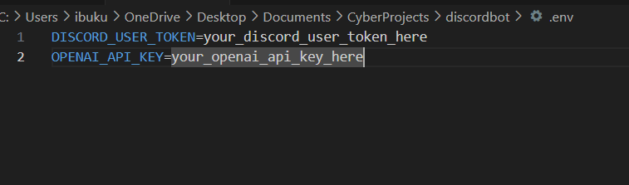

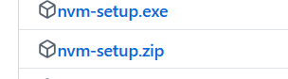

**Download nvm setup from:** [**https://github.com/coreybutler/nvm-windows/releases**](https://github.com/coreybutler/nvm-windows/releases) **and then in vs code type in those 2 things and follow the instructions**

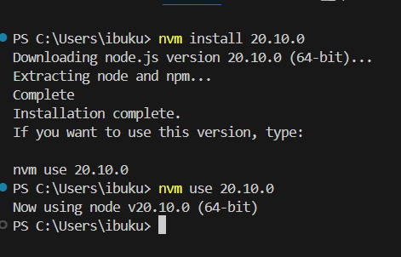

**ONCE YOU HAVE DONE ALL THIS the files to use will be there and the comments will have the instructions to use copy and paste everything and change ur own parameters depending on what u need to use**

**Where it says tokens put the discord user tokens that i showed u how to get earlier**

**Make sure u have the user id added allows you to control the bot and wake it up to receive messages**