“QueUA: A Real-Time Digital Queuing Architecture for the University of Abra”

Erald James Alcalde

Bemverly Ballacillo

John Romeo Rebubuet

Dominique Buenafe

A Capstone Project Presented to

The Faculty of the Department of Information Technology

Abra State Institute of Sciences and Technology

Main Campus, Lagangilang, Abra

In Partial Fulfilment of

the Requirements

for the Degree

BACHELOR OF SCIENCE IN INFORMATION TECHNOLOGY

2025

CHAPTER I

INTRODUCTION

BACKGROUND OF THE STUDY
The global educational sector is currently navigating a period of unprecedented administrative volatility, shaped by the convergence of accelerating digital expectations, systemic resource depletion, and a rapidly expanding student population. As higher education enrollment continues to expand, institutional service efficiency has emerged as a critical determinant of student satisfaction and operational stability. Research consistently demonstrates that administrative bottlenecks generate heightened stress and reduced institutional trust among students. These challenges demand technology-driven solutions tailored to the specific needs of modern academic environments.
At the international level, studies have documented a structural mismatch between administrative supply and enrollment-driven demand, particularly in developing-country contexts. Information asymmetries and fragmented manual processes continue to disadvantage students, who are frequently compelled to endure substandard service delivery or allocate disproportionate time to simple transactions. Even as digital platforms expand, many institutions still rely on manual protocols that expose users to operational risks and inefficiency.
In the Philippine setting, the rapid expansion of higher education enrollment has produced a growing population of students who must navigate stagnant administrative infrastructures. State universities and colleges (SUCs) frequently report significant shortfalls in service delivery, locking institutions into a cycle of manual dependence that compromises the student experience. While enrollment in regions like the Cordillera Administrative Region (CAR) has grown by as much as 18.2%, the infrastructure for managing client flow has remained restricted to traditional protocols, perpetually undermined by overcrowding and transaction bottlenecks.
At the local level, the University of Abra, formerly the Abra State Institute of Sciences and Technology (ASIST)—was converted to university status by Republic Act 11574 in 2021, mandating a modernization of its facilities and administrative services. Despite this legislative advancement, "administrative blank time"—the critical interval between a student’s arrival and the initiation of service—remains a profound limitation. The local service environment is composed primarily of manual transaction logs and verbal number-calling, culminations of which often result in physical congestion and conflicts arising from line-cutting or perceived unfairness.
The limitations of human-led visual assessment of queues are profound. Staff often depend on inconsistent manual logs, leading to "staff overload" and cognitive fatigue. The absence of a centralized, verified, and student-oriented queuing platform constitutes a significant gap in the support infrastructure available to University of Abra students.
In direct response to this gap, this study proposes the design and development of QueUA: A Real-Time Digital Queuing Architecture for the University of Abra. Deployed as a Progressive Web Application (PWA), the system integrates verified token generation, real-time sequence tracking, a centralized administrative dashboard, and "offline-first" resilience—providing UAbra students and staff with a centralized, trustworthy platform for transaction management

CONCEPTUAL FRAMEWORK
This study is guided by the Input–Process–Output (IPO) Model, which provides a clear and systematic representation of the research and development process. The IPO Model serves as the research paradigm by delineating the information and conditions that drive the study (Input), the methodological activities that transform those inputs (Process), and the outcomes that represent the study's intended results (Output).
The Input component encompasses the identified queuing challenges at University of Abra, user requirements from students and staff, and the theoretical frameworks guiding the study. Three foundational theories anchor this study. Systems Theory frames the university ecosystem as a network of interconnected stakeholders whose effective interaction depends on shared information systems. The Technology Acceptance Model (TAM) guides the interface design by emphasizing perceived usefulness and ease of use. The ISO/IEC 25010 Software Quality Model provides the multi-dimensional evaluative framework for assessing the system.
The Process component encompasses all activities of the Agile Software Development Life Cycle (SDLC): planning, requirements analysis, system design, iterative development, testing, and deployment. Each phase progressively transforms inputs into a functional, user-validated application.
The Output component represents the tangible result: the fully developed Digital Queuing Architecture—providing real-time sequence updates, improved transparency, and incident logs—along with the system evaluation report.
Figure 1. Research Paradigm (IPO Model)

INPUT
PROCESS
OUTPUT
Problem Identification: Manual queuing bottlenecks, physical overcrowding, and "administrative blank time".
Requirements: User needs from students/staff and theoretical frameworks (TAM, Systems Theory, ISO/IEC 25010).
Technical Specs: React framework, Supabase backend, and PWA "offline-first" configurations.
Development: 7-phase Agile SDLC including planning, system design, iterative coding, and alpha/beta testing.
Mathematical Modeling: Validation using Little’s Law ($L = \lambda W$) and Utilization Ratio ($\rho = \frac{\lambda}{c \cdot \mu}$) to manage traffic intensity.
Data Gathering: System evaluation through SUS scores and Likert-scale questionnaires administered to 70 respondents.

QueUA System: A functional PWA featuring digital tokens, real-time tracking, an admin dashboard, and FIFO algorithm implementation.
Evaluation Report: Documented performance of the architecture regarding functionality, usability, and operational efficiency.

STATEMENT OF THE PROBLEM
The general problem of this study is: How can the development of a real-time digital queuing architecture improve institutional service efficiency and reduce operational stressors for students and staff at the University of Abra? Specifically, the study seeks to answer the following primary questions:
- What are the common operational bottlenecks and manual queuing problems encountered by students and staff at the University of Abra?
- What system design and features should be integrated into the QueUA architecture (e.g., token generation, real-time tracking, administrative dashboard, First-In-First-Out sequencing, and offline-first resilience) to eliminate administrative blank time?
- How effective is the developed QueUA system as assessed by respondents in terms of functionality, usability, efficiency, reliability, and user satisfaction?

OBJECTIVES OF THE STUDY
The general objective of this study is to design and develop a real-time digital queuing architecture intended to address the service search and transaction challenges of students at the University of Abra. Specifically, the main objectives are:
- To identify and document the existing causes of transaction delays and physical line-cutting within the university's student service units.
- To build and implement the architecture as a mobile-accessible PWA incorporating verified digital tokens, real-time sequence tracking, a centralized administrative dashboard, First-In-First-Out (FIFO) logical sequencing, and "offline-first" Service Worker resilience.
- To comprehensively evaluate the effectiveness of the deployed system using the ISO/IEC 25010 software quality framework and the System Usability Scale (SUS).

SIGNIFICANCE OF THE STUDY
The proposed digital queuing architecture addresses a critical gap in the administrative infrastructure of the University of Abra.
For Students. It provides an organized, fair queuing process, transitioning them from "passive victims" of line-cutting to "active managers" of their own time, aligning with SDG 4 (Quality Education).
For Administrative Staff. It reduces workload stress and physical strain via a centralized dashboard and automated calling, supporting SDG 8 (Decent Work).
For the University Administration. It enhances institutional productivity and supports digital transformation goals under RA 11574 and SDG 9 (Innovation and Infrastructure).
For Future Researchers. This study contributes to literature on mobile-based welfare systems in rural contexts, serving as a reference model for future AI-assisted and real-time student services.

DEFINITION OF TERMS
Administrative Blank Time. The critical interval characterized by non-productive waiting between a student’s arrival and the initiation of professional intervention.
Agile Software Development Model. A flexible, iterative methodology emphasizing incremental progress and continuous stakeholder collaboration across seven phases.
Digital Queuing Architecture. The mobile-based PWA developed as the primary output, providing verified tokens, sequence tracking, and admin tools to assist University of Abra stakeholders.
FIFO (First-In, First-Out). An algorithmic discipline ensuring students are served in the exact chronological order of their registration.
ISO/IEC 25010. An international framework for evaluating software quality across dimensions such as functionality, usability, and reliability.
Progressive Web Application (PWA). A web-based application providing offline access and push notifications without requiring app store installation.
Service Worker. A browser script running in the background to enable "offline-first" functionality and asset caching.
Utilization Ratio (). A measure of system congestion, calculated as the arrival rate divided by the service capacity: .

CHAPTER II

METHODOLOGY
This chapter presents the research methodology employed in the design, development, and evaluation of the Real-Time Digital Queuing Architecture for the University of Abra. The methodology integrates descriptive research techniques with an iterative, collaborative system development approach.

RESEARCH DESIGN
This study adopts a descriptive-developmental research design, combining analytical rigor with constructive engineering. The descriptive component systematically documents existing manual queuing bottlenecks at the University of Abra through structured surveys and document analysis. The developmental component encompasses the planning, design, and construction of the PWA artifact representing a practical solution to "blank time". The development process is governed by the Agile Software Development Life Cycle (SDLC), ensuring iterative progress toward a validated final product.
Population and Sampling.
The study utilizes a purposive sampling technique to select participants with direct experience in the university's queuing processes.

Cluster Designation | Sample Size (n) | Profile and Justification
University Students | 40 | Active enrollees who frequently interact with the Registrar and Cashier offices and are the primary beneficiaries of the virtual queuing system.
Administrative Staff | 20 | Frontline clerks and office supervisors who operate the centralized dashboard and manage client flow.
IT Specialists | 10 | Faculty members and technicians with technical expertise in distributed systems, required to audit the software's synchronization logic and performance.
Total | 70 | Ensures statistical validity and data saturation for prototype evaluation.
Table 2.Distribution of Respondents

AGILE SOFTWARE DEVELOPMENT LIFE CYCLE
The development of the digital queuing architecture follows the 7-phase Agile SDLC, an iterative methodology focusing on continuous feedback and incremental releases.
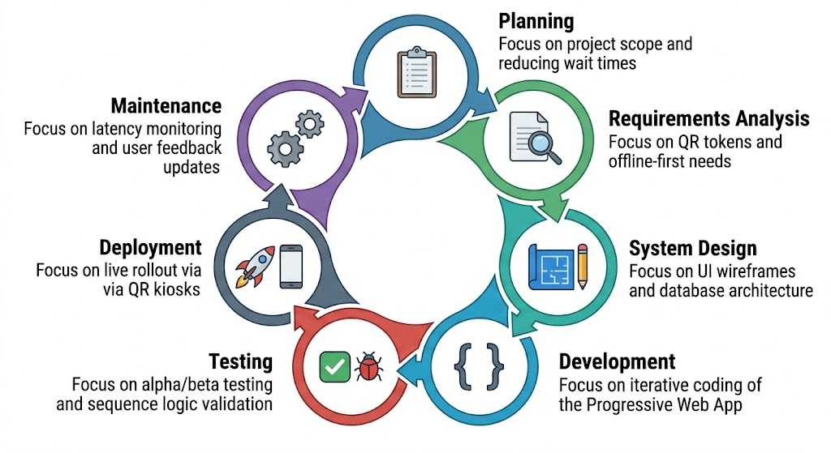
Figure 2: Agile Software Development Life Cycle

Phase 1: Planning.
The researchers established the scope and feasibility of the queuing project. Goals were defined based on the 60-180 minute historical wait times, with a target reduction of in idle time.
Phase 2: Requirements Analysis.
Functional requirements were documented, including QR-based token generation and real-time sequence updates. Non-functional requirements focused on "offline-first" resilience for rural network dead zones.
Phase 3: System Design.
The architecture was mapped as a hub-and-spoke system with a Supabase real-time backend hub and PWA client spokes. UI wireframes emphasized high-contrast elements for outdoor visibility.

Phase 4: Development.
Construction of the five core features was executed iteratively: token generation, sequence tracking, the admin dashboard, the FIFO algorithm, and offline service workers.
Phase 5: Testing.
Alpha testing resolved logic flaws in the FIFO sequence. Beta testing involved representative students and staff using the application under realistic campus conditions to validate "offline-first" transitions.
Phase 6: Deployment.
The finalized PWA was distributed via QR code kiosks at the Registrar and Cashier offices.² The evaluation questionnaire was administered following this period of live use.
Phase 7: Maintenance.
Post-deployment support involves monitoring synchronization latency (targeting <100 ms) and updating Ilocano localization based on user feedback.

DEVELOPMENT TOOLS AND TECHNOLOGIES
The queuing architecture is developed using tools selected for real-time synchronization and rural accessibility.

Tool / Technology | Purpose
React | Front-end framework for building the responsive PWA interface.
Supabase | Real-time backend using PostgreSQL and WebSockets for sequence updates.
Service Workers | Specialized browser scripts for "offline-first" caching of assets.
GitHub | Version control and team collaboration platform.
VS Code | Primary integrated development environment (IDE) for coding.
QR Code API | Generation of unique tokens for physical-to-digital registration.
Table 2. Development Tools and Technologies

SCOPE AND DELIMITATION OF THE STUDY
This study covers the design, development, and evaluation of a digital queuing architecture for the University of Abra, Lagangilang Campus. The system covers five core features: verified digital tokens, real-time sequence tracking, administrative dashboards, FIFO algorithms, and "offline-first" support. The study is delimited geographically to the Registrar and Cashier offices and excludes integrated online payments. The evaluation cohort is limited to 70 purposively selected respondents.

DATA GATHERING PROCEDURES
The data gathering follows a systematic six-stage procedure :
- Approval: Secured administrative authorization from University of Abra.
- Sampling: Identified 70 respondents (40 students, 20 staff, 10 IT specialists) through purposive sampling.
- Instrument Validation: Questionnaire submitted to experts for technical and contextual validation.
- Needs Assessment: Informal interviews and document analysis conducted to map current bottlenecks.
- System Evaluation: Validated questionnaire and SUS administered after the live deployment phase.
- Data Processing: Collected responses were encoded for statistical treatment.

DATA GATHERING INSTRUMENTS
The primary instrument is a structured questionnaire in three parts: Demographic Info, Queuing Preferences, and Formal Evaluation based on ISO/IEC 25010. The System Usability Scale (SUS) is used to measure the PWA's complexity and ease of use on a 0-100 scale. Direct observation of physical line-cutting behaviors provided supplementary contextual data for requirements.

DATA ANALYSIS
The data gathered from the evaluation phase will be subjected to a rigorous descriptive and qualitative analysis procedure, entirely avoiding complex mathematical modeling in favor of narrative and thematic evaluation.

For the structured survey components assessing the system against the software quality framework and usability scales, responses collected via the Likert scale will be evaluated using descriptive statistics. The analysis will strictly focus on identifying the frequency distributions and central tendencies—such as the median or most frequent responses—to summarize the prevailing stakeholder sentiments. The survey options, which represent a spectrum ranging from strong disagreement to strong agreement, will be translated directly into qualitative descriptive categories. This qualitative mapping allows the researchers to narratively interpret the exact level of user acceptance, functional suitability, and performance efficiency without relying on numerical scoring formulas or mathematical derivations.

Furthermore, any supplementary data obtained through direct non-participant observation of the campus queues, alongside open-ended feedback provided by the respondents, will undergo thematic analysis. This qualitative method involves systematically reviewing the feedback, generating initial categorical codes, and organizing those codes into overarching themes. This approach captures the nuanced human experience of using the application, revealing underlying operational contexts and real-world pain points that structured metrics alone cannot fully explain. By synthesizing the descriptive statistical summaries with these rich thematic insights, the researchers will formulate a highly detailed, comprehensive conclusion regarding the operational effectiveness of the newly deployed digital queuing architecture.

REFERENCE
Agile Alliance. (2025). Manifesto for agile software development. Retrieved from https://www.agilealliance.org/agile101/the-agile-manifesto/
ContextQA. (2026). 7 phases of SDLC: Software development life cycle guide. Retrieved from https://contextqa.com/blog/the-7-phases-of-software-development-life-cycle/
IBM. (2026). What is the software development lifecycle (SDLC)? Retrieved from https://www.ibm.com/think/topics/sdlc
International Organization for Standardization. (2011). ISO/IEC 25010:2011 Systems and software engineering — Systems and software Quality Requirements and Evaluation (SQuaRE) — System and software quality models. Retrieved from https://www.iso.org/standard/35733.html
Little, J. D. C. (2011). Little’s Law as viewed after 50 years. Operations Research. https://pubsonline.informs.org/doi/10.1287/opre.1080.0522
Republic of the Philippines. (2021). Republic Act No. 11574: An Act Converting the Abra State Institute of Sciences and Technology into a State University to be known as the University of Abra. Official Gazette of the Republic of the Philippines. Retrieved from https://www.officialgazette.gov.ph/2021/12/23/republic-act-no-11574/
Supabase. (2026). Realtime: Listen to PostgreSQL changes via WebSockets. Supabase Open Source. Retrieved from https://supabase.com/docs/guides/realtime
United Nations. (2023). Sustainable development goals (SDG 4, 8, & 9). Retrieved from https://sdgs.un.org/goals

