“QueUA: A Real-Time Digital Queuing Architecture for the University of Abra”

Erald James Alcalde
Bemverly Ballacillo
John Romeo Rebubuet
Dominique Buenafe

A Capstone Project Presented to
The Faculty of the Department of Information Technology
Abra State Institute of Sciences and Technology
Main Campus, Lagangilang, Abra
In Partial Fulfilment of
the Requirements
for the Degree

BACHELOR OF SCIENCE IN INFORMATION TECHNOLOGY

2026

ABSTRACT
This capstone project designed, developed, and evaluated QueUA, a real-time digital queuing architecture for the Office of the University Registrar of the University of Abra, Lagangilang Main Campus, using a descriptive-developmental design and the Agile development life cycle. A needs assessment survey was answered by 100 students and a questionnaire by 8 Registrar, Cashier, and MIS personnel. Students rated the problems of the manual queue at a composite weighted mean of 3.05, a moderate extent, most often citing difficulty keeping track of queue numbers (21%) and suggesting a screen showing the current and next numbers (25%). Staff reported physical lines, verbal calling, handwritten logbooks, and hand-carried payment receipts. QueUA was built as a web application using Next.js, React, TypeScript, and Supabase. It provides online mobile booking with automated fee assessment, cashier payment clearance, a first-in, first-out counter console, an audio-visual lobby display, a QR-linked queue tracker, and administrative monitoring and reports, protected by role-based access control and row-level security. In the system evaluation, students rated QueUA 4.41 and administrative staff 4.67, for an overall weighted mean of 4.54 (Strongly Agree, Excellent). The study recommends pilot adoption, push notifications, an evaluation by IT specialists, and a before-and-after measurement of actual waiting times.
Keywords: digital queuing system, real-time web application, registrar services, system evaluation, Supabase
TABLE OF CONTENTS
ABSTRACT ii
LIST OF TABLES iv
LIST OF FIGURES v
LIST OF PLATES vi
CHAPTER I – INTRODUCTION 1
BACKGROUND OF THE STUDY 1
CONCEPTUAL FRAMEWORK 3
STATEMENT OF THE PROBLEM 5
OBJECTIVES OF THE STUDY 6
SIGNIFICANCE OF THE STUDY 7
DEFINITION OF TERMS 8
CHAPTER II – METHODOLOGY 11
RESEARCH DESIGN 11
Population and Sampling 11
AGILE SOFTWARE DEVELOPMENT LIFE CYCLE 13
DEVELOPMENT TOOLS AND TECHNOLOGIES 16
SCOPE AND DELIMITATION OF THE STUDY 16
DATA GATHERING PROCEDURES 17
DATA GATHERING INSTRUMENTS 18
DATA ANALYSIS 19
CHAPTER III – RESULTS AND DISCUSSION 21
Problem 1. What are the common operational bottlenecks and manual queuing problems encountered by students and staff at the Office of the University Registrar? 21
Problem 2. What system design and features should be integrated into QueUA to address these problems? 33
Problem 3. How do students and administrative staff evaluate the developed QueUA system? 52
CHAPTER IV – CONCLUSIONS AND RECOMMENDATIONS 57
CONCLUSIONS 57
RECOMMENDATIONS 58
REFERENCES 61
APPENDIX A – STUDENT NEEDS ASSESSMENT QUESTIONNAIRE 64
APPENDIX B – STAFF QUESTIONNAIRE 67
APPENDIX C – SYSTEM EVALUATION QUESTIONNAIRE 69

LIST OF TABLES
Table 1. Distribution of Respondents 12
Table 2. Distribution of Student Respondents by Degree Program 12
Table 3. Profile of the Staff Respondents (n = 8) 13
Table 4. Development Tools and Technologies 16
Table 5. Five-Point Likert Scale and Interpretation 20
Table 6. Students’ Assessment of Waiting Time and Service Efficiency 21
Table 7. Students’ Assessment of Queue Organization and Order Management 23
Table 8. Students’ Assessment of Queue Information and Communication 24
Table 9. Students’ Assessment of Record Management and Queue Monitoring 25
Table 10. Students’ Assessment of the Waiting Area and Student Experience 26
Table 11. Summary of the Students’ Assessment of the Manual Queuing Process 27
Table 12. Most Common Problem Experienced in the Manual Queue 28
Table 13. Difficulties Encountered During Peak Hours 29
Table 14. Students’ Suggested Improvements 30
Table 15. Current Queuing Practices and Problems Reported by the Staff 31
Table 16. Problems Identified and the Corresponding Features of QueUA 34
Table 17. Service Categories and Fee Rules 38
Table 18. User Roles and Access Rights 38
Table 19. Quality Dimensions Covered by the System Evaluation Questionnaire 52
Table 20. Students’ Evaluation of QueUA 52
Table 21. Administrative Staff’s Evaluation of QueUA 54
Table 22. Summary of the Evaluation of QueUA by Respondent Group 55
Table 23. Evaluation of QueUA by Quality Dimension 55

LIST OF FIGURES
Figure 1. Research Paradigm (IPO Model) 5
Figure 2. Agile Software Development Life Cycle 14
Figure 3. Extent of Problems in the Manual Queuing Process by Area 28
Figure 4. Most Common Problems Cited by the Students 29
Figure 5. Improvements Suggested by the Students 30
Figure 6. System Architecture of QueUA 35
Figure 7. Ticket Workflow of QueUA 36
Figure 8. Entity-Relationship Diagram of QueUA 37
Figure 9. Evaluation of QueUA by Quality Dimension and Respondent Group 56

LIST OF PLATES
Plate 1. QueUA Landing Portal 39
Plate 2. Booking: Category Selection 40
Plate 3. Booking: Services and Assessment 40
Plate 4. Booking: Transactee Information 41
Plate 5. e-Pass for a Paid Request 42
Plate 6. e-Pass for a Free Request 42
Plate 7. Queue Tracker While Waiting 43
Plate 8. Queue Tracker When Called 43
Plate 9. Registrar Staff Portal Sign-In Page 44
Plate 10. Cashier Clearance: Ticket Awaiting Payment 45
Plate 11. Cashier Clearance: Payment Confirmed 45
Plate 12. Counter Console: Next in Line 46
Plate 13. Counter Console: Serving a Ticket 46
Plate 14. Audio-Visual Lobby Display 47
Plate 15. Administrative Dashboard 48
Plate 16. Live Monitoring 48
Plate 17. Service Windows Configuration 49
Plate 18. Queue Modules Configuration 49
Plate 19. Staff Accounts and Roles 50
Plate 20. Announcements Management 50
Plate 21. Reports 51

CHAPTER I
INTRODUCTION

BACKGROUND OF THE STUDY
The global educational sector is currently navigating a period of unprecedented administrative volatility, shaped by the convergence of accelerating digital expectations, systemic resource depletion, and a rapidly expanding student population. As higher education enrollment continues to expand, institutional service efficiency has emerged as a critical determinant of student satisfaction and operational stability. Research consistently demonstrates that administrative bottlenecks generate heightened stress and reduced institutional trust among students. These challenges demand technology-driven solutions tailored to the specific needs of modern academic environments.
At the international level, studies have documented a structural mismatch between administrative supply and enrollment-driven demand, particularly in developing-country contexts. Information asymmetries and fragmented manual processes continue to disadvantage students, who are frequently compelled to endure substandard service delivery or allocate disproportionate time to simple transactions. Even as digital platforms expand, many institutions still rely on manual protocols that expose users to operational risks and inefficiency. Waiting itself is shaped by perception: unexplained and uncertain waits feel longer than waits whose length and progress are known (Maister, 1985), which makes the visibility of a queue as important as its speed.
In the Philippine setting, the rapid expansion of higher education enrollment has produced a growing population of students who must navigate stagnant administrative infrastructures. State universities and colleges (SUCs) frequently report significant shortfalls in service delivery, locking institutions into a cycle of manual dependence that compromises the student experience. As government institutions, SUCs are also bound by Republic Act No. 11032, the Ease of Doing Business and Efficient Government Service Delivery Act of 2018, which requires efficient, transparent, and time-bound frontline services (Republic of the Philippines, 2018). While enrollment in regions like the Cordillera Administrative Region (CAR) has grown by as much as 18.2%, the infrastructure for managing client flow has remained restricted to traditional protocols, perpetually undermined by overcrowding and transaction bottlenecks.
At the local level, the University of Abra, formerly the Abra State Institute of Sciences and Technology (ASIST), was converted to university status by Republic Act No. 11574 in 2021, mandating a modernization of its facilities and administrative services (Republic of the Philippines, 2021). Despite this legislative advancement, “administrative blank time”—the critical interval between a student’s arrival and the initiation of service—remains a profound limitation. At the Office of the University Registrar, students line up physically along the hallway, are called verbally, and must walk to the Cashier and back whenever a request carries a fee, while transactions are recorded in handwritten logbooks. These practices often result in physical congestion and in conflicts arising from line-cutting or perceived unfairness.
The limitations of human-led visual assessment of queues are profound. Staff often depend on inconsistent manual logs, leading to “staff overload” and cognitive fatigue, and they cannot tell at any moment how many students are waiting or how long they have waited. The absence of a centralized, verified, and student-oriented queuing platform constitutes a significant gap in the support infrastructure available to University of Abra students.
In direct response to this gap, this study proposes the design and development of QueUA: A Real-Time Digital Queuing Architecture for the University of Abra. Deployed as a web-based application that runs in any browser without installation, the system lets students book a queue e-ticket from their own phones, computes the assessed fees automatically, routes paid requests through the Cashier before they reach a window, calls tickets in first-in, first-out order, announces each call on a lobby display with a chime and a spoken message, and lets students follow their place in line through a QR-linked tracker. A centralized administrative dashboard gives the Office of the Registrar live monitoring, window and module configuration, and exportable reports, providing UAbra students and staff with a centralized, trustworthy platform for transaction management.

CONCEPTUAL FRAMEWORK
This study is guided by the Input–Process–Output (IPO) Model, which provides a clear and systematic representation of the research and development process. The IPO Model serves as the research paradigm by delineating the information and conditions that drive the study (Input), the methodological activities that transform those inputs (Process), and the outcomes that represent the study’s intended results (Output).
The Input component encompasses the knowledge, software, and hardware requirements of the study. The knowledge requirements include the queuing problems identified at the Office of the University Registrar, the needs of students and staff, the Registrar’s service catalog and schedule of fees, and the theories that guide the study. Four foundational theories anchor this study. Systems Theory (von Bertalanffy, 1968) frames the Registrar, the Cashier, and the student body as interdependent parts of one service system whose effectiveness depends on shared, timely information. The Technology Acceptance Model (Davis, 1989) guides the interface design by emphasizing perceived usefulness and perceived ease of use. Queueing theory, in particular Little’s Law, which states that the average number of people in a queue equals their arrival rate multiplied by their average time in the system (Little, 2011), explains why shortening and making visible the waiting time relieves crowding, and it underlies the waiting-time and service-time measures that the system reports. The ISO/IEC 25010 software quality model (International Organization for Standardization [ISO], 2011) provides the framework for evaluating the developed system. The software requirements are Next.js, React, TypeScript, Tailwind CSS, and Supabase, while the hardware requirements are the computers used at the windows, the Cashier, and the administrator’s desk, a television for the lobby display, and the students’ own smartphones.
The Process component covers the needs assessment, conducted through a survey of 100 students and a questionnaire for 8 Registrar, Cashier, and MIS personnel; the seven phases of the Agile Software Development Life Cycle (SDLC), namely planning, requirements analysis, system design, development, testing, deployment, and maintenance; and the evaluation of the system through a system evaluation questionnaire answered by the same students and administrative staff, with the data analyzed through frequency, percentage, weighted mean, and thematic analysis.
The Output component is QueUA, a real-time, web-based digital queuing architecture that provides online booking with automated fee assessment, cashier payment clearance, a counter console, an audio-visual lobby display, a QR-linked queue tracker, and administrative monitoring and reports, together with the evaluation report that documents its software quality. The feedback arrow in Figure 1 indicates that the evaluation results inform the further refinement of the system.
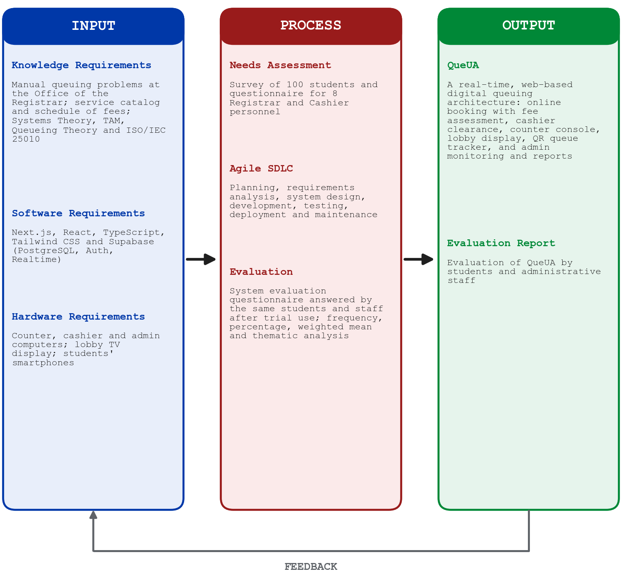
Figure 1. Research Paradigm (IPO Model)

STATEMENT OF THE PROBLEM
The general problem of this study is: How can the development of a real-time digital queuing architecture improve institutional service efficiency and reduce operational stressors for students and staff at the University of Abra? Specifically, the study seeks to answer the following questions:
- What are the common operational bottlenecks and manual queuing problems encountered by students and staff at the Office of the University Registrar in terms of waiting time and service efficiency, queue organization and order management, queue information and communication, record management and queue monitoring, and the waiting area and student experience?
- What system design and features should be integrated into QueUA, such as online booking with automated fee assessment, cashier payment clearance, first-in, first-out dispatch, an audio-visual lobby display, real-time queue tracking, and an administrative dashboard, to address these problems?
- How do students and administrative staff evaluate the developed QueUA system in terms of functional suitability, operational effectiveness, usability, performance efficiency, reliability, and user satisfaction?

OBJECTIVES OF THE STUDY
The general objective of this study is to design, develop, and evaluate a real-time digital queuing architecture that addresses the queuing and transaction challenges of students and staff at the Office of the University Registrar of the University of Abra. Specifically, the study aims:
- To identify and document the existing problems of the manual queuing process at the Registrar in terms of waiting time and service efficiency, queue organization, queue information and communication, record management and monitoring, and the waiting area and student experience.
- To design and develop QueUA as a web-based application that provides online mobile booking with automated fee assessment, cashier payment clearance, first-in, first-out counter dispatch, an audio-visual lobby display, a QR-linked real-time queue tracker, and an administrative dashboard for monitoring, configuration, and reporting.
- To evaluate the developed system through a system evaluation questionnaire, guided by the ISO/IEC 25010 software quality model, answered by students and administrative staff in terms of functional suitability, operational effectiveness, usability, performance efficiency, reliability, and user satisfaction.

SIGNIFICANCE OF THE STUDY
The proposed digital queuing architecture addresses a critical gap in the administrative infrastructure of the University of Abra.
For Students. It provides an organized and fair queuing process in which each student books a ticket from a phone, sees the assessed fee in advance, and follows their place in line from anywhere on campus, transitioning them from “passive victims” of line-cutting to “active managers” of their own time, in line with SDG 4 (Quality Education).
For Administrative Staff. It reduces workload stress and repeated inquiries through a counter console that calls the next ticket automatically and a cashier view that lists every unpaid ticket, supporting SDG 8 (Decent Work and Economic Growth).
For the University Administration. It gives the Office of the Registrar live monitoring and exportable reports on transaction volume, waiting time, and service time, supporting the modernization mandated by RA 11574, the service standards of RA 11032, and SDG 9 (Industry, Innovation and Infrastructure) (United Nations, 2023).
For Future Researchers. This study contributes to the literature on real-time, web-based student services in rural state universities and serves as a reference model for future queuing, notification, and student-service systems.

DEFINITION OF TERMS
Administrative Blank Time. The critical interval characterized by non-productive waiting between a student’s arrival and the initiation of service.
Agile Software Development Model. A flexible, iterative methodology emphasizing incremental progress and continuous stakeholder collaboration across seven phases (Agile Alliance, 2025).
Average Queue Wait Time (AQWT). The average number of minutes between the creation of a ticket and the moment a window calls it, as computed by the Reports module of QueUA.
Average Service Handling Time (ASHT). The average number of minutes between the calling of a ticket and its completion at the window.
Counter Console. The staff page used by a window officer to call, recall, hold, resume, transfer, complete, or mark a ticket as a no-show.
Digital Queuing Architecture. The web-based system developed as the primary output of this study, composed of student booking and tracking pages, staff consoles, a lobby display, and an administrative dashboard connected to one real-time database.
Documentary Stamp. The ₱30.00 fee that the fee engine adds to the Official Transcript of Records and to the second copy of a diploma.
e-Pass (e-Ticket). The digital queue ticket shown on the student’s phone after booking. It contains the ticket number, the booked services, the assessed fee, and a QR code that opens the queue tracker.
FIFO (First-In, First-Out). The queue discipline that serves students in the exact chronological order of their booking.
ISO/IEC 25010. An international model for evaluating software quality across characteristics such as functional suitability, performance efficiency, usability, reliability, and security (ISO, 2011).
Lobby Display. The public screen in the Registrar’s waiting area that shows the ticket being served at each window, the next tickets in line, and announcements, with a chime and a spoken message for every call.
Module. A group of related services, such as Credentials, Enrollment, Applications, or Clearances, that an administrator assigns to a window with a read, write, or full access level to control which tickets the window may call.
Queue Tracker. The zero-install web page opened through the e-Pass QR code that shows the student’s ticket, the number of students ahead, and an alert when it is the student’s turn.
Role-Based Access Control (RBAC). The security approach in which each staff account is assigned one role, such as Cashier, Registrar Officer, Counter station, Registrar Administrator, or System Administrator, that determines the pages and actions available to it.
Row Level Security (RLS). A PostgreSQL feature, enabled through Supabase, that restricts which database rows each user may read or change (Supabase, 2026b).
Supabase Realtime. The Supabase service that pushes database changes to connected browsers over WebSockets so that consoles update without reloading (Supabase, 2026a).

CHAPTER II
METHODOLOGY
This chapter presents the research methodology employed in the design, development, and evaluation of the Real-Time Digital Queuing Architecture for the University of Abra. The methodology integrates descriptive research techniques with an iterative, collaborative system development approach.

RESEARCH DESIGN
This study adopts a descriptive-developmental research design, combining analytical rigor with constructive engineering. The descriptive component systematically documents the existing manual queuing problems at the Office of the University Registrar through a structured survey of students and a questionnaire for staff. The developmental component encompasses the planning, design, and construction of the web-based system that serves as a practical solution to administrative blank time. The development process is governed by the Agile Software Development Life Cycle (SDLC), ensuring iterative progress toward a validated final product.

Population and Sampling
The respondents of the study were composed of two groups, as shown in Table 1. The first group consisted of 100 students who had transacted with the Office of the University Registrar. They were selected through purposive sampling from five degree programs: students who had requested credentials, enrollment forms, or clearances during the semester were invited to answer the needs assessment survey and, after booking and tracking a ticket during the trial period, Part II-A of the system evaluation questionnaire. The second group consisted of the 8 administrative staff who directly handle Registrar transactions: the University Registrar, 3 window officers, a records officer, 2 cashiers, and one MIS staff member, all included through total enumeration because they are the intended operators of the system. The same respondents answered both the needs assessment and the system evaluation, so the results before and after the introduction of QueUA come from one consistent group.
Table 1. Distribution of Respondents
Respondent Group | Profile and Role in the Study | n | %
University Students | Students from five degree programs who had transacted with the Registrar; answered the needs assessment survey and Part II-A of the evaluation | 100 | 92.59
Administrative Staff | Registrar, Cashier, and MIS personnel who operate the system; answered the current-practices questionnaire and Part II-B of the evaluation | 8 | 7.41
Total |  | 108 | 100.00

Table 2 shows the distribution of the 100 student respondents by degree program. The largest group came from BS Information Technology (35 students), followed by BS Mathematics (28) and CAFC (23), while BS Elementary Education and BS Secondary Education contributed seven students each.
Table 2. Distribution of Student Respondents by Degree Program
Degree Program | f | %
BS Information Technology | 35 | 35.00
BS Mathematics | 28 | 28.00
CAFC | 23 | 23.00
BS Elementary Education | 7 | 7.00
BS Secondary Education | 7 | 7.00
Total | 100 | 100.00

Table 3 presents the profile of the staff respondents. Five of the eight came from the Office of the University Registrar, two from the Cashier’s Office, and one from the Management Information System Office, and half had served for one to five years.
Table 3. Profile of the Staff Respondents (n = 8)
Profile | f | %
Position
Registrar Window Officer | 3 | 37.50
Cashier | 2 | 25.00
University Registrar | 1 | 12.50
Records Officer | 1 | 12.50
MIS / IT Staff | 1 | 12.50
Office
Office of the University Registrar | 5 | 62.50
Cashier's Office | 2 | 25.00
Management Information System Office | 1 | 12.50
Years in Service
1-5 years | 4 | 50.00
11-15 years | 2 | 25.00
6-10 years | 2 | 25.00

AGILE SOFTWARE DEVELOPMENT LIFE CYCLE
The development of the digital queuing architecture follows the seven-phase Agile SDLC, an iterative methodology focusing on continuous feedback and incremental releases (IBM, 2026; ContextQA, 2026). Each phase produced a working increment that was reviewed before the next one began, as illustrated in Figure 2.
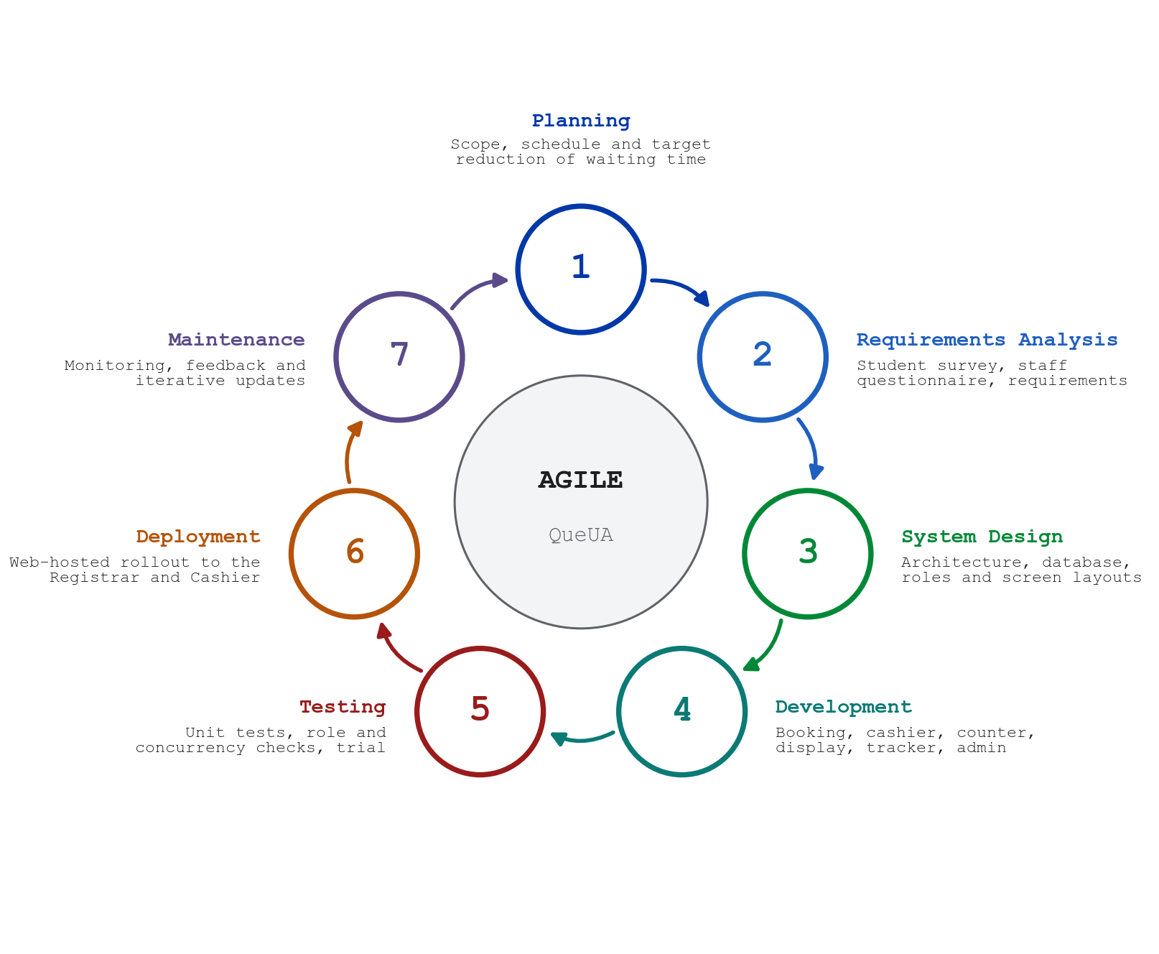
Figure 2. Agile Software Development Life Cycle
Phase 1: Planning.
The researchers defined the scope of the project, the offices covered (the Office of the University Registrar and the Cashier), the stakeholders, and the schedule. The planning target was to reduce the average waiting time of students by at least 40% by booking and assessing requests before students reach the window, and to make the queue visible to students wherever they wait.
Phase 2: Requirements Analysis.
The student survey, the staff questionnaire, and a review of the Registrar’s schedule of fees and request forms were used to write a product requirements document. It defined five functional modules (self-service booking and check-in, cashier integration, the counter console, the audio-visual display and mobile tracker, and the administrative dashboard) and the non-functional requirements: real-time synchronization, at most two taps to select a form, display text readable from a distance, masked names on public screens, and role-based access control.
Phase 3: System Design.
The architecture was organized into a client layer, an application layer, and a data layer (Figure 6). The ticket workflow (Figure 7), the relational database (Figure 8), the six user roles, and the screen layouts were designed in this phase. Public screens use the colors and seal of the University of Abra, while staff screens follow a dashboard layout with a sectioned side menu.
Phase 4: Development.
The system was built in increments: the database schema, service catalog, and fee engine; the secure booking (check-in) function; cashier payment clearance; the counter console with modules and access levels; the lobby display and mobile tracker; the administrative monitoring, user, announcement, and report pages; and finally station accounts that lock a workstation to its own window.
Phase 5: Testing.
Fifteen automated unit tests verified the fee engine, including per-page transcript fees, the documentary stamp, fractional peso amounts, and the rejection of invalid quantities. Static type checking and linting were run on every increment. Role and permission rules were tested by attempting restricted actions with each role, and concurrent calls from two windows were tested to confirm that no ticket can be called twice. An end-to-end walkthrough of booking, payment, calling, display, tracking, and completion preceded the trial use by the staff.
Phase 6: Deployment.
The finalized system was hosted on the web. Students open the booking page on their phones through a QR code posted at the Registrar, the lobby display runs in a browser on a television, and staff sign in from their workstations. The evaluation questionnaire was administered after the trial use.
Phase 7: Maintenance.
Post-deployment support covers the monitoring of queue activity through the dashboard and reports, the updating of services, fees, windows, and announcements through the administrative pages, regular database backups, and improvements based on user feedback.

DEVELOPMENT TOOLS AND TECHNOLOGIES
The queuing architecture was developed using tools selected for real-time synchronization, security, and access from any device, as listed in Table 4.
Table 4. Development Tools and Technologies
Tool / Technology | Purpose
Next.js 16 (App Router) | Full-stack React framework for the public and staff pages, server rendering, and protection of staff routes (Vercel, 2026).
React 19 and TypeScript | Component-based user interface with static type checking.
Tailwind CSS 4 | Utility-first styling for responsive layouts on phones, computers, and the lobby television.
Supabase (PostgreSQL) | Relational database for services, tickets, windows, modules, and announcements, secured with Row Level Security and SECURITY DEFINER functions.
Supabase Auth | Sign-in and session management for staff accounts.
Supabase Realtime | WebSocket push of ticket changes to the cashier and counter consoles.
qrcode (Node.js library) | Generation of the QR code on each e-Pass that opens the queue tracker.
Web Speech API and Web Audio API | Chime and spoken “Now serving” announcements on the lobby display (Mozilla, 2026).
Vitest and ESLint | Automated unit testing of the fee engine and static code analysis.
Git and GitHub | Version control and team collaboration.
Visual Studio Code | Primary integrated development environment (IDE).

SCOPE AND DELIMITATION OF THE STUDY
This study covers the design, development, and evaluation of QueUA for the Office of the University Registrar and the Cashier of the University of Abra, Lagangilang Main Campus. The system covers six functions: online mobile booking with automated fee assessment and a digital e-Pass; cashier payment clearance; a counter console with first-in, first-out dispatch and queue controls; an audio-visual lobby display; a QR-linked real-time queue tracker; and administrative monitoring, configuration of windows, modules, users, and announcements, and reports with CSV export. It handles the 24 services in the Registrar’s schedule: eight credential documents, three enrollment adjustments, and thirteen administrative forms.
The study does not include online payment, since fees are still paid in person at the Cashier, nor the printing of paper tickets, SMS or push notifications, integration with the student information or grading system, and offline operation when the internet connection is unavailable. The needs assessment was limited to 100 students from five programs and 8 staff members, and the system evaluation to the same respondents after trial use. IT specialists did not take part, so Part II-C of the evaluation questionnaire was not administered. The study did not measure actual waiting times before and after deployment.

DATA GATHERING PROCEDURES
The data gathering followed a systematic six-stage procedure:
- Approval: Secured permission from the University Registrar and the college administration to conduct the study.
- Instrument Preparation and Validation: Prepared the student survey, the staff questionnaire, and the system evaluation questionnaire and submitted them to the adviser and IT faculty for content validation.
- Needs Assessment: Administered the survey to 100 students and Parts I and II of the staff questionnaire to the 8 personnel to document current queuing problems and practices.
- System Development: Translated the identified requirements into QueUA through the phases of the Agile SDLC.
- Trial Use and Evaluation: Let the students book and track tickets, the staff use the cashier, counter, display, monitoring, configuration, and report functions, after which the students answered Part II-A and the staff Part II-B of the system evaluation questionnaire.
- Data Processing: Encoded the responses in spreadsheets, tallied them, and analyzed them using the statistical tools described below.

DATA GATHERING INSTRUMENTS
Three researcher-made instruments were used. The student survey (Appendix A) contains 23 statements rated on a five-point Likert scale (Likert, 1932) and grouped into five areas: waiting time and service efficiency, queue organization and order management, queue information and communication, record management and queue monitoring, and the waiting area and student experience. It ends with three open-ended questions on the most common problem, the difficulties met during peak hours, and suggested improvements.
The staff questionnaire (Appendix B) has two parts. Part I gathers the respondent’s position, office, and years in service. Part II contains eleven checklist items on current queuing practices, such as how students line up and are called, how transactions are recorded, daily volume, service time, payment coordination, and common problems.
The System Evaluation Questionnaire (Appendix C) begins with a respondent profile (Part I) that routes each respondent to one evaluation section: Part II-A for university students (10 statements), Part II-B for administrative staff (12 statements), and Part II-C for IT specialists (12 statements). Each statement is rated from 1 (Strongly Disagree) to 5 (Strongly Agree), and Part III invites comments and suggestions. Only Parts II-A and II-B were administered, since the respondents were students and administrative staff. Guided by the ISO/IEC 25010 model, each administered statement was mapped to one quality dimension: functional suitability, operational effectiveness, usability, performance efficiency, reliability, or user satisfaction (Table 19).

DATA ANALYSIS
Frequency and percentage were used to describe the respondents’ profiles, the staff’s current queuing practices, and the answers to the open-ended questions, where the percentage is computed as P = (f / N) × 100, with f as the frequency of a response and N as the number of respondents.
The weighted mean was used for the Likert-scale items, computed as WM = Σ(f × w) / N, where w is the scale value of each response. In the student survey, ten statements describe the current process favorably (for example, “The current manual queuing process is efficient”). Their item means are reported as answered, but they were reverse-scored (6 − x) when computing each area’s composite, so that a higher composite always means a greater extent of the problem. Means were interpreted using the scale in Table 5.
Table 5. Five-Point Likert Scale and Interpretation
Scale | Range | Descriptive Rating | Extent of Problem (Problem 1) | Software Quality (Problem 3)
5 | 4.21–5.00 | Strongly Agree | Very High | Excellent
4 | 3.41–4.20 | Agree | High | Very Good
3 | 2.61–3.40 | Neutral | Moderate | Good
2 | 1.81–2.60 | Disagree | Low | Fair
1 | 1.00–1.80 | Strongly Disagree | Very Low | Poor

The answers to the open-ended questions were examined through thematic analysis (Braun & Clarke, 2006): similar answers were coded, counted, ranked, and grouped into themes. Synthesizing the descriptive statistics with these themes allowed the researchers to connect each identified problem to a specific feature of the system and to interpret the evaluation results in context.

CHAPTER III
RESULTS AND DISCUSSION
This chapter presents the findings of the study based on the identified problems and objectives. It includes the analysis of the existing queuing problems and practices at the Office of the University Registrar, the design and development of the QueUA system, and the evaluation of the system based on the ISO/IEC 25010 software quality model.

Problem 1. What are the common operational bottlenecks and manual queuing problems encountered by students and staff at the Office of the University Registrar?
Data for this problem were gathered through the needs assessment survey answered by 100 students and through Parts I and II of the questionnaire answered by the 8 Registrar, Cashier, and MIS personnel. Item weighted means were interpreted using the descriptive ratings in Table 5. For each area, a composite was computed with the positively worded items reverse-scored, so that the composite expresses the extent of the problem.
a. Waiting Time and Service Efficiency
Table 6. Students’ Assessment of Waiting Time and Service Efficiency
No. | Indicator | WM | SD | % Agree | Descriptive Rating
A1 | The current manual queuing process is efficient. † | 3.32 | 1.05 | 47 | Neutral
A2 | Long waiting lines are frequently experienced. | 3.29 | 1.13 | 46 | Neutral
A3 | The current queuing process causes unnecessary waiting or delays. | 3.26 | 1.06 | 45 | Neutral
A4 | Delays occur because of slow manual recording or checking of student information. | 3.31 | 1.17 | 48 | Neutral
A5 | The waiting time becomes longer during peak hours. | 3.25 | 1.15 | 45 | Neutral
Composite (extent of problem) |  | 3.16 |  |  | Moderate
† Positively worded item; reverse-scored in the composite. % Agree = share of ratings of 4 or 5. n = 100.
As shown in Table 6, the students gave a neutral rating (3.32) to the statement that the current manual queuing process is efficient; fewer than half (47%) agreed with it. The four problem statements obtained similar neutral ratings, from 3.25 for longer waiting during peak hours to 3.31 for delays caused by slow manual recording or checking of student information, and each was affirmed by 45% to 48% of the respondents. The composite of 3.16 indicates that waiting-time problems exist to a moderate extent.
The standard deviations of 1.05 to 1.17 show that experiences varied considerably among students, which is consistent with a queue whose length depends on when a student happens to arrive. The staff responses support this reading: 6 of the eight personnel reported serving more than 200 students a day during peak periods, compared with 50 to 150 on regular days, and half reported spending five to ten minutes on one transaction. Under these conditions, the time spent encoding student information and computing fees at the window adds directly to every waiting student’s time, which QueUA addresses by capturing the student’s details and assessing the fees at the moment of booking.
b. Queue Organization and Order Management
Table 7. Students’ Assessment of Queue Organization and Order Management
No. | Indicator | WM | SD | % Agree | Descriptive Rating
B1 | There are instances of line-cutting or unfair queuing. | 3.23 | 1.06 | 43 | Neutral
B2 | It is easy to know whose turn is next in the current queue. † | 3.51 | 1.05 | 57 | Agree
B3 | The current queuing process follows a clear and organized order. † | 3.28 | 1.16 | 45 | Neutral
B4 | It is difficult to determine who should be served next. | 3.42 | 1.11 | 49 | Agree
B5 | Students who need priority assistance are properly accommodated. † | 3.28 | 1.20 | 49 | Neutral
Composite (extent of problem) |  | 2.92 |  |  | Moderate
† Positively worded item; reverse-scored in the composite. % Agree = share of ratings of 4 or 5. n = 100.
Table 7 shows that the students agreed both that it is easy to know whose turn is next (3.51) and that it is difficult to determine who should be served next (3.42). These opposing statements received agreement from 57% and 49% of the respondents, indicating that the order of service is clear on some occasions and unclear on others rather than consistently organized. Line-cutting or unfair queuing (3.23), the existence of a clear and organized order (3.28), and the accommodation of students needing priority assistance (3.28) were all rated neutral. The composite of 2.92 places this area at a moderate extent and makes it the least severe of the five areas.
The inconsistency itself is the finding: in a physical line, the order of service is enforced only by the students who happen to be present, and it breaks down whenever a student steps out, for example to pay at the Cashier. A system-generated sequence that is the same for everyone, and that the window follows automatically, removes this ambiguity.
c. Queue Information and Communication
Table 8. Students’ Assessment of Queue Information and Communication
No. | Indicator | WM | SD | % Agree | Descriptive Rating
C1 | Communication between students and office staff is clear and organized. † | 3.40 | 1.07 | 45 | Neutral
C2 | I can easily determine how many people are ahead of me in the queue. † | 3.18 | 1.26 | 42 | Neutral
C3 | I receive sufficient information about the status of the queue. † | 3.29 | 1.17 | 51 | Neutral
C4 | I sometimes need to stay near the service counter to avoid missing my turn. | 3.13 | 1.03 | 35 | Neutral
C5 | Students sometimes miss their turns because they do not hear or notice when they are called. | 3.46 | 1.10 | 54 | Agree
Composite (extent of problem) |  | 2.94 |  |  | Moderate
† Positively worded item; reverse-scored in the composite. % Agree = share of ratings of 4 or 5. n = 100.
In Table 8, the item with the highest rating is that students sometimes miss their turns because they do not hear or notice when they are called (3.46, Agree), affirmed by 54% of the respondents. The students were neutral on whether they can easily determine how many people are ahead of them (3.18), the lowest-rated favorable statement in this area, and on whether they receive sufficient information about the status of the queue (3.29). The need to stay near the counter to avoid missing one’s turn was rated 3.13. The composite of 2.94 indicates a moderate extent of problems in queue information and communication.
These results show that the verbal calling of names or numbers is the weakest point of the communication process. A student who cannot hear the call either stays close to the counter, adding to the crowd, or risks losing the turn altogether, which is why QueUA announces every call visually and audibly on the lobby display and shows each student’s position on the phone.
d. Record Management and Queue Monitoring
Table 9. Students’ Assessment of Record Management and Queue Monitoring
No. | Indicator | WM | SD | % Agree | Descriptive Rating
D1 | Errors or duplication may occur when student information is recorded manually. | 3.51 | 1.05 | 56 | Agree
D2 | It is difficult to retrieve previous queue records when needed. | 3.53 | 1.12 | 57 | Agree
D3 | Office staff can easily monitor the number of students waiting to be served. † | 3.46 | 1.16 | 56 | Agree
D4 | The current process makes it easy to track students who have already been served. † | 3.50 | 1.05 | 51 | Agree
D5 | Manual recordkeeping makes it difficult to prepare accurate queue reports. | 3.31 | 1.13 | 50 | Neutral
Composite (extent of problem) |  | 3.08 |  |  | Moderate
† Positively worded item; reverse-scored in the composite. % Agree = share of ratings of 4 or 5. n = 100.
Table 9 shows the highest area mean among the raw item ratings. The students agreed that errors or duplication may occur when student information is recorded manually (3.51) and that previous queue records are difficult to retrieve when needed (3.53), the second-highest item in the survey. At the same time, they agreed that office staff can easily monitor the number of students waiting (3.46) and that it is easy to track students who have already been served (3.50). The difficulty of preparing accurate queue reports was rated neutral (3.31). Because the favorable monitoring items offset the record problems, the composite of 3.08 is moderate.
The staff responses qualify the students’ favorable view of monitoring. Five of the eight personnel said they cannot tell how many students are waiting at a given time, and the remaining three could give only a rough estimate. Seven record transactions in handwritten logbooks, and five need one to two days to prepare a summary report. What appears to students as adequate monitoring is therefore achieved through manual effort that does not produce reliable records or timely reports.
e. Waiting Area and Student Experience
Table 10. Students’ Assessment of the Waiting Area and Student Experience
No. | Indicator | WM | SD | % Agree | Descriptive Rating
E1 | The current queuing process causes crowding in or near the office. | 3.21 | 1.17 | 47 | Neutral
E2 | Managing or following the queue causes stress during peak hours. | 3.58 | 1.18 | 62 | Agree
E3 | The waiting area is sufficient to accommodate students waiting for service. † | 3.07 | 1.08 | 38 | Neutral
Composite (extent of problem) |  | 3.24 |  |  | Moderate
† Positively worded item; reverse-scored in the composite. % Agree = share of ratings of 4 or 5. n = 100.
As presented in Table 10, the statement that managing or following the queue causes stress during peak hours obtained the highest rating in the entire survey (3.58, Agree), with 62% of the students agreeing. The sufficiency of the waiting area obtained the lowest rating of all items (3.07), with only 38% agreeing that it can accommodate the students waiting for service, while crowding in or near the office was rated 3.21. The composite of 3.24 is the highest among the five areas.
All eight staff respondents likewise identified crowding in or near the office as a common problem. Since a larger waiting area is a facilities matter, the practical remedy within the scope of this study is to reduce the number of students who must wait in the hallway at all, by allowing them to book from anywhere and to follow their turn remotely.
Table 11. Summary of the Students’ Assessment of the Manual Queuing Process
Area | Composite WM | Extent of Problem | Rank
Waiting Area and Student Experience | 3.24 | Moderate | 1
Waiting Time and Service Efficiency | 3.16 | Moderate | 2
Record Management and Queue Monitoring | 3.08 | Moderate | 3
Queue Information and Communication | 2.94 | Moderate | 4
Queue Organization and Order Management | 2.92 | Moderate | 5
Overall | 3.05 | Moderate
Positively worded items reverse-scored. n = 100.
Table 11 and Figure 3 summarize the five areas. The overall composite of 3.05 indicates that the students experience the problems of the manual queuing process to a moderate extent, with 48.6% of all ratings at Agree or Strongly Agree. The waiting area and student experience ranked first, followed by waiting time and service efficiency, and record management and queue monitoring. Queue information and queue organization ranked last but still fell within the moderate range. The ratings indicate that the problems are real but are not experienced uniformly; they depend on the period of the semester and the time of the student’s visit, which is consistent with the staff’s report that volume more than doubles during enrollment, the start and end of the semester, and the graduation and clearance period.
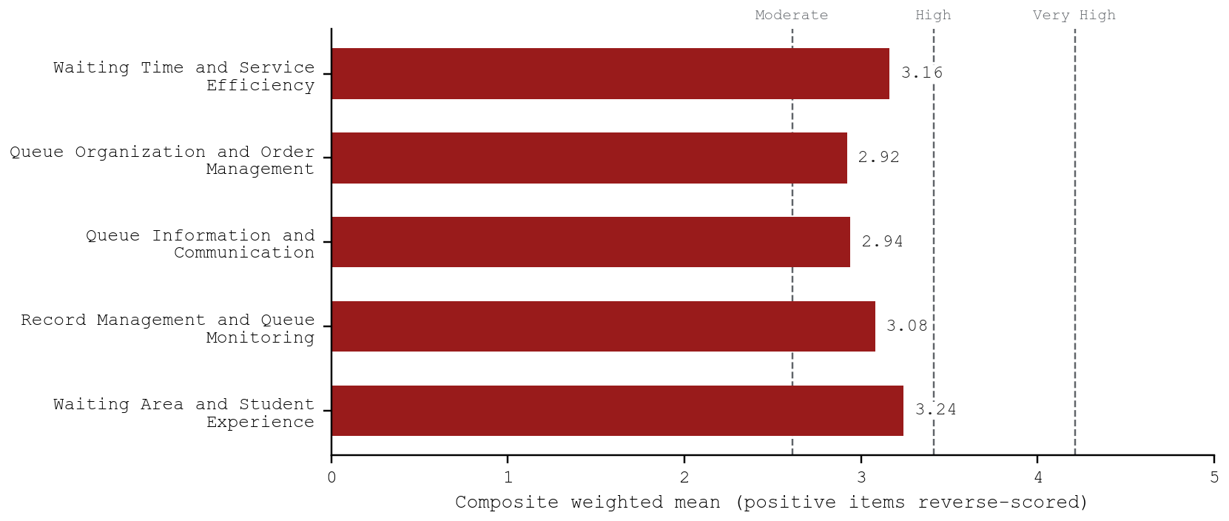
Figure 3. Extent of Problems in the Manual Queuing Process by Area
f. Open-Ended Responses of the Students
The three open-ended questions gave the students the opportunity to describe the problem in their own words. Tables 12 to 14 present the coded responses.
Table 12. Most Common Problem Experienced in the Manual Queue
Response | f | % | Rank
Difficulty keeping track of queue numbers. | 21 | 21 | 1
Not knowing how many people are ahead in the queue. | 19 | 19 | 2
Slow checking of student information. | 17 | 17 | 3
Crowded lines at the office. | 16 | 16 | 4
Long waiting time and delays. | 14 | 14 | 5
Unclear order of who should be served next. | 13 | 13 | 6
Total | 100 | 100

Table 12 shows that the most common problem was difficulty keeping track of queue numbers (21%), followed by not knowing how many people are ahead (19%) and slow checking of student information (17%). Grouped thematically, problems of queue visibility (keeping track of numbers, people ahead, and the order of service) account for 53% of the responses, while problems of congestion and delay (crowded lines, long waiting, and slow checking) account for 47%.
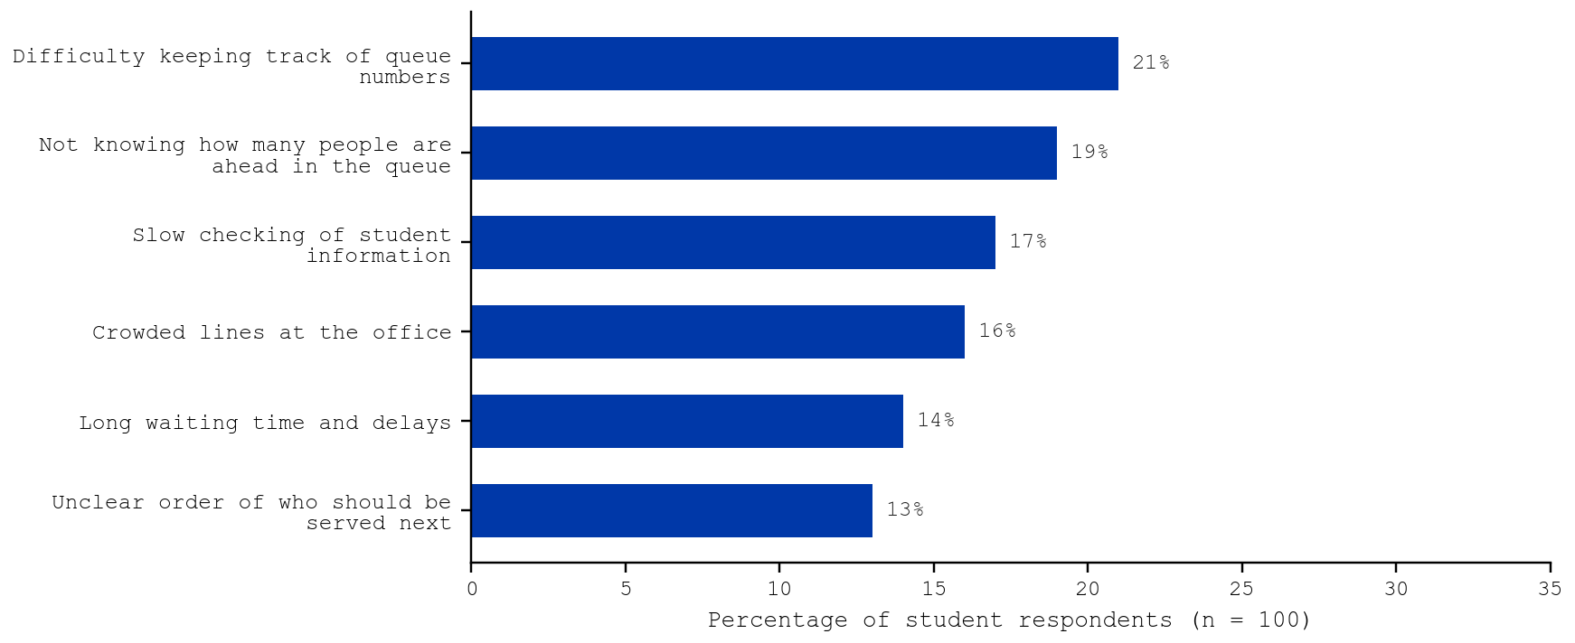
Figure 4. Most Common Problems Cited by the Students
Table 13. Difficulties Encountered During Peak Hours
Response | f | % | Rank
The office becomes crowded and waiting takes longer. | 23 | 23 | 1
I need to stay close to the counter so I do not miss my turn. | 20 | 20 | 2
Service becomes slower during busy hours. | 17 | 17 | 3
It is hard to know who is next in line. | 16 | 16 | 4
It is difficult to hear when my turn is called. | 12 | 12 | 5
There are too many students waiting at the same time. | 12 | 12 | 5
Total | 100 | 100

During peak hours (Table 13), the students most often reported that the office becomes crowded and waiting takes longer (23%) and that they need to stay close to the counter so they do not miss their turn (20%). Difficulties tied to the student’s physical presence (staying close to the counter, not knowing who is next, and not hearing the call) together account for 48% of the responses, showing that the manual process keeps students in the hallway precisely when the hallway is most crowded.
Table 14. Students’ Suggested Improvements
Response | f | % | Rank
Provide a screen showing the current and next queue numbers. | 25 | 25 | 1
Provide clearer announcements when calling students. | 20 | 20 | 2
Use an online queue registration system. | 19 | 19 | 3
Use a digital queue number and display the number being served. | 13 | 13 | 4
Add staff or service counters during peak hours. | 12 | 12 | 5
Improve the waiting area and organize the line clearly. | 11 | 11 | 6
Total | 100 | 100

Table 14 shows that the students most often suggested a screen showing the current and next queue numbers (25%), clearer announcements when calling students (20%), and an online queue registration system (19%). Together with the use of digital queue numbers (13%), these suggestions, which make up 77% of all responses, describe the core features of QueUA. The remaining suggestions, adding staff or counters during peak hours and improving the waiting area, are administrative and facilities matters, although QueUA supports the former by letting the administrator open more windows and reassign modules during peak periods.
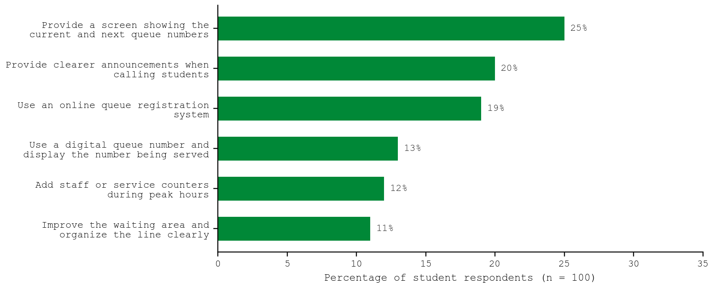
Figure 5. Improvements Suggested by the Students
g. Current Queuing Practices Reported by the Staff
Table 15 summarizes the staff’s answers to Part II of the questionnaire. Because the eight respondents constitute the entire personnel directly involved in Registrar transactions, their answers describe the actual operation of the office.
Table 15. Current Queuing Practices and Problems Reported by the Staff
Question / Indicator | Responses (f, n = 8)
Queue formation and calling
How do students line up for Registrar transactions? | Physical line along the hallway (8)  Handwritten number stubs (during peak periods) (3)
How are students called to the window? | Verbal calling of name or number (8)  Students approach the window on their own (4)
Transaction volume and service time
Average number of students served per day (regular days) | 50-100 (5)  101-150 (3)
Average number of students served per day (peak periods) | 151-200 (2)  More than 200 (6)
Average time spent serving one transaction | Less than 5 minutes (2)  5-10 minutes (4)  11-15 minutes (2)
Peak periods of Registrar transactions | Enrollment period (8)  Start and end of semester (7)  Graduation and clearance period (6)
Payment coordination
How are fee-based requests coordinated with the Cashier? | Student hand-carries the order of payment and returns with the official receipt (8)  Window officer verifies the official receipt manually (6)
Records, monitoring, and reporting
How are transactions recorded? | Logbook (handwritten) (7)  Excel spreadsheet (5)  Request slips filed in folders (4)
Time needed to prepare a summary report of transactions | Within the day (2)  1-2 days (5)  More than 2 days (1)
Can you tell how many students are waiting at any given time? | No (5)  Only a rough estimate (3)
Common problems
Common problems encountered in the current queuing process | Crowding in or near the office (8)  Students repeatedly asking about their turn (6)  Students returning from the Cashier and re-entering the line (6)  Difficulty preparing daily or monthly reports (5)  Students missing their turn when called (5)  Errors or duplicate entries in manual records (4)
Multiple answers were allowed where applicable.
Queue formation and calling. All eight staff reported that students line up physically along the hallway and are called verbally by name or number, with handwritten number stubs used only by three respondents during peak periods. Half also noted that students approach the window on their own, which explains the students’ mixed perception of whose turn is next.
Transaction volume and service time. Five staff reported serving 50 to 100 students on regular days, while six reported more than 200 during peak periods, which all identified as the enrollment period. Half reported that one transaction takes five to ten minutes, so a window can serve only about six to twelve students an hour; by Little’s Law, any increase in arrivals beyond this rate lengthens both the line and the wait (Little, 2011).
Payment coordination. All eight staff reported that, for requests with fees, the student hand-carries the order of payment to the Cashier and returns with the official receipt, and six said the window officer verifies the receipt manually. Six identified students returning from the Cashier and re-entering the line as a common problem, a direct source of line-cutting disputes.
Records, monitoring, and reporting. Seven staff record transactions in a handwritten logbook, often alongside spreadsheets and filed request slips. Six need at least a day to prepare a summary report, and none can tell exactly how many students are waiting at a given time.
Common problems. Crowding in or near the office was cited by all eight respondents, followed by students repeatedly asking about their turn and students returning from the Cashier (six each), difficulty preparing reports and students missing their turn (five each), and errors or duplicate entries in manual records (four).
Overall, the findings for Problem 1 show that the manual queuing process at the Office of the University Registrar suffers from three interrelated weaknesses: the queue is not visible to students or staff, its order depends on the physical presence of students, and the payment step splits each paid request into two separate lines. These weaknesses produce crowding and stress during peak periods and leave the office without reliable records for monitoring and reporting.

Problem 2. What system design and features should be integrated into QueUA to address these problems?
Guided directly by the findings of Problem 1, the researchers designed and developed QueUA following the Input–Process–Output framework and the Agile model described in Chapter II. Table 16 traces each identified problem to the feature that addresses it. The subsections that follow present the architecture, the ticket workflow, the database, the user roles, and each module of the system with its corresponding screen.
Table 16. Problems Identified and the Corresponding Features of QueUA
Problem Identified (Problem 1) | QueUA Feature (Problem 2)
Difficulty keeping track of queue numbers (21%) and not knowing how many are ahead (19%); staff report repeated inquiries (6 of 8) | Unique ticket number on a digital e-Pass; QR-linked queue tracker showing the number of students ahead and an alert when it is the student’s turn
Students miss calls (3.46) and must stay near the counter (20%) | Audio-visual lobby display with a two-tone chime and a spoken announcement of the ticket and window
Inconsistent order of service (3.51 vs. 3.42) and line-cutting | System-generated sequence per category; Call Next serves the oldest eligible ticket first (FIFO) and locks it so no two windows call the same ticket
Crowding and stress during peak hours (3.58); insufficient waiting area (3.07) | Online booking from any location and remote tracking, so students need not wait in the hallway
Slow checking of information (17%); payment back-and-forth (8 of 8) | Student details captured at booking; automated fee assessment; Cashier clears the ticket by number and the paid ticket joins the window queue automatically
Handwritten logbooks (7 of 8), reports taking 1–2 days, unknown number of students waiting | Central database of all tickets; live monitoring dashboard; reports of volume, AQWT, ASHT, and no-show rate with CSV export

a. System Architecture
QueUA is a web-based application organized into three layers, as shown in Figure 6. The client layer consists of ordinary web browsers on the students’ phones, the lobby television, and the cashier, window, and administrator computers, so nothing has to be installed. The application layer is built with Next.js 16 and React 19 in TypeScript; it serves the public pages (landing portal, booking, tracker, lobby display, and sign-in) and the staff pages, and checks the role of the signed-in user on every staff page. The data layer is Supabase, which provides authentication, the PostgreSQL database, and Realtime. All changes to tickets are made through server-side database functions rather than directly by the browser, so the rules of the queue are enforced in one place.
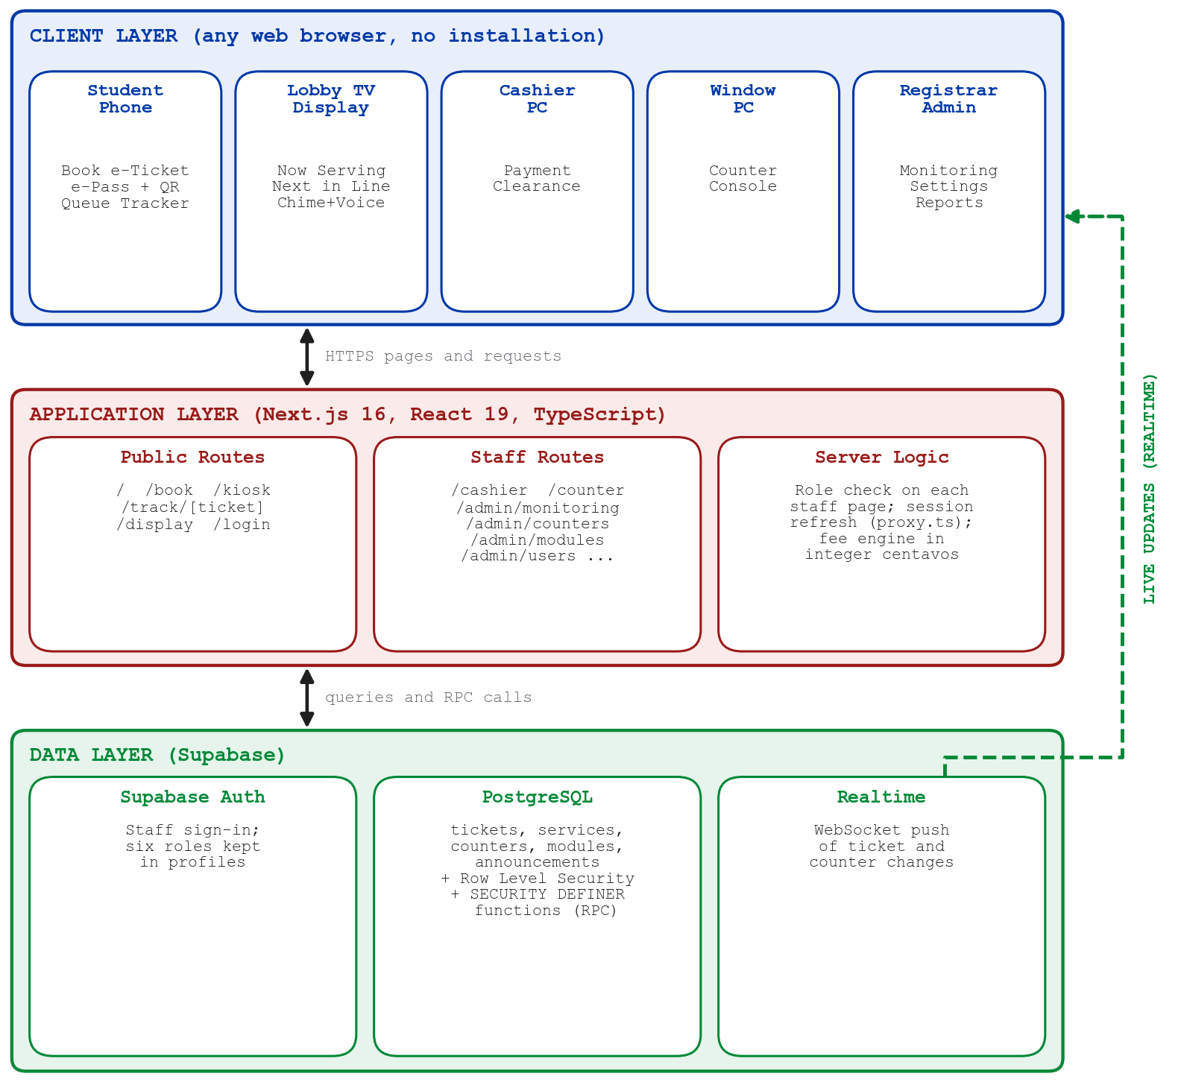
Figure 6. System Architecture of QueUA
b. Ticket Workflow
Figure 7 shows the life cycle of a ticket. A student books a ticket by selecting a category, the services, and their quantity. The fee engine computes the base fee, any per-page charge, and the documentary stamp using whole-centavo arithmetic, so that totals never drift by fractions of a peso. If the total is above zero, the ticket starts as PAYMENT_PENDING and joins the window queue only after the Cashier confirms payment; free requests join the queue immediately. When a window officer clicks Call Next, the database selects the oldest eligible ticket for that window’s modules and locks the row (FOR UPDATE SKIP LOCKED), so two windows calling at the same moment always receive different tickets (PostgreSQL Global Development Group, 2026). A serving ticket may be completed, recalled, put on hold and resumed, transferred to another window, or marked as a no-show after three recalls.
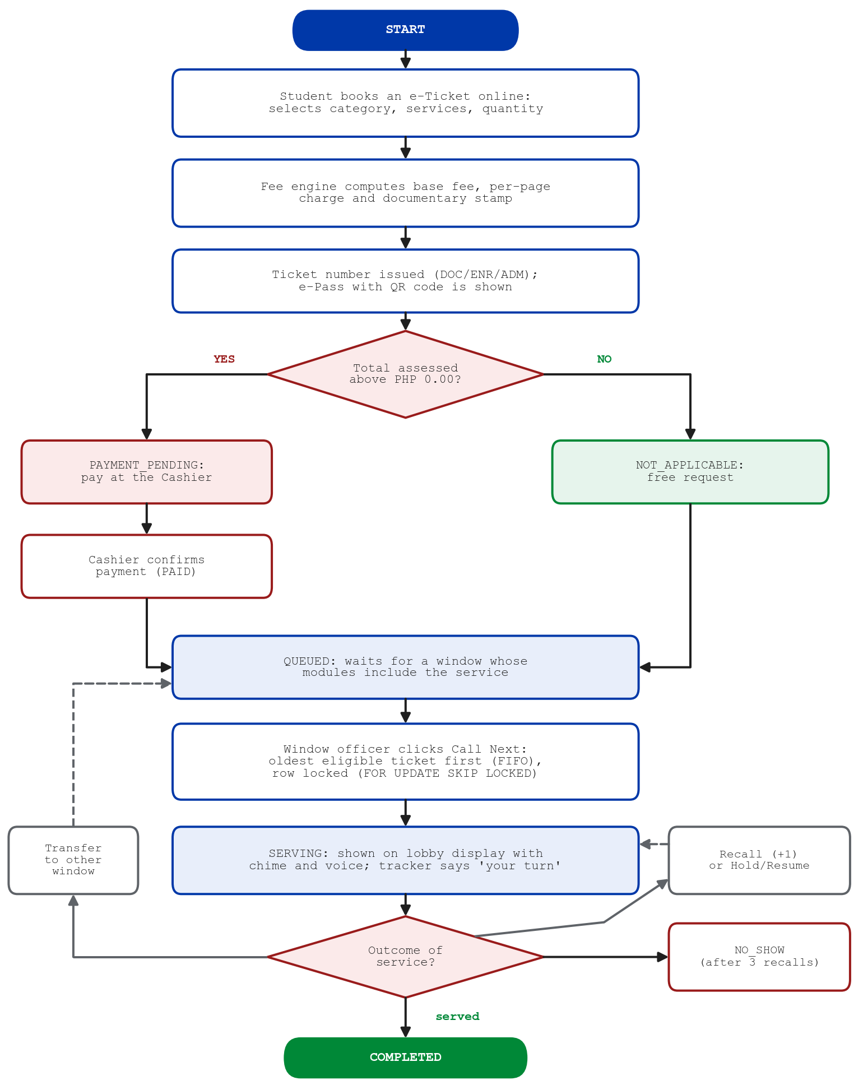
Figure 7. Ticket Workflow of QueUA
c. Database Design
Figure 8 presents the entity-relationship diagram. The services table holds the Registrar’s catalog and fee rules; each ticket has one or more ticket items, each linked to a service with its quantity and computed fee. Services are grouped into modules through module_services, and modules are assigned to windows (counters) through counter_modules with a READ, WRITE, or FULL access level, which determines which tickets a window may call and which actions it may perform. The profiles table stores each staff account’s role, and a counter may be bound to one station account. A restricted view, public_queue, exposes only the ticket number, status, window, and a masked name to the public pages, in keeping with the Data Privacy Act of 2012 (Republic of the Philippines, 2012).
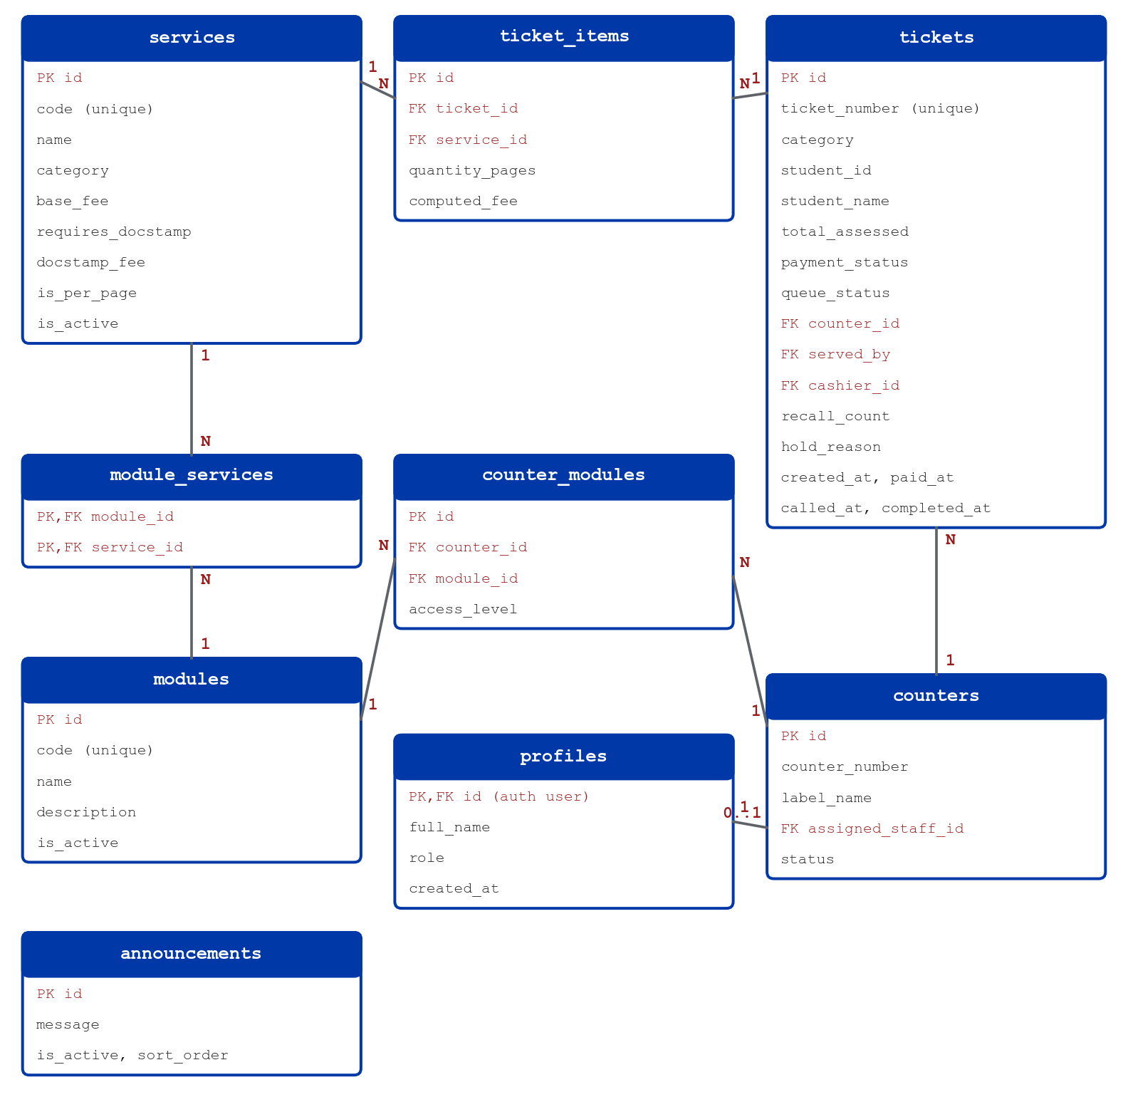
Figure 8. Entity-Relationship Diagram of QueUA
Table 17 summarizes the service catalog loaded into the system and the fee rules applied by the fee engine.
Table 17. Service Categories and Fee Rules
Category | Prefix | Services | Fee Rule
Credential Documents | DOC | 8 | ₱25–₱75 per copy or request; Official Transcript of Records at ₱50 per page plus a ₱30 documentary stamp; second copy of diploma at ₱50 plus a ₱30 documentary stamp
Enrollment Adjustments | ENR | 3 | ₱50 per form; paid at the Cashier first
Administrative Forms and Clearances | ADM | 13 | No fee; routed directly to the window queue

d. User Roles and Access
Access to QueUA is governed by role-based access control, summarized in Table 18. Students and other visitors use the public pages without an account. Each staff account has exactly one role, and the role is checked both by the page and by the database functions, so hiding a button is never the only safeguard.
Table 18. User Roles and Access Rights
Role | Access Rights
Student / visitor (no account) | Book an e-ticket, view the e-Pass and queue tracker, view the lobby display
Cashier | Cashier Clearance: view unpaid tickets and confirm payments
Registrar Officer | Counter Console for any window, limited by each window’s module access level
Counter (station account) | Counter Console locked to the single window bound to the account
Registrar Administrator | All staff pages: monitoring, reports, counter console, cashier clearance, windows, modules, staff accounts, and announcements
System Administrator | Same as the Registrar Administrator, for technical administration of the system

e. Landing Portal
The landing portal (Plate 1) is the public entry point of the system. It introduces QueUA in the colors and seal of the University of Abra and links to the four access points: booking a queue e-ticket, tracking a ticket, the lobby display, and the staff portal. Because the portal is a web page, students can open it from a QR code posted at the Registrar without installing an application.
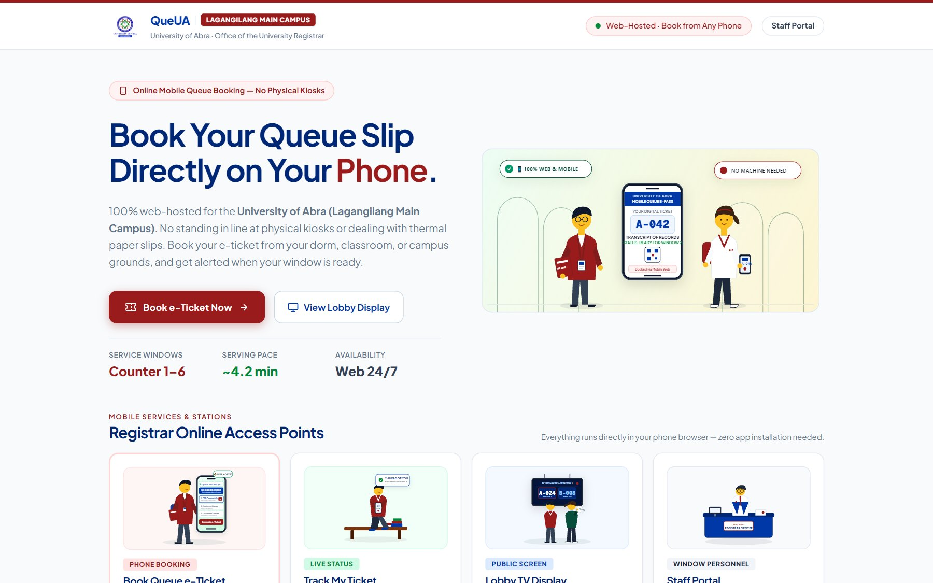
Plate 1. QueUA Landing Portal
f. Online Mobile Booking and Automated Fee Assessment
Booking follows four numbered steps shown at the top of the screen. The student first chooses one of three transaction categories (Plate 2). The services in the chosen category are then listed with their fees (Plate 3); per-page services such as the transcript have a quantity control, and the estimated assessment, including the ₱30.00 documentary stamp, is updated as the student selects items. In Plate 3, three pages of transcript and one certification are assessed at ₱205.00. The student then enters a full name and an optional student ID number (Plate 4). The fees shown on the phone are only an estimate; the official total is recomputed by the database when the ticket is issued, so it cannot be altered from the browser.
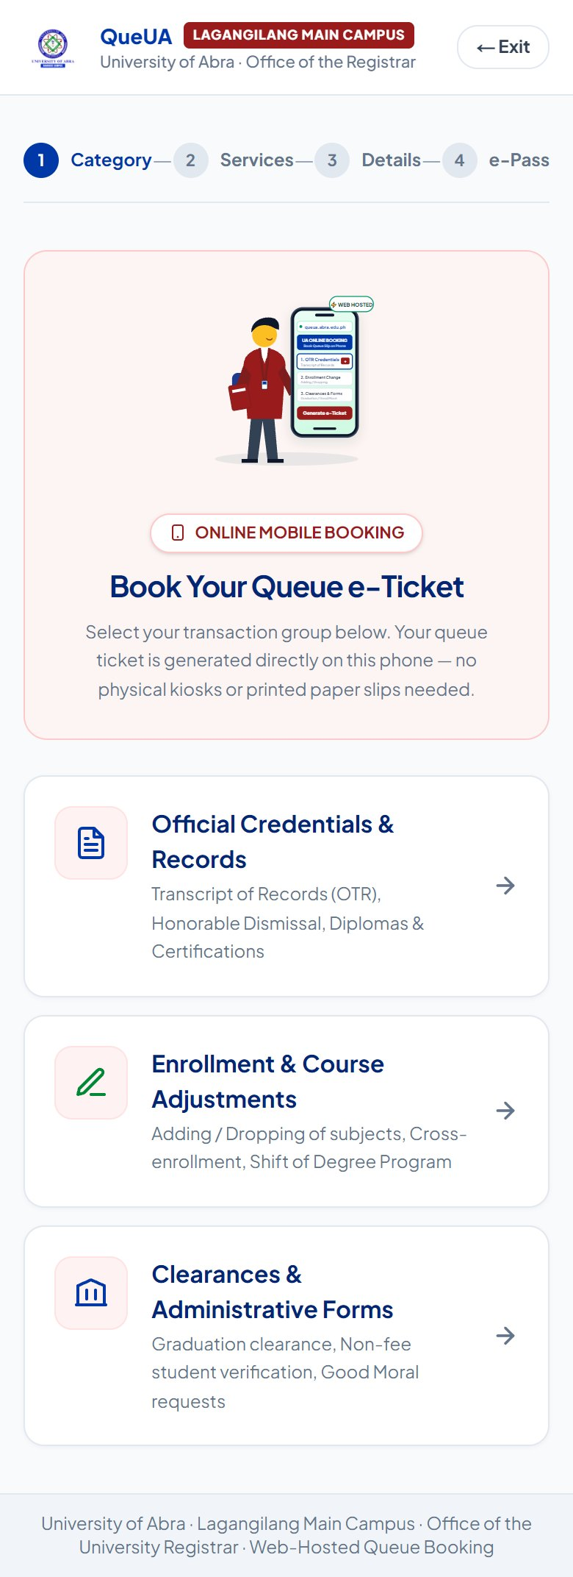  Plate 2. Booking: Category Selection | 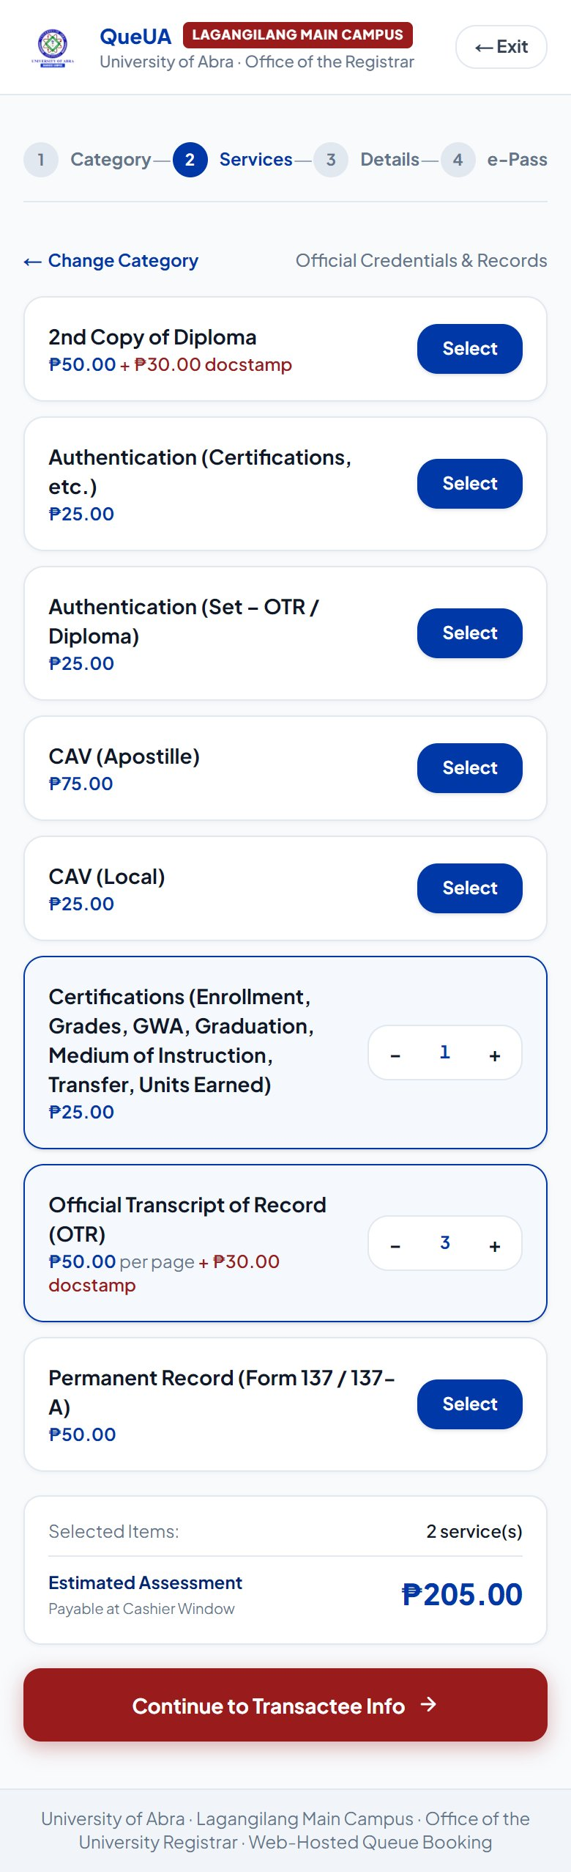  Plate 3. Booking: Services and Assessment

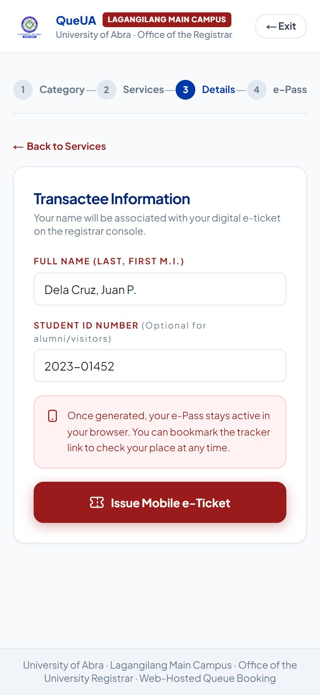
Plate 4. Booking: Transactee Information
g. Digital e-Pass
When the ticket is issued, the phone displays the official mobile e-Pass (Plate 5): the ticket number with its category prefix, the number of students ahead, the booked services with their computed fees, the total assessed, and a QR code that opens the live tracker. A paid request is labeled with the fee and an instruction to pay at the Cashier Window first, while a free request (Plate 6) tells the student to proceed to the window when called. The student can open the tracker, copy the ticket link, or book another ticket.
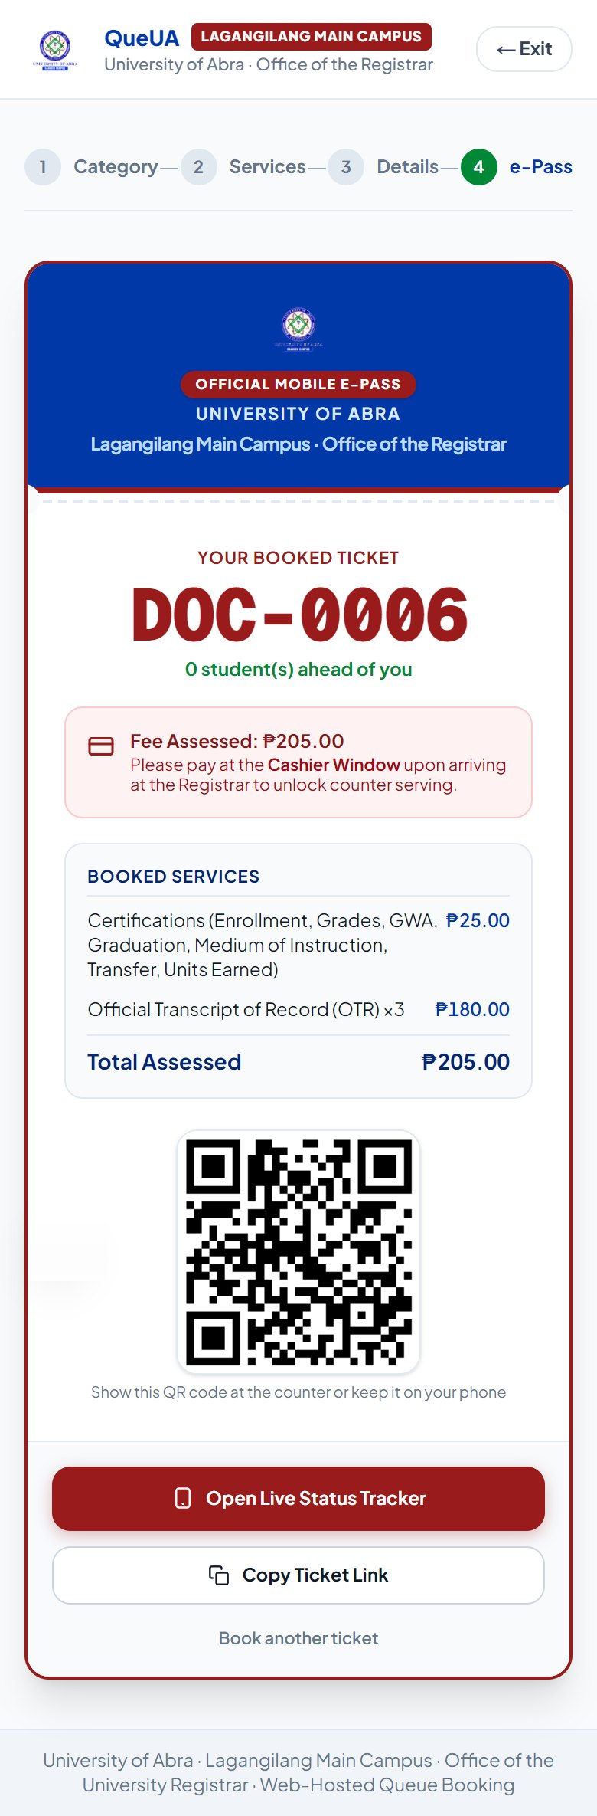  Plate 5. e-Pass for a Paid Request | 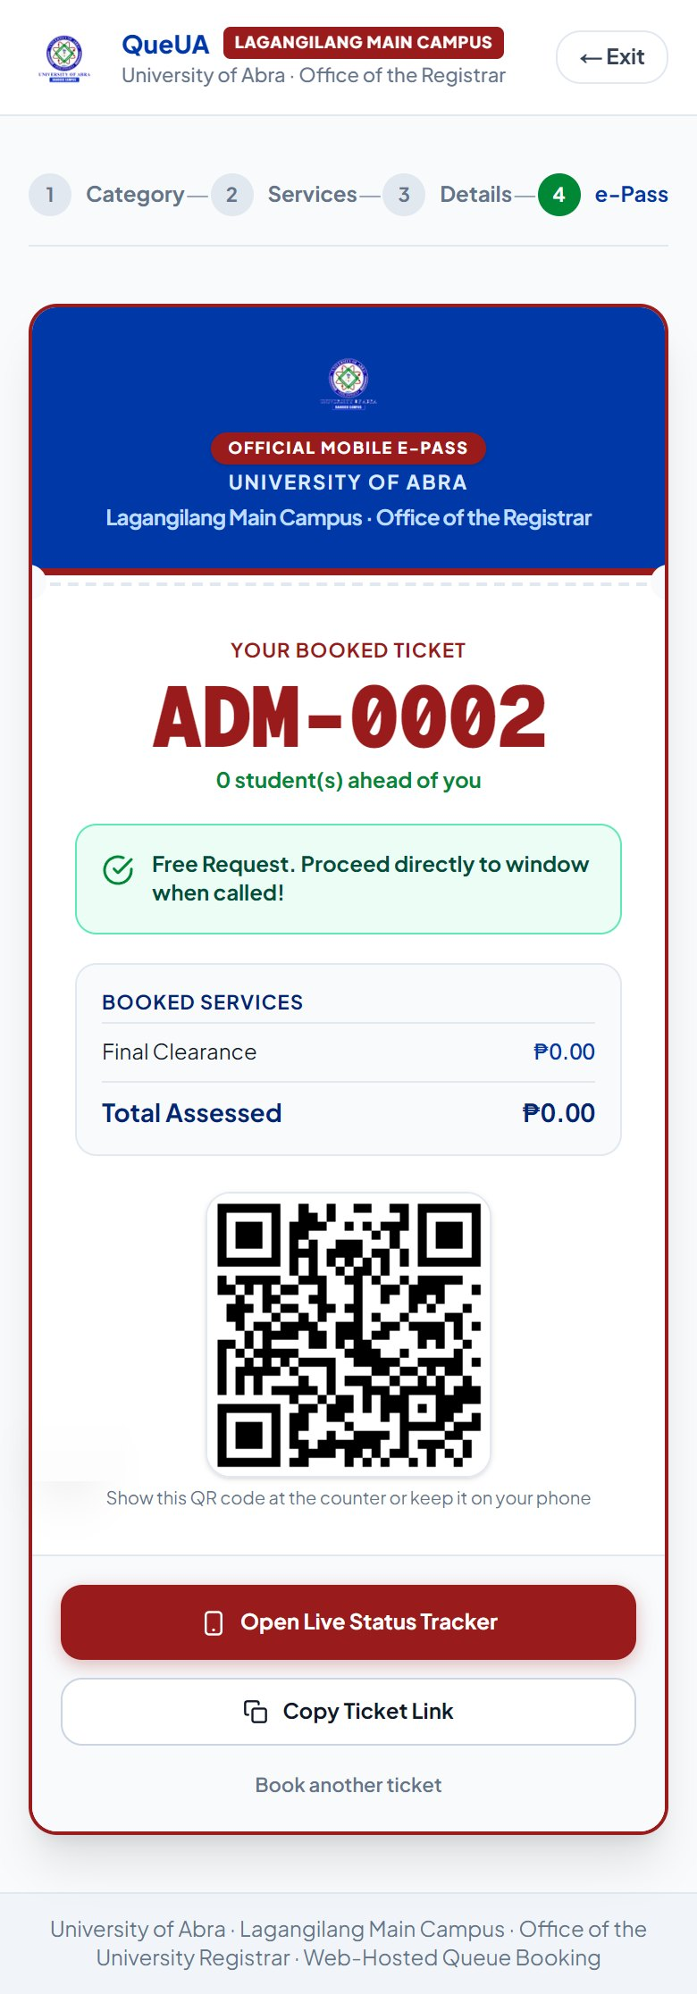  Plate 6. e-Pass for a Free Request

h. Live Mobile Queue Tracker
The queue tracker (Plates 7 and 8) is opened from the QR code or the copied link and needs no account. It shows the ticket number, the number of students ahead, and the tickets currently being served with their windows, and it refreshes itself every few seconds. When the student is near the front, a notice asks them to come to the Registrar lobby, and when the ticket is called the tracker changes to an “It’s your turn now” alert naming the window. This answers the most common problems cited by students, keeping track of their number and knowing how many are ahead, and frees them from waiting in the hallway.
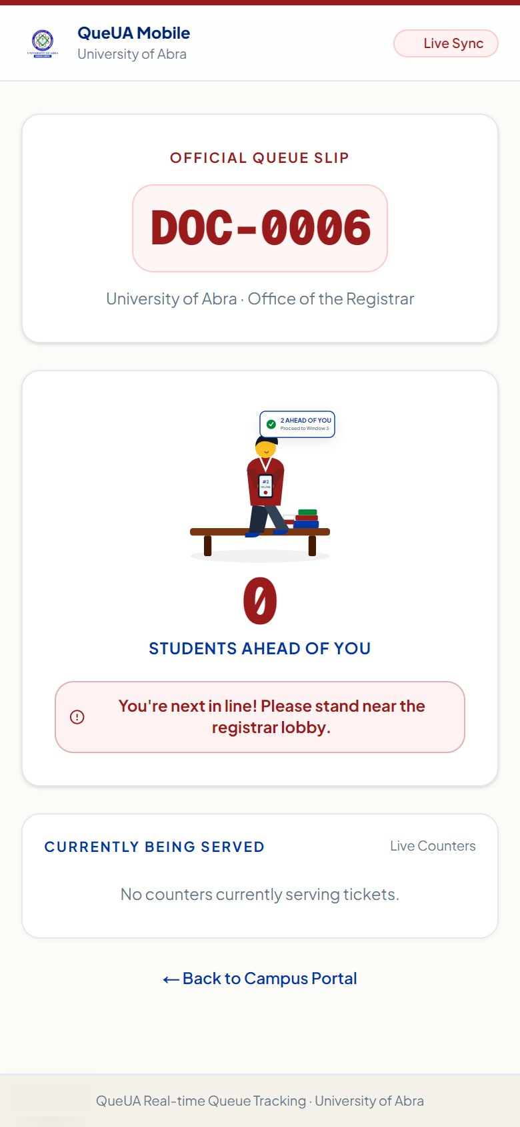  Plate 7. Queue Tracker While Waiting | 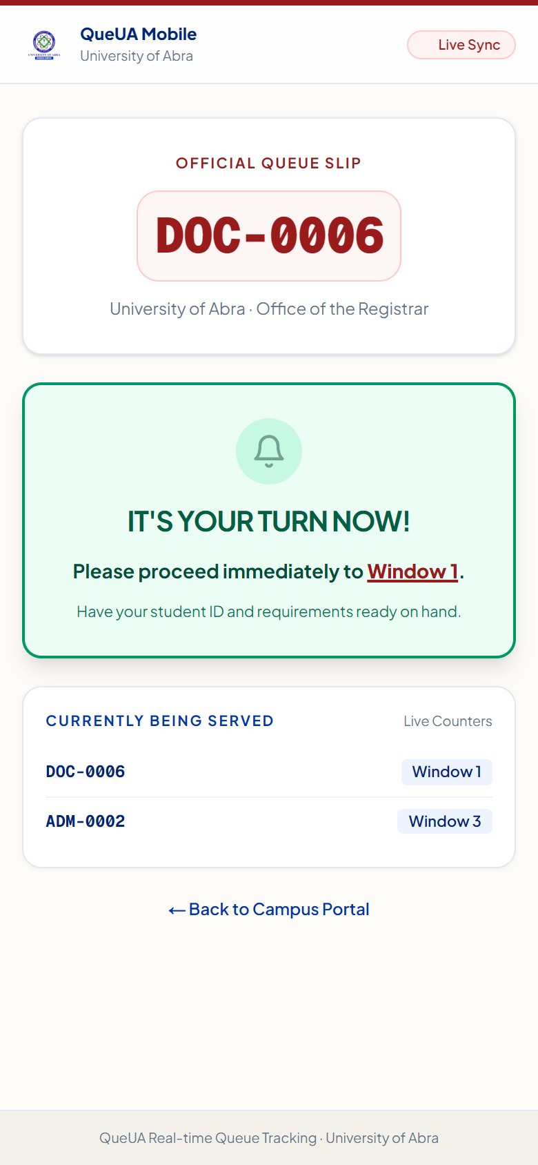  Plate 8. Queue Tracker When Called

i. Staff Sign-In
Staff pages are reached through the Registrar Staff Portal sign-in page (Plate 9). After signing in with an authorized account, each user is directed to the pages allowed for the account’s role; a user without a staff role cannot open any staff page.
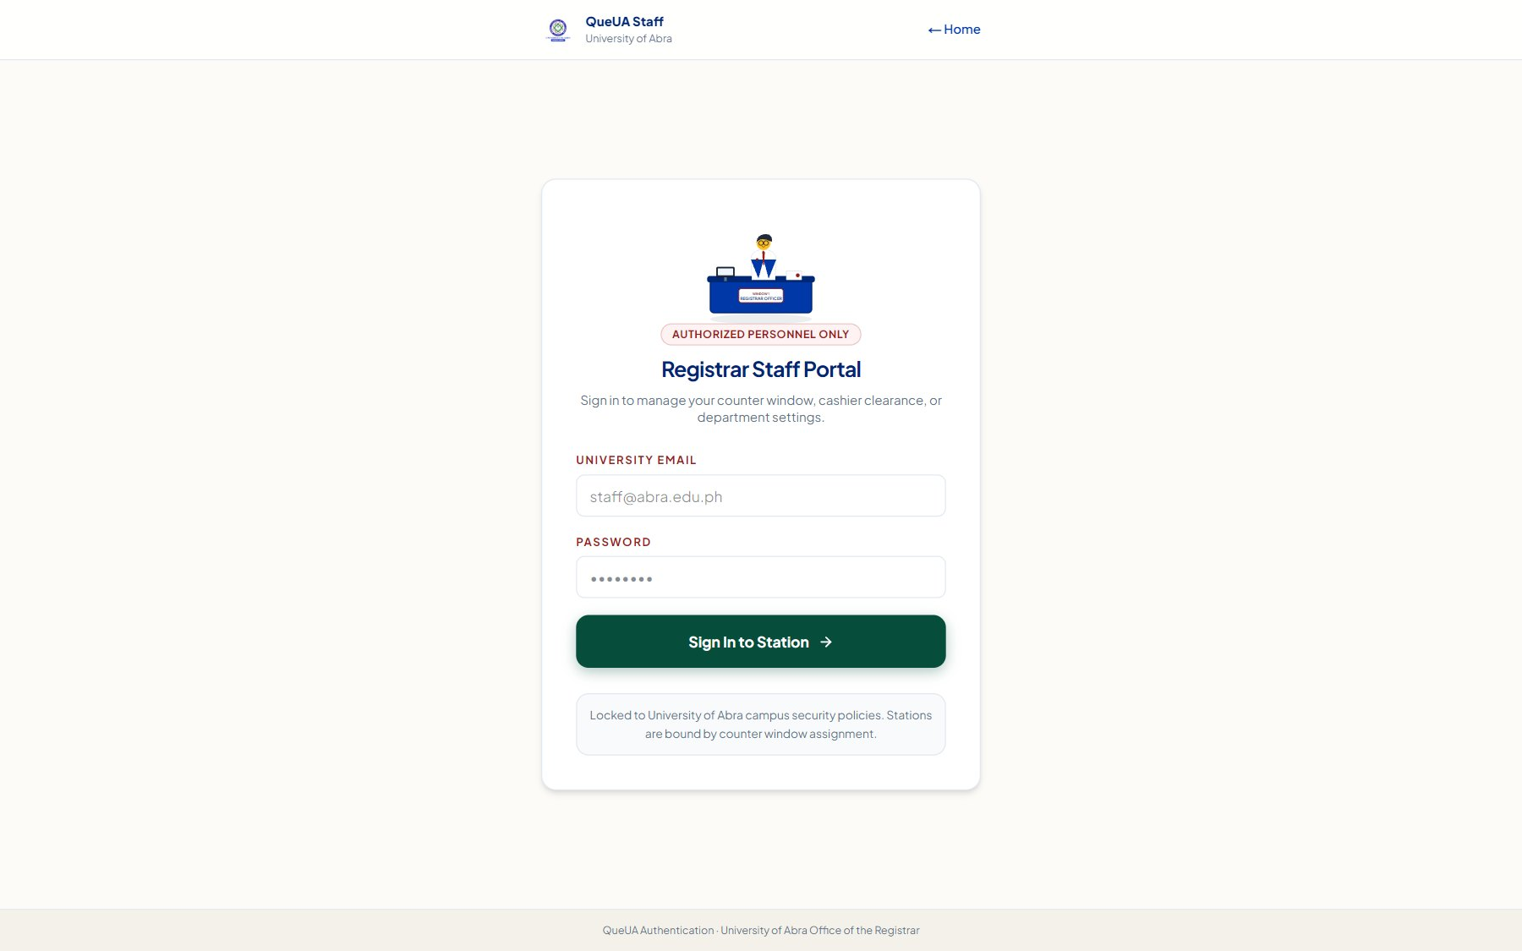
Plate 9. Registrar Staff Portal Sign-In Page
j. Cashier Payment Clearance
The Cashier Clearance page (Plate 10) lists every ticket awaiting payment with the student’s name and ID, the booked services, and the assessed total. The cashier confirms a payment by clicking Confirm on the ticket or by typing or scanning its ticket number. The confirmation records the time and the cashier, changes the ticket to PAID, and releases it to the window queue (Plate 11). The list updates in real time as students book, which removes the need for students to hand-carry the order of payment back to the window and re-enter the line.
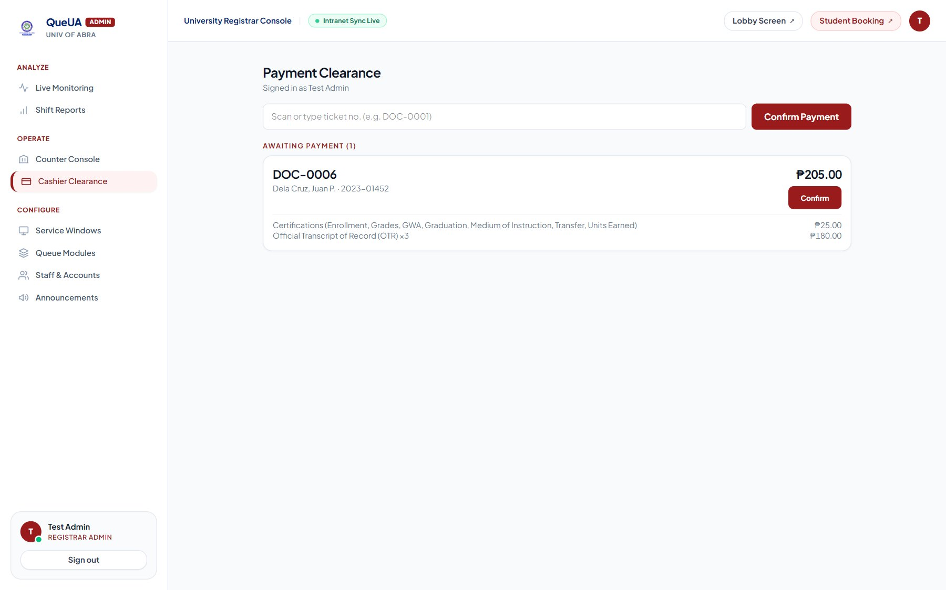
Plate 10. Cashier Clearance: Ticket Awaiting Payment
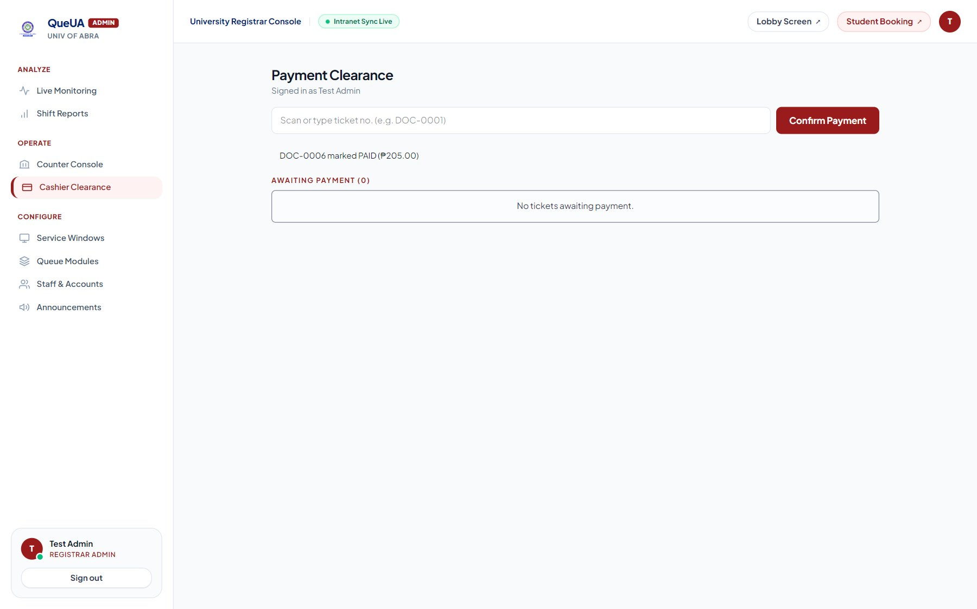
Plate 11. Cashier Clearance: Payment Confirmed
k. Counter Console
The Counter Console (Plate 12) is used by the window officer. It shows the selected window, its modules and access level, the window status (open, busy, on break, or closed), the ticket being served, and the next tickets in line for that window. Clicking Call Next serves the oldest eligible ticket (Plate 13), and the officer can then recall the student, put the ticket on hold with a reason and resume it, complete it, transfer it to another window that can serve it, or mark it as a no-show after three recalls. A station account sees only its own window, while a registrar officer or administrator may switch between windows.
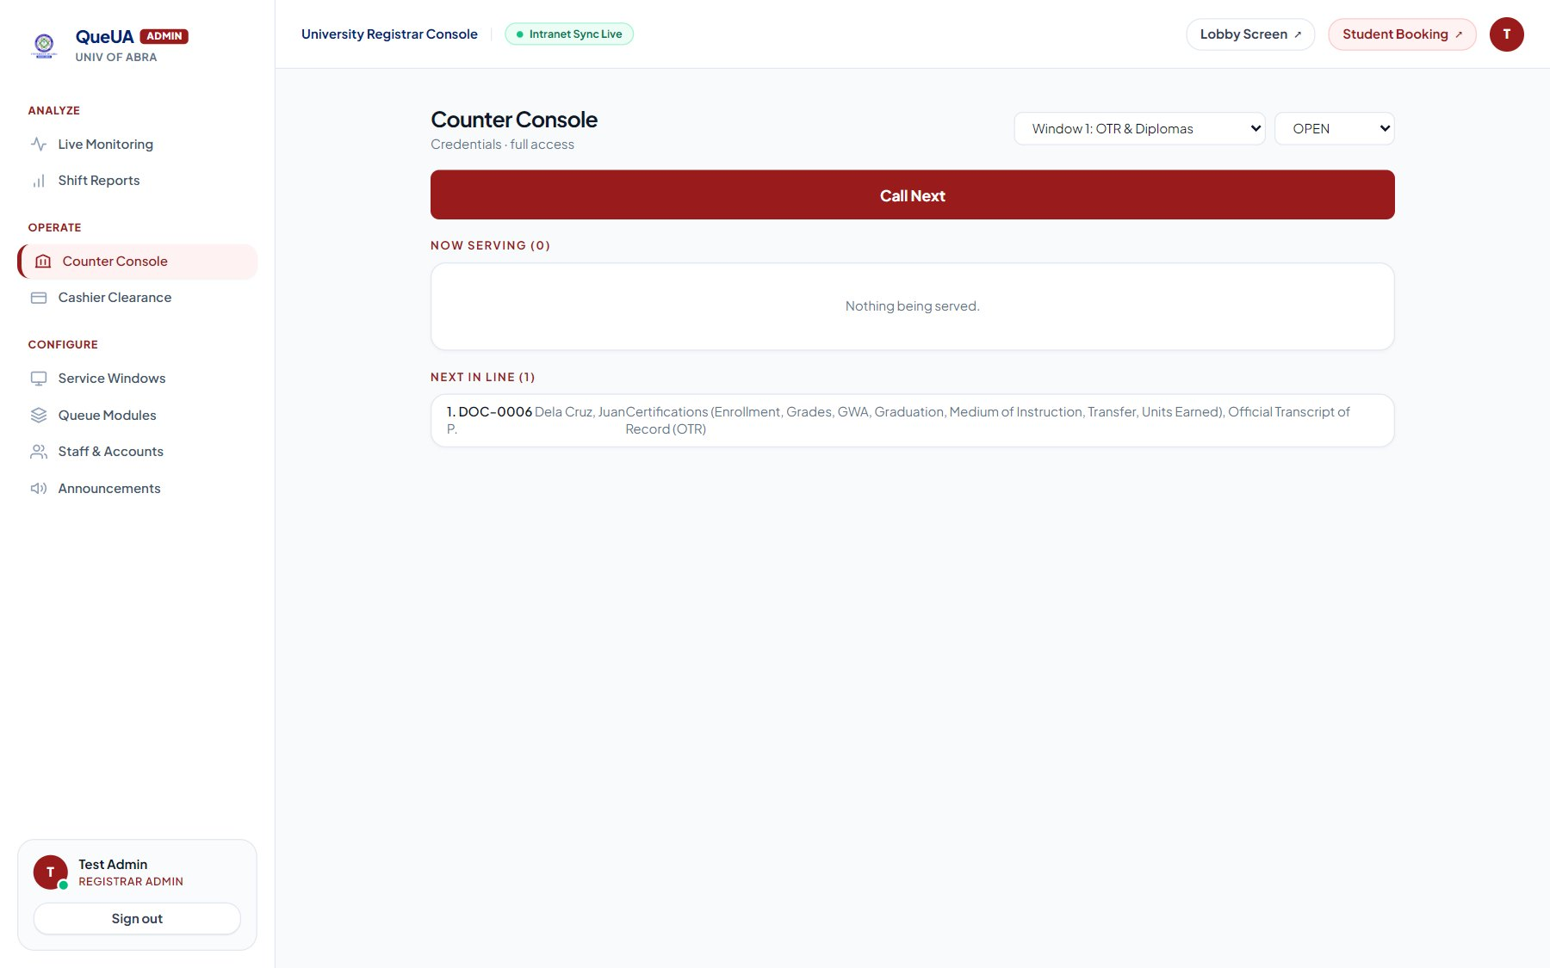
Plate 12. Counter Console: Next in Line
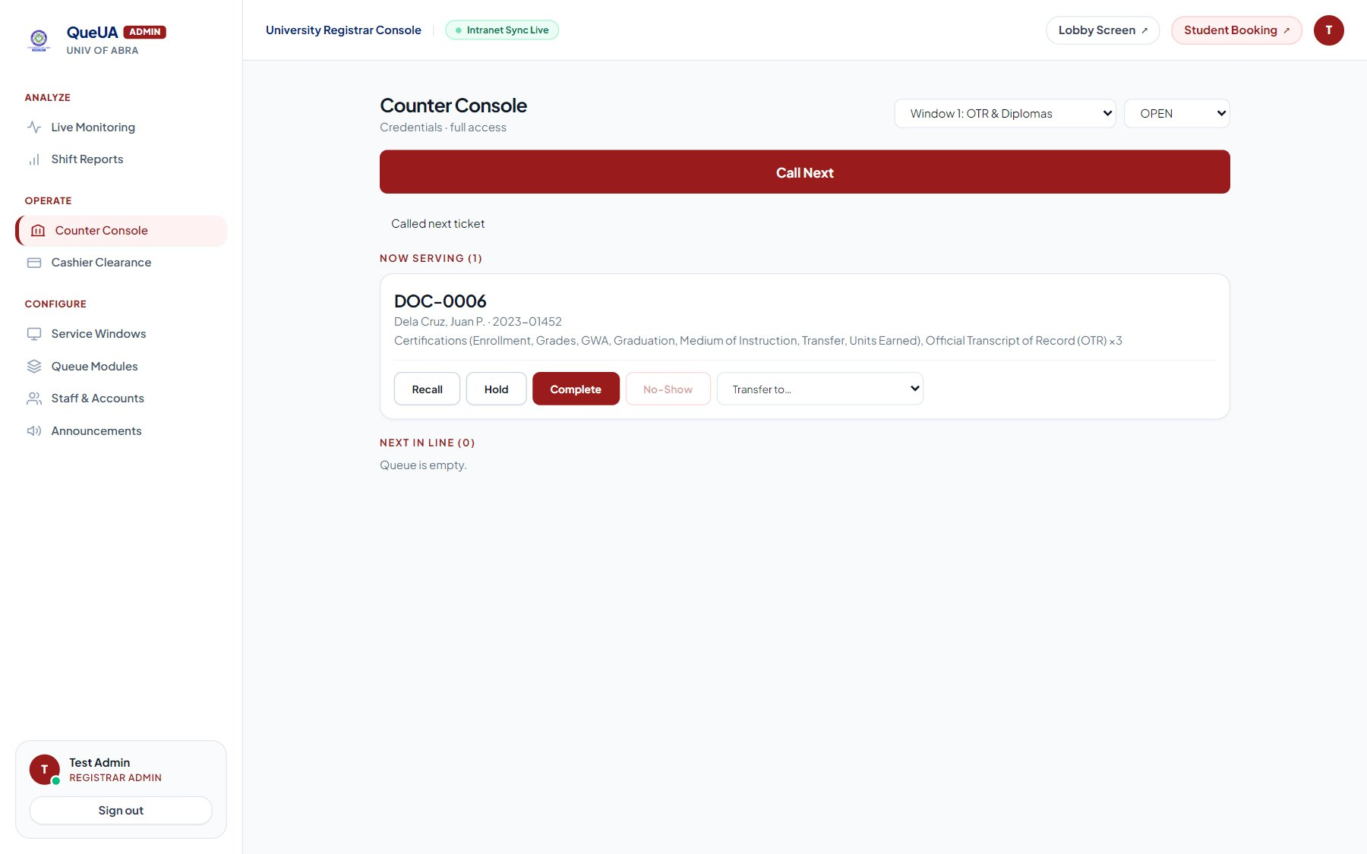
Plate 13. Counter Console: Serving a Ticket
l. Audio-Visual Lobby Display
The lobby display (Plate 14) runs in a browser on a television in the waiting area. Each window has its own panel showing the ticket being served, and the next tickets in line appear below, with announcements from the Registrar scrolling along the bottom and the Philippine Standard Time at the top. Once a staff member enables sound, every new call is announced with a two-tone chime and a spoken message such as “Now serving, D O C 0 0 0 6, at window 1,” produced by the browser’s speech synthesis. This feature corresponds to the students’ two most frequent suggestions, a screen showing the current and next numbers and clearer announcements.
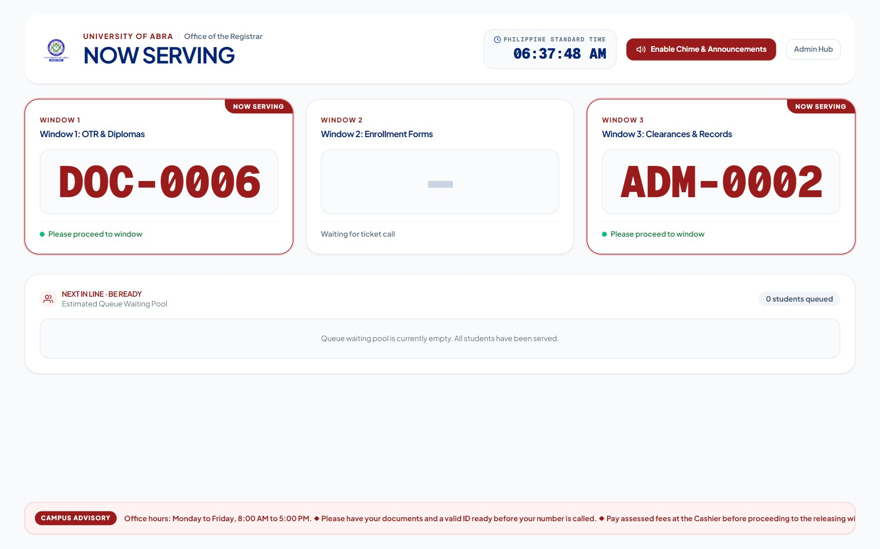
Plate 14. Audio-Visual Lobby Display
m. Administrative Dashboard and Live Monitoring
The administrative dashboard (Plate 15) is the home page of the Registrar Administrator. It shows the number of students in line, in a window session, and awaiting payment, the share of windows that are active, and links to every module. The Live Monitoring page (Plate 16) refreshes automatically and shows the queued, serving, on-hold, and awaiting-payment counts, the longest current wait, and the status and current ticket of every window. These pages give the office the real-time view of the queue that the staff reported lacking.
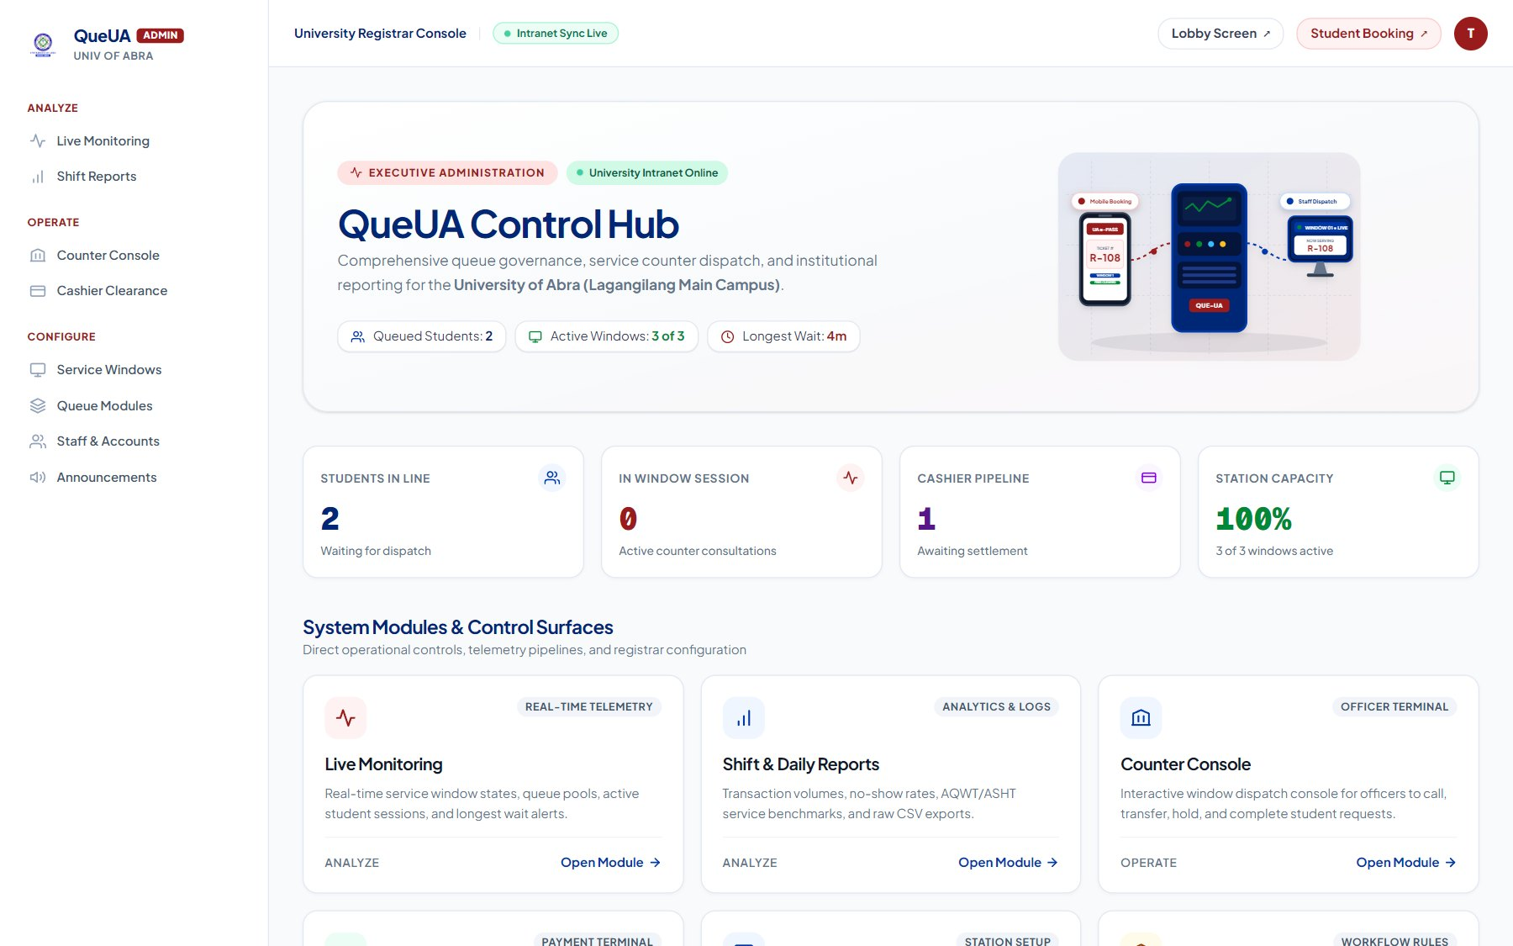
Plate 15. Administrative Dashboard
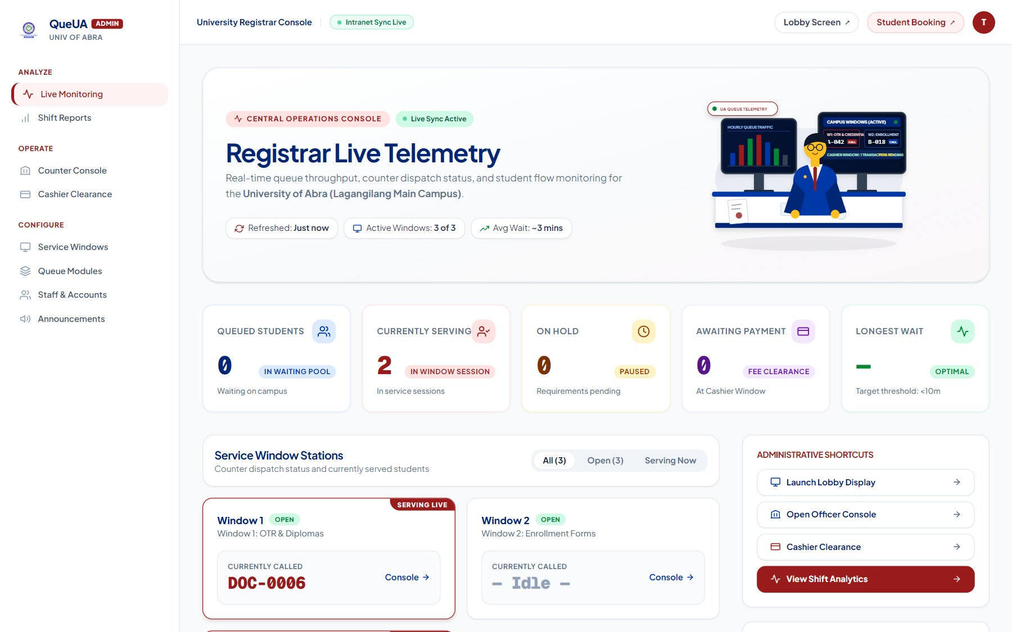
Plate 16. Live Monitoring
n. Service Windows and Module Routing
On the Service Windows page (Plate 17), the administrator adds windows, sets their status, assigns modules to each window with a READ, WRITE, or FULL access level, and binds a station login to a window. On the Queue Modules page (Plate 18), services are grouped into modules such as Credentials, Enrollment, Applications, and Clearances. Together these pages let the office reroute services during peak periods, for example by assigning the Enrollment module to several windows during enrollment week, without changing any program code.
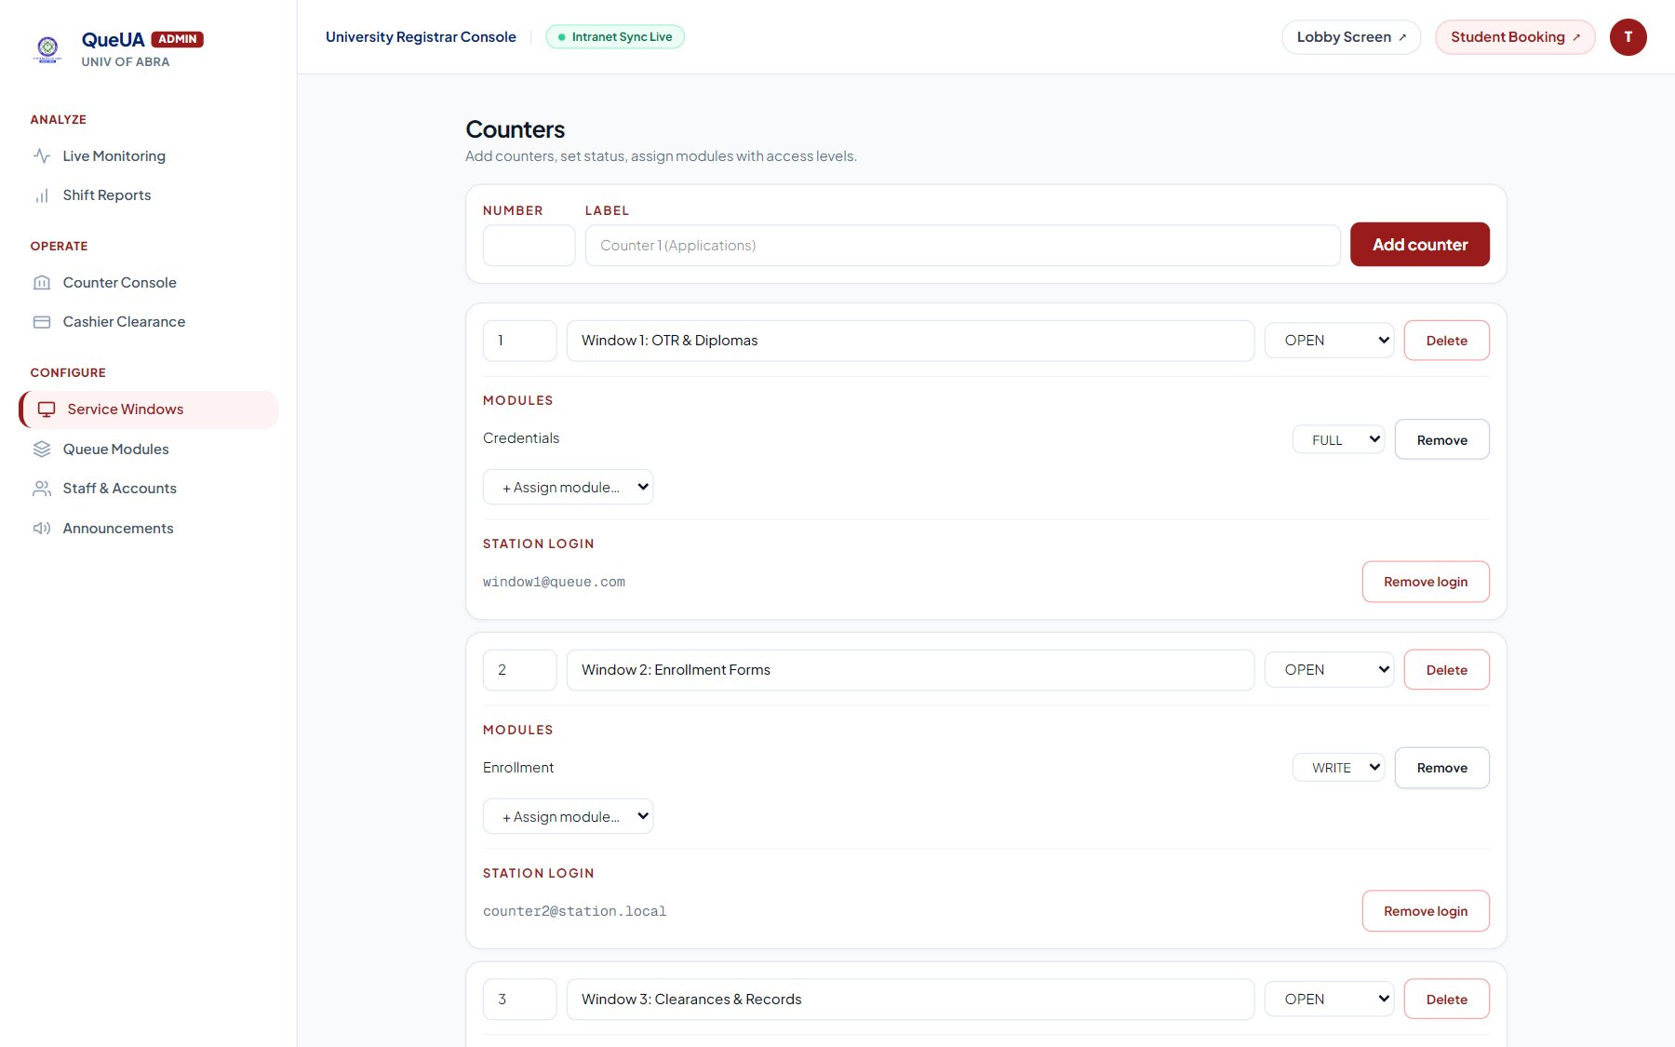
Plate 17. Service Windows Configuration
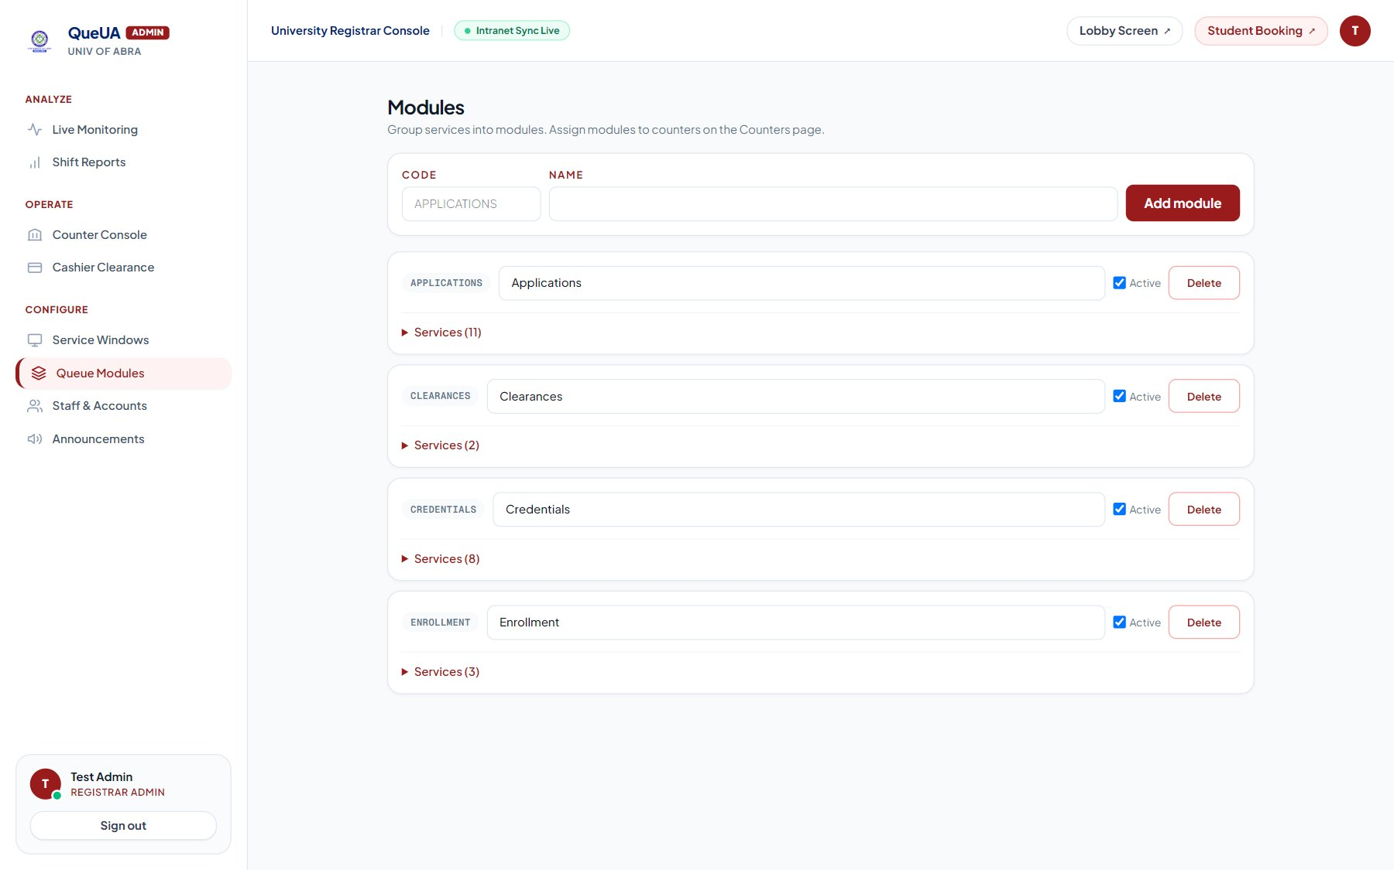
Plate 18. Queue Modules Configuration
o. Staff Accounts and Announcements
The Staff and Accounts page (Plate 19) lists every staff account and lets the administrator change its role. The Announcements page (Plate 20) manages the messages that scroll along the bottom of the lobby display, such as office hours and reminders to prepare documents and pay assessed fees first; each message can be activated, deactivated, or deleted.
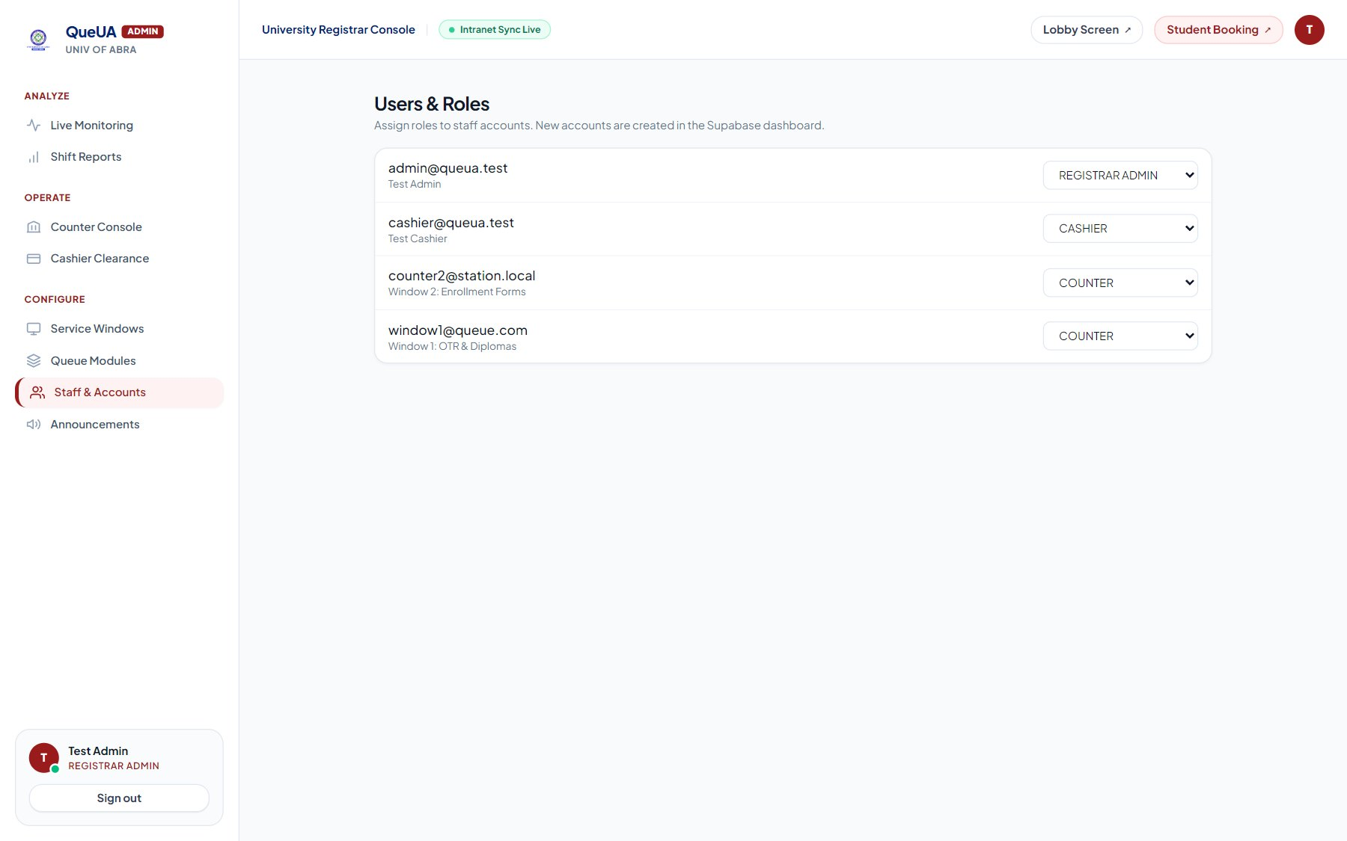
Plate 19. Staff Accounts and Roles
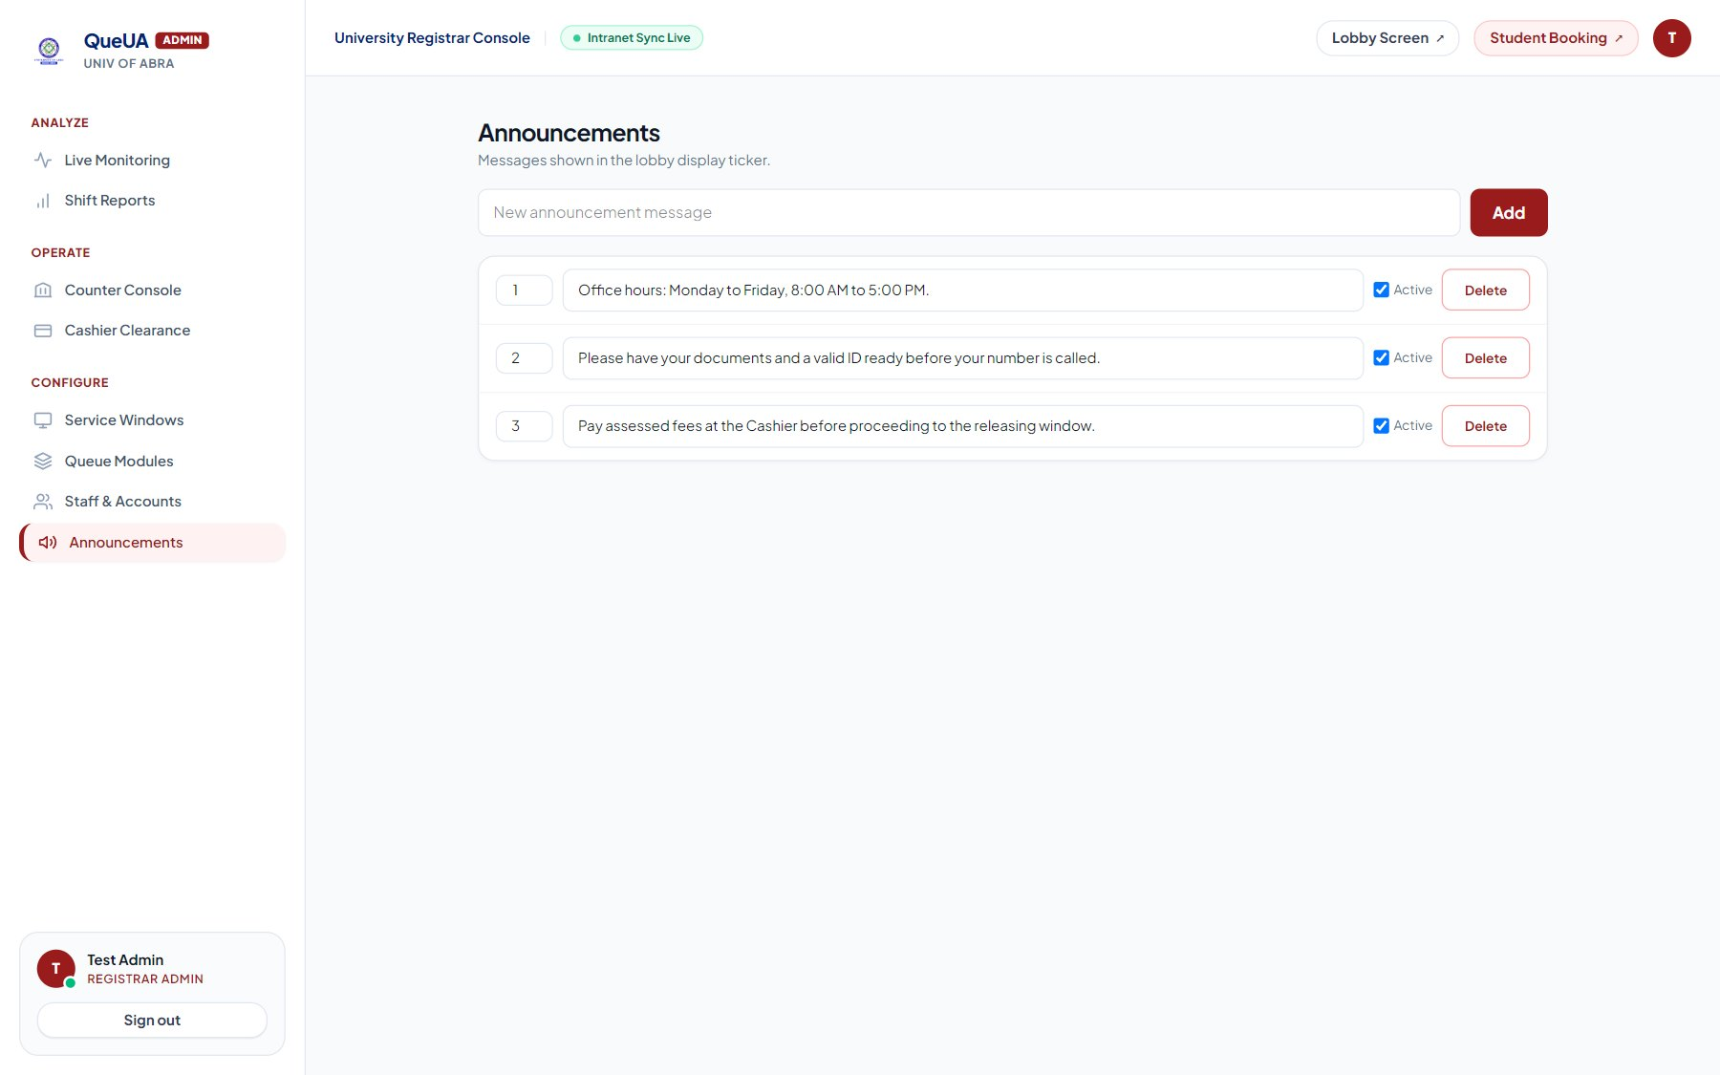
Plate 20. Announcements Management
p. Reports
The Reports page (Plate 21) summarizes the tickets created within a selected date range: total tickets, completed tickets, no-show rate, average queue wait time (AQWT), average service handling time (ASHT), peak hour, and the number of requests per service. The report can be exported as a CSV file. This replaces the one-to-two-day manual preparation of summary reports reported by most of the staff.
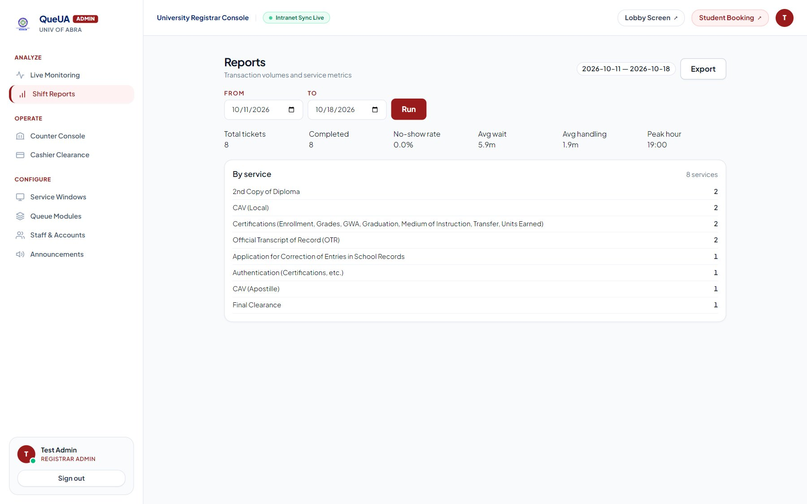
Plate 21. Reports
q. Summary of Security and Data-Integrity Measures
Beyond the module-specific measures described above, QueUA incorporates several system-wide safeguards: Row Level Security on every table, so that the public can read only the services, windows, announcements, and the masked public queue; server-side database functions as the only way to create tickets, confirm payments, and act on tickets, each of which checks the caller’s role and the window’s access level; fees and ticket numbers computed by the database rather than by the browser; row locking that prevents two windows from calling the same ticket; station accounts locked to their own window; masked names on all public screens; and the confinement of privileged database keys to the server. These measures collectively protect the confidentiality and integrity of student and transaction data.
Taken together, the features presented in this section answer Problem 2 by translating the manual, hallway-bound, and paper-based queuing practices identified under Problem 1 into a centralized, real-time, and accountable digital queuing process.

Problem 3. How do students and administrative staff evaluate the developed QueUA system?
Data for this problem were gathered through the System Evaluation Questionnaire (Appendix C). After the trial period, the same 100 students who answered the needs assessment answered Part II-A, and the 8 administrative staff answered Part II-B. Each statement was rated on a five-point scale, and its weighted mean was interpreted using the software-quality column of Table 5. Guided by the ISO/IEC 25010 model, each statement was mapped to one quality dimension, as shown in Table 19, so that the two groups’ ratings could also be compared by dimension.
Table 19. Quality Dimensions Covered by the System Evaluation Questionnaire
Quality Dimension | Students (II-A) | Staff (II-B)
Functional Suitability | A1, A2, A3, A6 | B2, B3, B7
Operational Effectiveness | A4, A5 | B1, B4, B5, B6, B10
Usability | A7, A8 | B8
Performance Efficiency | A9 | —
User Satisfaction | A10 | B12
Reliability | — | B9, B11

a. Students’ Evaluation
Table 20. Students’ Evaluation of QueUA
No. | Indicator | WM | Descriptive Rating | Interpretation
A1 | I can easily obtain a queue number using the QueUA system. | 4.41 | Strongly Agree | Excellent
A2 | The queue number issued to me clearly identifies my position in the queue. | 4.41 | Strongly Agree | Excellent
A3 | I can easily view my current queue status and know when my turn is approaching. | 4.40 | Strongly Agree | Excellent
A4 | The real-time queue updates help me avoid unnecessary waiting inside or near the office. | 4.46 | Strongly Agree | Excellent
A5 | The system helps reduce physical crowding in the Registrar or Cashier waiting area. | 4.15 | Agree | Very Good
A6 | The queue sequence appears fair and follows the order in which students receive queue numbers. | 4.58 | Strongly Agree | Excellent
A7 | The information displayed by QueUA is clear and easy for me to understand. | 4.49 | Strongly Agree | Excellent
A8 | I can use the system without needing extensive assistance from staff. | 4.49 | Strongly Agree | Excellent
A9 | QueUA responds quickly when I obtain a queue number or check my queue status. | 4.27 | Strongly Agree | Excellent
A10 | I am satisfied with my overall experience using the QueUA system. | 4.42 | Strongly Agree | Excellent
Overall Weighted Mean |  | 4.41 | Strongly Agree | Excellent
n = 100.
As shown in Table 20, the students rated QueUA with an overall weighted mean of 4.41, interpreted as Strongly Agree and Excellent. The highest-rated statement was that the queue sequence is fair and follows the order in which students receive their numbers (4.58), followed by the clarity of the information displayed and the ability to use the system without extensive assistance (4.49 each). Obtaining a queue number, knowing one’s position, and seeing when one’s turn is approaching were rated 4.41, 4.41, and 4.40, which directly answer the visibility problems the same students raised in Problem 1.
The lowest-rated statement was that the system helps reduce physical crowding in the Registrar or Cashier waiting area (4.15, Agree, Very Good), followed by the speed of obtaining a number or checking status (4.27). Crowding depends partly on student habits and on the physical layout, so a digital queue relieves it only to the extent that students actually wait elsewhere; the speed rating likewise reflects the few-second refresh interval of the tracker and the quality of mobile connections on campus.
b. Administrative Staff’s Evaluation
Table 21. Administrative Staff’s Evaluation of QueUA
No. | Indicator | WM | Descriptive Rating | Interpretation
B1 | QueUA makes it easier for me to manage students waiting for service. | 4.75 | Strongly Agree | Excellent
B2 | The system accurately maintains the sequence of queue numbers. | 4.88 | Strongly Agree | Excellent
B3 | The CALL NEXT, RECALL, HOLD, and TRANSFER functions support my daily queue management tasks. | 4.75 | Strongly Agree | Excellent
B4 | The system reduces the need for manual listing, calling, and monitoring of students. | 4.88 | Strongly Agree | Excellent
B5 | The real-time queue information helps me reduce administrative delays and blank time. | 4.13 | Agree | Very Good
B6 | QueUA helps reduce physical congestion around the service counter. | 4.88 | Strongly Agree | Excellent
B7 | The staff dashboard provides the information I need to monitor the current queue. | 4.75 | Strongly Agree | Excellent
B8 | The system is easy for me to learn and operate during regular office transactions. | 4.75 | Strongly Agree | Excellent
B9 | QueUA remains responsive and stable when many students are waiting for service. | 4.38 | Strongly Agree | Excellent
B10 | QueUA helps reduce the workload and stress associated with manual queue management. | 4.63 | Strongly Agree | Excellent
B11 | The system prevents duplicate or inconsistent queue entries during transactions. | 4.63 | Strongly Agree | Excellent
B12 | Overall, I am satisfied with QueUA as a tool for managing office queues. | 4.63 | Strongly Agree | Excellent
Overall Weighted Mean |  | 4.67 | Strongly Agree | Excellent
n = 8.
The administrative staff gave the higher overall rating of the two groups, 4.67 (Excellent), as shown in Table 21. They rated most highly that the system accurately maintains the sequence of queue numbers, reduces manual listing, calling, and monitoring, and reduces congestion around the counter (4.88 each), and that the queue functions, the dashboard, and the ease of learning support their daily work (4.75 each). These are the same tasks that the staff reported doing by hand in Problem 1.
The lowest rating among the staff, and the only one at the Agree level, was given to the statement that real-time queue information helps reduce administrative delays and blank time (4.13). The responsiveness and stability of the system when many students are waiting was rated 4.38. This suggests that the staff see the clearest gains in organizing the queue, while the time spent at the window itself, such as verifying documents, is largely outside what a queuing system can shorten.
c. Summary of the Evaluation
Table 22. Summary of the Evaluation of QueUA by Respondent Group
Respondent Group | n | WM | Descriptive Rating | Interpretation
Students | 100 | 4.41 | Strongly Agree | Excellent
Administrative Staff | 8 | 4.67 | Strongly Agree | Excellent
Overall (mean of groups) |  | 4.54 | Strongly Agree | Excellent

Table 23. Evaluation of QueUA by Quality Dimension
Quality Dimension | Students | Staff | Composite | Interpretation | Rank
Functional Suitability | 4.45 | 4.79 | 4.62 | Excellent | 1.5
Usability | 4.49 | 4.75 | 4.62 | Excellent | 1.5
User Satisfaction | 4.42 | 4.63 | 4.53 | Excellent | 3
Reliability | — | 4.50 | 4.50 | Excellent | 4
Operational Effectiveness | 4.31 | 4.65 | 4.48 | Excellent | 5
Performance Efficiency | 4.27 | — | 4.27 | Excellent | 6
Composite = mean of the group means for the groups that rated the dimension.
Tables 22 and 23 and Figure 9 summarize the evaluation. Both groups rated QueUA within the Strongly Agree range, the administrative staff at 4.67 and the students at 4.41, for an overall weighted mean of 4.54, interpreted as Excellent. By dimension, functional suitability and usability obtained the highest composite (4.62 each), followed by user satisfaction (4.53), reliability (4.50), and operational effectiveness (4.48), while performance efficiency obtained the lowest (4.27). Every dimension rated by both groups was rated higher by the staff than by the students, which is expected since the staff use the system daily and benefit most directly from its automation. These results indicate that both the students and the staff who use QueUA regard it as an excellent system, directly answering Problem 3.
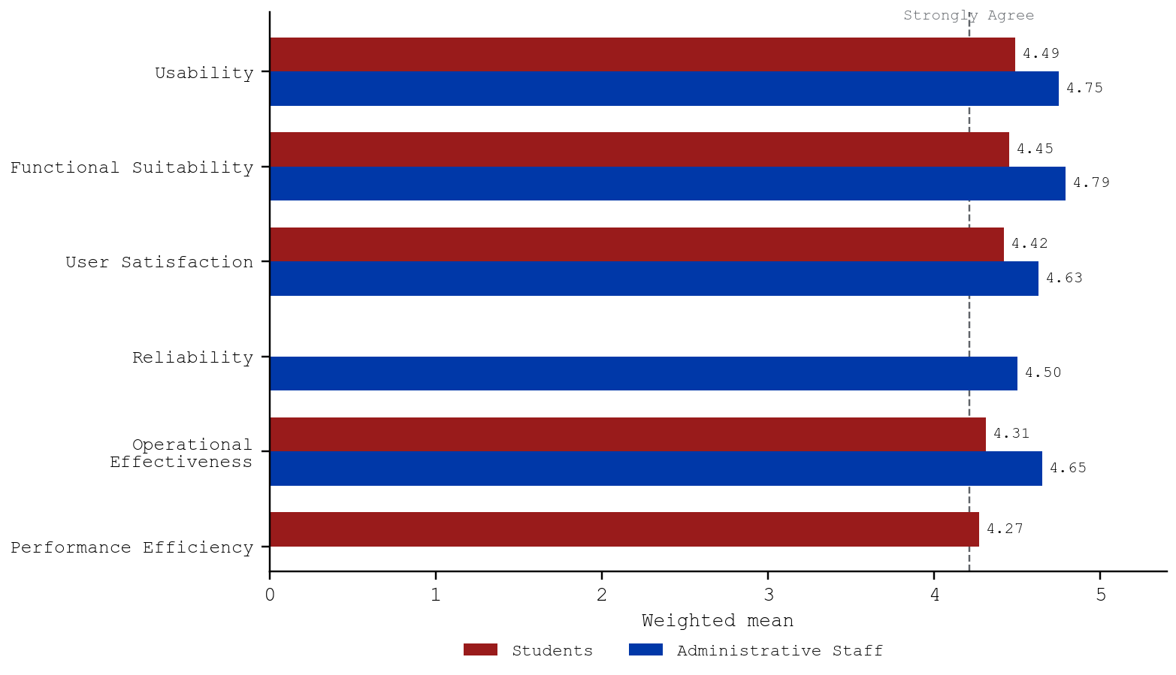
Figure 9. Evaluation of QueUA by Quality Dimension and Respondent Group

CHAPTER IV
CONCLUSIONS AND RECOMMENDATIONS

CONCLUSIONS
This study was conducted to develop QueUA: A Real-Time Digital Queuing Architecture for the University of Abra, in order to address the challenges of the manual queuing process at the Office of the University Registrar. Based on the findings presented in Chapter III, and guided by the three specific objectives of the study, the following conclusions are drawn.
On the problems of the manual queuing process, the students experience them to a moderate extent (composite weighted mean of 3.05), most strongly in the waiting area and student experience, where stress during peak hours was the highest-rated item, and in waiting time and service efficiency. Their most common complaints concern the visibility of the queue: keeping track of queue numbers (21%) and not knowing how many people are ahead (19%). The staff confirmed that students line up physically, are called verbally, and hand-carry payment receipts between the Cashier and the window, that transactions are recorded in logbooks, and that no one can tell exactly how many students are waiting. The manual process is therefore weak in three respects: the queue is invisible, its order depends on physical presence, and the payment step splits each paid request into two lines.
On the design and development of the system, QueUA was successfully built as a web-based application using Next.js, React, TypeScript, Tailwind CSS, and Supabase, following the IPO framework and the Agile model. It answers each problem identified under Problem 1 through online mobile booking with automated fee assessment and a digital e-Pass, cashier payment clearance that releases paid tickets to the window queue, a counter console with first-in, first-out dispatch and queue controls, an audio-visual lobby display with chime and spoken announcements, a QR-linked live queue tracker, and an administrative dashboard for monitoring, configuration, and reporting, all protected by role-based access control and row-level security. The students’ own suggestions, led by a screen showing the current and next numbers (25%), correspond directly to the features implemented.
On the evaluation of the system, QueUA obtained an overall weighted mean of 4.54, interpreted as Strongly Agree and described as Excellent. The administrative staff rated it 4.67 and the students 4.41. Every quality dimension was rated Excellent, with functional suitability and usability highest (4.62 each) and performance efficiency lowest (4.27). The lowest individual items concern the reduction of crowding and of administrative delays, which depend on factors beyond the queue itself.
Taken together, these findings show that the general objective of the study was achieved within its scope: QueUA translates a manual, hallway-bound queuing process into a centralized, real-time, and accountable digital one that both its students and its operators rate as excellent. The conclusions should be read with the study’s limitations in mind: the respondents came from five programs and a small staff office, IT specialists did not evaluate the system, the trial period was short, and actual waiting times were not measured before and after deployment.

RECOMMENDATIONS
Based on the conclusions drawn from this study, the following recommendations are offered.
a. For the Office of the University Registrar and the University Administration
It is recommended that the Office of the University Registrar adopt QueUA through a pilot implementation during a regular period before using it for enrollment, alongside the existing procedure. QR posters linking to the booking page should be placed at the campus entrance and outside the Registrar, and a television should be installed in the waiting area for the lobby display. All window, cashier, and administrative personnel should receive hands-on orientation, and a system administrator should be designated to manage accounts, windows, modules, and announcements, and to oversee regular backups of the database.
b. For System Enhancement and Future Development
Future developers are encouraged to deliver changes to the lobby display and tracker through Supabase Realtime instead of periodic refresh, which would improve the speed ratings given by the students. Other enhancements worth exploring include SMS or push notifications when a student is near the front of the line, installable progressive web application support and an offline or local-network fallback for internet outages, a priority lane for senior citizens, persons with disabilities, and pregnant students, online payment of assessed fees, integration with the student information system to prefill student details, and document-release tracking that notifies students when their requested credentials are ready.
c. For Future Researchers
Future researchers are encouraged to measure the actual effect of QueUA by comparing the average queue wait time and service handling time recorded by the system with times observed under the manual process during comparable periods. Part II-C of the System Evaluation Questionnaire should be administered to IT specialists to assess the technical quality of the architecture, including its security, compatibility, and maintainability. The evaluation should also be repeated with a larger and more varied group of students, including those from all colleges, alumni, and other clients of the Registrar, and may be supplemented with the System Usability Scale. The study may also be replicated in other offices with similar queues, such as the Cashier, the Accounting Office, and the Office of Student Affairs.
d. For Continuous Evaluation and Improvement
It is recommended that the Registrar review the reports of QueUA every semester to identify peak hours, slow services, and no-show rates and to adjust the assignment of windows and modules accordingly. The system should be re-evaluated after a full enrollment period to confirm that its reliability and performance ratings hold under maximum load, and periodic security reviews should ensure that its access controls continue to protect student information as the number of users grows.

REFERENCES
Agile Alliance. (2025). Manifesto for agile software development. https://www.agilealliance.org/agile101/the-agile-manifesto/
Braun, V., & Clarke, V. (2006). Using thematic analysis in psychology. Qualitative Research in Psychology, 3(2), 77–101. https://doi.org/10.1191/1478088706qp063oa
ContextQA. (2026). 7 phases of SDLC: Software development life cycle guide. https://contextqa.com/blog/the-7-phases-of-software-development-life-cycle/
Davis, F. D. (1989). Perceived usefulness, perceived ease of use, and user acceptance of information technology. MIS Quarterly, 13(3), 319–340. https://doi.org/10.2307/249008
IBM. (2026). What is the software development lifecycle (SDLC)? https://www.ibm.com/think/topics/sdlc
International Organization for Standardization. (2011). ISO/IEC 25010:2011 Systems and software engineering — Systems and software Quality Requirements and Evaluation (SQuaRE) — System and software quality models. https://www.iso.org/standard/35733.html
Likert, R. (1932). A technique for the measurement of attitudes. Archives of Psychology, 22(140), 1–55.
Little, J. D. C. (2011). Little’s law as viewed on its 50th anniversary. Operations Research, 59(3), 536–549. https://doi.org/10.1287/opre.1110.0940
Maister, D. H. (1985). The psychology of waiting lines. In J. A. Czepiel, M. R. Solomon, & C. F. Surprenant (Eds.), The service encounter: Managing employee/customer interaction in service businesses (pp. 113–123). Lexington Books.
Mozilla. (2026). Web Speech API. MDN Web Docs. https://developer.mozilla.org/en-US/docs/Web/API/Web_Speech_API
PostgreSQL Global Development Group. (2026). SELECT. In PostgreSQL documentation. https://www.postgresql.org/docs/current/sql-select.html
Republic of the Philippines. (2012). Republic Act No. 10173: Data Privacy Act of 2012. https://lawphil.net/statutes/repacts/ra2012/ra_10173_2012.html
Republic of the Philippines. (2018). Republic Act No. 11032: Ease of Doing Business and Efficient Government Service Delivery Act of 2018. https://lawphil.net/statutes/repacts/ra2018/ra_11032_2018.html
Republic of the Philippines. (2021). Republic Act No. 11574: An act converting the Abra State Institute of Sciences and Technology into a state university to be known as the University of Abra. Official Gazette of the Republic of the Philippines. https://www.officialgazette.gov.ph/2021/12/23/republic-act-no-11574/
Supabase. (2026a). Realtime. Supabase Docs. https://supabase.com/docs/guides/realtime
Supabase. (2026b). Row level security. Supabase Docs. https://supabase.com/docs/guides/database/postgres/row-level-security
United Nations. (2023). Sustainable development goals. https://sdgs.un.org/goals
Vercel. (2026). Next.js documentation. https://nextjs.org/docs
von Bertalanffy, L. (1968). General system theory: Foundations, development, applications. George Braziller.

APPENDIX A
STUDENT NEEDS ASSESSMENT QUESTIONNAIRE
Dear Respondent: This survey gathers information on your experience with the queuing process at the Office of the University Registrar. Your answers will be used only for this study and will be kept confidential.
Part I. Profile. Course and Year Level: ____________________
Part II. Please check the column that corresponds to your answer: 5 – Strongly Agree (SA), 4 – Agree (A), 3 – Neutral (N), 2 – Disagree (D), 1 – Strongly Disagree (SD).
A. Waiting Time and Service Efficiency
No. | Statement | SA  5 | A  4 | N  3 | D  2 | SD  1
A1 | The current manual queuing process is efficient.
A2 | Long waiting lines are frequently experienced.
A3 | The current queuing process causes unnecessary waiting or delays.
A4 | Delays occur because of slow manual recording or checking of student information.
A5 | The waiting time becomes longer during peak hours.

B. Queue Organization and Order Management
No. | Statement | SA  5 | A  4 | N  3 | D  2 | SD  1
B1 | There are instances of line-cutting or unfair queuing.
B2 | It is easy to know whose turn is next in the current queue.
B3 | The current queuing process follows a clear and organized order.
B4 | It is difficult to determine who should be served next.
B5 | Students who need priority assistance are properly accommodated.

C. Queue Information and Communication
No. | Statement | SA  5 | A  4 | N  3 | D  2 | SD  1
C1 | Communication between students and office staff is clear and organized.
C2 | I can easily determine how many people are ahead of me in the queue.
C3 | I receive sufficient information about the status of the queue.
C4 | I sometimes need to stay near the service counter to avoid missing my turn.
C5 | Students sometimes miss their turns because they do not hear or notice when they are called.

D. Record Management and Queue Monitoring
No. | Statement | SA  5 | A  4 | N  3 | D  2 | SD  1
D1 | Errors or duplication may occur when student information is recorded manually.
D2 | It is difficult to retrieve previous queue records when needed.
D3 | Office staff can easily monitor the number of students waiting to be served.
D4 | The current process makes it easy to track students who have already been served.
D5 | Manual recordkeeping makes it difficult to prepare accurate queue reports.

E. Waiting Area and Student Experience
No. | Statement | SA  5 | A  4 | N  3 | D  2 | SD  1
E1 | The current queuing process causes crowding in or near the office.
E2 | Managing or following the queue causes stress during peak hours.
E3 | The waiting area is sufficient to accommodate students waiting for service.

Part III. Open-Ended Questions
- What is the most common problem you experience in the current queuing process?
- What difficulties do you encounter during peak hours?
- What improvement would you suggest for the queuing process?

APPENDIX B
STAFF QUESTIONNAIRE
Dear Respondent: This questionnaire gathers information on the current queuing practices of the Office of the University Registrar. Your answers will be kept confidential.
Part I. Profile. Position: ______________ Office: ______________ Years in Service: ________
Part II. Current Queuing Practices. Please check all that apply.
Question | Options
P1. How do students line up for Registrar transactions? | □ Physical line along the hallway  □ Handwritten number stubs (during peak periods)
P2. How are students called to the window? | □ Verbal calling of name or number  □ Students approach the window on their own
P3. How are transactions recorded? | □ Logbook (handwritten)  □ Excel spreadsheet  □ Request slips filed in folders
P4. Average number of students served per day (regular days) | □ Fewer than 50  □ 50-100  □ 101-150  □ More than 150
P5. Average number of students served per day (peak periods) | □ 100-150  □ 151-200  □ More than 200
P6. Average time spent serving one transaction | □ Less than 5 minutes  □ 5-10 minutes  □ 11-15 minutes  □ More than 15 minutes
P7. Peak periods of Registrar transactions | □ Enrollment period  □ Start and end of semester  □ Graduation and clearance period
P8. How are fee-based requests coordinated with the Cashier? | □ Student hand-carries the order of payment and returns with the official receipt  □ Window officer verifies the official receipt manually
P9. Common problems encountered in the current queuing process | □ Crowding in or near the office  □ Students repeatedly asking about their turn  □ Students returning from the Cashier and re-entering the line  □ Difficulty preparing daily or monthly reports  □ Students missing their turn when called  □ Errors or duplicate entries in manual records
P10. Time needed to prepare a summary report of transactions | □ Within the day  □ 1-2 days  □ More than 2 days
P11. Can you tell how many students are waiting at any given time? | □ No  □ Only a rough estimate  □ Yes, exactly

APPENDIX C
SYSTEM EVALUATION QUESTIONNAIRE
QueUA: A Real-Time Digital Queuing Architecture for the University of Abra
SYSTEM EVALUATION QUESTIONNAIRE
Instructions: Please answer the questions honestly based on your actual experience with the QueUA digital queuing architecture. The information gathered will be used to evaluate the operational effectiveness, usability, efficiency, reliability, and user satisfaction of the system.
Rating Scale: 1 = Strongly Disagree 2 = Disagree 3 = Neutral 4 = Agree 5 = Strongly Agree
PART I. RESPONDENT PROFILE
Name (Optional): ______________________________________
Office/College/Program: _______________________________
Primary Office Interaction: ___ Registrar Office ___ Cashier Office
- If you are a University Student → proceed to Part II-A
- If you are an Administrative Staff → proceed to Part II-B
- If you are an IT Specialist → proceed to Part II-C
PART II-A. UA STUDENT EVALUATION
Please rate each statement using the following scale: 1 = Strongly Disagree, 2 = Disagree, 3 = Neutral, 4 = Agree, 5 = Strongly Agree.
No. | Statement | Rating (1–5)
1 | I can easily obtain a queue number using the QueUA system.
2 | The queue number issued to me clearly identifies my position in the queue.
3 | I can easily view my current queue status and know when my turn is approaching.
4 | The real-time queue updates help me avoid unnecessary waiting inside or near the office.
5 | The system helps reduce physical crowding in the Registrar or Cashier waiting area.
6 | The queue sequence appears fair and follows the order in which students receive queue numbers.
7 | The information displayed by QueUA is clear and easy for me to understand.
8 | I can use the system without needing extensive assistance from staff.
9 | QueUA responds quickly when I obtain a queue number or check my queue status.
10 | I am satisfied with my overall experience using the QueUA system.

PART II-B. ADMINISTRATIVE STAFF EVALUATION
Please rate each statement using the following scale: 1 = Strongly Disagree, 2 = Disagree, 3 = Neutral, 4 = Agree, 5 = Strongly Agree.
No. | Statement | Rating (1–5)
1 | QueUA makes it easier for me to manage students waiting for service.
2 | The system accurately maintains the sequence of queue numbers.
3 | The CALL NEXT, RECALL, HOLD, and TRANSFER functions support my daily queue management tasks.
4 | The system reduces the need for manual listing, calling, and monitoring of students.
5 | The real-time queue information helps me reduce administrative delays and blank time.
6 | QueUA helps reduce physical congestion around the service counter.
7 | The staff dashboard provides the information I need to monitor the current queue.
8 | The system is easy for me to learn and operate during regular office transactions.
9 | QueUA remains responsive and stable when many students are waiting for service.
10 | QueUA helps reduce the workload and stress associated with manual queue management.
11 | The system prevents duplicate or inconsistent queue entries during transactions.
12 | Overall, I am satisfied with QueUA as a tool for managing office queues.

PART II-C. IT SPECIALIST EVALUATION
Please rate each statement using the following scale: 1 = Strongly Disagree, 2 = Disagree, 3 = Neutral, 4 = Agree, 5 = Strongly Agree.
No. | Statement | Rating (1–5)
1 | The QueUA system provides the functions required for digital queue management.
2 | The system consistently maintains the correct FIFO (First-In, First-Out) queue sequence.
3 | The system provides timely and accurate updates of queue status.
4 | The system remains stable and responsive during periods of high user activity.
5 | The system uses available computing and network resources appropriately when multiple users are connected.
6 | The system can operate alongside existing institutional systems without causing significant operational problems.
7 | The system design supports maintainability and future modification or enhancement.
8 | The system interface is organized, consistent, and understandable from a technical and usability perspective.
9 | The system prevents duplicate queue entries and maintains data consistency.
10 | The system provides adequate reliability for actual Registrar and Cashier operations.
11 | The system demonstrates appropriate security and access control for its intended user roles.
12 | The QueUA architecture is suitable for continued institutional use and further development.

PART III. COMMENTS AND SUGGESTIONS
Please provide any comments or suggestions for improving the QueUA system:
______________________________________________________________
______________________________________________________________
______________________________________________________________

