Development documentation of Py++ IDE

Used development environment
- Python V 2.5 (since element tree is used)
- wxPython 2.8.1.1 and Boa V 0.5.2.
- The first Version (at the time of Py++ 0.8.5) was developped and tested under Windows XP
- Eclipse 3.2.1 and PyDev 1.3.2. Of course not needed but metioned, because remarkable :-)

Some words on Boa
Boa is used as GUI builder. The modules constructed by BOA are located in ../views/. They are slightly modified by hand. Take care that you only change methods, that are not marked to be generated by BOA.
Boa is (a bit) related on a wxPython version. This is the main reason for the version requirement. I don't know how the development of boa and wxPython go on. So it must be checked out weather the code of the views can be opened (and saved) with BOA Designer.

How to get into BOA / Py++ IDE GUI Design?
Read the BOA tutorial (Building your First Application) carefully to understand the BOA-Ide. Most of the needed know-how is covered there. Also „Specific components notes“ is worth of reading. WxWidgets knowhow is of course also needed.

Some words on sizers
Sizers are used to control the layout of the GUI. They manage the size of the controled widgets. You need a bit time to get into the principle.
In the IDE I used only (horizontal and vertical) BoxSizers to manage the layout. You can see all sizers in a own list, if you enter BOA Designer. If you double click a sizer, a collection editor is opened. If you mark a element in the collection editor, and change to „Constr“ in the BOA Inspector you can see and edit the layout related settigs of that control/widget.

Layout on other platforms
Font for label and static texts vary in size from plattform to plattform.

Splitter window issue
When you open the main frame of the IDE in BOA Designer, the splitter windows are on the upper left corner. I've not figured out weather this is a bug / unsupported issue or a misusage of mine. Because the spliter window position is a parameter of the Py++ IDE the position of the splitter window is saved in the project file, and resored for the user of the IDE.
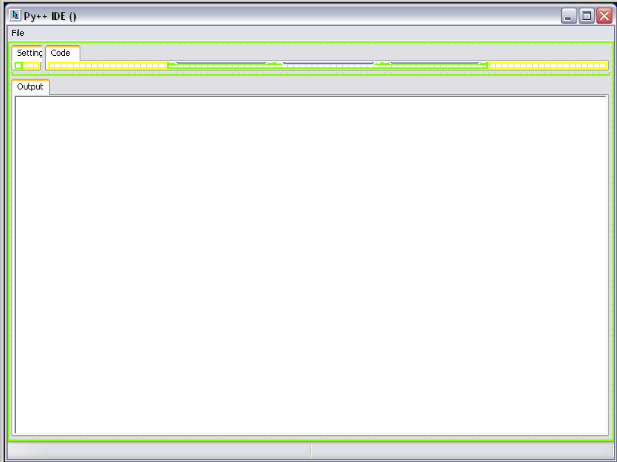Py++ IDE in BOA Designer

Software design of the IDE
The following diagram shows the classes of the IDE. The directory layout is related the the MVC Pattern (Where MVC is more a approach than a pattern). MVC stands for seperation of the view, model and the controller code.
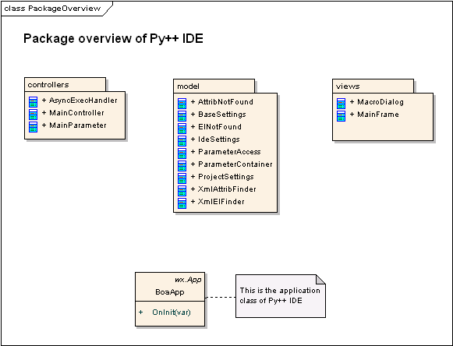
The diagramm was made with a source code import in Enterprise Architect. Yo can get a free EA viewer at: http://www.sparxsystems.com.au/products/ea_downloads.html to view the UML-Model. (It contains only the reverse engineered source code import of the ide)

Settings of Py++ IDE
Py++ IDE has two setting files. One is related to the IDE. The other is related to the project. Both files use XML. The SW-Design used the expression of settings as a collection of parameters.
For both files, template files are part of the model component. The IdeTemplate is copied to the $HOME directory at first startup. The project template is used when a new project is created (and at startup).

Tests
Only some regression tests are included.

