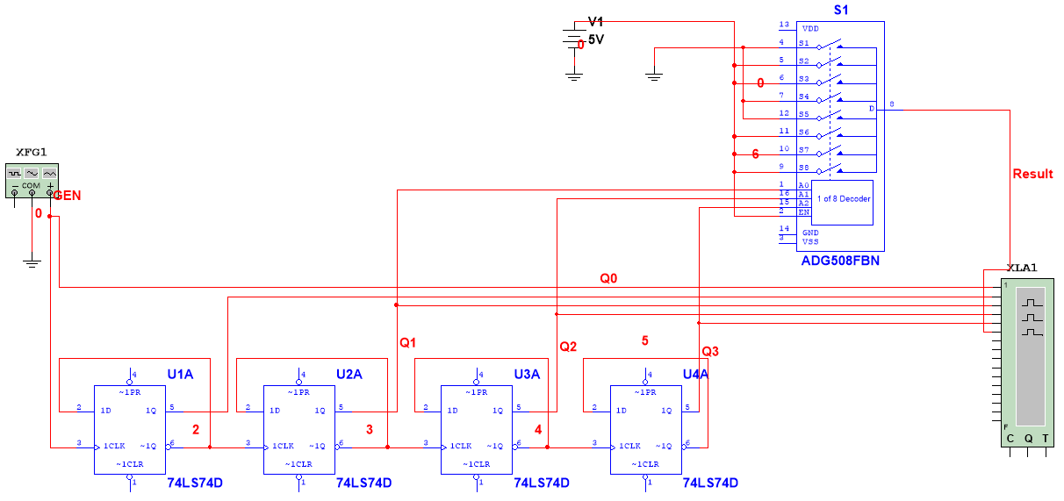

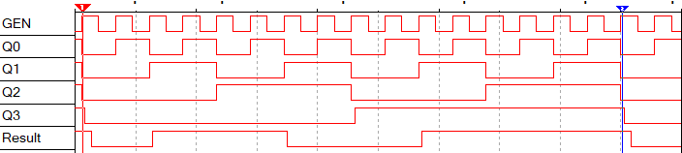

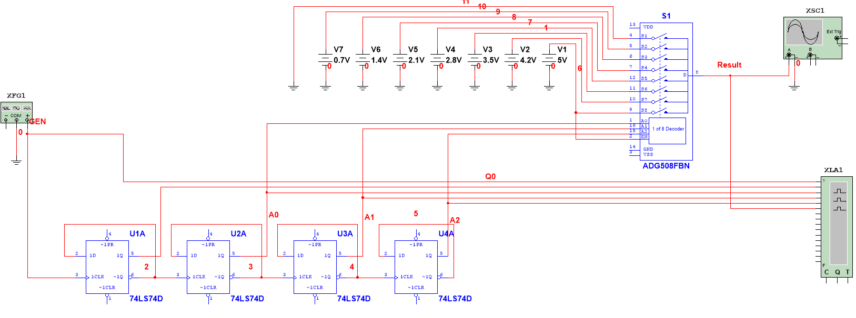

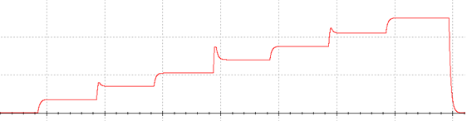

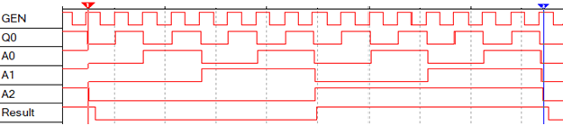

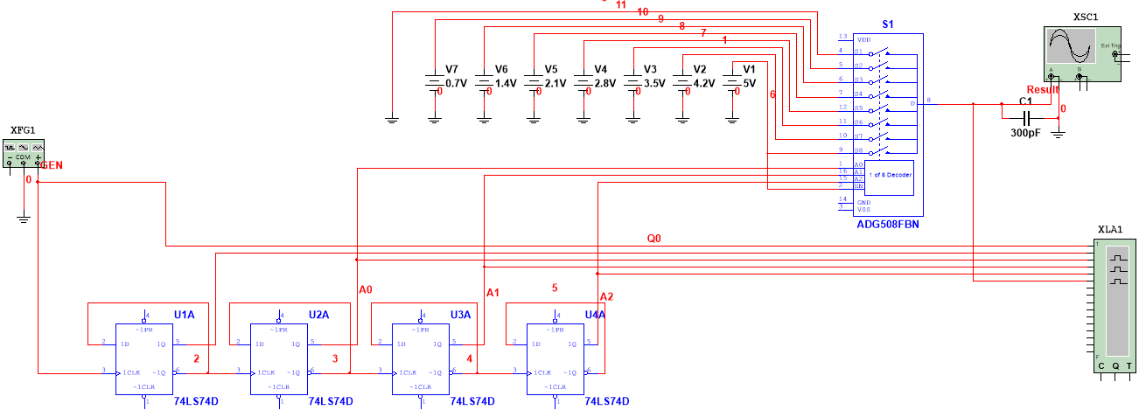

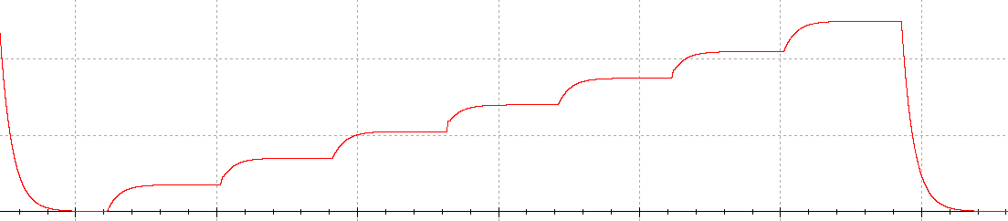



|  |  |  |  |  |  |  |
| --- | --- | --- | --- | --- | --- | --- |
| № набора | Х4 | Х3 | Х2 | Х1 | f | Примечание |
| 0 | 0 | 0 | 0 | 0 | 1 | Не Х |
| 1 | 0 | 0 | 0 | 1 | 0 |
| 2 | 0 | 0 | 1 | 0 | 0 | Х |
| 3 | 0 | 0 | 1 | 1 | 1 |
| 4 | 0 | 1 | 0 | 0 | 0 | 0 |
| 5 | 0 | 1 | 0 | 1 | 0 |
| 6 | 0 | 1 | 1 | 0 | 1 | 1 |
| 7 | 0 | 1 | 1 | 1 | 1 |
| 8 | 1 | 0 | 0 | 0 | 0 | 0 |
| 9 | 1 | 0 | 0 | 1 | 0 |
| 10 | 1 | 0 | 1 | 0 | 1 | 1 |
| 11 | 1 | 0 | 1 | 1 | 1 |
| 12 | 1 | 1 | 0 | 0 | 1 | 1 |
| 13 | 1 | 1 | 0 | 1 | 1 |
| 14 | 1 | 1 | 1 | 0 | 0 | Х |
| 15 | 1 | 1 | 1 | 1 | 1 |

