Semantic Drift, Not Rank Collapse:
Why Stable Coordinates Matter for Learning in Joint-Embedding Spaces
Andrey Lazarev
Independent Researcher
April 2026

Abstract
Representational collapse in Joint-Embedding Predictive Architectures (JEPAs) is conventionally attributed to rank degeneration of the latent space and addressed through geometric regularization (VICReg, SIGReg). We show that this explanation is incomplete. In a controlled Push-T world-model setting with gym-pusht physics, we demonstrate that a free encoder regularized by SIGReg maintains full rank (effective rank 2.99/3) and high isotropy (0.86) — yet produces predictions more than an order of magnitude worse than a prescribed encoder with lower rank and isotropy.
We identify the actual failure mode: temporal non-identifiability of the representation. In the first epochs of training, the free encoder restructures its coordinate system so rapidly that a linear decoder trained at epoch t produces catastrophically wrong outputs at epoch t+1 (R² = −62, averaged across seeds). Procrustes alignment confirms that 80% of this change is structural, not rotational. A causal freeze test shows that stabilizing the encoder at epoch 1 improves prediction by 20%.
A random fixed encoder — a frozen random orthogonal projection with no semantic content — outperforms the free encoder by 17×, confirming that coordinate stability alone provides a substantial advantage. A completed 2×2 factorial design reveals that the two factors are not independent: an encoder initialized on the exact ground-truth coordinates but allowed to drift performs no better than free (and sometimes worse). Stability is a prerequisite; alignment contributes only when stability is maintained.
Three seeds, 30 epochs, 200 episodes of real physics data per seed. Code and data: https://github.com/revenue7-eng/prescribed-axes

1. Introduction
JEPA architectures learn by predicting masked representations from visible context, without pixel reconstruction (LeCun, 2022; Assran et al., 2023). The central vulnerability: a free encoder can minimize the prediction loss by mapping all inputs to a constant, collapsing the representation.
Two families of solutions dominate the current discussion. Regularization-based approaches (VICReg, Bardes et al., 2022; SIGReg, Balestriero & LeCun, 2025) penalize geometric degeneration — low variance, high covariance, non-Gaussian marginals. Generative approaches (PAN, Ozkara et al., 2025) supplement prediction with pixel reconstruction. Both assume the problem is how the model trains.
Recent work on prescribed axes (Lazarev, 2026) proposed a different framing: the problem is where the model trains. If the axes of the latent space are fixed before training — from physical coordinates, semantic features, or cluster centroids — collapse is structurally impossible, and regularization is unnecessary. Four experiments across modalities showed 5–38× improvements over free baselines.
However, this framing raises a question: if prescribed axes prevent collapse, what exactly goes wrong in free space? We assumed rank collapse. The data shows otherwise.
Contributions:
1. Geometric metrics (rank, isotropy) do not explain the performance gap: a free encoder with rank 2.99 and isotropy 0.86 loses to a prescribed encoder with rank 2.91 and isotropy 0.66 by >30×.
2. We identify a phase of temporal non-identifiability: during epochs 0–2, linear decoders become invalid within one training step (R² transfer < −16 across all seeds).
3. Interventional evidence: freezing the encoder at epoch 1 improves prediction by 20%.
4. We decompose the advantage into two factors: coordinate stability and semantic alignment.
5. We complete a 2×2 factorial design with an aligned-but-drifting encoder control. A frozen random projection (no semantic content) outperforms the free encoder by 17×. An encoder initialized on ground-truth coordinates but allowed to drift performs no better than free. Stability is the prerequisite; alignment contributes only when stability is maintained.

2. Background and Setup

2.1 Problem Setting
We study a minimal LeWM world model (Maes et al., 2026) on the Push-T environment: a planar pushing task where a robot arm pushes a T-shaped block. The state is 5-dimensional: agent position (x_{a}, y_{a}) and block pose (x_{b}, y_{b}, θ_{b}). The world model predicts the next latent state from a context window of H=3 previous states and actions.
Prescribed encoder h(s) = normalize(s[2:5]): extracts and normalizes the block coordinates (x_{b}, y_{b}, θ_{b}). No learnable parameters.
Free encoder f_{θ}(s): an MLP (5→64→64→3) that learns a 3D embedding end-to-end with the predictor. Regularized by SIGReg (λ=0.09).
Both encoders produce 3D representations. The predictor architecture, loss function, optimizer, and training schedule are identical. The only difference is the encoder.

2.2 Protocol
Three seeds (42, 123, 777). 200 episodes collected via gym-pusht with real pymunk physics. 30 training epochs. SIGReg regularization coefficient λ=0.09. All results averaged across seeds with individual seed values reported.
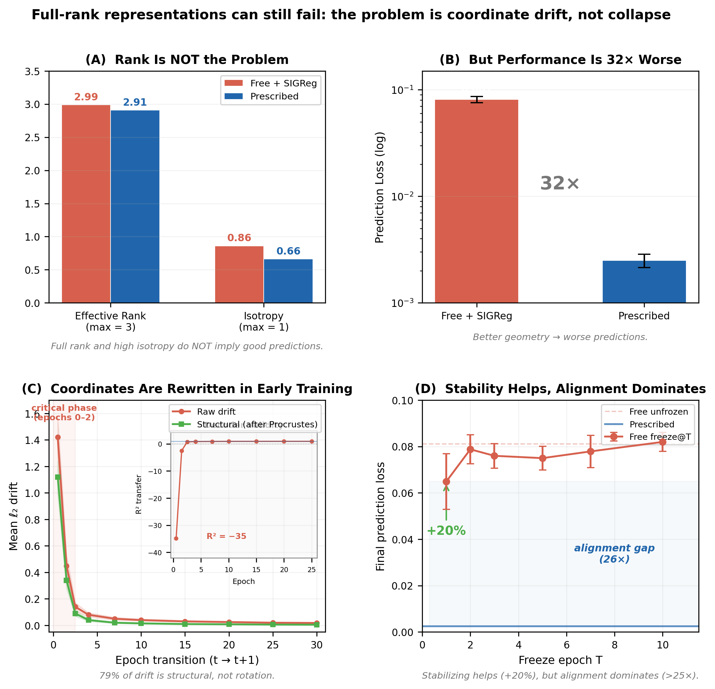
Figure 1. (A) Free encoder maintains full rank and high isotropy. (B) Despite this, prediction error is 32× worse than prescribed. (C) Early training causes large structural drift; inset shows R² transfer < −35 after one epoch. (D) Freezing the encoder improves performance (+20%) but remains far from prescribed (>25× gap).

3. Why Geometry Is Not Enough
Observation 1: Full rank, poor performance. The free encoder with SIGReg achieves effective rank 2.99/3 and isotropy 0.83–0.90 across seeds. The prescribed encoder has lower rank (2.91–2.99) and lower isotropy (0.53–0.79). Yet prescribed outperforms free by more than an order of magnitude in prediction loss (0.0025 vs 0.082).
Observation 2: Anisotropy reflects task structure. The prescribed eigenvalue spectrum [0.098, 0.078, 0.064] is anisotropic because the physical quantities (x, y, θ) have different ranges and dynamics. SIGReg forces the free encoder toward isotropy [0.98, 0.93, 0.85] — a uniform geometry that does not match the task.
These observations rule out rank collapse as the explanation. The free encoder maintains full rank and high isotropy — and still loses by an order of magnitude.

4. Temporal Drift in Representation Space

4.1 Large-Scale Structural Drift
In the first epoch of training, the free encoder restructures its entire coordinate system. Raw drift on epoch 0→1 ranges from 1.28 to 1.57 across seeds. Prescribed drift: exactly 0.000000 on every epoch.
After Procrustes alignment (removing optimal rotation, reflection, and uniform scaling), 79% of the epoch 0→1 drift remains. Procrustes does not remove nonlinear deformations, so this 79% is an upper bound on structural change. By epoch 3, raw drift drops below 0.14. The large-scale drift phase is confined to epochs 0–2.

4.2 Decoder Invalidation
R² transfer values on epoch 0→1: Seed 42: −16.9; Seed 123: −62.2; Seed 777: −25.4. All deeply negative. A linear decoder trained on the current coordinate system produces outputs worse than a constant predictor after a single epoch. By epoch 2→3, R² transfer recovers to 0.73–0.76 — but the predictor has already spent its critical early phase on a moving representation.

4.3 Implication
The predictor and the encoder train simultaneously. When the coordinate system changes faster than the predictor can adapt — epochs 0–2 — the predictor’s gradients become incoherent. Prescribed axes eliminate this phase entirely. The coordinate system is stable from epoch 0. Every gradient step is cumulative.

5. Does Drift Matter? Interventional Evidence

5.1 Freeze Test
Condition | Seed 42 | Seed 123 | Seed 777 | Mean | vs unfrozen
Prescribed | 0.0022 | 0.0030 | 0.0023 | 0.0025 | —
Free unfrozen | 0.0864 | 0.0832 | 0.0738 | 0.0811 | baseline
Free freeze@1 | 0.0794 | 0.0501 | 0.0651 | 0.0649 | +20.1%
Free freeze@5 | 0.0796 | 0.0774 | 0.0679 | 0.0750 | +7.6%
Free freeze@10 | 0.0822 | 0.0869 | 0.0770 | 0.0820 | −1.1%
Table 1: Freeze test results. Freezing at epoch 1 improves by 20%; epoch 10 is neutral.
Freezing the encoder at epoch 1 — before the large-scale drift — improves prediction by 20%. This provides interventional evidence that drift harms learning. But freeze@1 (0.065) remains >25× worse than prescribed (0.0025) — stability helps, but alignment dominates.

5.4 Random Fixed Encoder Control
Random fixed encoder: random orthogonal projection from normalized 5D state to 3D, frozen from initialization. No semantic content. Rotated prescribed: prescribed coordinates rotated by random orthogonal matrix. Stable and aligned, but not interpretable.
Condition | Seed 42 | Seed 123 | Seed 777 | Mean | vs free
Prescribed | 0.000048 | 0.000043 | 0.000016 | 0.000036 | 233×
Rotated prescribed | 0.000050 | 0.000043 | 0.000023 | 0.000039 | 212×
Random fixed | 0.000522 | 0.000446 | 0.000460 | 0.000476 | 17.4×
Free (drifting) | 0.008136 | 0.008988 | 0.007722 | 0.008282 | baseline
Table 2: Random fixed encoder control. Stability alone gives 17×; alignment adds 13×; rotated ≈ prescribed.
Result 1: Stability alone provides a 17× advantage. The random fixed encoder outperforms the free encoder by 17.4× across all three seeds. A random but stable coordinate system is vastly better than a learned but drifting one.
Result 2: Alignment provides an additional 13× advantage. The gap between random fixed (0.000476) and prescribed (0.000036) is 13.4×.
Result 3: Interpretability is irrelevant. Rotated prescribed performs identically to prescribed (ratio 1.09×). The predictor needs stable axes in the right subspace, not interpretable ones.
Approximate multiplicative decomposition. The total gap (233×) decomposes approximately into stability (17.4×) × alignment (13.4×) = 233×. Section 5.5 fills the missing factorial cell and reveals that these factors are not independent.

5.5 The Missing Cell: Aligned but Drifting
Aligned-drifting (linear): a single linear layer (5→3), initialized exactly as the prescribed mapping, then trained jointly with the predictor. Aligned-drifting (MLP): same architecture as free (5→64→64→3), pre-trained for 200 steps to reproduce prescribed outputs, then trained normally.
Condition | Seed 42 | Seed 123 | Seed 777 | Mean | vs free
Prescribed | 0.000049 | 0.000043 | 0.000026 | 0.000039 | 212×
Random fixed | 0.000522 | 0.000446 | 0.000452 | 0.000473 | 17.5×
Aligned-drifting linear | 0.011111 | 0.012090 | 0.015347 | 0.012849 | 0.64×
Aligned-drifting MLP | 0.008392 | 0.008429 | 0.008319 | 0.008380 | 0.99×
Free (drifting) | 0.008136 | 0.008988 | 0.007722 | 0.008282 | baseline
Table 3: Aligned-but-drifting control. Perfect initialization is erased by drift.
Alignment without stability is worthless. Both aligned-but-drifting encoders perform no better than free — the linear variant is actually 1.55× worse. An encoder initialized on exact ground-truth coordinates loses its entire advantage once allowed to train.
The factors are not independent. Stability effect among aligned encoders: 330×. Among unaligned: 17.5×. These differ by 19×. Stability matters far more when alignment is present, because alignment is fragile — it exists only as long as the coordinate system that carries it remains fixed.
Revised interpretation. Stability is not one of two independent factors — it is a prerequisite. Alignment contributes 12× on top of stability (random fixed → prescribed), but contributes nothing without it (free ≈ aligned-drifting). The correct framing: stability is necessary; alignment is sufficient only given stability.

6. Discussion

6.1 Reframing the Collapse Problem
In our setting, rank collapse is not the dominant failure mode. Full rank is not sufficient. The more productive question: how to maintain an identifiable, stable coordinate system. The JEPA prediction objective does not enforce temporal consistency — multiple coordinate systems yield equivalent loss at any single step. The optimizer traverses this equivalence class; the predictor cannot track the movement. Prescribed axes eliminate the equivalence class entirely.

6.2 Why SIGReg Can Hurt
SIGReg forces isotropy; the task is anisotropic. SIGReg on free encoder: 4.2× worse (free without SIGReg: 0.037, free with SIGReg: 0.156). It prevents rank collapse but interferes with the emergence of a stable coordinate system.

6.3 Connection to EMA and Stop-Gradient
EMA and stop-gradient are partial solutions — they slow drift without fixing it. Prescribed axes are the limiting case: the representation does not move at all.

6.4 Connection to GRASP
Our drift analysis provides evidence consistent with adversarial state gradients (Psenka et al., 2026). GRASP detaches state gradients during planning; prescribed axes remove the cause entirely. The approaches are complementary.

6.5 Limitations
All experiments use Push-T (3D latent). The random fixed encoder projects from 5D (different subspace than prescribed). No EMA or encoder LR sweep baseline; freeze@1 could reflect LR reduction rather than stability. CKA/SVCCA would complement Procrustes.
The completed 2×2 factorial (Section 5.5) shows stability and alignment interact strongly — they are not independent. The stability effect is 330× among aligned encoders but only 17.5× among unaligned ones. This hierarchical structure is established in this setting but may differ in higher dimensions where drift dynamics could be qualitatively different.

7. Conclusion
In this setting, the dominant failure mode is not rank collapse but loss of a temporally consistent coordinate parameterization. The completed factorial design reveals a hierarchical relationship: stability is the prerequisite, not merely a contributing factor. An encoder initialized on perfect coordinates but allowed to drift loses its entire advantage. A random but stable projection outperforms the free encoder by 17×. Alignment contributes an additional 12× — but only when stability is maintained.
Rotated prescribed ≈ prescribed (1.09×): interpretability is irrelevant — fixedness and subspace selection are what matter. Whether this generalizes beyond low-dimensional world models is open. But the result establishes a concrete alternative to rank-collapse: the goal may be to establish a coordinate system stable enough for other modules to build on, and aligned enough with the task to make building worthwhile.

8. Reproducibility
Three seeds (42, 123, 777), 200 episodes/seed, 30 epochs, SIGReg λ=0.09. All analysis code, data collection scripts, and results are available at https://github.com/revenue7-eng/prescribed-axes-drift.

References
Assran, M., et al. (2023). Self-Supervised Learning from Images with a Joint-Embedding Predictive Architecture. CVPR 2023.
Balestriero, R., & LeCun, Y. (2025). LeJEPA: Provable and Scalable Self-Supervised Learning Without the Heuristics. arXiv:2511.08544.
Bardes, A., Ponce, J., & LeCun, Y. (2022). VICReg: Variance-Invariance-Covariance Regularization for Self-Supervised Learning. ICLR 2022.
Lazarev, A. (2026). The Space Matters More Than the Loss: JEPA Collapse as a Problem of Structure, Not Optimization.
LeCun, Y. (2022). A Path Towards Autonomous Machine Intelligence. Technical Report, Meta AI.
Maes, L., Le Lidec, Q., Scieur, D., LeCun, Y., & Balestriero, R. (2026). LeWorldModel: Stable End-to-End JEPA from Pixels. arXiv:2603.19312.
Ozkara, B., et al. (2025). PAN: A World Model for General, Interactable, and Long-Horizon World Simulation. arXiv:2511.09057.
Psenka, M., Rabbat, M., Krishnapriyan, A., LeCun, Y., & Bar, A. (2026). GRASP: Parallel Stochastic Gradient-Based Planning for World Models. arXiv:2602.00475.

