Camera power connector:

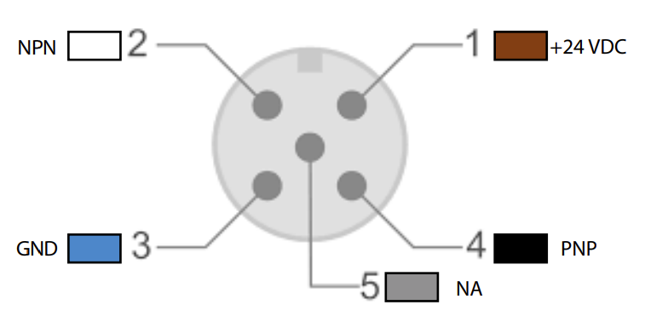

1 +24VDC

2 Not connected

3 GND

4 Not connected

5 Not connected

Camera flash connector:



1 +24VDC

2 GND

3 GND

4 Trigger 3.3V tolerant!

5 Not connected

Camera uses Lantronix Xport as ethernet interface.

Admin panel is at http://[camera ip]:8080 (user/password empty)

Settings for reference/recovery.

