

phone-receiver (2).pngclose-envelope (2).png吕昭庭adress3.pngclose-envelope.pngicon(1).png 出生年月：2003.03

姓 名 ： 吕昭庭

报考院校： 华南理工大学

毕业院校： 齐鲁工业大学

13803439355（微信同号）

lzting0717@163.com

**简 历**

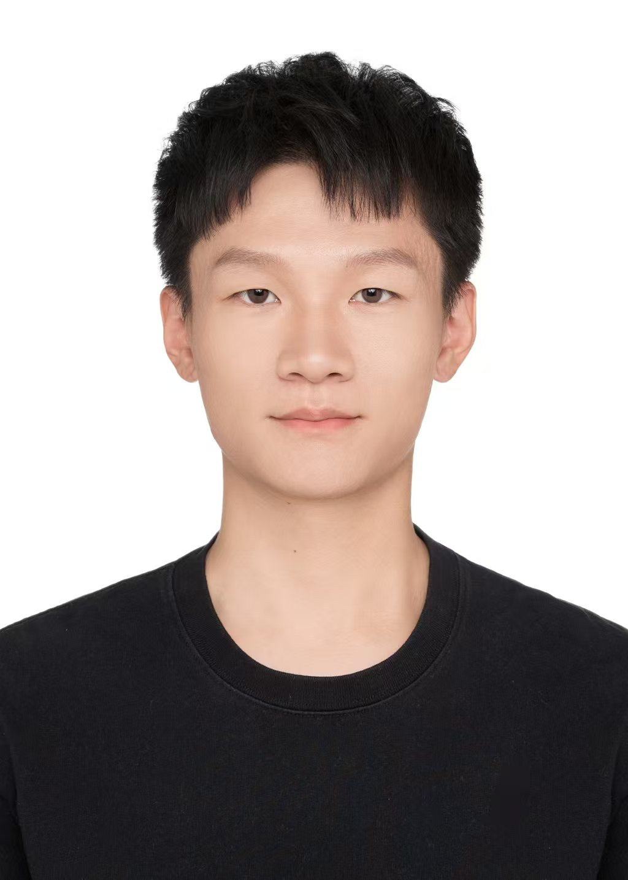

presentation(2).pngman-with-tie.png

**报考院校：华南理工大学 报考专业：计算机科学与技术（081200）**

|  |  |  |  |  |  |
| --- | --- | --- | --- | --- | --- |
| **初试成绩** | **政治101** | **英语（一）201** | **数学（一）301** | **计算机学科基础（408）** | **总分** |
| 69 | 60 | 84 | 99 | 312 |



**考 研 成 绩**

**荣 誉 获 奖**



**专 业 技 能**



**1）全国大学生数学竞赛** 山东赛区（2024.11）

二等奖

在 5000+ 名参赛者中脱颖而出，获二等奖。

每周练习 20+ 小时，深入研究微积分与线性代数。

**2）院级奖学金** 齐鲁工业大学（2021-2022）

二等奖

授予学业成绩前 15% 学生

团队编程项目中负责核心功能开发与版本管理，答辩表现优异，获 A 类成绩（90+） 。

**3）C1 驾 照**

* 掌握基本阅读文献软件的使用（Zotero, Endote, Noteexpress等）

**本科院校：齐鲁工业大学（山东省科学院）** 济南, 山东

计算机科学与技术，学士 2021.09 – 2025.06

GPA：3.4/5.0 英语六级CET6：516

主要课程：数据结构（88）、数值分析（93）、计算机组成原理（89）、高等数学（91）、线性代数（97）、概率论与数理统计（91）、数字图像处理、机器学习与模式识别

家庭住址：山西省太原市太原理工大学柏林校区7号楼

**基 本 资 料**

lzting0717@163.com

13803439355

university.pngbusinessman-clients-portfolio.png

A sustainability-oriented approach for performance assessment of existing buildings and a case study

SCI已收录，HELIYON（IF: 3.4） DOI：10.1016/j.heliyon.2024.e32151 第三作者

* 利用 PCA 对 47 个指标聚类，验证 7 个二级指标分类合理性。
* 识别关键指标并优化指标体系，减少 17% 的冗余数据。

**言信软件股份有限公司** 济南，山东

Java 后端开发实习 2023.08 – 2023.10

* 参与支付模块的业务逻辑与数据库设计，确保与前端和测试团队的无缝集成。
* 基于 OAuth 2.0 框架，使用短生命周期 JWT 令牌实现可靠会话管理，使用 TLS 对 HTTP 请求和响应进行加密。
* 参与代码评审并提出优化建议，在后端加入 HttpOnly Secure Cookie，与前端开发人员配合避免 XSS 前端安全漏洞。
* 掌握 JWT、Kerberos 鉴权机制，了解典型加密算法原理 (DES, AES, RSA, MD5 等).
* 掌握常见的爬虫技巧，包括 User-Agent 伪装、IP 代理池管理、利用 Tesseract 进行验证码识别及请求限流控制等。

**项 目 经 历**



**1）基于 Spring Boot 的订餐管理系统**

2023

* 采用 Spring Boot 构建系统，遵循 MVC 设计，提高开发效率和可维护性；
* 集成 Spring Security 和 Kerberos，配置 KDC 和 TGS，实现企业级 SSO 认证。

**2）基于 Django 框架的旅游推荐系统**

2024

* 使用原生Asyncio + Aiohttp 并发爬虫，数据采集速度较Scrapy提升20%；
* 利用已有Socks5隧道代理池定制IP轮换、动态请求间隔的反封锁策略，有效规避反爬限制；
* 使用Django + PyCharts 实现数据可视化，增强交互体验。

Spring Boot、MyBatis-Plus、Spring Security

爬虫、Django、PyCharts

**实 习 经 历**



**参 与 科 研**

**工 作 经 历**

**自 荐 信**



Although I have always been passionate about digital commerce, one particular online shopping experience reshaped my perspective. While browsing a well-known platform, I started receiving unsolicited and highly targeted ads for products I had just viewed. Though such tactics are common, the intrusion revealed vulnerabilities in digital transactions and made me question the widely held belief—advocated by Li Yanhong, CEO of a major Chinese internet company—that users willingly trade privacy for convenience. I strongly disagree. That experience sparked my interest in protecting user privacy and ultimately motivated me to transfer into the Computer Science and Technology major.

I am now pursuing a Bachelor’s degree in Computer Science and Technology at Qilu University of Technology, home to the National Supercomputing Jinan Center and the Shenwei Blue Light system. I was one of only five students selected from a pool of 300 in a competitive internal transfer process. Since the transfer occurred just before final exams, I focused on coursework most relevant to my new major, which may not be fully reflected in my GPA. Nonetheless, I have maintained strong academic performance, earning a Second-Class Scholarship and a Second Prize in the China Undergraduate Mathematical Contest.

One of my most impactful projects involved building an online food ordering system with a Kerberos-based Single Sign-On (SSO) mechanism. I carefully configured the Key Distribution Center (KDC) to verify pre-authentication requests and issue Ticket Granting Tickets (TGTs) with accurate timestamps. I also optimized ticket lifetimes and renewal policies to balance security with usability. This hands-on experience deepened my understanding of symmetric key cryptography and distributed authentication, equipping me to address vulnerabilities such as replay attacks.

Alongside this, I’ve developed a strong foundation in machine learning and data analysis through coursework and self-study. I’ve explored classical algorithms, model evaluation techniques, and data-driven thinking, expanding my view of what AI can achieve—from personalization to automation, and from intelligent decision-making to ethical challenges.

In the short term, I hope to deepen my understanding of AI, especially in building secure and ethical systems. In the long term, I aspire to contribute to trustworthy, human-centered technologies that prioritize fairness, transparency, and privacy. The Master’s program at the School of Artificial Intelligence at Taiyuan University of Technology perfectly aligns with these goals. Its interdisciplinary focus on machine learning, computer vision, natural language processing, and AI security offers the ideal environment for research and growth.

My academic path, project experience, and personal convictions have led me here. I am determined to advance AI not just for innovation’s sake, but to help create a future where intelligent systems are ethical, reliable, and beneficial to all.

最后作为抗日烈士吕汝爽（2015民政部授予第二批600名著名抗日英烈和英雄群体名录之一）的直系亲属，诚盼尊敬的导师给我一个追随您、继续深入学习的机会！！

此致

敬礼！

吕昭庭

2025年3月

吕昭庭

2024年3月31日



**致敬，谢谢 ！**