Designing for the Reviewer: A Human-in-the-Loop AI Pipeline for News-Driven Authority File Maintenance at the National Library and Archives Board Singapore
Ashwin Nair

Abstract
Maintaining current authority files through news monitoring is difficult to sustain at scale: the Singapore feeds of the three outlets this project follows carry a median of 60 articles a day, and fewer than one in ten is relevant to an authority record. This paper reports the building of an interface at the National Library and Archives Board Singapore that reads the news and proposes updates to its name authority file; run over 298,790 articles from 2015 to 2026, it generated candidate changes to existing records for 9,844 entities, none yet reviewed. Its lessons come from cases met along the way, not from controlled tests. The first is that a proposal a person cannot act on does not constitute useful output: the first version produced over nine thousand that no one could action. The second is that the failures that mattered were found by someone looking at the output, not by a test, which argues for building the review interface first. The third is to check first how much of the work comes from the news: a rough check of the file's history suggests most of it does not. Most failures were a missing step between the model and the reviewer rather than a failure of either; section 6 reports a pilot of a second model as a checker. The evaluation has not yet run.

1. The problem
When someone searches a library catalogue for Lee Kuan Yew, they should find everything the library holds about him, including material catalogued under his Chinese name, 李光耀, or under variant romanizations. An authority file makes this work. Each authority record establishes the preferred form of a name, records its variants, and carries structured fields such as occupation, affiliation, dates of birth and death, and a short description written by a cataloguer. Catalogue records link to it, and a search expands across every variant it holds; without it, a search retrieves only what matches the exact string typed.
The National Library and Archives Board's Thesaurus and Taxonomy Editor (TTE) holds the Board's name authority file: 52,437 records covering persons, organizations, buildings, places, events, awards, programmes and legal acts. These are the name-authority part of a file of about 1.8 million records that also holds subject headings and other vocabularies. TTE's records are the data dictionary behind the Board's discovery systems and the National Archives' Archives Online; other government agencies draw on its names for their own indexing, and selected records are published on VIAF, the international linked data network for authority data. Because other systems and agencies draw on TTE records, an incorrect or outdated record affects not just the Board's catalogue but every downstream system that depends on it.
Keeping these records current is routine cataloguing work: a person's record needs a new affiliation when they take up a post and a death date when they die, and an organization's needs updating when it merges or is renamed. The difficulty is one of volume rather than neglect. The knowledge organization team's practice has been to read the news: specialists monitor the major Singapore outlets, in English and Chinese, and update records by hand. The feeds of the three outlets this project follows carry about a median of 60 articles a day between them, and fewer than one in ten bears on an authority record. Reading all of them, every day, for the few that matter is more than a small team can sustain, and attention degrades well before an obvious error appears; each added source or language compounds the problem. The same volume problem drove earlier automation in authority maintenance, such as event-triggered data feeds that updated death dates in bibliographic records at scale (Kreyche, Lisius & Park, 2010).
The question this work set out to answer was how an AI-assisted authority pipeline should be designed so that its proposals stay reviewable, auditable and safe for cataloguers. The literature on AI in library cataloguing is optimistic but thin on specifics: a review of 25 papers found only 8 that described actual integration workflows, multilingual applications underexplored, and nearly half naming no cataloguing standard or controlled vocabulary, and it identified authority work as a gap still to be examined in depth (Engel et al., 2025). Four of the papers recommending some use of AI said human review of AI-produced records is necessary, but little about what that review should look like. This paper describes a complete workflow for authority work, in English and Chinese, held to TTE's exact field schema, and is centrally concerned with what the review should look like. The contribution is the design and the failure cases, and evaluation is planned but has not yet run.

2. The system
The pipeline has six stages. The first five run unattended, on a schedule. Only the last involves a person.
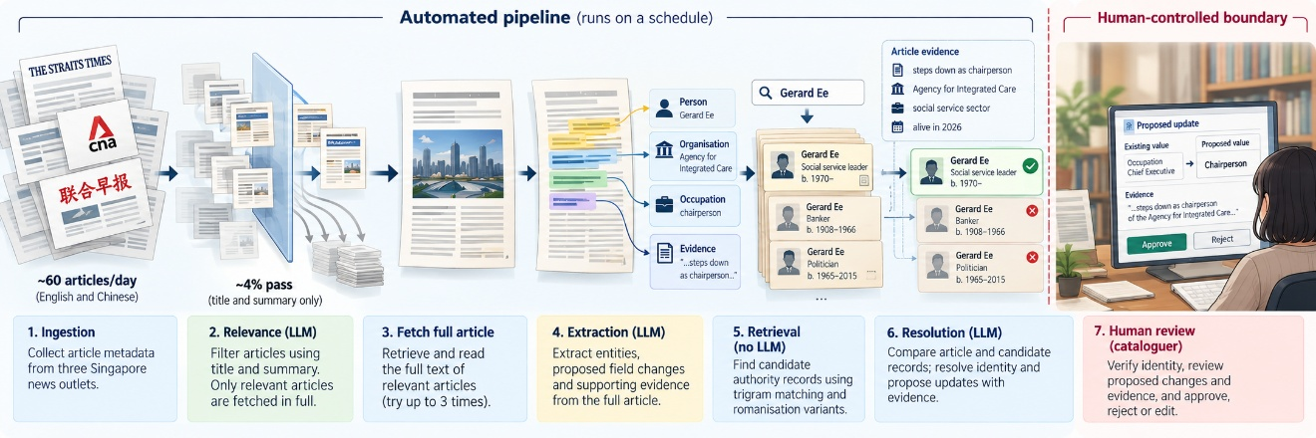
Figure 1. End-to-end authority-maintenance pipeline. Article metadata is filtered for relevance before full text is retrieved. Relevant articles are converted into structured observations, matched against candidate authority records, and resolved into proposed changes. The first five stages are automated; a cataloguer reviews every proposal and applies approved changes manually to TTE.

Ingestion collects article metadata from the RSS feeds of three Singapore news outlets in English and Chinese. Only the articles that pass relevance are fetched in full, and the article text is not kept, as the pipeline stores what is extracted from the model's output. A page that cannot be read is recorded and given up after three attempts.
The relevance stage determines whether an article describes a change that would affect an authority record. A single model call scores up to a hundred articles at once from title and summary alone, returning only those that pass. The kinds of change it looks for are: a person appointed, retired, honored or deceased; an organization founded, merged or renamed; a building opened or given heritage status. Between 3 August and 28 September 2026, 149 of the 3,511 (~4%) articles collected passed.
The extraction stage identifies the entities mentioned in each relevant article and the facts the article reports about each, recorded under TTE's own field names, with one sentence quoted verbatim as evidence so a reviewer can check the source.
The retrieval stage identifies which authority records might correspond to each extracted entity. This stage uses no model. It searches the database using character-level similarity (trigrams) on both the name as written and its English romanization. This is fast and tolerates minor spelling variation. An embeddings-based alternative was tried in a small pilot and dropped: it scored two different people as more similar to each other than one person's name written in two scripts, which would rank wrong candidates above correct ones. Retrieval methods were not compared systematically. The Library of Congress experimented with vector search for matching field values to authority records as part of broader AI cataloguing experiments; those experiments found accuracy below 50 per cent on subject and genre fields for content generation tasks, and overall performance did not meet quality standards for fully automatic operation (Saccucci & Potter, 2025). That concerns generating controlled-vocabulary strings, a different task from matching a named entity, and our decision rested on our own pilot.
The resolution stage determines whether the extracted entity matches a candidate record, and if so, what the record is missing. This is the only stage that sees both the article and the authority record at once. A model call receives each extracted entity alongside its candidates and their fields, and is asked those two questions in order. The prompt is explicit that a name match is not sufficient to confirm identity, that two people can share a name, and that the model must use the structured fields to decide.
The review stage presents the proposals to a human, one decision at a time. Proposals about the same record are merged first, so multiple articles about one person become one identity decision. The reviewer sees the identity question first, then each proposed change one screen at a time. If no candidate fits, the reviewer can search the full authority file directly. Approved changes leave as an Excel file in a layout the team agreed, and the reviewer makes each one in TTE and marks it done. The pipeline never writes to the authority file directly. This follows earlier authority maintenance projects that kept automated shadow files separate from the main file (Kreyche, Lisius & Park, 2010).
The same prompts have also been run over the three outlets' archives back to 2015, amounting to 295,279 articles, of which 27,941 were judged relevant. Across archive and live feed together, resolution proposed a change to an existing record for 9,844 entities, none yet reviewed, and found 22,331 entities with no record at all.
To make this concrete: on 31 August 2026, The Straits Times reported that a social service veteran had stepped down as chairperson of the Agency for Integrated Care. The article passed relevance with the reason "Gerard Ee stepped down and Anita Fam was appointed as chairperson." Extraction returned two entities, the outgoing chairperson and the incoming one, each with an occupation, a description and a quoted source sentence. Retrieval found the correct record for Gerard Ee and one other, which was far below the best match to be dropped automatically. Resolution confirmed the match and proposed two updates: a new affiliation, and a single clause added to the description that left 99 per cent of the cataloguer's text untouched.

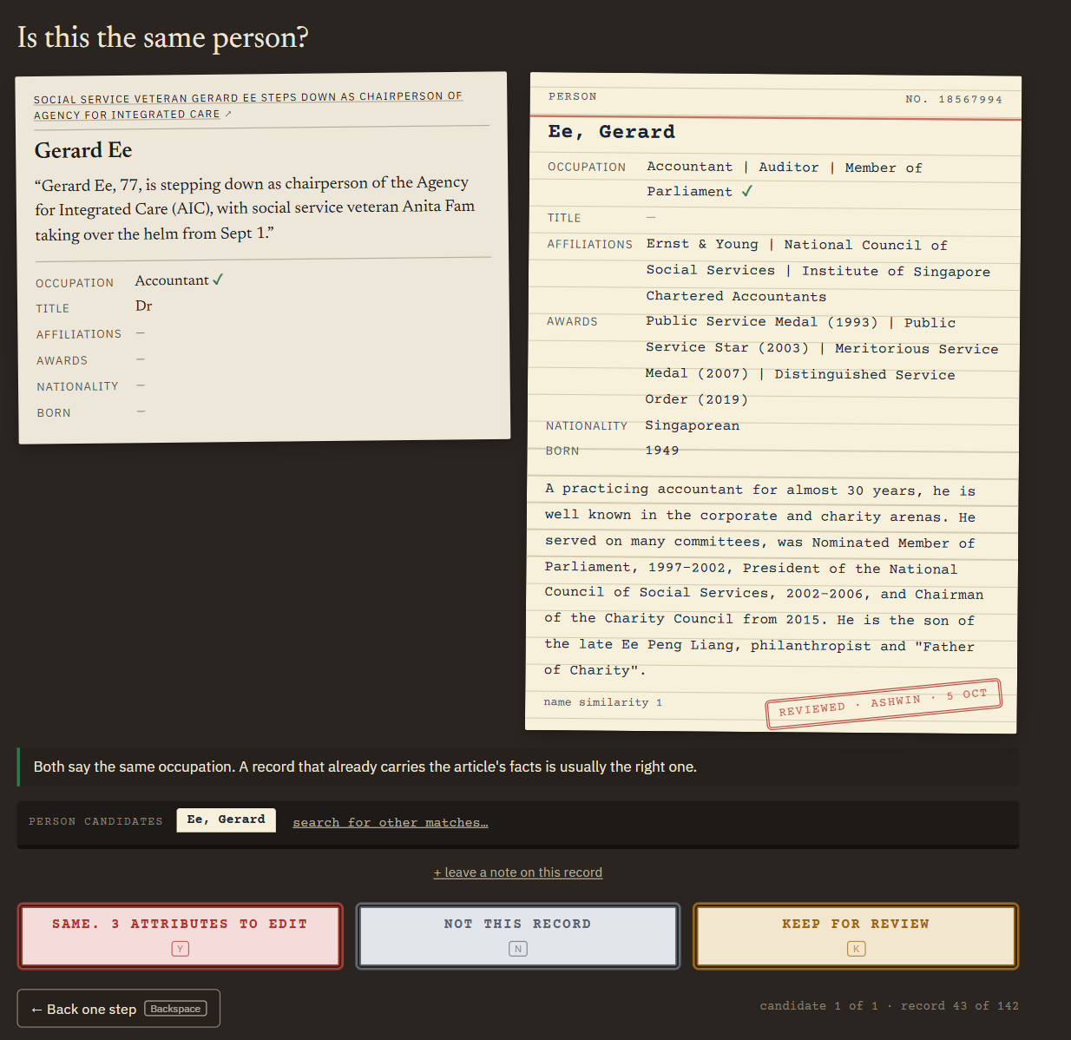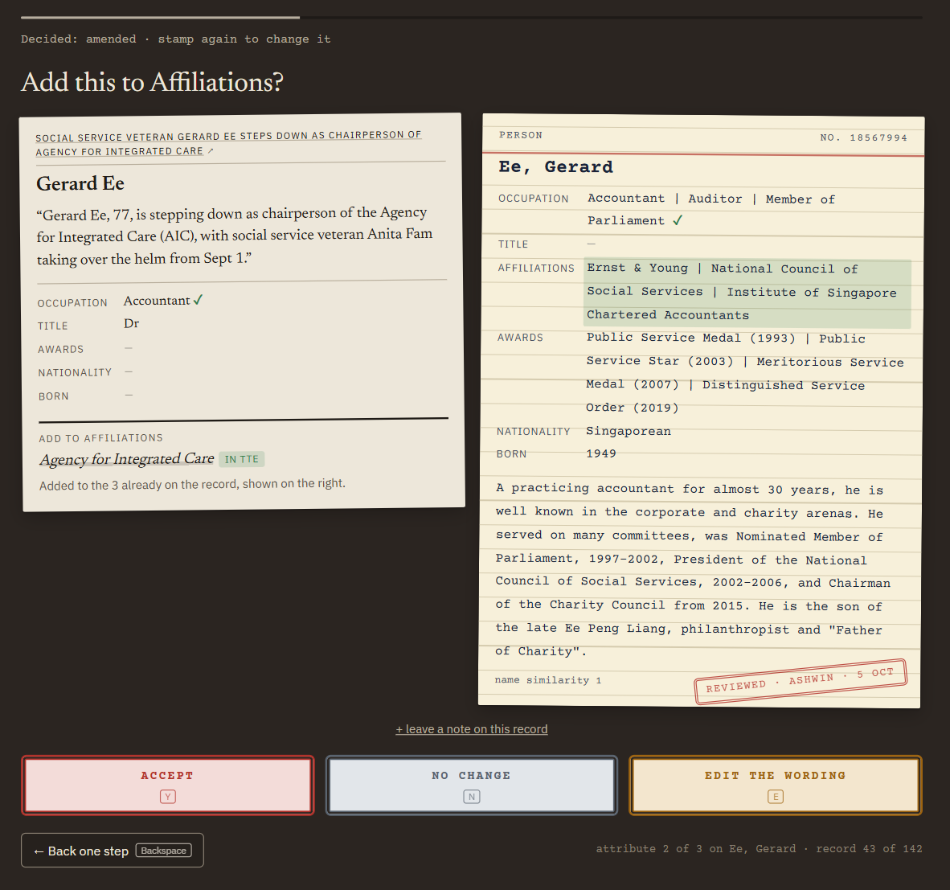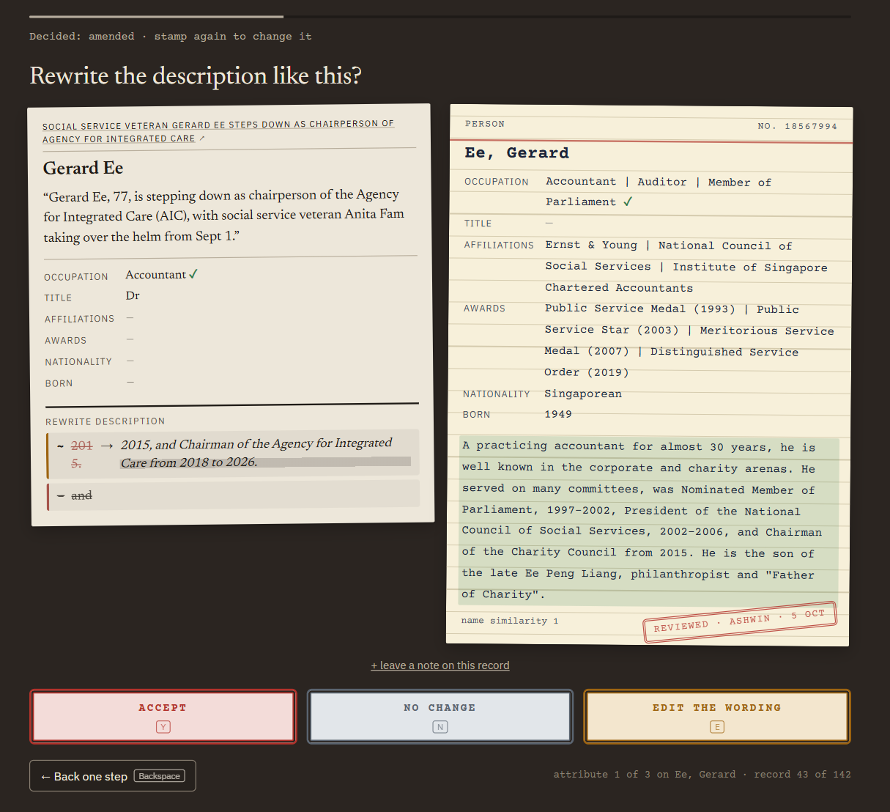
Figure 2. Reviewer-centred authority update workflow showing identity verification, field-level review, and description diff.

3. The handoff problem
An early version of the pipeline processed a backlog of news articles and surfaced over nine thousand candidate updates. The output was a flat list of entity names and proposed changes, with no source sentence to check a change against and no confirmation of whose record it was. A librarian examining it could not make a single decision.
A proposal that a reviewer cannot act on does not constitute useful output; it transfers unresolved work from the pipeline to the person without providing the means to complete it. People given AI suggestions tend to settle on a general sense of whether to trust the system rather than check each one (Buçinca, Malaya & Gajos, 2021), and a list that offers nothing to check against encourages exactly that. Every subsequent design decision in this project was made against a single standard: can a person decide this in seconds?
Four principles shaped what followed. The system never writes to the authority file, and every proposal ends at a named person who is accountable for it. Recall early, precision late: a news story wrongly judged irrelevant at the first stage is permanently and silently lost, while a wrong match at the last stage is a proposal a reviewer rejects in seconds, so errors belong at the end where they are visible and cheap (with one exception, the death-date filter in section 2). The model is told the field names it should use, but structured-output constraints and downstream validation enforce the permitted schema, since a prompt specifies behaviour while a schema enforces it. The review interface presents decisions as a sequence, first identity, then one proposed change at a time, so nothing requires the reviewer to remember anything from the previous screen. It aims at what Buçinca, Malaya and Gajos (2021) call cognitive forcing, deliberate engagement with each proposal, but is weaker than the designs they tested: the proposal is shown at once, and nothing stops a reviewer approving on sight.

4. Failure cases and their causes
Most of the following failures became visible only because the interface made someone look carefully at the output; the others were found by measuring it. Read together, most are a missing step between the model and the reviewer, not a failure of either, and each was fixed by adding a step.

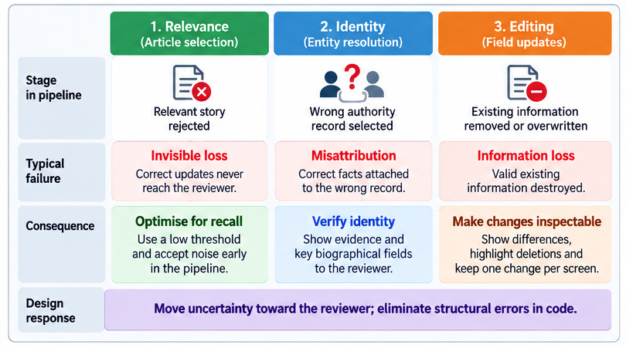
Figure 3. Different stages produce different failure costs. Relevance errors disappear silently from the pipeline, identity errors can attach correct facts to the wrong authority record, and editing errors can remove valid existing information.

Identity requires more than a name match. A name alone is not sufficient to identify which person a news article refers to; other fields on the record, such as job title, organisation, and birth year, are needed to confirm the match. This is particularly important when the name has been translated by the model itself. Matching Chinese names a second time through their English romanisation raised the match rate from 40 to 77 per cent, but the romanisation is an approximation. Of 66 Chinese-named people in the feed, TTE held the Chinese name for only 17; for the rest, the guessed spelling was the only bridge to the file. One guess matched exactly to a different person's record, a banker who died in 1966, at perfect name similarity. The resolution stage rejected the match on his death year and flagged the entity instead of confirming it; the reviewer found the right record by search. The fix prioritises the original-language name, treats any AI-guessed romanisation as weaker evidence, and marks it visibly to the reviewer.
Updating a description requires different guidance than writing one. Instructions appropriate for writing a description from scratch, such as "keep it short, don't list every post held," are counterproductive when applied to an existing one: they direct the model to remove content that was already there. This happened more than once, with one case removing a Navy career, ten years as Deputy Prime Minister and every constituency held from a 636-character description, reducing it to 405 characters. The problem is that such deletions are not immediately obvious; they would go unnoticed without a side-by-side comparison of the old and new text. The fix separates writing from editing in the model's instructions and measures every rewrite for how much of the original text survives. The standard text similarity measure penalises addition as much as deletion, and flagged rewrites that had deleted nothing at all; the more useful measure counts matched characters against the length of the old text alone, since deletion is the risk a reviewer needs to be alerted to. Rewrites that remove a significant portion of the original now reach the reviewer with a visible warning.
A merged note is not a sum of articles. One prime minister's description note carried thirteen new sentences, from 83 proposals, where the style guide allows three to five in total. Editing is told to keep every existing fact, so the length limit is off and descriptions only grow: 25 in 100 stored rewrites ended over five sentences, against 12 in 100 records beforehand. In a 48-card pilot, the 29 records built from two or more articles took 76 per cent of one reviewer's 55 minutes. A note now carries only the new sentences that fit under the limit, best supported first, and shows the rest as held back, which would have cut the sentences to read from 90 to 36; tested, not yet run live.
Proposals with no changes to review should be handled separately. In the first batch, 16 of 49 matches proposed no change, because the authority file already held every fact the article reported. The first reviewer set every one aside as unhelpful, and the interface was revised accordingly: a record with nothing to decide is no longer presented as a review card, and is instead listed at the end so the reviewer can see the article was processed.
Field names and controlled vocabularies should be enforced in code, not assumed from the prompt. TTE's guidelines define 113 fields with exact names, permitted values and exclusions. When the pipeline used its own field names instead, values were silently filed under incorrect fields: a value for the affiliation field created a new field rather than extending the existing one, because the stored field name includes a suffix the pipeline had omitted. Enforcing field names and controlled vocabularies in code after the model answers eliminated this class of error in the live runs observed, though it does not prevent a model choosing the wrong valid field. The archive illustrated the cost of relying on the prompt alone. In the first round, extraction returned the requested structure for 8,149 of 22,996 articles; the rest came back as prose, as the input handed back, or without the evidence sentence a reviewer needs. The live pipeline's model API enforces the schema, and it has not failed this way. Yang et al. (2026) report the same pattern in clinical documentation: under a free-text prompt one model configuration produced valid output for only 74-79 per cent of notes per run, while under API-level schema enforcement all three models tested were valid in every run.

5. The coverage ceiling
Comparing seven TTE exports from September 2024 to September 2026 gives the team's own edit history: 4,046 field changes. For about one in eight, one of the three outlets printed the record's name in a headline or summary in that period or the two months before; a full-text check on the articles where full text was available found 1.6 times as many names, which would put the figure nearer one in five. The remainder comes from sources this pipeline cannot read.
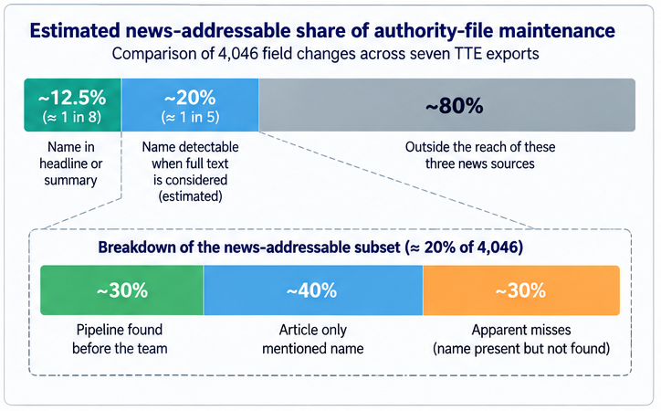
Figure 4. Estimated news-addressable share of authority-file maintenance. Comparison of 4,046 field changes across seven TTE exports found that roughly one in eight had a matching name in news headlines or summaries; a full-text comparison suggests the reachable share may be closer to one in five. These values estimate the coverage ceiling of the monitored news sources, not pipeline recall.
In a rough check of the changes the pipeline could in principle have reached, it had already identified about three in ten before the team made them, about four in ten mentioned the name only in passing, and about three in ten were genuine misses. These are estimates of a ceiling from one hand check that has not been reproduced, not measurements of failure.

6. Evaluation plan and open questions
The evaluation has not yet run. Three labelled sheets are drawn from one month of the feed: every article the pipeline judged relevant plus a stratified sample of what it rejected; matched and rejected identity pairs; and articles checked against what was extracted from them. Labellers do not see the pipeline's answer, fifty rows of each sheet are marked twice so inter-rater agreement can be reported as Cohen's kappa, and labels are frozen before scoring. Alongside it, two cataloguers use the application while two read the news as before, crossing over at six weeks so each person serves as their own control on time per change. Relevance and extraction are scored as precision, recall and F1, and identity matching as match precision and recall, split by Latin- and Chinese-script names; the crossover compares time per change. The proposals are decidable. Whether they are correct is still to be measured.
Buçinca, Malaya and Gajos (2021) found that interfaces designed to make people engage carefully with each AI suggestion reduced overreliance, but were also the designs people liked least. The review desk in this pipeline asks for that kind of engagement. Whether it remains acceptable when a cataloguer is working through fifty proposals in a session rather than five is not yet known.
First checks with a person. One reviewer, who is not a cataloguer, gave a pilot, not a measurement. A first pass over 160 cards, at a median of three seconds each, found nothing wrong at a glance. A slower pass over 48 cards exposed the merged-note problem above and showed that the nine decisions on new records followed three rules nobody had written down: the entity must be Singapore-centric (the Tokyo Paralympic Games were not), a brand whose parent organisation is already a record is the domain team's call, and an article about a regulatory penalty on one person should not have passed relevance. A notability question built from the cataloguing guidance matched those decisions no better than chance.
A second model as a checker (pilot). A decision model that answers typed questions and writes no text (jev-1.13.0, TypeSafe) was run beside the pipeline's own model on its stored decisions (mostly an internal model's archive answers, the rest Gemini's), sent only English summaries, translated quotes and public record fields; figures are agreement with those stored answers, not accuracy. Asked which candidate record matches, or none, it chose the same record for 99.4 per cent of the stored matches, on data not used to set its cut-off. Checking each change against the article's own quote, it found 71 per cent supported and 1 per cent contradicted. It writes nothing, and it agreed only weakly with the stored answers on which descriptions, affiliations and titles to record. Replaying the flow with no person, cut-offs and new-record rules decided the outcome, not matching: one relevance cut-off dropped 30 in 100 entities and another 6. This does not show that a person can be removed.

7. What transfers
The pipeline was built by one person and runs on the free tiers of a hosted database, a scheduled task runner and gemini-3.8-flash with thinking set to high. Paid API access is estimated at under SGD 15 a month at current volume, excluding staff time, development effort and the platform used for the archive. The more significant cost is the combination of skills required: someone or a team who can work across entity resolution, ML system design, library metadata practice, and interface design. Institutions considering this approach should plan for that requirement.
The practical requirements are an export of the authority file with its field structure, the cataloguing rules treated as a schema rather than as guidance, and a news source with a feed. Two constraints also need settling first. The pipeline copies an article only to analyse it: the page is fetched, entities and a single evidence sentence are extracted, and the body is discarded without being written to the database. This is designed to fall within Singapore's computational data analysis exception (Copyright Act 2021, ss. 243-244); a team in another jurisdiction should check the equivalent provision first. And the system asserts facts about living people into a file that other agencies and VIAF draw on. The control is procedural: nothing reaches the authority file without a named cataloguer's decision, which is why the accountability principle is not merely good practice but the actual safeguard.
The following design principles are expected to transfer: never write to the authority file; enforce the schema in code after the answer, not in the prompt that requests it; keep errors at the end where they are visible and cheap; confirm identity before proposing updates. One principle is worth particular emphasis: build the review interface before relying on the pipeline. A pipeline whose output cannot be clearly examined cannot be reliably improved.

8. Conclusion

Keeping an authority file current from the news involves three distinct problems: relevance, identity and editing, each with different failure costs. Relevance errors are lost silently; identity errors can misattribute facts; editing errors can remove existing information.

Our aim was not to delegate decisions to AI but to reduce the steps a person needs to decide: locating the record, gathering the evidence, drafting the change, so that the decision remains practical without leaving human hands. The institution remains accountable for the authority data it publishes; the workflow exists to ensure that an identifiable human decision precedes any change derived from an AI-generated proposal. A pilot of a second model suggests that identity and evidence checking can be automated much further than judgements with no written rule, such as what belongs in a description; until those are written and tested against cataloguers, the person stays.

This only works if the tool is one that cataloguers are willing to use: accurate, but also efficient and not cognitively demanding. In formative testing, two cataloguers used it, identified problems with the first version, and contributed to the redesign.

References
Buçinca, Z., Malaya, M. B., & Gajos, K. Z. (2021). To trust or to think: Cognitive forcing functions can reduce overreliance on AI in AI-assisted decision-making. Proceedings of the ACM on Human-Computer Interaction, 5(CSCW1), Article 188. https://doi.org/10.1145/3449287
Engel, J. Y., Do, D. T., Salem, B., & Cunningham, T. A. (2025). Artificial intelligence in library cataloging: A review of literature. Journal of Library Metadata, 25(4), 261–276. https://doi.org/10.1080/19386389.2025.2526913
Kreyche, M., Lisius, P. H., & Park, A. (2010). The DeathFlip project: Automating death date revisions to name headings in bibliographic records. Cataloging & Classification Quarterly, 48(8), 684–695. https://doi.org/10.1080/01639374.2010.497721
Saccucci, C., & Potter, A. (2025, August 15). Results of AI experimentation for cataloging at the Library of Congress [Conference presentation]. Artificial Intelligence, Bibliographic Control and Legal Matters: Navigating New Horizons, IFLA WLIC, Rotterdam, Netherlands. https://repository.ifla.org/items/4e25dfe1-336e-49a5-be2a-912e337e7624
Yang, Y.-L., Chen, C.-J., Lin, T.-K., Lin, S.-C., & Koo, M. (2026). Schema enforcement and structured-output stability in locally deployed LLMs for clinical admission-note editing: A proxy-based pre-deployment evaluation. Healthcare, 14(14), Article 2150. https://doi.org/10.3390/healthcare14142150

