**Cassandra**

**Preparing environment – Oracle VM**

1. There are several environments available for work with Cassandra – Oracle VM, Amazon AWS, your own computer. For this exercise we will use Oracle VM.

Requirements:

CPU - Multi-core 64-bit CPU

Disk Size - 10GB free space

Memory - 6GB or more

Operating System - Windows / Mac OSX / Linux

You'll also need to have Intel Virtualization Technology (VT-x) or AMD Virtualization (AMD-V) enabled in your BIOS or UEFI settings. See [this article](https://www.howtogeek.com/213795/how-to-enable-intel-vt-x-in-your-computers-bios-or-uefi-firmware/) for more details.

1. Install the software <https://www.virtualbox.org/> . Download the VM.

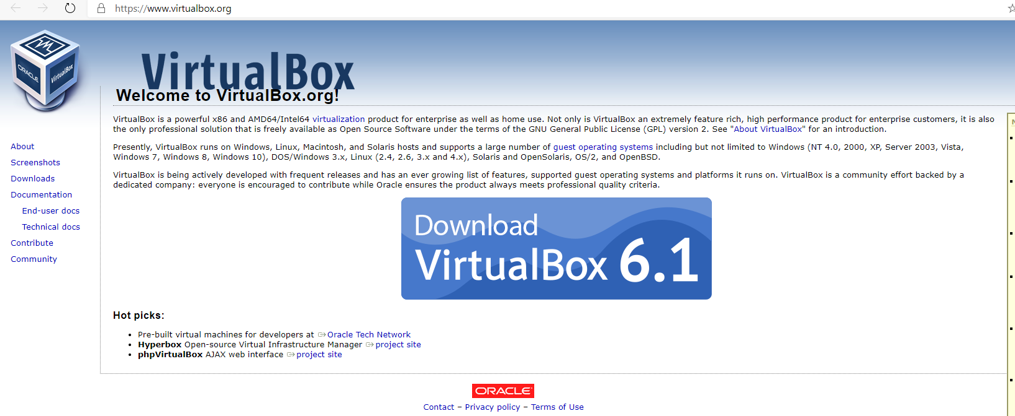

1. On your computer, double-click the file **DS201-VM-6.0.ova**. Follow the instructions to import the virtual machine.

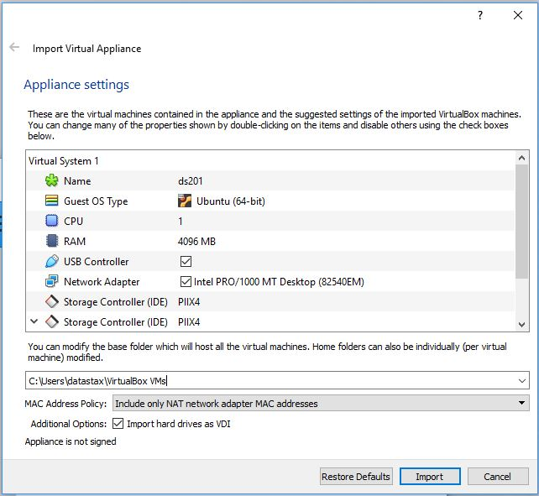

You can also open VirtualBox and click on the import button or select the option File > Import Appliance from the menu. Afterwards, select the **DS201-VM-6.0.ova** file.

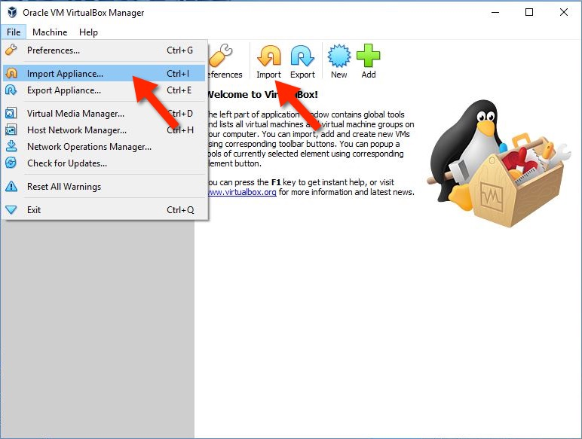

1. Start the DS201 virtual machine by double-clicking **ds201** from the Oracle VM VirtualBox Manager.

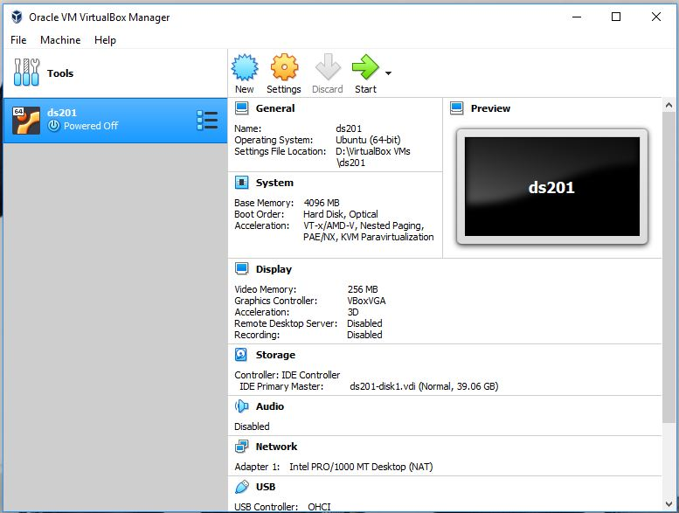

1. Once the virtual machine has started, click on the Terminal icon from the launcher to open a terminal session.

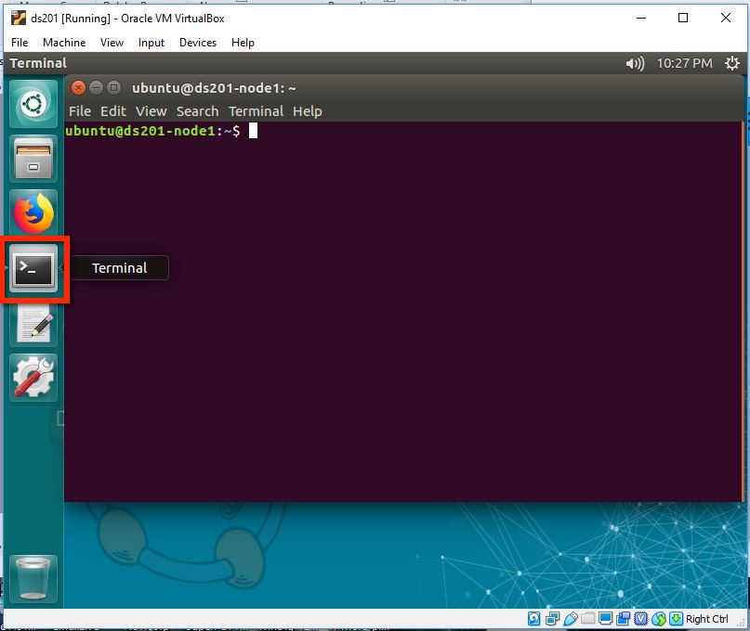

1. Troubleshooting:

**Error ‘Hardware virtualization is not enabled’**

You may run into this error message when starting up the virtual machine:

Copy CodeVT-x is disabled in the BIOS for all CPU modes (VERR_VMX_MSR_ALL_VMX_DISABLED).

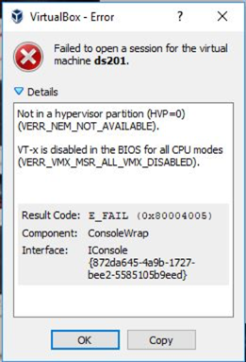

  Please check out [this article](https://www.howtogeek.com/213795/how-to-enable-intel-vt-x-in-your-computers-bios-or-uefi-firmware/) for possible solutions to resolve this error.

**Error ‘No Internet connection’**

  You do not need the Internet to run exercises in the virtual machine, however it should be set up automatically.

  In some cases, you may find that you are not able to access any webpages, or if you run the command ifconfig , you may find that there is no IP address assigned for the **enp0s3** network device.

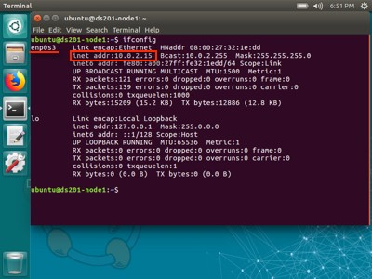

You should be able to see an IP address assigned here

This issue is usually fixed by restarting the virtual machine.

**Set up with DataStax Enterprise**

1. In your home directory, list the contents and notice the presence of dse-6.0.0-bin.tar.gz. For this course, we will install DataStax Enterprise by extracting it locally. Do so by running the following command in the Terminal:

tar -xf dse-6.0.0-bin.tar.gz

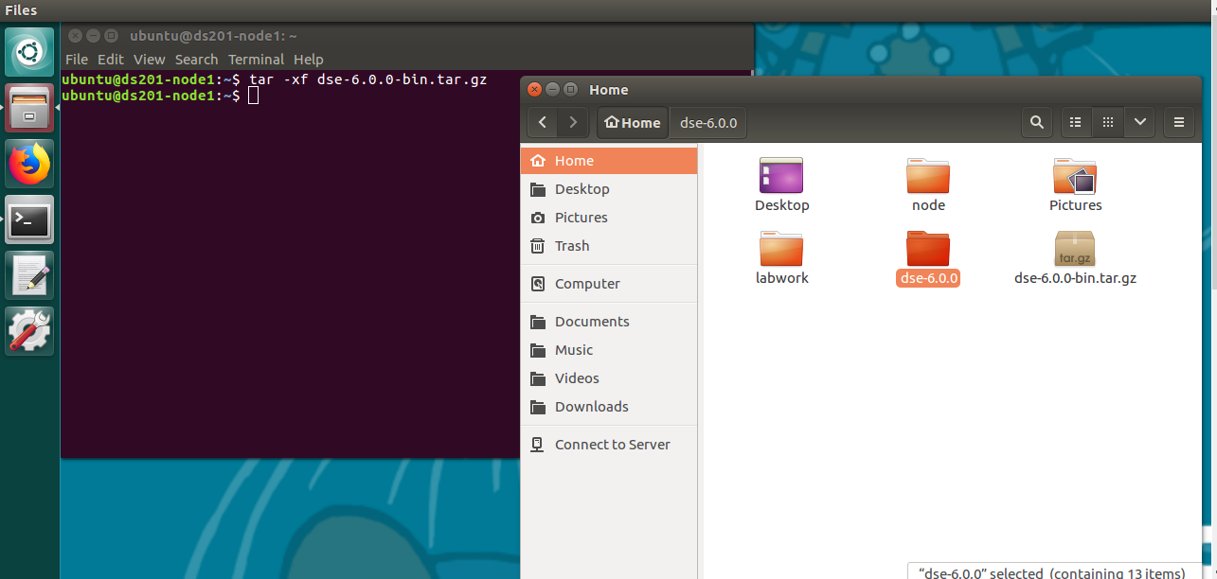

1. List the contents of the directory again. You now have a dse-6.0.0/directory. Rename this directory to node/ by executing the following command:

mv dse-6.0.0 node

1. We have a simple auto-configuration script for you to tweak some values so that we can run Apache Cassandra™ multiple times on the same virtual machine instance. Run the script like so:

labwork/config_node

1. CD into the directory with DataStax Enterprise by running:

cd node/bin

1. Start DataStax Enterprise (and thus, Apache Cassandra™) from here by running:

./dse cassandra

DataStax Enterprise might take a few minutes to start up! Be patient. You may need to hit enter to get back a prompt.

1. To check to see if DataStax Enterprise has started, run the following:

./dsetool status

1. Start sqlsh

/home/ubuntu/node/resources/cassandra/bin/cqlsh

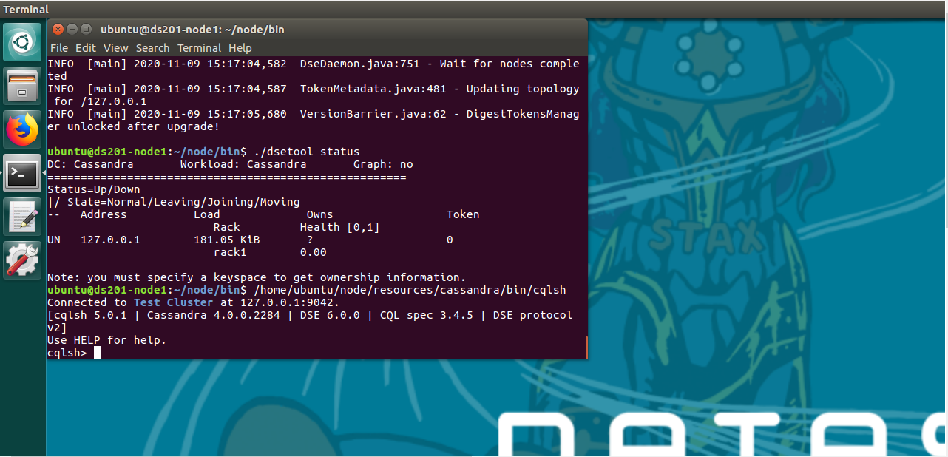

1. Create keyspace for your labwork.

CREATE KEYSPACE PASS2020 WITH replication = {'class': 'SimpleStrategy', 'replication_factor': 1};

Leave it up and running for the lab. Congrats! You installed and started DataStax Enterprise and ready to work with Cassandra.