**Scenario**

You are creating a database of all scientific papers. You expect the site to become as very popular worldwide. The site will have articles from a great variety of different fields. The users will be able to look up the articles by title, keywords or author.

To be able to access the articles the users will have to log in (so you will always know who accesses the articles). You need a mechanism for tracking the users (user name, first and last name, and e-mail address), as well as access to articles (user name, article accessed, date stamp). For the datestamp, assume that the data record is added as soon as the record gets added, so you can use the current time of the access/writing of the record.

Create a database in Cassandra that will support this service. Soon you will add the content of the articles as well, but for now we will store only the article data shown in the Data Model section below. Make up a few records for users and article access.

**Data Model**

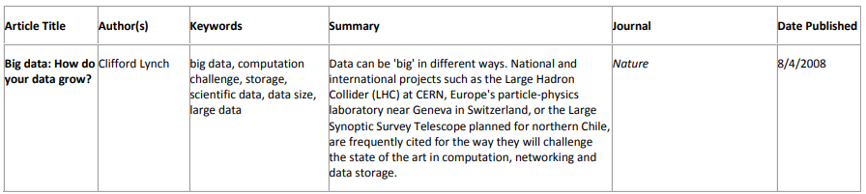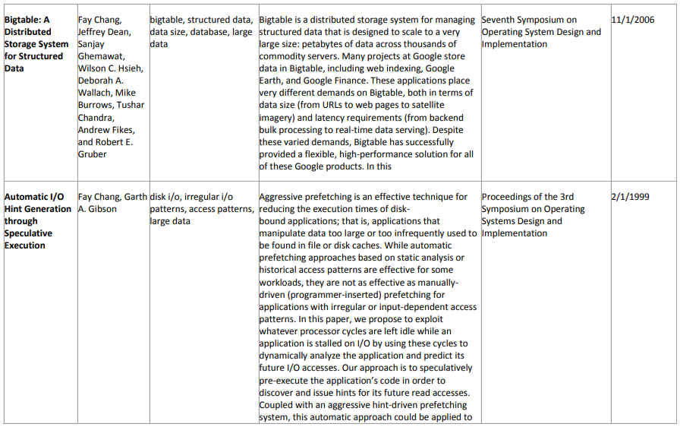

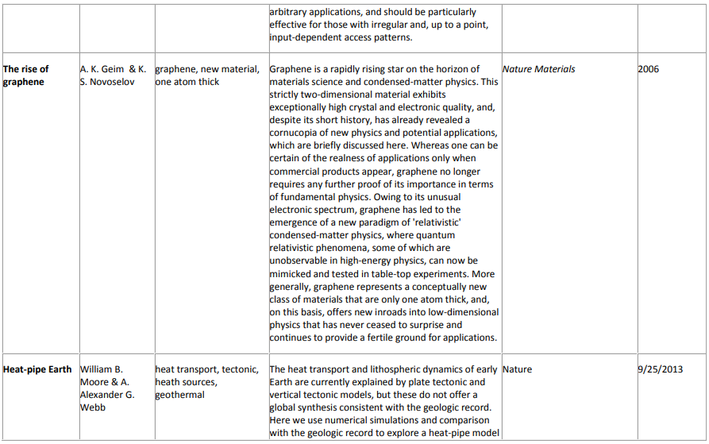

**Tasks**

1. Load data into Cassandraas ‘articles’ table.

Note: if you haven’t done it already, create keyspace.

CREATE KEYSPACE PASS2020 WITH replication = {'class': 'SimpleStrategy', 'replication_factor': 1};

Tip: use provided ‘Cassandra_Data’ file.

1. Show the data structure.
2. Alter the article table, so that it contains an additional field named ReviewScore.
3. Change value of the field for the “Big data: How do your data grow?” article to 5, value of the field for the “The rise of graphene “article to 4.76, article “Bigtable: A Distributed Storage System for Structured Data” value 4.5, and the rest of the articles the value of 4.
4. Update the publish date for the “Big data: How do your data grow?” article to 12/1/2016.
5. Write an INSERT query and an UPDATE query that will show the difference between the INSERT and UPDATE procedures and their effect in Cassandra, compared to a traditional RDBMS.