**MongoDB**

1. Only if you are running Windows 7 or Windows 2008 server, you need to install a Microsoft hotfix first. You can obtain it by going to <http://support.microsoft.com/kb/2731284> . You will have to click on the Hotfix Download Available button, accept the agreement, and fill out a short form, including your e-mail address. You will receive an e-mail from Microsoft containing the download link. Download, un-compress the file, and then execute the resulting file. You will need to re-boot at the end of the install.
2. To download the software, go to <http://www.mongodb.org/downloads> . Make sure you go to the Software - Community Server tab. Download the Windows Platform for the currently stable 4.4.1 version, and download the msi installer.

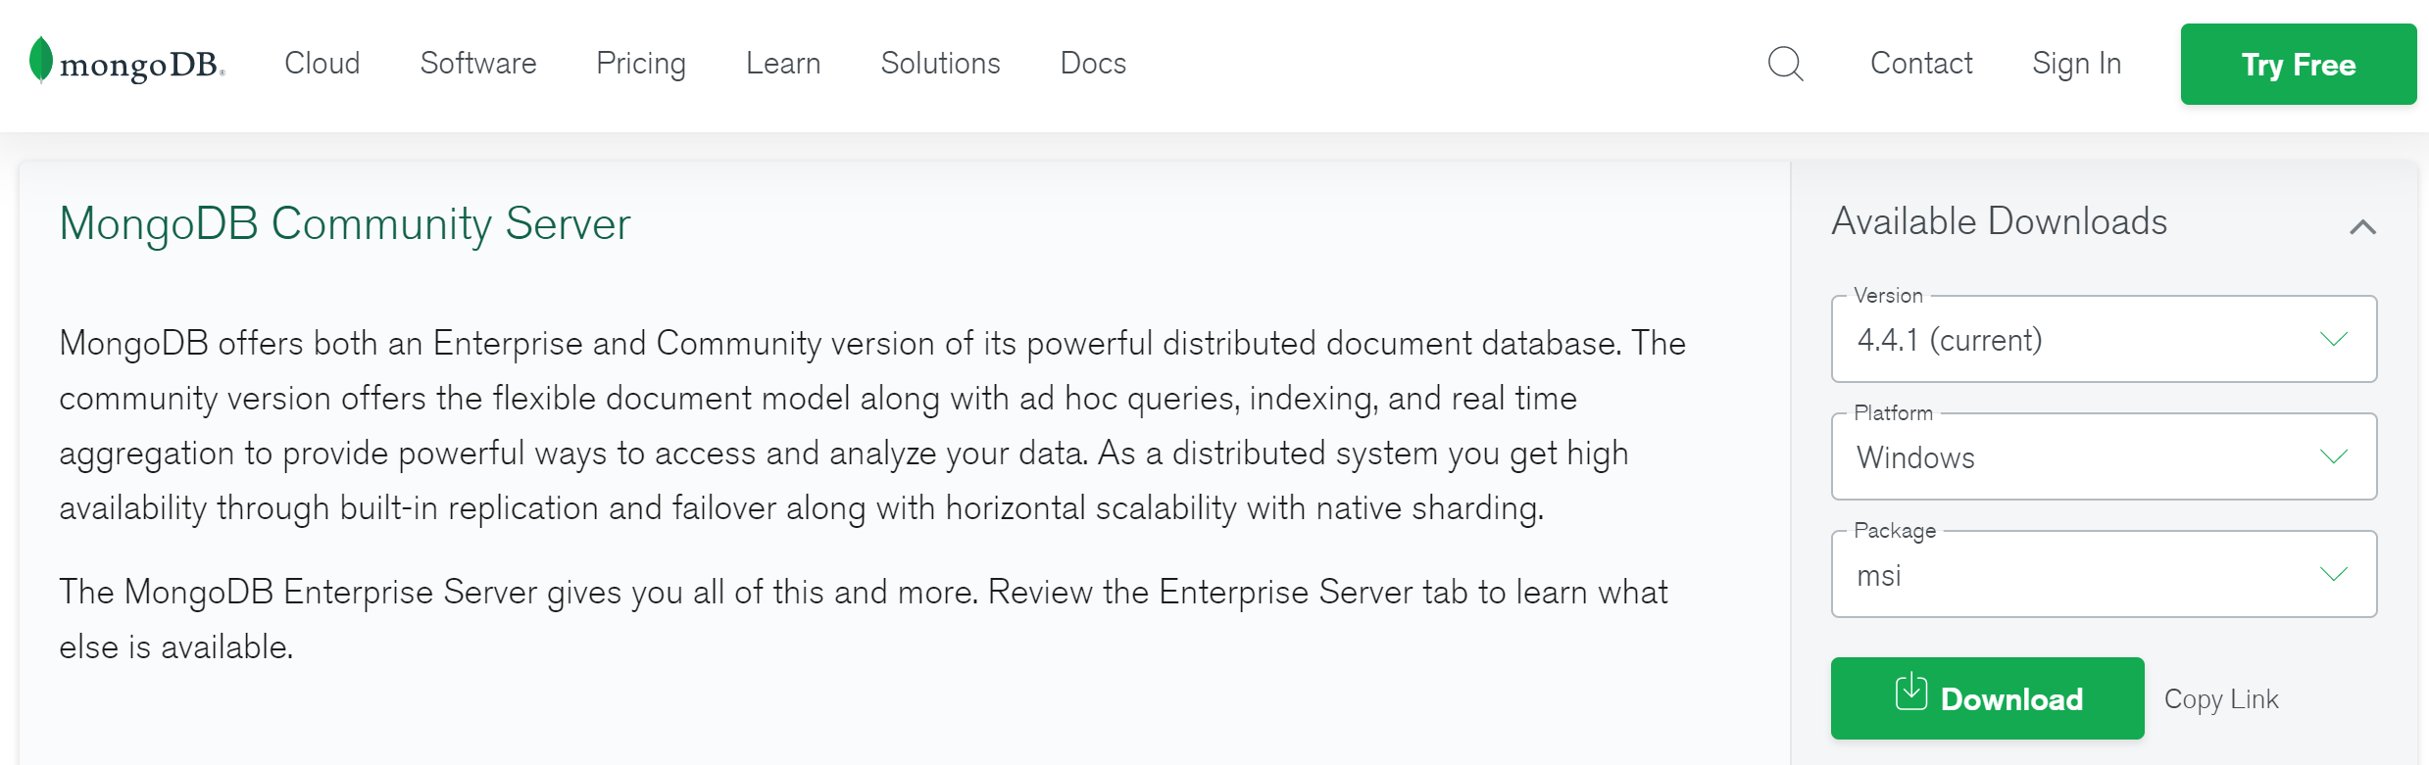

1. Double click on the msi file to start the install. Accept the license agreement and pick the Complete install and otherwise the default installation options. Before you can run MongoDB, you will need to create a data directory. By default, MongoDB will want to save the data to C:\data\db, so create that folder structure.
2. By default, MongoDB will be installed in the following folder:

C:\Program Files\MongoDB\Server\4.4. Look for the bin directory in that folder and mongod.exe file; double click on the file to run it. That will start the MongoDB service, and you should see a line stating the server is waiting for connections in the bottom of that window.

1. If you get an error message about the api-ms-win-crt-runtime-l1-1-0.dll missing, download the Visual C++ library distributable from <http://download.microsoft.com/download/9/3/F/93FCF1E7-E6A4-478B-96E7-D4B285925B00/vc_redist.x64.exe> , and install it.
2. Now that the server is running you can connect to it by running mongo.exe, which will start the client. Simply double click on the file to run it. Note server name at the top of the window.

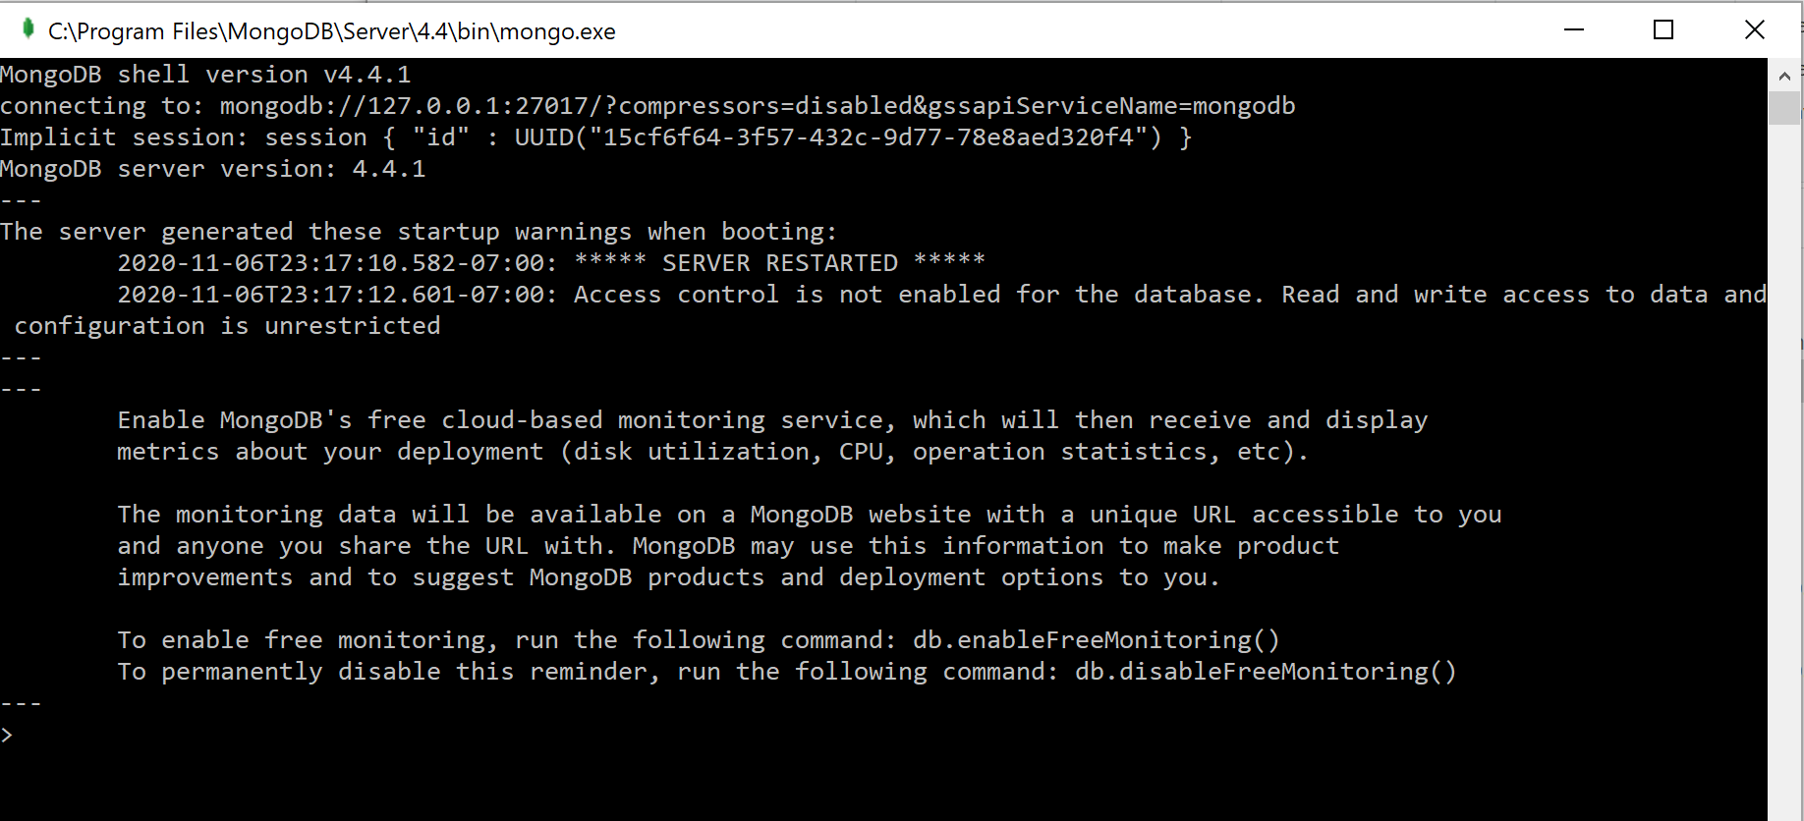

1. For our lab you can either run client as above or use MongoDBCompass that was installed as part of the same installation – use Search button to find and start it.
2. If connecting via MongoDBCompass, you will need to connect to a standalone cluster. Fill in New Connection window - you can get connection string from mongo.exe file as in Step 6 above. You will need to change compressors property to zlib.

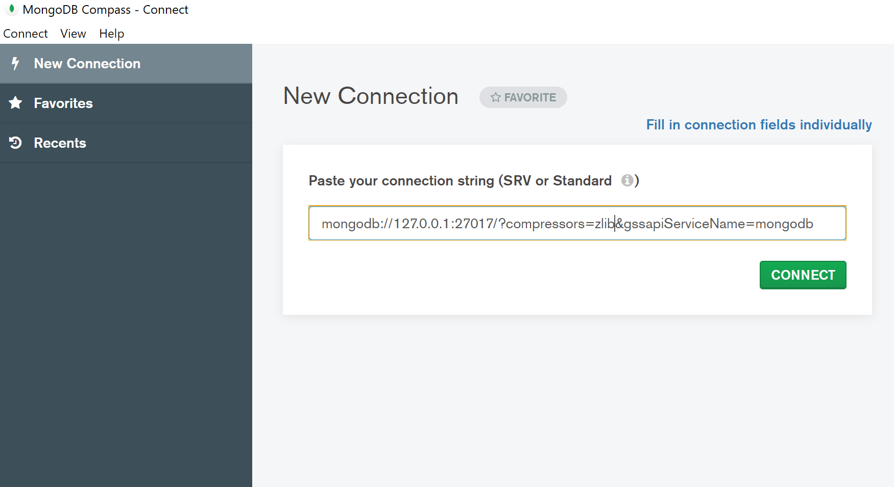

1. Once connected, create Database ‘PASS2020’ and Collection ‘artwork’.

Note: if using client, run command ‘use PASS2020’ to create a database.

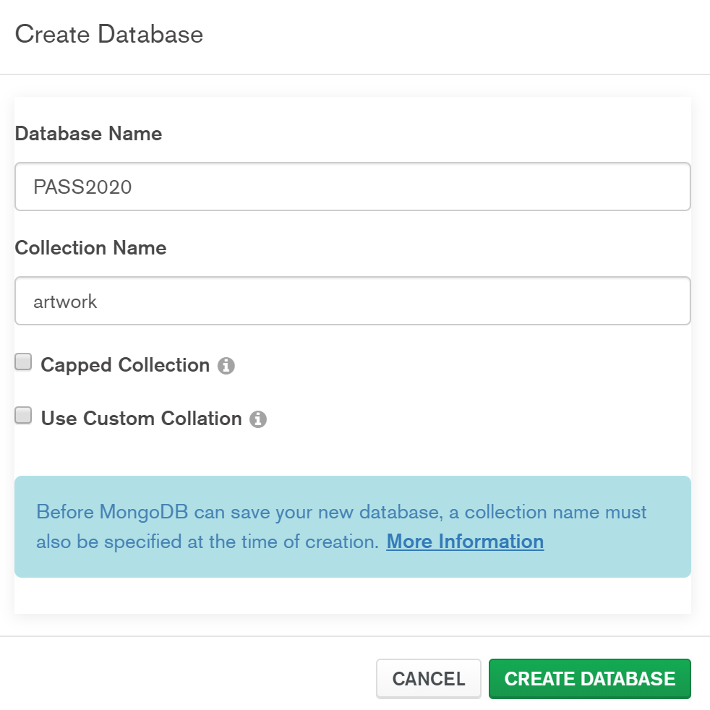

Your set-up for MongoDB is now complete.